ClassOS
AI-Powered Embedded Classroom Attendance System

Project Report

Developed by:
Abir Hasan Arko
Md Shomik Shahriar

Version 2.1 | 2026

Table of Contents
1. Project Description
2. System Features
3. Technology Stack
4. Hardware Components & Sensors
5. Hardware Wiring & Circuit Diagrams
6. Software Architecture
7. Database Design
8. AI & Recognition Pipeline
9. Key Code Snippets: Hardware-Software Bridge
10. Deployment & Configuration
11. User Workflow
12. Security & Privacy
13. Hardware & Software Specifications
14. Future Roadmap

1. Project Description
ClassOS is a fully self-contained, edge-computing classroom attendance management system. It replaces manual roll-call with an automated pipeline that combines Computer Vision (face recognition), hardware biometrics (fingerprint scanning), and a modern web-based dashboard — all running locally on a Raspberry Pi 5 without requiring any internet connection or cloud service.
Most existing automated attendance solutions fall into one of two categories: cloud-dependent APIs that introduce network latency and raise serious student privacy concerns, or fragile local scripts without any modern user interface. ClassOS bridges this gap by delivering a state-of-the-art enterprise software architecture entirely on the Edge. By leveraging the Raspberry Pi 5, ClassOS handles computationally heavy AI inferencing locally, orchestrates low-level hardware serial communication (UART) for fingerprint biometrics, and serves a beautiful, high-performance React dashboard to any device on the network — all without any cloud dependency.
The system is entirely containerized using Docker and Docker Compose, enabling one-command deployment. It supports dual-camera attendance (Camera 0 at the entry door for face recognition; Camera 1 on the classroom ceiling for YOLOv8 head counting), an R307 optical fingerprint sensor fallback, a physical GPIO push button, a 20×4 I2C LCD display, and a full-stack web dashboard with Role-Based Access Control for Admins, Teachers, and Students.

2. System Features
• Dual-Camera Attendance: Two cameras serve distinct roles: Camera 0 at the entry door runs face recognition; Camera 1 on the classroom ceiling runs YOLOv8 Nano for head counting. Both modes are switchable mid-session without data loss.
• Take Attendance Mode: Camera 0 streams the entry door feed. The dlib ResNet AI automatically marks students present at ≥70% confidence, prompts fingerprint verification at 30–69%, and ignores unknowns below 30%.
• Verify Head Count Mode: Camera 1 activates YOLOv8 Nano to count all heads visible in the classroom. The count is compared against recognized face/fingerprint attendance to detect proxy attendance and unrecognized students.
• R307 Biometric Fallback: Seamless UART-based fingerprint scanning is available as a verification fallback when face confidence is low or as a direct identification method when the face is not visible (e.g., hijab, mask, poor lighting).
• Hardware Push Button: A GPIO-connected momentary push button lets students trigger a fingerprint scan directly without any interaction from the teacher's web dashboard.
• 20×4 I2C LCD Display: The physical LCD shows real-time status: 'Total Attendee: XX / Name >> Present' during attendance mode, and 'Present = X / Head Count = X / ✓ Match' during head count mode.
• EXIF-Aware Face Enrollment: Gallery photos from phones (portrait-mode JPEG) are automatically rotated based on EXIF metadata before face detection, eliminating the most common cause of enrollment failures.
• Live MJPEG Video Streaming: Teachers watch a live, annotated camera feed with AI bounding boxes directly in their browser at 30 FPS.
• Real-Time WebSocket Sync: As students are detected, their full names and attendance status appear on the teacher's dashboard instantly without any page refresh.
• Role-Based Access Control: Distinct dashboards and permissions for Admins, Teachers, and Students. Teachers can only view data for courses explicitly assigned to them.
• Full-Stack Analytics & CSV Export: Historical session logs, attendance rates, visual pie/bar charts, and one-click CSV export for offline record-keeping.
• Ghost-Session Resiliency: The backend automatically recovers and cleans up abandoned sessions if the teacher's browser disconnects unexpectedly.
• USB Webcam Auto-Fallback: If a CSI Camera Module is unavailable, the system automatically probes USB webcam device indices and uses the first one that opens — zero configuration needed.
• One-Command Docker Deployment: The entire system is containerized and deployable with a single 'docker compose up -d --build' command.

3. Technology Stack

3.1 Frontend
Technology | Version | Role
React | 18 | Single Page Application framework
Vite | 5.x | Frontend build tool and dev server
Tailwind CSS | 3.x | Utility-first CSS styling
Axios | 1.x | HTTP REST API client with JWT interceptors
WebSocket API | Native | Real-time attendance event streaming
Chart.js (react-chartjs-2) | 4.x | Analytics charts and visualizations
React Router | 6.x | Client-side SPA navigation

3.2 Backend
Technology | Version | Role
Python | 3.11 | Primary backend language
FastAPI | 0.110 | Async REST API & WebSocket server
SQLAlchemy | 2.x (async) | ORM for database access
asyncpg | 0.29 | Async PostgreSQL driver
Alembic | 1.x | Database schema version management
JWT (python-jose) | 3.x | Stateless authentication tokens
bcrypt (passlib) | 1.x | Password hashing (12 rounds)
Pydantic | 2.x | Request/response data validation
Uvicorn | 0.29 | ASGI server for FastAPI

3.3 AI & Computer Vision
Technology | Version | Role
dlib | 19.24 | HOG face detection + ResNet 128D face embedding generation
face_recognition | 1.3 | High-level dlib wrapper for embedding comparison
YOLOv8 Nano (Ultralytics) | 8.x | Real-time crowd head counting on Camera 1
OpenCV (cv2) | 4.9 | Video capture, frame processing, annotation
NumPy | 1.26 | Numerical operations on face embedding vectors
Pillow (PIL) | 10.x | EXIF rotation correction during enrollment

3.4 Infrastructure
Technology | Version | Role
PostgreSQL | 16 | Relational database for all persistent data
Docker | 26.x | Container runtime
Docker Compose | 2.x | Multi-container orchestration
Nginx | Alpine | Reverse proxy, SSL termination, static file serving
RPLCD | 1.3 | I2C LCD driver library
smbus2 | 0.4 | Linux I2C bus communication
lgpio | 0.2 | Direct RP1 GPIO chip control (Pi 5 native)
pyserial | 3.5 | UART serial communication with R307 sensor

4. Hardware Components & Sensors
The following hardware components are used in the ClassOS system. Each is chosen specifically for its interface compatibility with the Raspberry Pi 5.

4.1 Component List
# | Component | Model / Specification | Qty | Interface | Purpose
1 | Single Board Computer | Raspberry Pi 5 (8GB RAM, BCM2712 quad-core Cortex-A76 @ 2.4GHz) | 1 | — | Central edge server running the full software stack
2 | Power Supply | Official Raspberry Pi 27W USB-C PSU (5.1V / 5A) | 1 | USB-C | Stable 25.5W power delivery via USB-PD negotiation
3 | Camera 0 (Entry) | Raspberry Pi Camera Module v2/v3 (IMX708 12MP) or USB Webcam | 1 | CSI (CAM/DISP 0) or USB | Entry door face recognition AI pipeline
4 | Camera 1 (Classroom) | Raspberry Pi Camera Module v2/v3 (IMX708 12MP) or USB Webcam | 1 | CSI (CAM/DISP 1) or USB | Ceiling-mounted head count via YOLOv8 Nano
5 | Fingerprint Sensor | R307 Optical Fingerprint Module (ZFM-20 compatible) | 1 | UART @ 57600 baud | Biometric identity fallback verification
6 | LCD Display | 20×4 HD44780 Character LCD + PCF8574 I2C Backpack | 1 | I2C (0x27) | Real-time hardware status and attendance feedback
7 | Push Button | Generic Momentary Tactile Switch (4-pin) | 1 | GPIO23 (Pin 16) | Physical trigger for direct fingerprint scan
8 | Jumper Wires | Female-to-Female Dupont Wires | 8+ | GPIO Header | Physical connections between Pi and peripherals
9 | MicroSD Card / SSD | 64GB+ Class 10 A2 MicroSD or USB SSD | 1 | MicroSD / USB3 | Operating system and Docker container storage

4.2 Component Roles Explained

Raspberry Pi 5 (8GB)
The Raspberry Pi 5 is the central brain of the entire system. It runs the full Docker stack (PostgreSQL database, FastAPI backend, React frontend, Nginx proxy) while simultaneously handling real-time AI inferencing (dlib face embeddings at ~5 FPS + YOLOv8 at ~10 FPS) and orchestrating all hardware peripherals. The 8GB RAM variant is essential — running the AI models alongside Docker containers requires at least 4–5GB of RAM under peak load. The BCM2712 SoC includes a dedicated RP1 south bridge chip that manages all GPIO, UART, I2C, and SPI peripherals.

Camera Module (Camera 0 — Entry Door)
Camera 0 connects to the CAM/DISP 0 CSI port on the Raspberry Pi 5 and is physically positioned at the classroom entry door at approximately head-height. It exclusively powers the Face Recognition Pipeline. The v4l2loopback kernel module exposes it as /dev/video42 inside the Docker container. Frames are captured at 640×480 resolution and fed to the dlib HOG face detector, which extracts 128-dimensional facial embeddings and compares them against the database to generate a confidence score.

Camera Module (Camera 1 — Classroom Ceiling)
Camera 1 connects to the CAM/DISP 1 CSI port and is ceiling-mounted at the front of the classroom to provide a wide-angle view of the entire student body. It exclusively powers the Head Count Pipeline using YOLOv8 Nano to count all visible human heads. The count is compared against the recognized /dev/video43 inside Docker.

Camera Firmware & Autofocus
The Raspberry Pi Camera Module 3 features a Sony IMX708 sensor equipped with Phase Detection Autofocus (PDAF). Unlike older fixed-focus modules, this allows the lens to dynamically adjust focus for sharp captures at varying distances. This hardware capability is driven entirely by the libcamera firmware stack in Raspberry Pi OS Bookworm, which natively handles PDAF calculations and voice-coil motor (VCM) lens actuation. ClassOS inherits this automatic focusing behavior seamlessly through the v4l2loopback layer, ensuring that students' faces are sharply in focus without any manual lens adjustments.

R307 Optical Fingerprint Sensor
The R307 (ZFM-20 compatible) is an optical fingerprint sensor that communicates over the UART0 serial port at 57600 baud. It connects to GPIO14 (TXD) and GPIO15 (RXD) on the Pi's GPIO header at 3.3V. The sensor has internal flash memory to store up to 200 fingerprint templates. During enrollment, it performs a two-sample capture workflow (GenImg → Img2Tz → RegModel → Store). During attendance verification, it performs a search (GenImg → Img2Tz → Search) and returns the matching template ID, which is then looked up in the PostgreSQL database to identify the student.

20×4 I2C LCD Display (HD44780 + PCF8574)
The 20×4 HD44780 character LCD provides real-time physical feedback to both teachers and students standing near the device. It uses a PCF8574 I2C backpack module to reduce the connection from 8 parallel data wires to just 4 wires (VCC, GND, SDA, SCL). The LCD communicates on I2C bus 1 (GPIO2 SDA + GPIO3 SCL) at the default I2C address 0x27. Custom CGRAM characters are loaded for a checkmark (✓) and cross (✗) symbol used in the head count mismatch display. The LCD requires 5V power (not 3.3V) for full backlight brightness.

Momentary Push Button
A simple 4-pin tactile push button is wired between GPIO23 (Pin 16) and GND (Pin 14). The lgpio library is used directly (instead of gpiozero) to explicitly activate the RP1 chip's internal pull-up resistor on GPIO23. This is critical: without an explicit pull-up on the Pi 5's RP1 GPIO, the floating pin can draw phantom current, causing unexpected low-voltage warnings. The button is polled at 10Hz in an async loop. When pressed (active-low), it triggers a full fingerprint verify_flow() over UART and automatically marks attendance in the database.

5. Hardware Wiring & Circuit Diagrams

5.1 Circuit Diagram
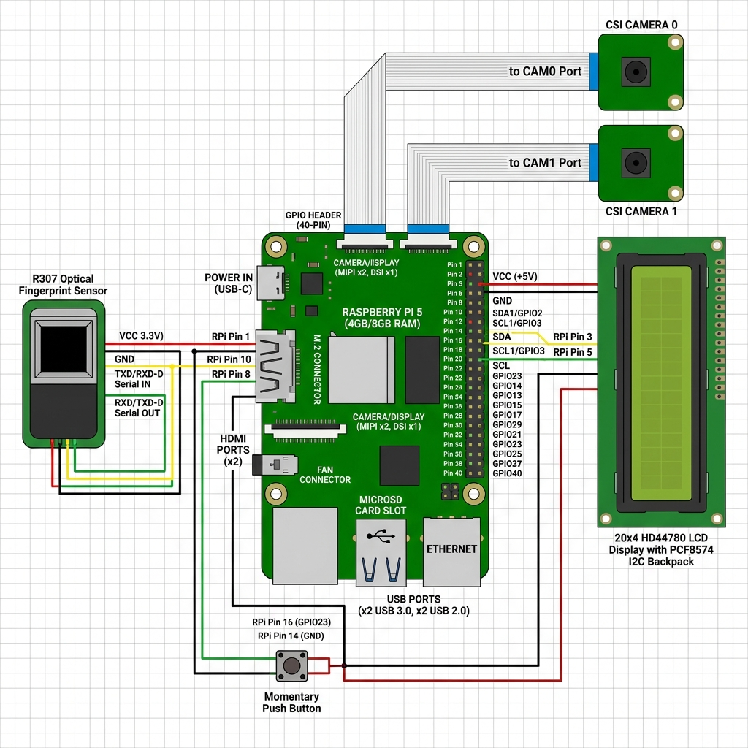
Figure 1: Complete Hardware Circuit Diagram — Raspberry Pi 5 with all peripherals

5.2 GPIO Pin Assignments
GPIO Pin | Pin Number | Signal | Connected To | Protocol
3.3V | Pin 1 | VCC (3.3V) | R307 VCC (Red) | Power
5V | Pin 2 | VCC (5V) | LCD VCC (Red) | Power
GPIO2 (SDA1) | Pin 3 | I2C Data | LCD SDA (Blue) | I2C
GPIO3 (SCL1) | Pin 5 | I2C Clock | LCD SCL (Yellow) | I2C
GND | Pin 6 | Ground | R307 GND (Black), LCD GND | Ground
GPIO14 (TXD0) | Pin 8 | UART Transmit | R307 RX (Green) | UART
GPIO15 (RXD0) | Pin 10 | UART Receive | R307 TX (Yellow) | UART
GND | Pin 14 | Ground | Push Button Leg 2 | Ground
GPIO23 | Pin 16 | Digital Input | Push Button Leg 1 | GPIO
CSI Port 0 | CAM/DISP 0 | Camera Serial | Camera 0 Ribbon | CSI
CSI Port 1 | CAM/DISP 1 | Camera Serial | Camera 1 Ribbon | CSI

5.3 Wiring Diagrams (Text Representation)
R307 Fingerprint Sensor (UART):
R307 Sensor Raspberry Pi 5
┌──────────┐ ┌──────────────┐
│ VCC (Red)├────────►│ Pin 1 (3.3V)│
│ GND (Blk)├────────►│ Pin 6 (GND) │
│ TX (Yel)├────────►│ Pin 10 (RXD) │ ← GPIO15
│ RX (Grn)├────────►│ Pin 8 (TXD) │ ← GPIO14
└──────────┘ └──────────────┘
NOTE: TX ↔ RX Cross-connection (always TX→RX)
20×4 LCD Display (I2C):
LCD I2C Backpack Raspberry Pi 5
┌──────────────┐ ┌──────────────────┐
│ VCC (Red) ├────►│ Pin 2 (5V) │
│ GND (Black) ├────►│ Pin 6 (GND) │
│ SDA (Blue) ├────►│ Pin 3 (GPIO2) │ ← SDA1
│ SCL (Yellow) ├────►│ Pin 5 (GPIO3) │ ← SCL1
└──────────────┘ └──────────────────┘
Default I2C address: 0x27
Momentary Push Button (GPIO):
Momentary Button Raspberry Pi 5
┌──────────────┐ ┌──────────────────┐
│ Leg 1 ├────►│ Pin 16 (GPIO23) │
│ Leg 2 ├────►│ Pin 14 (GND) │
└──────────────┘ └──────────────────┘
Pull-up enabled via lgpio (RP1 internal)

6. Software Architecture
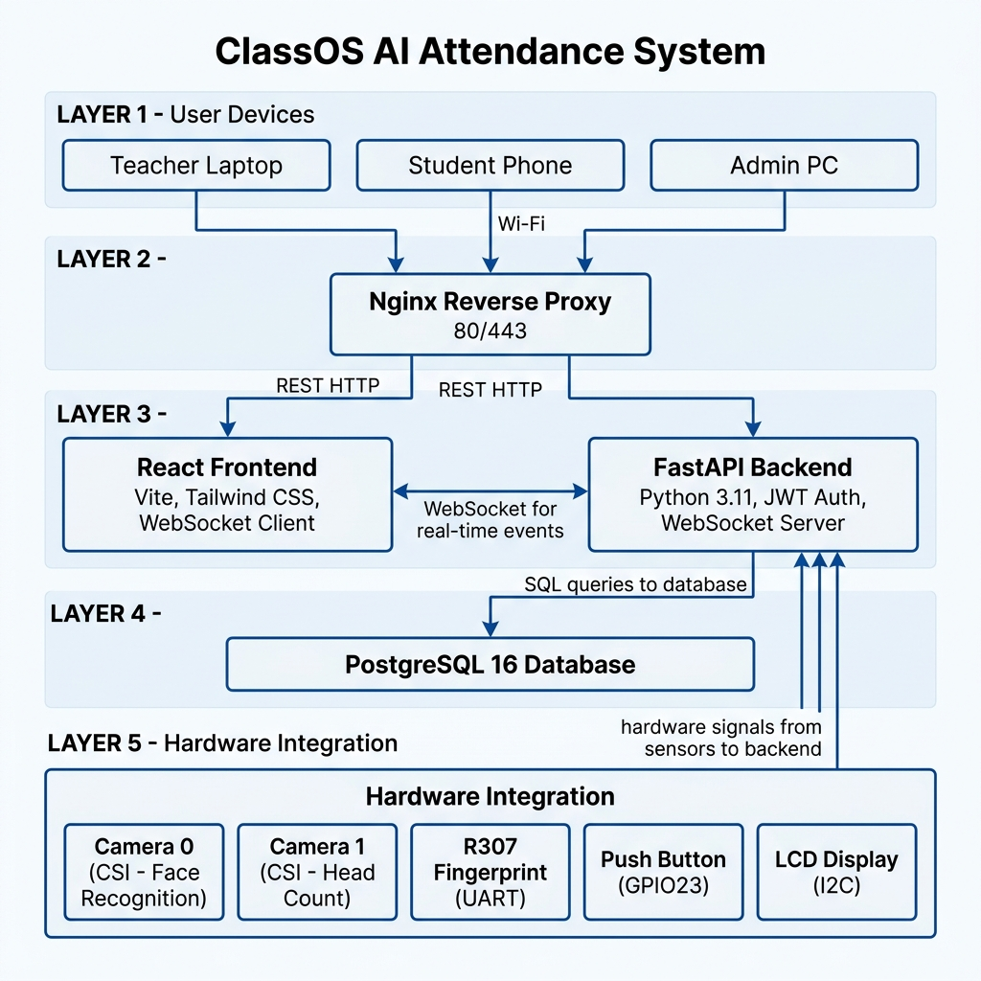
Figure 2: ClassOS System Architecture — Layers and Component Interactions

6.1 Architecture Overview
ClassOS uses a heavily decoupled, microservice-like structure packaged inside Docker containers. The system is divided into five distinct layers, each communicating through well-defined interfaces.

6.2 Project Module Structure
ClassOS/
├── ai_engine/ # FaceRecognitionPipeline + HeadCountPipeline (dlib + YOLOv8)
├── attendance_engine/ # Dual-mode orchestrator (Take Attendance / Verify Head Count)
├── backend/ # FastAPI application (REST endpoints, WebSockets, Auth, JWT)
├── camera_service/ # Dual-camera management (singleton CameraManager instances)
├── database/ # SQLAlchemy async engine + Alembic migration scripts
├── docker/ # Dockerfiles for backend and frontend containers
├── docs/ # Extended project documentation (ER diagrams, API reference)
├── fingerprint_service/# R307 UART sensor driver + GPIO button listener
├── frontend/ # React 18 SPA (Vite + Tailwind CSS)
├── lcd_service/ # 20×4 I2C LCD driver (RPLCD + smbus2, graceful fallback)
├── models/ # Shared SQLAlchemy ORM models (database schema)
├── nginx/ # Reverse proxy config + SSL certificate management
├── scripts/ # Utility scripts (seed_db.py, test_camera.py)
└── docker-compose.yml # Orchestrates all containers (Frontend, Backend, DB, Nginx)

6.3 Service Communication
From | To | Protocol | Purpose
Browser (Teacher/Student) | Nginx | HTTP/HTTPS | All web traffic entry point
Nginx | React Frontend | HTTP | Serve static SPA files
Nginx | FastAPI Backend | HTTP/WS proxy | Route API and WebSocket calls
React Frontend | FastAPI Backend | REST (Axios) | CRUD operations, auth, data
React Frontend | FastAPI Backend | WebSocket | Real-time attendance events
React Frontend | FastAPI Backend | HTTP (chunked) | MJPEG live camera stream
FastAPI Backend | PostgreSQL | asyncpg/SQLAlchemy | All database read/write
FastAPI Backend | Camera Service | Python in-process | Frame capture
FastAPI Backend | AI Engine | Python in-process | Frame inference
FastAPI Backend | R307 Sensor | UART (/dev/ttyAMA0) | Fingerprint capture/match
FastAPI Backend | Push Button | GPIO (lgpio) | Physical button press event
FastAPI Backend | LCD Display | I2C (/dev/i2c-1) | Real-time status display

7. Database Design

7.1 Entity-Relationship Overview
The ClassOS database uses PostgreSQL 16 with SQLAlchemy async ORM. The schema is strictly normalized with UUID primary keys, cascading foreign key deletions, and enum types for status and role fields.

7.2 Table Definitions
Table | Primary Key | Key Fields | Purpose
users | uuid id | email (unique), password_hash, role (ADMIN/TEACHER/STUDENT) | Base authentication entity for all users
teachers | uuid id | user_id (FK), first_name, last_name | Teacher profile linked to users table
students | uuid id | user_id (FK), student_id (unique), face_registered, fingerprint_registered | Student profile with biometric enrollment flags
courses | uuid id | teacher_id (FK), course_code (unique), course_name, schedule | Academic course entity managed by a teacher
enrollments | uuid id | student_id (FK), course_id (FK) | Many-to-many: which students are in which course
attendance_sessions | uuid id | course_id (FK), teacher_id (FK), status, mode, head_count, recognized_count | A single class meeting with live session state
attendance | uuid id | session_id (FK), student_id (FK), status (PRESENT/ABSENT), method (FACE/FINGERPRINT/MANUAL), confidence | Individual student attendance record per session
fingerprint_data | uuid id | student_id (FK), sensor_id (int) | Maps R307 internal template IDs to student UUIDs
face_embeddings | uuid id | student_id (FK), embedding (float array) | 128D dlib ResNet face vectors for recognition

7.3 Key Relationships
- User (1) ──── (0..1) Teacher / Student : Every person has exactly one User account
- Teacher (1) ──── (0..N) Course : A teacher can teach many courses
- Course (1) ──── (0..N) Enrollment : A course has many enrolled students
- Student (1) ──── (0..N) Enrollment : A student can be in many courses
- Course (1) ──── (0..N) AttendanceSession : Each class meeting is one session
- AttendanceSession (1) ──── (0..N) Attendance : Session contains all student records
- Student (1) ──── (0..N) Attendance : Student has records across all sessions

8. AI & Recognition Pipeline

8.1 Face Recognition (Camera 0)
The face recognition pipeline uses dlib's pre-trained ResNet model to generate 128-dimensional face embedding vectors. During student enrollment, 5–10 face photos are processed and their embeddings are averaged and stored in PostgreSQL. During a live session, the pipeline processes each frame through the following stages:
- Step 1: HOG Face Detection (dlib): Detects all face bounding boxes in the frame.
- Step 2: Embedding Generation: Extracts a 128D ResNet vector for each detected face.
- Step 3: Euclidean Distance Comparison: Calculates the distance between the live embedding and every stored student embedding.
- Step 4: Confidence Scoring: Converts distance to a 0–100% confidence score.
- Step 5: Threshold Decision: Routes the result based on the confidence level.

8.2 Recognition Thresholds
Confidence Score | Action | LCD Message | Bounding Box | Logging Method
≥ 70% | Auto-mark Present | Name >> Present | Green | FACE
30% – 69% | Prompt Fingerprint | Fingerprint Needed! | Orange | FINGERPRINT
< 30% | Ignore (Unknown) | — | Red | None
No face at all | Direct FP Scan available | Prompt visible | — | FINGERPRINT

8.3 Head Count Pipeline (Camera 1)
The YOLOv8 Nano model by Ultralytics is used to count all human heads in the classroom frame. To conserve CPU on the Raspberry Pi, YOLO inference runs every 5th frame (configurable). The count is compared to the recognized_count from the face/fingerprint pipeline. If the counts mismatch (more heads than recognized students), the teacher is immediately alerted on both the web dashboard and the physical LCD display.

9. Key Code Snippets: Hardware-Software Bridge
The following code snippets highlight the critical integration points where software logic directly controls or reads from physical hardware components.

9.1 GPIO Push Button — Direct RP1 Pull-Up Control
The push button uses lgpio directly (bypassing gpiozero's abstraction) to explicitly activate the Raspberry Pi 5's internal pull-up resistor on the RP1 chip. This is critical: without an explicit pull-up, the floating GPIO23 pin draws phantom CMOS shoot-through current inside the RP1 silicon, triggering low-voltage warnings even when the CPU is idle.
# fingerprint_service/button.py
import lgpio
class HardwareButtonListener:
def start(self, loop: asyncio.AbstractEventLoop):
self._gpio_pin = settings.BUTTON_GPIO_PIN # GPIO23
# Open the RP1 GPIO chip (gpiochip0 on Pi 5)
for chip_num in (0, 4):
try:
self._gpio_handle = lgpio.gpiochip_open(chip_num)
break
except Exception:
continue
# ← CRITICAL: Explicitly activate internal pull-up on RP1
# Without this, GPIO23 floats and draws phantom current.
lgpio.gpio_claim_input(
self._gpio_handle,
self._gpio_pin,
lgpio.SET_PULL_UP # Forces RP1 hardware pull-up
)
# Start async polling loop at 10Hz
self.loop.create_task(self._poll_button())
async def _poll_button(self):
while self._running:
level = lgpio.gpio_read(self._gpio_handle, self._gpio_pin)
if level == 0: # Active-low: button pressed (pulled to GND)
await self._handle_button_press()
await asyncio.sleep(2.0) # Debounce
await asyncio.sleep(0.1) # 10Hz poll rate
async def _handle_button_press(self):
# Run blocking UART fingerprint scan in a thread
success, match_id = await asyncio.to_thread(fp_sensor.verify_flow)
if success and match_id:
# Mark attendance directly in the database
await engine._mark_attendance(
session_id=session_manager.get_active_session(),
student_id=fp_data.student_id,
method=AttendanceMethod.FINGERPRINT,
confidence=1.0
)

9.2 R307 UART Fingerprint — Hardware Protocol
The R307 sensor uses a proprietary binary packet protocol over UART at 57600 baud. Every command is framed with a 6-byte header (0xEF01 + address + packet type + length) followed by the instruction byte and checksum. The verify_flow method orchestrates the full capture-to-match sequence:
# fingerprint_service/sensor.py
FINGERPRINT_HEADER = bytes([0xEF, 0x01, 0xFF, 0xFF, 0xFF, 0xFF])
class FingerprintSensor:
def __init__(self):
# Open UART port at 57600 baud to /dev/ttyAMA0
self.ser = serial.Serial('/dev/ttyAMA0', 57600, timeout=2)
def search_fingerprint(self):
"""Search Buffer1 against all stored flash templates (up to 200)."""
# Build the Search command packet (Cmd 0x04)
cmd = bytes([0x01, 0x00, 0x08, 0x04, 0x01, # buffer_id=1
0x00, 0x00, # start_page = 0
0x00, 0xC8, # page_num = 200
chk_hi, chk_lo])
self.ser.write(FINGERPRINT_HEADER + cmd)
resp = self.ser.read(16) # 9-byte header + 7 data bytes
if resp[9] == 0x00: # Success code
match_id = (resp[10] << 8) | resp[11] # Template ID
score = (resp[12] << 8) | resp[13] # Match score
return True, match_id, score
return False, None, None
def verify_flow(self):
"""Full workflow: wait for finger → capture → template → search."""
if not self._wait_for_image(timeout=15): return False, None
if not self.generate_template(buffer_id=1): return False, None
success, match_id, score = self.search_fingerprint()
if success:
return True, match_id # match_id maps to student via DB
return False, None

9.3 I2C LCD Display — Writing Real-Time Status
The LCD uses the RPLCD library over smbus2 to communicate with the PCF8574 I2C backpack at address 0x27. Custom CGRAM characters (✓ and ✗) are loaded at startup. All write operations are protected by a threading.Lock to prevent race conditions between the AI background loop and WebSocket event handlers both trying to update the screen simultaneously.
# lcd_service/display.py
from RPLCD.i2c import CharLCD
class LCDDisplay:
def __init__(self):
self._lcd = CharLCD(
i2c_expander='PCF8574',
address=0x27, # Default I2C address (scan with i2cdetect -y 1)
port=1, # I2C bus 1 (GPIO2/GPIO3)
cols=20, rows=4,
backlight_enabled=True,
)
# Load custom ✓ and ✗ characters into CGRAM slots 0 and 1
self._lcd.create_char(0, CHAR_CHECKMARK) # 5x8 pixel bitmap
self._lcd.create_char(1, CHAR_CROSS)
def show_attendance_update(self, total_present: int, student_name: str):
"""Called each time a student is marked present."""
self._write(
line1=f"Total Attendee:{total_present:3d} ",
line2=f"{student_name[:18]:<18s} ",
line3=" >> Present ",
line4="Mode: ATTENDANCE ",
)
def show_headcount_result(self, present_count: int, head_count: int):
is_match = present_count == head_count
# \x00 = custom checkmark, \x01 = custom cross
status = "\x00 Match! " if is_match else f"\x01 Mismatch({head_count - present_count:+d})"
self._write(
line1=f"Present ={present_count:4d} ",
line2=f"Head Count ={head_count:4d} ",
line3=status,
line4="Mode: HEAD COUNT ",
)
def _write(self, line1="", line2="", line3="", line4=""):
with self._lock: # Thread-safe write
self._lcd.home()
self._lcd.clear()
for i, line in enumerate([line1, line2, line3, line4]):
self._lcd.cursor_pos = (i, 0)
self._lcd.write_string(f"{line:<20.20s}")

9.4 AI Face Recognition Pipeline — Frame Processing
The core AI processing loop runs in a background thread. Each camera frame passes through face detection → embedding → confidence scoring → threshold decision → hardware feedback (LCD + WebSocket broadcast) in a single pipeline.
# ai_engine/pipeline.py
class FaceRecognitionPipeline:
def process_frame(self, frame, on_result):
"""Process one Camera 0 frame. Returns annotated frame."""
# Step 1: HOG face detection (dlib)
face_locations = face_detector.detect_faces(frame, upsample_num=1)
for face_loc in face_locations:
# Step 2: Generate 128D ResNet embedding
encoding = EmbeddingGenerator.generate_embedding_from_frame(frame, face_loc)
# Step 3: Compare vs all stored student embeddings (Euclidean distance)
student_id, confidence = recognizer.recognize_face(encoding)
# Step 4: Route by confidence threshold
if confidence >= 0.70: # ≥70% → Auto-mark Present
box_color = (0, 255, 0) # Green bounding box
on_result({"type": "recognition", "student_id": student_id,
"confidence": confidence})
elif confidence >= 0.30: # 30-69% → Request fingerprint
box_color = (0, 165, 255) # Orange bounding box
on_result({"type": "recognition", "student_id": student_id,
"confidence": confidence})
else: # <30% → Unknown, ignore
box_color = (0, 0, 255) # Red bounding box
return frame # Annotated frame for MJPEG stream

9.5 Camera Service — Dual-Camera Manager
The CameraManager runs a background thread that continuously grabs the latest frame from an OpenCV VideoCapture. It supports automatic USB webcam fallback if the primary CSI camera device index is unavailable.
# camera_service/camera.py
class CameraManager:
def start(self):
"""Open the camera, probing fallback indices if the primary fails."""
for idx in self._probe_order: # [preferred, fallback1, fallback2...]
if self._try_open(idx):
logger.info(f"Camera opened on /dev/video{idx}")
break
# Start background frame-grabbing thread
self._thread = threading.Thread(target=self._capture_loop, daemon=True)
self._thread.start()
def _capture_loop(self):
"""Continuously grab frames into the buffer at native FPS."""
while self._running:
ret, frame = self.cap.read()
if ret:
with self._lock:
self._latest_frame = frame # Consumers read this
def get_latest_frame(self):
"""Non-blocking: return the most recent frame from the buffer."""
with self._lock:
return self._latest_frame.copy() if self._latest_frame is not None else None
# Singleton instances
camera_0 = CameraManager(device_index=42) # Entry door (face recognition)
camera_1 = CameraManager(device_index=43) # Classroom ceiling (head count)

10. Deployment & Configuration

10.1 Docker Compose Services
Service | Container Name | Image/Build | Ports | Role
db | classos-db | postgres:16-alpine | 5432:5432 | PostgreSQL database
backend | classos-backend | Custom (Dockerfile.backend) | 8000:8000 | FastAPI + AI + Hardware
frontend | classos-frontend | Custom (Dockerfile.frontend) | — | React SPA (served by Nginx)
nginx | classos-nginx | nginx:alpine | 80:80, 443:443 | Reverse proxy + SSL

10.2 Hardware Device Pass-Through
The backend container requires direct access to physical hardware devices. These are mapped in docker-compose.yml:
# docker-compose.yml (backend service)
devices:
- /dev/video42:/dev/video42 # Camera 0 (v4l2loopback virtual device)
- /dev/video43:/dev/video43 # Camera 1 (v4l2loopback virtual device)
- /dev/ttyAMA0:/dev/ttyAMA0 # R307 fingerprint sensor (UART0)
- /dev/i2c-1:/dev/i2c-1 # I2C bus for LCD display
- /dev/gpiochip0:/dev/gpiochip0 # RP1 GPIO chip (Pi 5)
- /dev/gpiochip4:/dev/gpiochip4 # Fallback GPIO chip
privileged: true # Required for hardware access inside container

10.3 Deployment Steps
- 1. Clone the repository: git clone https://github.com/AbirHasanArko/ClassOS.git
- 2. Copy environment file: cp .env.example .env
- 3. Configure .env variables (database credentials, JWT secret, camera indices, LCD address)
- 4. Generate SSL certificates: chmod +x scripts/generate_ssl.sh && ./scripts/generate_ssl.sh
- 5. Build and launch: docker compose up -d --build
- 6. Access dashboard: https://<YOUR_PI_IP_ADDRESS>
- 7. Default Admin login: admin@classos.local / changeme123

11. User Workflow

11.1 Admin Workflow (Setup & Enrollment)
- Create courses with course codes and schedule information.
- Add teacher accounts and assign them to specific courses.
- Add student accounts (Student ID, Name, Email).
- Enroll student biometrics: upload 5–10 face photos per student for 128D embedding generation.
- Enroll fingerprints: student places finger on R307 sensor twice for template creation.
- Assign students to courses using the Manage Students interface.

11.2 Teacher Workflow (Daily Attendance)
- Navigate to Live Attendance page and select course from dropdown.
- Click Start Session — AI background thread activates, Camera 0 begins streaming.
- Take Attendance Mode: Students walk past Camera 0. Green boxes = auto-marked. Orange = fingerprint needed.
- Fingerprint verification: student places finger on R307, or presses physical button.
- Switch to Verify Head Count Mode: Camera 1 activates, YOLOv8 counts heads and compares to recognized count.
- Manual override: use the Sheet tab to manually change any student's status.
- End Session: cameras stop, LCD returns to idle, data is permanently saved.
- Export CSV: go to Courses → View Report → Export CSV for offline records.

11.3 Student Workflow (Self-Service)
- Log in with student credentials (default password: student123).
- Self-enroll face using webcam or gallery photo upload.
- Self-enroll in courses via the Available Courses tab.
- Monitor personal attendance records and percentage from My Attendance tab.

12. Security & Privacy
• JWT Authentication: All API endpoints are protected with JSON Web Tokens. Tokens expire and are auto-refreshed via Axios interceptors.
• Password Hashing: All user passwords are hashed using bcrypt with 12 rounds before storage. Plain-text passwords never touch the database.
• Edge Processing (Privacy-First): All video frames and facial embeddings are processed locally on the Raspberry Pi. Biometric data never leaves the device to any external cloud server, protecting student privacy.
• SQL Injection Prevention: SQLAlchemy ORM with parameterized queries prevents all SQL injection attacks.
• Role-Based Access Control: Teachers can only access courses they are explicitly assigned to. Students can only view their own data.
• HTTPS / SSL: Nginx enforces HTTPS with locally generated SSL certificates, encrypting all web traffic.
• Biometric Data Isolation: Facial embeddings are stored as float arrays. The R307 stores fingerprint templates in its own internal flash memory, and only the internal template ID is stored in the PostgreSQL database.

13. Hardware & Software Specifications

13.1 Hardware Specifications
Specification | Value
Compute Board | Raspberry Pi 5 (BCM2712, quad-core Cortex-A76 @ 2.4 GHz)
RAM | 8 GB LPDDR4X
Storage | 64 GB+ MicroSD (Class 10 A2) or USB SSD
Power Supply | Official RPi 27W USB-C PSU (5.1V / 5A, USB-PD negotiated)
Power Consumption (Idle) | ~3–5 W (bare OS, no Docker)
Power Consumption (Full Load) | ~8–12 W (Docker + AI + cameras + all peripherals)
Operating System | Raspberry Pi OS Bookworm 64-bit (Debian 12)
Camera Interface | 2× CSI (CAM/DISP 0 and CAM/DISP 1) via FPC ribbon cables
Camera Firmware | libcamera stack with native PDAF (Phase Detection Autofocus) support
GPIO Header | 40-pin GPIO header (RP1 south bridge chip)
UART | UART0 on GPIO14/GPIO15 (ttyAMA0, 57600 baud)
I2C | I2C Bus 1 on GPIO2/GPIO3 (SDA1/SCL1)
USB Ports | 2× USB 3.0 + 2× USB 2.0
Networking | Gigabit Ethernet + 802.11ac Wi-Fi + Bluetooth 5.0
R307 Sensor Voltage | 3.3V (from Pin 1)
LCD Display Voltage | 5V (from Pin 2, required for backlight)
Push Button GPIO | GPIO23 (Pin 16), internal pull-up via lgpio

13.2 Software Specifications
Specification | Value
Python Version | 3.11
FastAPI Version | 0.110
React Version | 18.x
PostgreSQL Version | 16
Docker Engine | 26.x
dlib Version | 19.24 (ResNet 128D face embeddings)
YOLOv8 Model | YOLOv8 Nano (Ultralytics 8.x) — 'person' class detection
OpenCV Version | 4.9
Face Recognition Threshold (Auto) | 70% confidence (Euclidean distance < 0.45)
Face Recognition Threshold (FP) | 30% confidence (distance < 0.6)
YOLO Inference Interval | Every 5th frame (configurable)
Camera Resolution | 640×480 @ 30 FPS
UART Baud Rate | 57600 bps (R307 standard)
I2C Address (LCD) | 0x27 (default PCF8574)
JWT Token Expiry | Configurable (default: 30 minutes)
Password Hashing | bcrypt, 12 rounds
API Protocol | HTTP/1.1 REST + WebSocket + HTTP chunked (MJPEG)

14. Future Roadmap

14.1 Completed (v2.1)
- ✅ Dual-Camera Support (Camera 0 face recognition + Camera 1 YOLOv8 head counting)
- ✅ 20×4 I2C LCD Display with real-time hardware feedback
- ✅ Split Session Modes: Take Attendance and Verify Head Count switchable mid-session
- ✅ Improved recognition thresholds (70% auto, 30–69% fingerprint, <30% ignore)
- ✅ USB Webcam Auto-Fallback for Camera 0 and Camera 1
- ✅ EXIF-Aware Face Enrollment (auto-rotate portrait phone photos)
- ✅ Smart Webcam Selection (front camera on phones, built-in on laptops, Camera 0 on Pi)
- ✅ Buttery Smooth 30 FPS MJPEG streaming (decoupled from AI inference rate)
- ✅ Pi 5 GPIO Docker Integration (/dev/gpiochip0-4 pass-through)
- ✅ lgpio Direct Pull-Up Control (fixes RP1 floating pin phantom current issue)
- ✅ Hardware LCD Locking Mechanism (prevents AI loop overwriting critical messages)

14.2 Planned
- ⬜ Offline Resilience: Cache attendance locally if Wi-Fi drops, auto-sync on reconnect.
- ⬜ Biometric Data Encryption: Encrypt facial vectors at rest + auto-purge for graduated students.
- ⬜ Automated Notifications: Email/SMS alerts for low attendance, weekly CSV reports for teachers.
- ⬜ 'At-Risk' Predictive Analytics: Dashboard insights for students trending negative.
- ⬜ Calendar Integration: Auto-start sessions from Google Calendar or Outlook schedules.
- ⬜ Teaching Assistant (TA) Role: New permission tier for session management without admin access.
- ⬜ Progressive Web App (PWA): Installable native app on iOS/Android home screens.
- ⬜ RTSP Multi-Camera Array: Support for IP cameras in large lecture halls.
- ⬜ RFID Integration: Tertiary fallback using standard student RFID cards.

Acknowledgments
ClassOS is an open-source educational project. We gratefully acknowledge the following open-source projects and their authors:
• FastAPI: Sebastián Ramírez — The high-performance async Python web framework
• React: Meta (Facebook) — The component-based UI library
• dlib / face_recognition: Davis King / Adam Geitgey — The face detection and embedding library
• YOLOv8: Ultralytics — The real-time object detection model
• PostgreSQL: The PostgreSQL Global Development Group — The relational database
• Docker: Docker Inc. — The containerization platform
• Raspberry Pi Foundation: For the Raspberry Pi 5 hardware platform
• RPLCD: Danilo Bargen — The Python LCD library for I2C displays
• lgpio: joan2937 — The direct GPIO library for Raspberry Pi 5 RP1 chip

Developed by Abir Hasan Arko & Md Shomik Shahriar | 2026

