
University of Science & Technology Chittagong
Lab Report

Department: Computer Science & Engineering
Course Title: Numerical Analysis
Course Code: CSE 312
Report No:
Report Topic:

Submitted By:
Name: Mohammad Abir Hayat
Roll No: 24010161
Semester: 5th
Date of Submission: 12-5-2026
Submitted To:

Nowshin Tasnim
Jr. Lecturer
Department Of CSE

Title of the Experiment: MATLAB Syntax Learning with Basic Algebraic Problems: Babylonian Method for Square Root and Prime Number Verification.
Objective:
- To implement the ancient Babylonian iterative algorithm for approximating the square root of a positive number.
- To design an efficient primality testing algorithm using fundamental loop mechanics and trial division.
Source Code:
- Babylonian Method
function x = Babylonian(S, es, x,max_iter)
% Find the square root of a number S using the Babylonian method
if S < 0
error('Cannot compute the square root of a negative number using this method.');
elseif S == 0
x = 0;
return;
end

% Initial guess
%x = 1;
fprintf('Iter\tApproximate Value\tAbsolute Error\n');
fprintf('----\t-----------------\t--------------\n');

for iter = 1:max_iter
x_old = x;
x = 0.5 * (x_old + S / x_old);
err = abs((x)-x_old)/x;

fprintf('%d\t\t%f\t\t%e\n', iter, x, err);

if err < es
fprintf('Convergence achieved after %d iterations.\n', iter);
return;
end
end
warning('Maximum iterations reached without full convergence to tolerance.');
end

- Prime Number Check
function check_prime(n)
% Checks if a given integer n is a prime number
if n <= 1
prime = false;
fprintf('%d is not a prime number.\n', n);
return;
end

prime = true;
limit = floor(sqrt(n));

for i = 2:limit
if rem(n, i) == 0
prime = false;
break;
end
end

if prime
fprintf('%d is a prime number.\n', n);
else
fprintf('%d is a composite number.\n', n);
end
end

Input and Output:
- Babylonian Method:
>> Babylonian(29,0.0001,1,100)
Iter Approximate Value Absolute Error
---- ----------------- --------------
1 15.000000 9.333333e-01
2 8.466667 7.716535e-01
3 5.945932 4.239428e-01
4 5.411608 9.873658e-02
5 5.385229 4.898333e-03
6 5.385165 1.199698e-05
Convergence achieved after 6 iterations.

ans = 5.3852

- Prime Number Check:
>> check_prime(29)
29 is a prime number.

Conclusion: This experiment provided practical experience with MATLAB programming through the implementation of two fundamental mathematical algorithms. The Babylonian method demonstrated how iterative numerical techniques can efficiently approximate the square root of a number with high accuracy by repeatedly refining an initial estimate. The prime number verification program showed how logical conditions and loop structures can be used to determine whether a number is prime while reducing computational effort by checking divisibility only up to the square root of the number.
Overall, the experiment enhanced understanding of MATLAB syntax, iterative computation, conditional statements, loops, mathematical operations, and algorithm development. It also highlighted the importance of efficient problem-solving techniques in numerical analysis and computational mathematics.


University of Science & Technology Chittagong
Lab Report

Department: Computer Science & Engineering
Course Title: Numerical Analysis
Course Code: CSE 312
Report No:
Report Topic:

Submitted By:
Name: Mohammad Abir Hayat
Roll No: 24010161
Semester: 5th
Date of Submission: 12-5-2026
Submitted To:

Nowshin Tasnim
Jr. Lecturer
Department Of CSE

Title of the Experiment: Solution of Algebraic and Transcendental Equations: Bisection, False Position, Fixed Point Iteration, and Newton-Raphson Methods.
Objective:
- To understand the difference between bracketing methods (Bisection, False Position) and open methods (Fixed Point, Newton-Raphson).
- To write reusable MATLAB routines to isolate roots of non-linear algebraic and transcendental functions.
- To compare convergence properties and iteration histories across multiple analytical schemes.
Source Code:
- Bisection Method:
function bisection(f,a,b,maxit,es)
fplot(f,'LineWidth',2)
hold on
xlim([-5,5])
ylim([-20,20])
xlabel('X');
ylabel('f(x)');
title('Root finding Using Bisection Method');
fplot(0,'-k')
xlim([-5,5])
grid on
fa = f(a);
fb=f(b);
if sign(fa) == sign(fb)
fprintf("\nError : no root or even number of roots in intervals\n");
return;

end
fprintf("\n# a b xi f(a) f(b) f(xi) er\n");
count = 0;
er =1;
xi = a;
xold=xi;
erplot=zeros(1,50);
%main loop
while(abs(er)>es&&count<maxit)
count = count+1;
xold=xi;
xi=(a+b)/2;
fxi=f(xi);
plot(xi,fxi,'o');
if count>0
er=abs((xi)-xold)/xi;
end
erplot(count)=er;
fprintf("\n%3g %10g %10g %10g %10.3g %10.3g %10.3g %10.3g \n",count,a,b,xi,fa,fb,fxi,er);
product=fa*fxi;
if product==0
er =0;
elseif product<0
b=xi;
fb=fxi;
else
a=xi;
fa=fxi;
end
end
%final root
fprintf("\nRoot found at x=%10.6g\n",xi);
hold off;
%figure2
figure;
hold on;
fplot(0,'-k')
xlim([0,count])
plot(erplot(1:count),'LineWidth',2)
title('Relative Error')
xlabel('Iteration Number')
ylabel('relative error')
hold off;
end

- False Position Method:
function falsePosition(f,a,b,maxit,es)
fplot(f,'LineWidth',2)
hold on
xlim([-5,5])
ylim([-20,20])
xlabel('X');
ylabel('f(x)');
title('Root finding Using Bisection Method');
fplot(0,'-k')
xlim([-5,5])
grid on
fa = f(a);
fb=f(b);
if sign(fa) == sign(fb)
fprintf("\nError : no root or even number of roots in intervals\n");
return;

end
fprintf("\n# a b xi f(a) f(b) f(xi) er\n");
count = 0;
er =1;
xi = a;
xold=xi;
erplot=zeros(1,50);
%main loop
while(abs(er)>es&&count<maxit)
count = count+1;
xold=xi;
xi=(a*fb-b*fa)/(fb-fa);%formula
fxi=f(xi);
plot(xi,fxi,'o');
if count>0
er=abs((xi)-xold)/xi;
end
erplot(count)=er;
fprintf("\n%3g %10g %10g %10g %10.3g %10.3g %10.3g %10.3g \n",count,a,b,xi,fa,fb,fxi,er);
product=fa*fxi;
if product==0
er =0;
elseif product<0
b=xi;
fb=fxi;
else
a=xi;
fa=fxi;
end
end
%final root
fprintf("\nRoot found at x=%10.6g\n",xi);
hold off;
%figure2
figure;
hold on;
fplot(0,'-k')
xlim([0,count])
plot(erplot(1:count),'LineWidth',2)
title('Relative Error')
xlabel('Iteration Number')
ylabel('relative error')
grid on
hold off;
end

- Fixed Point Iteration Method
function fixedPoint(f,x0,maxit,es)
fplot(f,'LineWidth',2)
hold on
xlim([-5,5])
ylim([-20,20])
xlabel('X');
ylabel('f(x)');
title('Root finding Using Fixed Point Method');
fplot(0,'-k')
xlim([-5,5])
grid on
fprintf("\n# xi f(xi) er\n");
count = 0;
er=1;
xi=x0;
xold=xi;
erplot= zeros(1,maxit);
while(abs(er)>es&&count<maxit)
count = count +1;
xold=xi;
xi=f(xold);
fxi = f(xi);
plot(xi,fxi,'o');
if count>0
er=abs((xi)-xold)/xi;
end
erplot(count)=er;
fprintf("\n%3g %10g %10.3g %10.3g \n",count,xi,fxi,er);
end
%final root
fprintf("\nRoot found at x=%10.6g\n",xi);
hold off;
%figure2
figure;
hold on;
fplot(0,'-k')
xlim([0,count])
plot(erplot(1:count),'LineWidth',2)
title('Relative Error')
xlabel('Iteration Number')
ylabel('relative error')
grid on
hold off;
end

- Newton- Raphson Method
function NewtonRaphsonM(f,fp,x0,maxit,es)
fplot(f,'LineWidth',2)
hold on
xlim([-5,5])
ylim([-20,20])
xlabel('X');
ylabel('f(x)');
title('Root finding Using Newton Raphson Method');
fplot(0,'-k')
xlim([-5,5])
grid on
fprintf("\n# xi f(xi) er\n");
count = 0;
er=1;
xi=x0;
xold=xi;
erplot= zeros(1,maxit);

while(abs(er)>es&&count<maxit)
count = count +1;
xold=xi;
xi=xold-(f(xold)/fp(xold));
fxi = f(xi);
plot(xi,fxi,'o');
%add
% Draw a dashed line from the curve down to the new xi on the x-axis
line([xold, xi], [f(xold), 0], 'Color', 'r', 'LineStyle', '--');

if count>0
er=abs((xi)-xold)/xi;
end
erplot(count)=er;
fprintf("\n%3g %10g %10.3g %10.3g \n",count,xi,fxi,er);
end
%final root
fprintf("\nRoot found at x=%10.6g\n",xi);
hold off;
%figure2
figure;
hold on;
fplot(0,'-k')
xlim([0,count])
plot(erplot(1:count),'LineWidth',2)
title('Relative Error')
xlabel('Iteration Number')
ylabel('relative error')
grid on
hold off;
end

Input and Output:
- Bisection Method:
>> bisection(@(x) x.^3 - x - 11,2,3,100,0.00001)

# a b xi f(a) f(b) f(xi) er

1 2 3 2.5 -5 13 2.12 0.2

2 2 2.5 2.25 -5 2.12 -1.86 0.111

3 2.25 2.5 2.375 -1.86 2.12 0.0215 0.0526

4 2.25 2.375 2.3125 -1.86 0.0215 -0.946 0.027

5 2.3125 2.375 2.34375 -0.946 0.0215 -0.469 0.0133

6 2.34375 2.375 2.35938 -0.469 0.0215 -0.226 0.00662

7 2.35938 2.375 2.36719 -0.226 0.0215 -0.102 0.0033

8 2.36719 2.375 2.37109 -0.102 0.0215 -0.0406 0.00165

9 2.37109 2.375 2.37305 -0.0406 0.0215 -0.00959 0.000823

10 2.37305 2.375 2.37402 -0.00959 0.0215 0.00594 0.000411

11 2.37305 2.37402 2.37354 -0.00959 0.00594 -0.00182 0.000206

12 2.37354 2.37402 2.37378 -0.00182 0.00594 0.00206 0.000103

13 2.37354 2.37378 2.37366 -0.00182 0.00206 0.000118 5.14e-05

14 2.37354 2.37366 2.3736 -0.00182 0.000118 -0.000853 2.57e-05

15 2.3736 2.37366 2.37363 -0.000853 0.000118 -0.000368 1.29e-05

16 2.37363 2.37366 2.37364 -0.000368 0.000118 -0.000125 6.43e-06

Root found at x= 2.37364
Graphs:

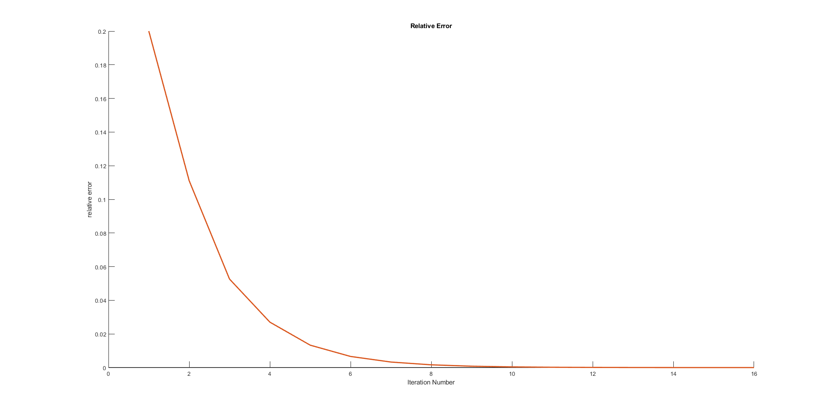
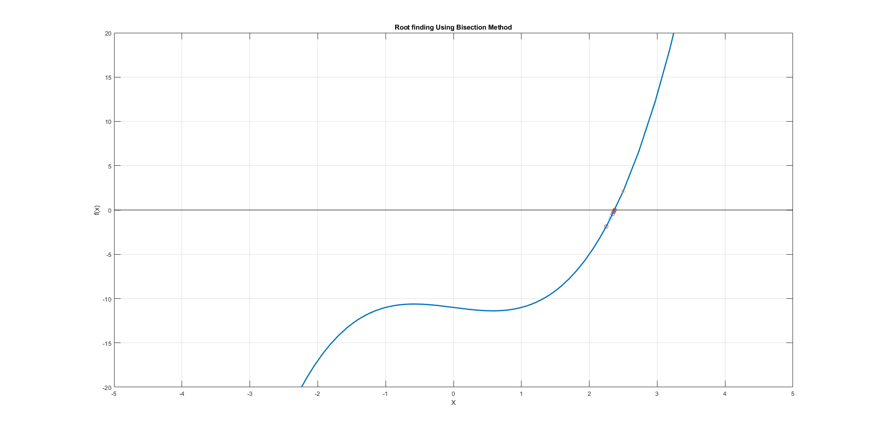
Conclusion:
This experiment demonstrated four fundamental numerical techniques for solving nonlinear algebraic and transcendental equations: the Bisection method, False Position method, Fixed Point Iteration, and Newton-Raphson method. The bracketing methods (Bisection and False Position) ensured guaranteed convergence when a valid interval containing a root was provided, although their convergence rate was relatively slow. In contrast, the open methods (Fixed Point Iteration and Newton-Raphson) showed faster convergence but depended strongly on a good initial guess and suitable function behavior.
Among all methods, Newton-Raphson exhibited the fastest convergence due to the use of derivative information, while Fixed Point Iteration showed moderate convergence depending on the chosen iteration function. The graphical outputs and error plots further illustrated how each method progressively reduced the approximation error over iterations.
Overall, the experiment provided a clear comparison of convergence behavior, stability, and efficiency among different root-finding techniques, reinforcing the importance of method selection based on problem type and required accuracy in numerical analysis.

Title of the Experiment:
Objective:
Source Code:
Input and Output:
Conclusion:

