# AMERICAN INTERNATIONAL UNIVERSITY BANGLADESH

Faculty of Engineering

**Laboratory Report Cover Sheet**

Metro RAIL APP IN DHAKA

Final Term LAB Reports



|  |  |  |
| --- | --- | --- |
| **Semester: Spring_22_23** | **Section: F** | **Group Number: 6** |

|  |  |  |  |
| --- | --- | --- | --- |
| Student Name: | **MD MOSTOFA HASIB** | Student ID: | **21-44938-2** |
| Student Name: | **ALIF HOSSAIN TALHA** | Student ID: | **21-44923-2** |
| Student Name: | **IRTIZA AHSAN ABIR** | Student ID: | **21-45009-2** |
| Student Name: | **SHAILA SHARMIN** | Student ID: | **21-45223-2** |

SOFTWARE ENGINEERING [F]

Supervised by,

DR.S.M. HASAN MAHMUD

**Lab:1**

**WBS Effort estimation:**

**Lab:2**

**Resource Allocation:**

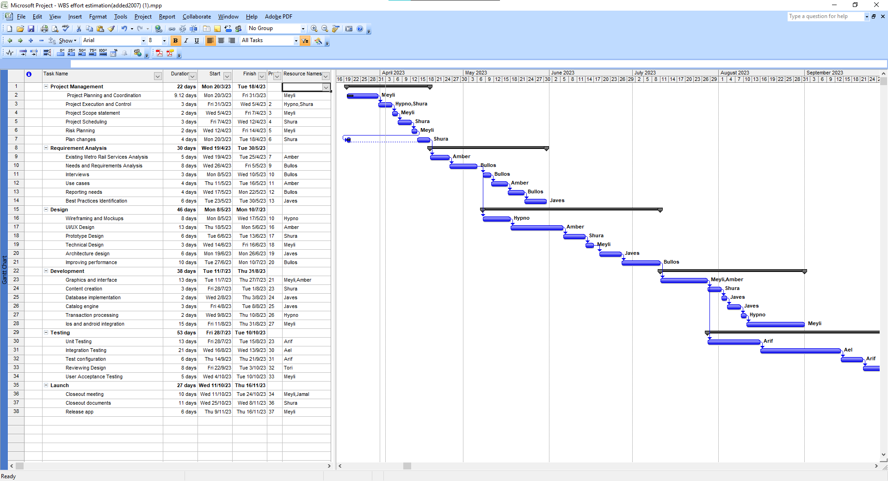

**Lab:3**

**Risk analysis:**

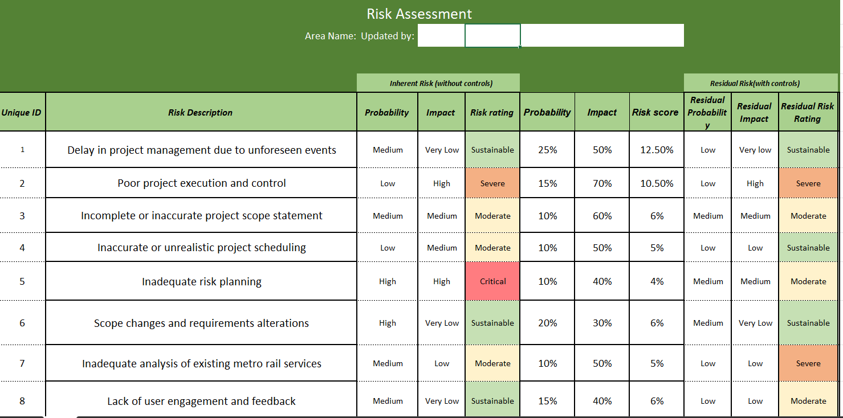

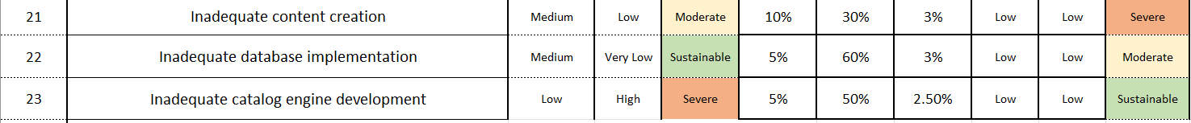

|  |  |
| --- | --- |
| Probability | Impact |
| Very High | Very High |
| High | High |
| Medium | Medium |
| Low | Low |
| Very Low | Very Low |

***Risk Matrix:***

|  |  |  |  |  |  |  |
| --- | --- | --- | --- | --- | --- | --- |
|  | **Impact:** | Very Low | Low | Medium | High | Very High |
| **Probability** | Very High | Moderate | Severe | Severe | Critical | Critical |
| High | Sustainable | Moderate | Severe | Critical | Critical |
| Medium | Sustainable | Moderate | Moderate | Severe | Critical |
| Low | Sustainable | Sustainable | Moderate | Severe | Critical |
| Very Low | Sustainable | Sustainable | Sustainable | Moderate | Severe |

|  |  |  |  |  |  |  |
| --- | --- | --- | --- | --- | --- | --- |
|  | **Impact:** | Very Low | Low | Medium | High | Very High |
| **Probability** | Very High |  |  |  |  |  |
| High | 1 |  |  |  |  |
| Medium | 1 | 1 | 1 | 1 |  |
| Low |  | 1 | 1 | 1 |  |
| Very Low |  |  |  |  | 1 |

|  |  |  |  |  |  |  |
| --- | --- | --- | --- | --- | --- | --- |
|  | **Impact:** | Very Low | Low | Medium | High | Very High |
| **Probability** | Very High |  |  |  |  |  |
| High |  |  |  |  |  |
| Medium |  |  | 1 |  |  |
| Low |  | 1 |  |  |  |
| Very Low |  |  |  |  |  |