**RESUME**

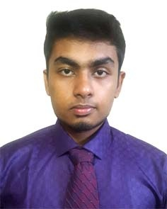**Nazmus Sakib**

13/1/A/2 RAJ NARAYAN DHAR ROAD, LALBAGH, DHAKA

Mobile: 01681968929

E-mail: abirsharkarmr9@gmail.com

**Career Objective:**

To work in the IT sectors as a software engineer of local or multinational companies in Bangladesh.

And also intend to become an entrepreneur and build my own IT firm.

**Education:**

Currently studying Bachelor of Science in Computer Science and Engineering

Institution                                  Institute of Science and Technology ( Affiliated with National University )

Semester                             4th

Degree                                      HSC

GPA                                         4.75

Institution                                   Engineering University School & College

Board                                        Dhaka

Passing Year                             2016

Degree                                      SSC

GPA                                         4.75

Institution                                   Engineering University School & College

Board                                        Dhaka

Passing Year                            2013

**Awards:**

May, 2018 Participated at " IST Ramadan Intra-University Programming Contest " . Got the position 7th among 25 teams.

June, 2017 Participated at " IST Ramadan Intra-University Programming Contest " . Got the position 7th among 18 teams.

December 2012 Participated at a book reading competition held by British council. Got the position 1st among 60 competitors of my class.

**Extracurricular Activities:**

Volunteered at preliminary contest of National Collegiate Programming Contest in IST campus

Member at " Badhon" a blood donating organization of Dhaka University

**Membership:**

Programming club of IST ( pcIST )

Electronics Communication and Robotics Club ( ECRC )

**Language Proficiency:**

Bengali: Excellent  in  speaking, reading and  writing

English: Excellent  in  speaking, reading and  writing

**Computer Skills:**

"C" & "C++" programming langauege

OS : Windows xp, Windows 8, Windows 10

Internet browsing

**Personal Details:**

Name Nazmus Sakib

Father’s Name                           Mohoshin Sarkar

Mother’s Name                          Kamrun Nahar

Date of Birth                              1st May 1997

Nationality                                 Bangladeshi

Blood Group                              A+

Marital Status                            Unmarried

**Interest:**

Reading novels, Watching Movies & Foreign TV series, Contest programming

**References:**

|  |  |
| --- | --- |
| Name:  Anisuzzaman Khan  Designation:  Senior Software Engineer at "Pathao"  Mobile:  01671169799    E-mail: aniskhan001@gmail.com  Name:  Sarwar Hossain  Designation:  Software Engineer at Divine IT limited  Mobile:  01521207745    E-mail  St.holmes.h@gmail.com |  |

Signature

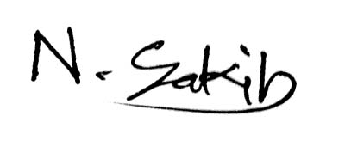

....................................

**(Nazmus Sakib)**