# Analysis

The breaking of the subsequent elements into simple one is known as analysis. We need to perform analysis to confirm the necessities can be included in the software without any problem.

Requirement, Natural language analysis (NLA), Use Case, class diagam and activity diagram are included in this part. The explanation of those analysis are as follows:

**Requirement:** it is the process of gathering all the information of client expectation before developing the system. This is the starting and most important and this features called requirement should be quantifiable, relevant, and then should be in detailed.

**NLA:** Natural language analysis is done after the requirement. This is done by separating the noun, verbs and objectives to made class diagrams and to made classes and objects.

**Use Case diagram:** Use case diagram define the essentials of actors and their collaborations with the system. It is used to increase extra imaginative textual use case.

**Class diagram:** It is the structured diagram that defines the system’s classes, attributes, operations and the relationship of the objects which is used for data modeling.

**Activity diagram**: It is the process of the system which is used to describe the flow of note from one activity to another.

Here in my project I am performing the SWOT analysis because it focus on both internal and external factors. The strengths and weakness focus on internal issues, while opportunities and threat focus on external issues. Likewise, PEST analysis only focus on the external factors whereas CATWOE only provides means to decide the issue of different view.

# Feasibility Study.

# Use Case Diagram

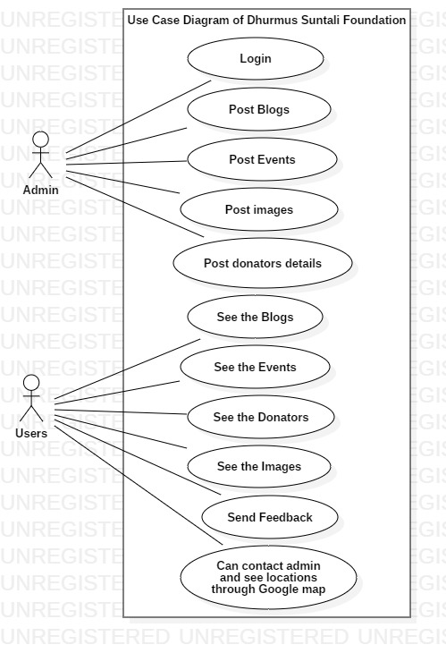

Fig: Use case diagram of Dhurmus Suntali foundation.