## Structural:

## Notation use.

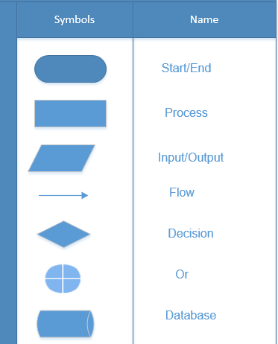

## 2.1. Flowchart for admin.

## 

Fig: Flowchart for admin.

## 2.2 Flowchart for user.

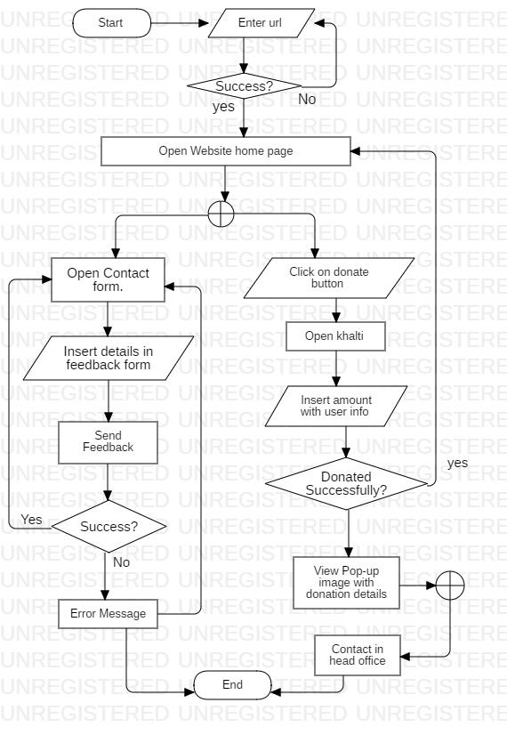

Fig: Flowchart for user.

## Behavioral:

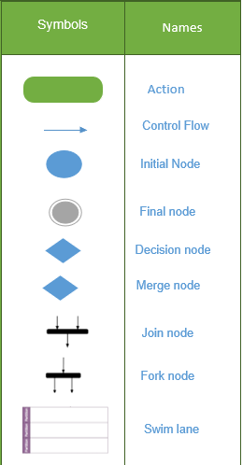

Fig: Notation used in activity diagram.

## Activity Diagram

## 

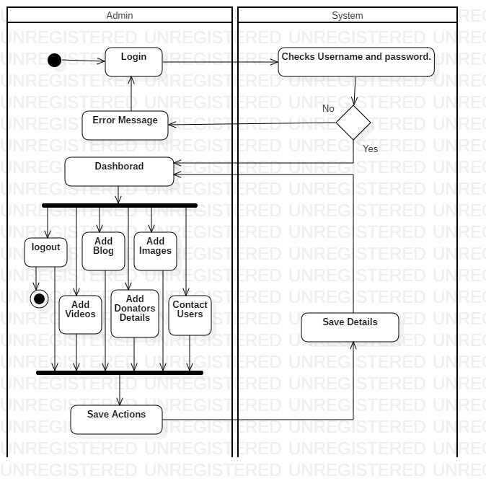

Fig: Activity diagram of admin of Dhurmus Suntali foundation.

## 1.2 Activity Diagram

# 

Fig: User activity diagram of Dhurmus Suntali Foundation.

# Architecture (User Design).

## **Prototyping**

* 1. Home page

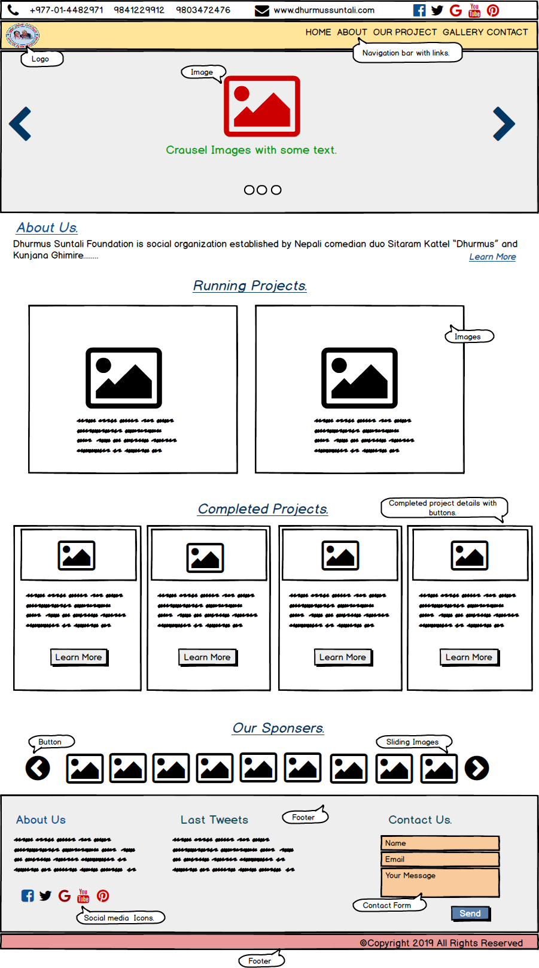

Fig: Digital prototyping of home page.

## - About us

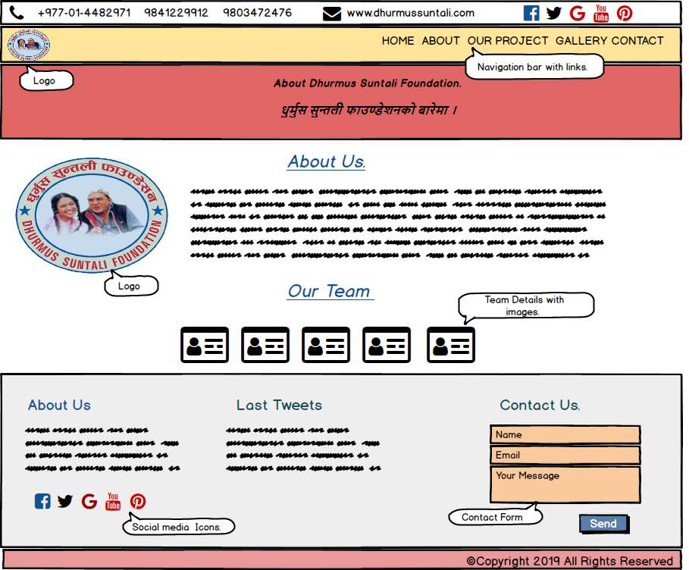

Fig: Digital prototyping about us page.

## - Our Project

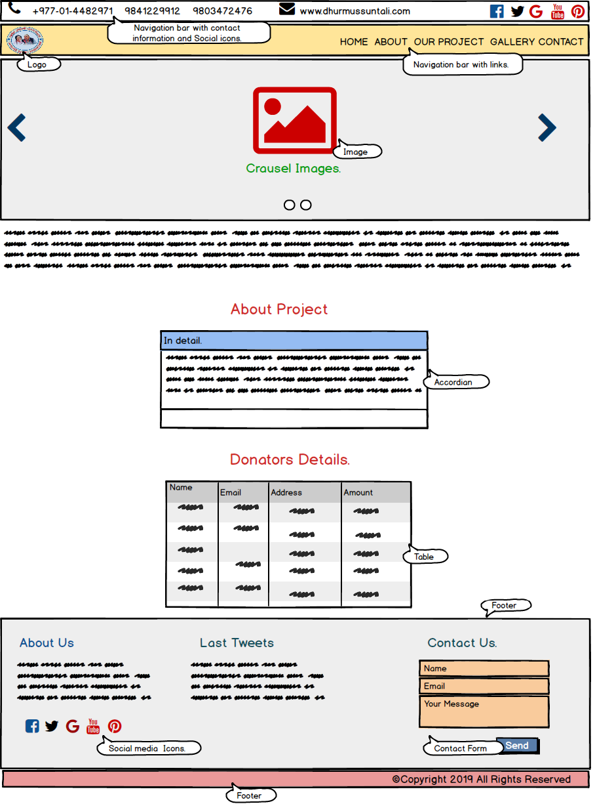

Fig: Digital prototyping of our project page.

## – Gallery

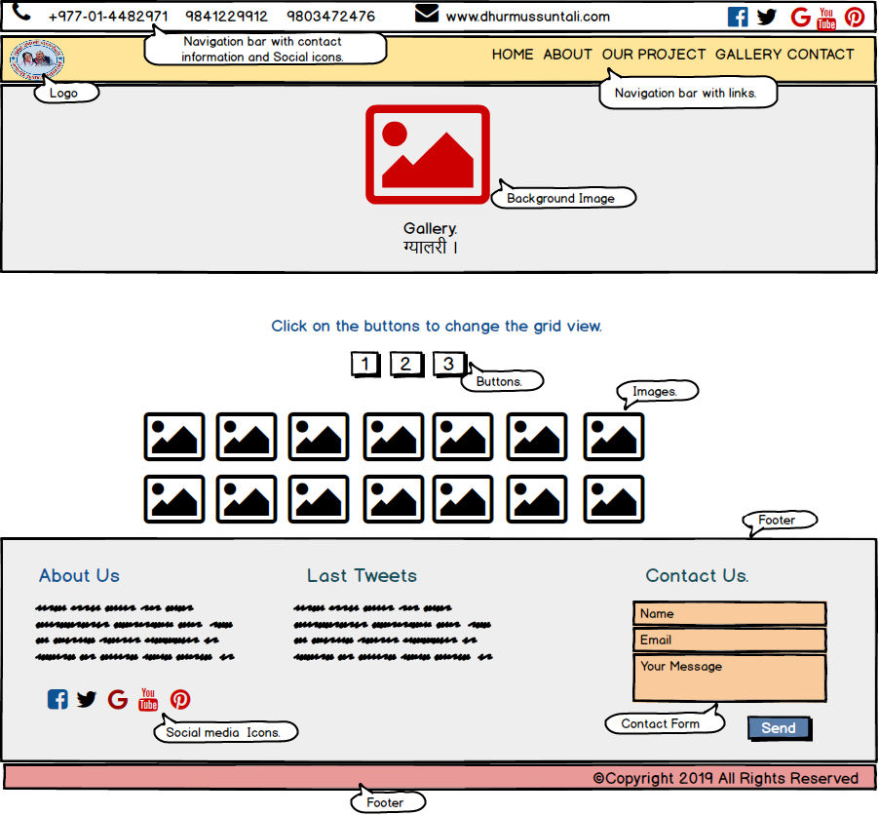

Fig: Digital Prototyping of gallery page.

## – Contact

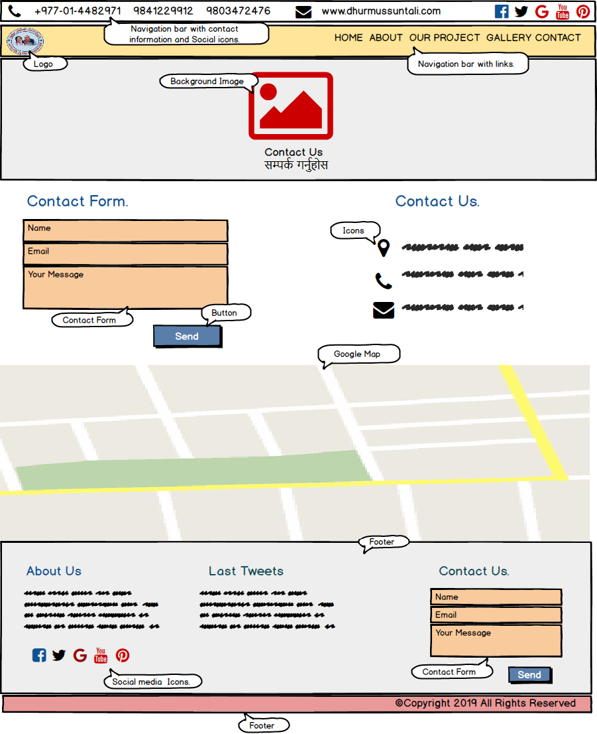

Fig: Digital Prototyping of contact page.

## – Admin login page

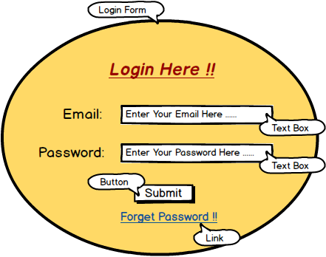

Fig: Digital prototyping of login page.

## - Admin page.

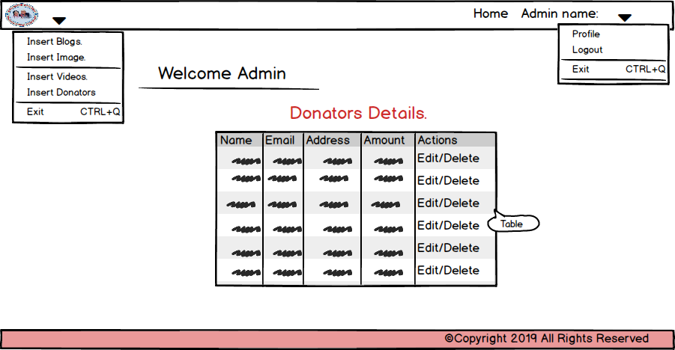

Fig: Digital prototyping of admin page.