 Assignment Cover Sheet
Assignment No.: _____

Student Information (For group assignment, please state names of all members) |  | Grade/Marks
Name | ID
Abiral Panta | E2400140
Manita Khatri | E2400149
Nabin Tamang | E2400151

Module/Subject Information |  | Office Acknowledgement
Module/Subject Code | BIT216
Module/Subject Name | Software Engineering Principles
Lecturer/Tutor/Facilitator | Sudeep Lal Bajimaya
Due Date | 12 June 2026
Assignment Title/Topic | Assignment 1 – Task 1
Intake (where applicable) | May 2026
Word Count | 2729 | Date/Time

Declaration
- I/We have read and understood the Programme Handbook that explains on plagiarism, and I/we testify that, unless otherwise acknowledged, the work submitted herein is entirely my/our own.
- I/We declare that no part of this assignment has been written for me/us by any other person(s) except where such collaboration has been authorized by the lecturer concerned.
- I/We authorize the University to test any work submitted by me/us, using text comparison software, for instances of plagiarism. I/We understand this will involve the University or its contractors copying my/our work and storing it on a database to be used in future to test work submitted by others.
Note: 1) The attachment of this statement on any electronically submitted assignments will be deemed to have the same authority as a signed statement.
2) The Group Leader signs the declaration on behalf of all members.

Signature: abiralPanta | Date: 6/12/2026
E-mail: abiral.panta.2024@midvalley.edu.np
ACA-F-020(010611:01)
Page 1 of 2

Feedback/Comments*
Main Strengths
Main Weaknesses
Suggestions for improvement

 | Student acknowledge feedback/comments
Grader’s signature | Student’s signature:
Date: | Date:
Note:
- A soft and hard copy of the assignment shall be submitted.
- The signed copy of the assignment cover sheet shall be retained by the marker.
- If the Turnitin report is required, students have to submit it with the assignment. However, departments may allow students up to THREE (3) working days after submission of the assignment to submit the Turnitin report. The assignment shall only be marked upon the submission of the Turnitin report.
*Use additional sheets if required.
ACA-F-020(010611:01)
Page 2 of 2

Contents
1. Overview: 5
2. Project aims: 5
3. Project Objectives: 6
4. Project Scope: 6
4.1. In Scope: 6
4.2. Out of scope: 7
5. Project Schedule: 8
5.1. Work Breakdown Structure (WBS): 8
5.2. Milestone and Deliverables: 8
5.3. Gantt Chart: 9
5.4. Resource Allocation Chart: 9
6. Technical Description of the Proposed System 10
7. Risk Management Plan: 12
8. Success Criteria: 13
Appendix B: Marking Scheme 14

Overview:
SavePlate is a proposed web-based application that aims to help reduce food waste in households. Many people buy more food than they need or forget about food items stored in their refrigerators and pantries, which often leads to unnecessary waste. The purpose of this project is to provide users with a simple platform to keep track of their food items, monitor expiry dates, plan meals, and share excess food with others before it goes to waste. Instead of only raising awareness about food waste, the system focuses on helping users manage food more effectively in their daily lives.
The main target users of SavePlate are household members who regularly store food at home and need an easier way to organise and monitor their food supplies. The system will allow users to create accounts, manage their food inventory, receive expiry notifications, view food donation listings, analyse food usage patterns, and create weekly meal plans. By combining these features into a single platform, the application aims to encourage better food management and reduce unnecessary food disposal.
SavePlate is suitable as a software engineering project because it involves requirement analysis, system design, project planning, and web application development. The project can be developed using freely available tools and technologies, making it practical for a student team to complete within the given timeframe.
The SavePlate project will follow an Agile and Iterative development approach. Requirements will be analyzed and implemented incrementally through short development cycles. Regular team reviews and feedback sessions will ensure continuous improvement and allow changes to be incorporated throughout the project lifecycle.
For Assignment 1, the focus is on preparing the project plan and proposal for the SavePlate system. This includes defining the project scope, planning project activities, identifying resources, and managing potential risks. The project planning phase is scheduled from 20 May 2026 until 12 June 2026, which is the submission date for Task 1. Since the team will use personal laptops and free software tools such as GanttProject, draw.io, Figma, GitHub, Visual Studio Code, and Google Docs, no additional financial cost is expected for this phase of the project.

Project aims:
- To design and develop SavePlate as a web-based platform that helps households minimise food waste by providing features for food inventory management, expiry-date monitoring, meal planning, and food donation.
- To promote better food management practices by helping users identify items that should be consumed soon, reducing unnecessary spoilage through reminders, notifications, and usage insights.
- To encourage community-based food sharing by allowing users to donate surplus food items and make them available for collection by other users within the platform.
- To provide a secure and trustworthy user experience through account authentication, email verification, two-factor authentication, and user-controlled privacy settings.
- To increase awareness of household food consumption patterns by offering reports and analytics that help users track their progress in reducing food waste over time.

Project Objectives:
The objectives of the SavePlate project are as follows:
- To prepare and complete the Task 1 project proposal by 12 June 2026, including all required project planning and management components.
- To identify and document the functional and non-functional requirements of the SavePlate system based on the provided case study.
- To define a clear project scope that outlines the features to be included in the system and identifies any features that are outside the scope of the project.
- To develop a project schedule consisting of a Work Breakdown Structure (WBS), milestones, Gantt chart, and resource allocation plan to support effective project management.
- To select suitable software tools, technologies, and development platforms for the design and implementation of the proposed web application.
- To identify potential project risks and prepare appropriate mitigation and contingency strategies to reduce their impact on project progress.
- To ensure that all project documentation is prepared according to academic standards and follows the required formatting and referencing guidelines.
- To establish a project plan that provides a strong foundation for the later analysis, design, development, testing, and deployment phases of the SavePlate system.

Project Scope:
The project scope defines the features and functions that will be included in the SavePlate system, as well as the features that will not be developed in this project. Establishing a clear scope helps the team focus on the required functionality and avoid unnecessary expansion of the project during development.

In Scope:
Feature Area | Description
User Registration and Privacy Settings | Users will be able to create an account, verify their email address, and manage account security settings. The system will also provide privacy options that allow users to control the visibility of their food listings and personal information.
Food Inventory Management | Users can add, update, and remove food items from their inventory. Information such as item name, quantity, category, expiry date, storage location, and notes can be recorded. Users can also mark items as used or donate suitable food items.
Browse Food and Donation Listings | Users will be able to view their stored food items and browse available donation listings. Search and filter functions will help users find items based on category, expiry date, storage type, and location.
Food Analytics and Reports | The system will generate simple reports and visual summaries to help users track food usage, monitor donations, and understand their progress in reducing food waste.
Notifications and Reminders | Users will receive notifications for food items approaching their expiry dates, meal planning reminders, donation updates, and important account-related alerts.
Weekly meal planning | Users will be able to create weekly meal plans using the ingredients available in their inventory. The system may also suggest meal ideas based on available food items.

Out of scope:
Out-of-scope item | Reason
Native mobile application | The project will be developed as a web-based application. Dedicated Android and iOS applications are not included in the current project scope.
Online Payment System | SavePlate focuses on food sharing and donation activities. Payment processing features are not required for the proposed system.
AI-based Food Imgae recognition | Automatic identification of food items through image recognition is beyond the scope of this academic project due to time and technical limitations.
Barcode scanning | Food items will be entered manually by users instead of using barcode scanning technology.
Real-time messaging | Direct chat functionality between users will not be implemented. Basic contact and pickup information will be sufficient for donation arrangements.
Third-Party Grocery Store Integration | Integration with external grocery store databases, shopping platforms, or APIs is not included in the initial version of the system.

Project Schedule:
The Task 1 schedule was prepared using GanttProject. It begins on 20 May 2026, two days after the assignment release date, and concludes on 12 June 2026. The schedule includes major planning tasks, milestones, dependencies, and resource allocation. The team follows a structured planning approach aligned with iterative and incremental software engineering principles.

Work Breakdown Structure (WBS):
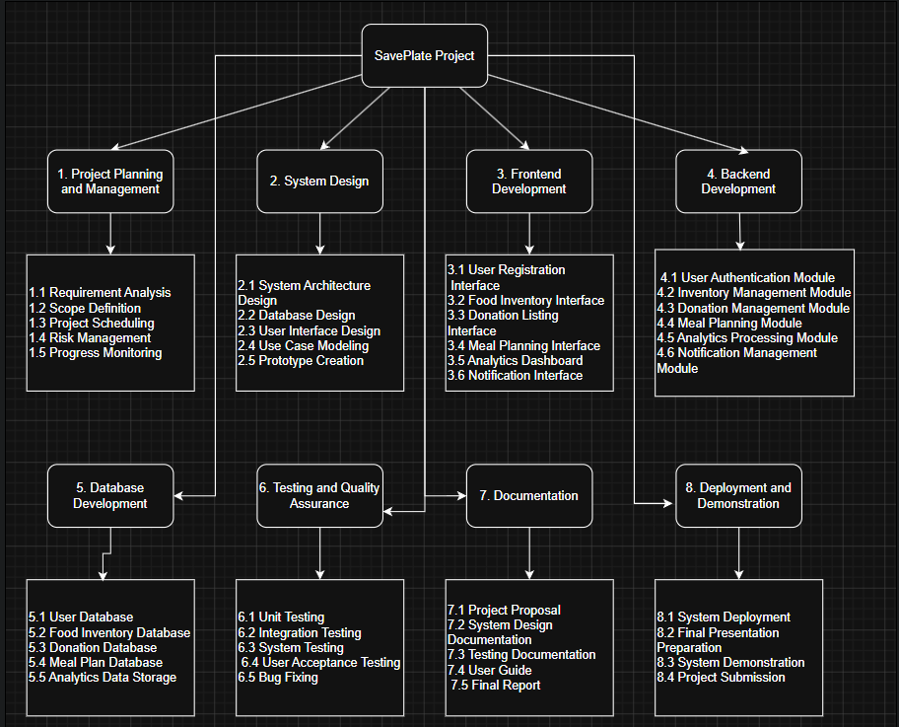
Figure1: Work Breakdown Structure of SavePlate

Milestone and Deliverables:
Milestone | Milestone Name | Target Date | Success Criteria
M1 | Project Title Finalized | Project Title Finalized
M2 | Proposal Draft Completed | Proposal Draft Completed | Complete draft containing overview, aims, objectives, scope, and schedule plan
M3 | Requirement Analysis Completed | Requirement Analysis Completed | Case study reviewed and requirements summarized
M4 | System Design Plan Completed | System Design Plan Completed | Design artefacts and modelling tools identified
M5 | Risk Plan Completed | Risk Plan Completed | Risk table with mitigation and contingency prepared
M6 | Task 1 Submitted | Task 1 Submitted | Final project plan/proposal submitted to HLMS

Gantt Chart:
Figure2 illustrates the Gantt chart developed for the SavePlate project planning phase. The chart provides a visual representation of the project schedule, showing the sequence of activities, task durations, dependencies, and milestone dates. The schedule covers the period from 20 May 2026 to 12 June 2026 and was prepared using GanttProject to support effective planning and time management throughout Task 1.
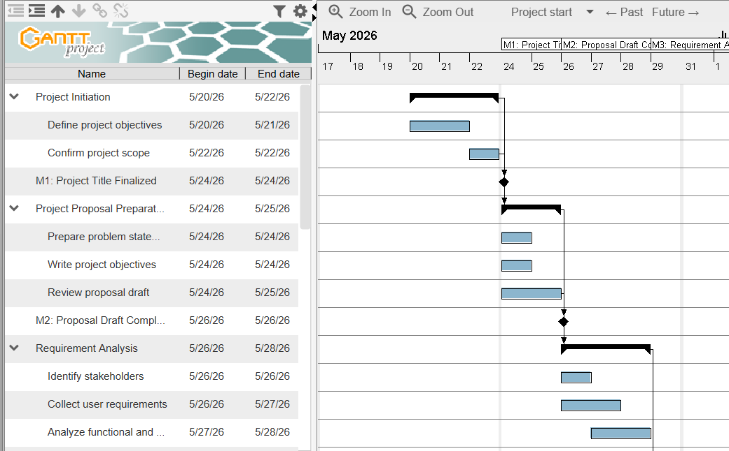
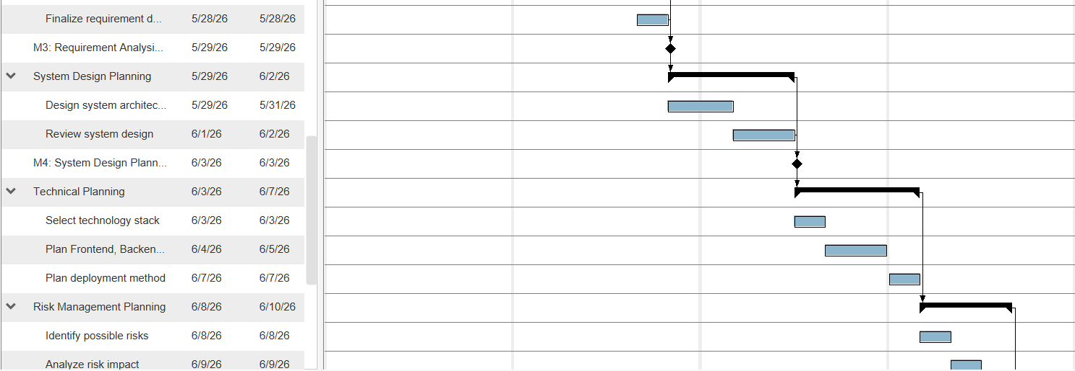
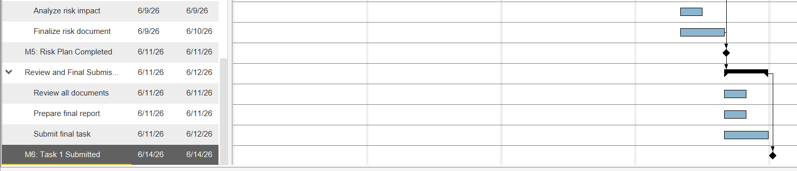
Figure2: SavePlate Task 1 Gantt Chart

Resource Allocation Chart:
Figure3 presents the planned allocation of project responsibilities among the three team members. The allocation was prepared using GanttProject and reflects the estimated workload assigned to each member during different stages of the project. Responsibilities were distributed to ensure a balanced contribution across the team while minimizing resource over-allocation and supporting the timely completion of project activities.
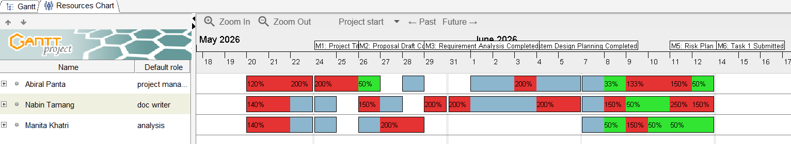
Figure3: SavePlate Resource Allocation Chart
All team members will participate in discussions, decision-making activities, document reviews, and presentation preparation to ensure a collaborative approach throughout the project lifecycle.

Technical Description of the Proposed System
SavePlate is proposed as a web-based application designed to assist households in reducing food waste through effective food inventory management, expiry-date monitoring, meal planning, and food donation services. The system will allow users to record food items, receive expiry reminders, organise meals based on available ingredients, and donate surplus food to other users within the community.
The application will follow a client-server architecture. The frontend will provide an interactive user interface for managing food-related activities, while the backend will process business logic, user authentication, notifications, and data management. All user information and application data will be stored within a cloud-hosted database to ensure accessibility and scalability.
- Development Platform

Criteria | Tools/Hardware | Version | Description
Documentation | Microsoft word/ google docs | Latest | Used to prepare project proposal, requirement specification, and final report documentation.
Modeling  - Requirement | draw.io / Lucidchart / Figma | Free | Used to create use case diagrams, activity diagrams, work breakdown structure (WBS), and user stories for requirement analysis.
- Design | draw.io / Figma | Free | Used to design ER diagrams, system architecture, wireframes, and site maps for system design.
Project Management | GanttProject | Latest version | Used for task scheduling, milestones, dependencies, and resource allocation.
Collaboration | GitHub / WhatsApp / Google Drive | Free | Used for version control, communication between team members, and file sharing.
Framework  - Frond End | Next.js with Tailwind CSS | Next.js 14+ | Used to develop responsive and user-friendly web interfaces such as dashboards, inventory pages, and user views.
- Backend | Next.js API (Node.js runtime) | Node.js 18+ | Used to build REST APIs for authentication, inventory management, donations, notifications, and system operations.
Hardware (Notebook Spec) | Personal Laptops | Hardware Spec : Windows 10/12, minimum 8 GB of RAM

- Demonstration Platform

Criteria | Tools/Hardware | Version | Description
Browser | Google Chrome / Firefox / Microsoft Edge / Brave | Latest | Used to run and test the web application and ensure cross-browser compatibility.

Risk Management Plan:
Risk Name | Description | Probability | Mitigation | Contingency
Late completion of assigned work | A team member may not finish their assigned tasks within the expected deadline. | M | Track progress regularly through weekly check-ins and shared task planning. | Reassign unfinished work to other team members and reduce less important sections if needed.
Requirement misunderstanding | Reassign unfinished work to other team members and reduce less important sections if needed. | M | Review requirements together as a group and compare understanding with the assignment brief. | Clarify with the lecturer and update the scope or documentation based on feedback.
GanttProject formatting issue | Problems may occur in the Gantt chart such as incorrect dependencies, scheduling, or resource allocation. | M | Problems may occur in the Gantt chart such as incorrect dependencies, scheduling, or resource allocation. | If issues cannot be fixed, present the schedule using tables or alternative diagrams.
Resource overload | Some team members may be assigned too many tasks at the same time, causing imbalance in workload. | L | Distribute tasks fairly using workload percentages (33%, 50%, 100%) depending on team size and task complexity. | Reallocate tasks among members to balance workload and avoid delays.
Documentation inconsistency | Different writing styles or formatting across sections may affect the overall quality of the report. | M | Use a common template and agree on writing guidelines before starting documentation. | The team leader or assigned editor reviews and edits the final report for consistency.
Technical tool unfamiliarity | Some team members may not be fully confident using tools like GanttProject, Figma, or draw.io | M | Use online tutorials and practice with simple templates before final work. | Switch to easier tools such as Word, Excel, or PowerPoint if necessary.
Late submission | The final report may not be submitted before the deadline. | L | Complete the final review at least one day before submission | Submit the most complete version available and keep backup copies ready.

Success Criteria:
The SavePlate project will be considered successful if the following criteria are achieved:
- Users are able to register, authenticate, and manage their accounts securely.
- Food inventory records can be created, updated, and removed without data loss.
- Expiry notifications are generated correctly for stored food items.
- Meal planning functionality successfully utilises available inventory information.
- Users are able to create and manage food donation listings.
- The analytics dashboard provides meaningful information regarding food usage and waste reduction.
- All identified functional requirements are implemented and validated through testing.
- The final system is delivered within the planned project schedule and documentation requirements.

Appendix B: Marking Scheme
Student 1: | Abiral Panta
Student 2: | Manita Khatri
Student 3: | Nabin Tamang
LO | Assessment Area | Marks | Poor | Satisfactory | Good | Excellent |  | Marks
CLO2 | Appropriate level of scope coverage  [17]
 | Title | 1
 | Overview | 4
 | Project Aims | 4
 | Project Objectives | 4
 | Project Scope | 4
CLO2 | Project plan [15]
 | Work breakdown | 5
 | Milestones/Deliverables | 5
 | Gantt chart - Timelines, Predecessors, Resource Usage, milestones | 5
CLO2 | Resource planning [8]
 | Development  Hardware/Software | 4
 | Demo Environment Hardware/Software | 2
CLO2 | Risk Management [4] | 2
CLO3 | Documentation[10]
 | Format Consistency | 10
 | Spelling/Grammar
 | Professionalism
 | TOTAL | 50 | SubTotal  ( /50) |  |  |  |  | 0
B. Requirements
CLO2 | Requirements definition [5]
 | Functional Requirements | 3
 | Non-functional Requirements | 2
CLO2 | Requirements specification [20] |  |  |  |  |  | Student 1 |  | Student 2 | Student 3
 | [1 + 2 + 4 + 3 = 10]  Epic + User Stories + AC+ Tasks | 10
 | [1 + 2 + 4 + 3 = 10]  Epic + User Stories + AC+ Tasks | 10
C. Design | Design [15]
CLO2 | Architectural Design | 2
 | Site Map | 2 | € | € | € | €
 | Data Design[2]  Database/File Design[3] | 5 | € | € | € | €
 | Wire frames [6] | 6 | € | € | € | €
 |  |  | € | € | € | €
CLO3 | Documentation [10]
 | Format Consistency | 10
 | Spelling/Grammar
 | Professionalism
 | TOTAL | 50 |  |  |  | Sub-total  (/50 marks) | 0 |  | 0 | 0
 |  |  |  |  |  |  | Student 1 |  | Student 2 | Student 3
Violation of Academic Integrity Penalty
Late Submission | 5 marks per day ( ____ days)
 |  |  |  |  |  | TOTAL | 0 |  | 0 | 0

