**PROTOBYTES HACKATHON**

**AARAMBHA 2024**



**ADVANCED COLLEGE OF ENGINEERING**

**Kalanki, Kathmandu**

**A Project Proposal**

**on**

**SAFE TOGETHER**

**Project work submitted under theme Medical in partial fulfilment of requirement for the ProtoBytes Hackathon**

**SUBMITTED BY**

**(Team ANANTA)**

Mukesh Prajapati

Poojan Koju

Sumina Awa

Sushant Twayana

21 Nov 2024

## ABSTRACT

Natural disasters frequently disrupt lives, leading to medical crises and heightened risks for affected communities. To address this, our project introduces a digital platform aimed at enhancing disaster response and victim assistance. The platform integrates real-time disaster alerts from national disaster centers and empowers users to mark their safety status through a mobile-friendly web application. When a disaster strikes, users are alerted with a sound that persists until they confirm their safety status as “Alert” (Yellow), "Safe" (Green), or "Emergency" (Red), indicating a need for help.

The application offers features such as alert on application devices at the time of disaster, visual mapping of affected individuals for optimized rescue efforts, and emergency contact access for police, ambulance, and fire services. Additionally, it provides a digital medical ID for users, ensuring efficient information sharing in emergencies. By leveraging community-driven support and seamless integration with rescue teams, the platform aspires to save lives and mitigate the impacts of medical crises during disasters.

Keywords: *disaster response, emergency contact access, rescue coordination, medical ID*

**.**

## 

## List of Abbreviations/Acronyms

API Application Programming Interface

SMS Short Message Service

SQL Structured Query Language

## CHAPTER 1

## INTRODUCTION

## Background

Natural disasters such as earthquakes, landslides frequently disrupt communities, causing significant loss of life and property. Nepal, being highly vulnerable to seismic activity and extreme weather, faces recurring challenges in managing disaster response and medical crises. The lack of timely communication, effective coordination, and access to medical resources exacerbates the situation, leaving many individuals stranded without help.

Disaster response technologies have seen advancements globally; however, gaps remain in integrating real-time data, community-driven rescue efforts, and medical assistance in a single platform. Inspired by successful systems like Japan's early earthquake warning systems, our project seeks to create a user-centric digital solution tailored for Nepal's context, addressing the need for efficient and inclusive disaster response mechanisms.

### 1.2 Statement of the Problem

Natural disasters often leave communities unprepared, resulting in delayed medical assistance and rescue operations. Key challenges include:

Absence of real-time communication channels to alert and assist disaster victims.

Lack of tools to track affected individuals or share their location with nearby responders.

Limited access to immediate medical guidance and emergency contacts during crises.

These challenges emphasize the need for a digital platform that can provide timely alerts, facilitate community-based assistance, and ensure efficient medical response, ultimately reducing casualties and mitigating disaster impacts.

### 1.3 Project objective

The main objective of the project is

* The focus will be on designing a digital platform that strengthens disaster response and medical assistance within communities during earthquake period.

## CHAPTER 2

## SYSTEM DESIGN AND ARCHITECTURE

**2.1 System Design**

A modular architecture design is followed here in order to make the system scalable and fault-tolerant. Some of the major modules include:

* **Alert Module:** It receives disaster notifications coming from authorized centers and notifies all subscribers through their apps.
* **Safety Status Module**: This will allow users to update their status and map them in real time.
* **Medical Assistance Module:** Maintains digital medical IDs.
* **Community Coordination Module:** Pairs the subscribers who need help with other safe subscribers in the neighborhood and rescue teams.

**2.2 Architecture**

The architecture involves:

1. **Web Responsive Application Front-end:** created by using libraries such as React.js to ensure smooth interactions.
2. **Server side:** using Node.js to take care of API calls/requests, user information, and sending live notifications.
3. **Database:** SQL database that securely contains user profiles and IDs with status.
4. **Third-party APIs:** Google Maps API for location tracking and Twilio API for SMS-based alerts. 2.3 Methodology Agile was used to ensure incremental development and rapid reaction to user responses. Initial stages involved: Requirement Analysis: The establishment of user needs and technical feasibility. Prototyping: Wireframing and testing the basic functionality.
5. **Development**: Module implementation with periodic testing and debugging. Testing: Unit and integration testing to ensure the reliability of the system.

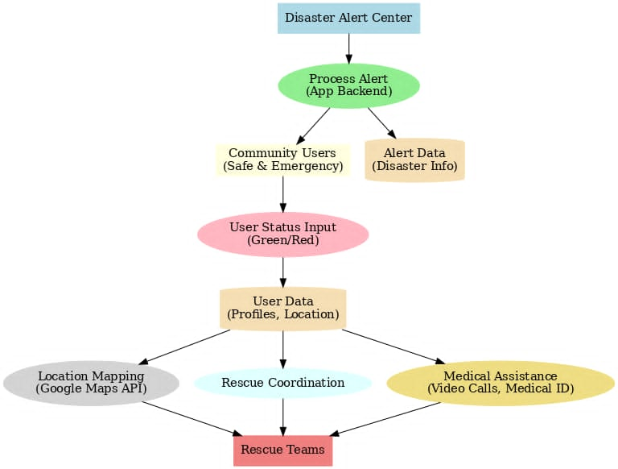

Fig 2.2.1 Block Diagram

## CHAPTER 3

## EXPECTED OUTPUT

**3.1 Functional Outputs**

3.1.1 Real-Time Alerts

* The user gets instant alerts on imminent disasters.
* Unceasing alert sounds until the users respond by updating their status.

3.1.2 Location-Based Mapping

* Map displaying safe/green and emergency/red users.
* Location updates for better coordination of rescue efforts.

3.1.3 Medical ID

* Provide detailed history of the victim in the digital format

3.1.4 Emergency Numbers

* Displays the emergency contact of the family members
* Provide the emergency life line number of the ambulance, fire etc.

**3.2 Non-Functional Outputs**

3.2.1 Scalability

* To bear the load of a high number of users concurrently during disaster incidents.

3.2.2 Accessibility

* Cross-platform compatibility for devices.

## CHAPTER 4

## CONCLUSION

This project would fill in the gaps that appear most critical: a platform that integrates real-time alerts, community-driven rescue, and medical support during disasters. Using such features as location mapping, access to emergency contact information this platform would enable prompt action by both individuals and responders. Casualties would decrease while there is more efficiency in disaster management. This could be extended in the future to offline mode, multilingual interaction, and interfacing with wearable health care monitors to improve real-time monitoring.