

**A HACKATHON PROJECT**

**“FINDLOCAL”**

**By Team Name: Knight Walkers**

**Team Members:**

**NIRAJ BHATTARAI**

**PARTIK NEUPANE**

**PRAGYAN ADHIKARI**

**RABIN ADHIKARI**

## ABSTRACT

This report aims to develop an innovative e-tourist platform through which tourist visiting various parts of Nepal are able to easily locate local business around their location and provide interactive maps where the major cultural spots, artisan markets are pinned. The platform also provides online shops which specialize in authentic handmade goods directly from artisan.

The platform empowers local communities by providing them a space to share their cultural heritage and promote their businesses, ensuring sustainable tourism and preserving Nepal’s rich traditions. The backend is developed using Python, while the frontend leverages HTML and CSS to deliver a seamless, user-friendly interface for exploration and engagement.

**Keyword**s*: e-tourist, local culture, interactive maps, handmade goods, sustainable tourism*

## CHAPTER 1

## INTRODUCTION

## 1.1 Background

Nepal is known for its landscape, mountains and rich cultural heritage and has attracted both the internal and external tourist. The beauty of country has been attracting visitors but there is a huge gap in availability of resources that provide information about the local culture. Local traditional, practice and rituals, not only of Nepal but of all over the world are beautiful. Nepal being rich in culture have huge number of traditional practice and have a long history but its history has not been in talk recently. These local traditional, practice and rituals are often preserved by local communities and the tourist visiting the place haven’t been able to enjoy the local culture to its fullest.

In this modern era, empowering local communities to give brief introduction and detailed overview to share their heritage and culture can reduce this gap. By providing resources to local individuals to contribute about their local cultural information and validating their identity, it becomes possible to provide authentic, real and attracting experiences to tourists. This approach not only enhance cultural knowledge but also supports local businessman, artist and service providers growing tourism and community.

### 1.2 Statement of the Problem

Despite Nepal’s richness in culture, there is lack of reliable platform for tourist to learn about and experience local culture. The current existing problem are:

* The current available resources for cultural information are scattered and limited to only few tourists’ attraction site leaving endangered local tradition unexplored.
* There is no formal channel for local individual to share their cultural knowledge, leading to disconnect tourist and local authentic experience.
* Local tourist, small scale local service providers and business struggling to grow due to difficult to connect to tourist and grow economically.

Addressing these issues is essential for promoting Nepal’s cultural tourism and empowering Nepal’s local communities.

### 1.3 Project objective

General Objective:

To develop a web application that will reduce the gap between tourist and local culture by providing an authentic platform for cultural exchange and interaction.

Specific Objective:

1. To create a platform where local individuals can contribute cultural information which will be validated by admin.
2. To enable local businesses, artists, and small-scale service providers to connect with tourists directly.
3. To empower local communities by preserving and showcasing their traditions and fostering sustainable tourism.

## CHAPTER 2

## SYSTEM DESIGN AND ARCHITECTURE

## 2.1 USE CASE

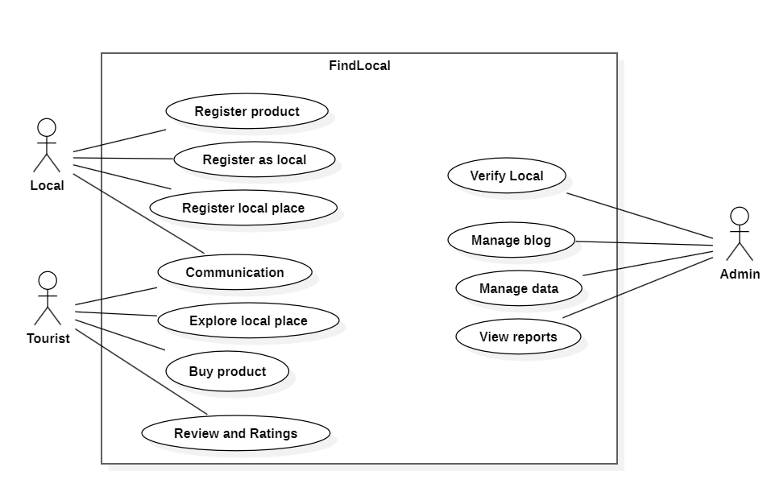

Figure 2.1: Use Case

# CHAPTER 3

# EXPECTED OUTPUT

#### This is the UI of the webpage that we will be creating in this duration of hackathon.

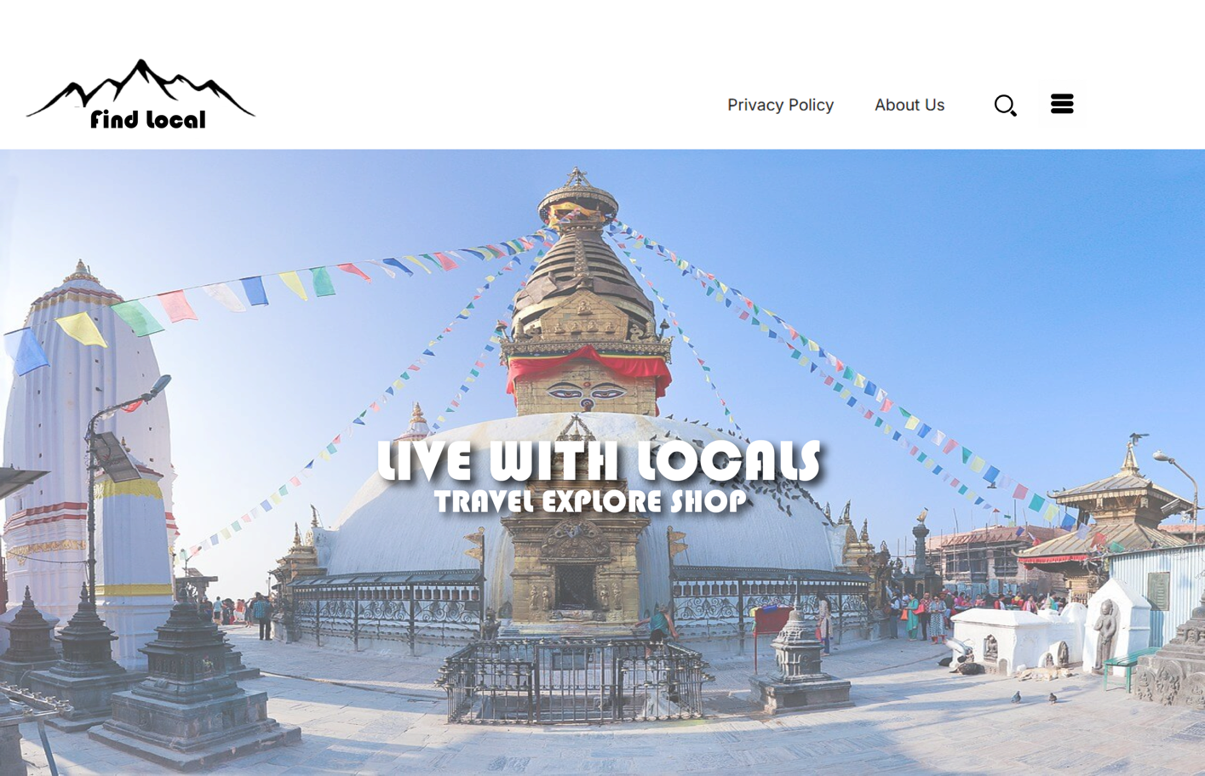

Figure 3.1: Expected UI of output

## CHAPTER 4

## CONCLUSION

In conclusion our web application helps to connect local businesses and artisan with tourist in Nepal that has potential to transform the travel experience and increase the livelihood of the locale businesses and people. By serving as a platform for showcasing traditional crafts, local products, and cultural experiences, the app can help preserve Nepal's rich heritage and drastically improve the travel experiences. It provides local people opportunities to showcase their product and services to wider market. Ultimately, such an app fosters a deeper appreciation of Nepal's unique cultural identity and ensures that tourism benefits communities at every level.