Project 1
AES-128 Crypto Accelerator
RTL Specification
Abiramasundar S EMP 6874

RTL SPECIFICATION
Project 1 — AES-128 Crypto Accelerator with Secure Register Access Control

Field | Detail
Project Engineer | Abiramasundar S
Project Theme | Hardware Security
Design Type | RTL / Hardware Security
Interface | APB4 Slave
Cryptographic Algorithm | AES-128
Clock Domains | APB clock (PCLK) – Slow Clock and  Crypto clock (crypto_clk) – Fast Clock
Primary Objective | Secure, constant-time AES-128 encryption/decryption accelerator
Doc Version | 1st Revision, 05/10/2026

Table of Contents
Chapter 1 — Introduction
1.1 Overview of AES-128
1.2 AES-128 Parameters
1.3 AES Encryption Round
1.4 AES Decryption Flow
1.5 Project Scope
1.6 Design Objectives
1.7 Top-Level Architecture
Chapter 2 — Signal Description
Chapter 3 — Register Map and Functional Description
3.1 APB Transfer Detection
3.2 APB Register Map
3.3 CONTROL Register
3.4 Key Loading
3.5 Key Security
3.6 Busy / Done Behaviour
3.7 Privilege Checking
3.8 STATUS Register
3.9 FSM Transition
3.10 Data Loading
3.11 Encryption/Decryption Latency
Chapter 4 — Reset Behaviour
Chapter 5 — Verification
5.1 Reference Test Vectors (FIPS-197)
5.2 Example APB Transaction Sequence
5.3 Maximum Blocks support
5.4 Clock Frequency
5.5 PSLVERR Behaviour

Chapter 1 — Introduction

1.1 Overview of AES-128
The AES-128 cryptographic core implements the Advanced Encryption Standard (AES) with a 128-bit key and a 128-bit data block, in accordance with NIST FIPS 197.
The core performs AES-128 encryption on a single 128-bit plaintext block and generates a 128-bit ciphertext block, and performs the corresponding decryption in reverse.
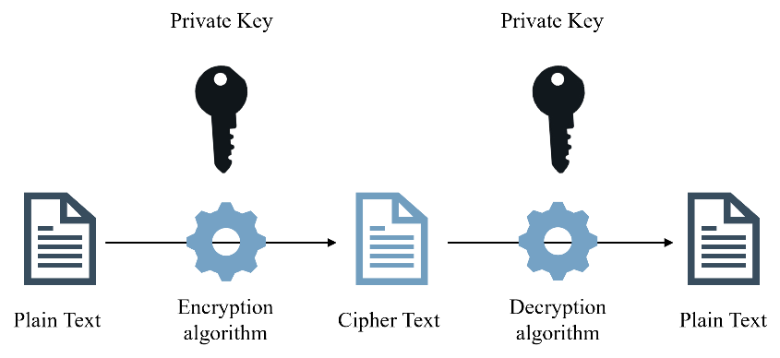
Figure 1.1 — AES encryption/decryption concept

1.2 AES-128 Parameters
Parameter | Specification
Algorithm | AES
Operation | Mode = 1 Encryption | Mode = 0 Decryption
Key size | 128 bits
Block size | 128 bits
Number of rounds | 10 + 1 (Initial round)
Number of round keys | 10 + 1
Round-key size | 128 bits
Plaintext input | 128 bits
Ciphertext output | 128 bits

1.3 AES Encryption Round
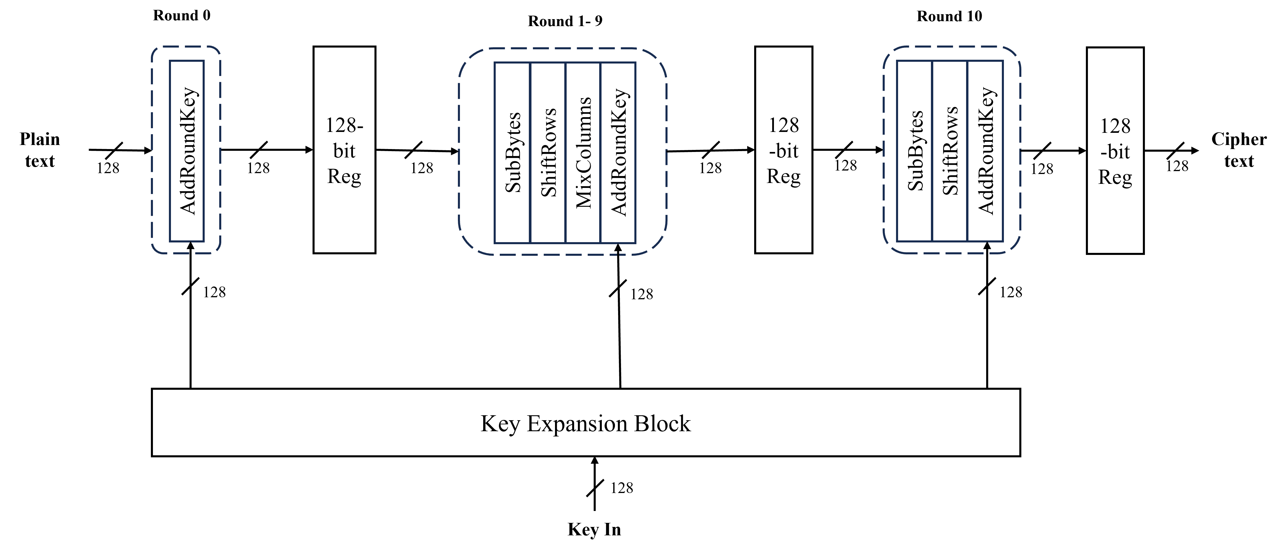
Figure 1.2 — AES encryption round structure
AES-128 encryption consists of 10 transformation rounds, preceded by an initial AddRoundKey operation. Each standard round performs SubBytes, ShiftRows, MixColumns, and AddRoundKey. The final round performs SubBytes, ShiftRows, and AddRoundKey, and does not perform MixColumns.

1.4 AES Decryption Flow
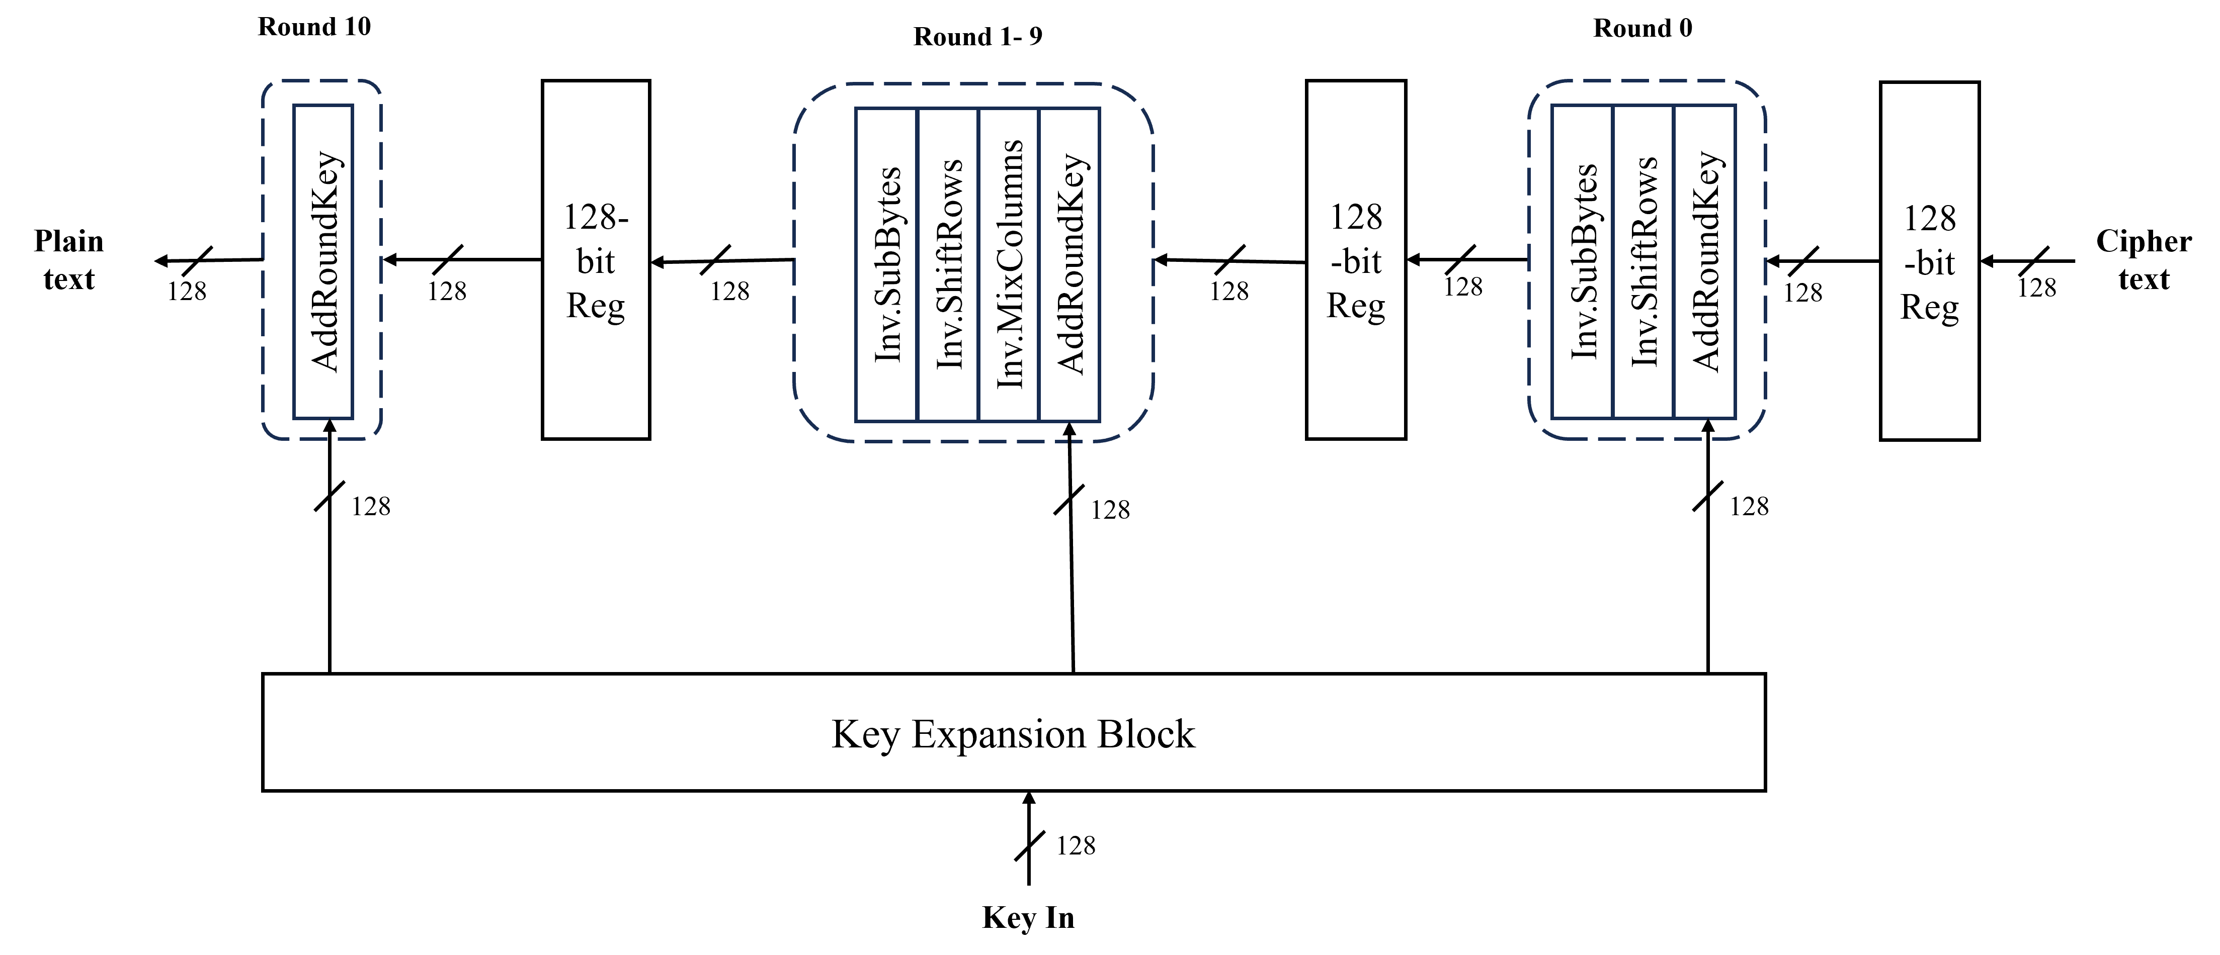
Figure 1.3 — AES decryption round structure
AES-128 decryption likewise consists of 10 rounds, preceded by InvSubBytes, InvShiftRows, and AddRoundKey (this initial stage does not perform InvMixColumns). Each standard round performs InvSubBytes, InvShiftRows, InvMixColumns, and AddRoundKey. The final round performs only AddRoundKey.

1.5 Project Scope
The RTL implementation supports the following features:
- AES-128 encryption and decryption
- 128-bit plaintext/ciphertext blocks
- 128-bit cryptographic key
- 10 AES rounds
- ECB mode
- APB4 slave interface
- Asynchronous TX and RX FIFOs
- Hardware key locking
- Software-triggered and reset-triggered key zeroization
- Privilege checking using PPROT[0]
- Security-violation detection
- Constant-time AES processing
- FIFO-threshold
The design is restricted to AES-128. The following are outside the mandatory scope:
- AES-192 and AES-256
- GCM and CTR modes
- Full differential-power-analysis (DPA) protection and full fault-injection protection
- Hardware key derivation

1.6 Design Objectives
The primary design objectives are to:
- Implement a functionally correct AES-128 engine according to FIPS-197.
- Provide secure configuration and data access through APB4.
- Prevent software from reading cryptographic key material.
- Prevent modification of the key after KEY_LOCK is asserted.
- Provide deterministic, constant-time AES operation.
- Prevent sensitive intermediate AES states from being externally observable.
- Safely transfer data between asynchronous clock domains.
- Provide sufficient verification visibility without exposing sensitive key material.
- Support synthesis and static timing analysis (STA) for a 200 MHz crypto-clock target.

1.7 Top-Level Architecture
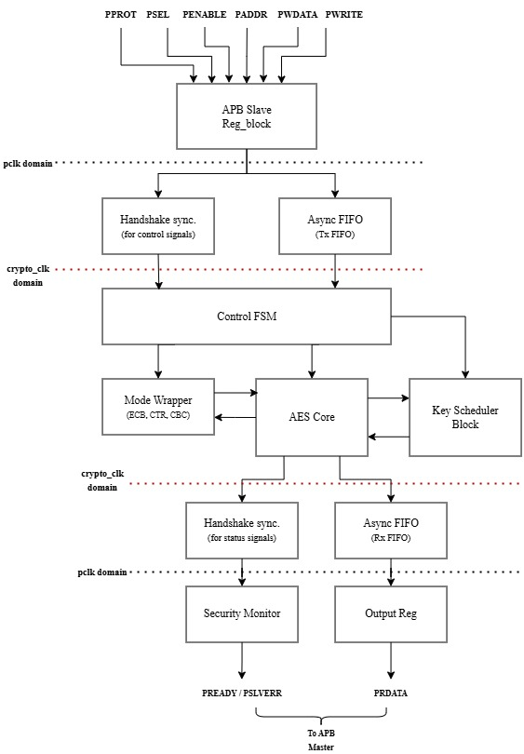
Figure 1.4 — Top-level block architecture

Chapter 2 — Signal Description
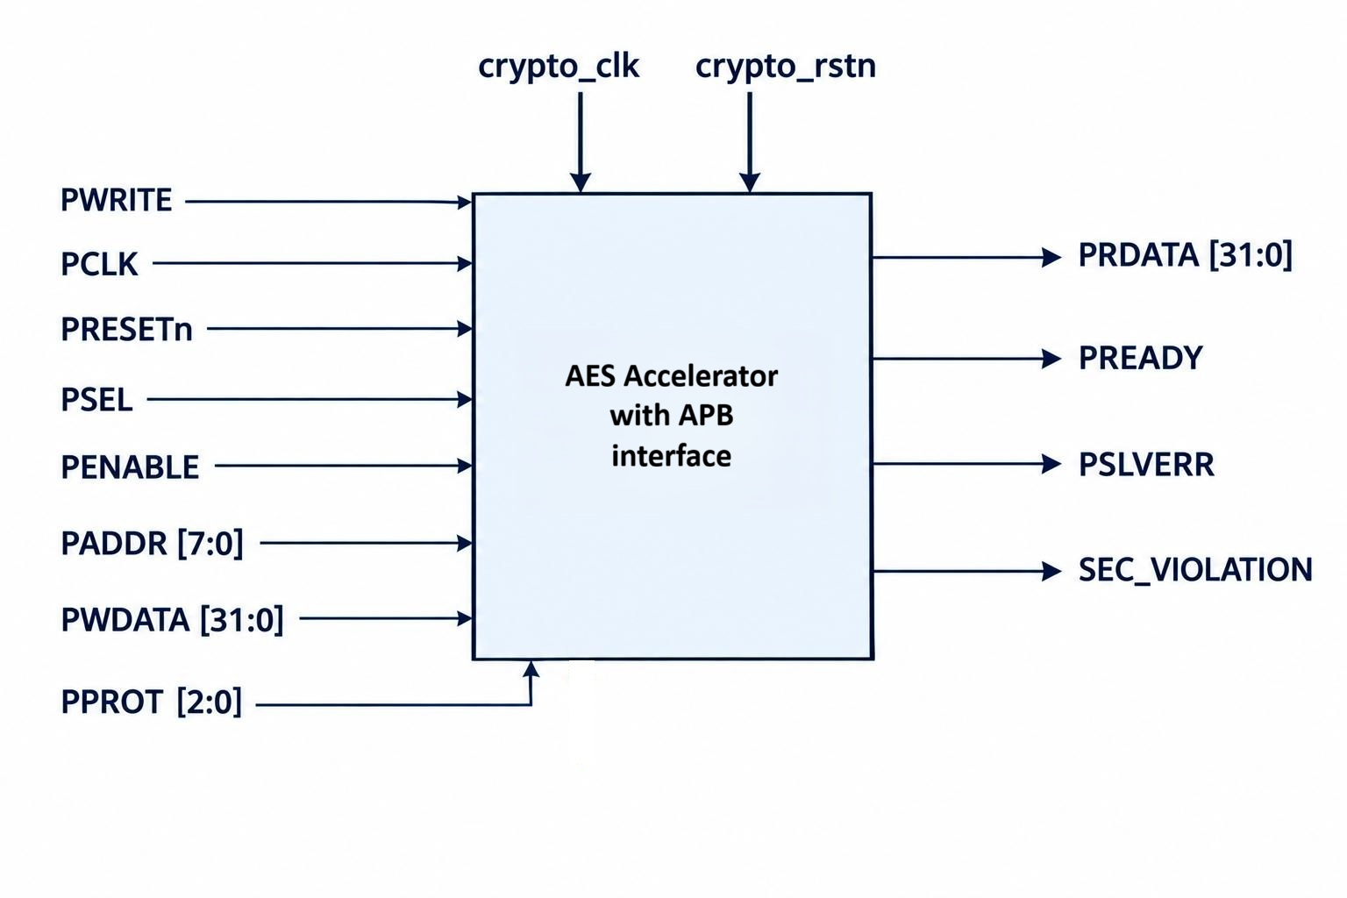
Figure 2.1 — Top-level port diagram
Type | Signal | Width | Description
Input | PCLK | 1 | APB interface clock
Input | PRESETn | 1 | Active-low APB reset (Asynchronous)
Input | PSEL | 1 | Selects the AES APB slave
Input | PENABLE | 1 | Indicates APB access phase
Input | PWRITE | 1 | 1 = Write, 0 = Read
Input | PADDR | 8 | Register address, per the register map
Input | PWDATA | 32 | APB write data (key, block data, control signals)
Input | PPROT[2:0] | 3 | Protection attributes (normal/privileged, security, instruction/data). PPROT[0] = 1: privileged; PPROT[0] = 0: normal
Input | crypto_clk | 1 | Crypto clock (AES)
Input | crypto_rstn | 1 | Active-low crypto reset (Asynchronous)
Output | PRDATA | 32 | APB read data (ciphertext)
Output | PREADY | 1 | Indicates completion of the APB transfer (always high in our case)
Output | PSLVERR | 1 | Indicates an APB transfer error, if there is any unprivileged read/write happens.
Output | SEC_VIOLATION | 1 | Indicates a security-violation status, if there any violation happened in the current transaction. (Once PSLVERR = 1, the SEC_VIOLATION = 1 till the complete transaction (till reset)).

Chapter 3 — Register Map and Functional Description

3.1 APB Transfer Detection
A valid APB write is detected when all of the following hold:
- PSEL = 1
- PENABLE = 1
- PWRITE = 1
A valid APB read is detected when all of the following hold:
- PSEL = 1
- PENABLE = 1
- PWRITE = 0

3.2 APB Register Map
Address | Register | Type | Purpose | Access Type
0x00 | CONTROL | R/W | START, MODE, KEY_LOCK, ZEROIZE | Privileged
0x04 | STATUS | RO | BUSY, DONE | Normal/ Privileged
0x08 | KEY0 | WO | 32-bit key word | Privileged
0x0C | KEY1 | WO | 32-bit key word | Privileged
0x10 | KEY2 | WO | 32-bit key word | Privileged
0x14 | KEY3 | WO | 32-bit key word | Privileged
0x18 | DATA0 | R/W | 32-bit data word | Privileged
0x1C | DATA1 | R/W | 32-bit data word | Privileged
0x20 | DATA2 | R/W | 32-bit data word | Privileged
0x24 | DATA3 | R/W | 32-bit data word | Privileged
0x28 | DATA_OUT0 | RO | Ciphertext | Normal/ Privileged
0x2C | DATA_OUT1 | RO | Ciphertext | Normal/ Privileged
0x30 | DATA_OUT2 | RO | Ciphertext | Normal/ Privileged
0x34 | DATA_OUT3 | RO | Ciphertext | Normal/ Privileged

Note: RO – Read Only, WO – Write Only, R/W – Read/Write

3.3 CONTROL Register
The CONTROL register governs operation of the AES accelerator and has the following bit layout:
Bits [31:4] | Bit 3 | Bit 2 | Bit 1 | Bit 0
Reserved | Zeroize | Key Lock | Mode | Start

Field behavior:
- Start — Setting Start = 1 begins AES processing. Before asserting Start, the master must ensure the key, data, and mode fields have all been written. Otherwise, the core will assume that the Key, Data, Mode values are 0, accordingly it will perform the operation.
- Mode — Mode = 1 selects encryption; Mode = 0 selects decryption.
- Key Lock — Setting Key Lock = 1 locks all key registers and the mode register; they cannot be modified by software until the next reset.
- Zeroize — Setting Zeroize = 1 resets all datapath registers (except ZEROIZE) and APB registers to 0.
If keylock asserted before Zeroize assertion, then the Key and Mode will not be cleared upon the zeroize assertion.

3.4 Key Loading
The AES key is 128 bits wide. Because each APB transfer carries 32 bits, the key is assembled from four sequential APB writes, in the following order:
Register | Key Bits | Write Order
KEY0 | Key[127:96] | Word 1
KEY1 | Key[95:64] | Word 2
KEY2 | Key[63:32] | Word 3
KEY3 | Key[31:0] | Word 4
The master must send the key words to the slave in this order.

3.5 Key Security
The key registers are write-only. Any APB read of a key register returns 0x00000000.
KEY_LOCK: once the key and mode have been received from the master, software can assert KEY_LOCK = 1. While KEY_LOCK = 1, all key registers and the mode register are locked and cannot be changed by software until the next reset.

3.6 Busy / Done Behaviour
When an AES operation starts, BUSY = 1. The core remains busy until the complete block operation finishes. At completion, BUSY = 0 and DONE = 1. The DONE indication corresponds to the completed AES operation. DONE signal will be cleared once you started the next process.

3.7 Privilege Checking
The APB protection attribute PPROT[0] is used for privilege checking:
- PPROT[0] = 1 — privileged access
- PPROT[0] = 0 — normal access
Security-sensitive accesses require the privileged attribute. For an unauthorized access, PSLVERR = 1 and SEC_VIOLATION = 1, and the unauthorized transaction does not modify any state.
During normal (non-privileged) access, the key, data, and mode registers cannot be changed, but PRDATA can still be read.

3.8 STATUS Register
The STATUS register provides non-sensitive operational information and has the following bit layout:
Bits [31:2] | Bit 1 | Bit 0
Reserved | Busy | Done

Bit | Field | Description
1 | BUSY | AES core busy
0 | DONE | Operation complete

3.9 FSM State Transition:

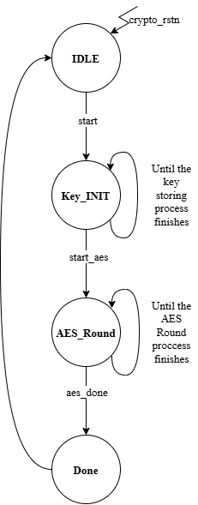
PRESETn
Figure 3.1 — FSM State diagram

3.10 DATA Loading:
The Data is 128 bits wide. Because each APB transfer carries 32 bits, the input data is assembled from four sequential APB writes, in the following order:
Register | Data Bits | Write Order
DATA0 | Data[127:96] | Word 1
DATA1 | Data[95:64] | Word 2
DATA2 | Data[63:32] | Word 3
DATA3 | Data[31:0] | Word 4
The master must send the data words together to the slave in any order, but block by block only. Example, master can send PWDATA as Data3, Data2, Data1, Data0 or other ways but these Data0-3 is one block, master should not mix blocks data.

3.11 Encryption / Decryption Latency

For both encryption and decryption of one 128-bit block, the AES core requires 13 crypto_clk cycles. When a new key is provided, key initialization requires an additional 13 crypto_clk cycles. This key initialization is performed only when the key is changed. Therefore, for a complete transaction with a new key:

Key Initialization: 13 crypto_clk cycles

AES Encryption/Decryption: 13 crypto_clk cycles

Output Registration: 1 crypto_clk cycle

Hence, the complete latency is 27 crypto_clk cycles when a new key is initialized. For subsequent blocks using the same key, the 13-cycle key initialization is not repeated.

Chapter 4 — Reset Behavior
On assertion of reset — PRESETn = 0 APB domain Config. registers will be cleared.
On assertion of crypto_rstn = 0 crypto-clock domain — all datapath registers in the AES core are cleared.
Both are Asynchronous Active low Reset signals.
Full reset means, both PRESETn and crypto_rstn should be asserted.

Chapter 5 — Test Vectors and Addtl., Info

5.1 Reference Test Vectors (FIPS-197)
The verification environment uses the standard FIPS-197 test vectors below.

Encryption
Field | Value (hex, 4×32-bit words)
Plaintext | 6BC1BEE2 2E409F96 E93D7E11 7393172A  AE2D8A57 1E03AC9C 9EB76FAC 45AF8E51  30C81C46 A35CE411 E5FBC119 1A0A52EF  F69F2445 DF4F9B17 AD2B417B E66C3710
Key | 2B7E1516 28AED2A6 ABF71588 09CF4F3C
Ciphertext | 3AD77BB4 0D7A3660 A89ECAF3 2466EF97  F5D3D585 03B9699D E785895A 96FDBAAF  43B1CD7F 598ECE23 881B00E3 ED030688  7B0C785E 27E8AD3F 82232071 04725DD4

Decryption
Field | Value (hex, 4×32-bit words)
Ciphertext | 3AD77BB4 0D7A3660 A89ECAF3 2466EF97  F5D3D585 03B9699D E785895A 96FDBAAF  43B1CD7F 598ECE23 881B00E3 ED030688  7B0C785E 27E8AD3F 82232071 04725DD4
Key | 2B7E1516 28AED2A6 ABF71588 09CF4F3C
Plaintext | 6BC1BEE2 2E409F96 E93D7E11 7393172A  AE2D8A57 1E03AC9C 9EB76FAC 45AF8E51  30C81C46 A35CE411 E5FBC119 1A0A52EF  F69F2445 DF4F9B17 AD2B417B E66C3710

5.2 APB Write Transaction Sequence
A representative APB transaction sequence for an AES operation is:
- Write key words 0–3 (KEY0–KEY3).
- Write Mode and
- Assert Key Lock.
- Write data block words 0–3 (DATA0–DATA3). Repeat for each additional block.
- Assert Start (Start may be de-asserted after one cycle).
- Set PWRITE = 0 and read PRDATA for the corresponding PADDR, per the register map. Each output-block read requires one wait cycle before the next block word can be read.

Write Operation of Key (4 words, each 32 bits)
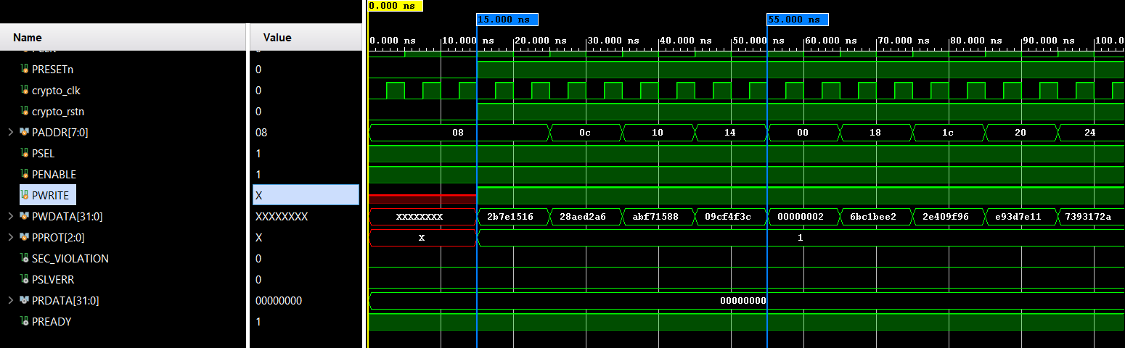
Write Key (4 words = 128 bit)

Figure 5.1 — Waveform: key write sequence

Write Operation of Mode and Key Lock
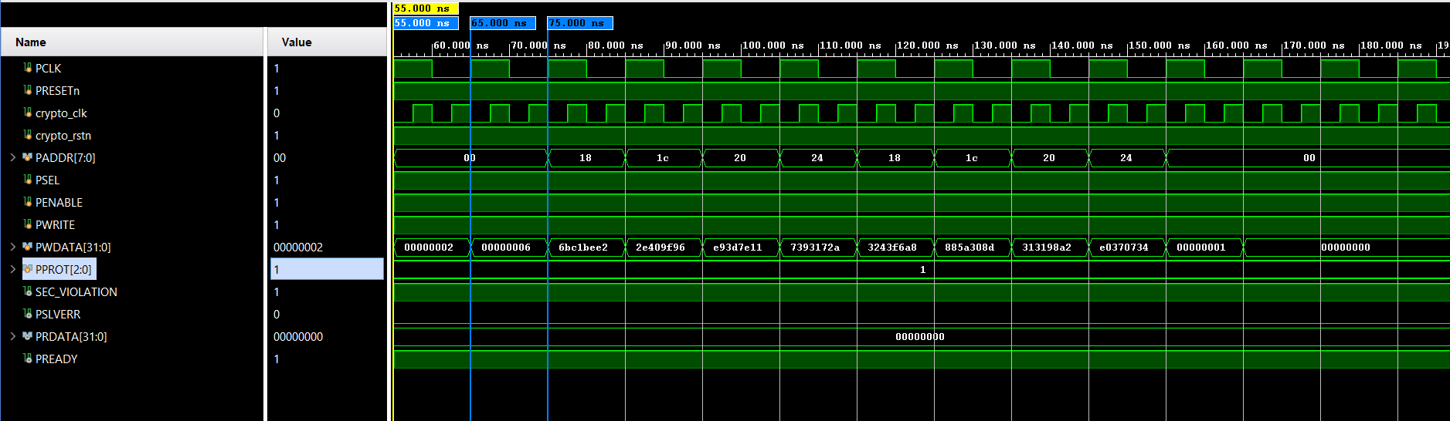
Write Keylock
Write Mode

Figure 5.2 — Waveform: mode and key-lock write

Write of Block Data
Example data blocks used in this sequence:
- Data Block 1 = 6BC1BEE22E409F96E93D7E117393172A
- Data Block 2 = 3243F6A8885A308D313198A2E0370734
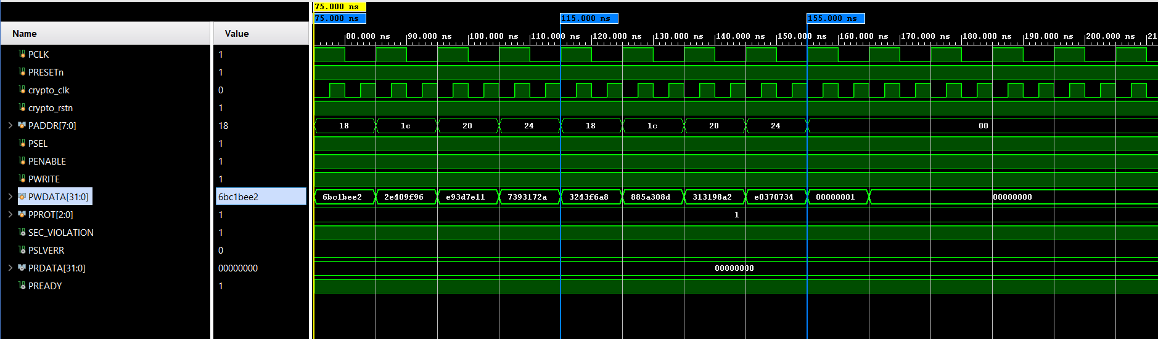
Write Data Block 1 (128 bit)
[6bc1bee22e409f96e93d7e117393172a]

Write Data Block 2 (128 bit)
[3243f6a8885a308d313198a2e0370734]

Figure 5.3 — Waveform: block-data write

Start of Process
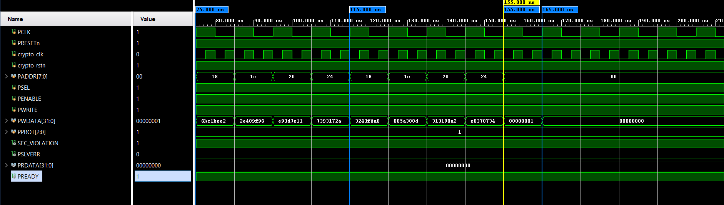
Write Start
Figure 5.4 — Waveform: Start assertion

Read Operation

A 2-cycle wait in PCLK is required before the next read data becomes valid.
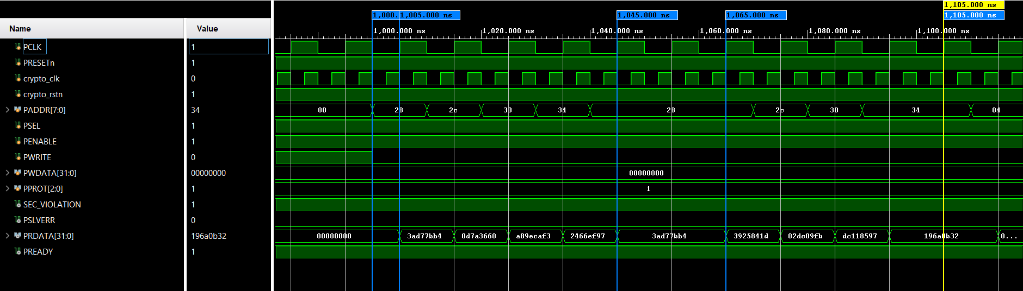
Wait for Next Read
Read Cipher Block 2 (128 bit)
[3925841D02DC09FBDC118597196]

Read Cipher Block 1 (128 bit)
[3ad77bb40d7a3660a89ecaf32466ef97]

Figure 5.5 — Waveform: output read sequence

5.3 Maximum Blocks support (FIFO Threshold):

The AES core supports up to 1024 blocks of data in the input & output storage. However, if a transaction is already in progress and new data is written before the previous transaction has completed, the newly written data will be discarded. Therefore, the verification environment should ensure that a new transaction is initiated only after completion of the previous transaction.

Maximum master/tb can write 1024 Blocks of Data in this AES design.

For Example, if master wants to encrypt 16KB data (1024 x 128bit), master have to send these data through PWDATA consecutively until the START assertion. Once START asserted the AES operation will start, during AES operation if you want to write a new data from master and before the data read from the FIFO (internal), the previous data will be replaced by the new data value. It is considered as Test bench fault or master fault.

5.4 Clock Frequency:
The supported clock frequencies are:
PCLK = 100 MHz
crypto_clk = 200 MHz
The APB interface operates in the PCLK domain, while AES processing operates in the crypto_clk domain. However, The RTL can be functionally simulated at different clock frequencies, because RTL simulation does not model physical propagation delay. But you must maintain the ratio between these two clocks.
Frequency ratio PCLK:Crypto_clk :: 1:2

5.5 PSLVERR Behaviour:
PSLVERR will be high, if the master gives wrong address access or the secure registers (i.e., Only accessible by privileged user PPROT[0] == 1) are access by unprivileged user (i.e., PPROT[0] == 0).

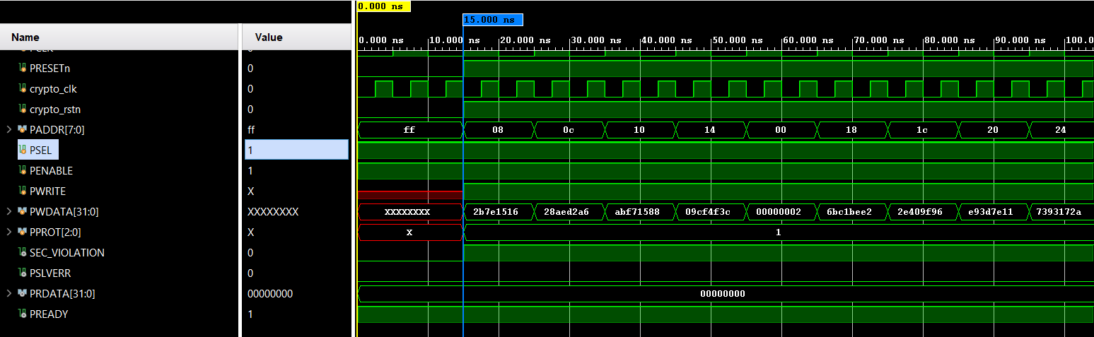
Wrong PADDR = 8’hFF

Figure 5.6 — Waveform: PSLVERR Scenario

