CPU Lite (V2)
Design a RISC core with a cached, clock-crossing memory subsystem
Project Specification Document
Duration: 4 weeks · Front-End SoC Design Flow

1. Problem Statement
- Design a small, single-issue RISC CPU with a 32-bit data path. It fetches instructions from a read-only program memory and operates on a 32-bit data memory.
- The CPU and its L1 data cache run in a fast clock domain (reference: 150 MHz). The data memory runs in a slow clock domain (reference: 70 MHz). Clock frequencies are parameters.
- An L1 data cache sits at the head of the load/store path in the fast domain and is the first point of access for LOAD/STORE. On a miss, the request is forwarded across the clock boundary to data memory; the returned data fills the cache.
- The two clock domains are asynchronous. The only legal communication between them is through the clock-domain-crossing (CDC) bridge you must design.
2. System Architecture
The required top-level structure is shown below. The two dashed regions are the clock domains; the only crossing is the CDC bridge. How each block is built internally is yours to design.
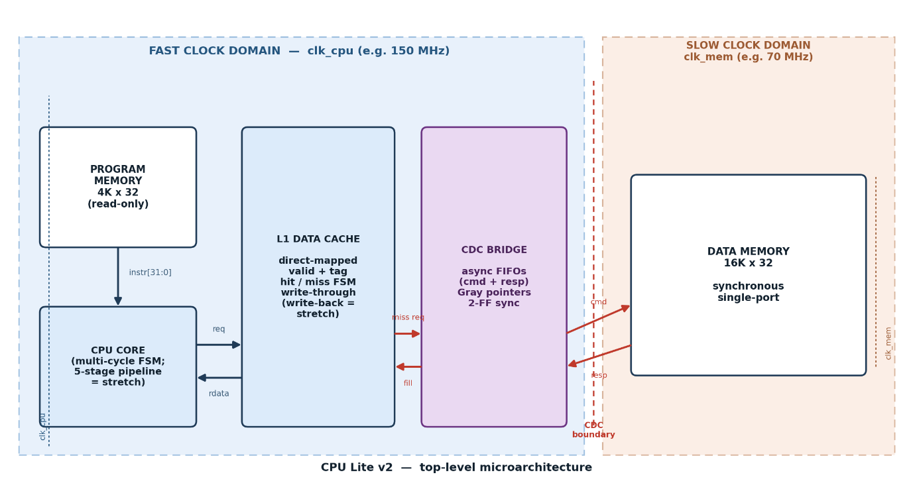
Figure 1 — Required top-level structure and clock domains.
2.1 Register set
Register | Width | Role
R0 – R15 | 32-bit | Sixteen general-purpose registers.
PC | 12-bit | Program counter — word index into program memory (0 – 4095).
PSR | 4-bit | Processor status register holding the Z, N, C, V flags (see 2.3).

2.2 Memory map
Region | Size | Word | Clock domain | Access
Program memory | 4K × 32 | 32-bit | Fast | Read-only; fetched every instruction via PC.
Data memory | 16K × 32 | 32-bit | Slow | Backing store; reached through the cache + CDC bridge.
L1 data cache | your choice | 32-bit | Fast | Direct-mapped; first access point for LOAD/STORE.
Memories are word-addressed (each address selects one 32-bit word).
2.3 Processor status register (flags)
ALU and compare operations update the flags; loads, stores, and jumps do not. The flags drive conditional branches.
Flag | Bit | Set when
Z (Zero) | PSR[0] | Result is exactly 0.
N (Negative) | PSR[1] | Result bit [31] is 1 (two’s-complement sign).
C (Carry) | PSR[2] | Carry-out on add; NOT-borrow on subtract (C=1 = no borrow). Drives unsigned comparisons.
V (Overflow) | PSR[3] | Signed two’s-complement overflow. Drives signed comparisons via (N ⊕ V).

2.4 Cache and CDC requirements
- Design a direct-mapped L1 data cache (line size, number of lines, and tag/valid organisation are yours). Minimum acceptable write policy is write-through, no-write-allocate; write-back with a dirty bit is a bonus.
- On reset the cache must be empty (all lines invalid).
- Design the CDC bridge as an asynchronous FIFO with Gray-coded read/write pointers synchronised through two flip-flops into the opposite domain. This must be the only crossing between the two clock domains — any other crossing is a bug.
- Never write a full FIFO or read an empty one; you must be able to prove this as a part of your design.
3. Instruction Set
3.1 Instruction format
Every instruction is a fixed 32-bit word. Field positions are constant; not every field is used by every instruction.
Field | Bits | Width | Meaning
OPCODE | [31:24] | 8 | Operation code.
Rd / OUT | [23:20] | 4 | Destination register (also the data-source register for STORE).
Rs1 / OP1 | [19:16] | 4 | First source register; base register for register-indirect addressing.
Rs2 / OP2 | [15:12] | 4 | Second source register; shift amount uses Rs2[4:0].
IMM / ADDR | [11:0] | 12 | 12-bit immediate or direct address.
- Direct LOAD/STORE use the 12-bit ADDR and reach the first 4K words of data memory. Register-indirect LOAD_IND/STORE_IND use a register as a full 14-bit address and reach the entire 16K.
- LOAD_IMM zero-extends the immediate. ADDI/SUBI sign-extend it. ANDI/ORI/XORI zero-extend it. Shifts take their amount from Rs2[4:0].
3.2 Core instructions (mandatory)
“Flags” shows which PSR bits are updated.
Mnemonic | Opcode | Fields used | Operation | Flags
NOP | 00 | — | No operation. | —
LOAD | 01 | Rd, ADDR | Rd ← DATA[ADDR] (via cache) | —
LOAD_IND | 02 | Rd, Rs1 | Rd ← DATA[Rs1] (via cache) | —
LOAD_IMM | 03 | Rd, IMM | Rd ← zero_ext(IMM) | —
STORE | 04 | Rd(src), ADDR | DATA[ADDR] ← Rd (through cache) | —
STORE_IND | 05 | Rd(src), Rs2 | DATA[Rs2] ← Rd | —
ADD | 06 | Rd, Rs1, Rs2 | Rd ← Rs1 + Rs2 | Z N C V
SUB | 07 | Rd, Rs1, Rs2 | Rd ← Rs1 − Rs2 | Z N C V
MUL | 08 | Rd, Rs1, Rs2 | Rd ← (Rs1 × Rs2)[31:0] | Z N
AND | 09 | Rd, Rs1, Rs2 | Rd ← Rs1 & Rs2 | Z N
OR | 0A | Rd, Rs1, Rs2 | Rd ← Rs1 | Rs2 | Z N
NOT | 0B | Rd, Rs1 | Rd ← ~Rs1 | Z N
CMP | 0C | Rs1, Rs2 | flags ← (Rs1 − Rs2); no write-back | Z N C V
EQ | 0D | Rd, Rs1, Rs2 | Rd ← (Rs1 == Rs2) ? 1 : 0 | Z
ADDI | 16 | Rd, Rs1, IMM | Rd ← Rs1 + sign_ext(IMM) | Z N C V
SUBI | 17 | Rd, Rs1, IMM | Rd ← Rs1 − sign_ext(IMM) | Z N C V
SHL | 11 | Rd, Rs1, Rs2 | Rd ← Rs1 << Rs2[4:0] (logical) | Z N
SHR | 12 | Rd, Rs1, Rs2 | Rd ← Rs1 >> Rs2[4:0] (logical) | Z N
SAR | 13 | Rd, Rs1, Rs2 | Rd ← Rs1 >>> Rs2[4:0] (arithmetic) | Z N
JMP | 0E | ADDR | PC ← ADDR | —
JMP_IF | 0F | Rs1, ADDR | if (Rs1 ≠ 0) PC ← ADDR | —
BEQ | 20 | ADDR | if Z: PC ← ADDR | —
BNE | 21 | ADDR | if ¬Z: PC ← ADDR | —
BLT | 22 | ADDR | if (N ⊕ V): PC ← ADDR (signed <) | —
BGE | 23 | ADDR | if ¬(N ⊕ V): PC ← ADDR (signed ≥) | —
HALT | FF | — | Stop execution. | —

3.3 Optional instructions
Mnemonic | Opcode | Fields used | Operation | Flags
XOR | 10 | Rd, Rs1, Rs2 | Rd ← Rs1 ^ Rs2 | Z N
ROL / ROR | 14 / 15 | Rd, Rs1, Rs2 | Rotate left / right by Rs2[4:0] | Z N
ANDI / ORI / XORI | 18 / 19 / 1A | Rd, Rs1, IMM | Logical op with zero_ext(IMM) | Z N
MOV | 1B | Rd, Rs1 | Rd ← Rs1 | —
SLT / SLTU | 1C / 1D | Rd, Rs1, Rs2 | Rd ← (Rs1 < Rs2) ? 1 : 0 (signed / unsigned) | Z
LUI | 1E | Rd, IMM | Rd ← {IMM, 20’b0} | —
BLTU / BGEU | 24 / 25 | ADDR | Unsigned < / ≥ branch (uses C) | —
JMP_REG | 26 | Rs1 | PC ← Rs1[11:0] (computed jump / return) | —
CALL / RET | 27 / 28 | ADDR / — | Subroutine call / return (define a link register + stack) | —

3.4 Example program
Sums DATA[0x100 .. 0x109] and stores the result at DATA[0x200]. Use it to check your understanding of the ISA — not as a design hint.
LOAD_IMM R1, 0x100 ; base address
LOAD_IMM R2, 0x00A ; N = 10
LOAD_IMM R3, 0x000 ; sum = 0
LOAD_IMM R4, 0x000 ; i = 0
loop: CMP R4, R2 ; flags <- (i - N)
BGE done ; if i >= N, exit
ADD R5, R1, R4 ; addr = base + i
LOAD_IND R6, [R5] ; R6 = DATA[addr]
ADD R3, R3, R6 ; sum += R6
ADDI R4, R4, 0x001 ; i++
JMP loop
done: STORE R3, 0x200 ; DATA[0x200] = sum
HALT
4. What You Must Deliver
- Microarchitecture document: your block diagram, data path, control design, cache and CDC design, and the reasoning behind your decisions.
- Synthesizable RTL, parameterized and lint-clean.
- SDC constraints and STA reports; Lint and CDC reports; synthesis reports (area and timing).

