L1_Cache:
Lint Report: PASS
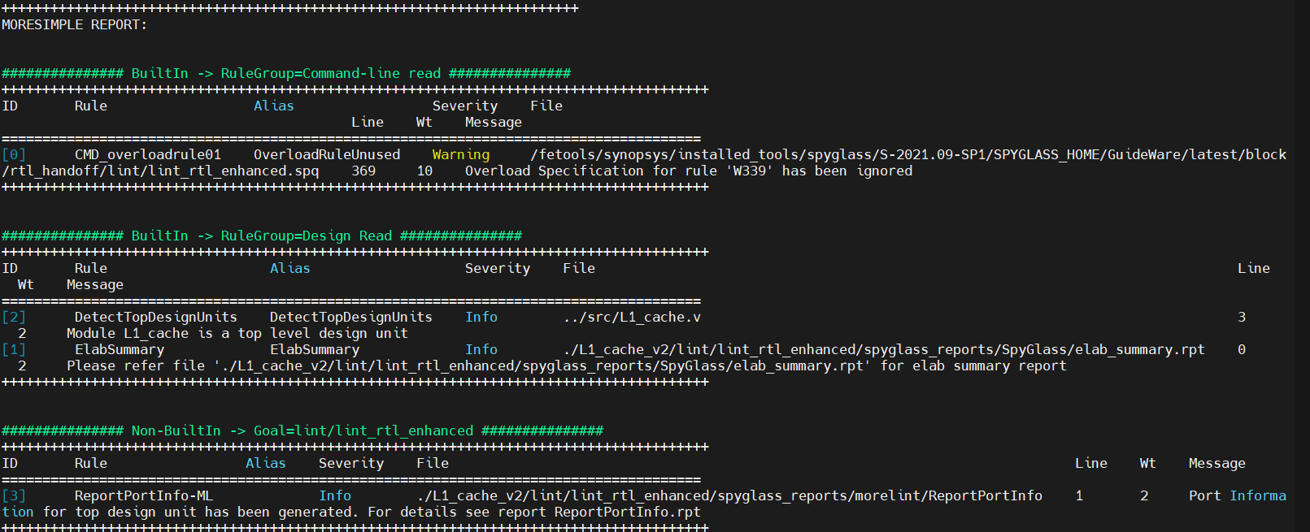

FIFO:
Lint: Fifo mem reset error but Ok.
CDC: 1 warning Ac datahold & Need to do RDC
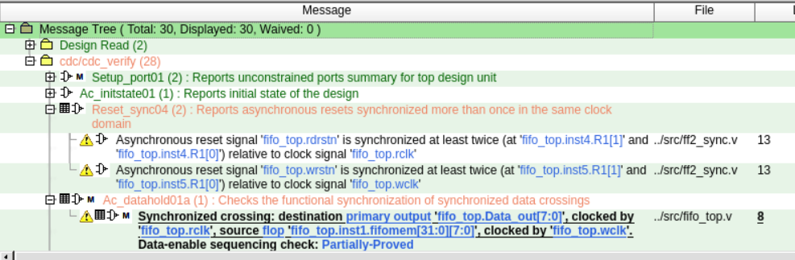
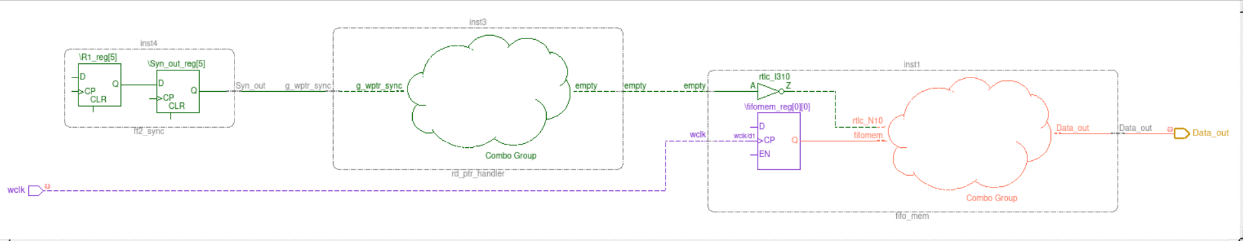

Main_mem:
Lint: Ok

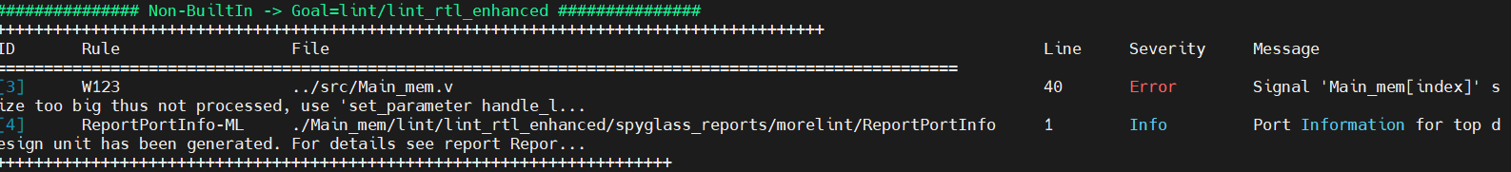

ALU: Efficient Mul will do later
Lint: PASS
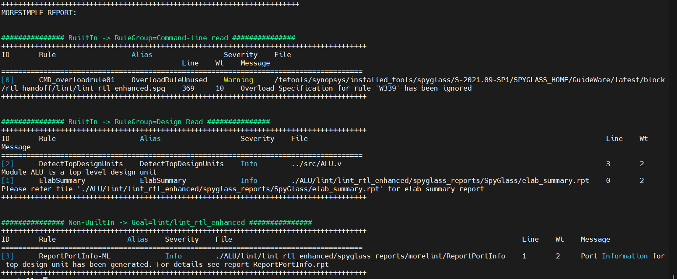

RegFiles:
Lint: PASS
