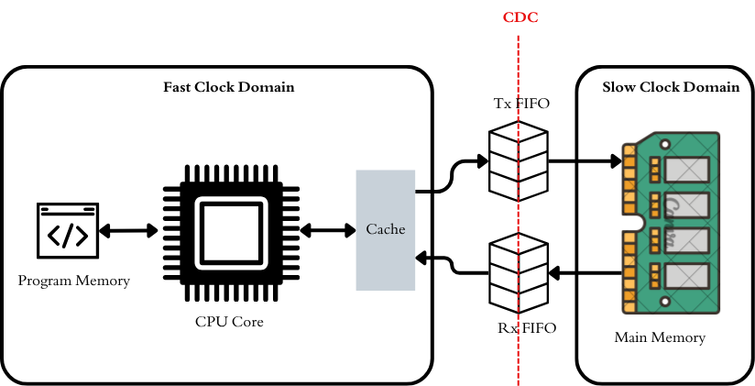

Top Memory Interface -- Micro Architecture:
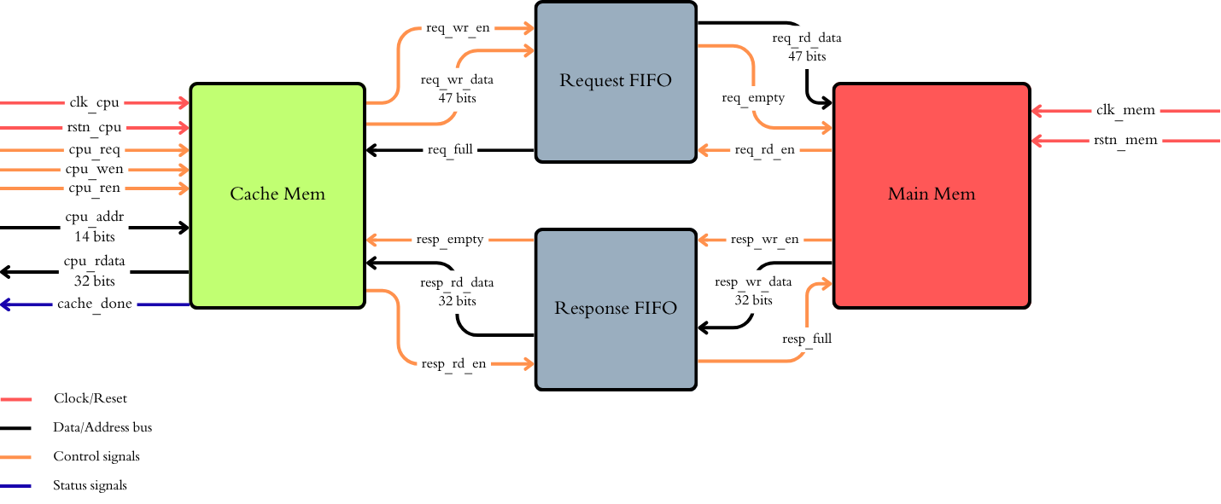

Cache Memory FSM:
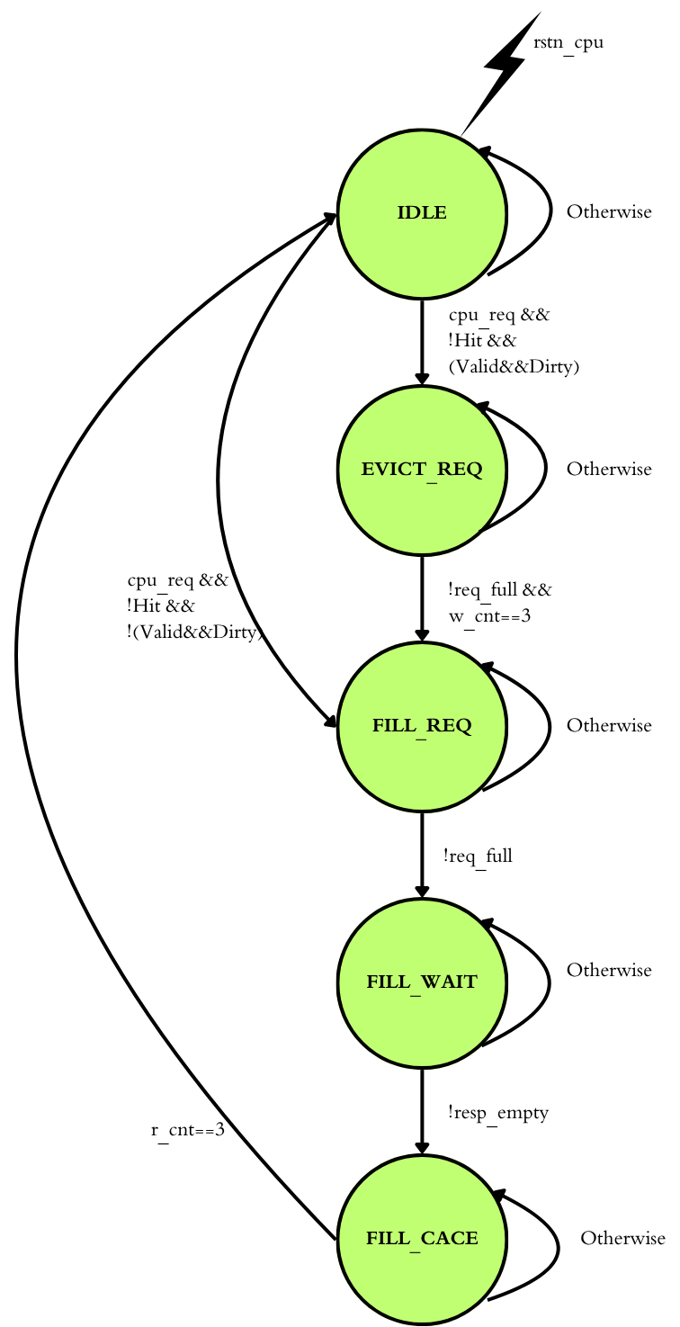

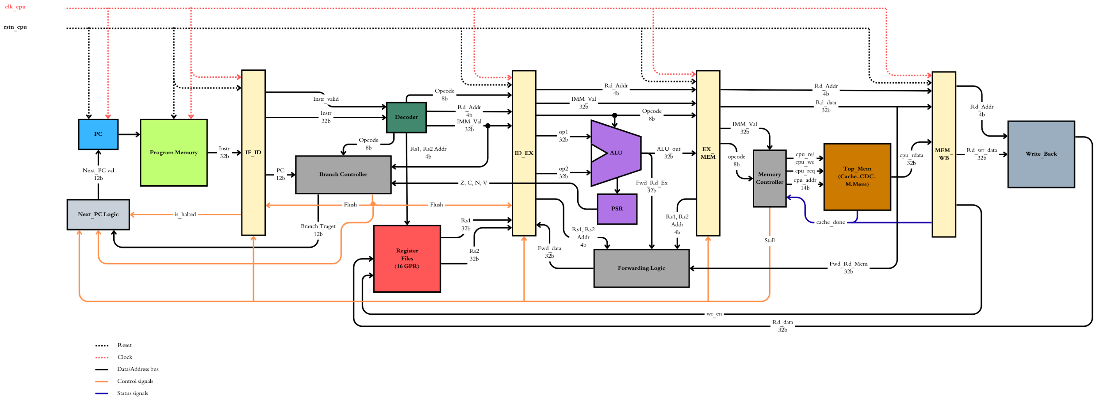

Instruction Set:

No Operation (Stall)
Mnemonic | Opcode | Fields used | Operation | Stages
NOP | 00 | — | No operation. | IF, ID

Load/Store Instructions
Mnemonic | Opcode | Fields used | Operation | Stages
LOAD | 01 | Rd, ADDR | Rd ← DATA[ADDR] (via cache) | All 5 Stages
LOAD_IND | 02 | Rd, Rs1 | Rd ← DATA[Rs1] (via cache) | All 5 Stages
STORE | 04 | Rd(src), ADDR | DATA[ADDR] ← Rd (through cache) | IF,ID,EX,MEM
STORE_IND | 05 | Rd(src), Rs2 | DATA[Rs2] ← Rd | IF,ID,EX,MEM

Register type Instructions
Mnemonic | Opcode | Fields used | Operation | Stages
ADD | 06 | Rd, Rs1, Rs2 | Rd ← Rs1 + Rs2 | IF,ID,EX,WB
SUB | 07 | Rd, Rs1, Rs2 | Rd ← Rs1 − Rs2 | IF,ID,EX,WB
MUL | 08 | Rd, Rs1, Rs2 | Rd ← (Rs1 × Rs2)[31:0] | IF,ID,EX,WB
AND | 09 | Rd, Rs1, Rs2 | Rd ← Rs1 & Rs2 | IF,ID,EX,WB
OR | 0A | Rd, Rs1, Rs2 | Rd ← Rs1 | Rs2 | IF,ID,EX,WB
NOT | 0B | Rd, Rs1 | Rd ← ~Rs1 | IF,ID,EX,WB
XOR | 10 | Rd, Rs1, Rs2 | Rd ← Rs1 ^ Rs2 | IF,ID,EX,WB
CMP | 0C | Rs1, Rs2 | flags ← (Rs1 − Rs2); no write-back | IF,ID,EX,WB
EQ | 0D | Rd, Rs1, Rs2 | Rd ← (Rs1 == Rs2) ? 1 : 0 | IF,ID,EX,WB
ADDI | 16 | Rd, Rs1, IMM | Rd ← Rs1 + sign_ext(IMM) | IF,ID,EX,WB
SUBI | 17 | Rd, Rs1, IMM | Rd ← Rs1 − sign_ext(IMM) | IF,ID,EX,WB
SHL | 11 | Rd, Rs1, Rs2 | Rd ← Rs1 << Rs2[4:0] (logical) | IF,ID,EX,WB
SHR | 12 | Rd, Rs1, Rs2 | Rd ← Rs1 >> Rs2[4:0] (logical) | IF,ID,EX,WB
SAR | 13 | Rd, Rs1, Rs2 | Rd ← Rs1 >>> Rs2[4:0] (arithmetic) | IF,ID,EX,WB
ROL / ROR | 14 / 15 | Rd, Rs1, Rs2 | Rotate left / right by Rs2[4:0] | IF,ID,EX,WB
ANDI / ORI / XORI | 18 / 19 / 1A | Rd, Rs1, IMM | Logical op with zero_ext(IMM) | IF,ID,EX,WB
MOV | 1B | Rd, Rs1 | Rd ← Rs1 | IF,ID,EX,WB
SLT / SLTU | 1C / 1D | Rd, Rs1, Rs2 | Rd ← (Rs1 < Rs2) ? 1 : 0 (signed / unsigned) | IF,ID,EX,WB
LUI | 1E | Rd, IMM | Rd ← {IMM, 20’b0} | IF,ID,EX,WB
LOAD_IMM | 03 | Rd, IMM | Rd ← zero_ext(IMM) | IF,ID,EX,WB

Branch Instructions
Mnemonic | Opcode | Fields used | Operation | Stages
JMP | 0E | ADDR | PC ← ADDR | IF, ID
JMP_IF | 0F | Rs1, ADDR | if (Rs1 ≠ 0) PC ← ADDR | IF, ID
BEQ | 20 | ADDR | if Z: PC ← ADDR | IF, ID
BNE | 21 | ADDR | if ¬Z: PC ← ADDR | IF, ID
BLT | 22 | ADDR | if (N ⊕ V): PC ← ADDR (signed <) | IF, ID
BGE | 23 | ADDR | if ¬(N ⊕ V): PC ← ADDR (signed ≥) | IF, ID
BLTU / BGEU | 24 / 25 | ADDR | Unsigned < / ≥ branch (uses if C = 0, BLTU valid | if C = 1, BGEU valid) | IF, ID
JMP_REG | 26 | Rs1 | PC ← Rs1[11:0] (computed jump / return) | IF, ID
CALL / RET | 27 / 28 | ADDR / — | Subroutine call / return (define a link register + stack) | IF, ID

Stop
Mnemonic | Opcode | Fields used | Operation | Stages
HALT | FF | — | Stop execution. | IF, ID

Instruction Bit Mapping:
Field | Bits | Width | Meaning
OPCODE | [31:24] | 8 | Operation code.
Rd / OUT | [23:20] | 4 | Destination register (also the data-source register for STORE).
Rs1 / OP1 | [19:16] | 4 | First source register; base register for register-indirect addressing.
Rs2 / OP2 | [15:12] | 4 | Second source register; shift amount uses Rs2[4:0].
IMM / ADDR | [11:0] | 12 | 12-bit immediate or direct address.

