Abirami L 240701010
Experiment No. 2: Setting up a Zoho Creator account and exploring the platform architecture and interface
1. Aim
To set up and explore the Zoho Creator platform by creating a Corporate Asset Maintenance application, designing forms, generating reports and dashboards, and understanding the Develop, Deploy and Manage sections of the platform.
2. Setting up Zoho Creator
A Zoho Creator application named Corporate Asset Maintenance was created to manage company assets and their maintenance activities.
The application contains the following forms:
- Department – Stores department details such as Department ID, Department Name, Department Head and Location.
- Asset Details – Maintains information about company assets such as Asset ID, Asset Name, Category, Purchase Cost and Asset Status.
- Technician – Stores technician details such as Technician ID, Name, Specialization, Experience and Availability.
- Maintenance Request – Records maintenance requests raised for company assets.
- Maintenance Approvals – Manages approval of maintenance requests based on the estimated cost.
- Repair Progress – Tracks the repair activities performed by technicians.
Sample Application:
Corporate Asset Maintenance
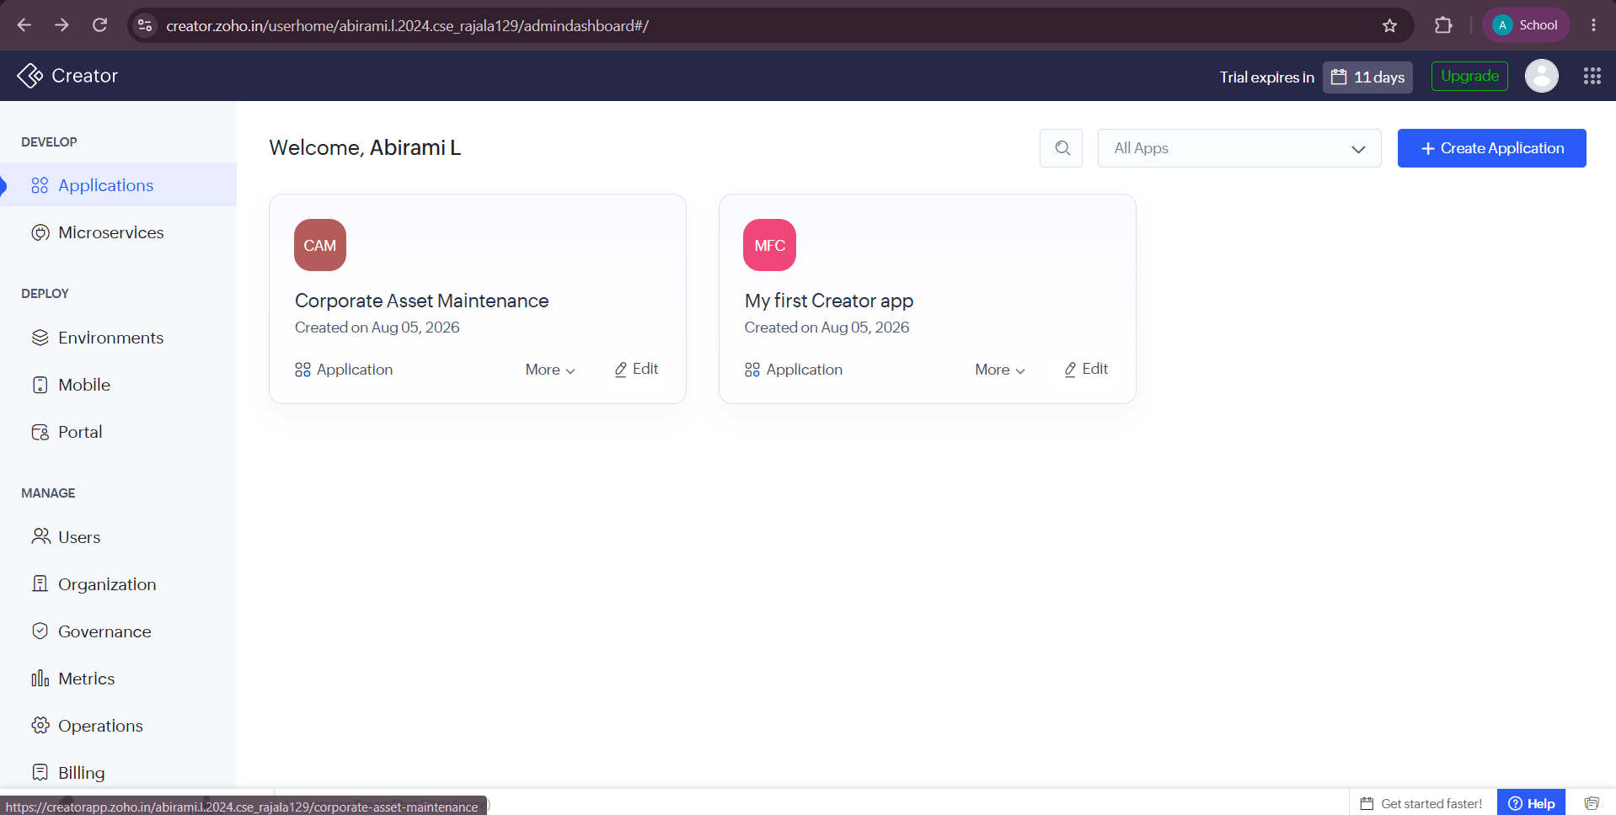
A. Creating Form
A Form in Zoho Creator is used to collect and store information from users. In the Corporate Asset Maintenance application, forms are created for departments, assets, technicians, maintenance requests, approvals and repair progress.
For example, the Technician Form collects information such as Technician Name, Phone Number, Email, Specialization, Experience and Availability Status.
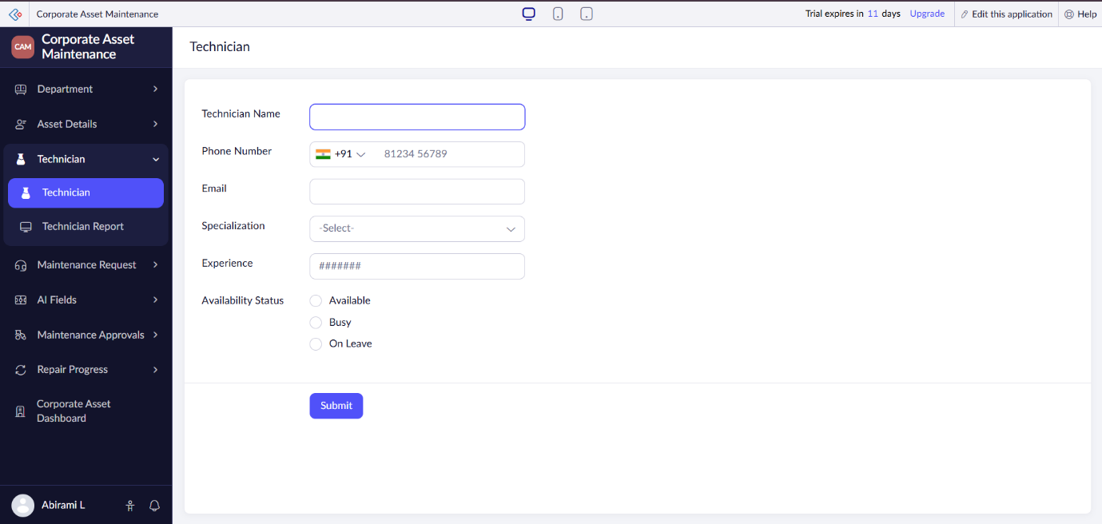
Explanation:
The form provides fields for entering technician information. When the user submits the form, the entered data is stored in the application's database and can be viewed through reports.

B. Creating Report
A Report is used to display and organize the data submitted through a form.
- The Asset Report displays where the asset category is laptop.(created by me)
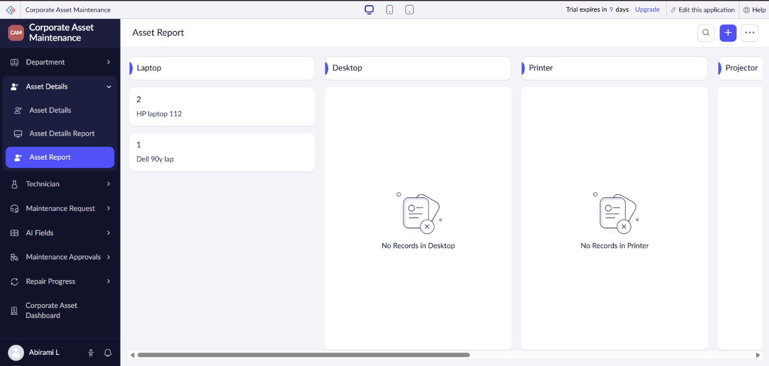
- The Asset Details Report displays all the assets information.(default report)
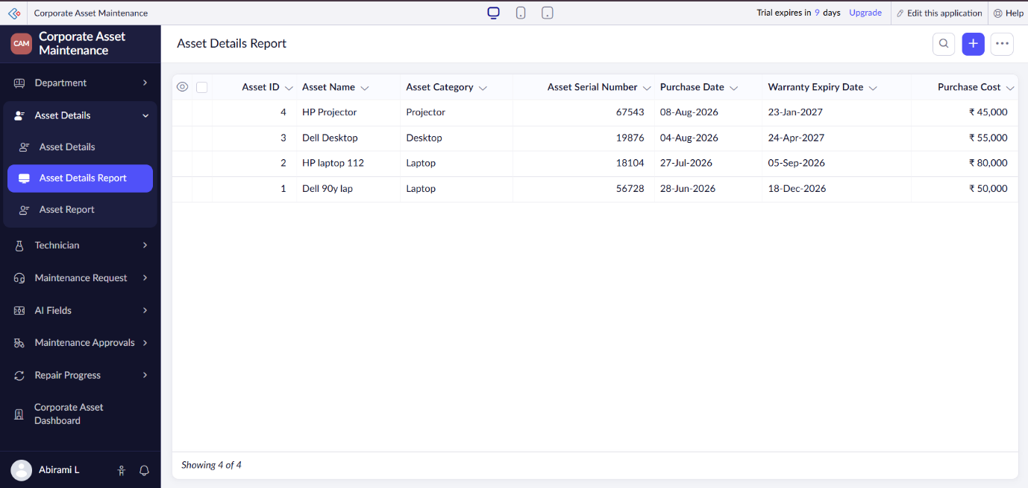
Explanation:
The report automatically displays the records entered through the Asset Details form. It helps users view, search, sort and manage asset information efficiently.

C. Creating Dashboard
A Dashboard provides a visual summary of important information using panels and charts.
The Corporate Asset Dashboard displays key information such as:
- Total Assets
- Total Maintenance Requests
- Pending Approvals
- Completed Repairs
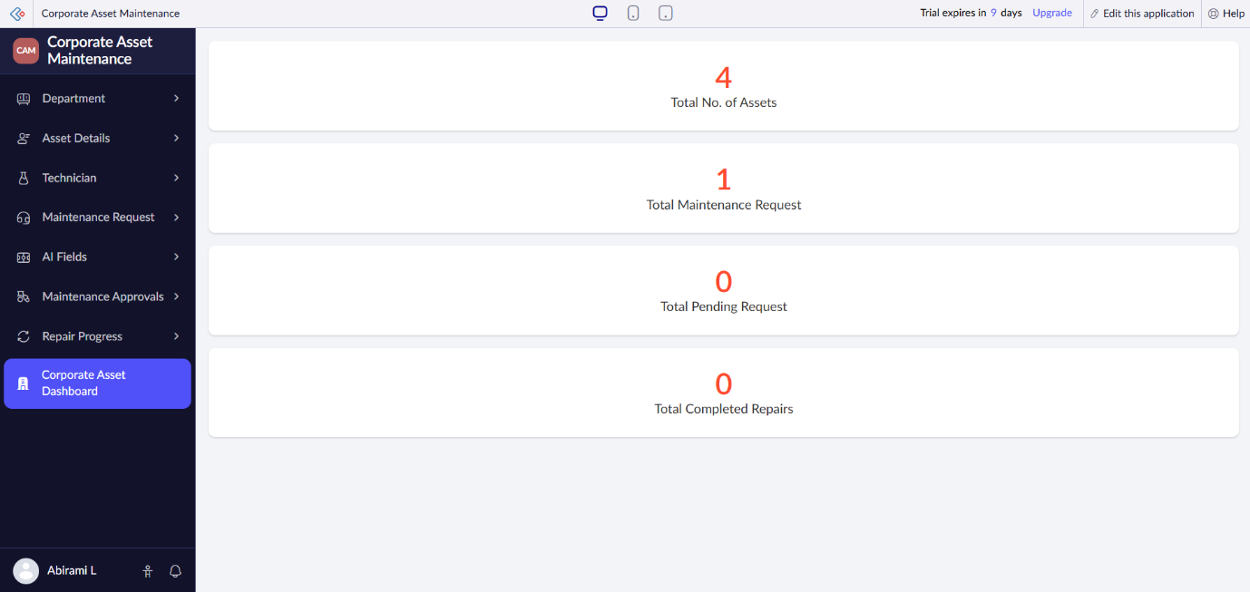
Explanation:
The dashboard provides management with a quick overview of asset and maintenance activities. The values are automatically updated based on the data stored in the application.
3. Exploring the Platform Architecture and Interface:
A. Develop
- The Develop section is used to create and customize applications in Zoho Creator.
- It allows developers to create forms, reports, pages, workflows and dashboards.
- It also supports Deluge scripting for implementing application logic and automation.

B. Deploy
- The Deploy section is used to make the developed application available to end users.
- Applications can be accessed through web and mobile interfaces.
- User access and permissions can be configured based on different roles.
C. Manage
- The Manage section is used to maintain and administer the application.
- It provides options to manage users, permissions, data, settings and integrations.
- Administrators can monitor the application and modify its configuration when required.

Result:
Thus, the Corporate Asset Maintenance application was successfully created and explored using Zoho Creator. Forms, reports and a dashboard were created to manage asset maintenance activities, and the Develop, Deploy and Manage sections of the Zoho Creator platform were studied.

