Abirami L 240701010

Experiment No. 1: Comparative Study of Low-Code Development Versus Traditional Application Development Approaches

Aim
To study and compare the Traditional Application Development approach with the Low-Code Development approach based on their development process, speed, cost, flexibility, and ease of use.

Introduction to Traditional Application Development
Traditional application development is the conventional method of building software by writing source code using programming languages such as Java, Python, C#, or
JavaScript. Developers manually design, code, test, deploy, and maintain the application.
This approach provides complete control over the application's functionality, performance, and customization. However, it requires skilled developers, longer development time, and higher development costs.

Features
  - Manual coding is required.
  - High flexibility and customization.
  - Suitable for complex applications.
  - Requires experienced developers.
  - Longer testing and deployment cycles.

Introduction to Low-Code Development
Low-code development is a modern software development approach that enables applications to be built using graphical user interfaces, drag-and-drop components, and minimal hand-written code.
It allows both professional developers and non-technical users (citizen developers) to create applications quickly, reducing development time and effort.

Examples of low-code platforms include Microsoft Power Apps, Mendix, OutSystems, and Appian.

Features
  - Drag-and-drop interface.
  - Minimal coding required.
  - Faster application development.
  - Easy integration with existing systems.
  - Suitable for rapid application development and business applications.

Diagram for Stages in Traditional Application Development
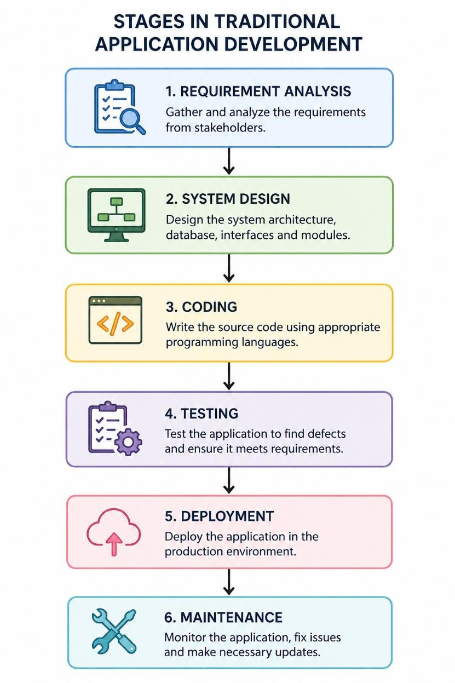

Diagram for Steps in Low-Code Development
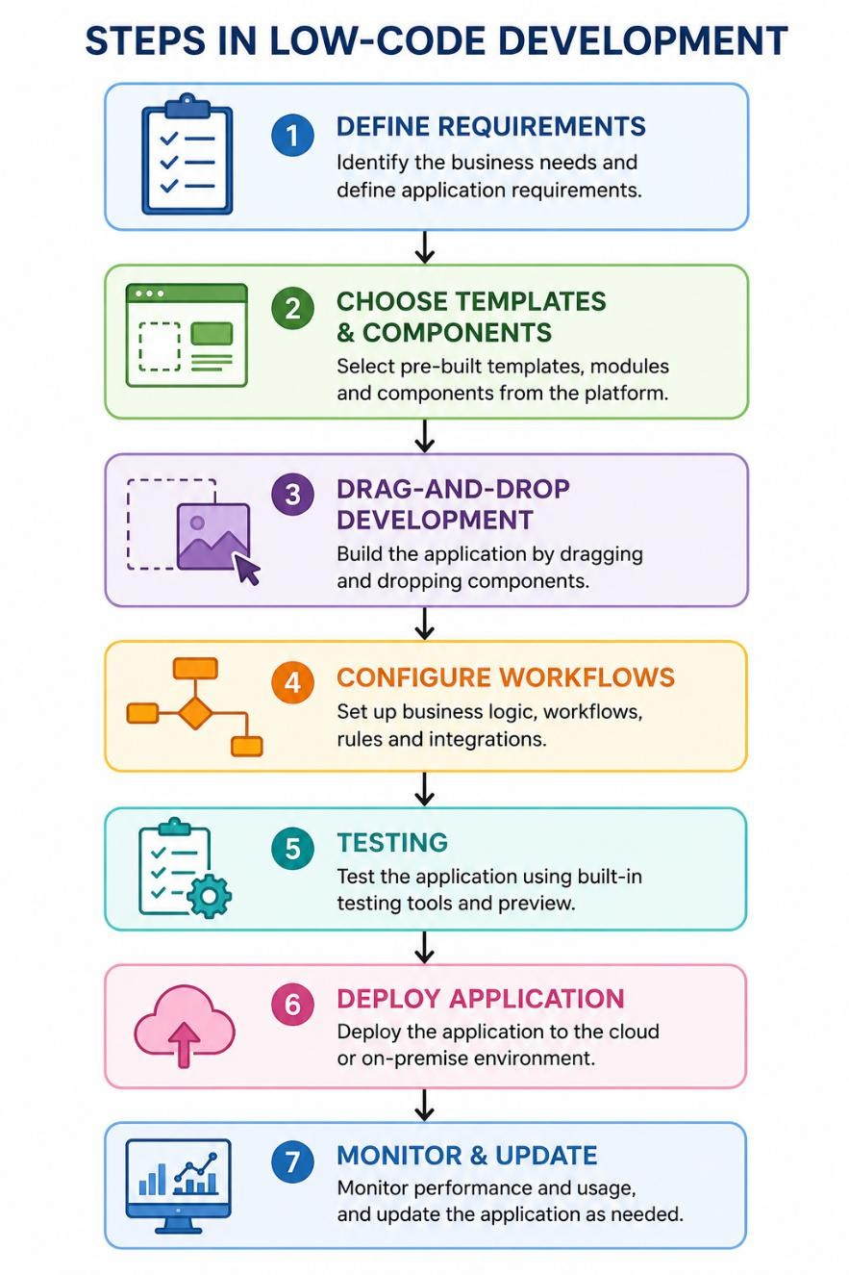

Comparative Analysis of Traditional and Low-Code Development

Parameter | Traditional Development | Low-Code Development
Coding | Extensive manual coding | Minimal coding
Development Speed | Slow | Very Fast
Development Cost | High | Low
Required Skills | Professional programmers | Developers and non-developers
Customization | Very High | Moderate to High

Parameter | Traditional Development | Low-Code Development
Learning Curve | Steep | Easy
Maintenance | Time-consuming | Easier
Testing | Mostly manual | Automated tools available
Deployment | Takes more time | Quick deployment
Best Suitable For | Large and complex applications | Business applications and rapid development

Result
The comparative study shows that Traditional Application Development offers maximum flexibility and customization but requires more time, skilled developers, and higher costs.
On the other hand, Low-Code Development significantly reduces development time, simplifies application creation, and lowers development costs, making it ideal for rapid application development and business solutions. The choice between the two approaches depends on the project's complexity, budget, and development timeline.

