AERIS (Details)
AERIS: An Explainable Reasoning and Investigation System for Intelligent Aircraft Maintenance
📌 Project Vision
Traditional aircraft predictive maintenance systems can detect anomalies such as engine vibration, overheating, or pressure changes. However, they rarely explain the underlying reason behind these anomalies.
The Edge AI Digital Flight Investigator is an intelligent AI-powered maintenance investigation platform that not only predicts failures but also reconstructs the chain of events leading to the failure.
Instead of answering:
"What will fail?"
It answers:
- Why is it failing?
- Which component caused it?
- What evidence supports this conclusion?
- How confident is the explanation?
- What maintenance action should engineers take?
- What happens if no action is taken?
This shifts the project from Predictive AI to Explainable and Causal AI.

🎯 Problem Statement
Aircraft generate massive amounts of telemetry from onboard sensors. Existing predictive maintenance systems detect abnormal behavior but leave maintenance engineers to manually investigate:
- Maintenance history
- Environmental conditions
- Flight history
- Component degradation
- Technical manuals
This investigation is time-consuming and delays maintenance decisions.
The proposed system automates this investigation using AI.

💡 Proposed Solution
Develop an AI-based software platform that investigates aircraft anomalies by integrating:
- Aircraft telemetry (datasets)
- Maintenance history
- Weather information
- Component life
- Flight history
- Aircraft manuals
The system predicts failures, identifies the root cause, estimates Remaining Useful Life (RUL), explains its reasoning, and generates engineer-friendly maintenance reports.

🚫 Project Scope (What We Will NOT Build)
To keep the project realistic for a final-year B.Tech project:
We will not include:
- Physical hardware sensors
- ESP32 or Raspberry Pi integration
- Vision AI
- Audio analysis
- Real aircraft deployment
- Federated Learning
- Reinforcement Learning
The project remains a software-based aerospace AI platform.

✅ Final Modules
1. Data Processing Module
Collects and processes:
- Aircraft engine sensor data
- Maintenance history
- Weather information
- Component lifecycle

2. Predictive Maintenance Module
Uses Time-Series AI to estimate:
- Remaining Useful Life (RUL)
- Failure probability

3. Explainable AI Module
Uses SHAP to explain:
- Which features influenced the prediction
- Feature importance
- Confidence score

4. Knowledge Graph Module
Creates relationships among:
Aircraft
↓
Engine
↓
Compressor
↓
Blade
↓
Maintenance
↓
Weather
↓
Failure
The Knowledge Graph enables relationship-aware reasoning rather than isolated predictions.

5. Causal AI Module
Uses causal inference to determine the most likely chain of events leading to a failure.
Example:
Dust Exposure
↓
Blade Erosion
↓
Rotor Imbalance
↓
Engine Vibration
↓
Potential Failure
Instead of learning correlations, the system identifies probable causes.

6. Retrieval-Augmented Generation (RAG)
Builds a searchable knowledge base using:
- Aircraft manuals
- Maintenance procedures
- Historical maintenance cases
The system retrieves relevant information before generating explanations.

7. LLM-Based Flight Investigator
Uses an open-source Large Language Model to convert technical AI outputs into engineer-friendly reports.
Example:
Engine 2 exhibits increasing vibration consistent with compressor blade erosion. Maintenance records indicate the inspection interval exceeded recommendations. Dust exposure from multiple desert flights accelerated wear. Immediate inspection is advised before the next long-haul flight.

8. Multi-Agent AI Workflow
Instead of one large AI model, the system consists of specialized agents:
- Sensor Analysis Agent
- Maintenance Agent
- Weather Agent
- Knowledge Graph Agent
- Causal Reasoning Agent
- Report Generation Agent
The agents collaborate to produce the final investigation.

9. Digital Twin (Software Simulation) (we are not going to do this)
A software representation of the aircraft displays:
- Engine health
- Remaining Useful Life
- Root cause graph
- Maintenance recommendations
No real aircraft or hardware integration is required.

📊 Project Workflow
Aircraft Dataset
│
▼
Data Cleaning & Feature Engineering
│
▼
Time-Series Prediction (RUL)
│
▼
Anomaly Detection
│
▼
Knowledge Graph
│
▼
Causal AI
│
▼
Explainable AI (SHAP)
│
▼
RAG
│
▼
LLM Report Generation
│
▼
Multi-Agent Coordination
│
▼
Digital Twin Dashboard

🛠 Technology Stack
Frontend
- React
- TypeScript
- Tailwind CSS
- Plotly
Purpose:
Interactive dashboard and data visualization.

Backend
- FastAPI
- Python
- PostgreSQL
- Redis
Purpose:
API development and structured data storage.

AI / Machine Learning
PyTorch
For deep learning model development.

Temporal Fusion Transformer (TFT)
Predicts Remaining Useful Life using multivariate time-series sensor data.

XGBoost / LightGBM
Structured-data baseline models for comparison with deep learning.

SHAP
Explains every prediction by showing feature contributions.

DoWhy / PyWhy
Performs causal reasoning to identify probable root causes.

Neo4j
Stores relationships between aircraft systems and failure events.

LangChain
Builds the Retrieval-Augmented Generation pipeline.

FAISS
Efficient similarity search over aircraft manuals and maintenance documents.

Llama 3 / Qwen
Generates natural-language maintenance investigation reports.

LangGraph
Coordinates the specialized AI agents into one investigation workflow.

Deployment
- Docker
For containerized application deployment during development and testing.

📂 Datasets
Primary Dataset
NASA C-MAPSS
Used for:
- Remaining Useful Life prediction
- Time-series modeling
- Predictive maintenance

Additional Data
- Historical weather data (NOAA)
- Synthetic maintenance records
- Public FAA aircraft manuals
- Component lifecycle information

📚 Literature Survey
The project is based on:
- NASA C-MAPSS research
- NASA N-CMAPSS
- IEEE predictive maintenance papers
- Transformer-based Remaining Useful Life prediction
- Explainable AI for maintenance
- Aircraft prognostics research

📅 Development Timeline
Phase 1
Problem definition and literature review.

Phase 2
Requirement analysis and architecture.

Phase 3
Dataset collection.

Phase 4
Data preprocessing and feature engineering.

Phase 5
Predictive maintenance model development.

Phase 6
Explainable AI integration.

Phase 7
Knowledge Graph and Causal AI.

Phase 8
RAG implementation.

Phase 9
LLM-based Flight Investigator.

Phase 10
Agentic AI workflow.

Phase 11
Digital Twin dashboard.

Phase 12
Testing, evaluation, documentation, and final presentation.

🌟 Innovation
Unlike conventional predictive maintenance systems that only estimate failures, this project performs an end-to-end investigation.
It answers:
- What is failing?
- Why is it failing?
- Which factors contributed?
- How much useful life remains?
- What evidence supports the conclusion?
- What maintenance action should be taken?
- What is the expected outcome if the issue is ignored?

🎓 Why This Is a Strong Final-Year Project
This project is:
- Research-oriented and aligned with current aerospace AI trends.
- Built around publicly available datasets, making it feasible without proprietary aircraft data.
- End-to-end, covering data engineering, machine learning, explainability, knowledge representation, natural language generation, and full-stack software development.
- Realistic to complete within a one-year B.Tech timeline while still demonstrating advanced AI concepts.

🚀 Final Project Statement
Edge AI Aerospace: Digital Flight Investigator is an AI-powered software platform that transforms aircraft predictive maintenance into an intelligent investigation system. By combining Time-Series AI, Explainable AI, Knowledge Graphs, Causal AI, Retrieval-Augmented Generation, Large Language Models, Agentic AI, and a software Digital Twin, it predicts failures, identifies their root causes, explains the reasoning behind every decision, and generates actionable maintenance recommendations—helping engineers move from reactive troubleshooting to proactive, evidence-based maintenance planning.

I think this is a good decision. Removing Vision AI, Audio AI, hardware sensors, and actual aircraft deployment makes the project much more feasible for a final-year team while still keeping it technically strong.
The final project can focus on:
- ✅ Time-Series AI
- ✅ Predictive Maintenance
- ✅ Explainable AI (SHAP)
- ✅ Knowledge Graph
- ✅ Causal AI
- ✅ RAG
- ✅ LLM-based Report Generation
- ✅ Agentic AI (LangGraph)
- ✅ Digital Twin (software simulation only) (we are not going do this)
That is already a research-level software system.

1. Professional Project Timeline (1 Year)
I would divide it into 12 phases, with each phase ending in a measurable deliverable.
Phase | Duration | Objectives | Deliverables
Phase 1 – Problem Definition & Research | Weeks 1–2 | Define the project scope, identify research gaps in predictive maintenance, explainable AI, and causal reasoning. Collect IEEE papers and study existing aerospace maintenance systems. | Problem Statement, Objectives, Literature Survey
Phase 2 – System Requirements & Architecture | Weeks 3–4 | Design the overall architecture, identify functional/non-functional requirements, define modules, prepare UML diagrams, ER diagrams, and knowledge graph structure. | SRS Document, Architecture Diagram
Phase 3 – Dataset Collection & Understanding | Weeks 5–6 | Download and analyze aircraft engine datasets, maintenance logs (synthetic), weather data, and aircraft manuals. Understand sensor variables and target outputs. | Data Repository, Dataset Documentation
Phase 4 – Data Engineering & Feature Engineering | Weeks 7–9 | Clean datasets, remove noise, normalize values, generate Remaining Useful Life (RUL), merge maintenance history, weather, and component life. | Processed Dataset, Feature Engineering Pipeline
Phase 5 – Predictive Maintenance Module | Weeks 10–14 | Develop ML/DL models to predict Remaining Useful Life (RUL). Compare XGBoost, Random Forest, LSTM, and Temporal Fusion Transformer. Select the best-performing model. | Trained Prediction Model, Evaluation Metrics
Phase 6 – Explainable AI Module | Weeks 15–17 | Integrate SHAP to explain predictions. Show feature importance, local explanations, and confidence levels for every prediction. | Explainability Dashboard
Phase 7 – Knowledge Graph & Causal Reasoning | Weeks 18–21 | Build a Neo4j knowledge graph linking aircraft components, maintenance history, weather, and failures. Apply DoWhy/PyWhy to infer causal chains rather than correlations. | Knowledge Graph, Causal Reasoning Module
Phase 8 – Retrieval-Augmented Generation (RAG) | Weeks 22–24 | Create a searchable knowledge base from aircraft manuals, maintenance procedures, and historical cases using FAISS and LangChain. | RAG Pipeline
Phase 9 – LLM-Based Flight Investigator | Weeks 25–27 | Integrate an open-source LLM to generate engineer-friendly explanations, maintenance reports, and recommendations using RAG context. | AI Investigation Report Generator
Phase 10 – Agentic AI Workflow | Weeks 28–30 | Build LangGraph agents (Sensor Analysis Agent, Maintenance Agent, Weather Agent, Causal Agent, Report Agent) to coordinate the complete investigation pipeline. | Multi-Agent Workflow
Phase 11 – Digital Twin Simulation & Dashboard | Weeks 31–34 | Create a software-based digital twin showing aircraft health, RUL, causal graph, recommendations, and maintenance timeline. Develop the React dashboard. | Interactive Dashboard
Phase 12 – Testing, Evaluation & Documentation | Weeks 35–40 | Evaluate system performance, compare with baseline methods, perform user testing, write IEEE-format paper, thesis, and prepare final presentation. | Thesis, Research Paper, Final Demo

2. Dataset Availability
I recommend not using random Kaggle datasets. Use datasets that are accepted in aerospace prognostics research.
Dataset 1 (Primary Dataset) ⭐⭐⭐⭐⭐
NASA C-MAPSS (Commercial Modular Aero-Propulsion System Simulation)
This is the standard benchmark used in most aircraft predictive maintenance research. It contains run-to-failure multivariate time-series from simulated turbofan engines, including 21 sensor measurements, operational settings, and Remaining Useful Life (RUL) labels. (NASA Open Data Portal)
Official NASA dataset:
NASA C-MAPSS Dataset

Dataset 2 (Advanced Version)
NASA N-CMAPSS
An enhanced version of C-MAPSS that models more realistic flight conditions and degradation behavior, making it suitable for advanced deep learning and prognostics research. (NASA Technical Reports Server)
NASA Technical Report:
N-CMAPSS Dataset Documentation

Dataset 3
Weather information (for contextual reasoning)
Use historical weather data to enrich the investigation with environmental conditions.
Recommended:
NOAA Climate Data Online

Dataset 4
Maintenance Logs
There is no complete public airline maintenance log because of security and confidentiality.
Recommendation:
Create a synthetic maintenance log based on:
- inspection date
- replaced component
- maintenance type
- technician
- flight hours
- remarks
This is a common research practice when real maintenance records are unavailable.

Dataset 5
Aircraft Manuals
Use publicly available FAA manuals for retrieval-augmented generation (RAG).
Recommended:
FAA Aircraft Handbooks and Manuals

3. IEEE Literature Survey
Below are real IEEE (and closely related aerospace research) publications that are directly relevant to your project.

Paper 1
Damage Propagation Modeling for Aircraft Engine Run-to-Failure Simulation
This foundational IEEE PHM paper introduced the CMAPSS degradation simulation that almost every aircraft RUL study uses today. (NASA Open Data Portal)
Dataset/Paper:
NASA CMAPSS Damage Propagation Paper

Paper 2
Aircraft Engine Run-to-Failure Dataset Under Real Flight Conditions for Prognostics and Diagnostics
Describes the N-CMAPSS dataset with realistic flight profiles for developing advanced prognostic models. (NASA Technical Reports Server)
Paper:
NASA N-CMAPSS Technical Report

Paper 3
Remaining Useful Life Estimation of Aircraft Engines Using a Joint Deep Learning Model Based on TCNN and Transformer
Shows how Transformer-based deep learning can outperform traditional sequence models for aircraft engine RUL prediction using NASA C-MAPSS. (Wiley Online Library)
Paper:
TCNN + Transformer for Aircraft Engine RUL Prediction

Paper 4
Predictive Maintenance of Aircraft Engines: Machine Learning Approaches for Remaining Useful Life Estimation (IEEE Conference)
Compares XGBoost, Random Forest, SVM, and other ML models on C-MAPSS, while also discussing explainability. (DOI)
Paper:
IEEE Predictive Maintenance for Aircraft Engines

Paper 5
Predictive Maintenance Programs for Aircraft Engines Based on Remaining Useful Life Prediction
A recent survey discussing RUL prediction techniques, datasets, and maintenance scheduling for aircraft engines. (PMC)
Paper:
Predictive Maintenance Programs for Aircraft Engines

My Recommendation
To keep the project ambitious but achievable, I recommend fixing the scope before implementation.
Core modules to build
- Data preprocessing and feature engineering
- Remaining Useful Life prediction (Time-Series AI)
- Explainable AI (SHAP)
- Knowledge Graph (Neo4j)
- Causal AI (DoWhy/PyWhy)
- RAG over aircraft manuals and maintenance procedures
- LLM-generated investigation reports
- Multi-agent workflow (LangGraph)
- React dashboard
- Software-only Digital Twin visualization
Modules to exclude
- Physical sensors
- Vision AI
- Audio analysis
- Real aircraft deployment
- Federated learning
- Reinforcement learning
This scope is realistic for a one-year B.Tech project while still being technically sophisticated and well aligned with current aerospace AI research.

Output for EDA before cleaning for CMAPSS
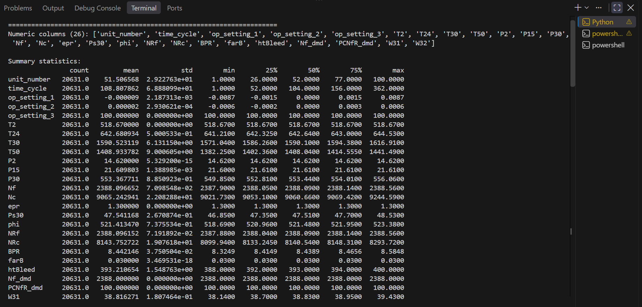
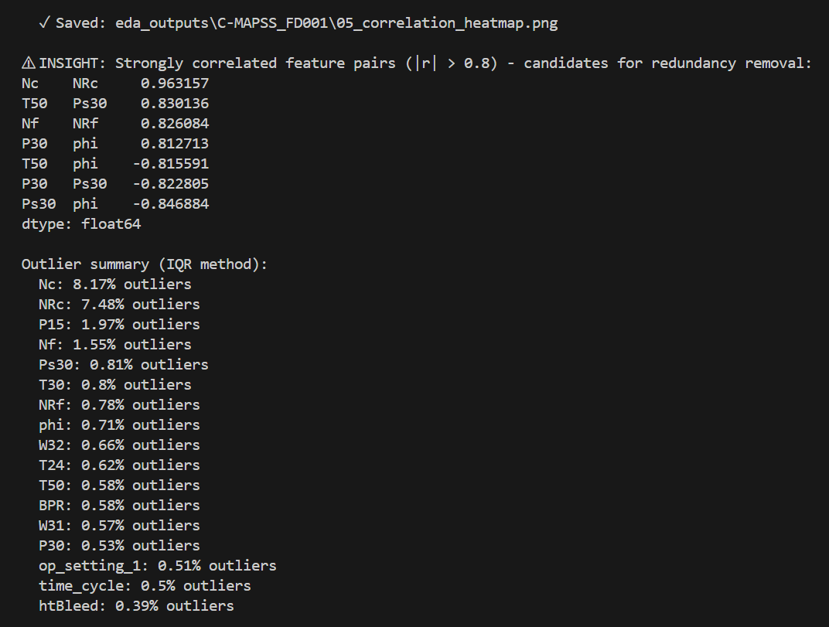
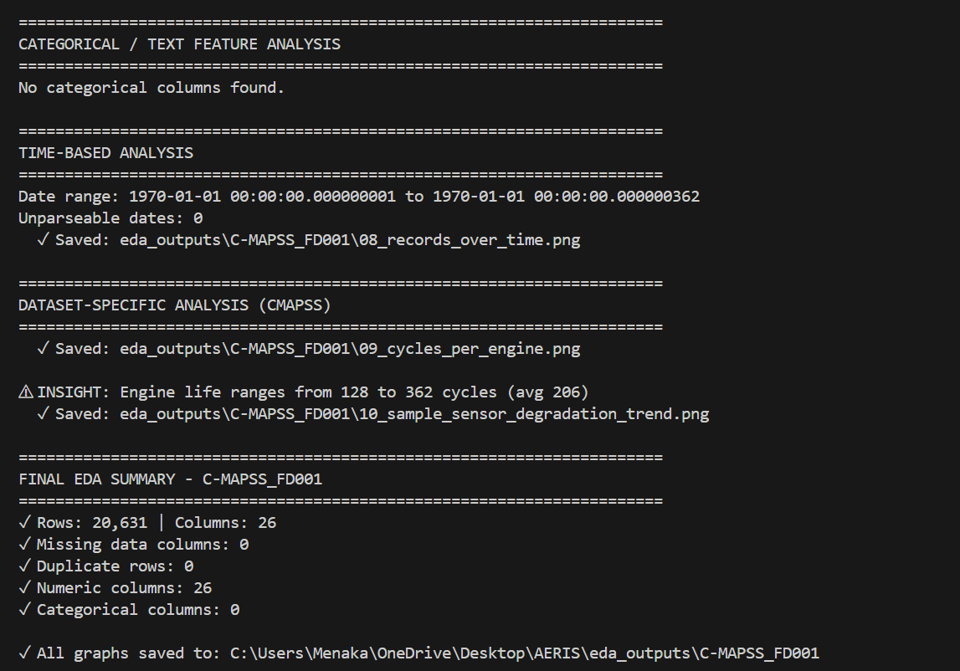

Output for EDA before cleaning for SDR
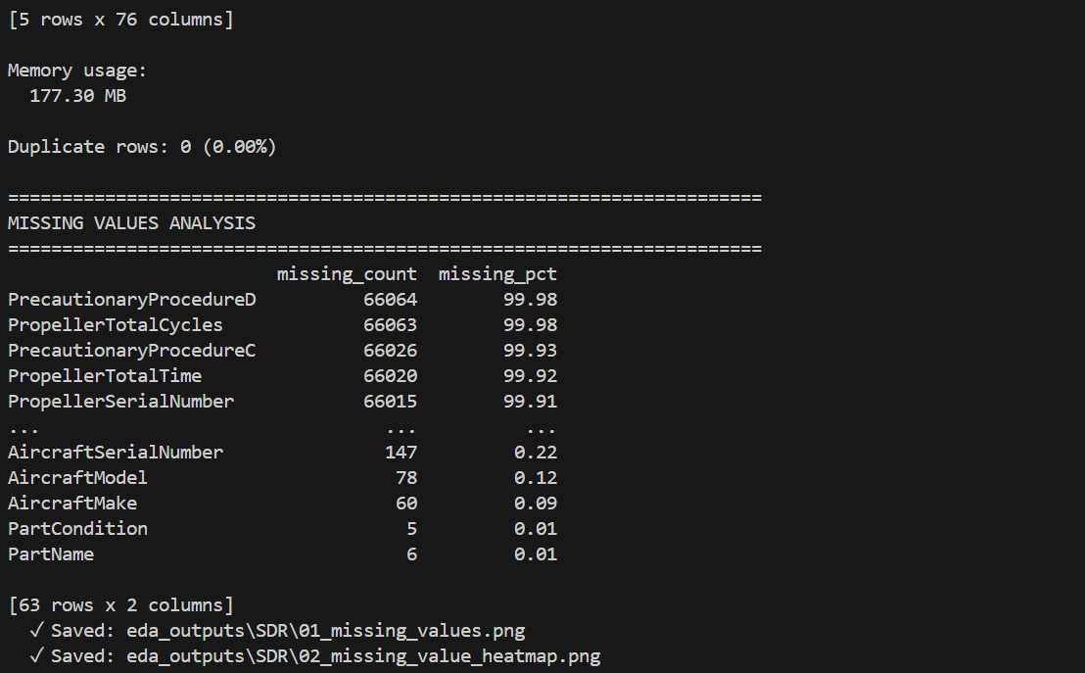

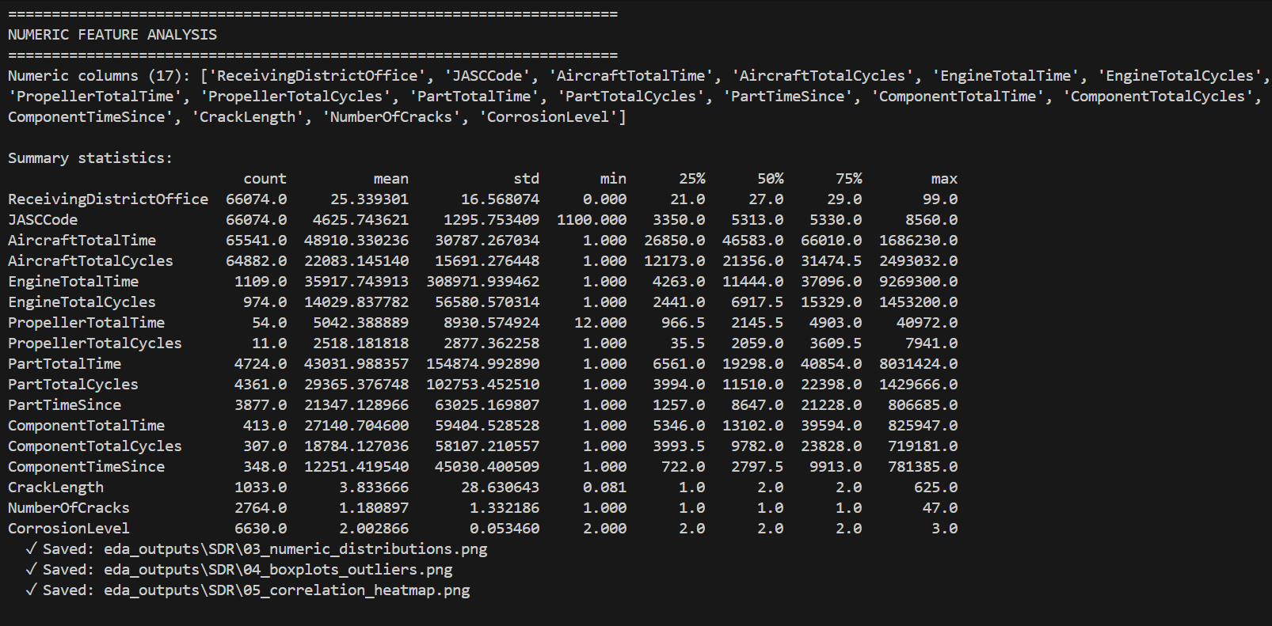

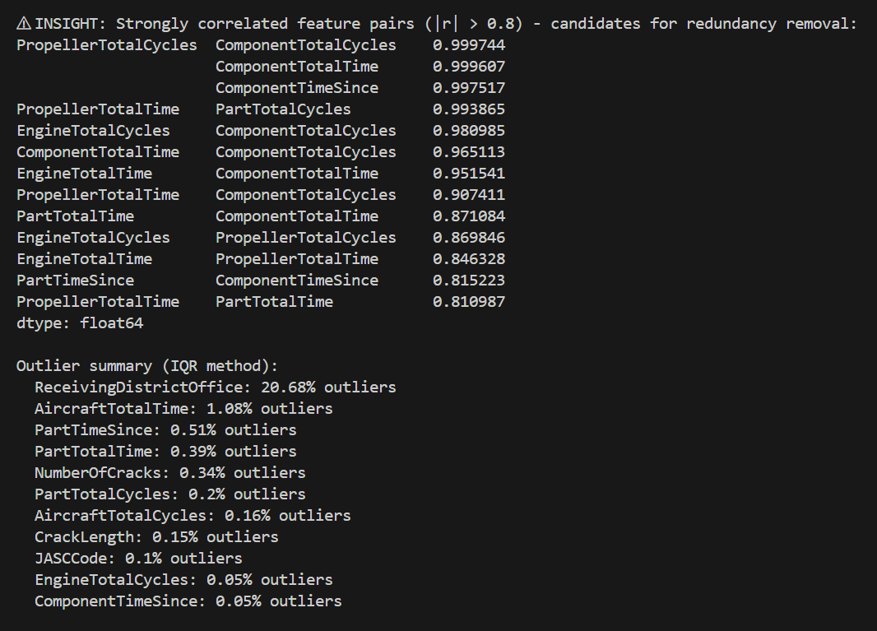
After cleansing:
