INDIA’S AGRICULTURAL CROP PRODUCTION(1997-2021)

1.INTRODUCTION

**1.1 Overview**

* **India’s is the second largest producer of wheat and rice, the world’s major food staples.**
* **India is currently the world’s second largest producer of several dry fruits, agriculture-based textile raw materials, roots and tuber crops, pulses, farmed fish, eggs, coconut, sugarcane and numerous vegetables.** 
  1. **Purpose**
* **The country has also emerged as the world's highest milk producer along with other agrarian produces, such as spices, pulses, tea, cashew, and jute. India also tops as the second largest producer of rice, wheat, oilseeds, fruits, vegetables, sugarcane, and cotton.**

**2.PROBLEM DEFINITION AND DESIGN THINKING**

**2.1 Empathy Map**

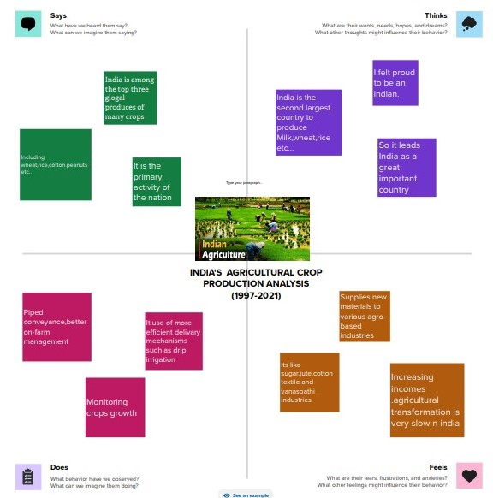

**2.2 Ideation & Brainstorming Map**

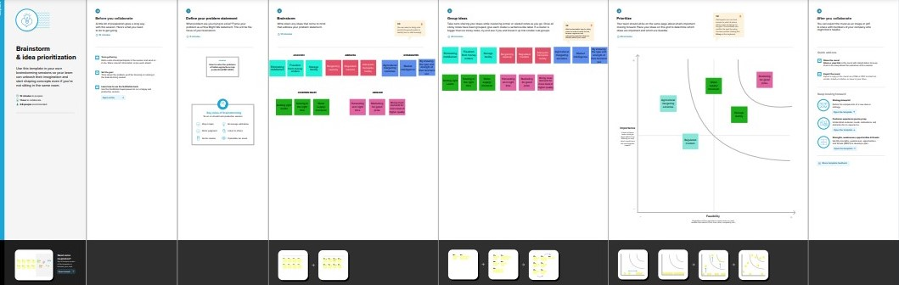

**3. RESULT**

**Story 1**

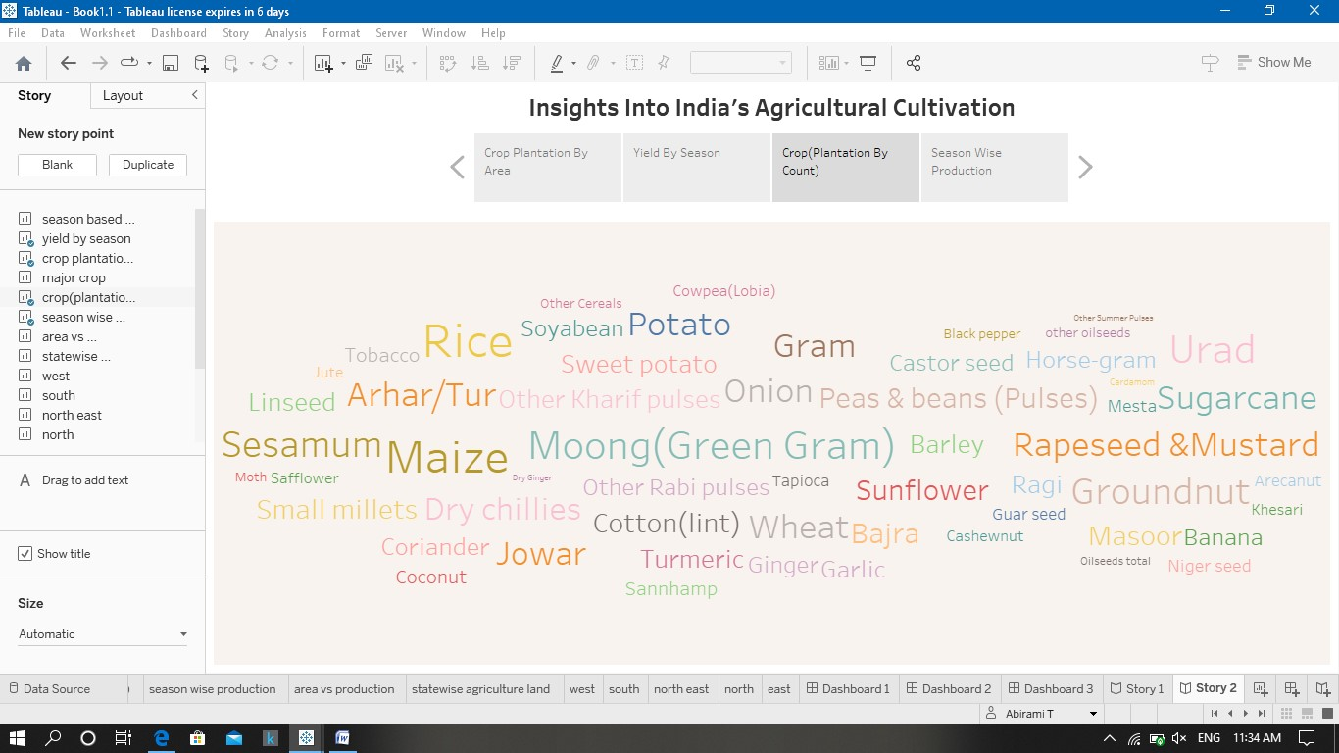

**Story 2**

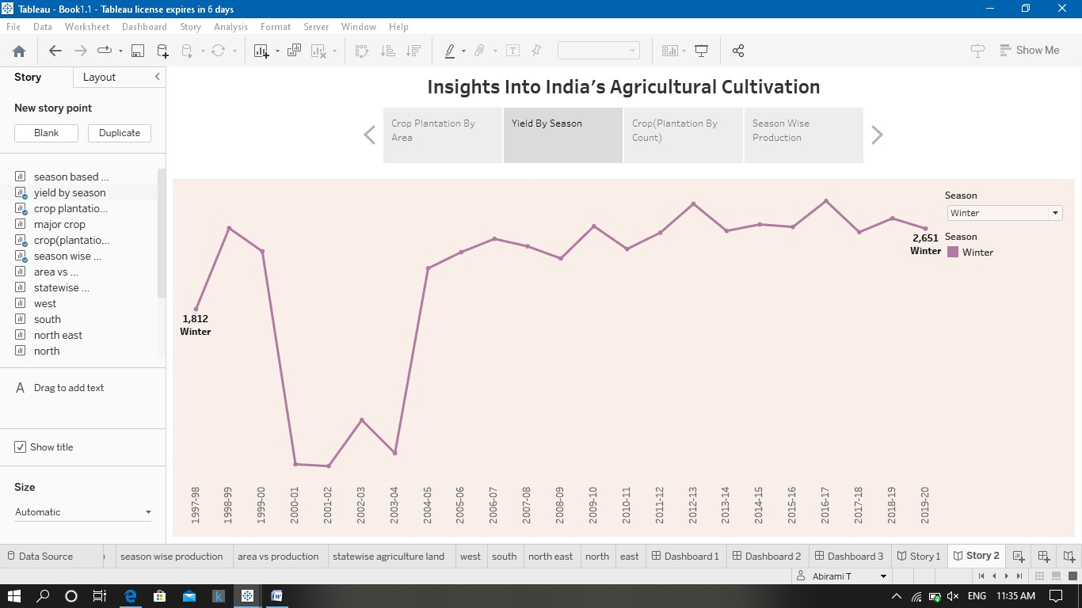

**Story 3**

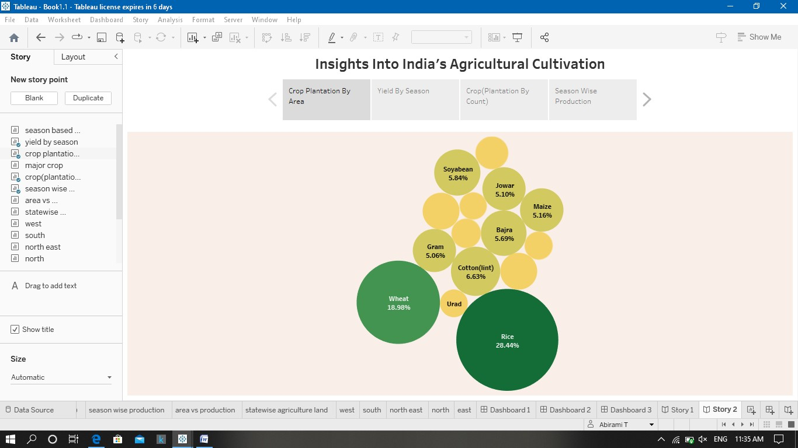

**Story 4**

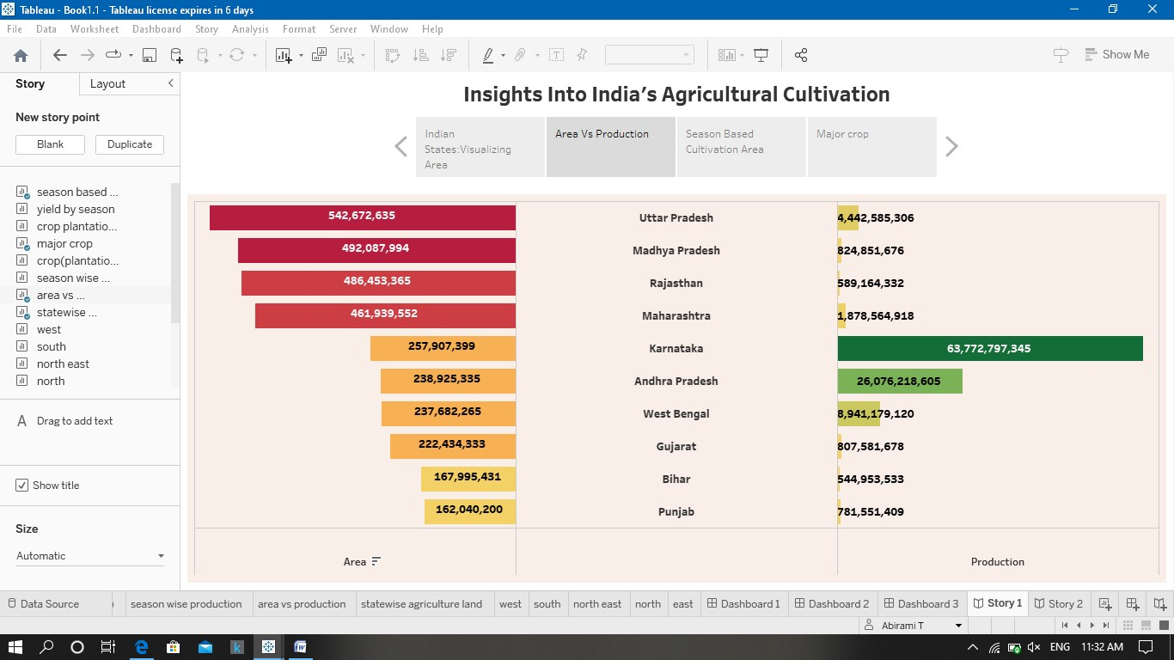

**Story 5**

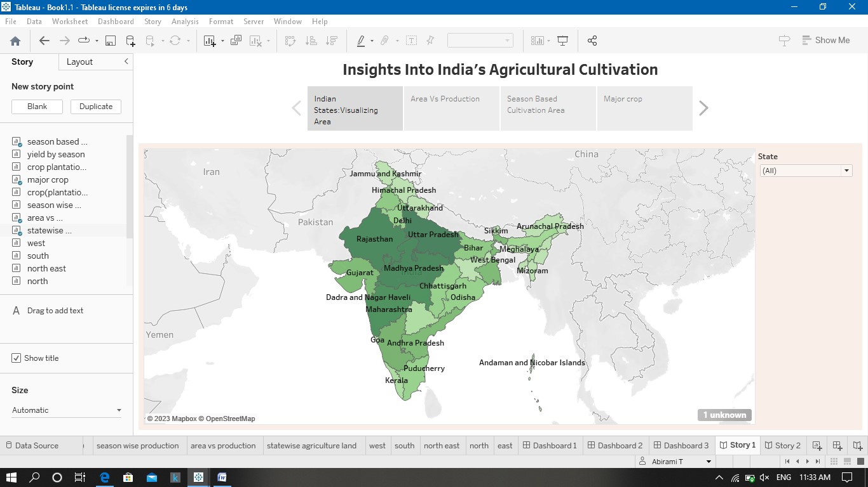

**Story 6**

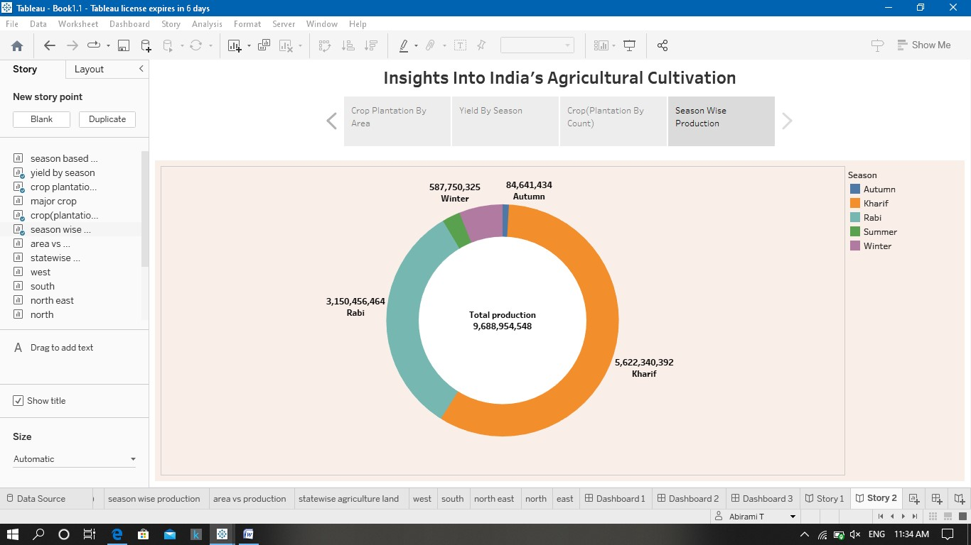

**Story 7**

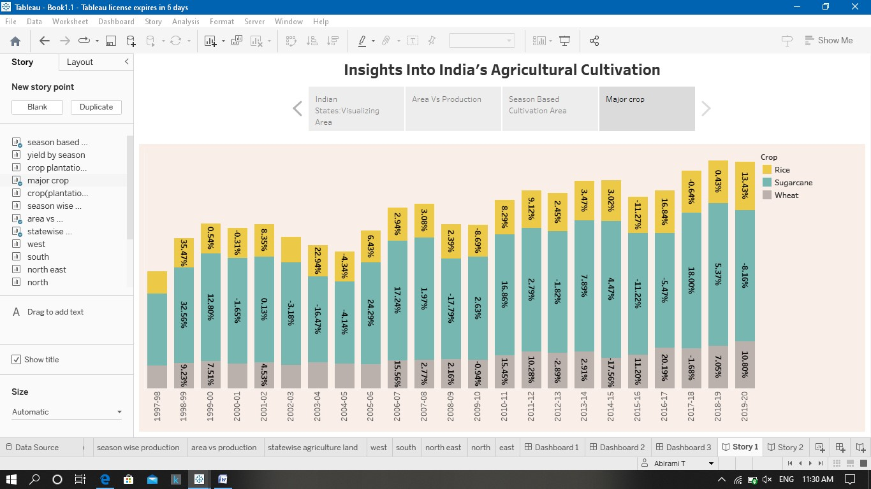

**Story 8**

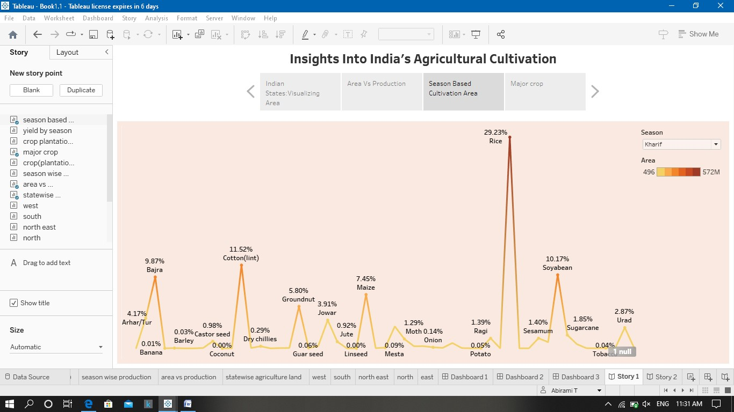

**4. ADVVANTAGES AND DISADVANTAGES**

**4.1 Advantages**

* **India is self sufficient in crop farming . And about 60 % of population depends on farming . So it has a vast stage in india.  Hight subsidy on morganic and inorganic manure, techonlogies like tractors and other tools and other infrasture incourages farmer for crop farming .**

**4.2 Disadvantages**

* **Erosion of soil by heavy rain, floods, insufficient vegetation cover etc., reduces farm productivity. Inadequate irrigation facilities and poor management of water resources have led to a great decline in agricultural productivity.**

**5. APPLICATION**

* **Increasing incomes. Agricultural transformation is very slow in India.**
* **Generating employment opportunities.**
* **Reducing risks in agriculture.**
* **Developing agri-infrastructure.**
* **Improving quality of rural life.**

**6.FUTURE SCOPE**

* **There will be more of vertical and urban farming and there will also be efforts in long term to find new areas for production like barren deserts and seawater. Hydroponic farming, which is a soil-less, water-based farming operation, that may even be done in a tiny space is going to pick up the pace.**

**7.Conclusion**

**Indian agriculture sector accounts for 18 per cent of India's gross domestic product (GDP) and provides employment to 50% of the countries workforce. India is the world's largest producer of pulses, rice, wheat, spices and spice products.**