**Topics: Descriptive Statistics and Probability**

1. Look at the data given below. Plot the data, find the outliers and find out $μ, σ, σ^{2}$

|  |  |
| --- | --- |
| **Name of company** | **Measure X** |
| Allied Signal | 24.23% |
| Bankers Trust | 25.53% |
| General Mills | 25.41% |
| ITT Industries | 24.14% |
| J.P.Morgan & Co. | 29.62% |
| Lehman Brothers | 28.25% |
| Marriott | 25.81% |
| MCI | 24.39% |
| Merrill Lynch | 40.26% |
| Microsoft | 32.95% |
| Morgan Stanley | 91.36% |
| Sun Microsystems | 25.99% |
| Travelers | 39.42% |
| US Airways | 26.71% |
| Warner-Lambert | 35.00% |

**Sol:**

**Morgan Stanley is an outlier** in the above data, where its measure is distinctly different from others.

Where mean, variance and standard deviation was calculated below:

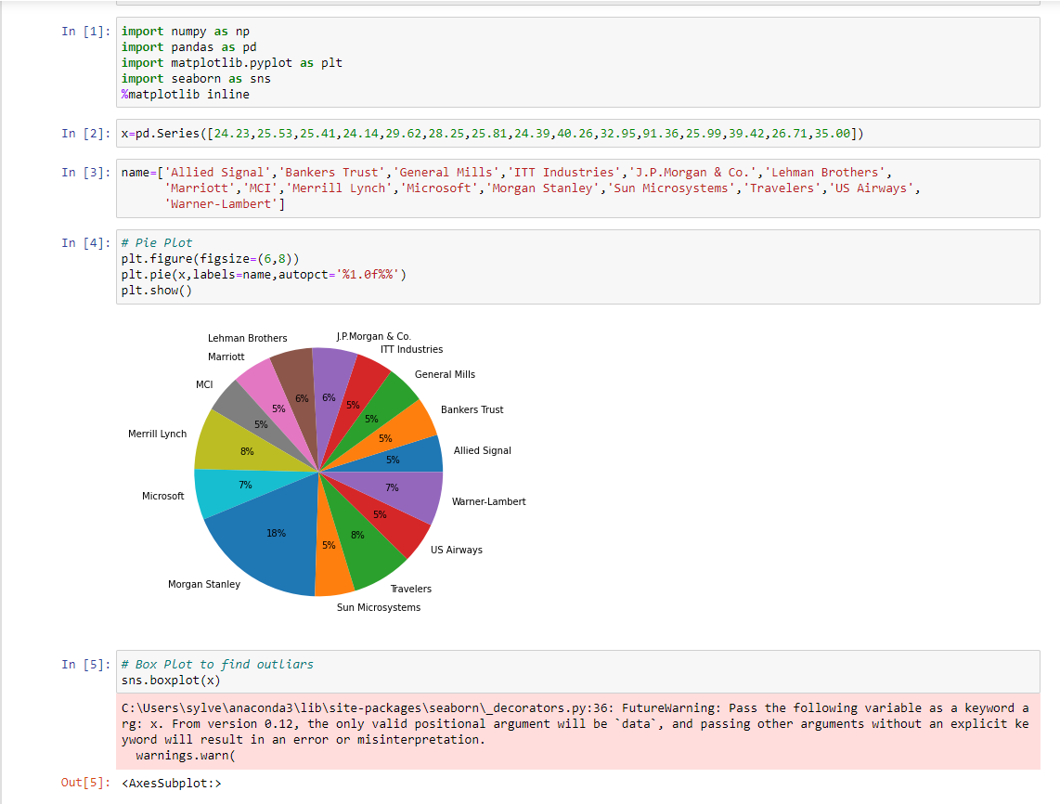

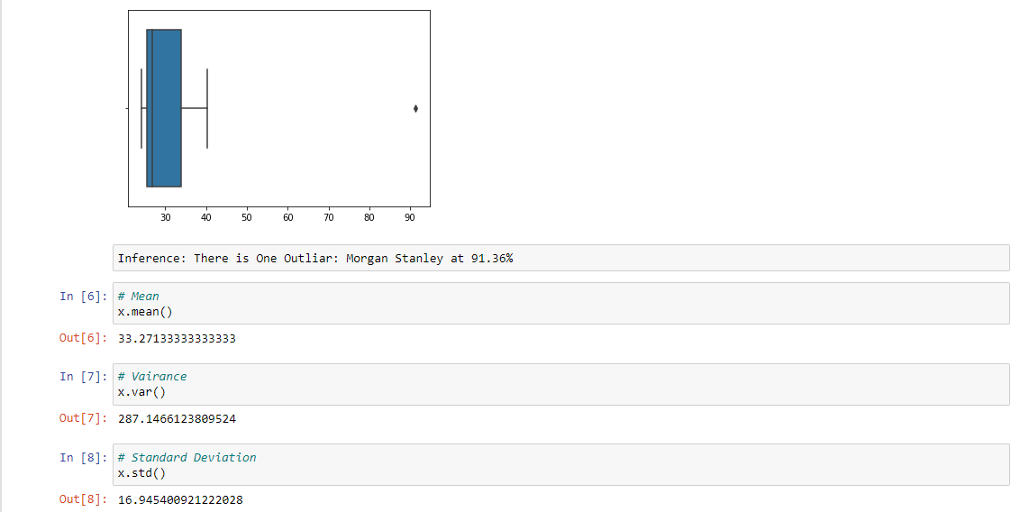



Answer the following three questions based on the box-plot above:

1. What is inter-quartile range of this dataset? (please approximate the numbers) In one line, explain what this value implies.

**Sol:** **IQR=Q3-Q1=12-5=7**

**Value implies that range contains 50% of data**

1. What can we say about the skewness of this dataset?

**Sol: Positively Skewed**

1. If it was found that the data point with the value 25 is actually 2.5, how would the new box-plot be affected?

**Sol:** **2.5 is not considered as an outlier, bcoz boxplot sends data from 0 to 20 in the above representation.**

3.



Answer the following three questions based on the histogram above:

1. Where would the mode of this dataset lie?

**Sol:** **Mode lies between 4 and 8**

1. Comment on the skewness of the dataset.

**Sol: Positively Skewed**

1. Suppose that the above histogram and the box-plot in question 2 are plotted for the same dataset. Explain how these graphs complement each other in providing information about any dataset.

**Sol:**

**Mode in histogram and Median in boxplot.**

**Where histogram provides the frequency distribution so that we can view data points as many times and whereas boxplot provides quantile distribution (50% of data lies between 5 and 12).**

**No information can obtain from histogram whereas outliers can be find from boxplot and the outlier here is 25.**

4.AT&T was running commercials in 1990 aimed at luring back customers who had switched to one of the other long-distance phone service providers. One such commercial shows a businessman trying to reach Phoenix and mistakenly getting Fiji, where a half-naked native on a beach responds incomprehensibly in Polynesian. When asked about this advertisement, AT&T admitted that the portrayed incident did not actually take place but added that this was an enactment of something that “could happen.” Suppose that one in 200 long-distance telephone calls is misdirected. What is the probability that at least one in five attempted telephone calls reaches the wrong number? (Assume independence of attempts.)

**Given:**

One in 200 long-distance telephone calls is misdirected

**Sol:**

Therefore probability of call misdirecting p = 1/200

Probability of call not misdirecting = 1 - 1/200 = 199/200

Number of Calls = 5

**P(x) = ⁿCₓpˣqⁿ⁻ˣ**

n = 5, p = 1/200,q = 199/200

At least one in five attempted telephone calls reaches the wrong number:

= 1 -  none of the call reaches the wrong number

= 1 - p(0)

= 1   -  ⁵C₀(1/200)⁰(199/200)⁵⁻⁰

= 1  -  (199/200)⁵

= 0.0247

**Probability that at least one in five attempted telephone calls reaches the wrong number = 0.02475**

5.Returns on a certain business venture, to the nearest $1,000, are known to follow the following probability distribution

|  |  |
| --- | --- |
| x | P(x) |
| -2,000 | 0.1 |
| -1,000 | 0.1 |
| 0 | 0.2 |
| 1000 | 0.2 |
| 2000 | 0.3 |
| 3000 | 0.1 |

1. What is the most likely monetary outcome of the business venture?

**Sol: Most likely monetary outcome of the business venture is 2000 with the highest probability of 0.3**

1. Is the venture likely to be successful? Explain

**Sol:** **The venture is successful, whereP(x=1000)+P(x=2000)+P(x=3000)=0.2+0.3+0.1=0.6**

**Venture yields profit=0.6 whereas loss=0.2**

**Therefore venture yields with profit, thus it is successful.**

1. What is the long-term average earning of business ventures of this kind? Explain

**Sol: Long term average earning=X*P(X)**

**=(0.1*-2000)+(0.1*-1000)+(0.2*0)+(0.2*1000)+(0.3*2000)+(0.1*3000)**

**=800(all losses and gain over period is calculated)**

1. What is the good measure of the risk involved in a venture of this kind? Compute this measure

**Sol: P(loss)=P(x=-2000)+ P(x=-1000)=0.2**

**Therefore risk associated is 20%**