CHAPTER 1

INTRODUCTION

  - AIM
The article is an overview of a project “THEFT SMS TRACKER AND LOCATION TRACKER” which is aimed at developing software utility based on android which tracks the mobility of a human being.
1.2. OVERVIEW OF THE PROJECT
A wide range of tracking systems has been developed so far tracking vehicles and displaying their position on a map, but none of the applications has been developed so far which tracks the mobility of a human being. Now a day's tracking a person's mobility has became a crucial issue these days be it tracking a criminal came on payroll or a detective going to detect a case or any other utility. The overall objective of this project is to develop a system which is cost effective and can be used for tracking a human being using a GPS and GPRS equipped mobile phone rather than using a handheld GPS receiver.
The main focus of our project is to reduce the overall cost of tracking based on GPS system every part of the world across the boundaries. The GSM/GPRS is one of the best and cheapest modes of communication present these days and in future, which is a satellite based service which is available 24X7 everywhere in the whole world. GPS system can be used to get location which includes details like latitude, longitude and altitude values along with the timestamp details etc. it a free of cost service available to every individual.

1.3 OBJECTIVE
Theft sms tracker and location tracker system is really very helpful for the owner to monitor their stolen mobile. The stolen mobile will act as a both GPS receiver and GPRS transmitter which will use the GSM network to transmit the GPRS packets. On this phone itself we'll install our application which is supposed to perform all the operations of tracking. So by using this system, we can monitor the stolen mobile and also we can the location of the theft using GPS.

1.4 SCOPE OF THE PROJECT
The scope of our project is to monitor the stolen mobile’s each and every activities, current location and sending alert to their parent mobile(owner mobile) by using the android application.

1.5 DOMAIN INTRODUCTION
Surveillance is therefore an ambiguous practice, sometimes creating positive effects, at other times negative. It is sometimes done in a surreptitious manner. It most usually refers to observation of individuals or groups by government organizations, but disease surveillance, for example, is monitoring the progress of a disease in a community.
The word surveillance is the French word for "watching over". The word surveillance may be applied to observation from a distance by means of electronic equipment (such as CCTV cameras), or interception of electronically transmitted information (such as Internet traffic or phone calls). It may also refer to simple, relatively no- or low-technology methods such as human intelligence agents and postal interception.

CHAPTER 2
LITERATURE SURVEY
2.1 LITERATURE SURVEY
The purpose of the Literature Survey is to give the brief overview and also to establish complete information about the reference papers. The goal of Literature Survey is to completely specify the technical details related to the main project in a concise and unambiguous manner.
[1] Brent Long staff, Deborah Estrin, Sasank Reddy, Yu Jason Ryder “Ambulation: a tool for monitoring mobility patterns over time using mobile phones”( 2009)
An important tool for evaluating the health of patients who suffer from mobility-affecting chronic diseases such as MS, Parkinson’s, and Muscular
Dystrophy is assessment of how much they walk. Ambulation is a mobility monitoring system that uses Android and Nokia N95 mobile phones to automatically detect the user’s mobility mode. The user’s only required interaction with the phone is turning it on and keeping it with him/her throughout the day, with the intention that it could be used as his/her everyday mobile phone for voice, data, and other applications, while Ambulation runs in the background. The phone uploads the collected mobility and location information to a server and a secure, intuitive web-based visualization of the data is available to the user and any family, friends or caregivers whom they authorize, allowing them to identify trends in their mobility and measure progress over time and in response to varying treatments.

[2] Bong-Nam Nohin ,Dong-Hoon “Android platform based Linux kernel root kit”( 2011).
Android with Linux kernel is on its way to be a standard platform of various smart devices. Therefore, Android platform based Linux kernel root kit will be a major security threat to smart phones, tablet PCs, smart TVs and so on. Although there is an urgent need of remedy for this threat, no solution or even a suitable study has been announced. In this paper, we are going to depict some root kits which exploit android kernel by taking advantage of LKM (loadable kernel module) and/dev/memo device access technology and discuss the danger that the root kit attack will bring.
[3] Chen-China Chuang, Jin-Tsong Jeng, Jhih-Ciao Chen, Yu-Chih Liao “Systematic Design for the Global Positional Systems with Application in Intelligent Google Android Phone” (2011)
GPS embedded into intelligent mobile devices is considered in this study. The Lead Management System is developed. The features include capture the current location map, the location of the display itself can be set emergency contact telephone, E-MAIL can be automatically attached map, the current latitude and longitude and location of some of the address. The most prominent feature of the entire application is allows users to live in different places, can immediately grasp the current location, latitude and longitude and address. And the interception of the currently displayed maps and automatically add your new emergency contact telephone number and text. Then, the Android SDK, Google API and using java and eclipse platform is applied to develop the applications of intelligent mobile devices with GPS.
[4] Eric Y. Chen, Joon Heo, Kenji Teroda, Masashi Toyama and Shunsuke kurumatani “Android as a Server Platform” (2011).
The number of Smartphone users and mobile applications are growing rapidly. Though Smartphone’s are expected to have PC like functionality, hardware resources such as CPUs, memory and batteries are still limited. To solve this resource problem, many resources have proposed architecture to use server resources in the cloud of mobile devices. We propose a conceptual architecture of Android as a Server Platform, which enables multiple user Android applications on cloud Server via network. Though Android is mainly designed for physical smart phones, Android two other features are useful to construct a server Platform – Android is a Open source product and run on an X86 CPU. We show three types of multi-tenant architecture for an Android server platform and discus the direction to take its reality.
[5] Hsian-Yi, Shyi-Shiou the article “The Design of an Intelligent Pedometer using Android”( 2011).
Google’s Android has become the leading platform in smart phone market. Android has also integrated various sensors including gyroscope, orientation and accelerometer, so it is quite suitable to design mobile sensor applications. Pedometer is a common auxiliary device used for maintaining health and fitness. In this paper, an intelligent pedometer is developed using Android. The user's walking motion was detected via android sensor and pedometer application then analyzes the signal, calculates the walking distance and calories burned, and provides real time feedback to user via Bluetooth. The system provides three action modes: time-based mode, distance-based mode and count-based mode. All the tracking data are saved in SQLite database, and automatic threshold detection is used to improve the accuracy.
[6] Jianchao Luo, Lei Luo, Yonghong Wu in the article “Porting mobile web application engine to the Android platform” (2010).
Android which Google released as an open-source mobile phone operating system is a Linux-based platform; it consists of the operating system, middleware, and user interface and application software. XFace is a cross-platform web application engine for mobile Internet. As a global leader in mobile web application engine, xFace has the advantages of versatility, easy to master, universal. It significantly reduces the effort of development; while the services of testing which porting layer provides, will greatly reduce the developer's development costs. A perfect transplant will greatly reduce the Android platform migration workload, but also to make widget's operating efficiency to be improved. This paper describes xFace of native code (c + +) runs on the Android (java) platform through JNI called, xFace porting layer(c++) also calls the Android platform APIs(JAVA) by JNI, such as Graphics, HTTP and other related system modules.

[7] In the view of Liu Wen-chao, Li Xiao, Yu Pan Yong-Cai the article “Development and Research of Music Player Application Based on Android” (2010).
First, Introduce the Google's mobile equipment platform –Android, and then develop a kind of music player through the research and analysis on the system structure and the application framework of the platform. This player has friendly interface, convenient operation, good expansibility and maintainability. After testing, the player can satisfy the basic demand of users and run stable.

CHAPTER 3
SYSTEM ANALYSIS
3.1 PROBLEM DEFINITION
The purpose of the System Analysis is to produce the brief analysis task and also to establish complete information about the concept, behavior and other constraints such as performance measure and system optimization. The goal of System Analysis is to completely specify the technical details for the main concept in a concise and unambiguous manner.

  - EXISTING SYSTEM
- In the existing system,when the mobile is stolen the incoming ,outcoming text or calls cannot be tracked.
- When the SIM is being changed the process of tracking becomes tedious.
- The location of mobile cannot be tracked.
    - LIMITATION OF EXISTING SYSTEM
- In this system call log and SMS details can be deleted, so the content of the message cannot be monitored.
- The incoming call and SMS details are not available in bill. Content of the message cannot be monitored.

    - PROPOSED SYSTEM
- Theft sms tracking and mobile location tracking sent the every incoming/outgoing SMS and call; GPS location details are stored in a centralized server.
- In the tracking phase the mobile device's application developed in Android using the mobile phone GPS receiver fetches the GPS location, after calculating the exact location it further creates a GPRS packet which includes the along with the location details a unique identifier called International Mobile Equipment Identity (IMEI) number and timestamp details.
- The call log and SMS content of the theft can be monitored by the owner manually.These data are stored in server as well as in the friend mobile.
    - ADVANTAGE OF PROPOSED SYSTEM
- Content of the message and log can be viewed by their owner, even though the theft changes the Number.
- It provides a low cost human tracking system.
- Helps to find the GPS position of theft.

CHAPTER 4
SYSTEM REQUIREMENTS SPECIFICATION
The purpose of the Software Requirement Specification is to produce the specification of the analysis task and also to establish complete information about the requirement, behavior and other constraints such as functional performance and so on. The goal of Software Requirement Specification is to completely specify the technical requirements for the software product in a concise and unambiguous manner.

4.1 Software Requirements:
- Operating system : Windows XP
- Technology Used : Android 2.2
- IDE : Eclipse 3.4 (min)
- Emulators : Micro emulator 5055
- Plug-in : ADT plug-in
- Tools used : Android SDK1.2, GoogleAPIv8 or minv7
  - Hardware Requirements:
- Processor : Pentium P4
- Motherboard : Genuine Intel
- RAM : Min 1 GB
- Hard Disk : 80 GB

  - MOBILE-PHONE APPLICATION DEVELOPMENT

- Mobile phone application development comes with its own unique set of challenges. While advancements have been made in processing power, touch interface and internet connectivity; battery longevity is still a major drawback. Therefore, application developers must find a way to conserve power as much as possible when using battery-draining resources such as the GPS receiver.
- Responsiveness is also a paramount factor in a mobile phonem application, a 100 to 200 milliseconds delay is noticeable by a user and therefore the application must always find a way of engaging the user while doing resource intensive work.
- Also, due to the small screen size of mobile phones, mobile phone developers must find creative ways to provide easy navigations from one functionality to another.
- Mobile phone development also lacks cross-platform tools like those that can be found in desktop software development in which a developer can write the source code once and run it on different operating system. Due to lack of such tool, time and other resource constraints, one of the mobile platforms has to be chosen for this project.
  - WHY ANDROID?
- Android is a software stack for mobile devices that includes an operating system, middle-ware and key applications. Android includes the application framework, the Dalvik virtual machine, media support, integrated browser and optimized graphics support. It also includes support for GPS, Blue-tooth, Accelerometer, Camera, WIFI and 3G Networks amidst other things.
- Figure 4.4 below shows the major components of the Android operating system. This project directly makes use of the Applications and the Application-framework layer and also makes use of the SQLite library.
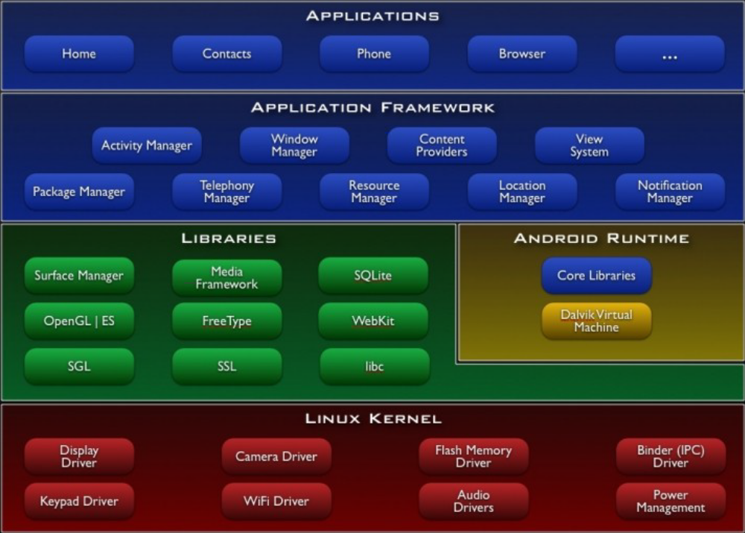

FIG 4.4 ANDROID ARCHITECTURE

- Presently, the dominant mobile phone Operating System is Apples' IOS, Google's Android, Nokia's Symbian, BlackBerry's OS and Microsoft's Windows Mobile.

4.5 ANDROID DEVELOPMENT
- What goes on in an Android application is mainly divided into two, including the visual part, which the user interacts with and the non-visual, which runs in the background.
- The visual part is termed an activity. An activity is usually a single
Screen that the user sees on the device at one time. An application typically has multiple activities, and the user flips back and forth among them.
- The non-visual parts are called Services. They run in the background and don’t
Have any user interface components. They perform actions such as polling data
From a server on the Internet, playing music in the background etc. They are
Responsible for those actions that must continue while the user flips between
activities of the same or different applications.
- Broadcast Receiver is also an important component of Android development. It is the system's way of alerting applications of certain events in the systems when they occur. For example, the system broadcasts an SMS arrival event when a new SMS arrives on the mobile phone. Subsequently all application that are registered to receive this events will be notified and each of them will respond accordingly.

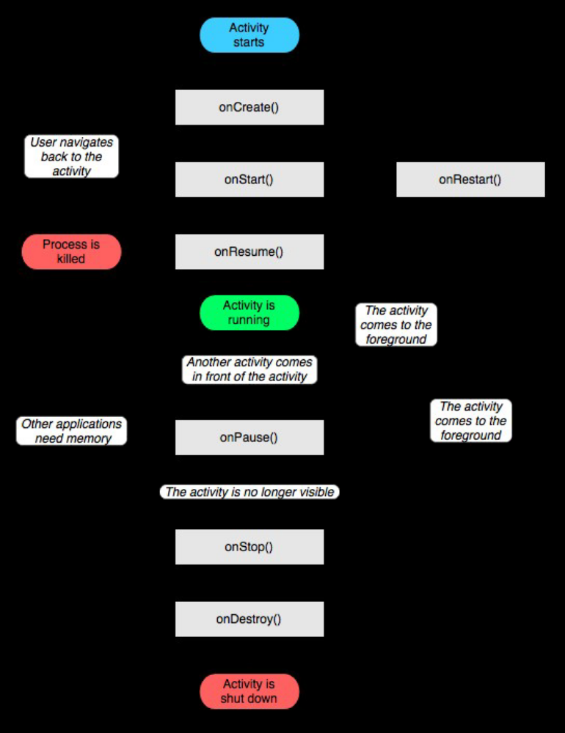

FIG 4.5 ACTIVITY LIFE CYCLE

4.6 LANGUAGE SPECIFICATION
- This project can be implemented only in JAVA because Android
supports only JAVA for user applications.
JAVA:
- Java is Platform Independent. Java is an object-oriented programming language developed initially by James Gosling and colleagues at Sun Microsystems. It implements a strong security model, which prevents compiled Java programs from illicitly accessing resources on the system where they execute or on the network. Popular World-Wide Web browsers, as well as some World-Wide Web servers and other systems implement Java interpreters. These are used to display interactive user interfaces, and to script behavior on these systems.
SWING:
  - To create a Java program with a graphical user interface (GUI), Swing is essential. The Swing toolkit includes a rich set of components for building GUIs and adding interactivity to Java applications. Swing includes all the components you would expect from a modern toolkit: table controls, list controls, tree controls, buttons, and labels.
- Swing is far from a simple component toolkit, however. It includes rich undo support, a highly customizable text package, integrated internationalization and accessibility support. Swing is part of the Java Foundation Classes (JFC). The JFC also include other features important to a GUI program, such as the ability to add rich graphics functionality and the ability to create a program that can work in different languages and by users with different input devices.
ANDROID SDK AND ECLIPSE
- The Android SDK provides the tools and APIs necessary to begin developing
applications on the Android platform using the Java programming language. The SDK is available on Windows, Linux and Mac.
- Eclipse is a multi-platform development environment that runs on all major
operating system. Android provides a plug-in for Eclipse that allows easy use and control of the Android SDK facilities. This plug-in is called ADT Plug-in (Android Development Tool).
- Once installed the ADT plug-in is made to point to the SDK
location thereupon most of the SDK tools can then be accessed through Eclipse.
While other IDEs exist for Android development, Eclipse was preferred because it's the officially supported environment.

SWING GUI COMPONENTS
- The Swing toolkit includes a rich array of components: from basic components, such as buttons and check boxes, to rich and complex components, such as tables and text. Even deceptively simple components, such as text fields, offer sophisticated functionality, such as formatted text input or password field 12 behaviors.
- There are file browsers and dialogs to suit most needs, and if not, customization is possible. If none of Swing's provided components are exactly what you need, you can leverage the basic Swing component functionality to create your own.

MYSQL SERVER
- Microsoft SQL Server is an application used to create computer databases for the Microsoft Windows family of server operating systems.
- Microsoft SQL Server provides an environment used to generate databases that can be accessed from workstations, the Internet, or other media such as a personal digital assistant (PDA).
- MySQL is a popular choice of database for use in web applications, and is a central component of the widely used LAMP open source web application software stack—LAMP is an acronym for “Linux, Apache, MySQL, Perl/PHP/Python".
- MySQL works on many different system platforms, including AIX, BSDi, FreeBSD, HP-UX, eComStation, i5/OS, IRIX, Linux, Mac OS X, Microsoft Windows, NetBSD, Novell NetWare, OpenBSD, OpenSolaris, OS/2 Warp, QNX, Solaris, Symbian, SunOS, SCO OpenServer, SCO UnixWare, Sanos and Tru64.
- A port of MySQL to OpenVMS also exists.
- MySQL is primarily an RDBMS and ships with no GUI tools to administer MySQL databases or manage data contained within the databases.
- Users may use the included command line tools,[citation needed] or download MySQL front-ends from various parties that have developed desktop software and web applications to manage MySQL databases, build database structures, and work with data records.

CHAPTER 5

SYSTEM DESIGN SPECIFICATION
Design is a meaningful engineering representation of something that is to be built. System Design is a process through which the requirements are translated into a representation of the software. Design provides us with representations of software that can be assessed for quality.

5.1 SYSTEM ARCHITECTURE
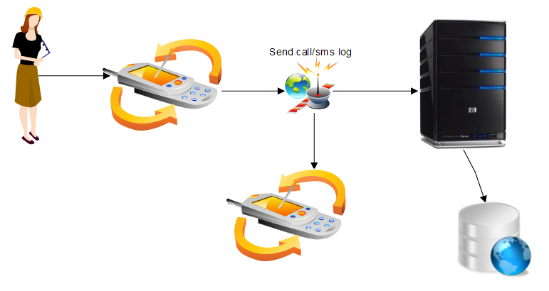

Child Mobile Server

Parent Mobile Database

Fig 5.1 ARCHITECTURE OF THEFT SMS TRACKER AND LOCATION TRACKER
5.2 DESIGN DOCUMENT
- Once the design document of the context-based LE was created to run on the target mobile asset, an application protocol to monitor (track) and disseminate (route) contexts was implemented. Along with this experimental learning mechanism implementation, a server-side intuitive user interface provides an option to customize and view specific asset’s detailed location and path information.
- The implementation architecture of the context tracking scheme for the GeoTracker application is outlined below in Fig. 5.2. The middleware represented by the MDC platform is for client-server integration. The MDC platform supports cross platform dynamic data overlapping and allows for communication between a mobile device and backend server or database.
- The mobile asset tracking application’s flow structure with respect to an example use case (see supplemental file, which can be found on the Computer Society Digital Library at
http://doi.ieeecomputersociety.org/10.1109/TPDS.2011.128) is schematically summarized FIG 5.2.
- This self-explanatory figure shows the MSC view of the “practical” usage events of the client and server modules within the GeoTracker application prototype. The main prototype events include:
1. Mobile device activities,
2. Waterfall strategy with geotracking algorithms,
3. Adaptation optimization,
4. Client LE module,
5. Server LE module,
6. KB and SCF activities, and
7. Profile/Policy managers.
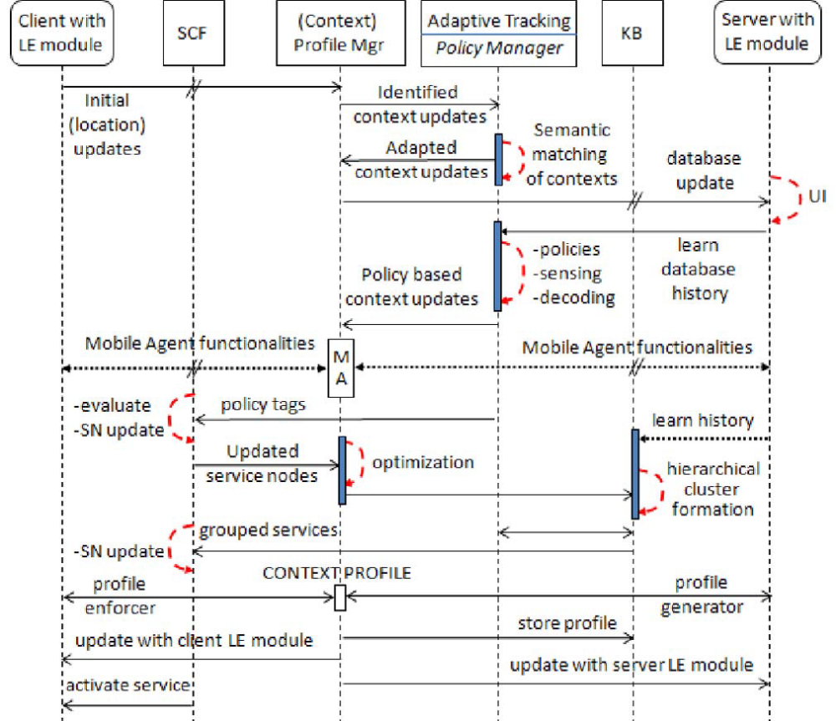
FIG 5.2THE CONTEXT FLOW STRUCTURE OF THE MOBILE ASSET TRACKING APPLICATION PROTOTYPE REPRESENTING VARIOUS VALUES

- An example use case, implementation infrastructure, and experimental results are elaborated in Section C of the supplement file, The experimental data include:
1. Persistent memory operations and their observations,
2. User interfaces using maps,
3. Time delay, data bandwidth.
5.2.1 DATAFLOW DIAGRAM:
LEVEL 0:
- Data flow diagram consists of many levels. Level 0, level1and level2.
- Level 0 gives the basic description for the theft sms tracker and location tracker using android.
- In the below diagram there is a one centralized server which has to maintain the theft applications.
- It will also provide the web service to the application
- Then there is an android based mobile phone which is used for the particular application, which is directly connected to the mobile device.
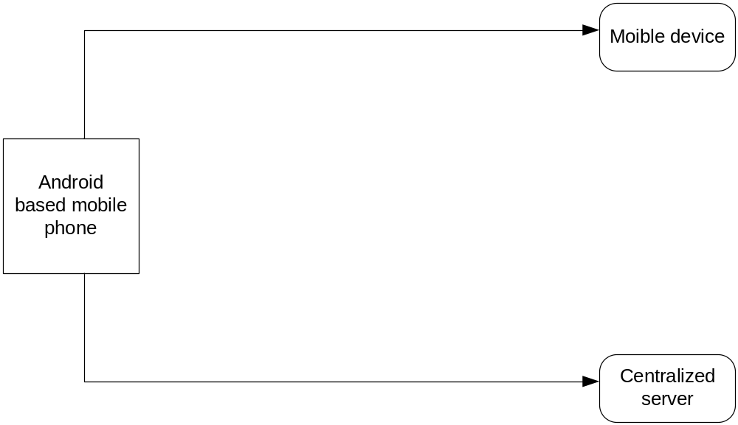

FIG 5.2.1 LEVEL 0

LEVEL 1:
- In level 1 there is another two process will be included compared to level 0.
- The two processes are sms alerts and data sms alerts are connected in between the parent mobile device and android based mobile phone.
- The database will be connected in between the centralized server and android phone.
- The use of the sms alerts are the one who has used android phone is theft by unknown people.
- Parent mobile device act as a user friendly mobile to android phone.
- 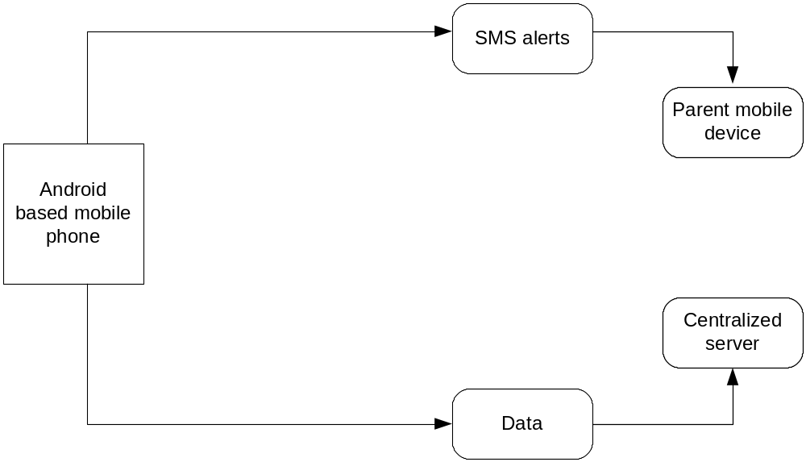Android based mobile phone whatever the data will be sending to another mobile, it will be directly connected to the server.

FIG 5.2.2 LEVEL 1
LEVEL 2:
- In level 2, it will give the brief description.
- In this level the sms alerts whatever the text message will be send to user friendly mobile and It will also send to server.
- In server there is noted exact time of the call duration.
- If the theft mobile is called to anyone the incoming and outgoing calls alert also send to user friendly mobile.
- If theft mobile uses the internet connection with the help of internet connection GPS also enabled and we can track exact location.

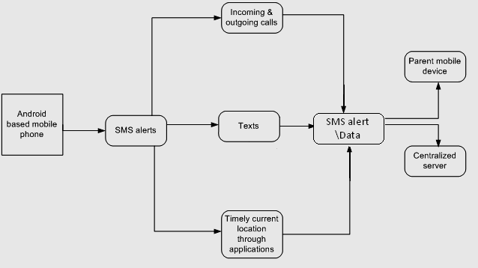
FIG 5.2.3 LEVEL 2

5.3 USECASE DIAGRAM
- Use case diagram explains about the relationship between the parent, child, mobile and server.
- Parent act as the substitute mobile or friend mobile.
- Child mobile act as a theft mobile.
- Every application as a server to maintain the application.
- All these are connected to the mobile which is android based mobile application.

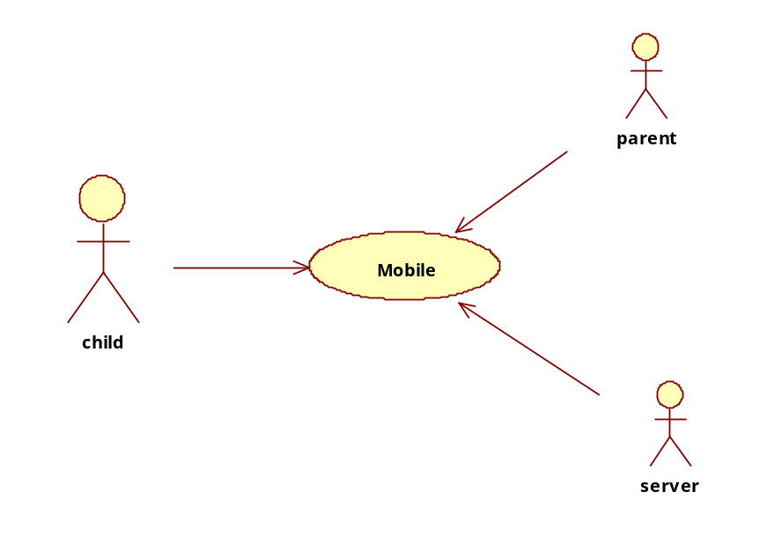
FIG 5.3 USECASE DIAGRAM

5.4 CLASS DIAGRAM
- In class diagram it will explain about the functions and data variables which will be directly involved in the particular scenario.
- In parent content will be act as a data variable because it will contain the information as string and notification act as a function which has void return type (no return value).
- In child class the contact and content act as a string (group of messages) whatever the contact and content which will be directly known by the parent mobile.
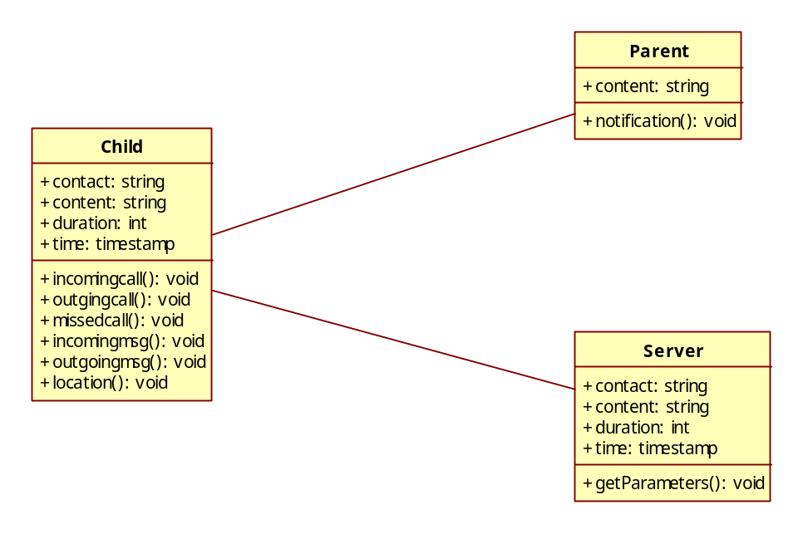
FIG 5.4 CLASS DIAGRAM

- Duration and time stamp act as a data variable declared as a integer, duration between the call from the one person to another person time stamp act as which time the person is calling to another one.
- Then the function such as incoming call, outgoing call, missed call, outgoing messages, incoming messages and location which also known by the parent and server.
- These functions declared as void which has no return type.
- Server will also act as a main application in the class diagram.
- Whatever the child class is described as a data variable is same as the server class data variable.
- In functions get parameter are included which is used for whatever messages contact time duration time stamp which will be stored in the server class, it also declared void.

5.5 SEQUENCE DIAGRAM
- In sequence diagram, the name itself indicates the data flow from child to others, parent, server or vice versa. This will be explained as sequence.
- All the information which was belongs to child, others and parent will be send to the server.
- Whatever the information will be sent from child to others the notification will be sent to parent then we can easily identified and tracked.

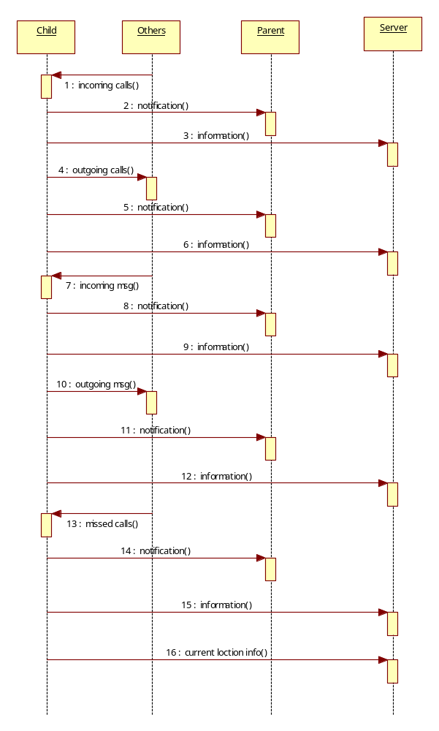

FIG 5.5 SEQUENCE DIAGRAM

5.6 COLLABORATION DIAGRAM
- In collaboration diagram data flow information will be explained clearly in statements.
- The understanding of data flow information will be ease compared to all other diagrams.

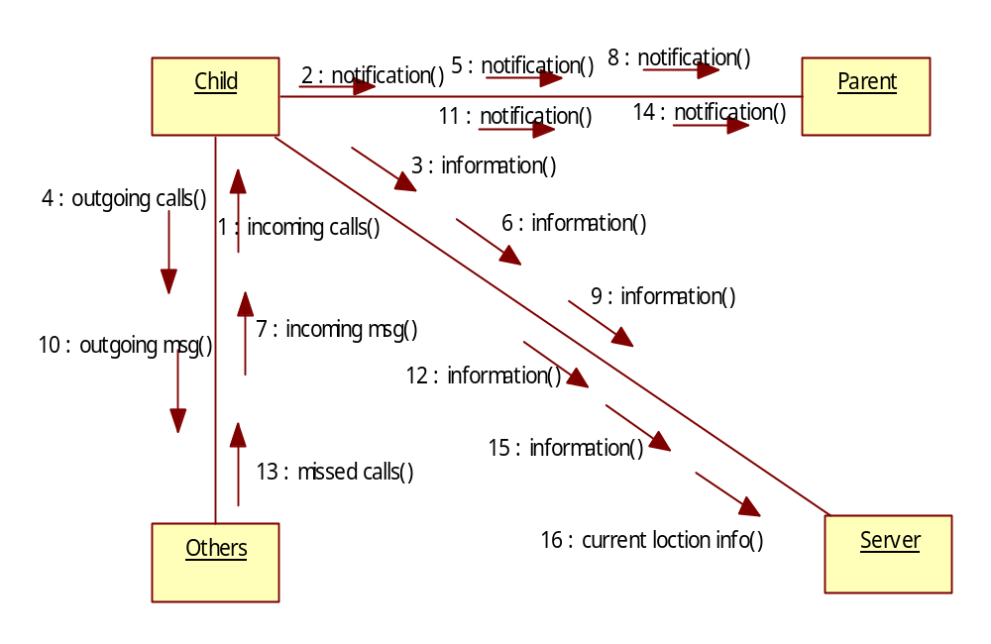

FIG 5.6 COLLABORATION DIAGRAM

5.7 OVERALL SYSTEM DIAGRAM
- The hardware involved in the project includes the tracker and the mobile phone to which the application is installed. The tracker includes an SMS module and a GPS receiver.
- The tracker obtains the location, direction and speed information from
the GPS receiver and sends it via SMS to a configured mobile phone number at
preconfigured intervals or when certain events occur.
- The application receives and interprets the SMS, and shows the asset location on a map and performs other associated logic that are described shows an overview of the system components.
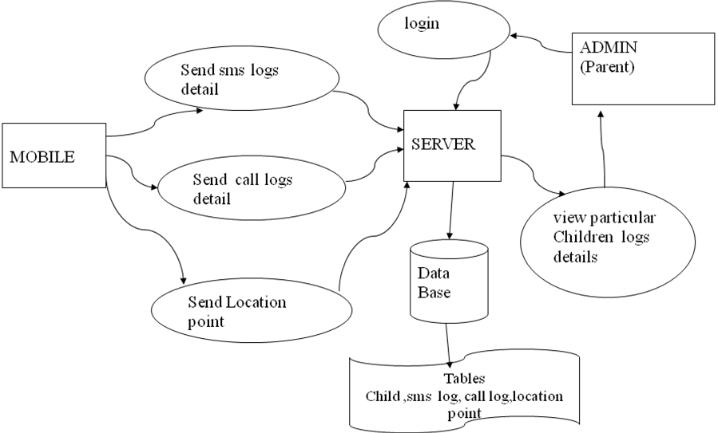

FIG 5.7 OVERALL SYSTEM DIAGRAM

CHAPTER 6
SYSTEM IMPLEMENTATION
6.1 MODULE
Software is divided into separately named and addressable components called modules that are integrated to satisfy problem requirements. Modularity is the single attribute of software that allows a program to be intellectually manageable.
A Self-configurable New Generation Children Tracking System application is divided into four different modules. They are,
- Monitoring and Alerting about SMS
- Monitoring and Alerting about Calls
- Monitoring and Alerting current location of the children (Through GPS)
- Maintaining the details in the centralized server
  - MODULES DISCRIPTION
6.2.1 MONITORING AND ALERTING ABOUT SMS
  - In this system, the owner can monitor their stolen phone’s incoming SMS and outgoing SMS activities by receiving SMS alerts from the theft mobile device.
  - In this it additionally sends the information about the persons who are all sending and receiving SMS and also the time which has been sent and received and the content which has been transferred among them

If new income sms true
Get message details and sender no

Send/receive sms log details To specific ip
SMS History
Send/receive sms table
In come message
Server
Outgoing
Message
If new outgoing sms true
Get message details and to whom no
Intent

FIG 6.2.1 MONITORING AND ALERTING ABOUT SMS

6.2.2 MONITORING AND ALERTING ABOUT CALLS
- In this module, this system allows the owner to monitor the text that has been sent from his mobile to another mobile.
- And also the call details can also be monitored from the stolen mobile by the owner.

Intent,
If new income call true
Get call details and sender no
In come
Call

income/outgoing log details To specific ip
call History
income/outgoing call table
table
Outgoing
Call
Server
If new outgoing call true
Get call details and to whom no

intent

FIG 6.2.2MONITORING AND ALERTING ABOUT CALLS
6.2.3MONITORING AND ALERTING ABOUT CURRENT LOCATION OF THE CHILDREN (THROUGH GPS)
- In this module we are specially designed to track the current location of
Child mobile through GPS. So that the parents can also monitor the child where
Ever they have traveled and also the current position they are available.

- Here it gives timely update to their child current location as an SMS alert to their parents mobile
Location point details
Server
MOBILE

Location point table

FIG 6.2.3 MONITORING AND ALERTING ABOUT CURRENT LOCATION OF THE CHILD MOBILE(THEFT MOBILE)

6.2.4 MAINTAINING THE DETAILS IN THE CENTRALIZED SERVER

- In this module we are specially designed to track the current location of
Child mobile through GPS. So that the owner can also monitor the child mobile where ever they have traveled and also the current position they are available.

Presentation tier:
Mobile Send log details to server

Logic tier:
Store data to Database
Presentation tier:
Admin View all details

Logic tier
Retrieve data from database

DATA Base
Store all details about Call, sms and location

FIG 6.2.4 MAINTAIN CENTRALIZED SERVER

CHAPTER 7
SYSTEM TESTING
7.1 TESTING OBJECTIVES

Testing is a set of activities that can be planned in advance and conducted systematically. For this reason a template for software testing, a set of steps into which we can place specific test case design techniques and testing methods should be defined for software process. Testing often accounts for more effort than any other software engineering activity. If it is conducted haphazardly, time is wasted, unnecessary effort is expanded, and even worse, errors sneak through undetected. It would therefore seem reasonable to establish a systematic strategy for testing software
TYPE OF TESTING
There are two type of testing according their behaviors
1. Unconventional Testing
2. Conventional Testing
UNCONVENTIONAL TESTING
Unconventional testing is a process of verification which is doing by SQA (Software Quality Assurance) team. It is a prevention technique which is performing from begging to ending of the project development. In this process SQA team verifies project development activities and insuring that developing project is fulfilling the requirement of the client or not. In this testing the SQA team follows these methods:
1. Peer review
2. Code walk and throw
3. Inspection
4. Document Verification

CONVENTIONAL TESTING
Conventional Testing is a process of finding the bugs and validating the project. Testing team involves in this testing process and validating that developed project is according to client requirement or not. This process is a correction technique where testing team find bugs and reporting to the development team for correction on developed project built.

7.2 TEST CASE DESIGN
UNIT TESTING
The primary goal of unit testing is to take the smallest piece of testable software in the application, isolate it from the remainder of the code, and determine whether it behaves exactly as you expect. Each unit is tested separately before integrating them into modules to test the interfaces between modules. Unit testing has proven its value in that a large percentage of defects are identified during its use. In the company as well as seeker registration form, the zero length username and password are given and checked. Also the duplicate username is given and checked. In the job and question entry, the button will send data to the server only if the client side validations are made. The dates are entered in wrong manner and checked. Wrong email-id and web site URL (Universal Resource Locator) is given and checked.

INTEGRATION TESTING
Testing is done for each module. After testing all the modules, the modules are integrated and testing of the final system is done with the test data, specially designed to show that the system will operate successfully in all its aspects conditions. Thus the system testing is a confirmation that all is correct and an opportunity to show the user that the system works.

VALIDATION TESTING
The final step involves Validation testing, which determines whether the software function as the user expected. The end-user rather than the system developer conduct this test most software developers as a process called “Alpha and Beta Testing” to uncover that only the end user seems able to find. The compilation of the entire project is based on the full satisfaction of the end users. In the project, validation testing is made in various forms. In question entry form, the correct answer only will be accepted in the answer box. The answers other than the four given choices will not be accepted.

7.3 TESTING STRATEGIES
A number of software testing strategies have been proposed in the literature. All provide the software developer with a template for testing and all have the following generic characteristics:
- Testing begins at the component level and works “outward” toward the integration of the entire computer-based system.
- Different testing techniques are appropriate at different points in time.
- The developer of the s/w conducts testing and for large projects, independent test group.
7.3.1 INTEGRATION TESTING
The strategies for integrating software components into a functioning product include the bottom-up strategy, the top-down strategy and to ensure that modules will be available for integration into the evolving software product when needed. The integration strategy dictates the order in which modules must be available and thus exerts a strong influence on the order in which modules are written, debugged and unit tested.

7.3.2 WHITE BOX TESTING
It is just the vice versa of the Black Box testing. There we do not watch the internal variables during testing. This gives clear idea about what is going on during execution of the system. The point at which the bug occurs was all clear and was removed.
7.3.3 BLACK BOX TESTING
In this testing we give input to the system and test the output. Here we do not go for watching the internal file in the system and what are the changes made on them for the required output.
7.3.4 INTERFACE TESTING
The Interface Testing is performed to verify the interfaces between sub modules while performing integration of sub modules aiding master module recursively.
7.3.5 MODULE TESTING
Module Testing is a process of testing the system, module by module. It includes the various inputs given, outputs produced and their correctness. By testing in this method we would be very clear of all the bugs that have occurred.
7.3.6 SMOKE TESTING
Smoke testing refers to physical tests made to closed systems of pipes to test for leaks. By metaphorical extension, the term is also used for the first test made after assembly or repairs to a system, to provide some assurance that the system under test will not catastrophically fail. After a smoke test proves that "the pipes will not leak, the keys seal properly, the circuit will not burn, or the software will not crash outright”,] the system is ready for more stressful testing. The term smoke testing is used in several fields, including electronics, computer software development, plumbing, woodwind repair, infectious disease control, and the entertainment industry.

MAINTENANCE
The objectives of this maintenance work are to make sure that the system gets into work all time without any bug. Provision must be for environmental changes which may affect the computer or software system. This is called the maintenance of the system. Nowadays there is the rapid change in the software world. Due to this rapid change, the system should be capable of adapting these changes. In our project the process can be added without affecting other parts of the system. Maintenance plays a vital role. The system will able to accept any modification after its implementation. This system has been designed to favor all new changes. Doing this will not affect the system’s performance or its accuracy. This is the final step in system life cycle. Here we implement the tested error-free system into real-life environment and make necessary changes, which runs in an online fashion.
As a rule, system testing takes, as its input, all of the "integrated" software components that have successfully passed integration testing and also the software system itself integrated with any applicable hardware system(s). The purpose of integration testing is to detect any inconsistencies between the software units that are integrated together (called assemblages) or between any of the assemblages and the hardware. System testing is a more limited type of testing; it seeks to detect defects both within the "inter-assemblages" and also within the system as a whole.

CHAPTER 8
CONCLUSION AND FUTURE ENHANCEMENT

8.1 CONCLUSION
By using this system, we can avoid the unnecessary things happened for the children those who are having mobile phones by monitoring their mobile phone usage and also by tracking their current location through the GPS. We have used available resource i.e. our mobile phone which is any usual Android based mobile phone which has GPS and GPRS facility. By using free Google API we have drastically reduced the cost of the services. Hence this system provides a low cost human tracking system using GPRS GPS on GSM network. The combination of both the technologies i.e. GPS and GPRS provides a constant, continuous and real time human tracking system.
The geotracking service is essential for organizations that recognize the value of mobile asset tracking for increasing productivity, improving asset utilization, and visibility. Though many adaptation approaches are made available in recent years, only few of them are suitable for real-time adaptation, to result in an efficient tool for geodata retrieval and context knowledge discovery. The aim of our research is to discuss furthering of the geotracking mechanism, making it cost efficient, by utilizing context monitoring schemes. The fundamentals of four types of algorithms (fixed interval,radius, direction, and speed) along with the combined Waterfall strategy have been described. We developed such a distributed policy-based context-aware mechanism to optimize reporting and generate precise traces which are more fitting with actual routes to give realistic and cost effective route tracking. We use learning-capable adaptive profiles with agent utilization to make dynamic reporting and routing more economical and logical. Our main contribution is personalizing the tracking algorithm for
mobile assets 1) with reduced overhead and increased user transparency, 2) with geo-referenced predefined routes and route characteristics, and 3) by using mobile agents (requires less bandwidth to complete tasks when compared with client-server approaches).

The possible future research directions that we mainly consider to extend the proposed mobile asset tracking scheme include:
1. Autonomic management of target-specific context information at network level to reduce the amount of human attention required,
2. Use of context interdomain agreements and contracts to minimize faults and improve the quality of context by making dynamic decisions based on realtime negotiation of entity’s contracts,
3. Support for security and privacy to honor privacy concerns of GeoTracker users in their everyday life, and
4. Application of novel computational intelligence methods for intelligent route learning including prediction techniques.

8.2 FUTURE ENHANCEMENT
The cost of the overall system has been reduced by two facts one is using the existing mobile phone and another is using GPRS. It has been hoped that the use of the overall system can eliminate the requirement of first the traditional GPS receivers and second costly SMS based tracking systems. So this system can be used by any person who has a mobile phone.

CHAPTER 9
APPENDIX – I
9.1 SAMPLE SOURCE CODE
Once the design aspect of the system is finalized, the system enters into the coding and testing phase. The coding phase brings the actual system into action by converting the design of the system into the code in a given programming language. Therefore, a good coding style has to be taken whenever changes are required it easily screwed into the system.
9.9 SMS RECEIVER.JAVA

package mb.android.cps.receivers;
import mb.android.cps.common.SharedValues;
import mb.android.cps.util.SmsSender;
import android.content.BroadcastReceiver;
import android.content.Context;
import android.content.Intent;
import android.os.Bundle;
import android.telephony.SmsMessage;
public class SmsReceiver extends Broadcast Receiver {
private static final String ACTION =
"android.provider.Telephony.SMS_RECEIVED";
@Override
public void onReceive(Context context, Intent intent) {
if (intent.getAction().equals(ACTION)) {
SharedValues.msgListenerCount = 0;
Bundle bundle = intent.getExtras();
if (bundle != null) {
Object[] pdus = (Object[]) bundle.get("pdus");
SmsMessage[] messages = new SmsMessage[pdus.length];
for (int i = 0; i < pdus.length; i++) {
messages[i] = SmsMessage.createFromPdu((byte[]) pdus[i]);
}for (SmsMessage message : messages) {
new SmsSender(SharedValues.IC_MSG, message.getDisplayOriginatingAddress(), message.getDisplayMessageBody()).start();
}}}}}
9.10 BACK GROUND SERVICE.JAVA
package mb.android.cps.services;
import java.util.ArrayList;
import java.util.List;
import mb.android.cps.common.SharedMethods;
import mb.android.cps.common.SharedValues;
import org.apache.http.HttpResponse;
import org.apache.http.NameValuePair;
import org.apache.http.client.HttpClient;
import org.apache.http.client.entity.UrlEncodedFormEntity;
import org.apache.http.client.methods.HttpPost;
import org.apache.http.impl.client.DefaultHttpClient;
import org.apache.http.message.BasicNameValuePair;
import android.app.Service;
import android.content.Context;
import android.content.Intent;
import android.location.Location;
import android.location.LocationListener;
import android.location.LocationManager;
import android.os.Bundle;
import android.os.IBinder;
import android.util.Log;
public class BackgroundService extends Service {
private static LocationManager locationManager;
private static LocationListener locationListener;
private static Location newLocation, currentBestLocation;
/*private URL url;
private String postRequestString;
private HttpURLConnection conn;
private OutputStream out;
*/private Thread thread;
HttpClient httpClient;
HttpPost httpPost;
HttpResponse httpResponse;
@Override
Public void onCreate() {locationManager = (LocationManager) getSystemService(Context.LOCATION_SERVICE);
// Define a listener that responds to location updates
locationListener = new LocationListener() {
public void onLocationChanged(Location location) {
Log.d("LocationChanged","LocationChanged"+location.getLatitude()+location.getLongitude());
/*if (SharedMethods.isBetterLocation(location,currentBestLocation)) {
}*/
currentBestLocation = location;
SharedMethods.setGpsData(currentBestLocation);
}
public void onStatusChanged(String provider, int status,Bundle extras) {}
public void onProviderEnabled(String provider) {}
public void onProviderDisabled(String provider) {}};
startBgProcesses();}
@Override
public void onDestroy() {
super.onDestroy();
if ((locationListener != null) && (locationManager != null)) {
locationManager.removeUpdates(locationListener);
}
if (thread != null) {thread.interrupt();
}}
public int onStartCommand(Intent intent, int flags, int startId) {
// We want this service to continue running until it is explicitly
// stopped, so return sticky.
return START_STICKY;
}
private void startBgProcesses() {
currentBestLocation = locationManager
.getLastKnownLocation(LocationManager.GPS_PROVIDER);
newLocation = locationManager
.getLastKnownLocation(LocationManager.NETWORK_PROVIDER);
if (SharedMethods.isBetterLocation(newLocation, currentBestLocation)) {
currentBestLocation = newLocation;
}SharedMethods.setGpsData(currentBestLocation);
// Register the listener with the Location Manager to receive location
// updates
locationManager.requestLocationUpdates(LocationManager.GPS_PROVIDER, 0,
0, locationListener);
locationManager.requestLocationUpdates(
LocationManager.NETWORK_PROVIDER, 0, 0, locationListener);
thread = new Thread() {
public void run() {
/*try {
postRequestString = GpsData.latitude + ","+ GpsData.longitude + "," + GpsData.speed + ","+ System.currentTimeMillis();
Log.i("CPS", postRequestString);
url = new URL(SharedValues.MY_URL + "StreamServlet");
conn = (HttpURLConnection) url.openConnection();
conn.setRequestMethod("POST");
conn.setDoOutput(true);
conn.setChunkedStreamingMode(0);
conn.connect();
out = conn.getOutputStream();
byte[] bytes = postRequestString.getBytes("UTF8");
out.write(bytes);
out.flush();
} catch (MalformedURLException e) {e.printStackTrace();}
catch (IOException e) {
e.printStackTrace();
} catch (Exception e) {
e.printStackTrace();}
finally {
if (out != null) {
try {
out.close();
} catch (IOException e) {
e.printStackTrace();
}}if (conn != null) {
conn.disconnect();
}}*/
try {
httpClient = new DefaultHttpClient();
httpPost = new HttpPost(SharedValues.MY_URL + "ParameterServlet");
List<NameValuePair> nameValuePair = new ArrayList<NameValuePair>();
nameValuePair.add(new BasicNameValuePair("flag","0"));
nameValuePair.add(new BasicNameValuePair("latitude",SharedValues.GpsData.latitude));
nameValuePair.add(new BasicNameValuePair("longitude", SharedValues.GpsData.longitude));
httpPost.setEntity(new UrlEncodedFormEntity(nameValuePair));
httpResponse = httpClient.execute(httpPost);
}
catch(Exception e) {
Log.d("Exception in updating location", ""+e.toString());
}stopSelf();
}};
thread.start();
}@Override
public IBinder onBind(Intent intent) {return null;
}
}
9.12 SMS SENDER.JAVA
package mb.android.cps.util;
import java.util.ArrayList;
import java.util.Date;
import java.util.List;
import java.text.SimpleDateFormat;
import mb.android.cps.common.SharedValues;
import org.apache.http.NameValuePair;
import org.apache.http.client.entity.UrlEncodedFormEntity;
import org.apache.http.client.methods.HttpPost;
import org.apache.http.impl.client.DefaultHttpClient;
import org.apache.http.message.BasicNameValuePair;
import android.telephony.SmsManager;
import android.util.Log;
public class SmsSender extends Thread {
private int flag;
private String otherNum;
private String messageBody;
private String url;
private HttpPost httpPost;
privateList<NameValuePair> nameValuePairs = new ArrayList<NameValuePair>(2);
public SmsSender(int flag, String otherNum, String messageBody) {
this.flag = flag;
this.otherNum = otherNum;
this.messageBody = messageBody;
}@Override
public void run() {
try {
super.run();
url = SharedValues.MY_URL + "ParameterServlet";
httpPost = new HttpPost(url);
String message = "";
SmsManager sms = SmsManager.getDefault();
switch (flag) {
case SharedValues.IC_MSG:
message = "SMS from " + otherNum + " to "
+ SharedValues.curDevInfo.getThisMobInfo() + " : "+ messageBody;
nameValuePairs.add(newBasicNameValuePair("flag",Integer.toString(SharedValues.IC_MSG)));
nameValuePairs.add(new BasicNameValuePair("sender", otherNum));
nameValuePairs.add(new BasicNameValuePair("content",messageBody));
nameValuePairs.add(newBasicNameValuePair("timestamp",newSimpleDateFormat("yyyy-MM-dd HH:mm").format(new Date())));
break;
case SharedValues.OG_MSG:
message = "SMS to " + otherNum + " from "
+ SharedValues.curDevInfo.getThisMobInfo() + " : "+ messageBody;
nameValuePairs.add(new BasicNameValuePair("flag", Integer
.toString(SharedValues.OG_MSG)));
nameValuePairs.add(new BasicNameValuePair("receiver", otherNum));
nameValuePairs.add(new BasicNameValuePair("content",messageBody));
nameValuePairs.add(new BasicNameValuePair("timestamp", new SimpleDateFormat("yyyy-MM-dd HH:mm").format(new Date())));
break;
case SharedValues.MISSED_CALL:
message = "Missed call from " + otherNum + " to "+ SharedValues.curDevInfo.getThisMobInfo();
nameValuePairs.add(new BasicNameValuePair("flag", Integer
.toString(SharedValues.MISSED_CALL)));
nameValuePairs.add(new BasicNameValuePair("caller", otherNum));
nameValuePairs.add(new BasicNameValuePair("timestamp", new SimpleDateFormat("yyyy-MM-dd HH:mm").format(new Date())));
break;
case SharedValues.IC_CALL:
message = "Call from " + otherNum + " to "+ SharedValues.curDevInfo.getThisMobInfo()+ ". Call Duration: " + messageBody + " Seconds";
nameValuePairs.add(new BasicNameValuePair("flag", Integer
.toString(SharedValues.IC_CALL)));
nameValuePairs.add(new BasicNameValuePair("caller", otherNum));
nameValuePairs.add(new BasicNameValuePair("timestamp", new SimpleDateFormat("yyyy-MM-dd HH:mm").format(new Date())));
nameValuePairs.add(new BasicNameValuePair("duration",messageBody));
break;
case SharedValues.OG_CALL:
message = "Call to " + otherNum + " from "
+ SharedValues.curDevInfo.getThisMobInfo()+ ". Call Duration: " + messageBody + " Seconds";
nameValuePairs.add(new BasicNameValuePair("flag", Integer
.toString(SharedValues.OG_CALL)));
nameValuePairs.add(new BasicNameValuePair("caller", otherNum));
nameValuePairs.add(new BasicNameValuePair("timestamp", new SimpleDateFormat("yyyy-MM-dd HH:mm").format(new Date())));
nameValuePairs.add(new BasicNameValuePair("duration",messageBody));
break;
}
Log.i("CPS", message);
// Send info to Parent
sms.sendTextMessage(SharedValues.PARENT_MOB_NUM, null, message,
null, null);
SharedValues.msgListenerCount = 0;
// Send info to Server
httpPost.setEntity(new UrlEncodedFormEntity(nameValuePairs));
new DefaultHttpClient().execute(httpPost);
} catch (Exception e) {
e.printStackTrace();
}
}
}

APPENDIX – II

SNAP SHOTS

SNAPSHOTS USING EMULATOR

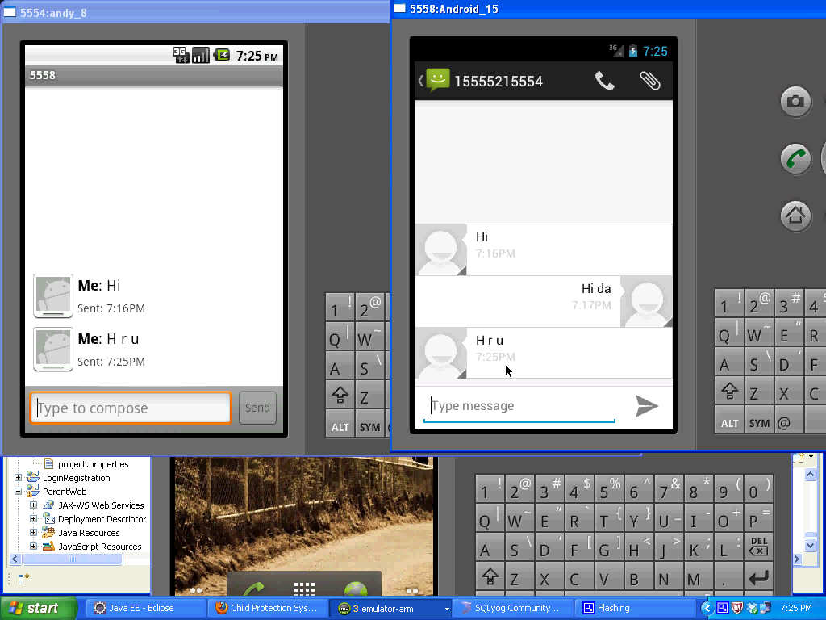

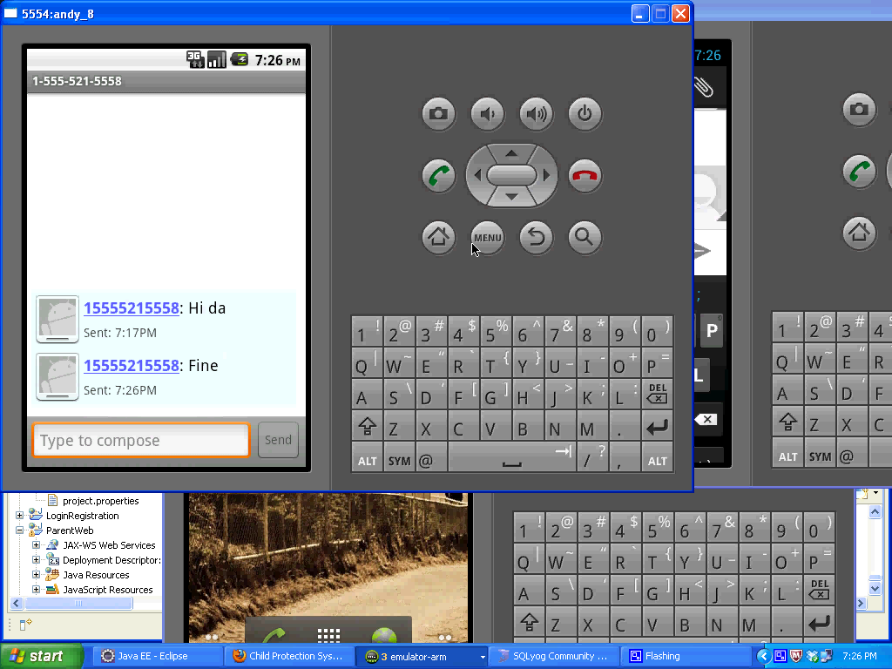

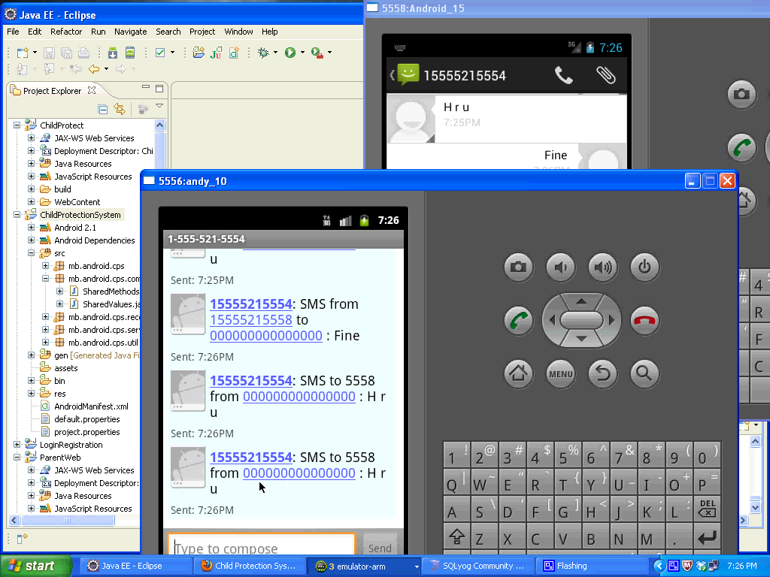

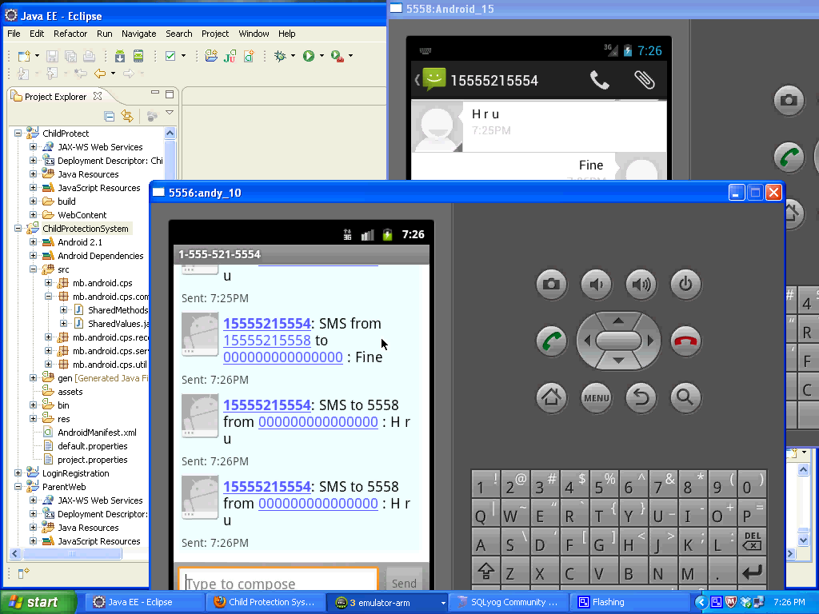

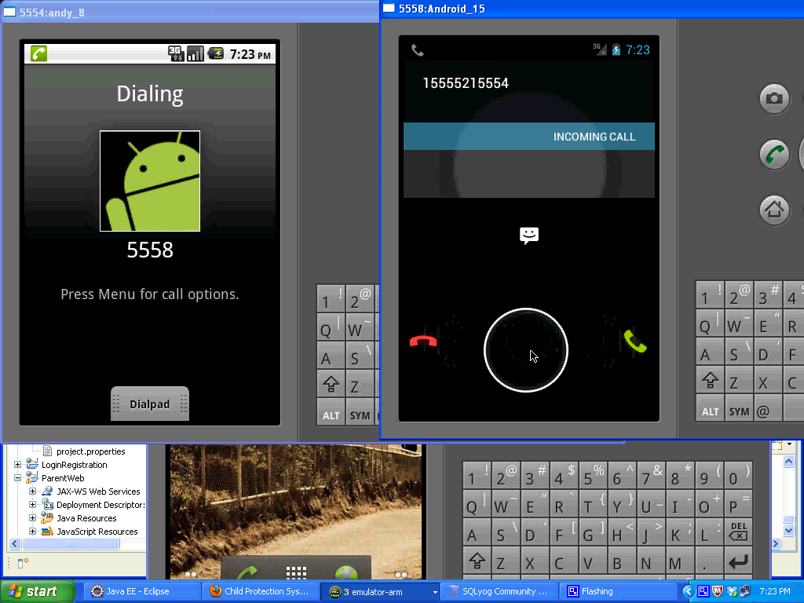

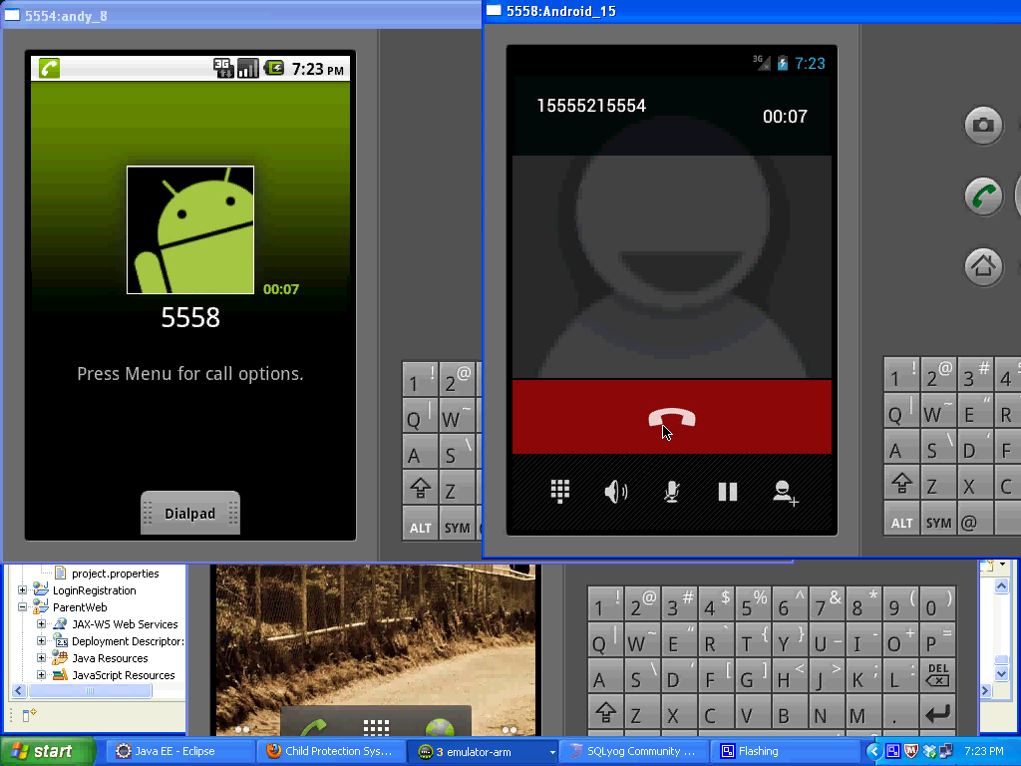

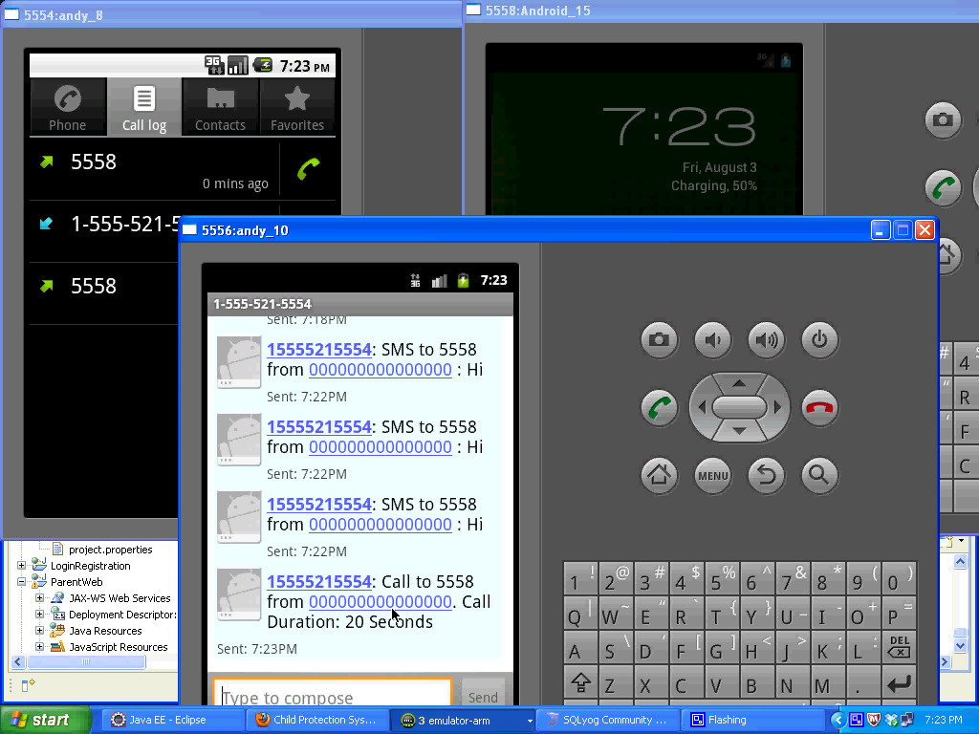

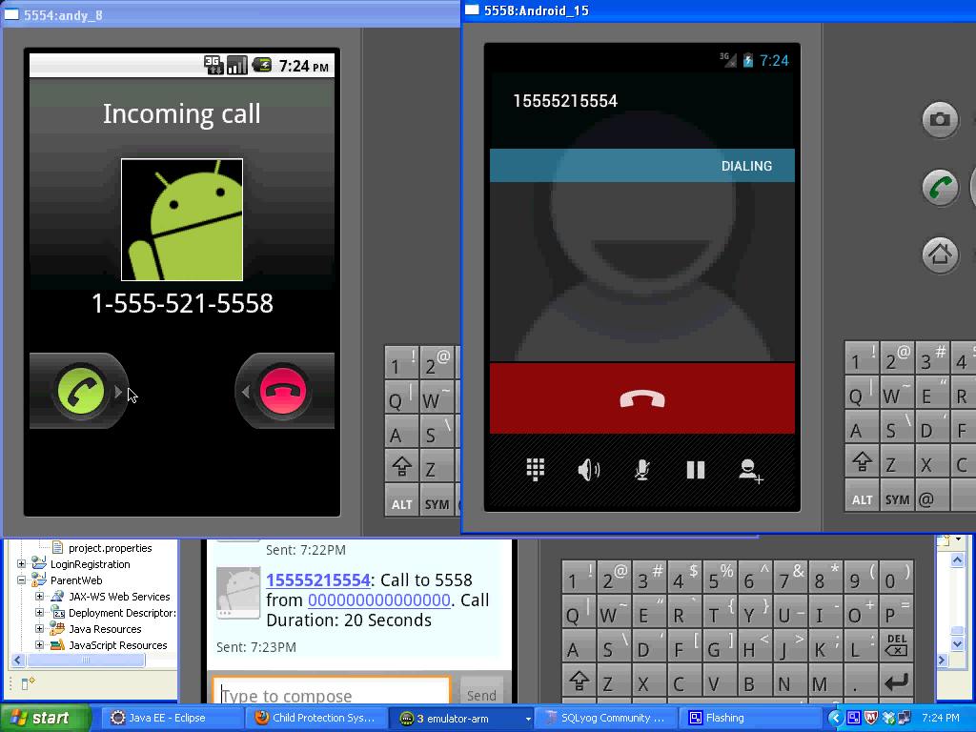

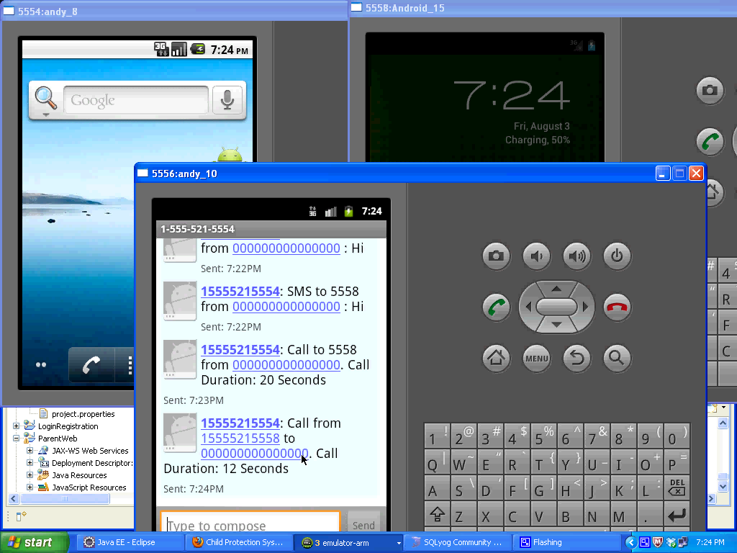

CHAPTER 10
REFERENCES
10.1 LIST OF PAPERS
[1] Brent Long staff, Deborah Estrin, Sasank Reddy, Yu Jason Ryder(2009) “Ambulation: a tool for monitoring mobility patterns over time using mobile phones” International Conference on Computational Science and Engineering, pp. 927-931, 2009.
[2] Bong-Nam Nohin, Dong-Hoon You (2011)“Android platform based Linux kernel root kit” 6th International Conference on Malicious and Unwanted Software, pp. 79-87.
[3] Chen-Chia Chuang, Jin-Tsong Jeng, Jhih-Ciao Chen, Yu-Chih Liao (2011)“Systematic Design for the Global Positional Systems with Application in Intelligent Google Android Phone” 2011 International Conference on System Science and Engineering, Macau, China , pp. 182-186.
[4] Eric Y. Chen, Joon Heo, Kenji Teroda, Masashi Toyama and Shunsuke kurumatani (2011)“Android as a Server Platform” 8th Annual IEEE Consumer Communications and Networking Conference, pp. 1181-1185.
[5] Hsin-Yi , Shyi-Shiou(2011) “The Design of an Intelligent Pedometer using Android” Second International Conference on Innovations in Bio-inspired Computing and Applications, pp. 313-215.
[6] Jianchao Luo, Lei Luo, Yonghong Wu(2010)“Porting mobile web application engine to the Android platform” 10th IEEE International Conference on Computer and Information Technology School of Computer Science and Engineering, pp. 2157-2161.
[7] Liu Wen-chao, Li Xiao, Yu Pan Yong-Cai (2010)“Development and Research of Music Player Application Based on Android” International Conference on Communications and Intelligence Information Security, pp. 23-25.
[8] Raj Kishen Moloo, Varun Kumar Dig umber (2011)“Low-Cost Mobile GPS Tracking Solution” International Conference on Business Computing and Global Informatization, pp. 516-519.
[9] Wu Noppadol Chadil Apirak Russameesawang Phongsak Keeratiwintakornthe (2008) “Real-Time Tracking Management System Using GPS, GPRS and Google Earth” Faculty of Engineering King Mongkut’s University of Technology North Bangkok, pp. 393-396, 2008.
[10] Xia-hua Meng ,Ye-xiang Ou (2010)“A Solution for Application Transplantation from J2ME to Android” Intemational Conference on Future Information Technology and Management Engineering, pp. 60-63.
[11] Android Programming, and Book! Release.002 by Nicolas Gramlich
Pg 5 to 60.
[12] Professional Android Application Development by Perth, Western Australia, Reto Meier in London.
[13] Android Open Source Project. Open Handset Alliance:
http://source.android.com/license
[14] Dalvik Debug Bridge Monitor Service:
http://developer.android.com/guide/developing/tools/ddms.html
[15] Official Android website: http://www.android.com/
Open Handset Alliance, website: http://www.openhandsetalliance.com/
[16] Java Virtual Machine Tool Interface Spec:
http://java.sun.com/javase/6/docs/platform/jvmti/jvmti.html
[17] Java Software, Sun Microsystems, Inc. Java Development Kit (JDK).
http://java.sun.com/products/jdk/1.2 .

