LOW CODE
EXERCISE-1

NAME:ABIRAMI S ROLL NO:240701011

Aim:
To study and compare traditional application development and low-code application development approaches based on their development process, time, technical skills, flexibility, cost, maintenance, and scalability.
Introduction to Traditional Application Development:
Traditional application development is a conventional software development approach in which applications are built by writing code manually using programming languages and development frameworks.
In this approach, developers are responsible for designing the user interface, writing business logic, developing the backend, creating databases, testing the application, and deploying it.
Common technologies used include:
- HTML, CSS, JavaScript
- Java, Python, C#, PHP
- React, Angular, Node.js
- MySQL, PostgreSQL, MongoDB
Traditional development provides complete control over the application and is suitable for complex and highly customized applications. However, it generally requires more time, technical knowledge, and development effort.
Introduction to Low-Code Development:
Low-code development is a modern application development approach that allows applications to be created using visual development tools, drag-and-drop components, pre-built templates, and minimal manual coding.
Low-code platforms provide ready-made components for:
- User interface design
- Database management
- Workflow automation
- Application logic
Examples of low-code platforms include:
- Zoho Creator
- Microsoft Power Apps
Diagram for Stages in Traditional Application Development:
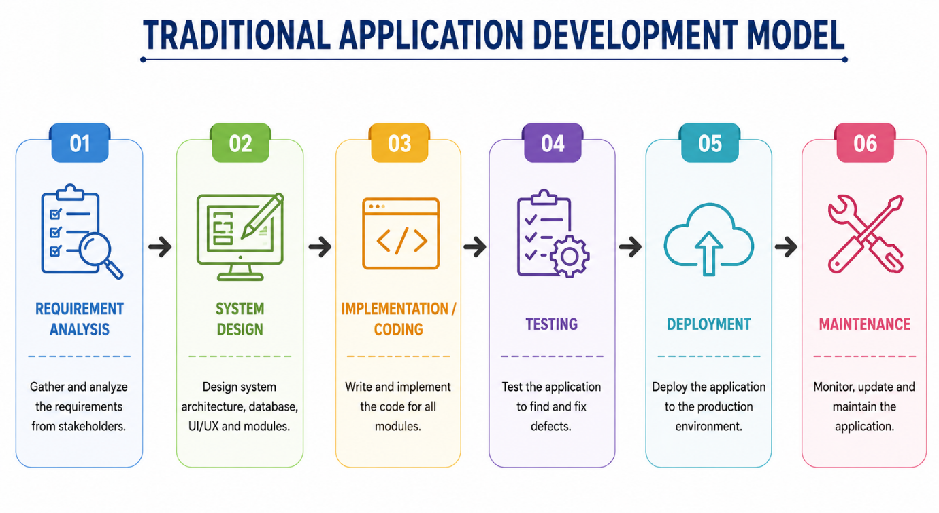

Diagram for Steps in Low-Code Development:
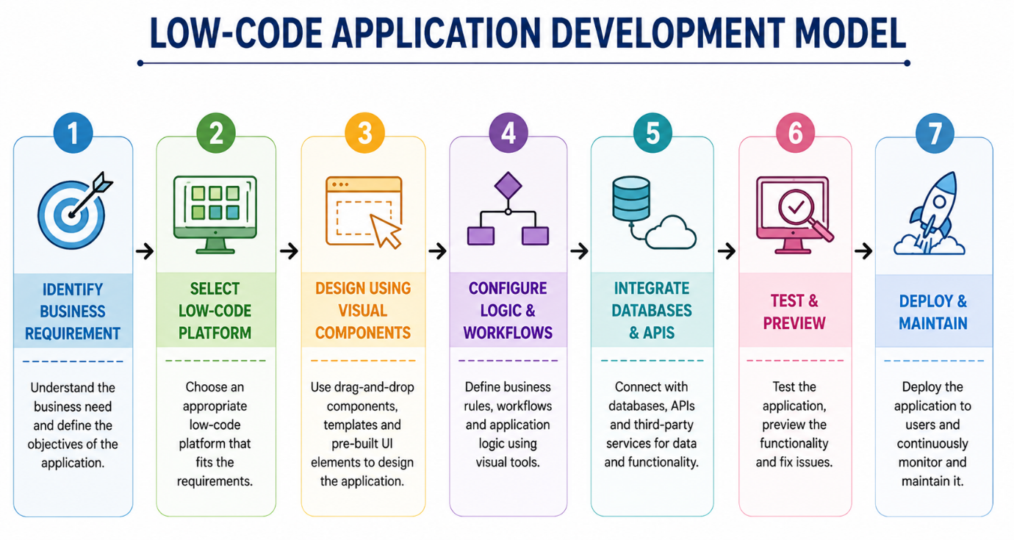

Comparative Analysis:
Criteria | Traditional Application Development | Low-Code Application Development
Development Method | Manual coding | Visual development and configuration
Coding Requirement | High | Low or minimal
Development Speed | Generally slower | Faster
Technical Skill | Requires highly skilled developers | Requires less coding expertise
Customization | Highly customizable | Customization depends on the platform
Cost | Higher development cost | Generally lower development cost
Development Process | Complex and time-consuming | Simplified and faster
Maintenance | Requires manual updates and maintenance | Platform provides several built-in features
Scalability | Highly scalable with proper architecture | Depends on the capabilities of the platform
Best Suitable For | Complex and highly customized applications | Business applications and rapid development

Result:
The comparative study of traditional application development and low-code development was successfully carried out. Traditional development offers greater flexibility, customization, and control but requires more time and technical expertise. Low-code development simplifies the development process through visual tools and pre-built components, reducing development time and coding effort.
Therefore, low-code development is suitable for rapid application development and business applications, while traditional development is more suitable for complex applications requiring extensive.

