LOW CODE
EXPERIMENT-2

NAME:ABIRAMI S ROLL NO:240701011

Aim:
To create a sample application in Zoho Creator, create a form, report, and dashboard, and explore the Develop, Deploy, and Manage sections of the Zoho Creator platform.
Setting up Zoho Creator:
I. Create the Sample Application
Procedure:
- Logged in to Zoho Creator.
- Clicked Create New Application.
- Selected From Scratch.
- Entered the application name as Sample Application.
- Clicked Create.

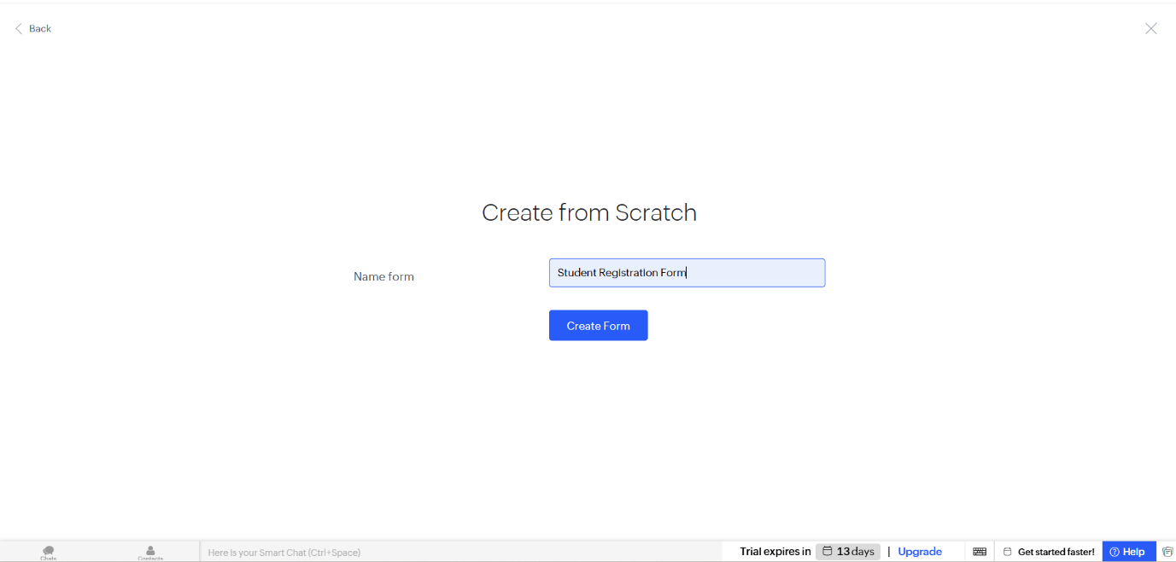

II. Creating Form
Procedure:
- Clicked Create → Form.
- Entered the form name as Student Details.
- Added the required fields such as Name, Roll Number, Department, Email, and Phone Number.
- Saved the form.
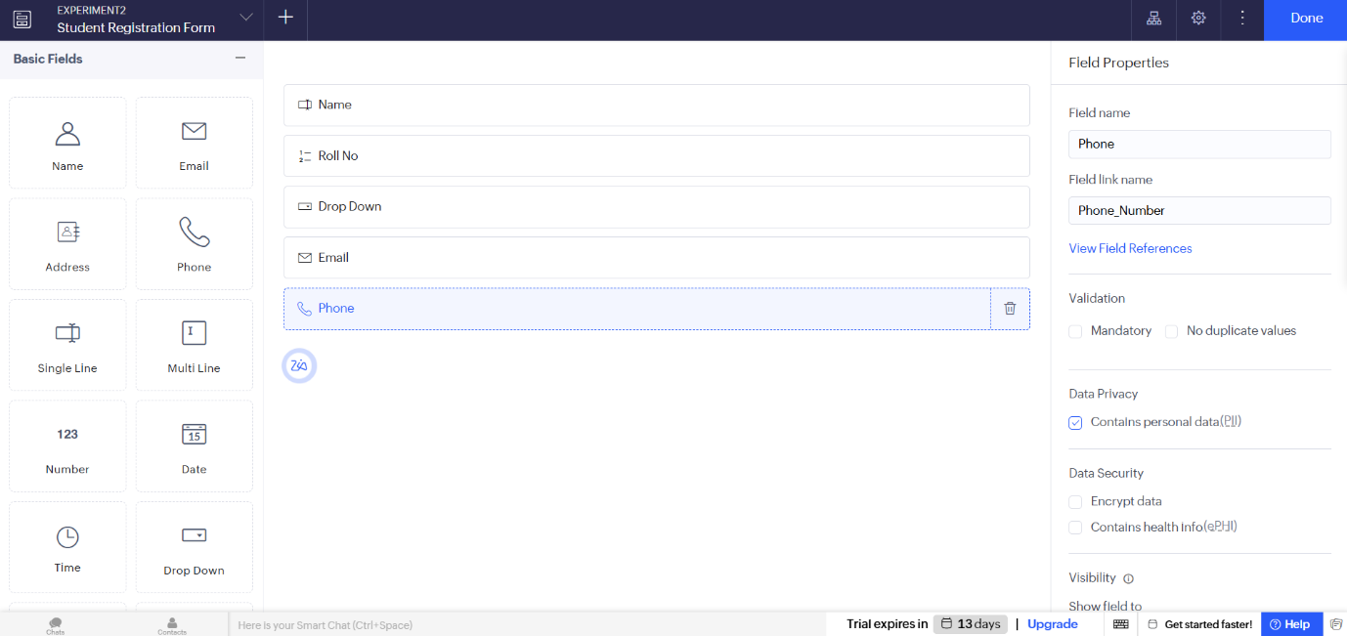

Explanation:
A form is used to collect information from users. It contains various input fields where users can enter data. The submitted data is stored in the application's database.
III. Creating Report
Procedure:
- Clicked Create → Report.
- Selected the Student Details form.
- Created the report and saved it.

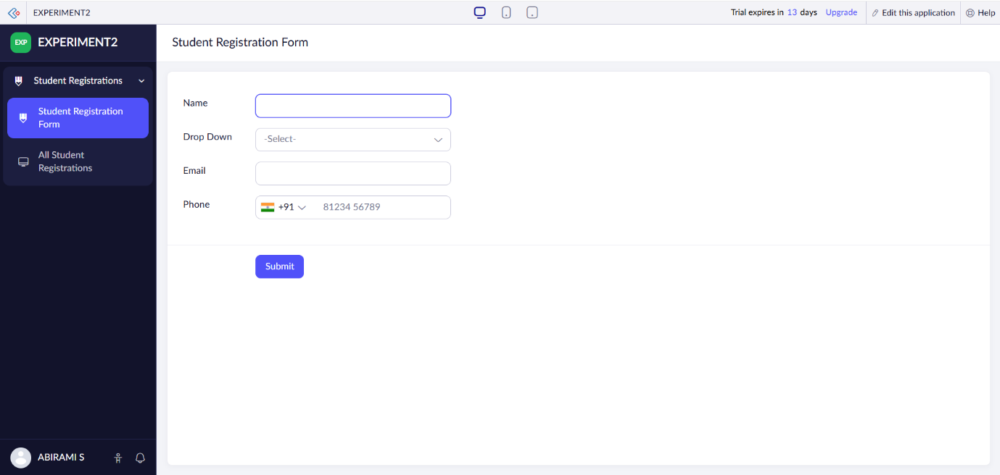

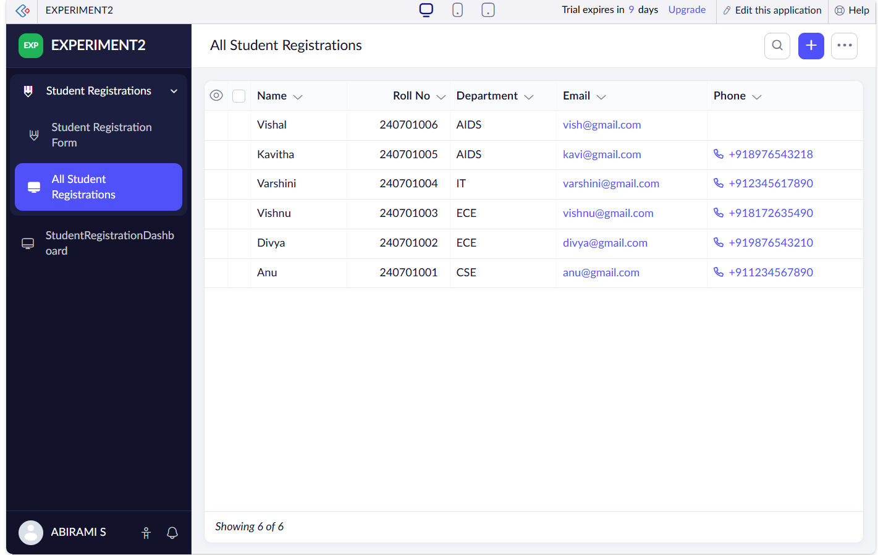

Explanation:
A report displays all the records entered through the form. It helps users search, sort, filter, and manage the stored data efficiently.
IV. Creating Dashboard
Procedure:
- Clicked Create → Dashboard.
- Added report/chart components.
- Saved the dashboard.
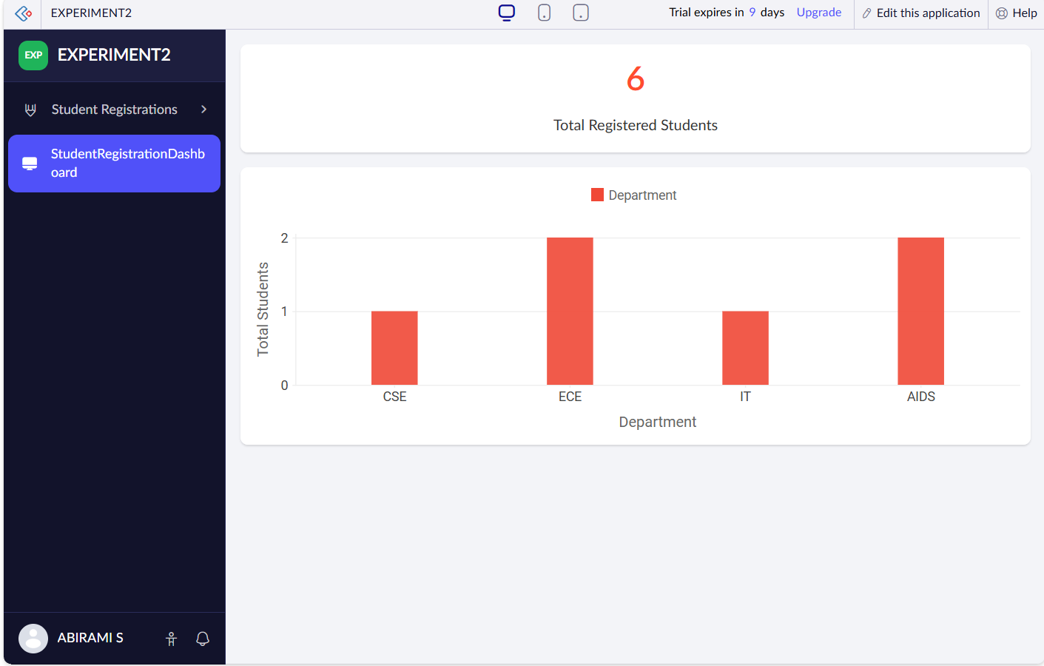

Explanation:
A dashboard provides a graphical overview of application data. It combines reports and charts in a single page, making it easier to analyze information quickly.
Exploring the Platform Architecture and Interface
Develop
- The Develop section is used to build applications.
- It allows users to create forms, reports, pages, and workflows.
- It also supports application customization using Deluge scripting.
Deploy
- The Deploy section is used to publish applications.
- It allows sharing applications with users securely.
- User roles and permissions can also be configured here.
Manage
- The Manage section is used to administer the application.
- It helps manage users, backups, and integrations.
- It also monitors application performance and security.
4. Result
Thus, a Zoho Creator account was created successfully. A sample application with a form, report, and dashboard was developed, and the Develop, Deploy, and Manage sections of the Zoho Creator platform were explored successfully.

