**TASK – 6 SCREENSHOTS**

**Q1 Output Screenshot :**

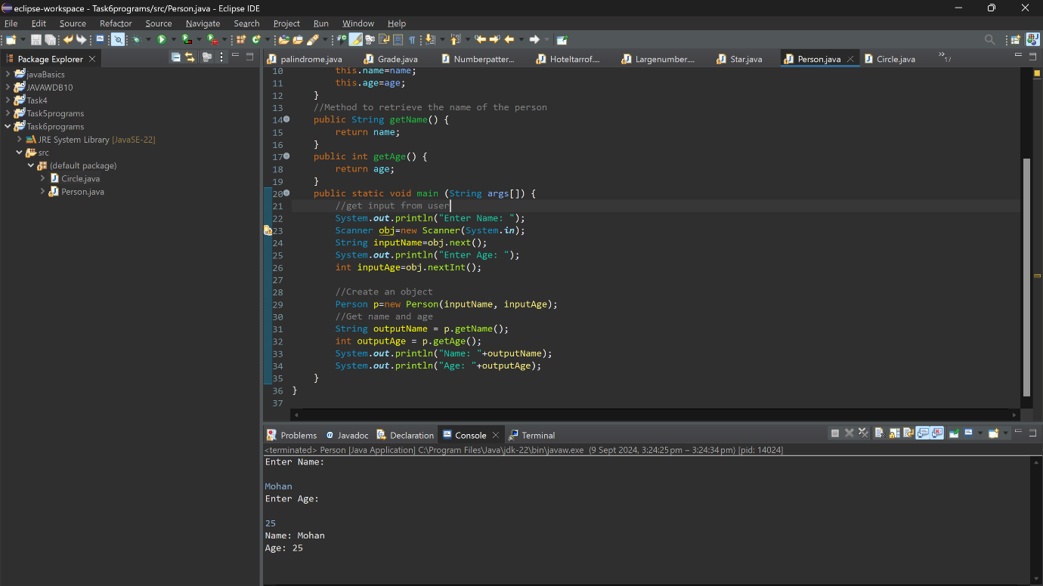

**Q2 Output Screenshot :**

**Q3 Output Screenshot :**

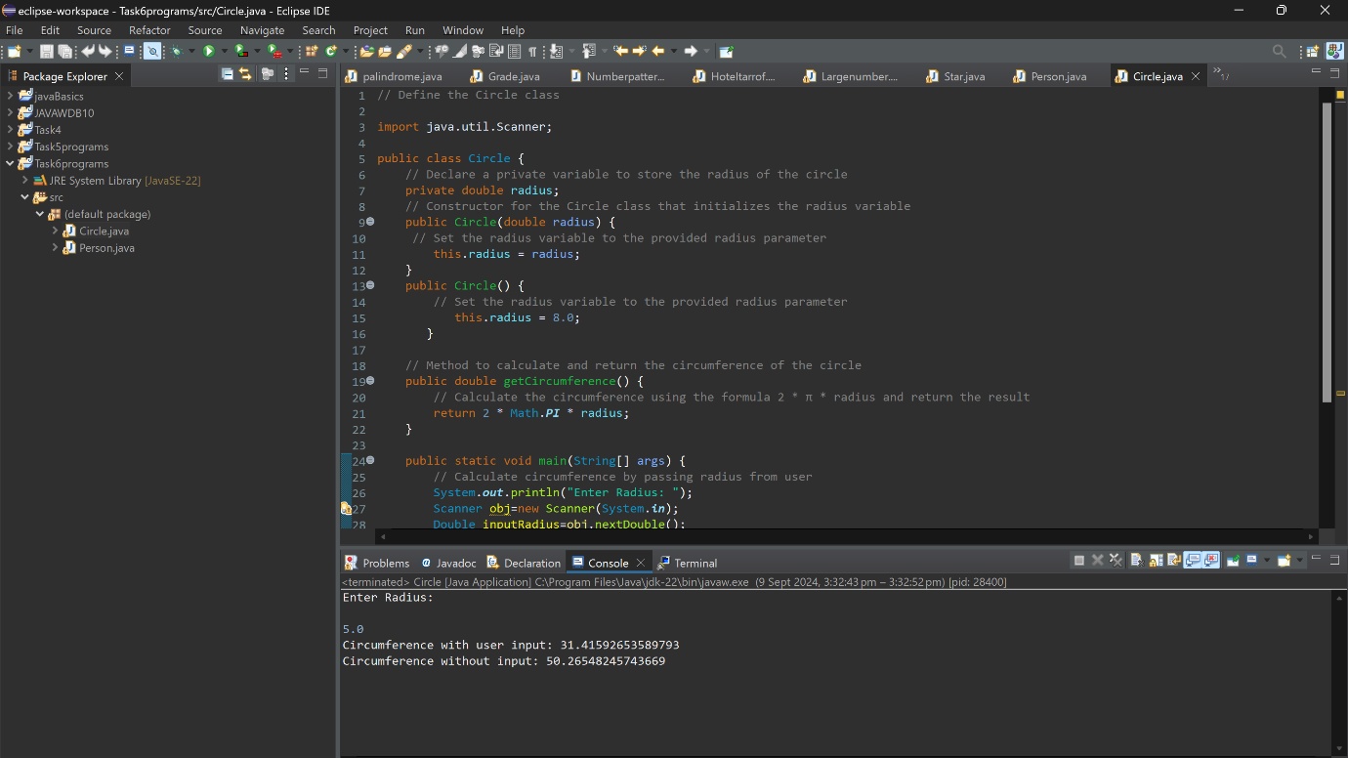

**Q4 Output Screenshot :**

