AI Product Service Prototype Development and Business / Financial Modelling

S.ABIRAMI

**Step 1: Prototype selection**

**Problem Statement**

Mobile phones were first invented back in 1992 and launched in the market for commercial use by 1994 by IBM. Since then, the importance of mobiles are increasing. With the internet revolution, the ease of availability of data has boomed the gadget industry to a new high. In present day scenario, use of mobile phones serve n number of purposes including calling, texting, streaming, photography, official work, shopping etc. Therefore, in order to buy a mobile phone, an user thinks of several parameters that must be satisfied. However, the main objective of this report is to cross-validate the price of a mobile phone based on its features.

**Market/Customer/Business need assessment**

Price of a commodity is directly related to its market availability and demand. It is often the most important parameter that single handedly determines the success of a product in terms of business point of view. An user considers whether the price he/she is giving to buy the mobile is justified or not.

**Target specification and characterization**

Almost all business runs on the 80-20 rules where 80% of the business-revenue will be generated through only 20% of the potential customers. Mostly companies acquiring this prototype will be a small business company finding their way of stabilizing their business. Target buyers are all regular buyers who order good online regularly. Tapping this faithful customer market will be a challenge.

The services will be essential for almost everyone in predicting the mobile-phone price by:

1) Brand,

2) RAM capacity,

3) Internal memory,

4) Battery backup,

5) Front and back camera,

6) Android version,

7) Heating problems,

**Loading the Dataset:**

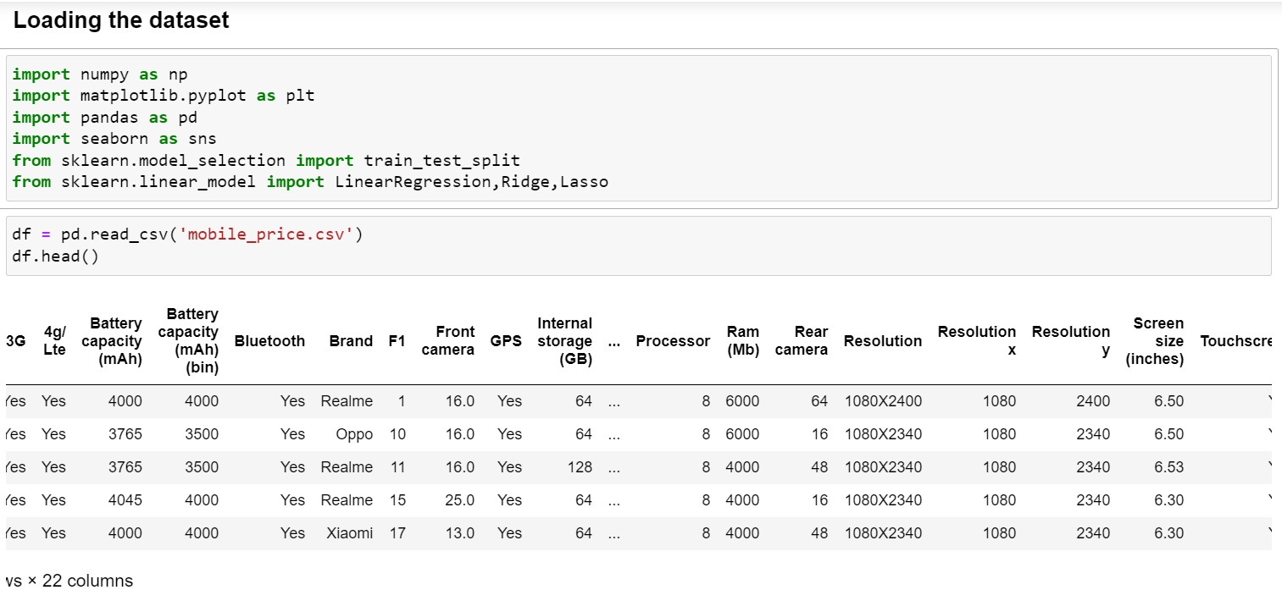

**Info of the dataset:**

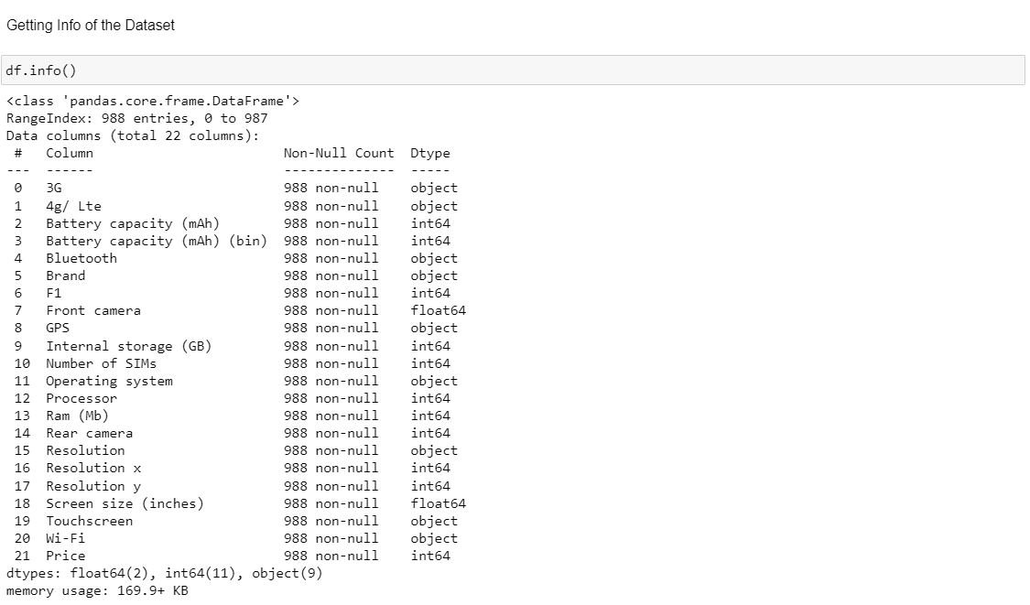

**Exploratory Data Analysis (EDA)**

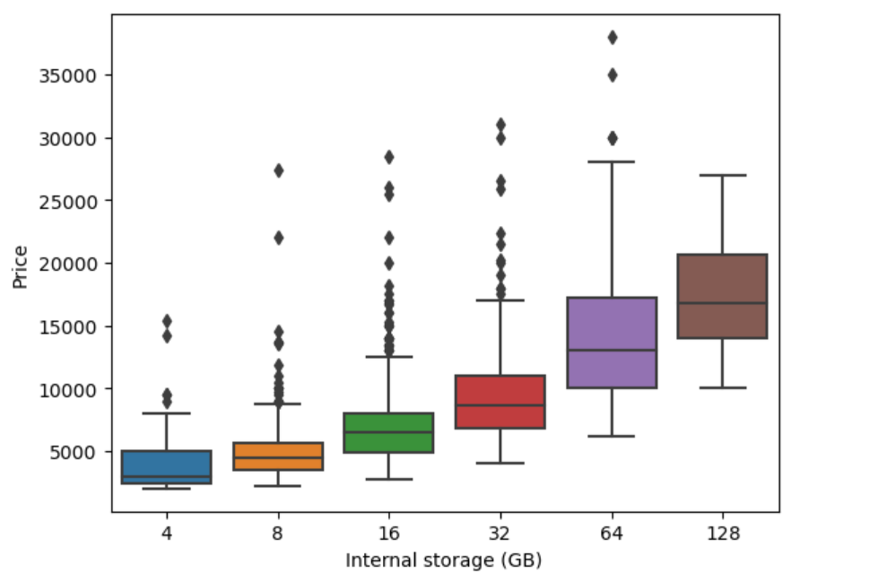

Fig 1 – boxplot showing Price along Y-axis and Internal storage of smartphone along X-axis.

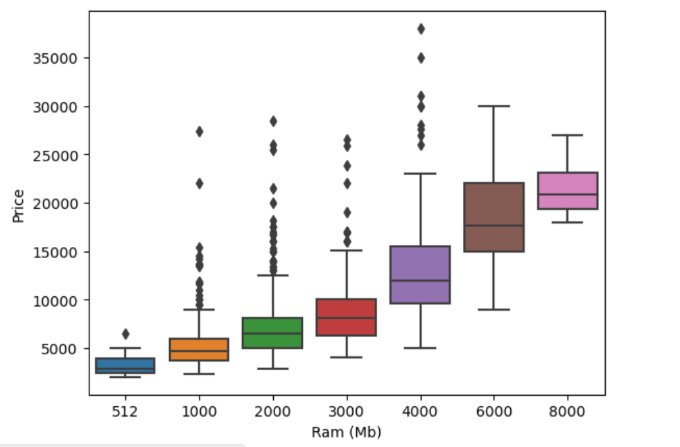

Fig 2 - boxplot showing Price along Y-axis and RAM of smartphone along X-axis.

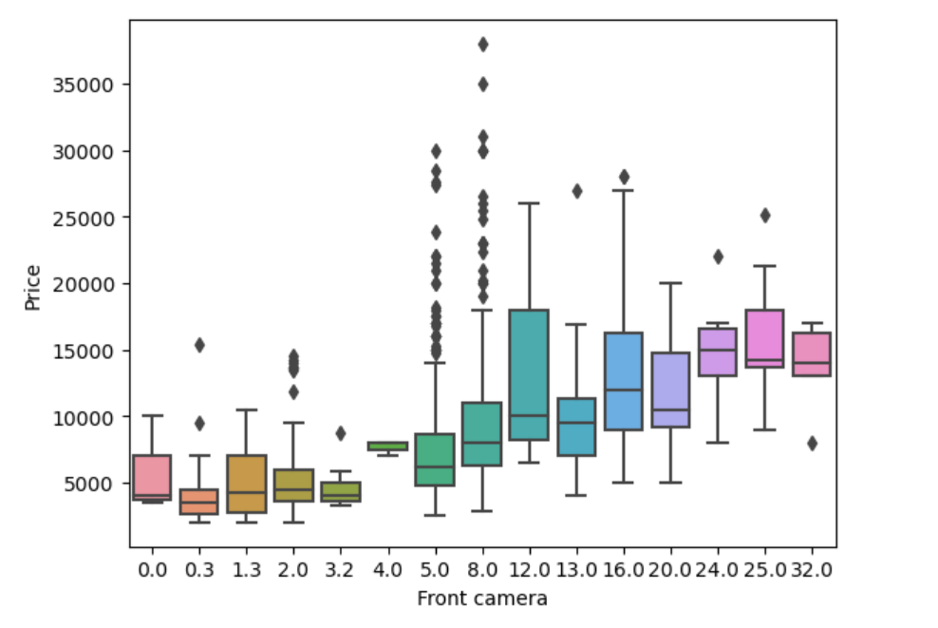

Fig - 3 - boxplot showing Price along Y-axis and front camera of smartphone along X-axis.

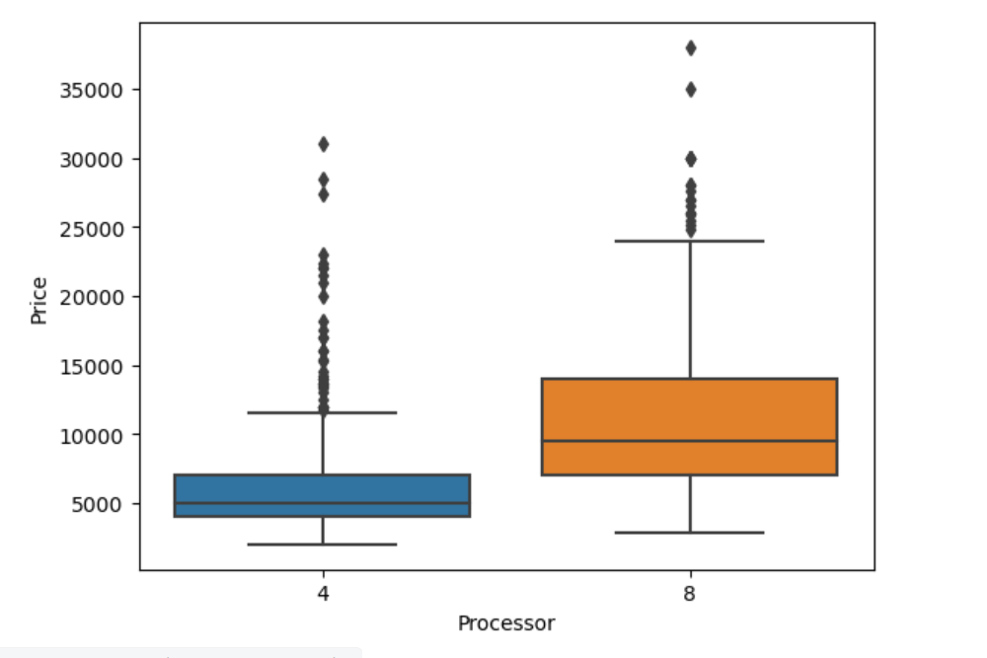

Fig 4- boxplot showing Price along Y-axis and processor of smartphone along X-axis.

**Preparing the file:**

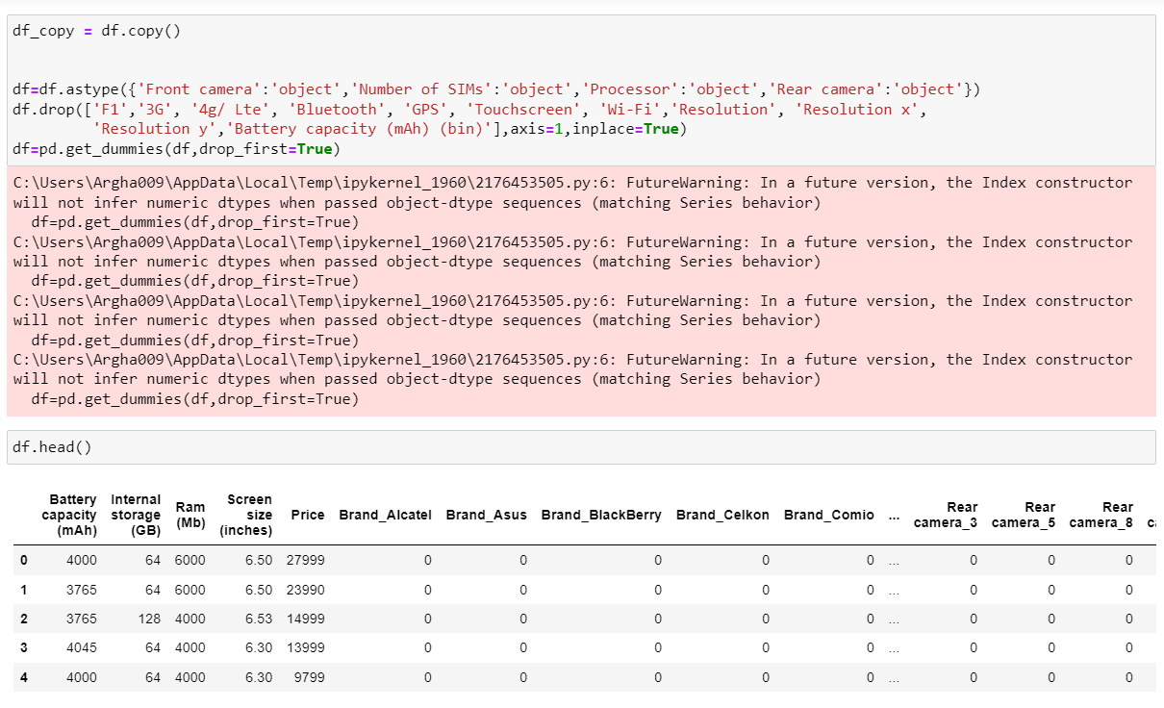

**Train Test Split**

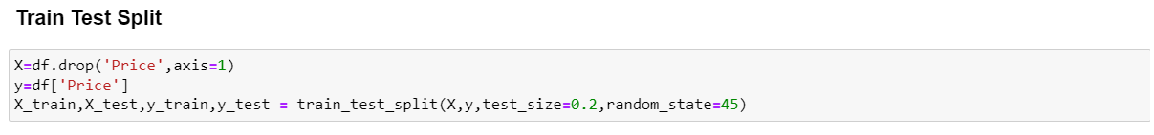

**Linear regression**

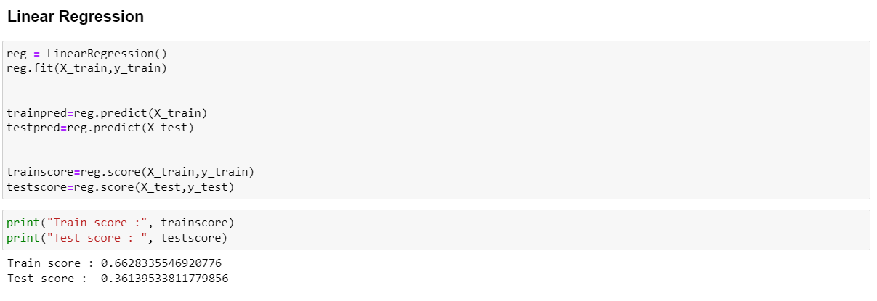

**Ridge regression**

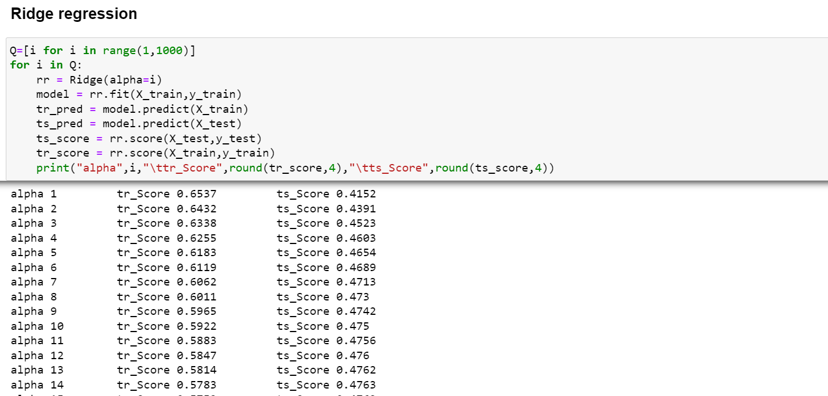

**Lasso regression**

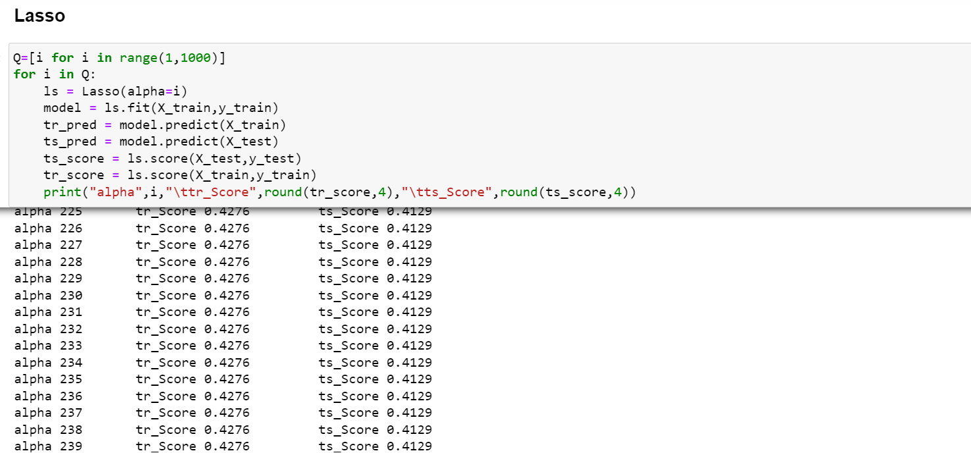

**Applicable regulations**

Restrictions in data scraping from many mobile company websites present challenges in data collection.

**Applicable constraints**

As the mobile market is dynamic, continuous data collection and upgradation is important in order to improve the data quality to maintain the accuracy of the model.

**Business Opportunity**

Phone-price prediction is a very demanding area of business where there’s no specific service in place to do it. Hence the service can be proven useful to the customers as well as to the sellers who can understand what the customers are looking for.

**Tools used:**

1) Python – programming language used to build the model,

2) Pandas – Python library used to handle, manipulate and transform data in tabular format,

3) Matplotlib, seaborn – Two visualization libraries,

4) Sci-kit learn – Extremely useful library for machine learning to perform regression for the model.

**Step 3 - Business modelling**

Fee for service business models are centred around labour and providing services. These business model may charge by an hour rate or at a fixed cost for a specific agreement.

Fig 5 : Diagram showing the proposed business model

Type of our product is mostly service based but is useful for both mobile manufacturers and customers. The service we will provide will try to set a benchmark price for the mobile manufacturers ensuring that they set the price of their products properly. Our price predictor model works based on the inputs regarding specifications of the device and it calculates an output of a desirable price for the same. Hence by knowing the price range, customers can decide to buy or skip the mobile based on their requirements and budget.

**Operational procedure**

The operational procedure consists of several steps targeting manufacturers and customers alike to successfully deploy the price predictor model in the service provider market. We plan to employ different marketing strategies to reach out to them. As the market is dynamic, we need to rely heavily on the customer feedbacks to improve the prediction model. Therefore, it is important to make our product available as a web-based application and can be accessed easily and updated after a specific time interval. Different means of purchase is important taking into account purchase for one time use, purchase for subscription (monthly or yearly) and purchase for infinite usage.

**Step 4 – Financial Modelling with Machine learning and Data Analysis**

**Smartphone statistics in India**

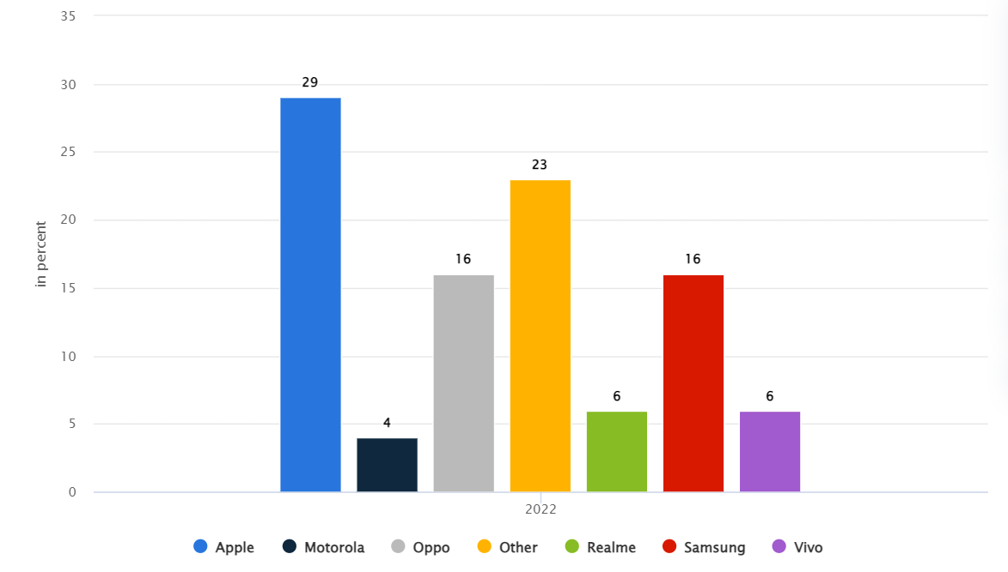

Fig 6 – Bar chart showing brand-shares of different smartphone companies in India as of Aug,2023 (source: Statista Market Insights).

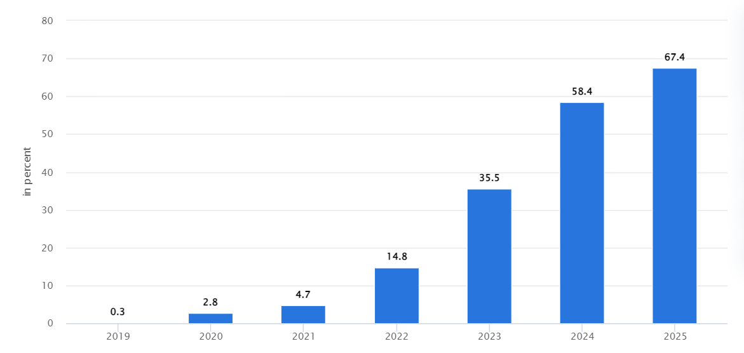

Fig 7 – Bar chart showing growth of 5G smartphones in India over the recent years (source- Statista Market Insights).

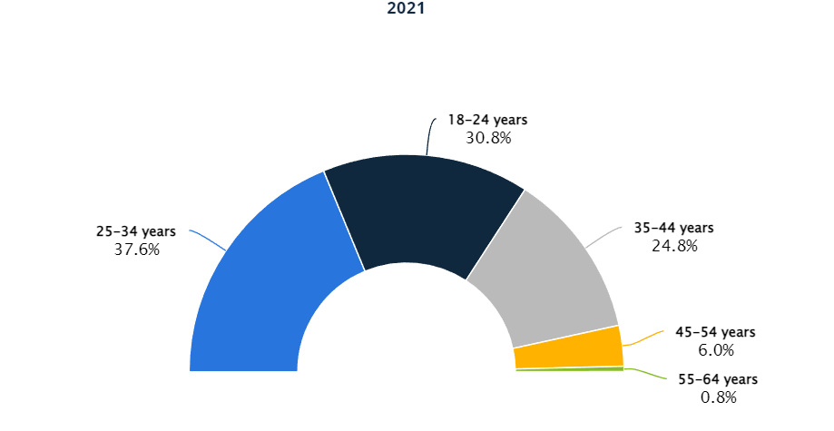

Fig 8– Diagram showing age-wise user % using smartphones as of 2021 (source- Statista Consumers Insights Global).

**Financial equation:**

The previous diagram regarding the market growth of smartphones in India shows that even during the pandemic period the smartphone market continued to grow. We can set our initial base service price as 1000 INR keeping in mind the market demand and affordability of the customers. Once the customer base increases, we can adjust our base-price accordingly.

For starting the journey in a technical team of 5 people 2 should cover the role of ML-engineer, 1 person looking after the software development role, 1 person for product management role and 1 person leading the team having managerial and leadership qualities.

If we consider the salaries of each ML-engineer as a1, SDE as a2, product management guy as a3 and team leader as a4, then the financial equation will be –

f(x) = 1000* x(t) – (2a1 + a2 + a3 + a4)

where x(t) represents the growth of the customer base as a function of time and f(x) represents the profit.