**NORTH SOUTH UNIVERSITY**

## **CSE 231 PROJECT**

**PROJECT IN SEVEN SEGMENT**

**Display COVID19**

**Combinational Part**

March 5, 2020

FACULTY: **KMM**

Section: 10

GROUP NO: **02**

# **MEMBERS**

Md. Lutfor Rahman (1811215642)

Masfik Alam (1812425642)

Riyadul Islam (1813139042)

**INTRODUCTION**

Display COVID19 by using 7 segment decoder in a combinational circuit.

**OBJECTIVE**

* Understanding the concept of 7 segment decoder in the context of digital logic circuits.
* Learn about the internal logic of digital seven segment decoder.
* Implement digital logic functions using 7 segment decoder.
* Observe and Analysis the operations of the A to Z and 0 to 9 in line decoder.

**THEORY**

A seven-segment display is a form of electronic display device for displaying decimal numerals that is an alternative to the more complex dot matrix displays. Seven-segment displays are widely used in digital clocks, electronic meters, basic calculators, and other electronic devices that display numerical information

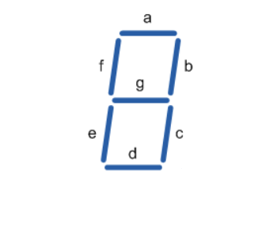

We are going to display the most famous word in these moment COVID19, for this the whole world is in worried and the world economy is stacked.

In COVID19 there are 7 letter. Only the showing segment for a letter is one and rest of them are zero. For an example we are wanted to display the alphabet C, then only a, f, e, d should be one and rest three g, b, c will be zero. Then we can see the letter of C. In the below we are showing how every letter is look in 7 segment display.

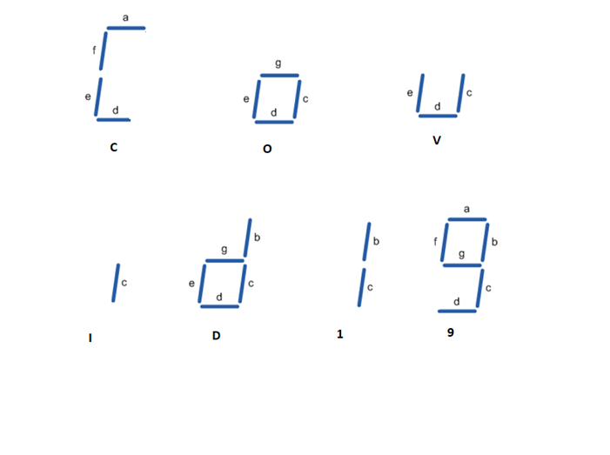

**TRUTH TABLE**

|  |  |  |  |  |  |  |  |  |  |  |  |
| --- | --- | --- | --- | --- | --- | --- | --- | --- | --- | --- | --- |
|  | **X** | **Y** | **Z** | **A** | **B** | **C** | **D** | **E** | **F** | **G** | **OUTPUT** |
| **0** | 0 | 0 | 0 | 1 | 0 | 0 | 1 | 1 | 1 | 0 | C |
| **1** | 0 | 0 | 1 | 0 | 0 | 1 | 1 | 1 | 0 | 1 | O |
| **2** | 0 | 1 | 0 | 0 | 0 | 1 | 1 | 1 | 0 | 0 | v |
| **3** | 0 | 1 | 1 | 0 | 0 | 1 | 0 | 0 | 0 | 0 | i |
| **4** | 1 | 0 | 0 | 0 | 1 | 1 | 1 | 1 | 0 | 1 | d |
| **5** | 1 | 0 | 1 | 0 | 1 | 1 | 0 | 0 | 0 | 0 | 1 |
| **6** | 1 | 1 | 0 | 1 | 1 | 1 | 1 | 0 | 1 | 1 | 9 |
| **7** | 1 | 1 | 1 | X | X | X | X | X | X | X | X |

**K-MAP & EQUATION**

## **a = $\sum{(0,6)}$**

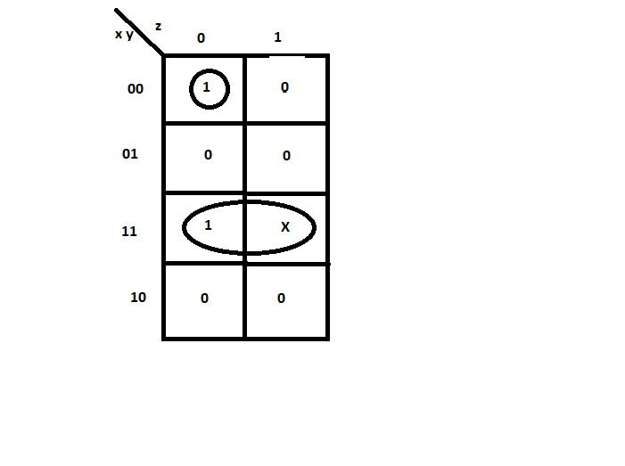

a = xy + $\overline{x}\overline{y}\overline{z}$

## **b = $\sum{(4,5,6)}$**

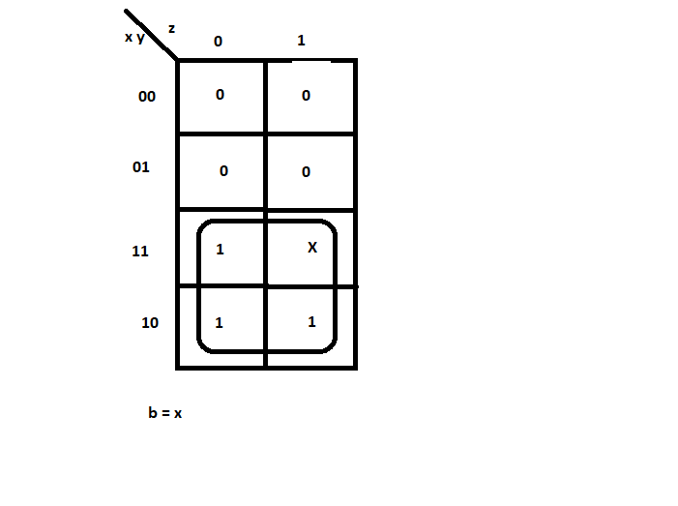

## **c = $\sum{(1,2,3,4,5,6)}$**

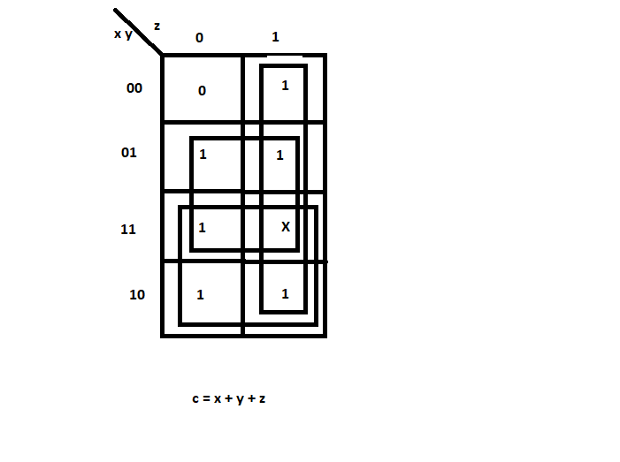

## **d = $\sum{(0,1,2,4,6)}$**

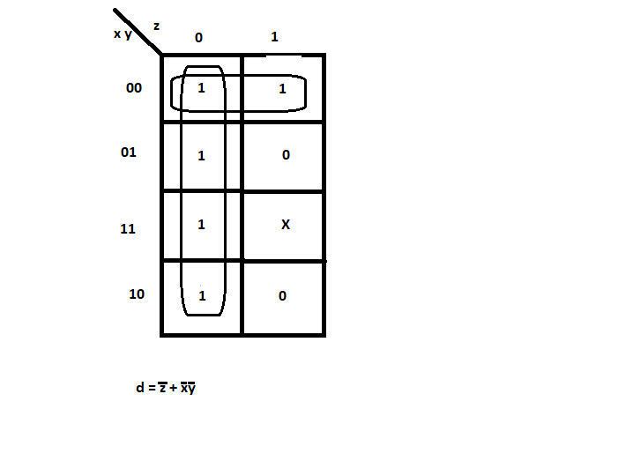

## **e = $\sum{(0,1,2,4)}$**

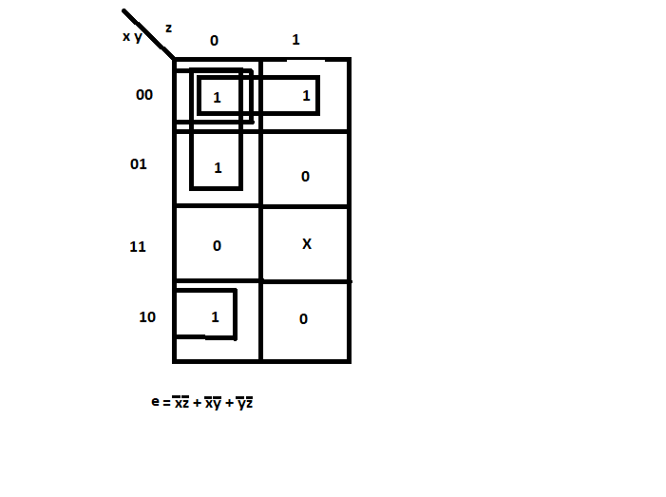

## **f = $\sum{(0,6})$**

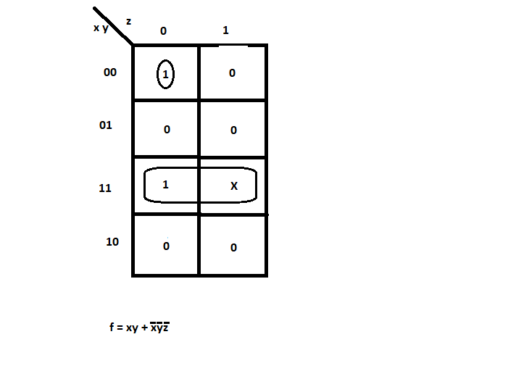

## **g = $\sum{(1,4,6)}$**

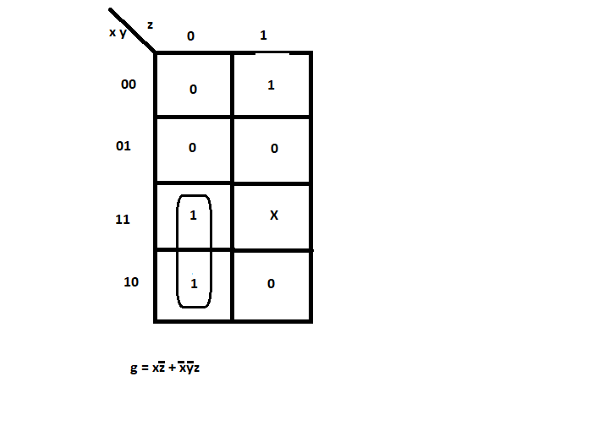

**CONCLUSION**

* It is possible to display any single digit number on a 7-segment display by sending a high digital signal to the specific segments that make up the number. However, this method requires us to encode the letters manually. It is not the best solution to output changing numbers for application such as counters.
* It is possible to display the decimal value of a binary number on a 7-segment display using a BCD decoder.
* However, this method will allow displaying only digits from 0 to 9 and letters A to F.
* The only way to display number more than 9 is to use a display that has more than 7 segments or just using multiple 7-segment displays at once with the corresponding BCD decoder.
* In the case of the decoder circuit, any binary number between 1010 through 1111 (A to F) is an invalid input and would provide distorted shapes on the LCD display.
* Current limiting resistors of 150 ohms are connected in series between the decoder and each of the LED display segment. They serve to limit the maximum current flow and have no impact on the LCD display.
* The usage of a 7-segment display paired with a BCD decoder is opening the door for an application using digital computation requiring a human-readable That application can be for instance: “a clock, a timer, a calculator, counter

## **ATTACHMENT** –

## 

