

the Fazoli Project

Texas Tech University – Hospitality Services



November 29, 2022

sai santosh reddy anisetti, Bhargava naidu dasari, manoj giri, rishidhar rao avirineni, md ariful haque miah, hemanthh reddy aredla



Contents

Executive Summary: 2

Introduction: 2

Problem Statements: 3

Problem 1 3

Problem 2 4

Problem 3 4

Approach & Methodology: 4

Data source: 4

Solution for problem 1 5

Solution for problem 2 5

Solution for problem 3 5

Data Collection 6

Qualitative Improvement 7

Flow between chart of the sales data of the facility 7

Qualitative flow measurement – Relationship chart (REL) 8

Block Diagram 9

Quantitative Improvement: 9

Cost Analysis 9

Final Proposed Facility layout and flows: 10

Advantages and Disadvantages 11

Conclusion 11

Acknowledgement 12

References: 12

Appendix 13

# Executive Summary:

Going out to eat is supposedly one of the most well-liked pastimes in the world. Every person would love periodically visit their preferred eatery. Checking out the newest eateries is fun, and dining there might mark a special event. Everyone loves gathering with friends and family for delicious meals in a warm setting like a restaurant. Customers return to a restaurant time and time again because of the food, the service, and the inviting atmosphere. As a group, we went to the "Fazoli's" restaurant on the Texas Tech University campus. Similar to how joy might become an annoyance if there is too much time spent waiting for food to be ordered or served. We identified a few potential problems, such as extended wait times for customers during busy times and extended preparation times that result in extended wait times for food delivery. Following a thorough analysis of the facility and collecting necessary information, we offered solutions and discussed their advantages and disadvantages in this project report.

# Introduction:

Located in Lexington, Kentucky, Fazoli's is a national brand of fast-casual restaurants. FAT Brands is the current owner; it was created in 1988. Serving American-Italian food is the specialty of Fazoli's. The United States 26 states are home to more than 200 Fazoli's 〖restaurants〗^([1]).

Fazoli’s is a restaurant that serves a range of foods, such as oven-baked pasta, pizzas, baked lasagna, salads, and desserts. It is situated in Stangel Hall at Texas Tech University. Lunch and dinner are primarily on the menu. Every day, from direct customer visits and online orders, Fazoli’s receives many orders. Students, professors, and university employees make up most of the clientele. Fazoli’s is one of the best-performing restaurants on campus. Our crew encountered a few issues in the Fazoli's when visiting the restaurants, preventing it from serving the most significant number of guests throughout multiple busy days. A critical problem in this situation is the architecture and design of the facilities. As any restaurant's goal is to increase sales and maintain profitability by serving the customers good quality food while utilizing less food preparation time, our project's goal is to analyze the facility plan and the operation process and propose pertinent recommendations to improve the service.

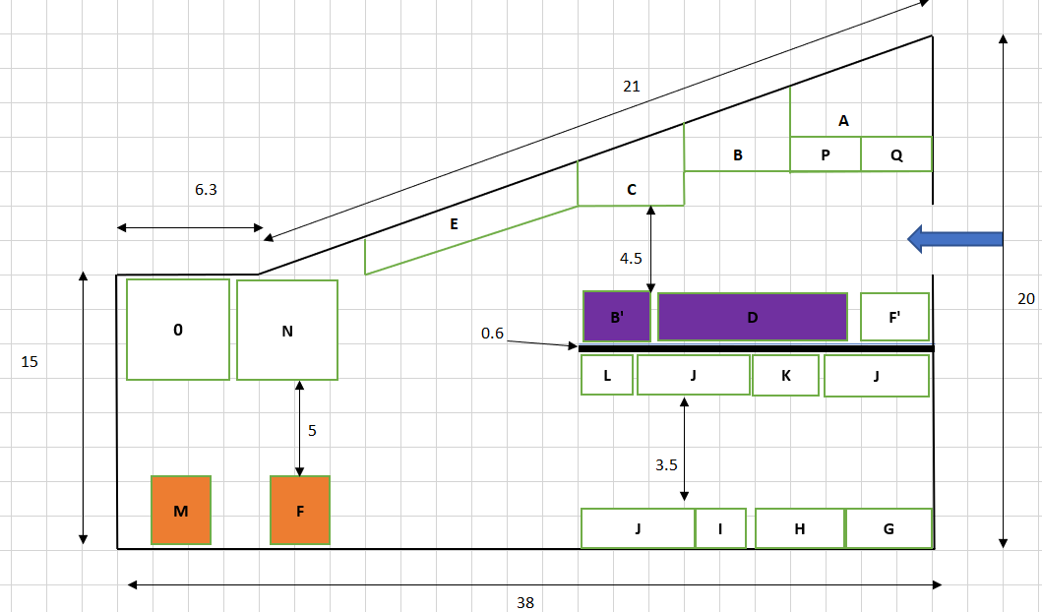 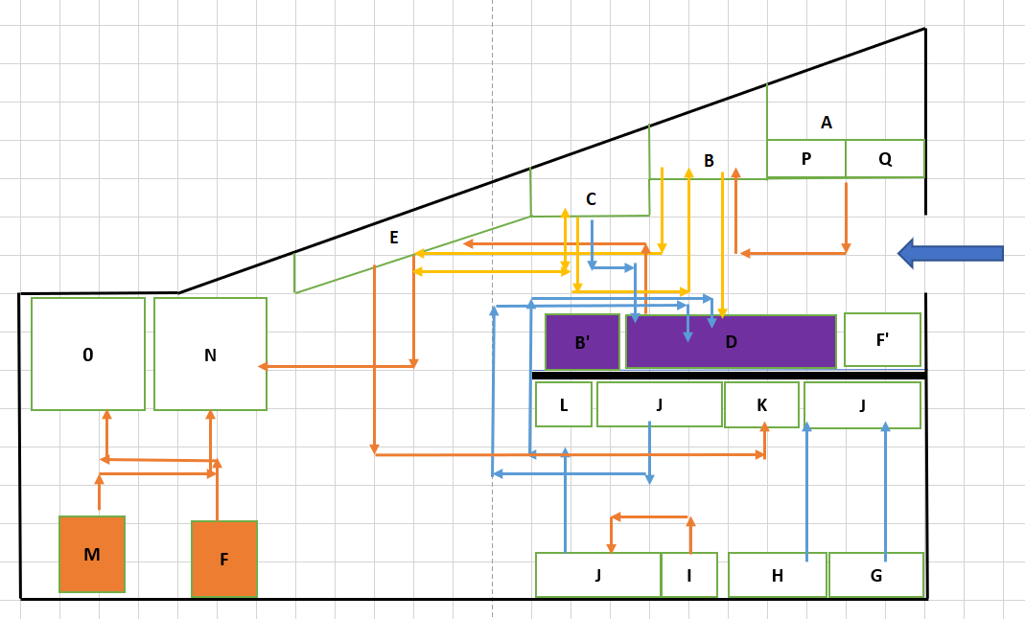  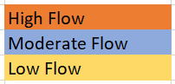

*Initial Facility layout (in feet) and Initial Facility flow*

# Problem Statements:

This section identifies the three main problems that our team has identified and the solutions we plan to address in the final layout.

## Problem 1

When there are many people in the building simultaneously, the facility only has one billing counter, so consumers must wait a long time to place their orders and pay for them. During certain times, the typical wait time for a consumer in line is at least twenty minutes before they reach the front of the line. In addition, it takes them an additional two to three minutes to place their order and then collect it. The waiting line is starting to spill out of the facility's waiting room and into the neighboring walkways leading to the building's other eateries due to the lengthy wait time. Because of this, there is a delay in the flow of clients due to the bottleneck caused by the extended wait time.

## Problem 2

The typical time it takes for the facility to deliver orders is significantly longer. The student who manages Fazoli claims that the staff members have a very intensive workload owing to the limited number of employees, which needs frequent mobility inside the building. This is according to the student who manages Fazoli. The employment satisfaction of students who work there part-time is, like that of the whole workforce, lower. Short 15-minute breaks are taken at various points throughout four to seven-hour shifts.

## Problem 3

* The cooking area has space constraints, which leads to an inefficient flow of materials. Nearly all sandwiches on the sandwich table must be prepared by cooking them in the main oven, and the sandwich table is farther from the main oven, which affects material flow.
* Additionally, cheesecakes are easily accessible. The cashier must go further to deliver the order to the customer because the cheesecake cooler is farther away from the billing counter.
* According to the facility's student manager, 95% of the things sold there require sauces, making sauces the primary ingredient. Typically, the sauces are put under the sandwich table, and the temperature is lowered. As a result, the sauces are not liquid and are not suitable for use with the food.

# Approach & Methodology:

We went as a group to Fazoli's during the busiest part of the day to observe their operation, collect data relating to the type of products, process flow, process sequence, and processing time, and make a note of the problems that were encountered at the facility, as well as the amount of time that customers had to wait in line and at the billing counter. We built a flow chart, a relationship chart, and the basic architecture of the facility by basing it all on the data we acquired.

## Data source:

* The blueprint of the facility.
* The observations of the employees during the peak hours and regular hours.
* Feedback from the owners and employees.

## Prospective Solutions:

## Solution for problem 1

We suggest adding another billing counter similar to the one in use.

• The time people wait in line will be reduced with the implementation of the updated billing counter, and this is because orders are now processed more quickly than in the past.

• In addition to the new billing counter, the obstruction brought on by consumers is also addressed. Therefore, by following these tactics, the total waiting time will be shortened, and customer satisfaction can be raised.

## Solution for problem 2

• Because there are few staff, there is much activity inside the facility while items are prepared, which disrupts the flow. As a result, we suggested that the workforce be expanded and that they only be tasked with specific duties.

• As the number of employees rises, the workload per employee will be reduced, resulting in less employee travel inside the kitchen. Overall, the factor that contributes most to effective performance—job satisfaction—will be enhanced.

## Solution for problem 3

We suggest switching the main oven and secondary Steam table. 70% of the items go between the steam table, sandwich table, and main oven directly and indirectly, according to the routing plan. The main oven is, therefore, not adjacent to the sandwich table in the first configuration, as can be seen. According to data collecting, the route between the sandwich table and the oven appears to be more frequent. So, we switched the steam table to the primary oven. By doing this, the flow is made more efficient.

• We suggest switching the Cheesecake chiller and the hot box so that the cashier has to move less while delivering the cheesecakes. Hot box is usually utilized in rare cases because it is the secondary one, which locates at the counter. So, there wouldn’t be any flow-related issues when the two pieces of equipment were switched to different places.

• Maintaining the sauces in the ideal form and temperature to fit underneath the steam table, we will suggest purchasing a new sauce table where the sauces would be prepared for application to the food under the steam table.

## Data Collection

|  |  |
| --- | --- |
| **Machine’s** | **Sequence** |
| Main Steam | A |
| Steam Table | B, B’ |
| Sandwich Table | C |
| Main Oven | D |
| Expo | E |
| Hot Box | F |
| Hot Box | F’ |
| Double Door Freezer | G |
| Double Door Cooler | H |
| Breadstick cabinet | I |
| Table(prep) | J |
| Sink | K |
| Soda dispenser | L |
| Cheesecake Cooler | M |
| Billing Counter | N |
| Mobile Order Counter | O |
| Pasta Table | P |
| Pasta Magic Machine | Q |
| Staff Entrance | R |
| Sauce | S |

|  |  |  |
| --- | --- | --- |
| **Item Number** | **Items** | **Process Sequence** |
| 1 | Chicken Fettuccine Alfredo (Pasta) | A-B-E-N |
| 2 | Breadstick | I-J-D-E-N |
| 3 | Spaghetti Marinara | A-B-E-C |
| 4 | Baked Spaghetti Meatballs | A-B-C-D-E-N |
| 5 | Meatballs Davinci | C-B-D-E-N |
| 6 | Chicken Carbonara | A-B-C-E-N |
| 7 | Lasagna | B-C-D-E-N |
| 8 | Gluten Free Chicken Pesto Rotini | C-B-C-D-E-N |
| 9 | Ravioli | A-B-E-N |

# Qualitative Improvement

## Flow between chart of the sales data of the facility

|  |  |  |  |  |  |  |  |  |
| --- | --- | --- | --- | --- | --- | --- | --- | --- |
| **Flow/btw** | **A** | **B** | **C** | **D** | **E** | **I** | **J** | **N** |
| **A** | - | 482 |  |  |  |  |  |  |
| **B** |  | - | 435 | 97 | 390 |  |  |  |
| **C** |  |  | - | 213 | 236 |  |  |  |
| **D** |  |  |  | - | 437 |  |  |  |
| **E** |  |  |  |  | - |  |  | 775 |
| **I** |  |  |  |  |  | - | 127 |  |
| **J** |  |  |  |  |  |  | - |  |
| **N** |  |  |  |  |  |  |  | - |

## Qualitative flow measurement – Relationship chart (REL)

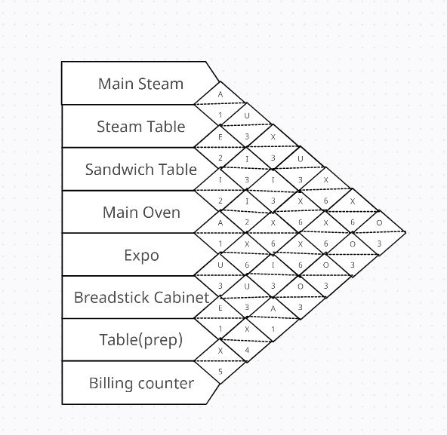

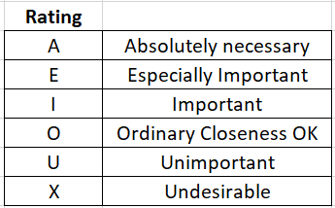 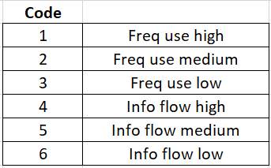

* According to the routing map, the material flow between the equipment can be understood. As per that observation, the relationship rating and codes are assigned accordingly.
* We can observe that almost all the items need to flow through the

1. Main steam and Steam table
2. Main oven and Expo
3. Expo and Billing counter

* So, placing those pieces of equipment nearer to each other is vital to attain a good efficiency rating. Similarly,

1. Steam and sandwich table
2. The breadstick cabinet and Table prep should be placed nearer to each other.

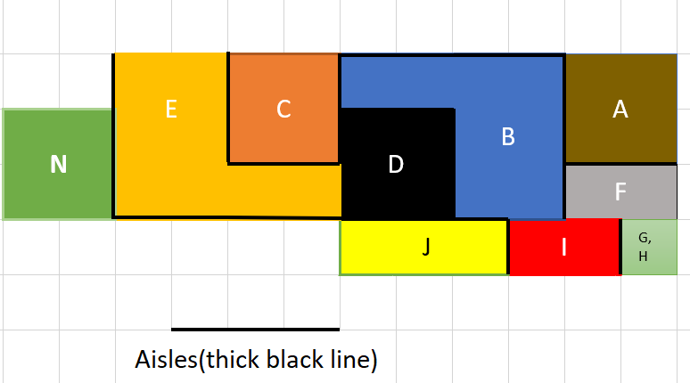

Block Diagram with aisles and showing relationship between each department

# Quantitative Improvement:

## After Conducting the flow*cost*distance analysis, the flow has been minimized from 18032 to 15385. Separate calculations and tables are shown in Appendix.

## Cost Analysis

|  |  |  |  |
| --- | --- | --- | --- |
| **S.no** | **Item** | **No. of Items** | **Cost of Item** |
| 1 | Sauce Table | 1 | **$300** |
| 2 | Toast POS System | 1 | **$809** |
|  |  | Total | **$1109** |

The purchasing of the following things is suggested. The table above estimates their cost, which equals $1109. Because it boosts productivity, this is a minimal cost for the facility. Although the Toast POS system is more expensive than the other, its presence will reduce order wait times and the line for the order to be processed. The sauce table is the finest selection among the products bought because the cooking time will be kept to a minimum.

## Final Proposed Facility layout and flows:

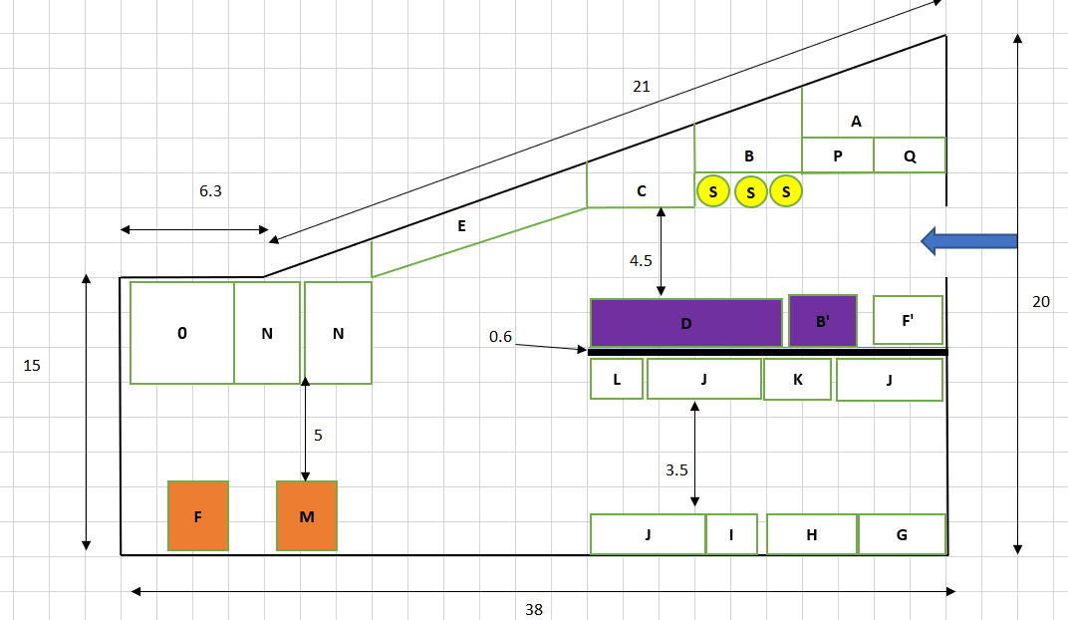

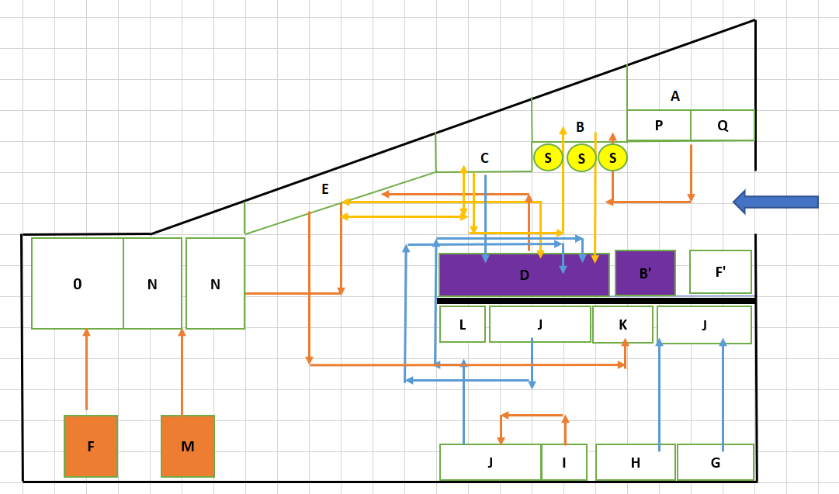

# Advantages and Disadvantages

Advantages:

* The layout is now more efficient than it was previously.
* Orders are taken faster with the new billing counter.
* There is minimal waiting time. It is cleared up at the entryway and the access points to the other restaurants.
* With the equipment switching, the item’s flow rate is moving more quickly than before.
* The least utilized hot box is replaced with the cheesecake cooler.

Disadvantages

* Inside the building, there are pillars and a fixed restaurant arrangement. Therefore, substantial alterations to the facility layout are not possible.
* After adding a second billing counter, no more room will remain.
* Aspect ratio of the layout could be improved.

# Conclusion

The flow has been reduced as much as possible inside the layout, which has had the effect of cutting down on the amount of time that employees spend within the layout. Finally, it helps reduce the time required to produce everything. The layout's efficiency rating has been increased, enhancing the flow of materials and the management of materials.

# Acknowledgement

At the commencement of this report, we would like to convey our sincere appreciation to every member of the team who was instrumental in the successful accomplishment of this mission. Their helpful advice, support, collaboration and encouragement give us the motivation we need to move forward.

We sincerely appreciate Dr. Bryan A. Norman's direction and direction in helping us complete this project.

The management group and the manager of the Fazoli’s restaurant in Texas Tech University's Stangel Hall deserve our sincere gratitude. This is due to how helpful they have shown us around their facility and given us insightful information about how they do things.

# References:

1. <https://en.wikipedia.org/wiki/Fazoli%27s>
2. Tompkins, J. A., White, J. A., Bozer, Y. A., & Tanchoco, J. M. A. (2010). Facilities planning. John Wiley & Sons.
3. State of Texas and Texas Tech University. (n.d.). Hospitality services. TTU. Retrieved November 23, 2021, from <https://www.depts.ttu.edu/hospitality/>.

# Appendix

# 

**Initial Flow times Distance**

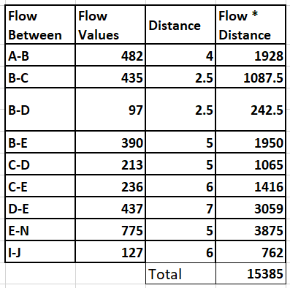

**Final Flow times Distance**

# Calculations

From Between -chart,

**AB=482, BC=435, BD=97, BE=390, CD=213, CE=236, DE=437, EN=775, IJ=127**

**Efficiency of Initial Layout**

# A= Value of the positive flow between adjacent department:

# A= AB+BC+BD+BE+CE+EN+IJ = 482+435+97+390+236+775+127= 2542.

# B= Value of the positive flow between non-adjacent department:

B= CD+DE=213+437= 650.

C= Value of the negative flow between adjacent department:

C= 0

D= Value of the negative flow between non-adjacent department:

D= 0

Efficiency= (A-D)/A+B-(C+D)

= 2542/3192

= 0.7963 = 79.63 %.

**Efficiency of Final Layout**

# A= Value of the positive flow between adjacent department:

# A= AB+BC+BD+CD+CE+DE+EN+IJ = 482+435+97+213+236+437+775+127= 2802.

# B= Value of the positive flow between non-adjacent department:

B= BE= 390.

C= Value of the negative flow between adjacent department:

C= 0

D= the value of the negative flow between non-adjacent department is

D= 0

Efficiency= (A-D)/A+B-(C+D)

= 2802/3192

= 0.8778 = 87.78 %.

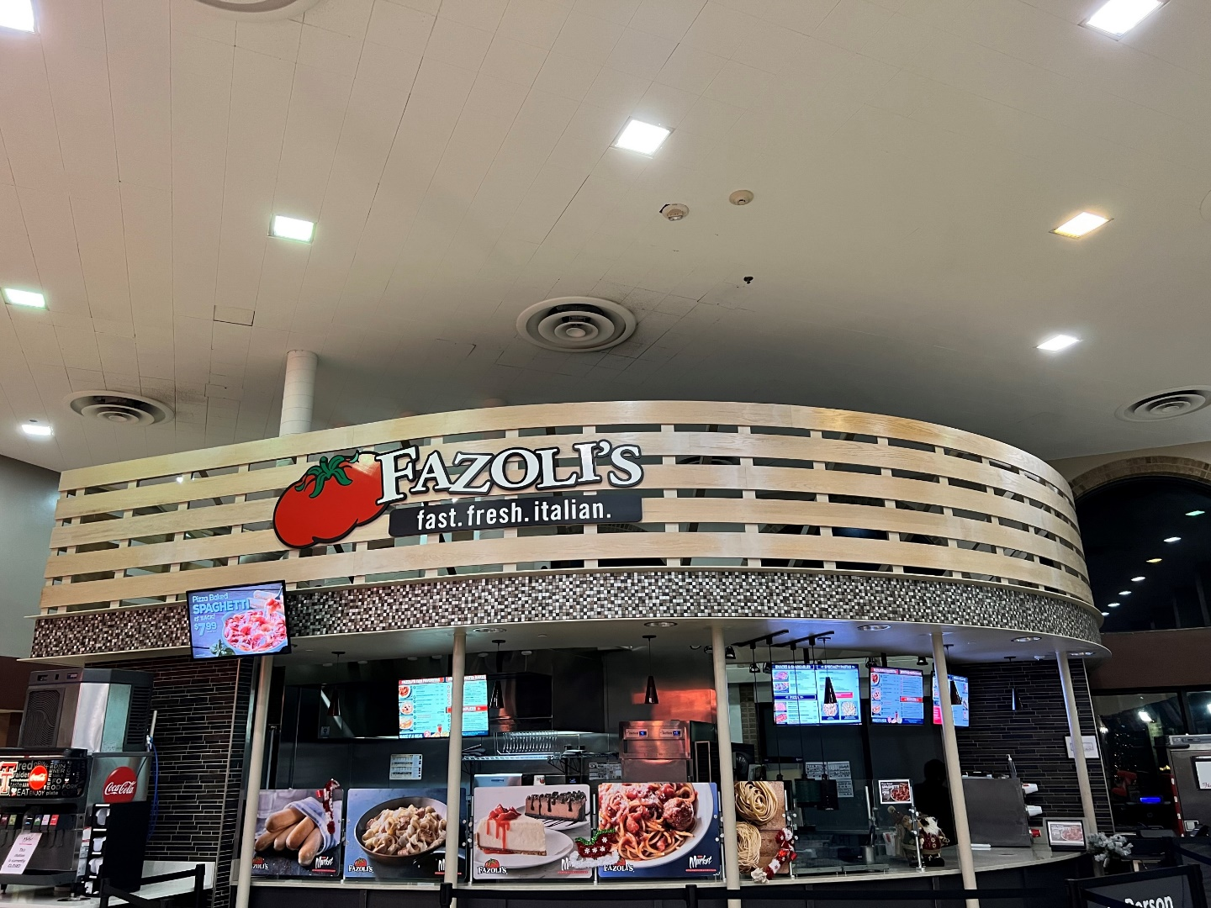

PICTURE 01: FAZOL’S

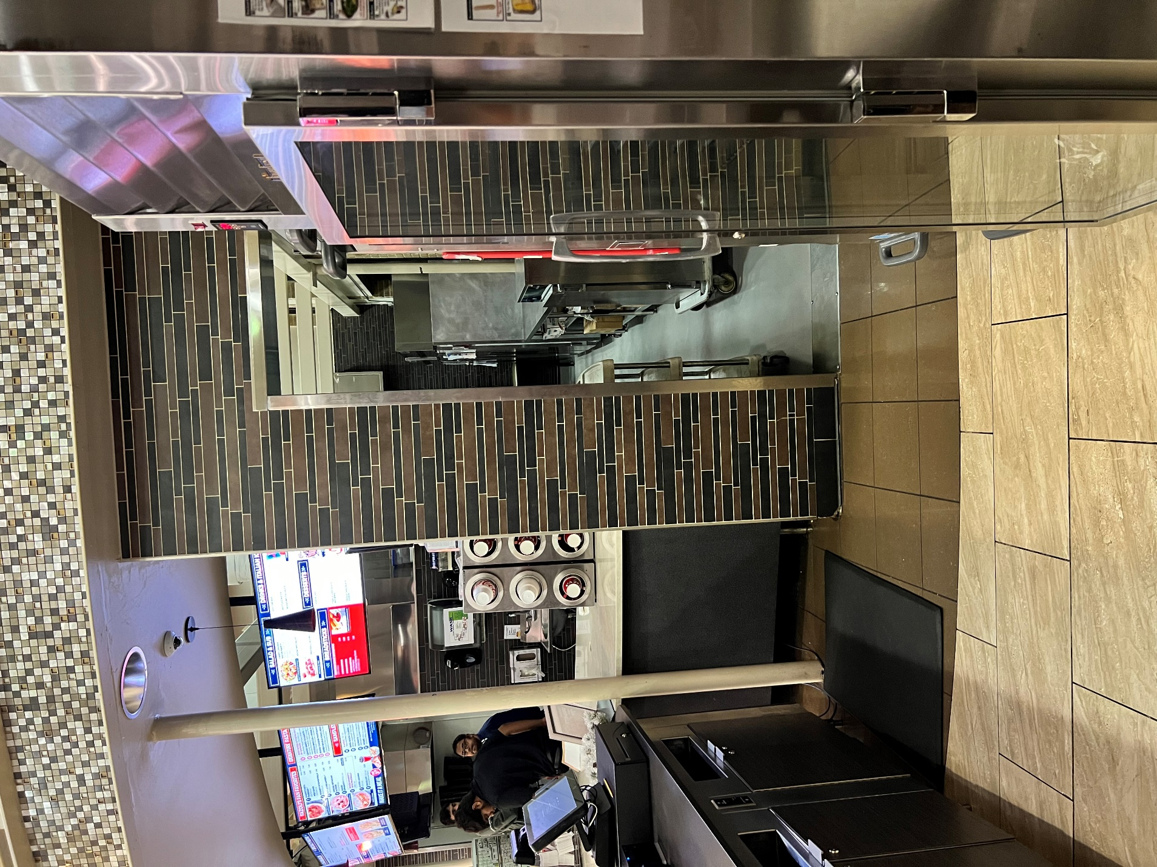

PICTURE 02: BILLING COUNTER AND CHEESECAKE COOLER.

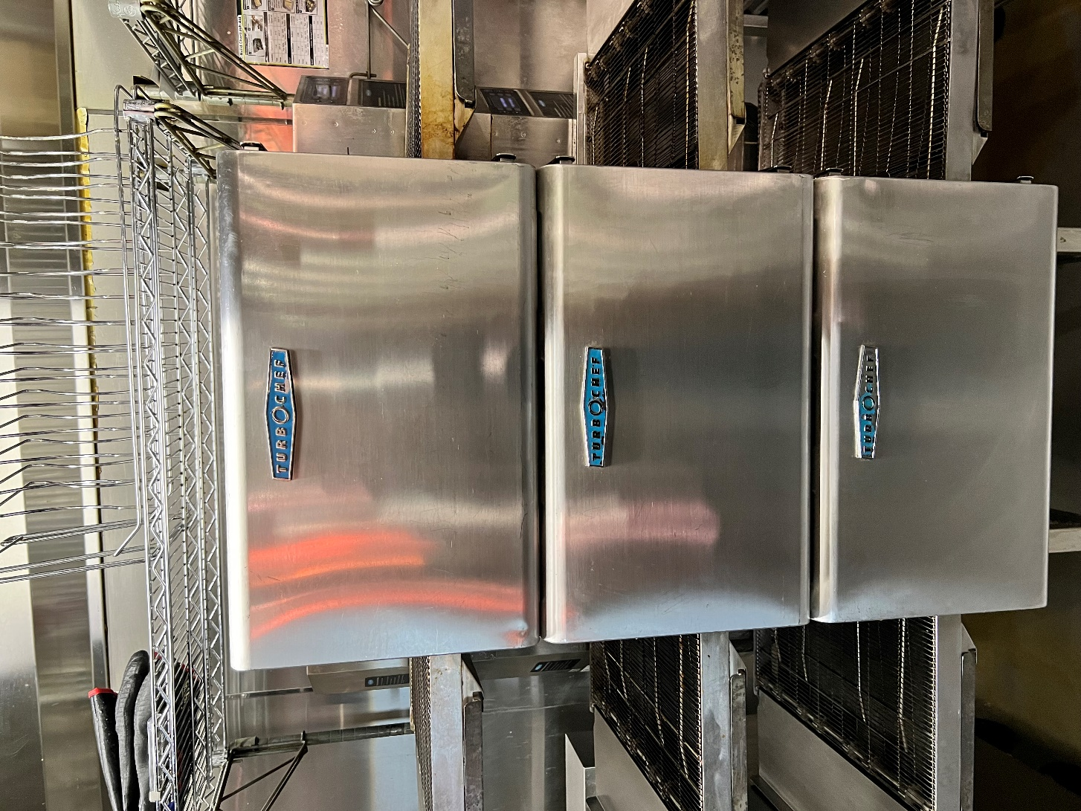

PICTURE 03: STEAM TABLE.