Submitted By: ABIS AHMAD
Sap: 61589

AI-Powered Online Food Ordering and Restaurant Management System
BSSE-6
Submitted to: Dr muhammad adnan

Task 1: AI-Powered UI Generation:

Git Link:

Used Flowstep.ai for the screen interface generation:

Prompt:

Create a complete, modern, responsive web application named "FoodHub – AI-Powered Online Food Ordering and Restaurant Management System".
Generate all FIVE application interfaces in one project. Do not create just a landing page. Each interface must be a separate screen/page, connected through a consistent navigation system.
DESIGN THEME
- Professional restaurant food ordering design.
- White background with orange primary color and dark text.
- Modern typography, rounded cards, subtle shadows and clean spacing.
- Attractive, realistic food images.
- Responsive desktop, tablet and mobile layouts.
- Consistent sidebar, header, buttons and components across all pages.
- Currency: Pakistani Rupees (PKR).

SCREEN 1: CUSTOMER DASHBOARD
Include:
- FoodHub logo and navigation sidebar.
- Navigation links to all five screens.
- Welcome message.
- Promotional banner with food image and Order Now button.
- Featured food items with images, names, prices and ratings.
- Food categories: Burgers, Pizza, Fast Food, Drinks and Desserts.
- Special offers and discounts.
- Recently placed orders with order status.
- Search bar and customer profile.

SCREEN 2: FOOD MENU
Include:
- Page heading and search bar.
- Food categories and category filters.
- Food cards with images, names, descriptions, prices and ratings.
- Add to Cart buttons.
- Featured and popular food sections.
- Shopping cart indicator showing the number of selected items.
SCREEN 3: SHOPPING CART AND CHECKOUT
Include:
- List of selected food items.
- Food images, names and prices.
- Increase and decrease quantity controls.
- Remove item buttons.
- Order subtotal, delivery charges and grand total.
- Customer information form with name, phone number, email and delivery address.
- Payment method selection: Cash on Delivery and Online Payment.
- Place Order button.
- Order confirmation design.
SCREEN 4: ORDER TRACKING
Include:
- Order ID and order details.
- Ordered food items and total bill.
- Order confirmation status.
- Visual progress timeline with five stages:
  - Order Confirmed.
  - Preparing Food.
  - Ready for Delivery.
  - Out for Delivery.
  - Delivered.
- Estimated preparation and delivery time.
- Delivery progress indicator.
- Current order status.

SCREEN 5: AI CUSTOMER SUPPORT CHATBOT
Include:
- Professional chatbot interface.
- Welcome message from FoodHub AI Assistant.
- Interactive chat window.
- Message input field and Send button.
- Conversation history.
- Chatbot response bubbles.
- Suggested questions:
  - Where is my order?
  - What food items are available?
  - What are today's special offers?
  - How long will delivery take?
  - What payment methods are available?
- Clear chat option.
NAVIGATION AND PROJECT STRUCTURE
- Create all five screens within the same project.
- Use a shared navigation sidebar and header.
- Every screen must be accessible through navigation links.
- Keep the design and branding consistent across all screens.
- Add appropriate icons and realistic sample data.
- Make all five screens visually complete, not wireframes.
- Use reusable UI components.
- Prioritize a professional, polished university assignment quality.
IMPORTANT: Generate all five screens in this single generation request. Do not omit any screen or replace the required interfaces with a simple landing page.

SCREEN 1: CUSTOMER DASHBOARD
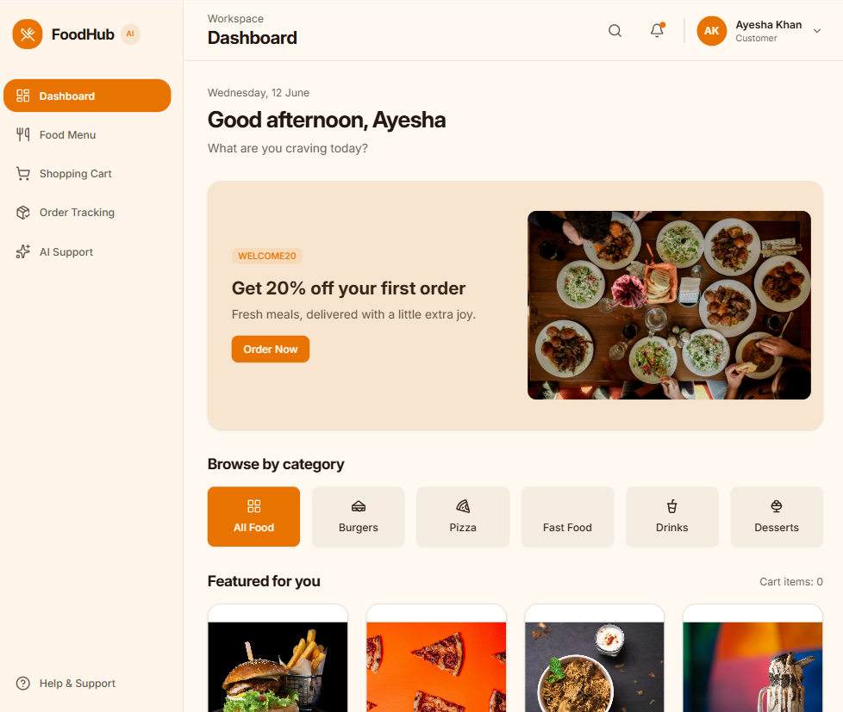
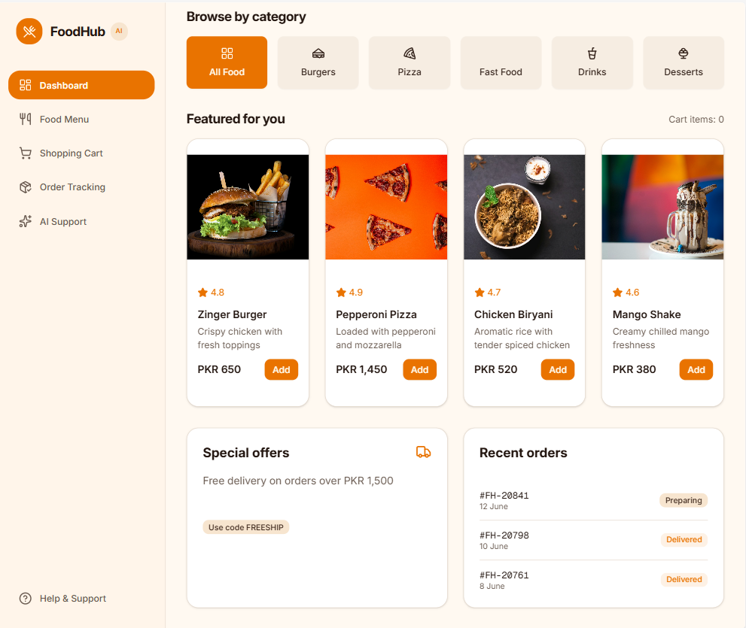
Tablet View:
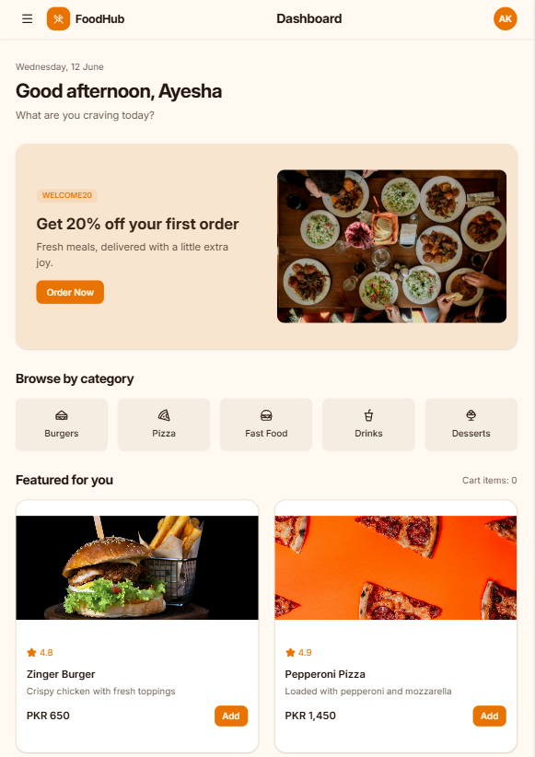

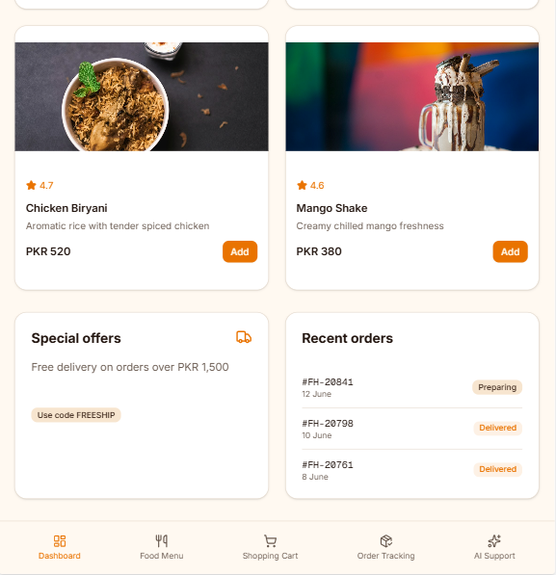
SCREEN 2: FOOD MENU
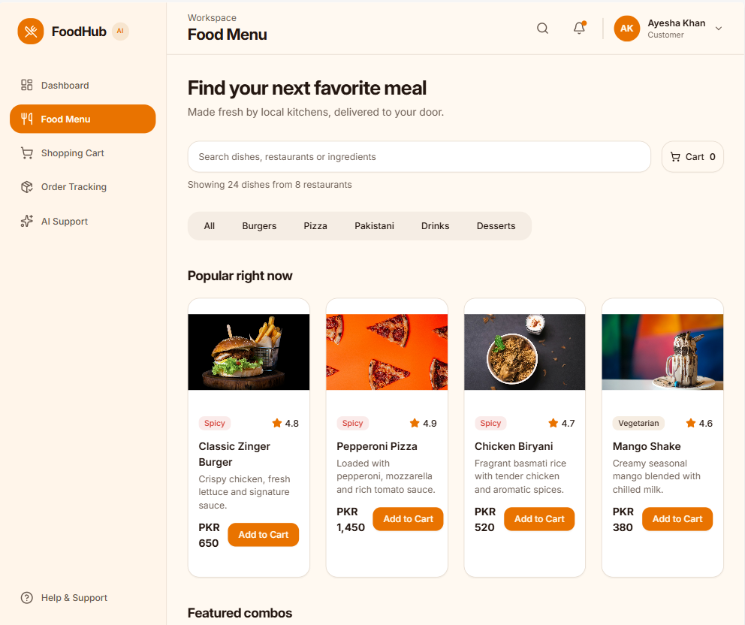
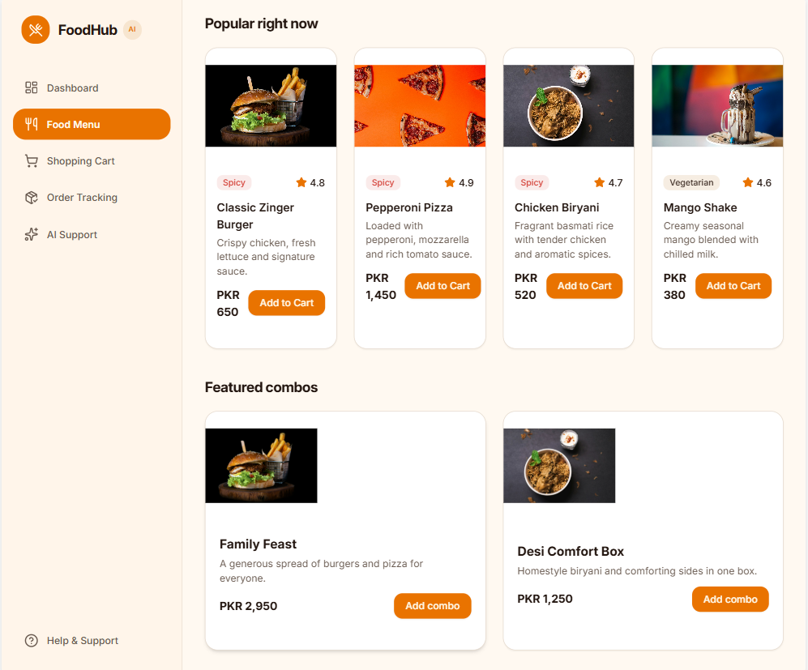

Tablet View:
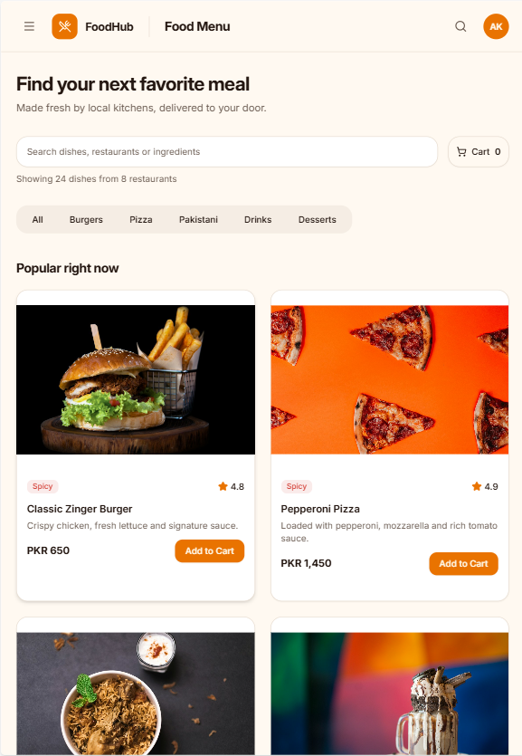
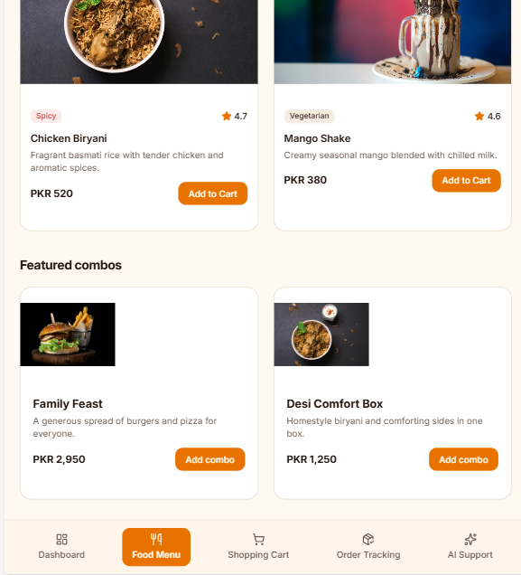
SCREEN 3: SHOPPING CART AND CHECKOUT
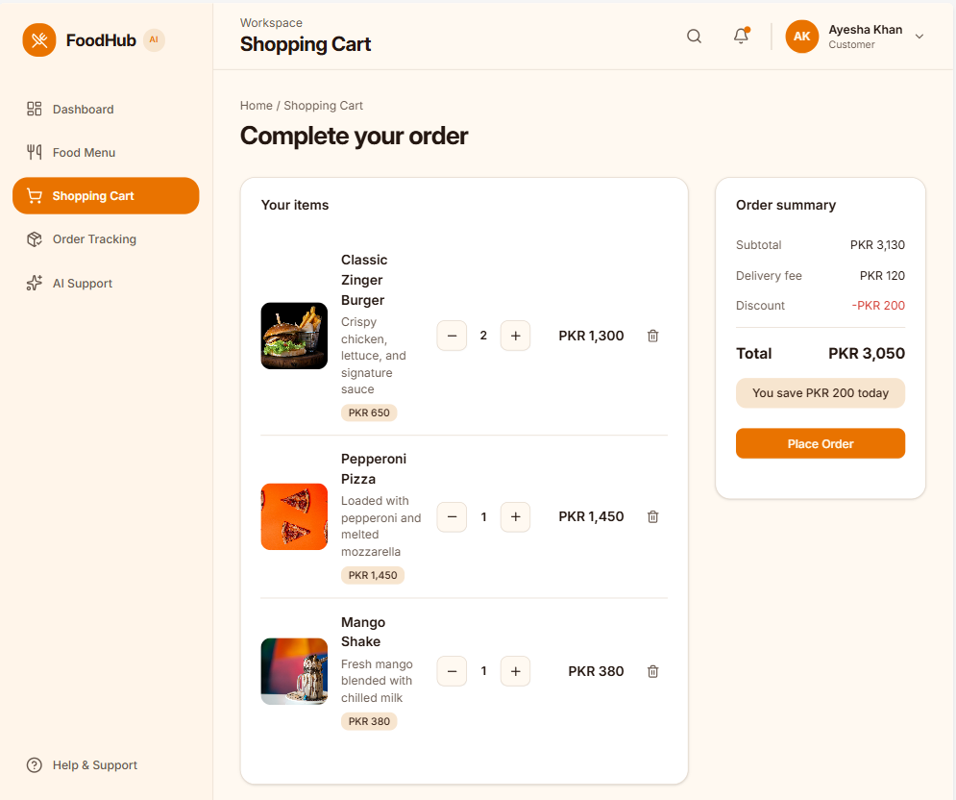
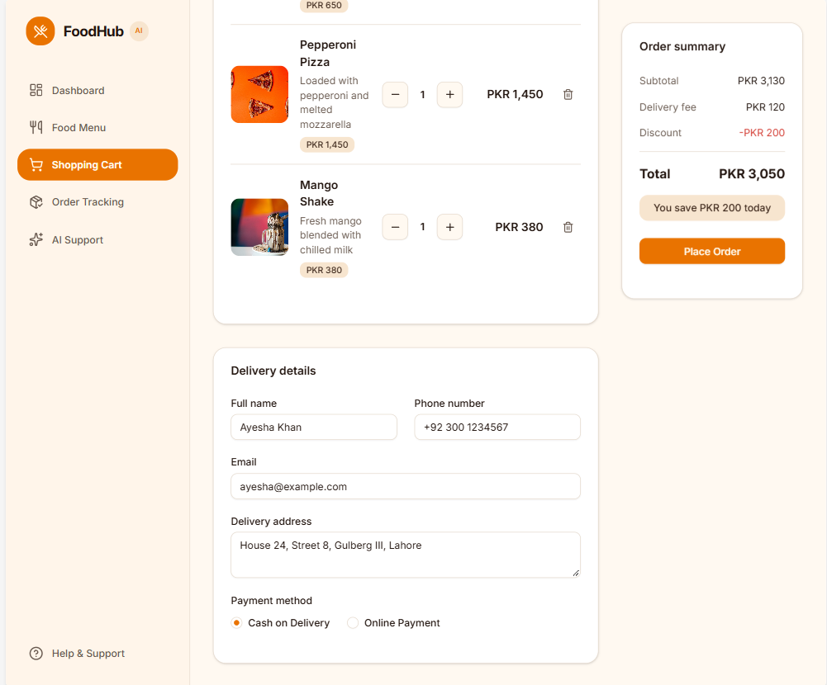
Tablet View:
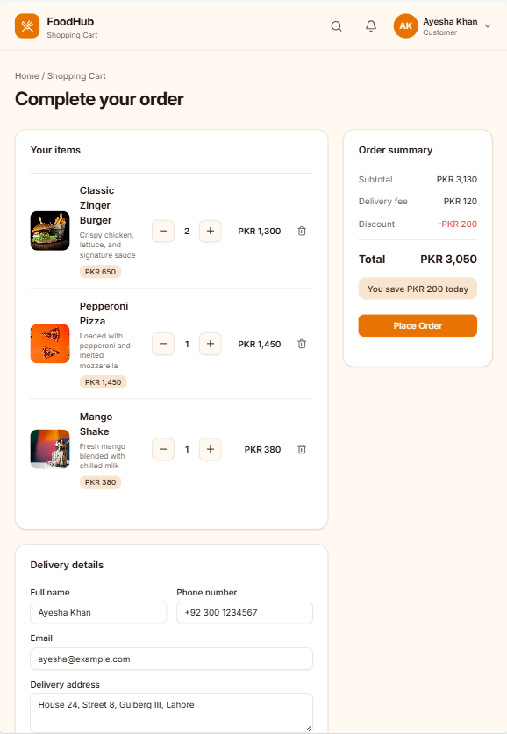
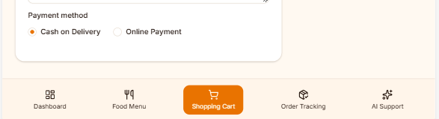

SCREEN 4: ORDER TRACKING
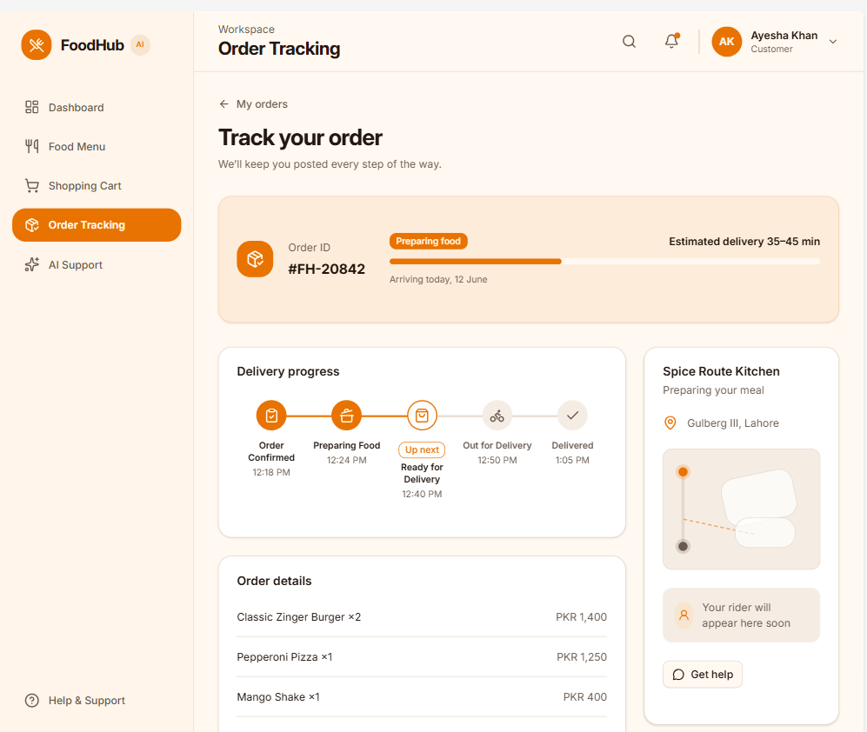
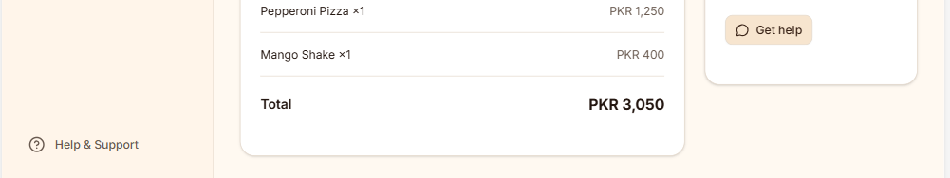

Tablet View:
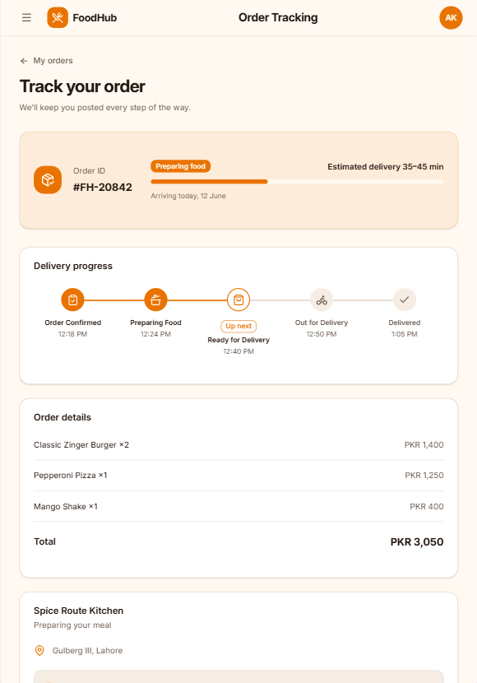
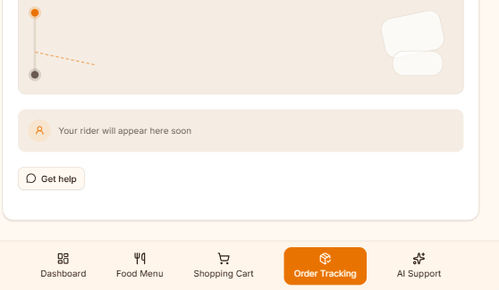

SCREEN 5: AI CUSTOMER SUPPORT CHATBOT
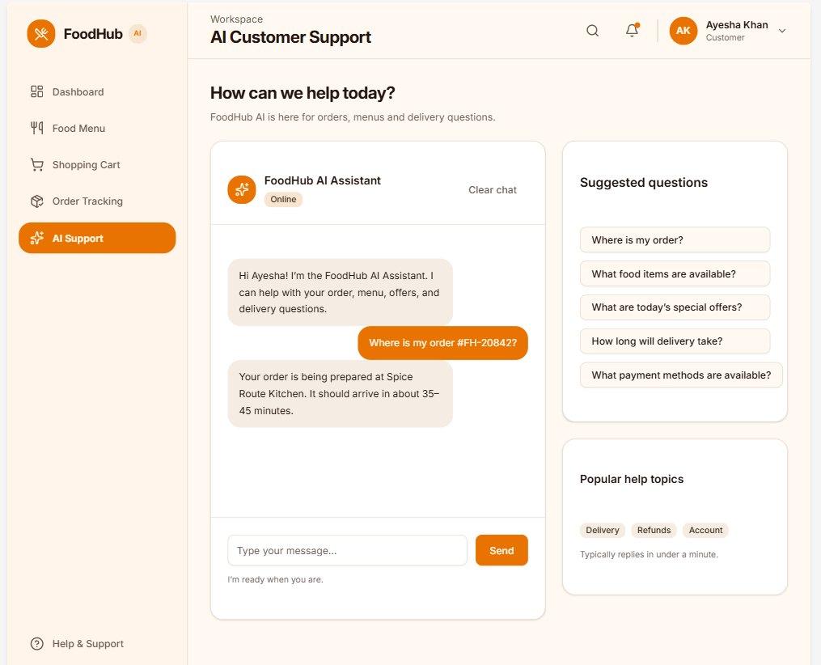

Tablet View:
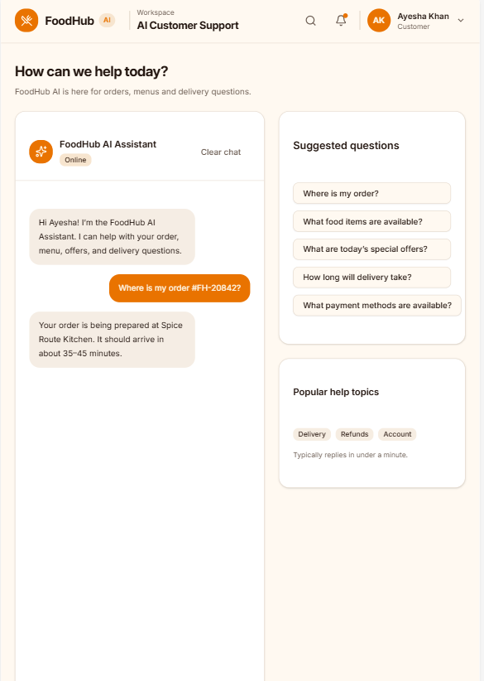
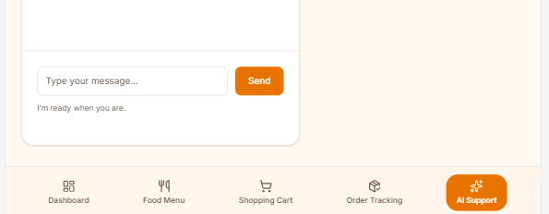

ALL SCREENS:
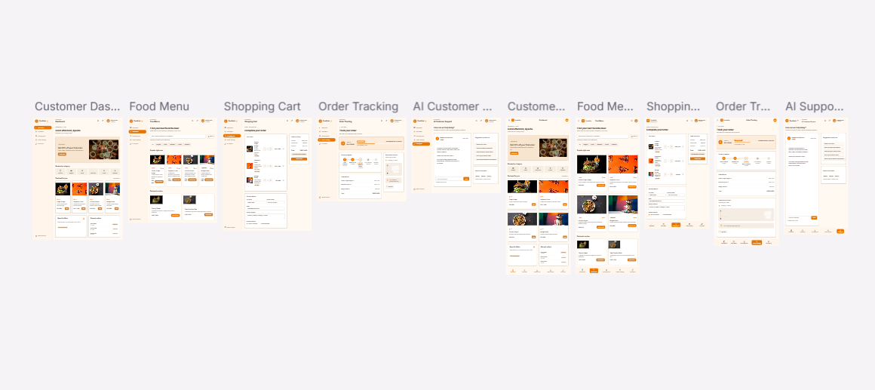

Task 2: Frontend Development and Coding

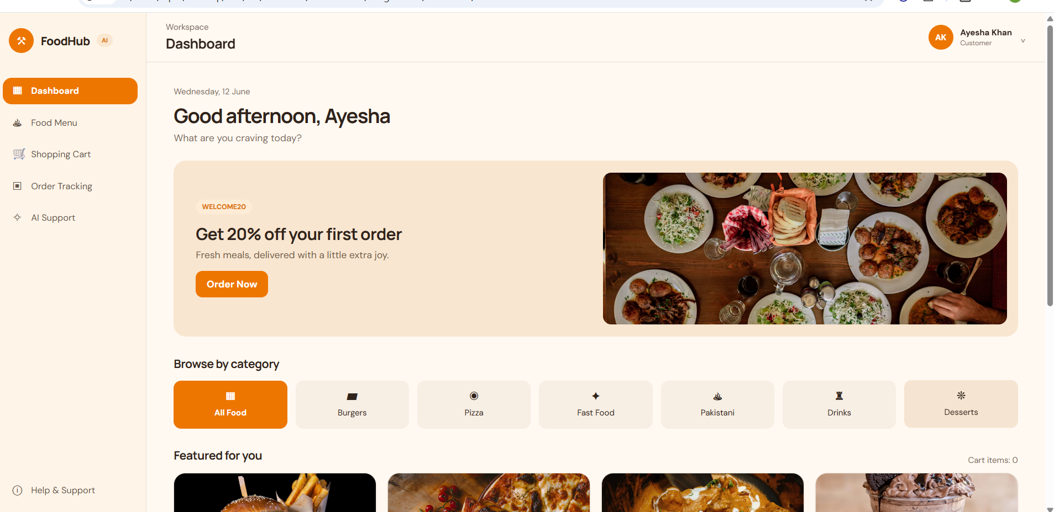

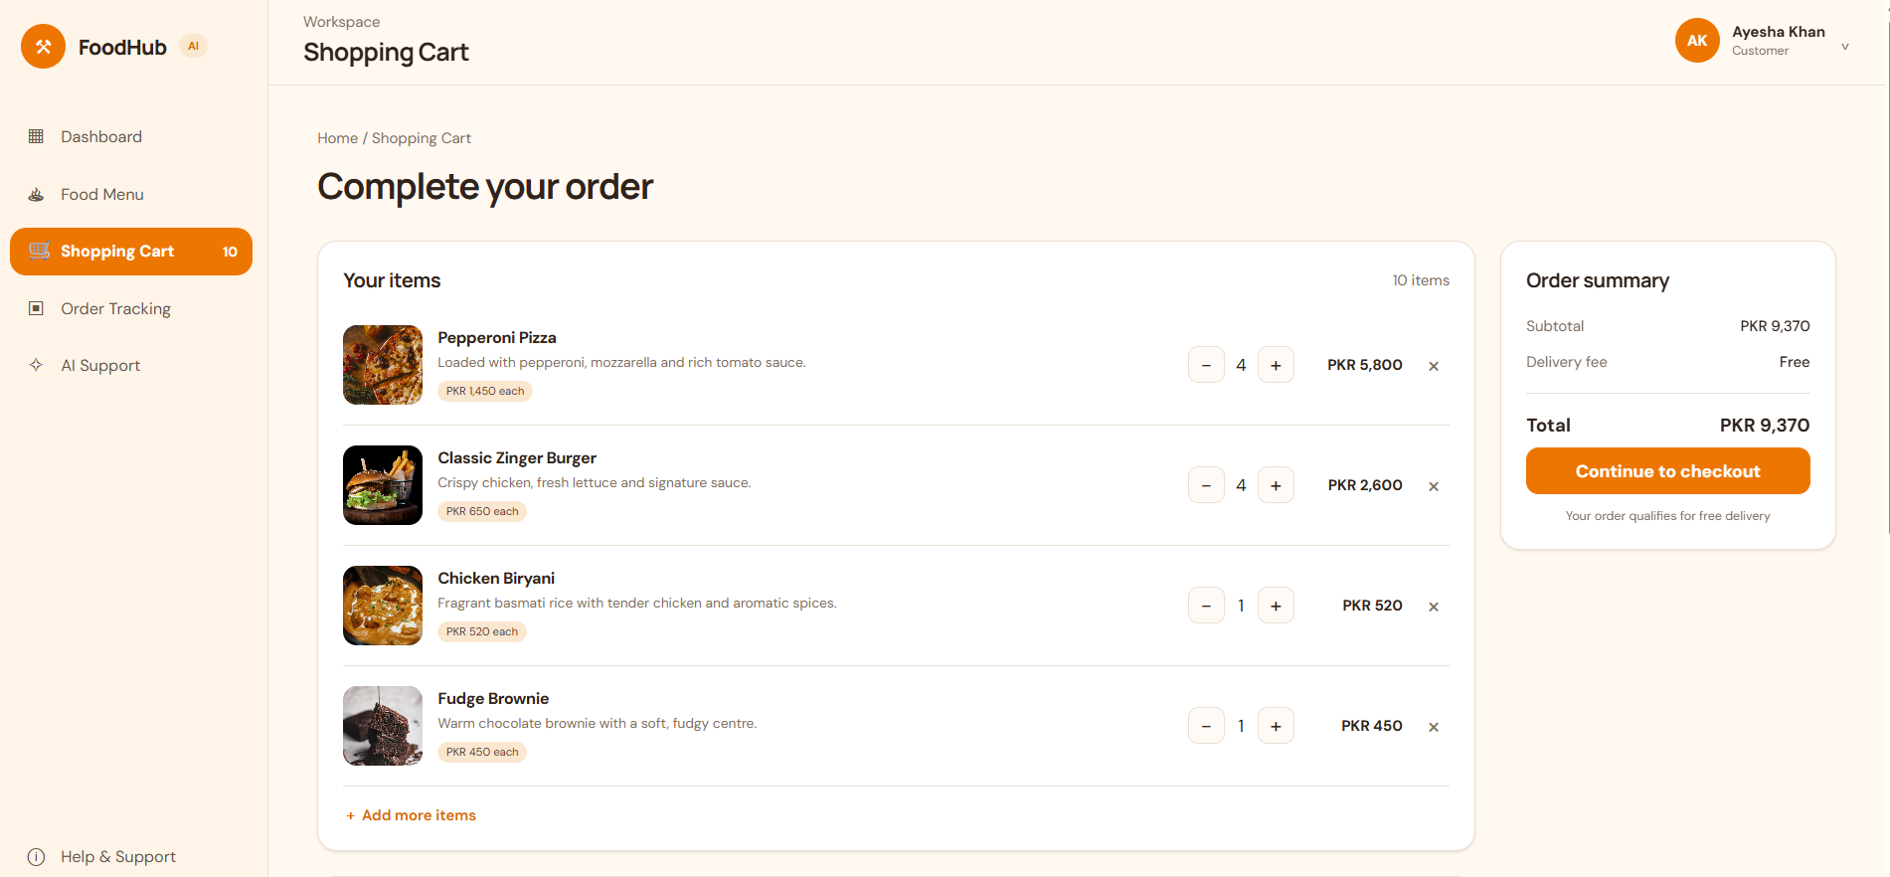

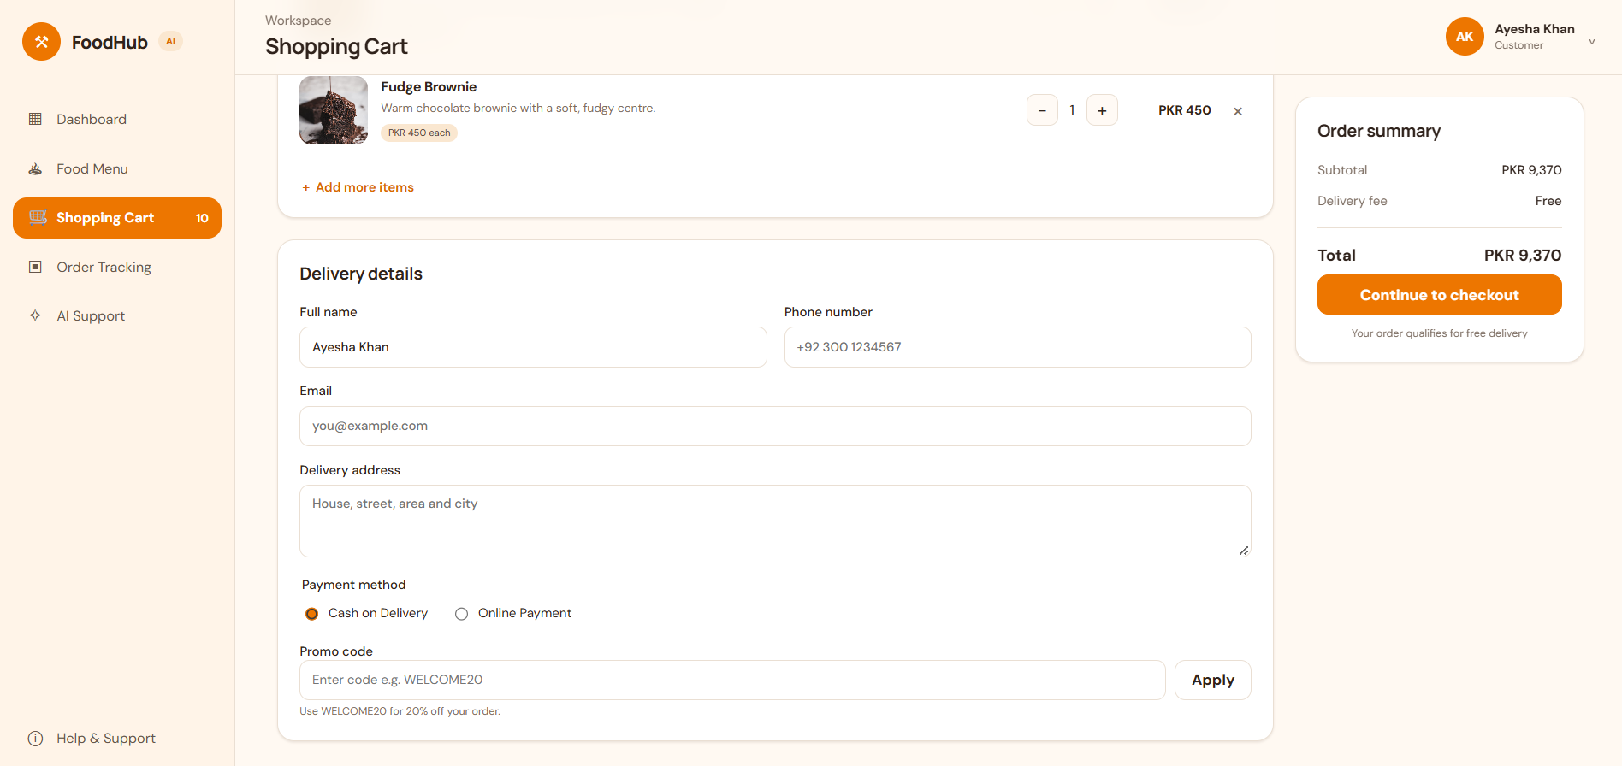
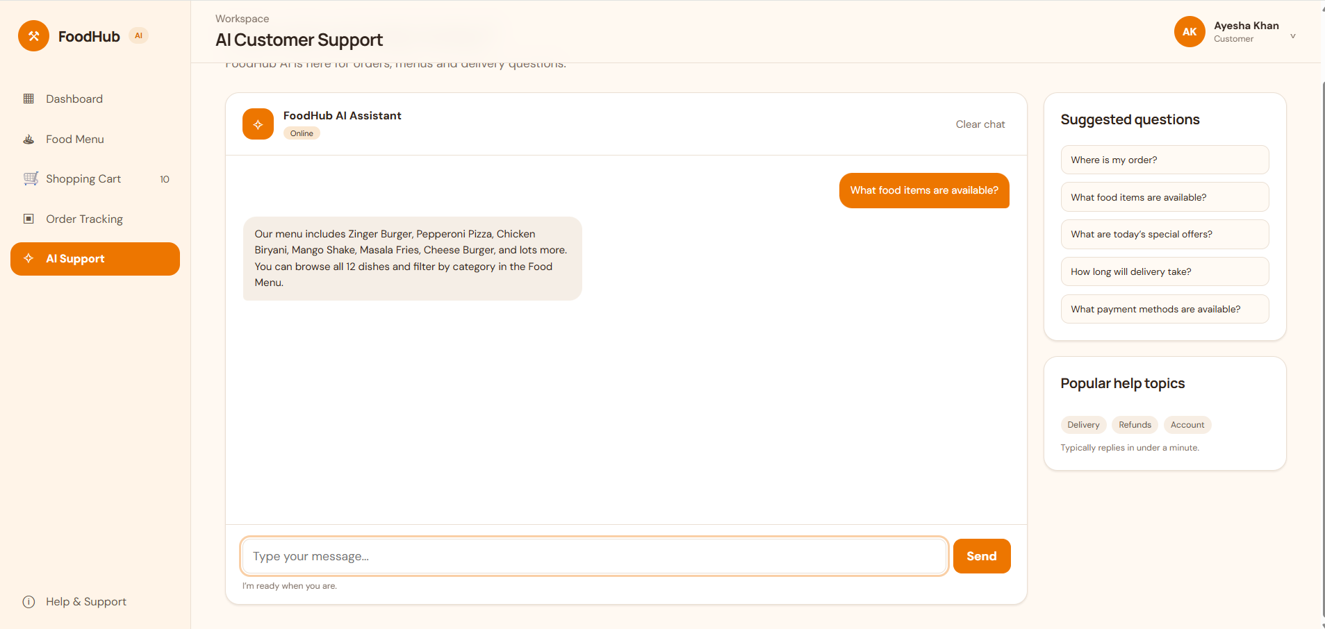

Task 3: AI-Assisted Code Review, Debugging, and Optimization

IDENTIFIED CODE ISSUES

1. The checkout summary's "Continue to checkout" control only scrolled to the
form, and the form had no submit control. A customer could not complete an
order using the interface.

2. The two combo prices did not match their contents: Family Feast displayed
PKR 2,950 while its items totaled PKR 2,750; Desi Comfort Box displayed
PKR 1,250 while its items totaled PKR 1,040.

3. Saved JSON was parsed but its structure was not validated. Incorrect or
stale browser data could cause invalid quantities, item references, or
order statuses to break a view.

4. Storage writes were not protected against browser storage errors or quota
restrictions.

5. Re-rendering checkout after applying a coupon or changing cart contents
cleared the delivery form values.

6. Dashboard and tracking dates were hard-coded, so the interface became
inaccurate on a different day.
7. Navigation labels were hidden on small screens without accessible names,
and selected category buttons did not expose their state to assistive
technology.

8. The free-delivery calculation included exactly PKR 1,500, while the
explanatory copy said "over PKR 1,500".

9. Mobile navigation did not reserve space for device safe areas, and
animations did not respect reduced-motion preferences.

10. The page enforced a 320-pixel minimum width, causing horizontal scrolling
on narrower mobile viewports.

BUGS AND SOLUTIONS

Bug: Checkout never created an order from the visible checkout form.
Solution: Added a "Place order" submit button. The existing required-field
validation runs before the order is stored and the user is taken to tracking.

Bug: Combo prices disagreed with the cart contents.
Solution: Defined combo items once and calculate both displayed prices and
cart additions from that shared definition.

Bug: Malformed saved data could produce bad totals or invalid order status
lookups.
Solution: Added cart, order, and chat data normalizers. Unknown products and
invalid quantities are discarded; order statuses are clamped to valid steps.

Bug: localStorage or sessionStorage write errors could interrupt a customer
action without explanation.
Solution: Each storage write is guarded, errors are logged, and a visible
notification explains that changes could not be saved.

Bug: Applying a coupon reset delivery details already entered by the customer.
Solution: Preserve the checkout draft in page memory during rendering and
navigation, and clear it after placing an order.

Bug: The displayed date could be stale.
Solution: Format the current date using Intl.DateTimeFormat in the dashboard,
tracking view, and newly created order.

Bug: Icon-only mobile navigation and filter selection were not adequately
announced.
Solution: Add accessible labels to navigation links and aria-pressed states
to category buttons.

Bug: The delivery threshold description was inconsistent with the calculation.
Solution: State that free delivery applies to orders of PKR 1,500 or more.

Bug: Very narrow mobile screens scrolled horizontally because of the page's
minimum width.
Solution: Reduced the minimum supported layout width to 280 pixels.

VALIDATION PERFORMED

1. Loaded the improved app in a browser and checked the dashboard, menu, cart,
order tracking, and support views.

2. Added the Family Feast combo and verified a PKR 2,750 subtotal.

3. Applied WELCOME20 and verified the PKR 550 discount and PKR 2,200 total.

4. Entered checkout details, applied the coupon, and verified the entered
delivery and payment values remained in the form.

5. Submitted a valid order and verified it appeared as Order Confirmed in
order tracking.

6. Tested malformed saved cart, order, and chat values. Invalid cart entries
were discarded, an out-of-range order status was normalized, and invalid
chat roles were removed.

7. Filtered the menu to Desserts and verified that exactly two dishes remained
and that the selected filter exposed aria-pressed="true".

8. Checked mobile navigation labels at 390 pixels and the narrow layout at
291 pixels; every navigation link had an accessible name and the document
did not overflow horizontally.

9. No browser page errors were observed during the successful validation run.

10. A Node.js executable was not available in the environment; JavaScript
parsing and behavior were therefore validated by loading and exercising the
app in the browser.

PROMPTS USED WITH AI CODING ASSISTANTS

Original AI-generated source code, improved and modified
source code, identified code issues, bugs and solutions, prompts used with AI
coding assistants, and screenshots demonstrating improvements. Improve the
code and place the new code in Task3Deliverables. Add the theoretical work in
a .txt file for later inclusion in a document. Use Task2Code as the old code."



