**Faculty of Computing and Technology**

**University of Kelaniya**

**CTEC 22043**

**Object Oriented Programming**

**LAB Worksheet-1**

**CT/2021/080**

**Abisekan A.**

**Q1**

Code

package Q_01;  
import javax.swing.*;  
public class SampleWindow {  
 public static void main(String[] args) {  
 JFrame myWindow;  
 myWindow= new JFrame();  
 myWindow.setSize(800, 600);  
 myWindow.setTitle("Welcome to Java");  
 myWindow.setVisible(true);  
 }  
}

Output

**Q2**

**Code**

**package Q_02;  
import javax.swing.*;  
import java.util.*;  
public class FullNameFrame {  
 public static void main(String[] args){  
 *//Scan the user input* Scanner scanner=new Scanner(System.*in*);  
 System.*out*.print("Enter your first name:");  
 String firstName = scanner.nextLine();  
 System.*out*.print("Enter your last name:");  
 String lastName = scanner.nextLine();  
 scanner.close();  
 *//Create the JFrame* JFrame frame= new JFrame();  
 frame.setTitle(firstName +" " + lastName);  
 frame.setSize(800, 600);  
 frame.setVisible(true);  
  
 }  
  
}**

**Q3**

**Code**

**package Q_03;  
import java.util.*;  
public class FullNameFormatter {  
 public static void main(String[] args) {  
 *//Scan the user input* Scanner scanner = new Scanner(System.*in*);  
 System.*out*.print("Enter your first name:");  
 String firstName = scanner.nextLine();  
 System.*out*.print("Enter your middle name:");  
 String middlename = scanner.nextLine();  
 System.*out*.print("Enter your middle name:");  
 String lastName = scanner.nextLine();  
 scanner.close();  
 *//Take first letter of middle name* char middleInitial = middlename.charAt(0);  
 String formattedname = firstName+ " "+middleInitial+"."+lastName;  
 System.*out*.println("Formatted Name: "+formattedname);  
 }  
}**

**Output**

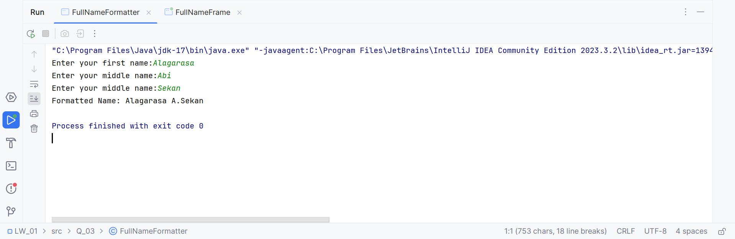

**Q4**

**Code**

**package Q_04;  
import java.time.LocalDate;  
import java.time.format.DateTimeFormatter;  
public class DisplayDate {  
 public static void main(String[] args) {  
 LocalDate today = LocalDate.now();  
  
 DateTimeFormatter formatter = DateTimeFormatter.ofPattern("d MMM yyyy");  
  
 String formattedDate = today.format(formatter);  
 System.*out*.println("Date: " + formattedDate);  
  
  
 }  
}**

**Output**

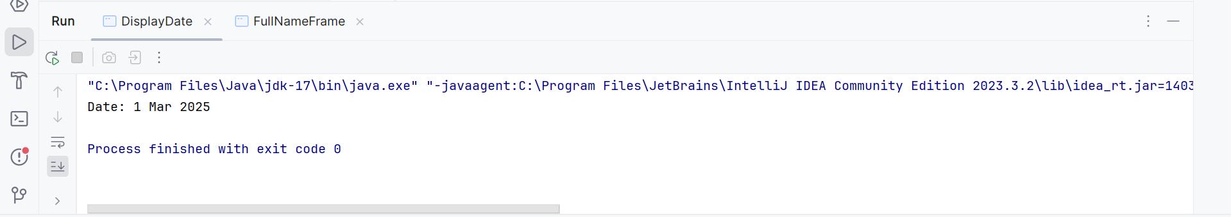

**Q5**

**Code**

**package Q_05;  
import java.time.LocalDate;  
import java.time.format.DateTimeFormatter;  
  
public class Displaydate_week {  
 public static void main(String[] args) {  
 LocalDate today = LocalDate.now();  
  
 DateTimeFormatter formatter = DateTimeFormatter.ofPattern("EEEE, MMMM d, yyyy");  
  
 String formattedDate = today.format(formatter);  
 System.*out*.println("Date: " + formattedDate);  
 }  
}**

**Output**

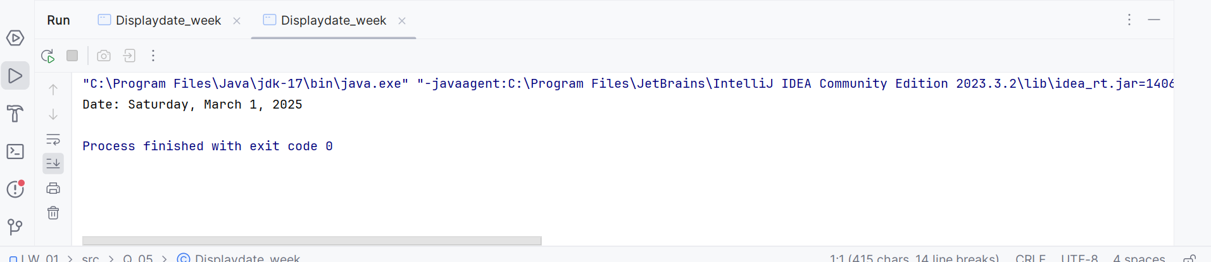

**Q6**

**Code**

**package Q_06;  
import javax.swing.*;  
import java.util.*;  
  
public class UserDefinedFrame {  
 public static void main(String[] args) {  
 Scanner scanner = new Scanner(System.*in*);  
  
 System.*out*.print("Enter the width of the frame (W): ");  
 int W = scanner.nextInt();  
  
 System.*out*.print("Enter the height of the frame (H): ");  
 int H = scanner.nextInt();  
  
 scanner.nextLine();  
 System.*out*.print("Enter the title of the frame: ");  
 String title = scanner.nextLine();  
  
 JFrame frame = new JFrame(title);  
 frame.setSize(W, H);  
 frame.setVisible(true);  
 }  
}**

**Output**

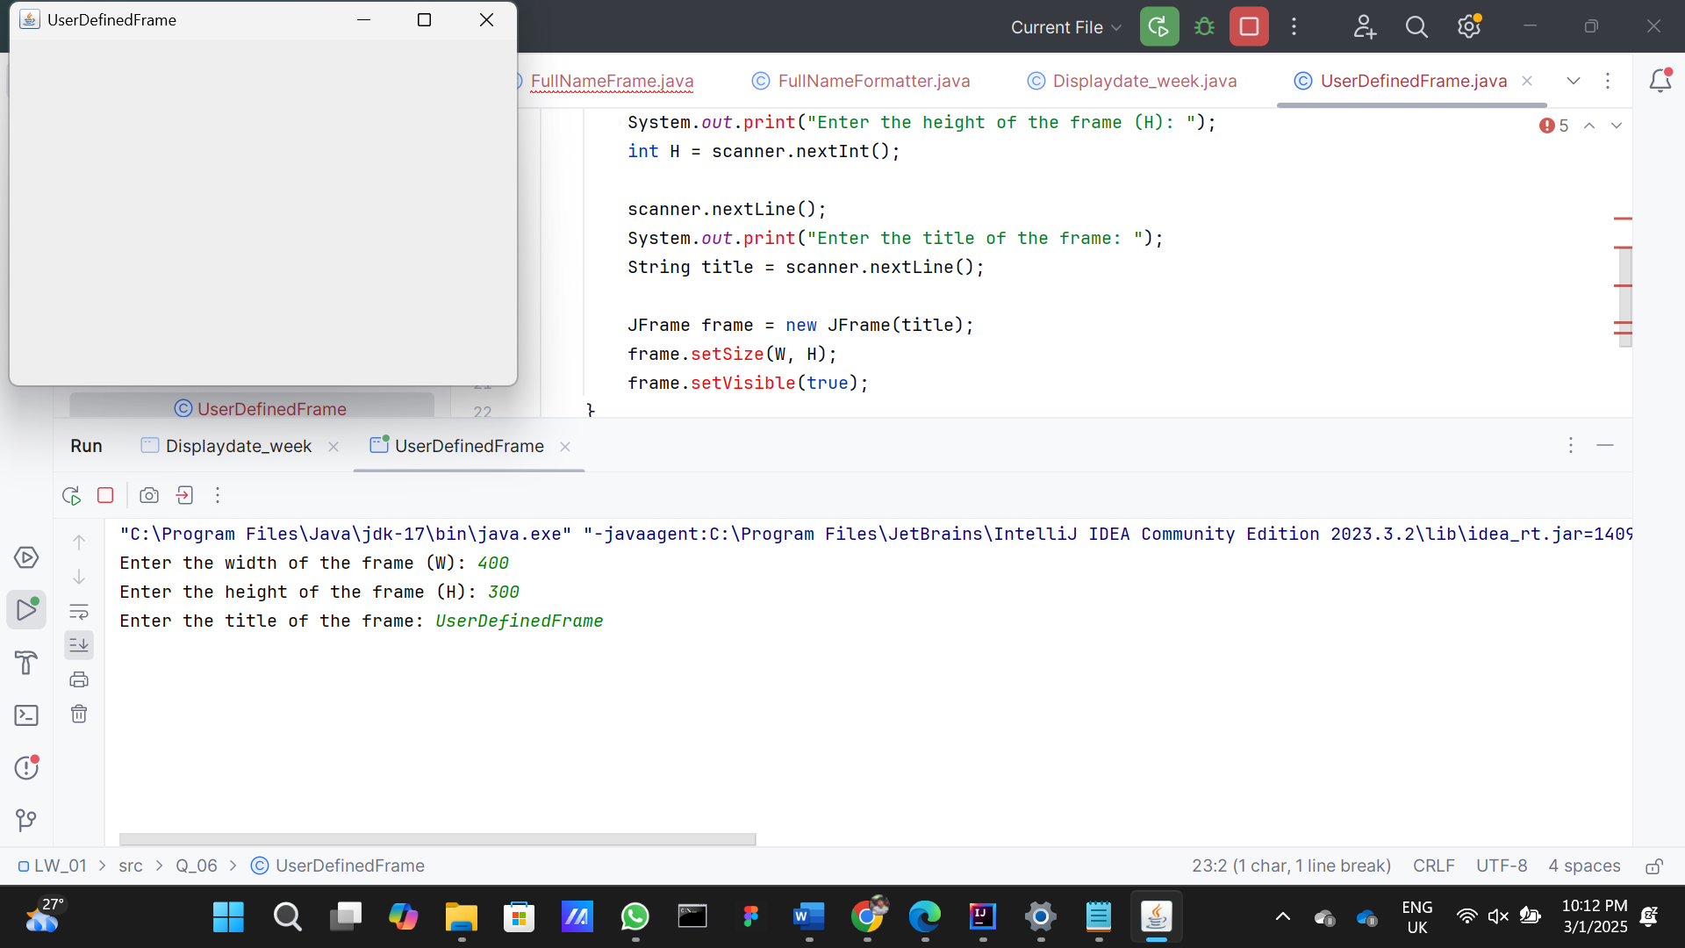

**Q7**

**Code**

**package Q_07;  
import javax.swing.*;  
import java.text.SimpleDateFormat;  
import java.util.Date;  
public class CurrentTimeInFrameTitle {  
 public static void main(String[] args) {  
 JFrame frame = new JFrame();  
 frame.setSize(800, 600);  
  
 SimpleDateFormat dateFormat = new SimpleDateFormat("hh:mm:ss a");  
 String currentTime = dateFormat.format(new Date());  
  
 frame.setTitle(currentTime);  
 frame.setVisible(true);  
 }  
}**

**Output**

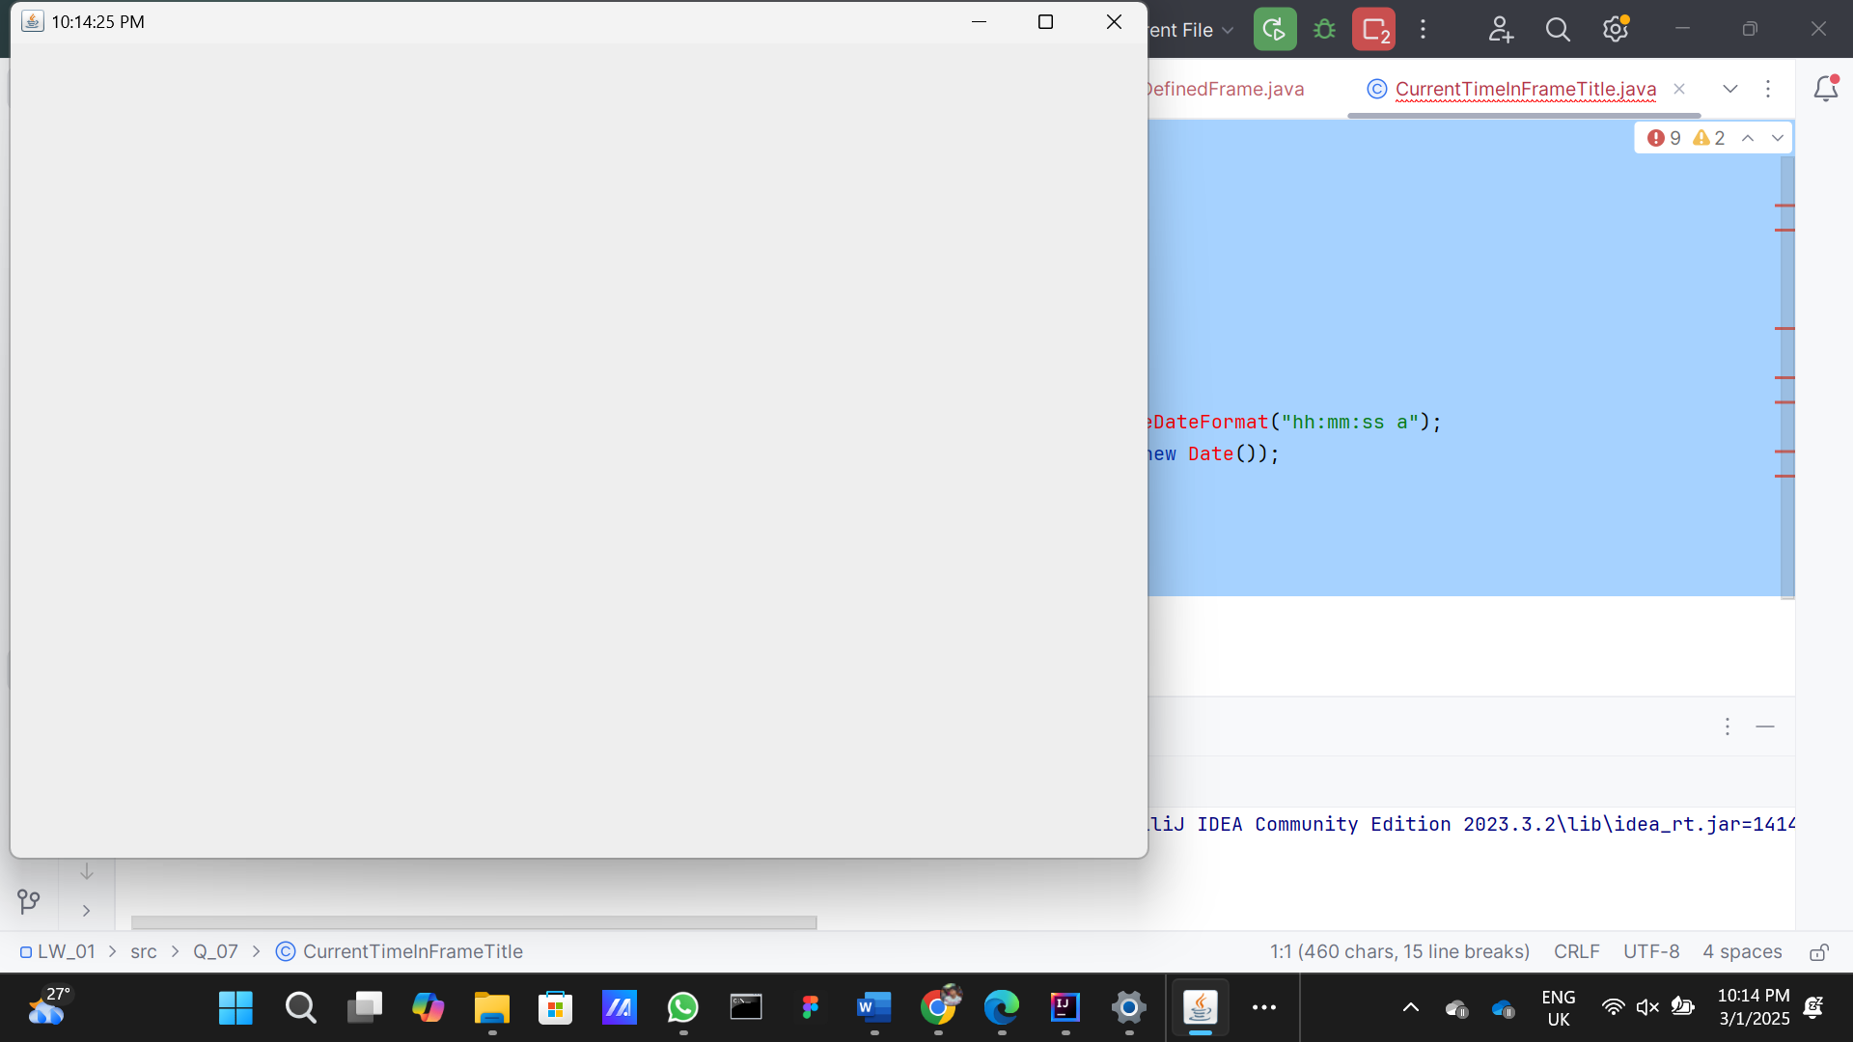

**Q8**

**Code**

**package Q_08;  
import java.util.*;  
public class RemoveExclamationMark {  
 public static void main(String[] args) {  
 Scanner scanner = new Scanner(System.*in*);  
  
 System.*out*.print("Enter a string with one exclamation mark: ");  
 String input = scanner.nextLine();  
  
 int exclamationIndex = input.indexOf('!');  
 String beforeExclamation = input.substring(0, exclamationIndex).trim();  
 String afterExclamation = input.substring(exclamationIndex + 1).trim();  
  
 System.*out*.println(beforeExclamation);  
 System.*out*.println(afterExclamation);  
 }  
}**

**Output**

**Q9**

**Code**

**package Q_09;  
import java.util.*;  
public class StringInfo {  
 public static void main(String[] args) {  
 Scanner scanner = new Scanner(System.*in*);  
  
 System.*out*.print("Enter a string: ");  
 String input = scanner.nextLine();  
  
 int length = input.length();  
 char firstChar = input.charAt(0);  
 char lastChar = input.charAt(length - 1);  
  
 System.*out*.println(length);  
 System.*out*.println(firstChar);  
 System.*out*.println(lastChar);  
 }  
}**

**Output**

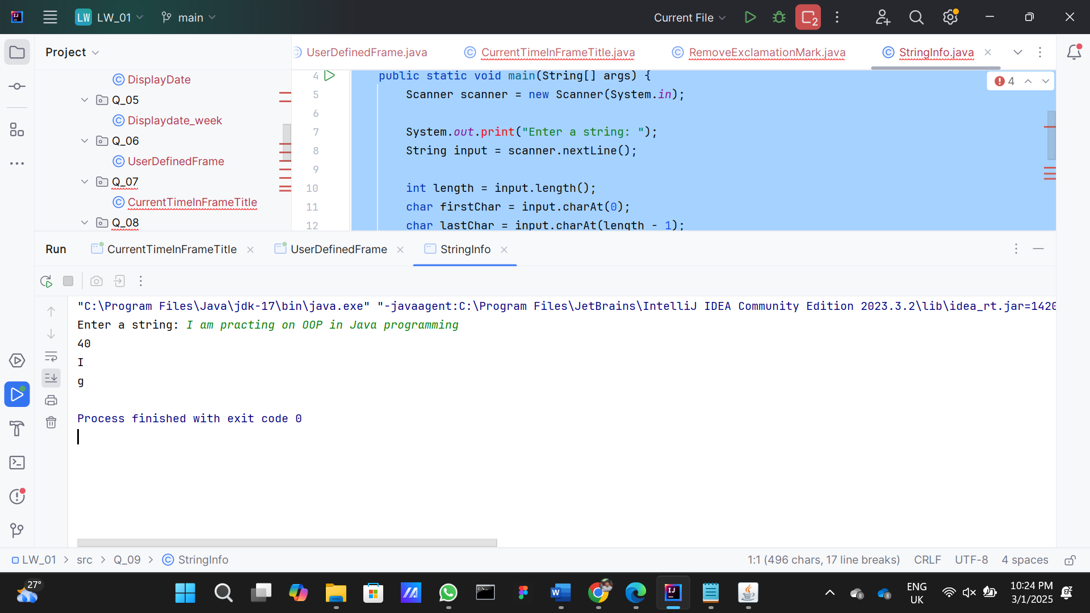

**Q10**

**Code**

**package Q_10;  
import java.util.*;  
public class MiddleCharacter {  
 public static void main(String[] args) {  
 Scanner scanner = new Scanner(System.*in*);  
  
 System.*out*.print("Enter an odd-length word: ");  
 String word = scanner.nextLine();  
  
 if (word.length() % 2 == 0) {  
 System.*out*.println("The word must have an odd length.");  
 } else {  
 int middleIndex = word.length() / 2;  
 char middleChar = word.charAt(middleIndex);  
 System.*out*.println(middleChar);  
 }  
 }  
}**

**Output**

**Q11**

**Code**

**package Q_11;  
import java.util.*;  
public class NameFormat {  
 public static void main(String[] args) {  
 Scanner scanner = new Scanner(System.*in*);  
  
 System.*out*.print("Enter your full name (first middle last): ");  
 String fullName = scanner.nextLine();  
  
 String[] names = fullName.split(" ");  
 String firstName = names[0];  
 String middleName = names[1];  
 String lastName = names[2];  
  
 String formattedName = lastName + ", " + firstName + " " + middleName.charAt(0) + ".";  
 System.*out*.println(formattedName);  
 }  
}**

**Output**

**Q12**

**Code**

**package Q_12;  
import javax.swing.*;  
public class FrameLocation {  
 public static void main(String[] args) {  
 JFrame frame = new JFrame("My First Frame");  
 frame.setSize(300, 200);  
 frame.setLocation(100, 50);  
 frame.setVisible(true);  
 }  
}**

**Output**

