Inventory.ts
let productName: string = "Laptop";
let price: number = 45000;
let inStock: boolean = true;
let tags: string[] = ["Electronics", "Computer"];
let productId: number | string = "P101";

console.log(productName);
console.log(price);
console.log(inStock);
console.log(tags);
console.log(productId);

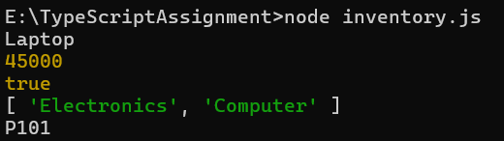

error1.ts

let price: number = "500";
console.log(price);

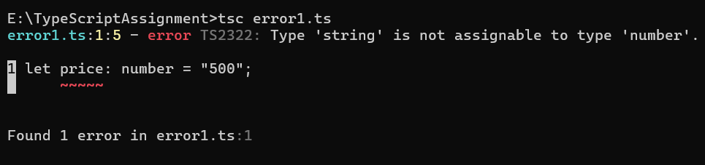
error2.ts
function add(a: number, b: number): number {
return a + b;
}

console.log(add(10));

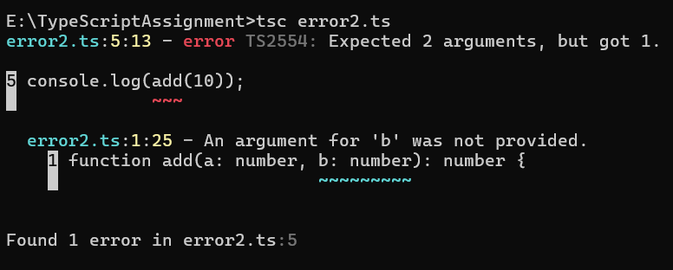

function add(a: number, b: number): number {
return a + b;
}

console.log(add(10, 20));

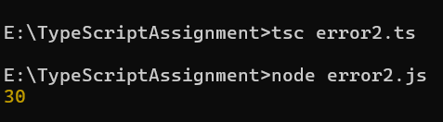

tsconfig.json

{
"compilerOptions": {
"target": "ES6",
"strict": true,
"outDir": "./dist"
},
"include": ["*.ts"]
}

