

**Amrita School of Engineering, Bengaluru**

**Department of Electronics and Communication Engineering**

**B.Tech. in Electronics and Communication Engineering**

**LAB MANUAL**

**Submitted by**

**Abishai G**

**BL.EN.U4ECE22263**

**19ECE283/Linear Integrated Circuits Lab**

**IV Semester**

**Electronics and Communication Engineering**

**Vision and Mission of the Department**

|  |  |  |
| --- | --- | --- |
| Vision | | To provide a value-based learning environment for producing engineers with a blend of technical skills, moral values, and leadership qualities in the field of Electronics, Communication and Computing channelized towards technological advancement to cater to the needs of the industry and the society. |
| Mission | M1 | Achieving excellence in teaching and learning with an emphasis on fundamental knowledge and hands-on exposure to match the state-of-the-art in technology. |
| M2 | Providing an environment for core competency development and enhancing quality research in emerging areas. |
| M3 | Facilitating professional growth to the students for higher education and career in industry and academia |
| M4 | Imbibing the essence of human values, ethics, and professional skills to sustain socio-economic development |

**Course Objectives**

• To be able to characterize operational amplifiers to extract the parameters.

• To experimentally verify and appreciate the difference between op-07 and UA-741.

• To be able design, simulate and implement amplifiers, non-linear wave shaping circuits and

Oscillators.

**Course Outcomes**

**CO1**: Able to characterize op-amp.

**CO2**: Able to understand the various specification parameters of op-amp

**CO3**: Able to design, simulate, analyze, and implement linear and non-linear circuits with   
 op-amps

**CO4**: Able to design, simulate, analyse, and implement sinusoidal oscillator circuits.

**List of Experiments**

|  |  |
| --- | --- |
| **Sl. No** | **Name of the Experiment** |
| 1 | Characterization of operational amplifiers. |
| 2 | Study and investigate the application of operational amplifier as an inverting amplifier, non-inverting amplifier and voltage follower. |
| 3 | Study and design a difference amplifier using op-amp. |
| 4 | Study and design an instrumentation amplifier using op-amps. |
| 5 | Design op-amp based Integrator and Differentiator circuits and analyze its frequency response. |
| 6 | Study and investigate the use of Precision Rectifiers. |
| 7 | Design op-amp based comparator, zero crossing detector, and Schmitt Trigger circuits and understand the significance of Hysteresis curve. |
| 8 | Study of 555 Timer as Astable and Mono-stable Multivibrators. |
| 9 | Design an RC Phase Shift Oscillator and understand the importance of regenerative feedback. |
| 10 | Design a square wave and a triangular wave generator circuit using op-amp. |

**Experiment – 1 Date:**

**Characterization of operational amplifier**

**Aim:**

Measurement of operational amplifier parameters like Common mode gain, difference mode gain, CMRR, and slew rate.

**Apparatus Required:**

1. Op–amp IC 741
2. Dual power supply of 12 V
3. Digital Multimeter
4. Resistors
5. Cathode Ray Oscilloscope (CRO)
6. Breadboard and Connecting wires
7. Probes

**Circuit Diagram:**

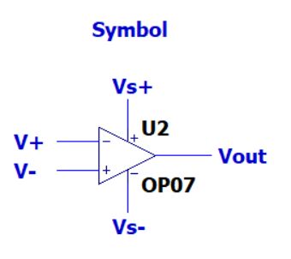 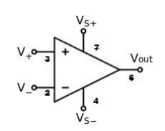

Fig. 1.1 Symbol of Op-amp

**Common Mode Rejection Ratio (CMRR):**

The CMRR is defined as the ratio of the differential gain over the common-mode gain, measured in positive decibels.



Differential mode voltage gain Ad = Vout / (V1 – V2)

Where V1 = Voltage applied at non-inverting pin through resistor.

V2 = Voltage applied at inverting pin through resistor.

Common mode voltage gain Acm = Vout / Vcm

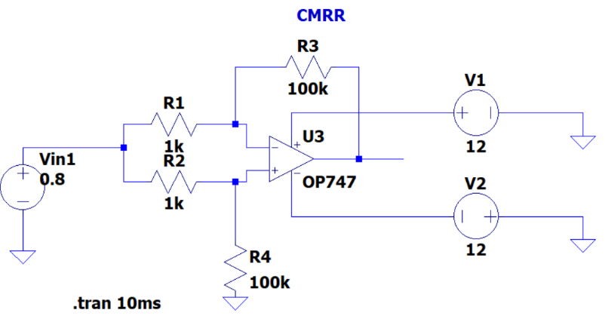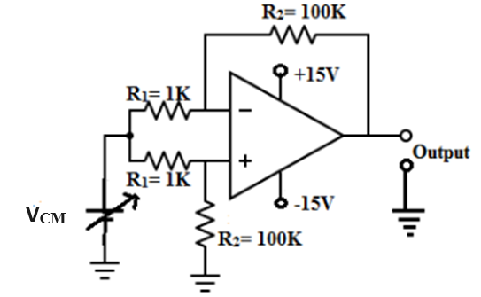

Fig. 1.2 Circuit Diagram for Measurement of ACM

**Procedure:**

1. Vary VCM (0.6 V, 0.7 V, 0.8 V) in the circuit shown in fig 1.2, note down the output voltage for each input and calculate ACM.
2. Modify the circuit shown in fig 1.2 such that V1 and V2 can be applied separately.
3. Vary voltage V1 and V2 and note down the output voltage for each inputs and calculate Ad.
4. Note the input and output voltages in observation table and calculate CMRR.

For 0.8 For 0.6 For 0.7

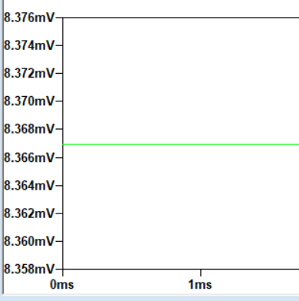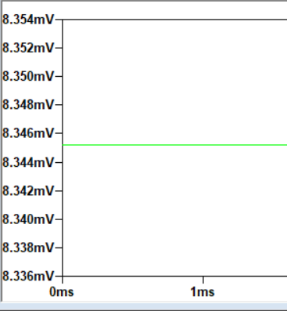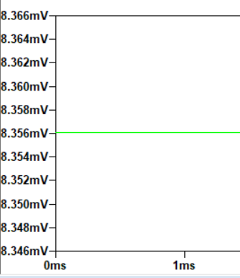

**Observation Table:**

|  |  |  |  |  |  |  |  |  |
| --- | --- | --- | --- | --- | --- | --- | --- | --- |
| **S.No.** | **VCM** | **Vo** | **AC= Vo/ VCM** | **S.No.** | **V1** | **V2** | **Vo** | **Ad = Vo/(V1-V2)** |
|  |  |  |  |  |  |  |  |  |
|  |  |  |  |  |  |  |  |  |
|  |  |  |  |  |  |  |  |  |

**CMRR = 20 log10 (Ad/Ac)**

**Slew Rate:**

The slew rate of an electronic circuit is defined as the rate of change of the voltage per unit time. Slew rate is usually expressed in units of V/µs.



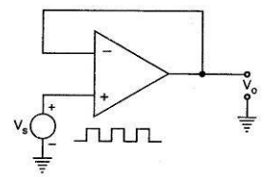 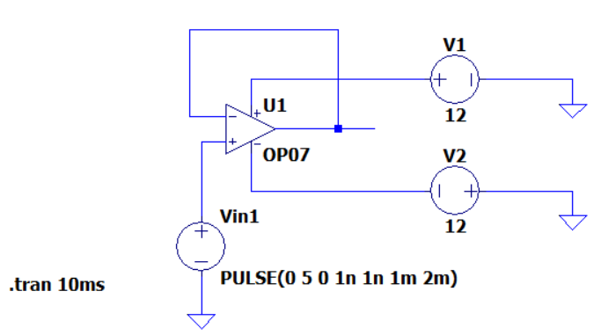

Fig. 1.3 Circuit Diagram for Measurement of Slew Rate

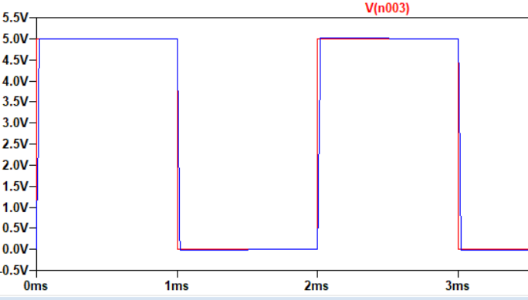 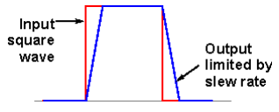

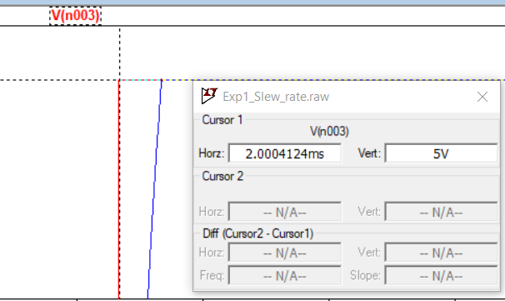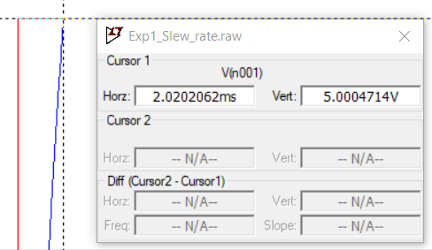

**Result:**

We have conducted measurement of operational amplifier parameters like Common mode gain, difference mode gain, CMRR, and slew rate.

|  |  |
| --- | --- |
| **For Faculty Use Only** | |
| Performance Marks (Out of 5) |  |
| Viva Marks (Out of 5) |  |
| Report Grade |  |
| Faculty Signature with date |  |

**Experiment – 2 Date:**

**Study and investigate the application of operational amplifier as an inverting amplifier, non-inverting amplifier and voltage follower.**

**Aim:**

To study and realize the following configurations of op-amp-

1. Inverting amplifier of gain -10V/V using IC 741.
2. Non-Inverting amplifier of gain 11V/V using IC 741
3. Voltage Follower

**Apparatus Required:**

1. Op – amp IC 741
2. Dual Power Supply of 12 V
3. Resistors
4. Function Generator
5. DSO or CRO
6. Breadboard and Connecting Wires
7. Probes

**i). Inverting Amplifier**

**Circuit Diagram:**

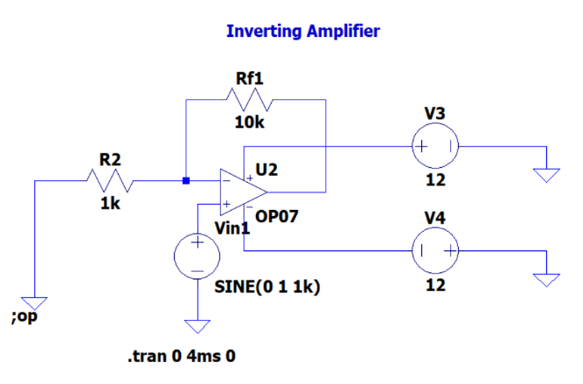

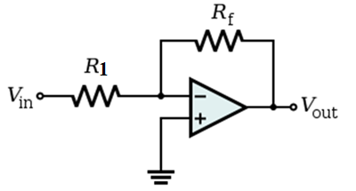

Fig. 2.1 Circuit Diagram of Inverting Operational Amplifier

R1 =

Rf =

Close loop gain G =

**Procedure:**

1. Make connections as given in Fig. 2.1 for inverting amplifier.
2. Give sinewave input of Vi volts using function generator with the frequency of 1 KHz.
3. The output voltage Vout observed on a CRO. A dual channel CRO to be used to see input and output Vin & Vout.
4. Vary Rf and measure the corresponding Vout and observe the phase of Vout with respect to Vin.
5. Tabulate the readings and verify with theoretical values.

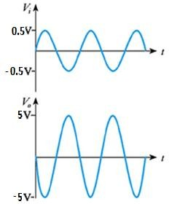**Model Graph:**

Fig. 2.2 Model Graph for Inverting Operational Amplifier

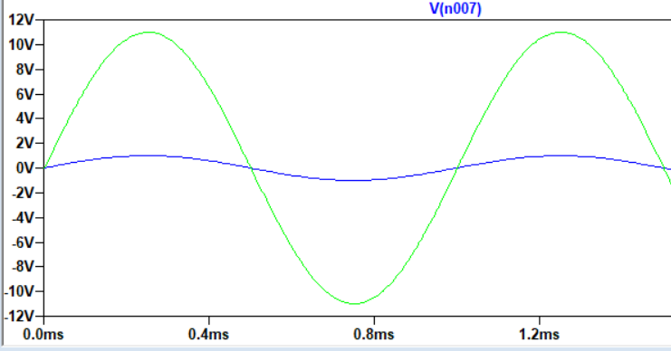

**ii). Non–inverting Amplifier**

**Circuit Diagram:**

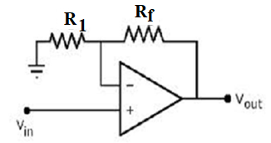 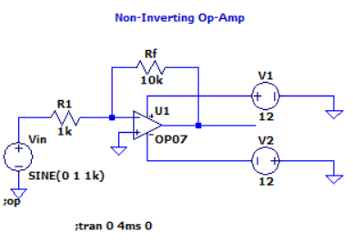

Fig. 2.3 Circuit Diagram of Non-inverting Operational Amplifier

R1 =

Rf =

Close loop gain G =

**Procedure:**

1. Make connections as given in Fig. 2.3 for non-inverting amplifier.
2. Give sinewave input of Vi volts using AFO with the frequency of 1 KHz.
3. The output voltage Vout observed on a CRO. A dual channel CRO to be used to see input and output Vin & Vout.
4. Vary Rf and measure the corresponding Vout and observe the phase of Vout with respect to Vin.
5. Tabulate the readings and verify with theoretical values.

**Model Graph:**

Fig. 2.4 Model Graph for Non-inverting Operational Amplifier

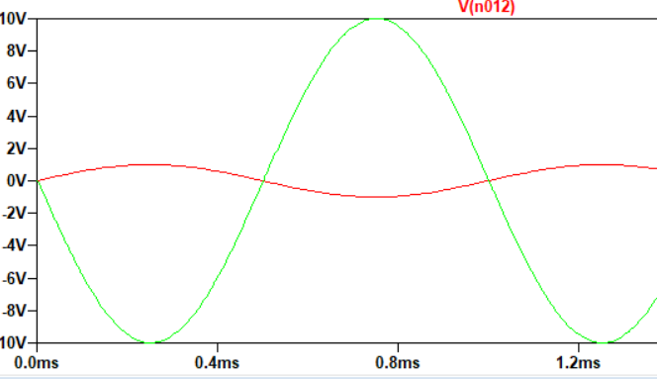

**iii). Voltage Follower**

**Circuit Diagram:**

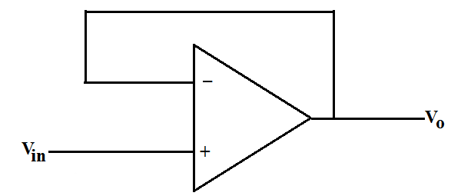

Fig. 2.5 Circuit Diagram of Voltage Follower

VO = Vin

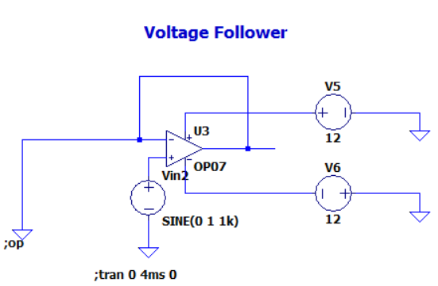

**Procedure:**

1. Make connections as given in Fig. 2.5 for voltage follower.
2. Give sinewave input of Vi volts using AFO with the frequency of 1 KHz. The output voltage V0 observed on a CRO.

**Model Graph:**

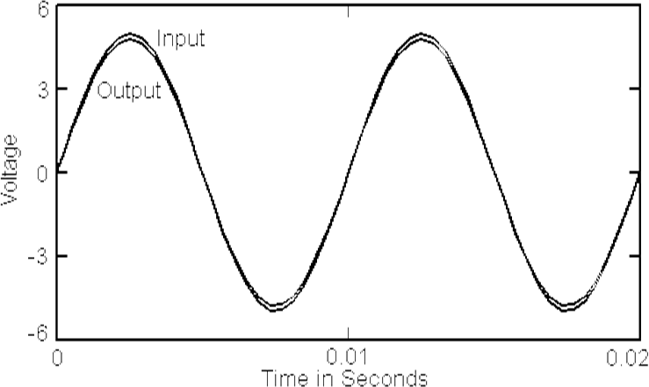

Fig. 2.6 Model Graph for Voltage Follower

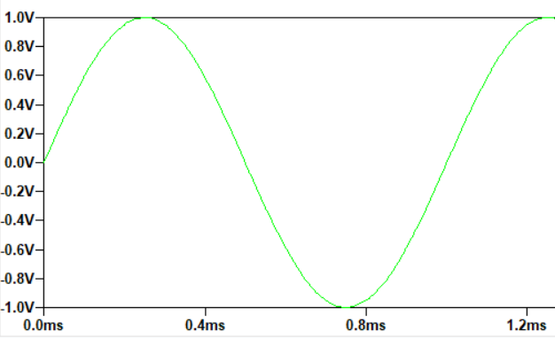

**Observation Table:**

|  |  |  |  |  |
| --- | --- | --- | --- | --- |
| **Circuits** | **I/P Voltage**  **Vp-p** | **O/P Voltage**  **Vp-p** | **Theoretical Gain** | **Practical Gain** |
| Inverting |  |  |  |  |
| Non-inverting |  |  |  |  |
| Voltage follower |  |  |  |  |

**Result:**

We have studied and realized the Inverting amplifier configuration of gain -10V/V using IC 741, Non-Inverting amplifier of gain 11V/V using IC 741 and Voltage Follower.

|  |  |
| --- | --- |
| **For Faculty Use Only** | |
| Performance Marks (Out of 5) |  |
| Viva Marks (Out of 5) |  |
| Report Grade |  |
| Faculty Signature with date |  |

**Experiment – 3 Date:**

**Study and design a difference amplifier using op-amp**

**Aim:**

To study and design the operation of differential amplifier.

**Apparatus required:**

1. Op-amp IC 741
2. Dual power Supply
3. Resistors
4. Function Generator
5. Cathode Ray Oscilloscope (CRO)
6. Multimeter
7. Breadboard and Connecting wires.
8. Probes

**Circuit Diagram:**

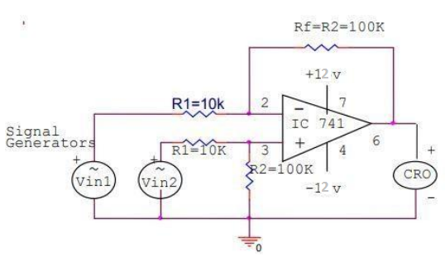

Fig. 3.1 Circuit Diagram of Difference Amplifier

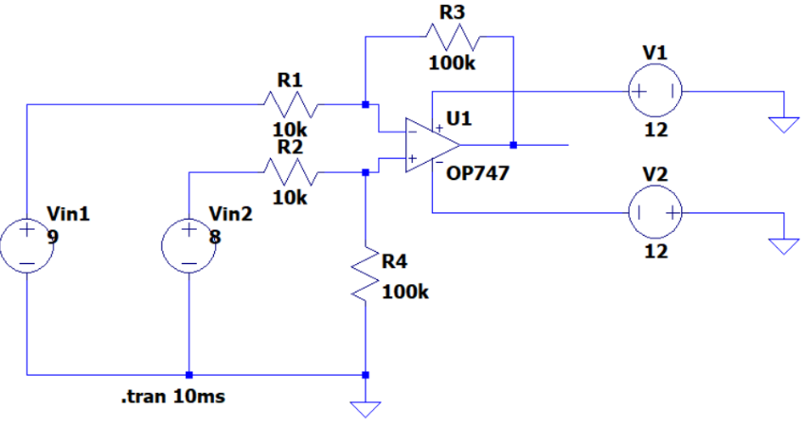

**Procedure**:

1. Select the value of R1, R2, R3 & Rf such that R1 = R2 and R3 = Rf.
2. Connect the circuit as per the circuit diagram shown in Fig. 3.1.
3. Provide constant input voltage Vin1 to inverting terminal of op-amp through R1 & constant input voltage Vin2 to non-inverting terminal of op-amp.
4. Measure the output voltage using CRO.
5. Calculate the theoretical gain and compare it with practical gain.
6. Practical gain & theoretical gain should be approximately equal.

**Observation Table:**

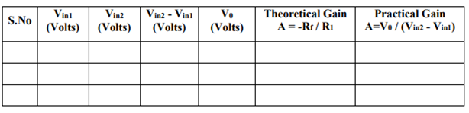

**Result:**

We studied and designed the operation of differential amplifier.

|  |  |
| --- | --- |
| **For Faculty Use Only** | |
| Performance Marks (Out of 5) |  |
| Viva Marks (Out of 5) |  |
| Report Grade |  |
| Faculty Signature with date |  |

**Experiment – 4 Date:**

**Study and design an instrumentation amplifier using op-amps**

**Aim:**

To Study and design an instrumentation amplifier using op-amps.

**Apparatus required:**

1. Op-amp IC 741
2. Resistors
3. Function Generator
4. Cathode Ray Oscilloscope (CRO)
5. Multimeter
6. Breadboard and Connecting wires.
7. Probes

**Circuit Diagram:**

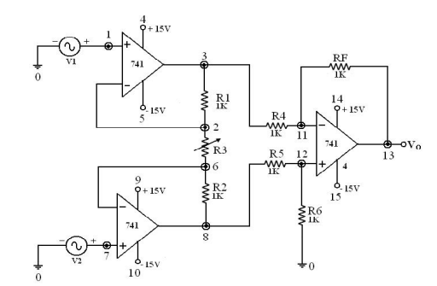

Fig. 4.1 Circuit Diagram of Instrumentation Amplifier

**Design Procedure:**

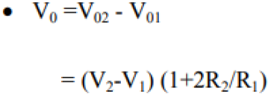

Gain = __________________

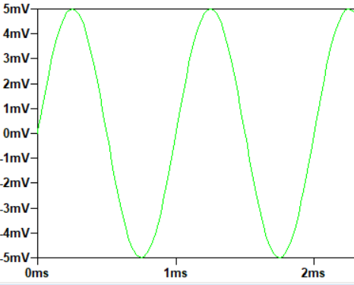 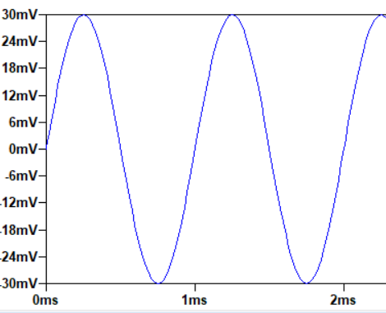

**Procedure**:

1. Connect the circuit as per the experimental set up shown in Fig. 4.1.
2. Provide the input signal V1 and V2.
3. Switch On the dual power supply.
4. Vary the input signal in steps and note the corresponding output readings from CRO.
5. The practical gain is calculated from the readings and compared with the theoretically designed gain.

**Observation Table:**

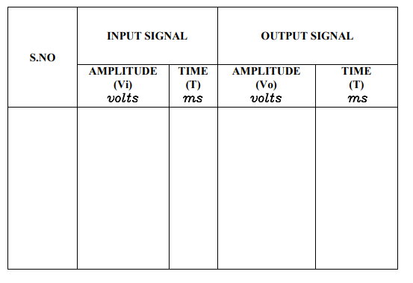

**Model Graph:**

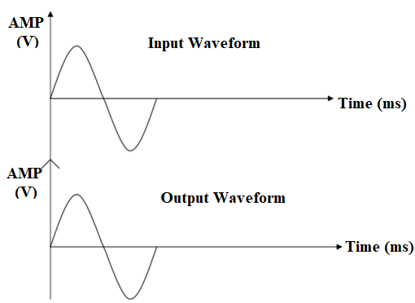Figure 4.2 Model Graph for Instrumentation Amplifier

**Result:**

We studied and designed an instrumentation amplifier using op-amp.

|  |  |
| --- | --- |
| **For Faculty Use Only** | |
| Performance Marks (Out of 5) |  |
| Viva Marks (Out of 5) |  |
| Report Grade |  |
| Faculty Signature with date |  |

**Experiment – 5 Date:**

**Design op-amp based integrator and differentiator circuits and analyze its frequency response.**

**Aim:**

To design op amp based integrator and differentiator circuits and analyze its frequency response.

**Apparatus Required:**

1. Resistor
2. Capacitor
3. Function Generator
4. Op-amp IC 741
5. Dual Supply
6. Cathode Ray Oscilloscope (CRO)
7. Bread Board, Connecting wires and probes.

**Integrator:**

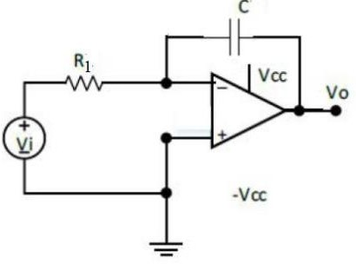**Circuit Diagram:**

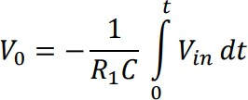Figure 5.1 Circuit Diagram of Integrator

Figure 5.2 Circuit Diagram of Practical Integrator

**Procedure:**

1. Connect the circuit as shown in the figures.
2. Set the input voltage using function generator.
3. Observe the output waveform in CRO and measure the output parameters.

**Observation Table:**

**Vi =**

|  |  |  |  |  |
| --- | --- | --- | --- | --- |
| **S.No.** | **Frequency (Hz)** | **Output Voltage Vo (Volts)** | **Gain = Vo/Vi** | **Av = 20logVo/Vi (dB)** |
|  |  |  |  |  |
|  |  |  |  |  |
|  |  |  |  |  |
|  |  |  |  |  |
|  |  |  |  |  |
|  |  |  |  |  |
|  |  |  |  |  |
|  |  |  |  |  |

**Model Graph:**

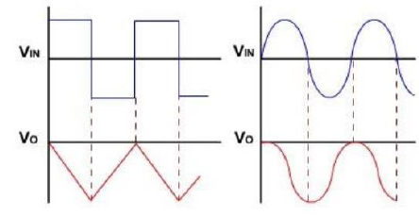

Fig. 5.3 Model Graph for Integrator

**Frequency Response Characteristics:**

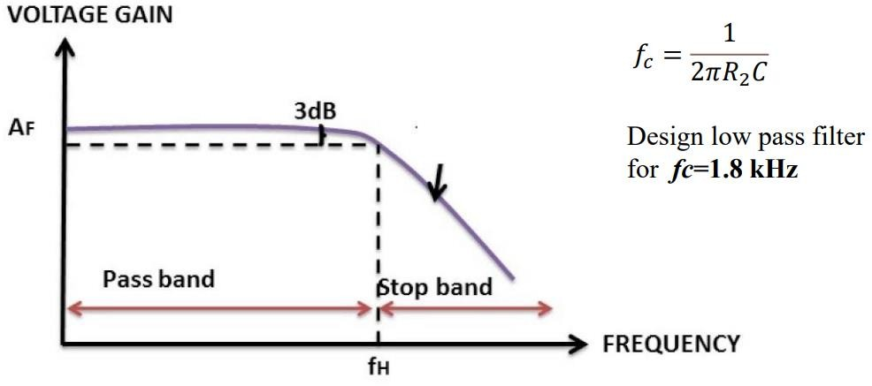

Fig. 5.4 Frequency Response for Integrator

**Differentiator:**

**Circuit Diagram:**

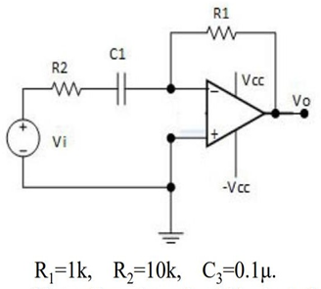

Fig. 5.5 Circuit Diagram of Differentiator

**Procedure:**

1. Connect the circuit as shown in the Fig. 5.5.
2. Set the input voltage using function generator.
3. Observe the output waveform in CRO and measure the output parameters.
4. Draw frequency response between the voltage gain and different frequencies and check the cutoff frequency.

**Observation Table:**

**Vi =**

|  |  |  |  |  |
| --- | --- | --- | --- | --- |
| **S.No.** | **Frequency (Hz)** | **Output Voltage Vo (Volts)** | **Gain = Vo/Vi** | **Av = 20logVo/Vi (dB)** |
|  |  |  |  |  |
|  |  |  |  |  |
|  |  |  |  |  |
|  |  |  |  |  |
|  |  |  |  |  |
|  |  |  |  |  |
|  |  |  |  |  |

**Model Graph:**

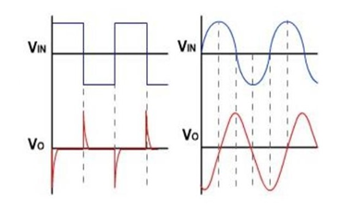

Figure 5.6 Model graph for Differentiator

**Frequency Response Characteristics:**

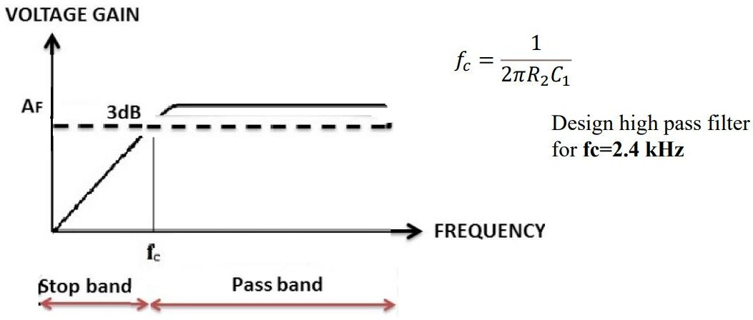

Fig. 5.7 Frequency Response of Differentiator

**Result:**

|  |  |
| --- | --- |
| **For Faculty Use Only** | |
| Performance Marks (Out of 5) |  |
| Viva Marks (Out of 5) |  |
| Report Grade |  |
| Faculty Signature with date |  |

**Experiment – 6 Date:**

**Study and investigate the use of Precision Rectifiers**

**Aim:**

To construct precision half wave rectifier and full wave rectifier using Op-amp and observe the output signal and draw their transfer characteristics.

**Apparatus Required:**

1. Resistor
2. Op-amp IC 741
3. Function generator
4. Diode IN 4001
5. Connecting wires and probes
6. CRO
7. Bread board

**Precision Half-wave Rectifier:**

**Circuit Diagram:**

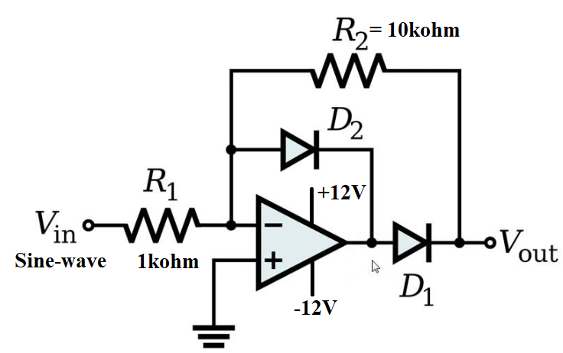

Fig. 6.1 Precision Half wave Rectifier

**Observation Table:**

|  |  |  |  |  |  |
| --- | --- | --- | --- | --- | --- |
| S.No. | Input  Vinp-p | Output Voutp-p | | | |
| During the positive cycle of input | | During the negative cycle of input | |
| Theoretical | Practical | Theoretical  (-R2/R1)Vin | Practical |
|  |  |  |  |  |  |

**Model Graph:**

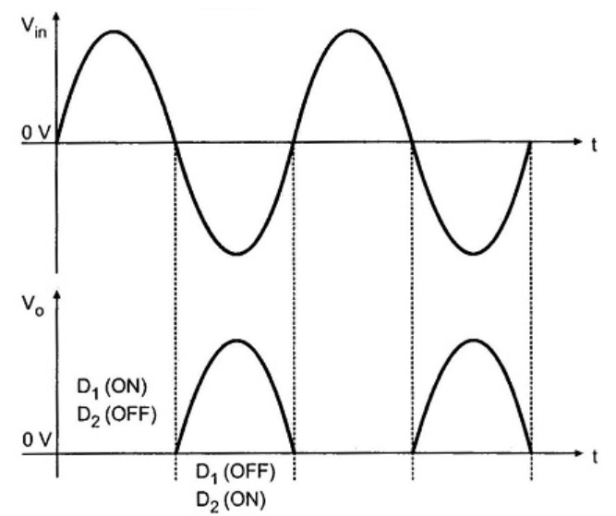

**Transfer Characteristics:**

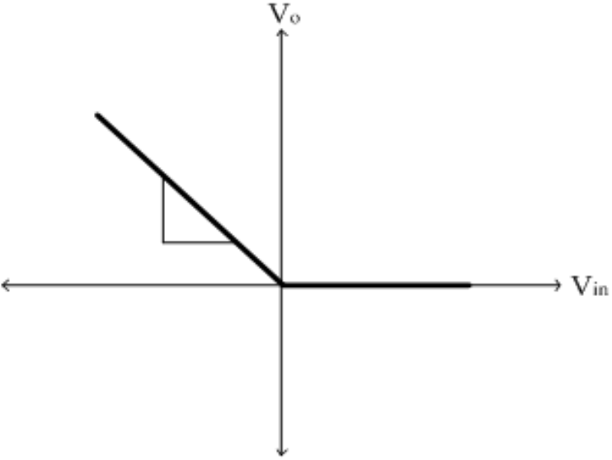

**Precision Full-wave Rectifier:**

**Circuit Diagram:**

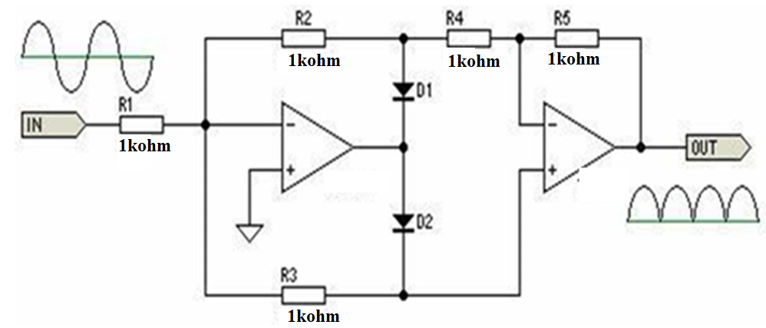

Fig. 6.2 Precision Full-wave Rectifier

**Observation Table:**

|  |  |  |  |  |  |
| --- | --- | --- | --- | --- | --- |
| S.No. | Input  Vinp-p | Output Voutp-p | | | |
| During the positive cycle of input | | During the negative cycle of input | |
| Theoretical | Practical | Theoretical | Practical |
|  |  |  |  |  |  |

**Model Graph:**

Input waveform: Output waveform:

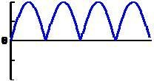

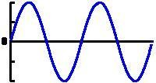

**Transfer Characteristics:**

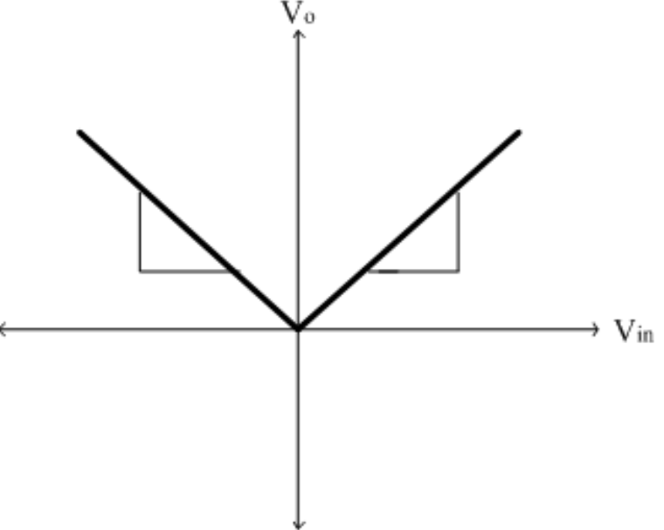

**Procedure:**

1. Connect the circuit as shown in the Fig. 6.1 and Fig. 6.2 for Half wave and Full wave precision rectifier respectively.
2. Set the input signal using function generator.
3. Observe the output waveform in CRO and measure the output parameters.

**Result:**

|  |  |
| --- | --- |
| **For Faculty Use Only** | |
| Performance Marks (Out of 5) |  |
| Viva Marks (Out of 5) |  |
| Report Grade |  |
| Faculty Signature with date |  |

**Experiment – 7 Date:**

**Design op-amp based comparator and Schmitt Trigger circuits and understand the significance of Hysteresis curve.**

**Aim:**

To design and verify the non-linear op-amp circuits like comparator, zero crossing detector and Schmitt trigger.

**Apparatus required:**

1. Resistor
2. Capacitor
3. Function Generator
4. Op-amp IC741
5. Dual power supply
6. CRO
7. Bread board
8. Connecting wires and probes

**Comparator:**

**Inverting Comparator:**

**Circuit Diagram:**

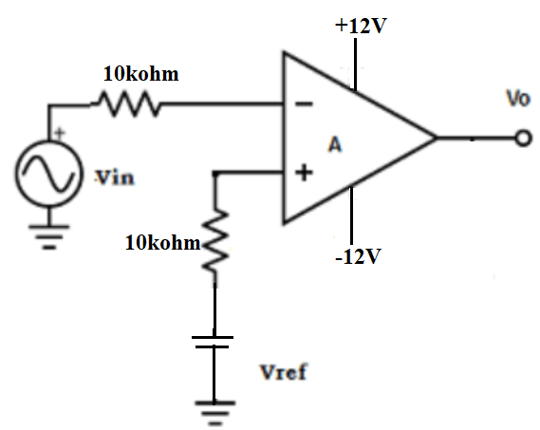

Fig. 7.1 Inverting Comparator

**Model Graph:**

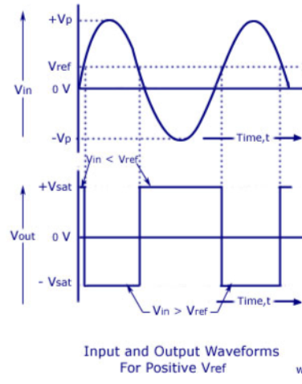

**Non-inverting Comparator:**

**Circuit Diagram:**

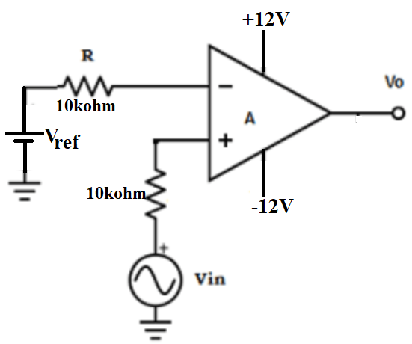

Fig. 7.2 Non-inverting Comparator

**Model Graph:**

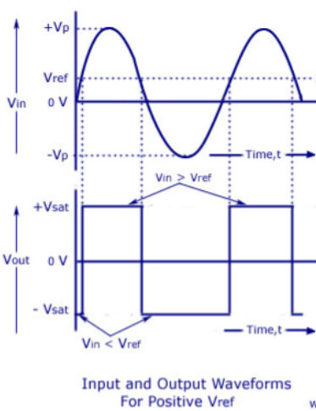

**Zero Crossing Detector:**

**Circuit Diagram:**

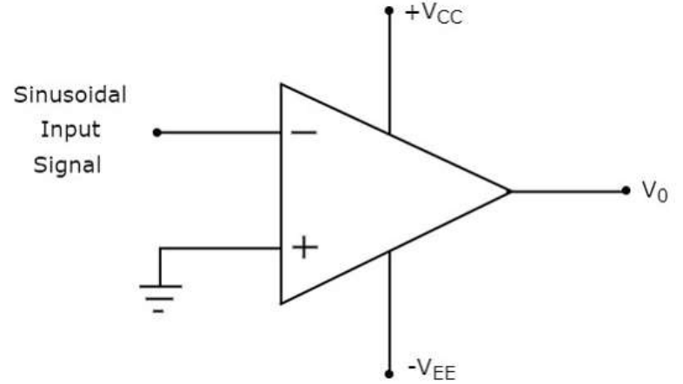

Fig. 7.3 Inverting Zero Crossing Detector

**Model Graph:**

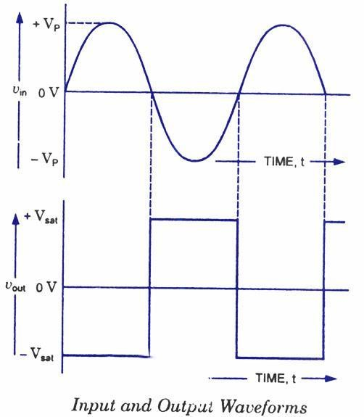

**Procedure:**

1. Connect the circuit for inverting comparator, non-inverting comparator and zero crossing detector as shown in the Fig. 7.1, Fig. 7.2, and Fig 7.3 respectively.
2. Set the input voltage using function generator to 100mV.
3. Observe the output waveform in CRO and measure the output parameter.

**Schmitt Trigger:**



**Circuit Diagram:**

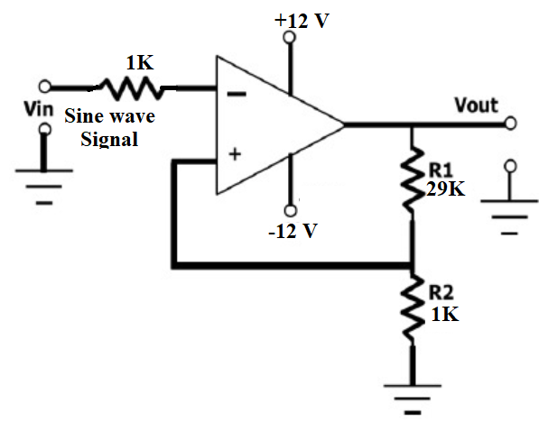

Fig. 7.4 Schmitt Trigger

**Model Graph:**

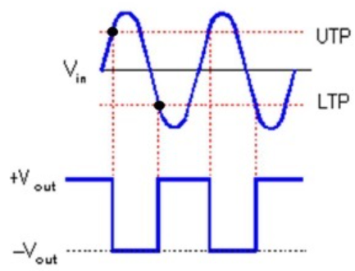

**Observation Table:**

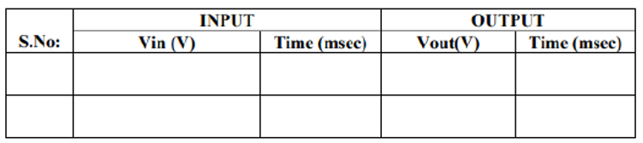

**Hysteresis Graph:**

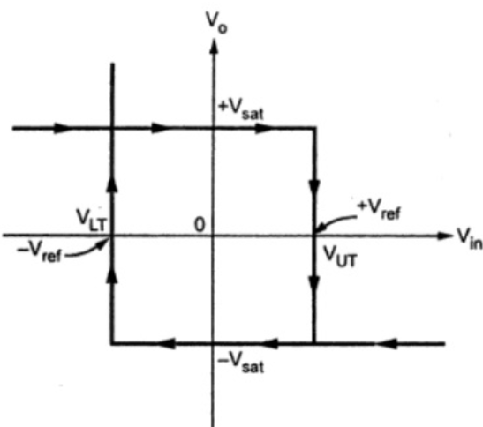

**Procedure:**

1. Connect the circuit as shown in Fig. 7.4.
2. Observe the input sine wave and output wave from in a dual channel CRO.
3. Plot the input and output waveform in a linear graph.
4. Calculate the lower threshold voltage and upper threshold voltage from the plotted graph.
5. Calculate the lower threshold voltage and upper threshold voltage theoretically using the formula.

**Result:**

|  |  |
| --- | --- |
| **For Faculty Use Only** | |
| Performance Marks (Out of 5) |  |
| Viva Marks (Out of 5) |  |
| Report Grade |  |
| Faculty Signature with date |  |

**Experiment – 8 Date:**

**Study of 555 Timer as Astable and Mono-stable Multivibrators**

**Aim:**

To design and study the following circuits using 555 timer-

1. Monostable multivibrator 2. Astable multivibrator

**Apparatus Required:**

1. IC 555
2. Resistors
3. Capacitors
4. CRO
5. Function generator
6. Connecting wires and probes

**Monostable Multivibrator:**

**Design of monostable multivibrator:**

Time period of pulse =T = 1.1RC = 1ms

Let C = 0.1µF

T = 1.1RC = 10ms = 1.1*R*100f

R = 10kΩ

**Circuit Diagram:**

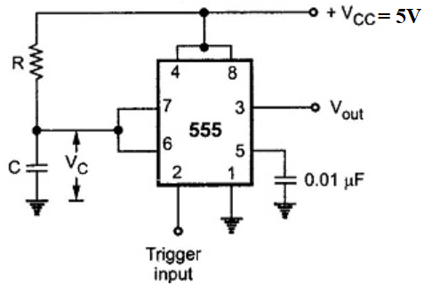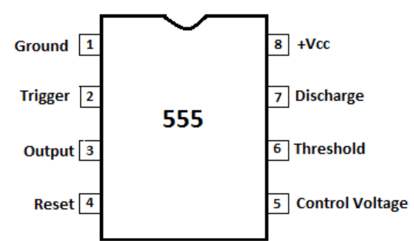

1. (b)

Fig 8.1(a) Monostable multivibrator using IC 555 (b) Pin iagram of IC 555

**Model Graph:**

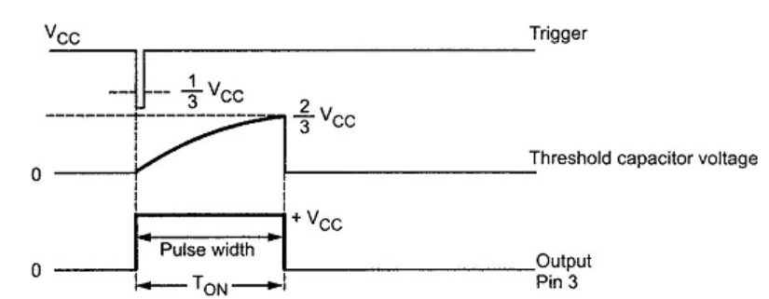

**Observation Table:**

|  |  |  |  |  |  |
| --- | --- | --- | --- | --- | --- |
| Value | Across Capacitor C | | Output pin 3 | | |
| Vmax (2/3Vcc) | Vmin | ON Period TON | Vmax | Vmin |
| Theoretical |  |  |  |  |  |
| Practical |  |  |  |  |  |

**Procedure:**

1. Connections are made as per the circuit diagram shown in Fig 8.1.

2. A trigger pulse is given to pin No 2.

3. Note the time duration for which the LED glows and note down Ton

**Astable Multivibrator:**

**Circuit Diagram:**

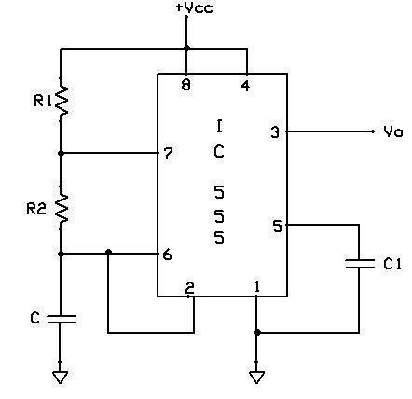

Fig 8.2 Astable multivibrator using IC 555

R1 = 10k Ω, R2 = 10kΩ, C = 0.1µf, C1=0.01µf

**Model Graph:**

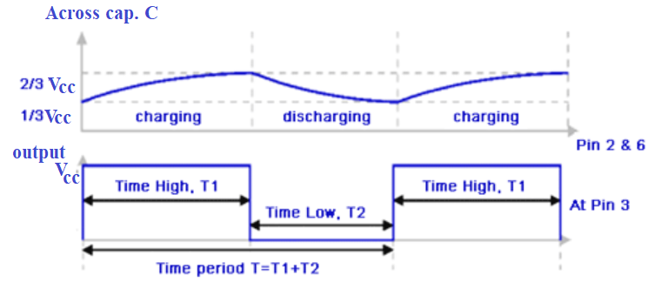

**Observation Table:**

|  |  |  |  |  |  |
| --- | --- | --- | --- | --- | --- |
|  | Vmax (2/3Vcc) | Vmin (1/3Vcc) | ON Period TON | OFF Period TOFF | Duty cycle (%) |
| Theoretical |  |  |  |  |  |
| Practical |  |  |  |  |  |

Theoretically

TON = 0.69 (RA + RB) C

TOFF = 0.69 (RB) C

Duty cycle (%) = TON × 100

(TON +TOFF)

**Procedure:**

1. Connections are made as per the circuit diagram as shown in Fig. 8.2.
2. A supply voltage of 5 V to be given to IC555.
3. The output waveforms at pin 3 and pin 2 are observed on a CRO.
4. Measure TON and TOFF of the waveform.

**Result:**

|  |  |
| --- | --- |
| **For Faculty Use Only** | |
| Performance Marks (Out of 5) |  |
| Viva Marks (Out of 5) |  |
| Report Grade |  |
| Faculty Signature with date |  |

**Experiment – 9 Date:**

**Design an RC Phase Shift Oscillator and understand the importance of regenerative feedback.**

**Aim:**

To design, construct and test the RC Phase Shift Oscillator using op-amp.

**Apparatus Required:**

1. Op-amp IC741
2. Dual power supply
3. Resistors
4. Capacitors
5. Diode IN 4001
6. CRO
7. Bread board
8. Connecting wires and probes

**RC Phase Shift Oscillator:**

**Design:**

f = 1/(2Π)

Rf ≥ 29R1

R1 ≥ 10R

Choose C = 0.1µF

f = 500 Hz

from the frequency formula

R = 1.3 kΩ

Choose R = 1.5kΩ

R1≥15KΩ (to prevent loading) Therefore,

R1 = 10R = 15kΩ

Rf = 29R1=29 x 15kΩ = 435kΩ (Use 1MΩpot)

**Circuit Diagram:**

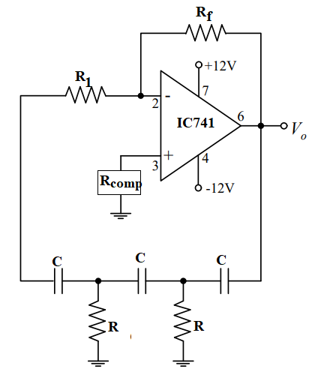

Fig. 9.1 RC phase shift oscillator

**Values:**

R = 1.5kΩ

C = 0.1µF

Rf = 1MΩ

R1 = Rcomp = 15kΩ

**Model Output:**

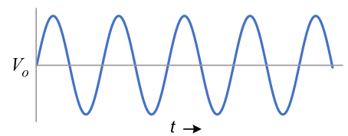

**Observation Table:**

|  |  |  |  |
| --- | --- | --- | --- |
| Output Waveform | | | |
| Amplitude | Time Period | Practical Frequency | Theoretical frequency |
|  |  |  |  |

**Procedure:**

1. Design the RC phase shift oscillator circuit for frequency f = 500Hz. Calculate R1, R2, and Rf.
2. Connect the circuit as shown in Fig. 9.1 with the obtained values.
3. Switch on the power supply and observe the waveform.
4. Note down the amplitude and time period.
5. Plot the waveforms on a graph sheet.

**Result:**

|  |  |
| --- | --- |
| **For Faculty Use Only** | |
| Performance Marks (Out of 5) |  |
| Viva Marks (Out of 5) |  |
| Report Grade |  |
| Faculty Signature with date |  |

**Experiment – 10 Date:**

**Square wave and a Triangular wave generator circuit using op-amp**

**Aim:**

To set up and study square waveform, schmi waveform generator using Op-amp.

**Apparatus required:**

1. Resistors
2. Capacitor
3. Function Generator
4. Op-amp IC741
5. Dual power supply
6. CRO
7. Bread board
8. Connecting wires and probes

**Square Wave Generator:**

**Design of Square wave generator:**



**Circuit Diagram:**

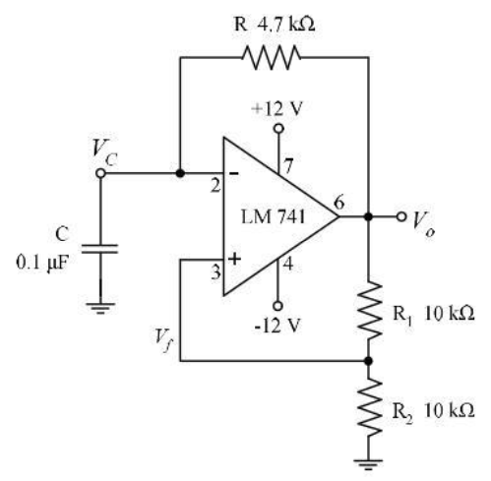

Fig. 10.1 Square wave generator

**Model Graph:**

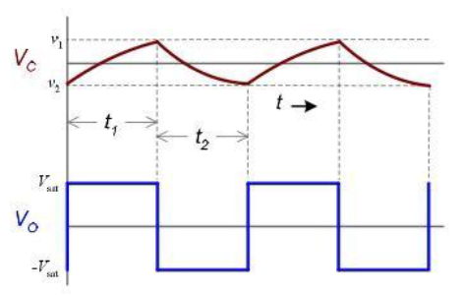

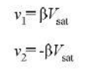

**Triangular Wave Generator:**

**Design of Triangular wave generator:**

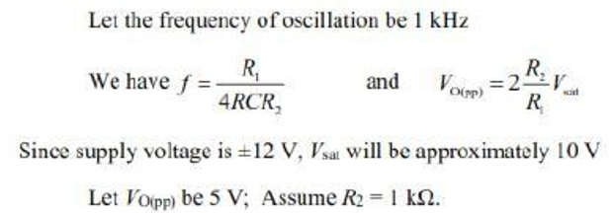

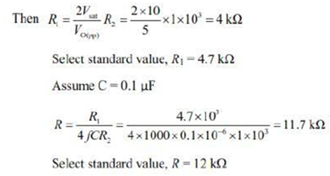

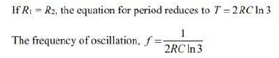

**Circuit Diagram:**

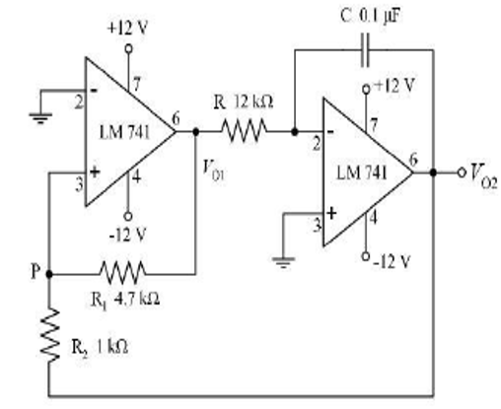

Fig. 10.2 Triangular wave generator

**Model Graph:**

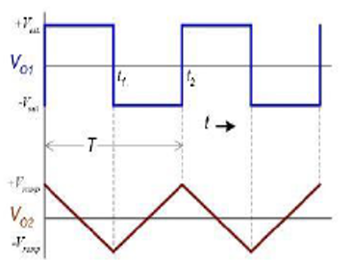

**Procedure:**

1. Set up the circuit after testing the components.
2. Set up the square wave generator as shown in Fig. 10.1 and observe the output waveform and note down their amplitudes and frequencies.
3. Set up the triangular wave generator as shown in Fig. 10.2 and observe the variation in frequencies of output waveform by varying the values of resistances.
4. Move the wiper of the potentiometer in both directions and observe the changes taking place in the waveform.

**Result:**

|  |  |
| --- | --- |
| **For Faculty Use Only** | |
| Performance Marks (Out of 5) |  |
| Viva Marks (Out of 5) |  |
| Report Grade |  |
| Faculty Signature with date |  |