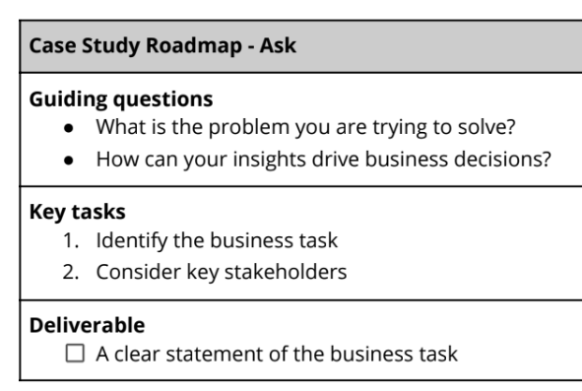

**Guiding Questions**

* What is the problem you are trying to solve?
  + Analyze and identify why casual riders are not opting for an annual membership
* How can your insights drive business decisions?
  + By identifying the reasons behind why casual riders are not opting for an annual membership, the business can make strategic maneuvers to entice casual riders to choose an annual membership effectively. If it is successful, the business will experience increased profits.

**Key Tasks**

* Identify the business task
  + Analyze the past 12 months of ridership data to identify why casual riders are not opting for an annual membership
* Consider key stakeholders
  + Company (Cyclistic)
  + Cyclists that use the service
  + City of Chicago

**Business Task**

* Analyze the past 12 months of ridership data to identify why casual riders are not opting for an annual membership