As stated previously from the Analysis Section, the first notable difference between members and non-members is that non-members use docked bikes whereas members do not use this type of bike, which can be seen in figures 1 and 2. For non-members, the number of docked bikes gradually increases from winter to summer. From these figures, it is evident that the most used bike type is the classic bike. The highest incidence of classic bikes amongst members and non-members occurred in June. In addition, the highest incidence of electric bikes for non-members happened in July, whereas it was in August for members. During the summer months, the margin between classic bikes and electric bikes is large, especially in May and June. However, as the summer months wane, the margin between classic bikes and electric bikes start to get smaller.

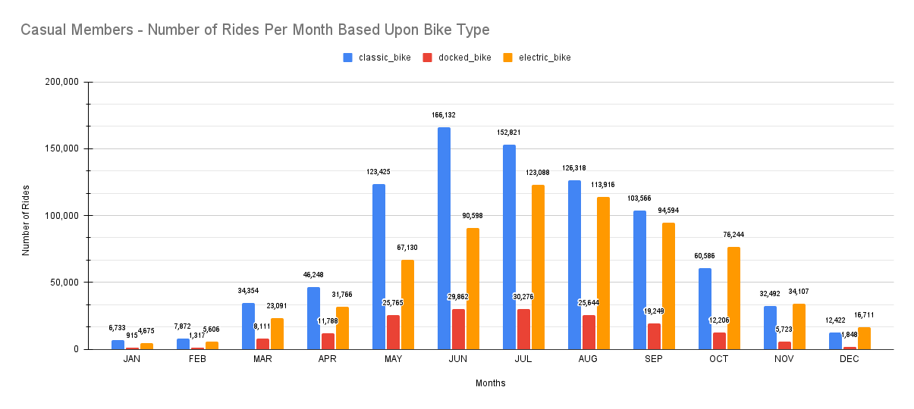

*Figure 1: Casual Members - Number of Rides Per Month Based Upon Bike Type*

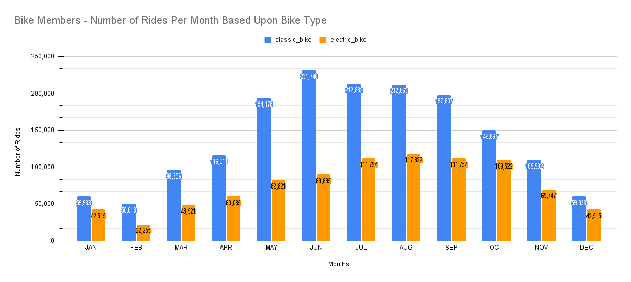

*Figure 2: Bike Members - Number of Rides Per Month Based Upon Bike Type*

For every month of the year, there were more non-members than members. From January until July, the number of rides for members and non-members had increased. Ridership had then decreased gradually from July until December. This trend aligns with the seasons, where riders tend to bike in Spring and Summer and not during Autumn and Winter. The average ride length for non-members was higher when compared to members. A parabolic trend was observed for non-members where the average ride length gradually increased until June and then it started to gradually decrease from June until December. From January until May, a discernible trend was not apparent. Compared to non-members, there was a sharp decrease in the average ride length from July until December. These trends can be found in figures 3 and 4.

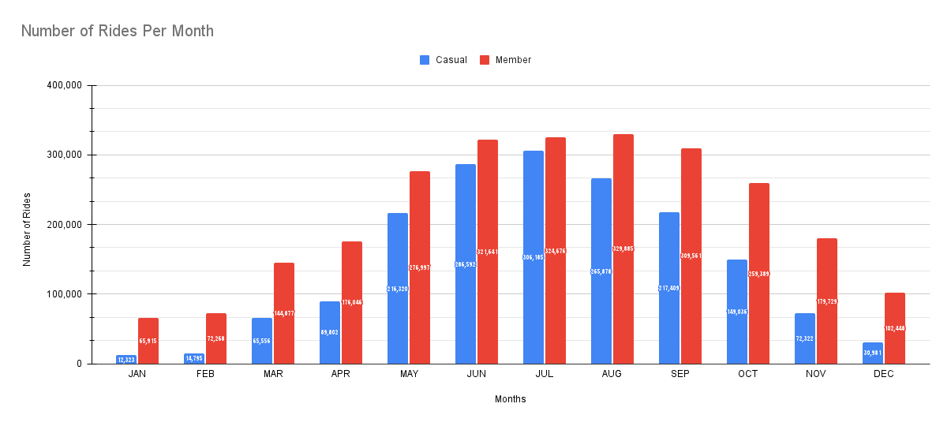

*Figure 3:Number of Rides Per Month*

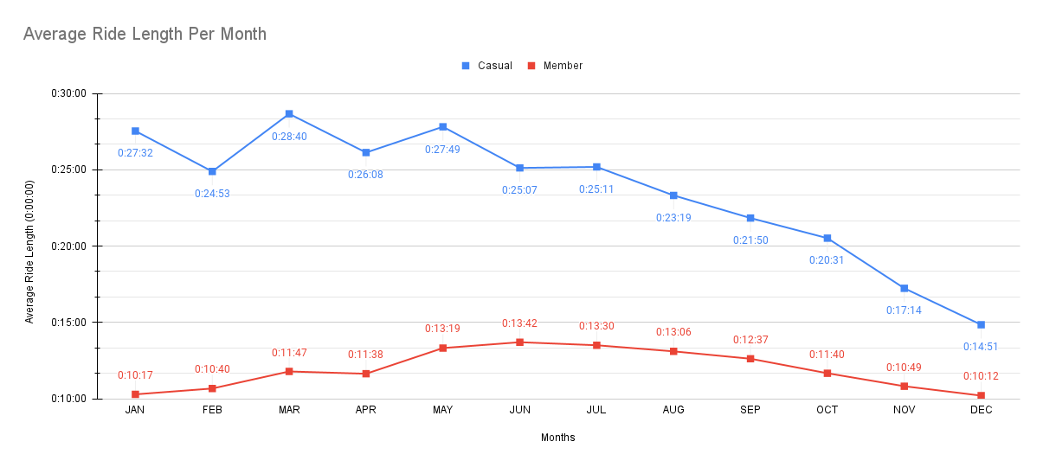

*Figure 4:Average Ride Length Per Month*

The margin between the average ride length for members between the classic bike and the electric bike was not substantial. However, this was not the case for non-members. This was evident in figures 5 and 6. If one looks at April, the average ride length for members for classic bikes was 0:12:16 whereas it was 0:10:24 for electric bikes. On the contrary, for non-members it was 0:26:17 for classic bikes whereas it was 0:17:30 for electric bikes. The average ride length significantly increased from April to May and drastically decreased from May to June for classic bikes when it came to non-members. However, this trend did not occur for members who used classic bikes from April to June. Regardless of the bike type, the average ride length for non-members is much higher than members.

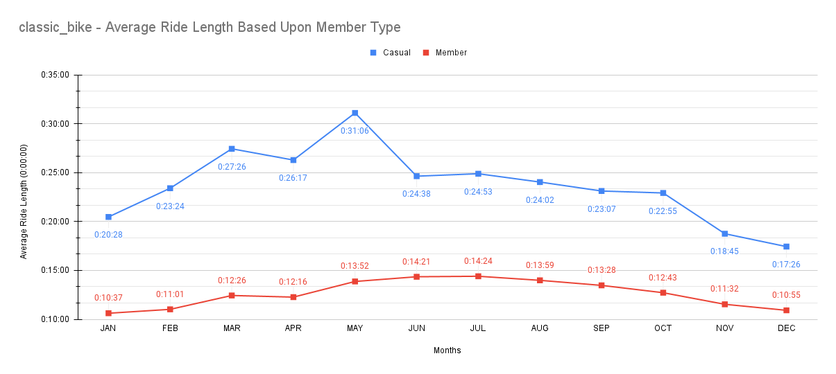

*Figure 5:classic_bike - Average Ride Length Based Upon Member Type*

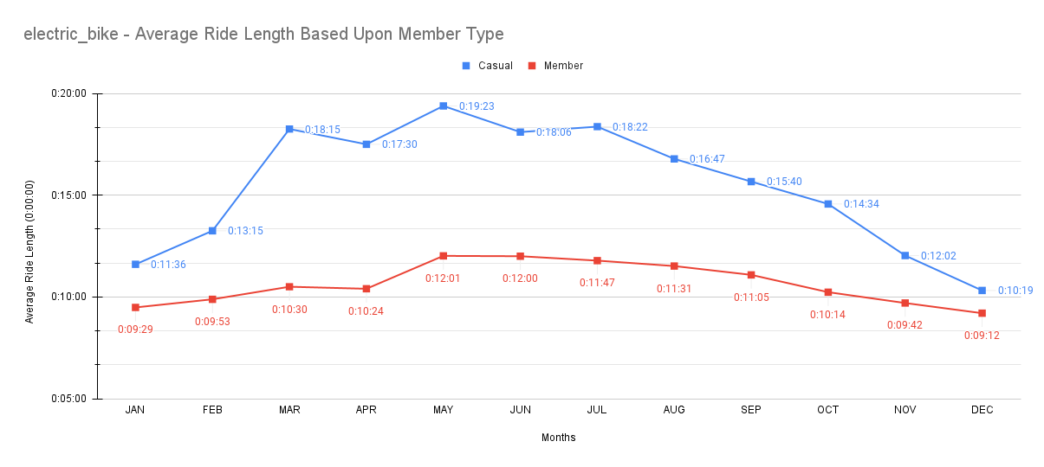

*Figure 6:electric_bike - Average Ride Length Based Upon Member Type*

Based upon Figure 7, it is evident that non-members use the service primarily on the weekends, where the highest incidence of ridership occurs on Saturday. In fact, in terms of ridership, there are more non-members than members on the weekends. Conversely, in terms of ridership on the weekdays, an inverse relationship occurs where there are more members than non-members. As stated previously, the average ride length is higher for non-members than members. Based upon Figure 8, the trend from Sunday until Saturday is identical for both members and non-members. To elaborate, from Sunday until Tuesday, the average ride length decreased. From Wednesday until Friday, the average ride length gradually increased. Lastly, there is a sharp increase from Friday until Saturday.

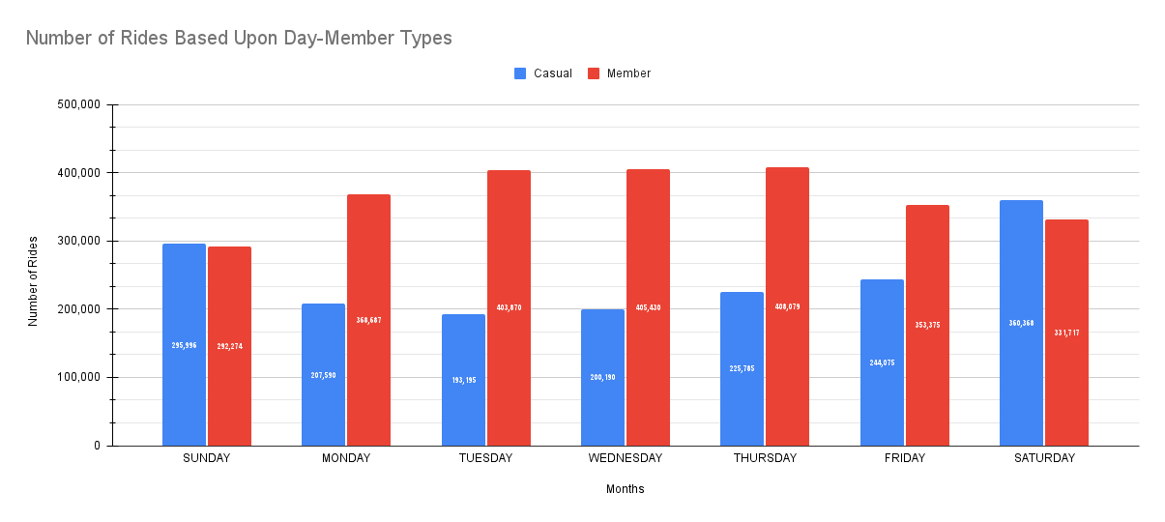

*Figure 7:Number of Rides Based Upon Day-Member Types*

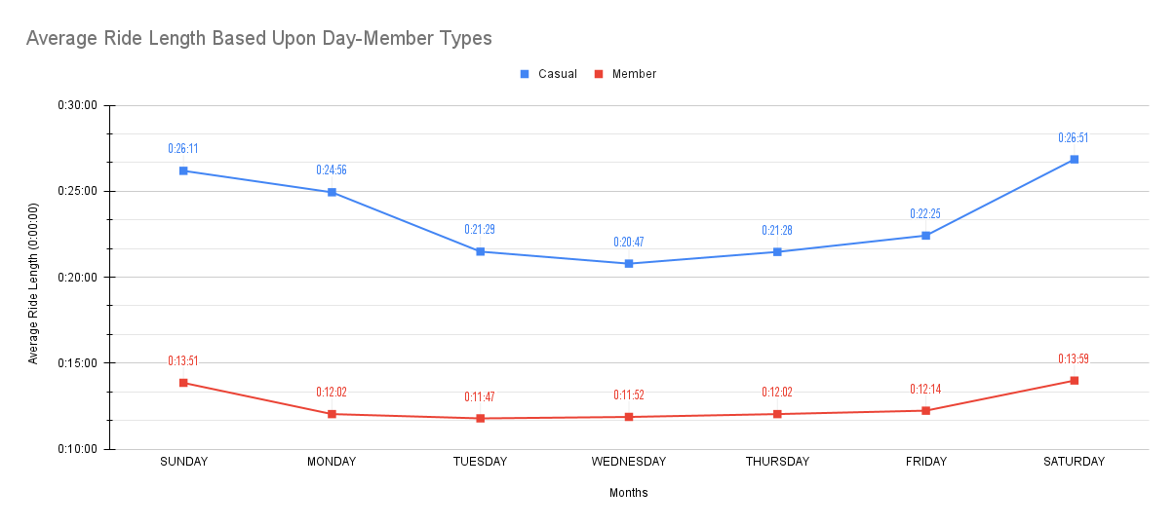

*Figure 8:Average Ride Length Based Upon Day-Member Types*