Chat Application
Tech Stack
Frontend:
- React.js
A JavaScript library for building user interfaces. Used to create dynamic, component-based UI for real-time chat interactions and seamless routing across pages.
- React Bootstrap
A popular library combining Bootstrap and React components. Used for responsive and styled UI elements like Cards, Navbars, Modals, etc., without writing much custom CSS.
- Axios
Used for making API calls between the frontend and backend to send and retrieve data (e.g., users, messages, notifications).
- Socket.IO Client
Enables real-time, event-based communication. Used in the frontend to connect with the backend and receive/send live chat messages instantly.
Backend:
- Node.js
JavaScript runtime environment. Used to build the backend server that handles API routes, WebSocket connections, and database communication.
- Express.js
Lightweight web framework for Node.js. Used to define REST API endpoints for users, messages, and notifications. Also serves as the core of the HTTP server.
- Socket.IO
Real-time communication library. Used to implement live chat functionality, enabling instant message broadcasting between clients without page reloads.
- pg (node-postgres)
PostgreSQL client for Node.js. Used to connect and interact with the PostgreSQL database for storing user info, messages, and other relational data.
- dotenv
Loads environment variables from a .env file. Used to securely manage sensitive configuration data like DB credentials, port numbers, etc.
- CORS
Middleware to enable Cross-Origin Resource Sharing. Ensures the frontend (React running on a different port) can communicate with the backend API.
- jsonwebtoken (JWT)
Used for creating and verifying JSON Web Tokens to manage secure user authentication and authorization. JWT tokens are issued at login and used to protect private routes.

Backend
1. Prerequisites
Before starting, ensure you have the following installed:
- Node.js (v16 or above)
- PostgreSQL
- pgAdmin4 (for Database management)
- Postman (for API testing)
2. Initialization
- Initialized using Node.js
npm init -y
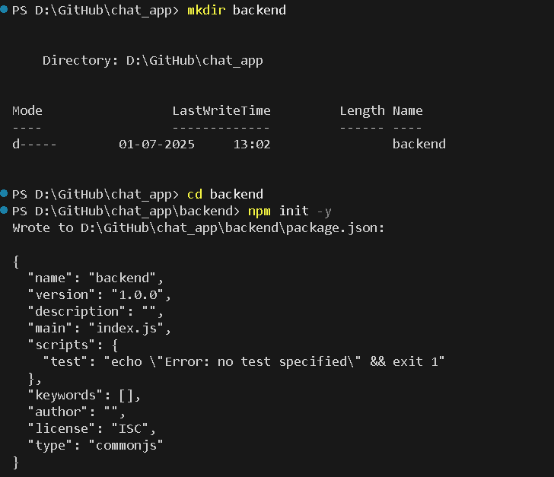
3. Project Setup
Backend:
Extract the backend.zip and follow the steps:

- Install necessary dependencies
npm install
npm install -g nodemon
npm install bcrypt cookie-parser cors dotenv express pg socket.io jsonwebtoken
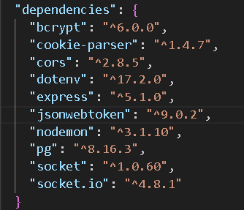
- Set up the PostgreSQL database
CREATE DATABASE chatApp;
- Create the following table
- Table to store user data
CREATE TABLE users (
userid VARCHAR(255) NOT NULL,
username VARCHAR(255),
email VARCHAR(255),
passwords VARCHAR(255),
bio VARCHAR(255),
image VARCHAR(255),
role VARCHAR(20),
PRIMARY KEY (userid)
);

- Table to store chat messages
CREATE TABLE chat (
msgid INTEGER NOT NULL GENERATED ALWAYS AS IDENTITY(INCREMENT 1 START 1),
sender VARCHAR(255),
receiver VARCHAR(255),
sendername VARCHAR(255),
text VARCHAR(1000),
image BYTEA,
seen BOOLEAN DEFAULT false,
timestamp VARCHAR(255),
PRIMARY KEY (msgid),
FOREIGN KEY (sender) REFERENCES users(userid)
);

4. Configuration of the Application
Backend:
Update your environment variables in a .env file
PORT = 8080
HOST = 'localhost'
USER = your_db_user
DBPORT = 5432
PASSWORD = your_database_password
DATABASE = 'chatApp'
JWT_SECRET='your_JWT_secret_key'

5. Application Structure
Backend:
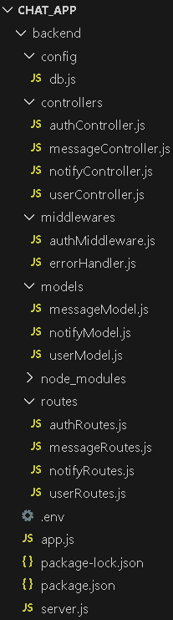
- backend/ : Node.js and Express.js
- config/:
- db.js: Sets up and exports the database connection
- controllers/: Defines how to handle requests and responses.
- authController.js: Handles login, signup, and authentication processes.
- messageController.js: Manages sending, receiving, and retrieving chat messages.
- notifyController.js: Handles notifications logic (e.g., new messages, friend requests).
- userController.js: Handles user-related operations like fetching user data or updating profile info.
- middlewares/: Middleware functions to control the flow of requests.
- authMiddleware.js: Protects routes by checking if a user is authenticated (e.g., JWT token verification).
- errorHandler.js: Handles application-wide errors in a consistent format.
- models/: Defines the structure of your database collections or tables.
- messageModel.js: Defines the schema for chat messages.
- notifyModel.js: Defines the schema for notifications.
- userModel.js: Defines the schema for user accounts.
- Routes/: Maps URLs to specific controller methods.
- authRoutes.js: Routes for login, signup, and authentication.
- messageRoutes.js: Routes for chat message handling (send, fetch).
- notifyRoutes.js: Routes for notification-related operations.
- userRoutes.js: Routes for profile, user fetching, and updates.
- app.js : Express app initialization
- .env : contains environment variables
- server.js :
- Initializes Express server
- Creates a PostgreSQL connection using pg.Pool
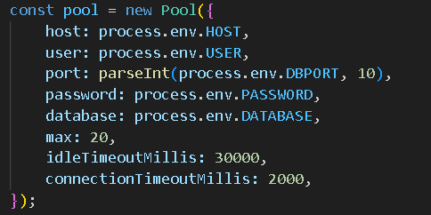
- Uses socket.io for real-time chat
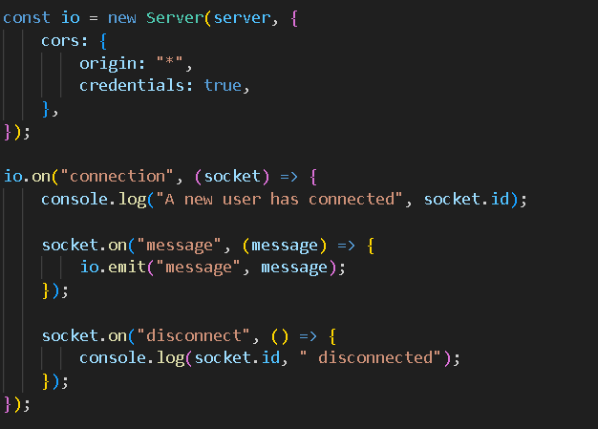
- Provides REST APIs:
- /user endpoints to manage users
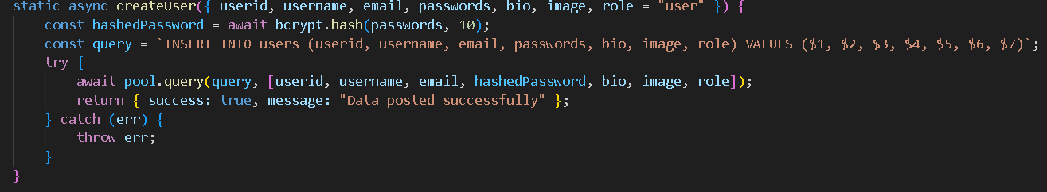

- /message endpoints to manage chat messages
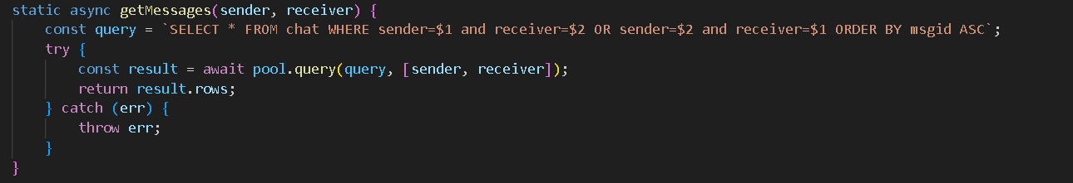
- /notify endpoints to manage message seen/unseen flags
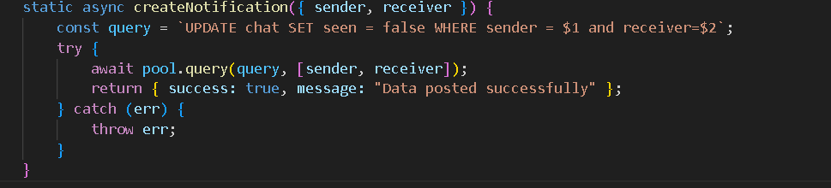
- Listens on port defined in .env

6. Running the Application
npm start
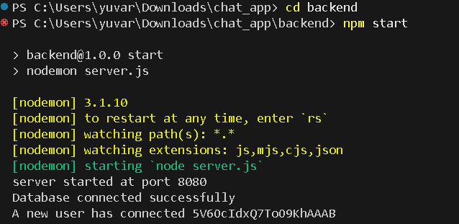
7. Application API Overview
- user API
Method | Route | Description
POST | /user | Create a new user
GET | /user | Get all users
GET | /user/:id | Get users ordered by last message
GET | /user/:id/:query | Search messages by text (filtered)
PUT | /user/:id | Update user
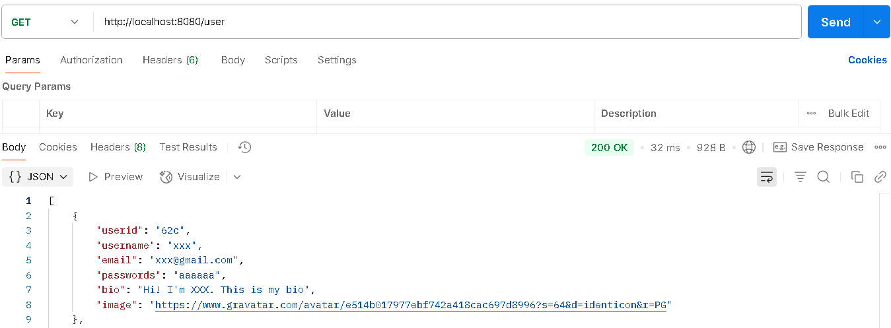
- message API
Method | Route | Description
POST | /message | Send a new message
GET | /message/:sender/:receiver | Get conversation between 2 users
GET | /message/:query | Search messages by text or sender id
DELETE | /message/:sender/:receiver | Delete conversation between 2 users
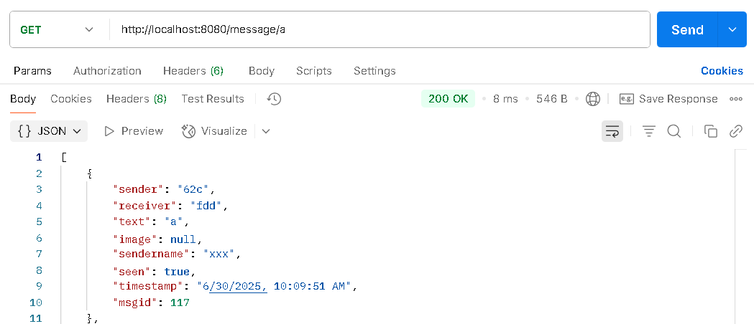
- notify API
Method | Route | Description
POST | /notify | Set message as unseen
GET | /notify | Get all notification flags
PUT | /notify | Mark messages as seen
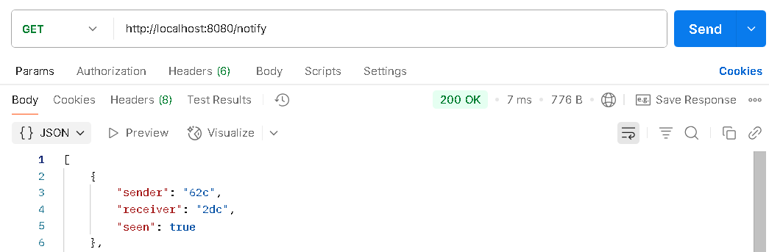
8. WebSockets (Socket.IO)
- Connect:
Socket.io establishes a connection and logs a new user ID.
- Message event:
When a client sends a message, it is broadcast to all other clients in real time.
- Disconnect:
On user disconnect, logs their socket ID.
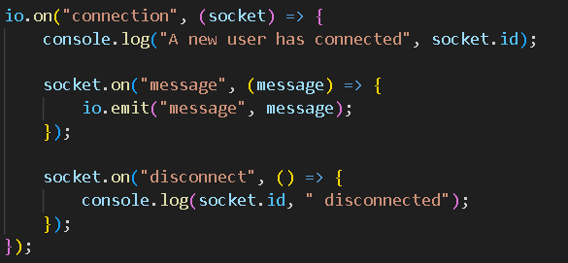

Frontend
- Prerequisites
Before starting, ensure you have the following installed:
- Node.js (v16 or above)
- Initialization:
npx create-react-app frontend
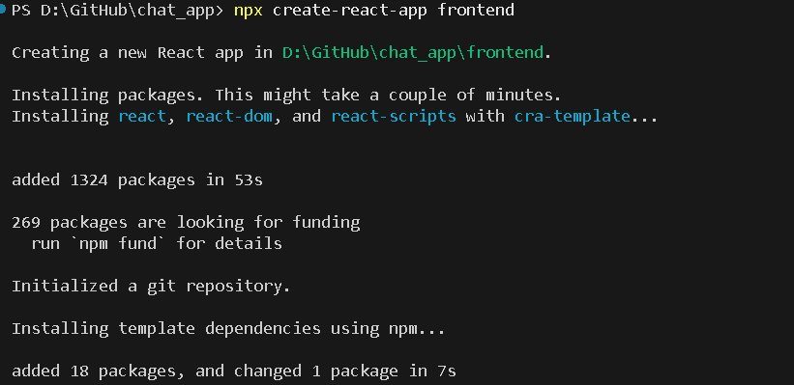
- Project Setup
Frontend:
Extract the frontend.zip and follow the steps:
- Install necessary dependencies
npm install
- React bootstrap – for UI
npm install react-bootstrap bootstrap
- Axios – for making HTTP requests
npm i axios
- Socket.io-client – for
npm i socket.io-client
- uuid – for generating unique id
npm install uuid
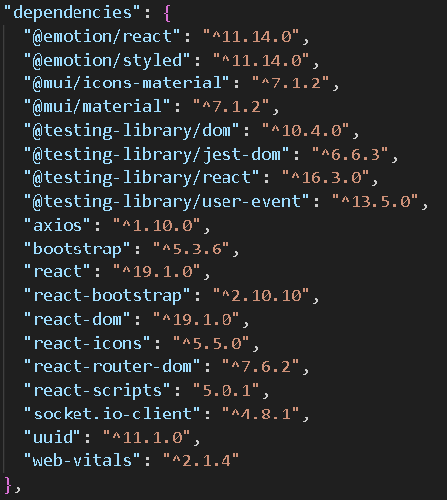

- Configuration of the Application
Frontend:
Update your environment variables in a .env file
REACT_APP_PREFIX=http://localhost:8080

- Application Structure
Frontend:
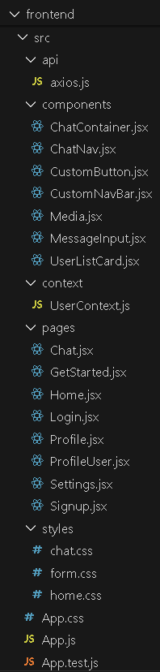
- frontend/ : React.js
- src/api: API utilities
- axios.js: Axios instance configuration for HTTP requests, often includes base URL and interceptors
- src/components/ : Reusable building blocks of UI
  - ChatContainer.jsx: stores and manages chat messages and socket logic
  - CustomNavBar.jsx: navigation bar component
  - UserListCard.jsx: displays user information
- src/pages/ :
  - Home.jsx: homepage after login
  - Login.jsx: user login page
  - Chat.jsx: chat interface
  - Signup.jsx: page to create new account
  - Profile.jsx: shows personal user profile
  - Settings.jsx: settings page
  - GetStarted.jsx: landing screen
- src/context/ : React context for global state
- UserContext.js: Manages and provides global user state across the app using React Context API.
- src/styles/: Stylesheet for the react app
- App.js:
- Root react component
- Defines routing
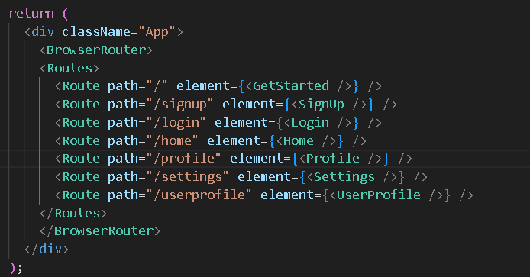

- Index.js:
- Entry point, renders the React app into the DOM
- App.css:
- Global styles

- Functional Overview of Application Screens
- Landing Page
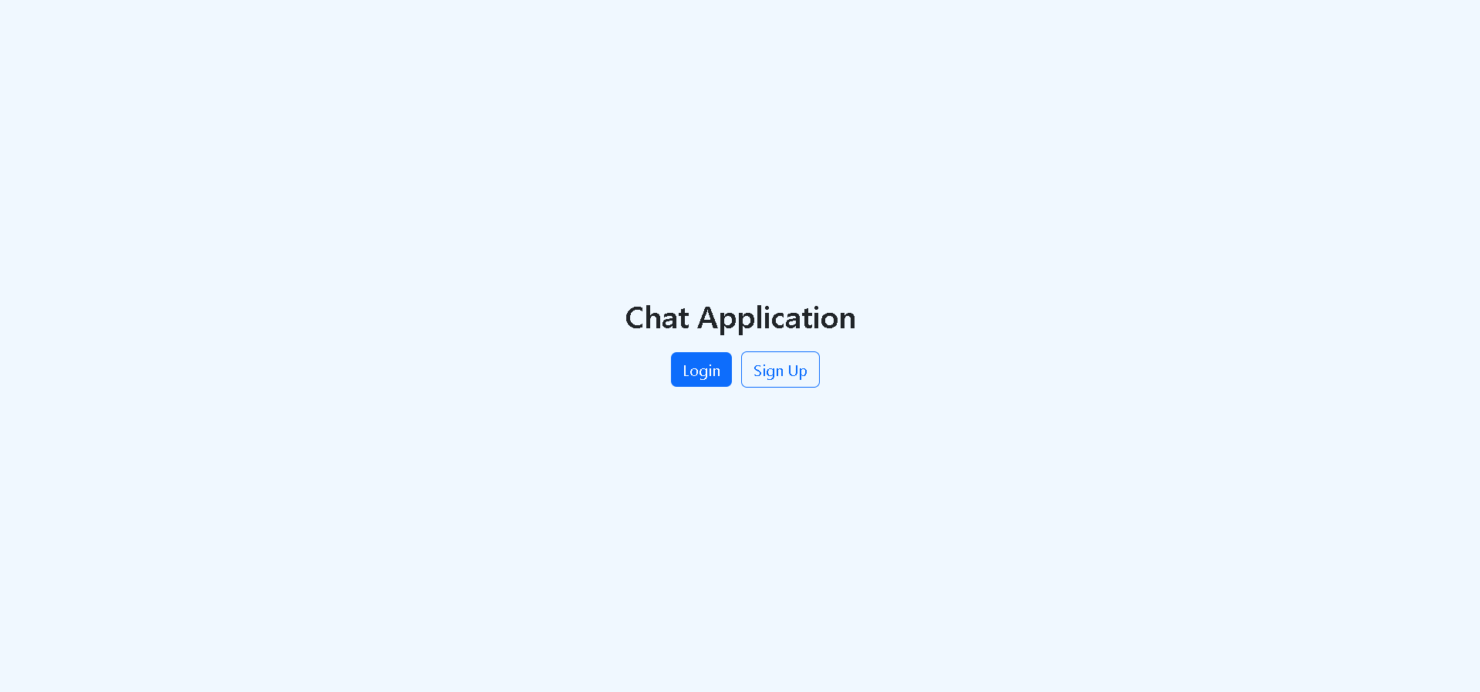
- Route: / (http://localhost:3000/)
- File: GetStarted.jsx
- Functionality:
The landing page serves as the introduction to the chat application. It provides users with options to navigate either to the Login page (for existing users) or the Signup page (for new users).
- Login Page
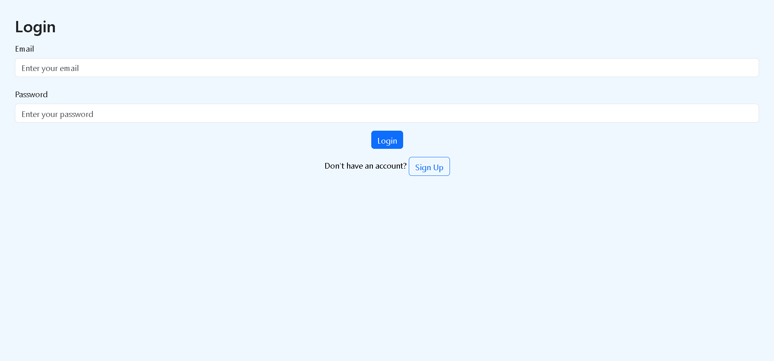
- Route: /login (http://localhost:3000/login)
- File: Login.jsx
- Functionality:
This page allows existing users to sign into their accounts using their credentials (email/username and password). Successful login redirects the user to their home or chat dashboard. It also handles proper validation.
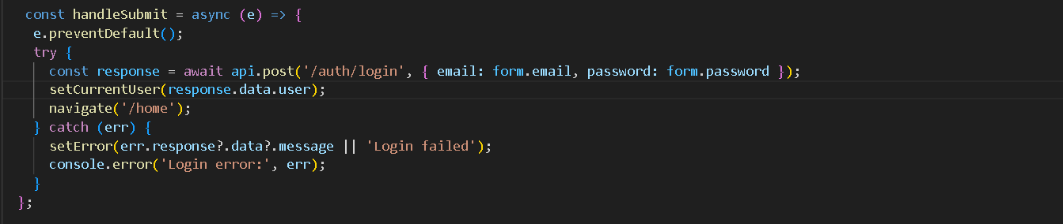

- Signup Page
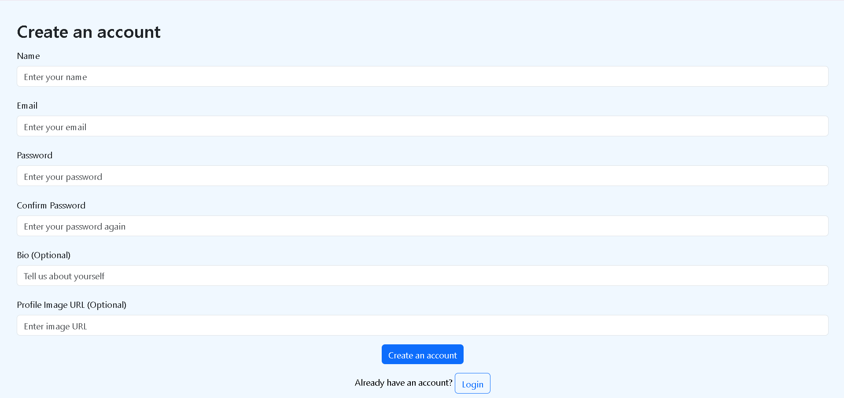
- Route: /signup (http://localhost:3000/signup)
- File: Signup.jsx
- Functionality:
Enables new users to register by providing their details including username, email and password. It also handles validation. If all validations pass, the data is sent to the backend to create the user. Otherwise, appropriate error messages are displayed on the form.
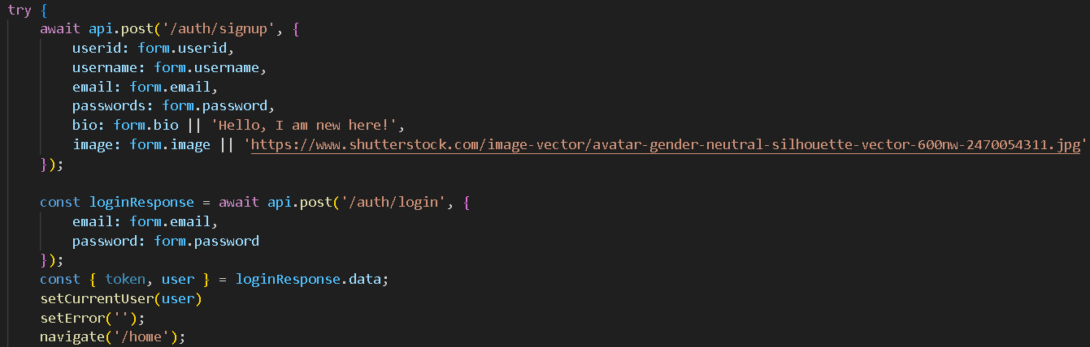

- Home Page
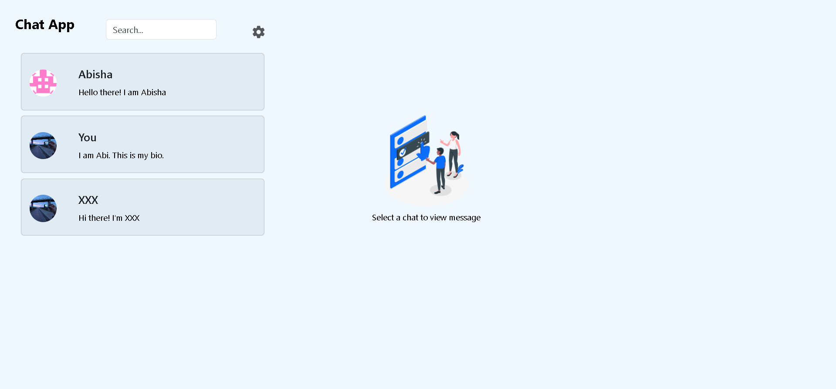
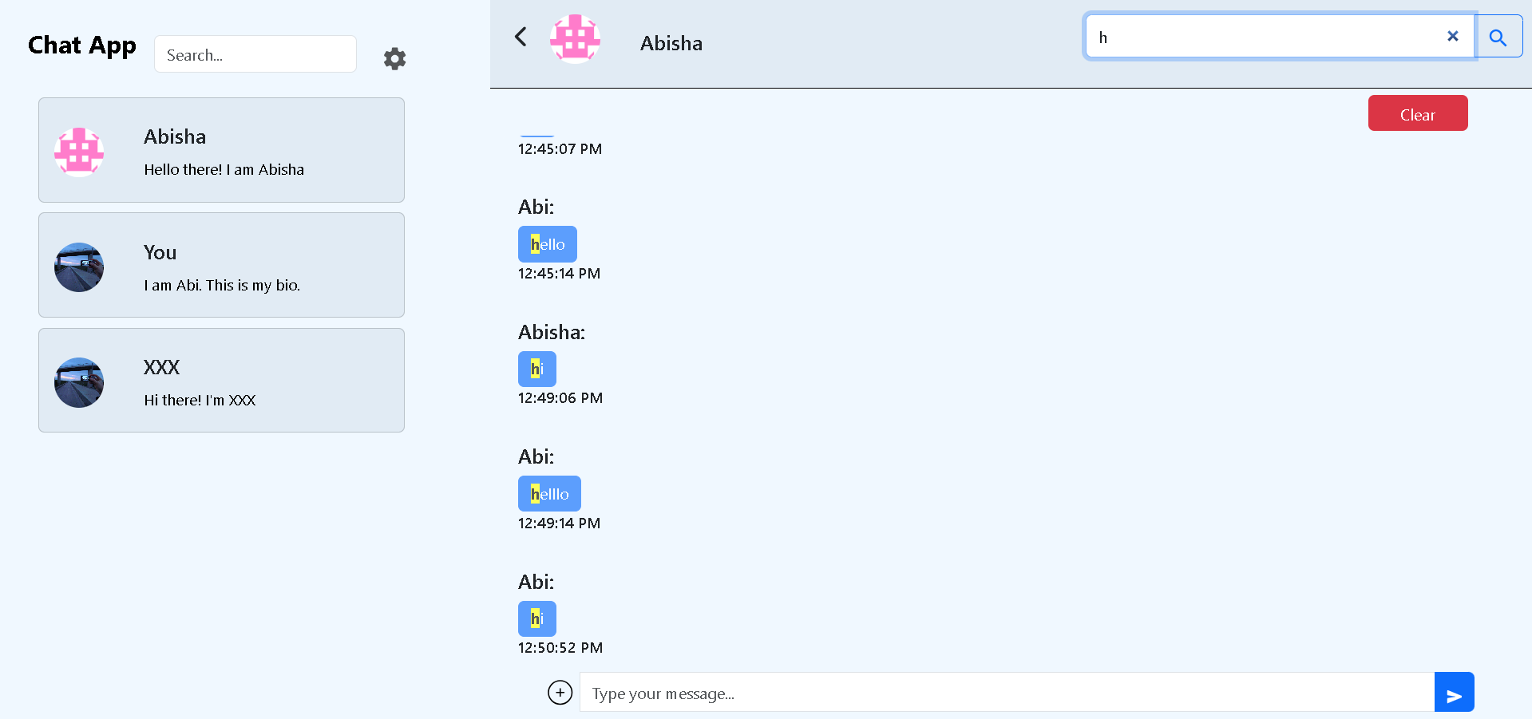
- Route: /home (http://localhost:3000/home)
- File: Home.jsx
- Functionality:
Displays the main user dashboard with a navigation bar, user list, and a chat area. Users can search the messages, view available profiles, and click to open a chat. If no chat is selected, a placeholder image and message are shown. User data is loaded from the backend on page load.
- Components:
- CustomNavBar.jsx – used to search and filter the messages and provides quick navigation to settings page
- UserListCard.jsx – lists all the user and can chat with the selected user
- Chat.jsx – Shows the active chat window with messages and a navigation bar for filtering or searching chats. Displays the conversation between the current user and a selected user, with support for real-time messaging using Socket.IO. Allows sending messages, highlights search terms in messages, and includes a button to clear the conversations. Automatically scrolls to the latest message, and notifies the receiver for new messages.
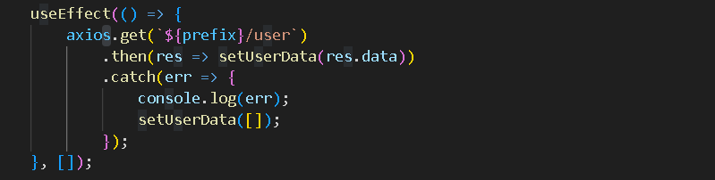

- User Profile Page
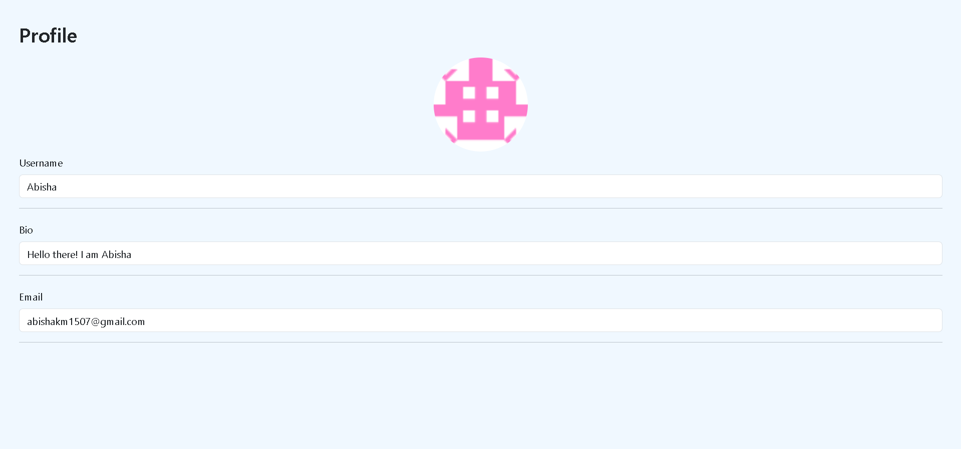
- Route: /userprofile (http://localhost:3000/userprofile)
- File: ProfileUser.jsx
- Functionality:
Displays the profile image, username, bio and email of the selected user. Fetches user data from the backend and displays them.
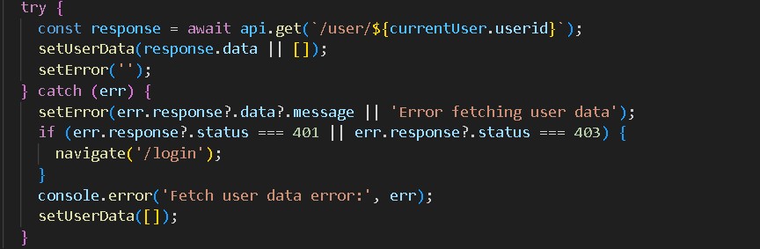

- Settings Page

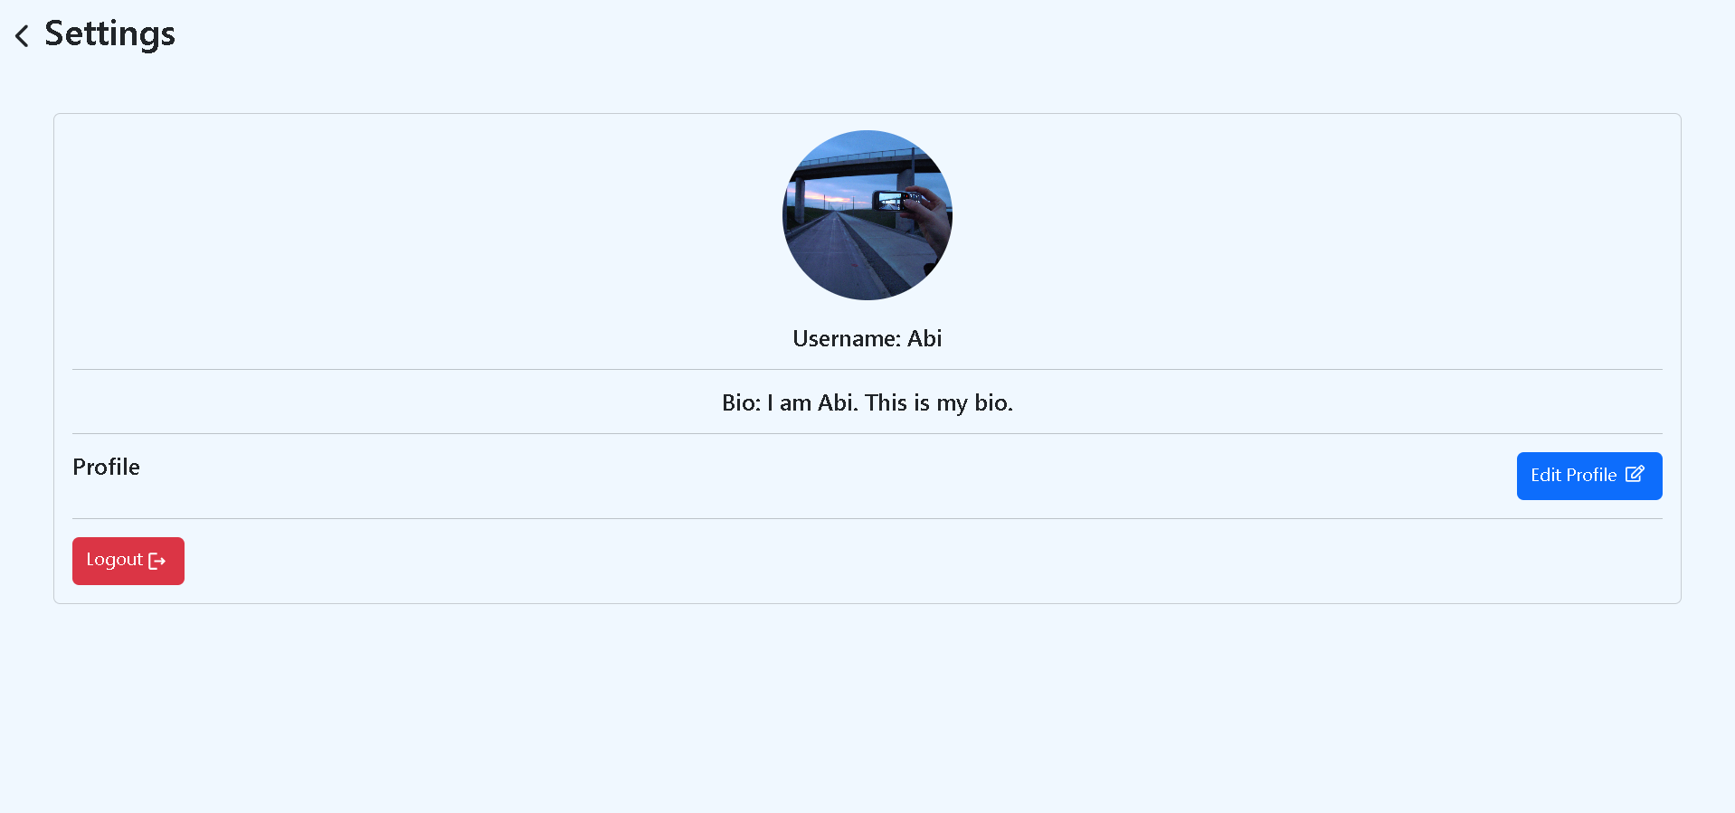
- Route: /settings (http://localhost:3000/settings)
- File: Settings.jsx
- Functionality:
Displays the profile image, username, bio and email of the current user. Fetches user data from the backend and displays them. It gives quick navigation to edit the profile data and to logout from the chat app.
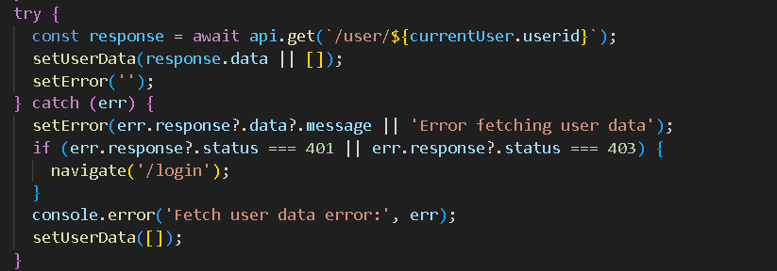

- Profile Page
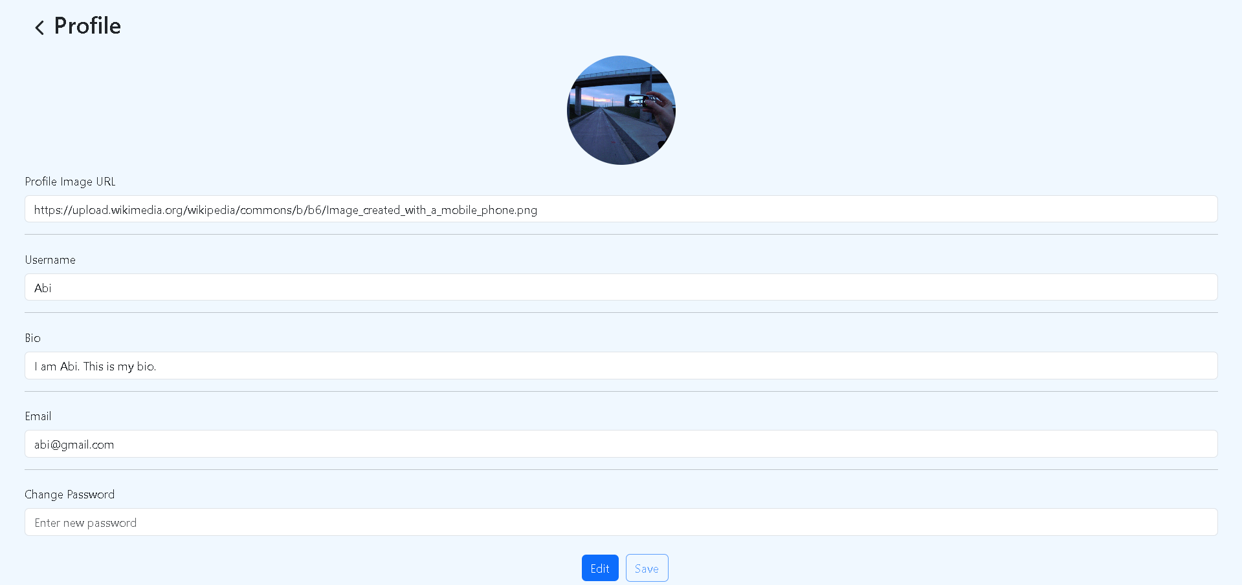
  - Route: /profile (http://localhost:3000/profile)
  - File: Profile.jsx
  - Functionality:
Lets the user view and edit their profile information, including username, email, password, bio, and profile picture. The form is initially disabled, but becomes editable when clicking Edit, and saves changes back to the backend when clicking Save. Displays a circular preview of the profile picture if provided.

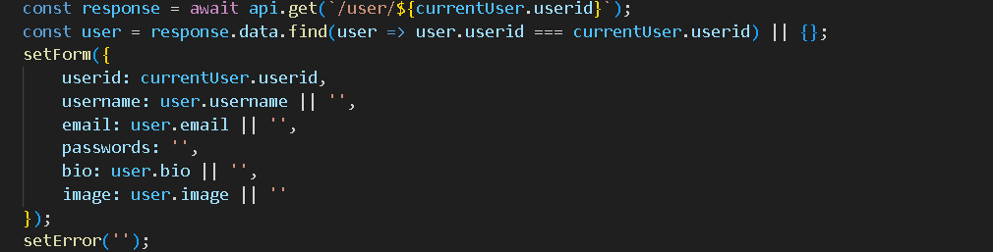
- Running the Application
npm start
