**Business problems & Analytics **

There are countless real-life business problems that companies face, and the solutions to these problems can vary depending on the industry, company size, and specific circumstances. However, here are some common business problems and potential solutions:

Low sales/revenue: A common problem for businesses is low sales or revenue, which can be caused by factors such as ineffective marketing, lack of customer engagement, or low product quality. Solutions to this problem might include:

Re-evaluating your marketing strategy and targeting a new audience or adjusting your messaging

Improving the customer experience by providing better customer service or offering promotions to incentivize purchases

Conducting market research to determine why your product or service is not resonating with consumers and making changes accordingly

Employee turnover: High employee turnover rates can be detrimental to a business, as it can result in decreased productivity, lower morale, and increased hiring and training costs. Solutions to this problem might include:

Offering competitive salaries and benefits packages to attract and retain top talent

Providing opportunities for career development and growth within the company

Creating a positive company culture that values employee satisfaction and well-being

Supply chain disruptions: Disruptions to the supply chain can cause delays, increased costs, and decreased customer satisfaction. Solutions to this problem might include:

Diversifying your supply chain to reduce reliance on a single supplier or region

Building stronger relationships with suppliers and working collaboratively to identify potential issues before they arise

Investing in technology and automation to streamline supply chain processes and reduce the risk of errors or delays

Cash flow issues: Cash flow problems can arise when a business is not generating enough revenue to cover its expenses, resulting in financial strain and potential bankruptcy. Solutions to this problem might include:

Reducing expenses by cutting unnecessary costs or renegotiating contracts with vendors

Increasing revenue by exploring new markets or products, or by raising prices

Improving the billing and collection process to ensure timely payment from customers

Cybersecurity threats: In today’s digital age, cybersecurity threats are a real concern for businesses of all sizes. Solutions to this problem might include:

Investing in robust cybersecurity systems and software to protect against attacks

Educating employees on best practices for safe online behavior and implementing strict security protocols

Conducting regular security audits to identify vulnerabilities and potential areas of risk.

These are just a few examples of common business problems and potential solutions. Ultimately, the key to successfully addressing any business problem is to thoroughly analyze the situation and develop a tailored strategy that addresses the underlying causes.

**BUSINESS RECRUITMENT**



Business recruitment refers to the process of identifying and hiring the right candidates to fill open positions within a company. Here are some steps that businesses can take to improve their recruitment process:

Identify the job requirements: Before starting the recruitment process, it is important to identify the specific skills, experience, and qualifications required for the open position. This will help to ensure that the right candidates are targeted for the role.

Create a job posting: Develop a job posting that clearly outlines the job requirements, responsibilities, and qualifications. This job posting should be shared on job boards, social media, and other relevant channels to attract a large pool of potential candidates.

Use an applicant tracking system: An applicant tracking system (ATS) can help to manage the recruitment process by tracking applications, scheduling interviews, and managing candidate communication. This can help to streamline the recruitment process and improve efficiency.

Conduct interviews: Once candidates have been identified, conduct interviews to assess their skills, experience, and cultural fit. Behavioral interviewing techniques can be used to assess how candidates have responded to similar situations in the past.

Check references: Before making a job offer, it is important to check references to verify the candidate's skills, experience, and qualifications.

Make a job offer: Once the candidate has been selected, make a job offer that includes salary, benefits, and other terms of employment. Be prepared to negotiate these terms to ensure that both parties are satisfied with the offer.

**LITERATURE SURVEY**

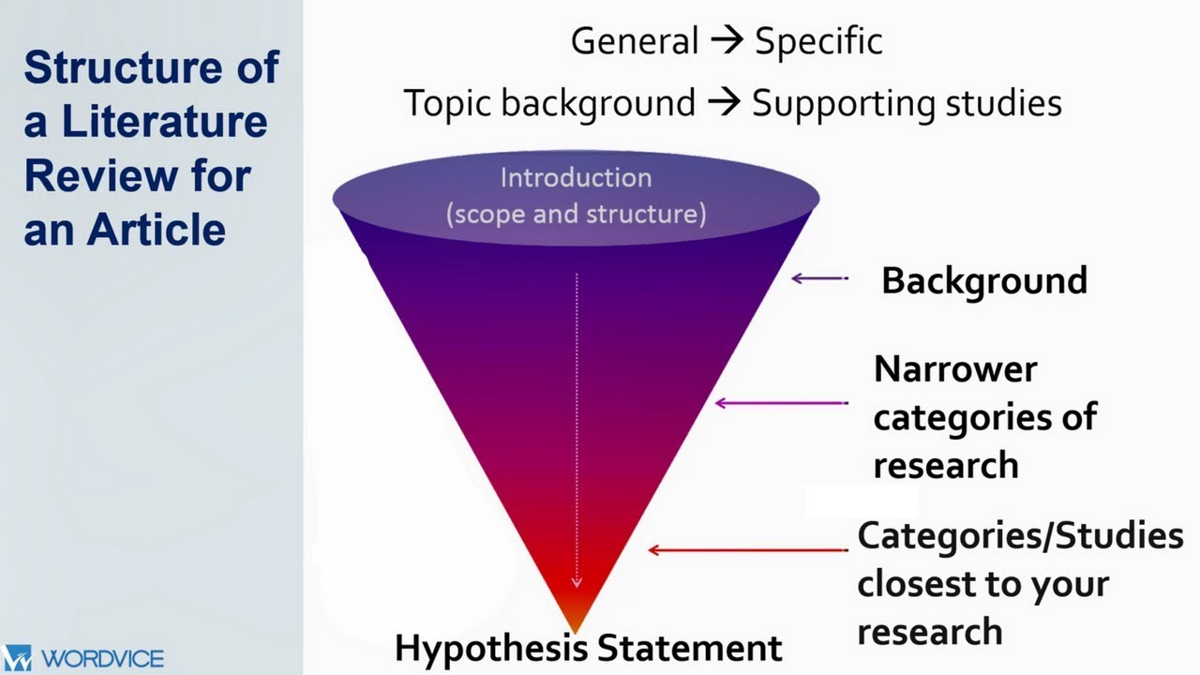

literature survey is a comprehensive review of existing academic literature related to a specific research topic. It involves identifying and reviewing relevant articles, books, and other sources of information to gain a deeper understanding of the research topic and the existing knowledge in the field. Here are the steps involved in conducting a literature survey:

Define the research question or topic: The first step in conducting a literature survey is to define the research question or topic that will be explored. This will help to narrow down the focus of the literature search and identify the most relevant sources of information.

Identify relevant sources of information: The next step is to identify relevant sources of information, such as academic journals, books, and conference proceedings. Databases such as Google Scholar, JSTOR, and PubMed can be used to search for relevant literature.

Evaluate the sources: Once relevant sources have been identified, it is important to evaluate the quality and relevance of each source. This involves reading the abstract and introduction of each source to determine its relevance to the research question, as well as evaluating the methodology and findings presented in the source.

Organize the information: As sources are identified and evaluated, it is important to organize the information in a way that makes it easy to access and understand. This can be done by creating an annotated bibliography or by using a reference management tool such as Zotero or EndNote.

Analyze and synthesize the information: After the relevant literature has been identified, evaluated, and organized, it is important to analyze and synthesize the information to gain a deeper understanding of the research topic. This involves identifying common themes, trends, and patterns in the literature and using this information to inform the research question and methodology.

Write the literature review: Finally, the literature survey should be summarized and synthesized into a comprehensive literature review that provides an overview of the existing knowledge in the field and identifies gaps in the research that need to be addresses study

**SOCIAL OR BUSINESS IMPACT**

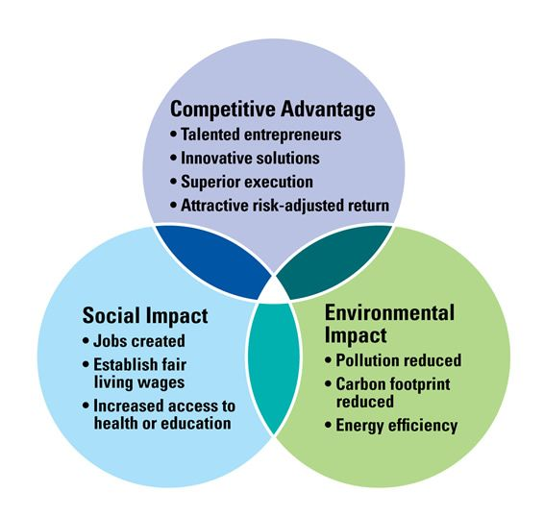

Social or business impact refers to the effects that a particular action, event, or decision has on society or the business community. Here are some examples of social or business impacts:

Social impact: The implementation of a new policy or program can have a significant social impact, such as improving public health, reducing poverty, or increasing access to education. Social impact can also refer to negative effects, such as increased crime rates, environmental degradation, or reduced quality of life.

Business impact: Changes in the business environment, such as the introduction of new technology or changes in consumer behavior, can have a significant impact on businesses. For example, the rise of e-commerce has transformed the retail industry, forcing traditional brick-and-mortar stores to adapt to new consumer preferences and shopping habits. Other examples of business impact include mergers and acquisitions, changes in regulations or laws, and shifts in economic conditions.

It is important for organizations to consider the potential social and business impacts of their actions, decisions, and policies. By doing so, they can identify potential risks and opportunities and develop strategies to mitigate negative impacts and capitalize on positive ones. This can help to ensure that businesses are sustainable and socially responsible, while also contributing to the overall well-being of society.