TRIBHUVAN UNIVERSITY
INSTITUTE OF SCIENCE AND TECHNOLOGY
AMRIT COLLEGE

A Final Year Project Report On
“ResuMatrix: An AI-Powered Resume Analysis
and Job Matching Platform”
Under the Supervision of
Er. Akkal Bist, Lecturer, Amrit College
Submitted To:
DEPARTMENT OF COMPUTER SCIENCE AND INFORMATION TECHNOLOGY
AMRIT COLLEGE
In partial fulfilment of the requirements for the degree of
Bachelor of Science in Computer Science and Information Technology (B.Sc. CSIT)
Submitted By:
Alex Phuyal (79010151)
Abishek Khadka (79010149)
Biraj Sapkota (79010173)
July, 2026

SUPERVISOR'S RECOMMENDATION
This is to certify that the project report entitled “ResuMatrix: An AI-Powered Resume Analysis and Job Matching Platform” has been prepared under my supervision by Alex Phuyal (Roll No: 79010151), Abishek Khadka (Roll No: 79010149), and Biraj Sapkota (Roll No: 79010173), students of the Bachelor of Science in Computer Science and Information Technology (B.Sc. CSIT), Amrit College, affiliated to Tribhuvan University, Institute of Science and Technology.
The project work has been carried out in the Department of Computer Science and Information Technology in partial fulfillment of the requirements for the degree of Bachelor of Science in Computer Science and Information Technology (B.Sc. CSIT) under the Faculty of Institute of Science and Technology, Tribhuvan University.
I hereby recommend this project report for evaluation and defense.

______________________________
Er. Akkal Bist
Supervisor
Lecturer, Department of Computer Science and Information Technology
Amrit College

LETTER OF APPROVAL
This is to certify that the project report entitled “ResuMatrix: An AI-Powered Resume Analysis and Job Matching Platform” submitted by Alex Phuyal (Roll No: 79010151), Abishek Khadka (Roll No: 79010149), and Biraj Sapkota (Roll No: 79010173), students of B.Sc. CSIT, Amrit College, has been examined and approved for the partial fulfillment of the requirements for the Bachelor of Science in Computer Science and Information Technology degree under Tribhuvan University, Institute of Science and Technology.
The project report has been found to be satisfactory for the partial fulfillment of the requirements for the degree of Bachelor of Science in Computer Science and Information Technology.

______________________________
Er. Akkal Bist
Supervisor
Amrit College

______________________________
Internal Examiner
Name: ________________________
Amrit College

______________________________
External Examiner
Name: ________________________

ACKNOWLEDGEMENT
First and foremost, we would like to express our sincere gratitude to Tribhuvan University, Institute of Science and Technology, for providing the academic framework and guidelines that have shaped the direction of this project.
We extend our deepest thanks to our project supervisor, Er. Akkal Bist, Lecturer, Department of Computer Science and Information Technology, Amrit College, for his constant guidance, constructive feedback, and encouragement throughout the development of this project. His expertise and willingness to address our queries at every stage of the project have been invaluable.
We are also grateful to the Head of the Department of Computer Science and Information Technology, Amrit College, for providing a supportive academic environment and for facilitating the resources and infrastructure necessary for carrying out this project work.
Our sincere appreciation goes to all the faculty members and staff of the Department of Computer Science and Information Technology, Amrit College, whose teachings during the course of our B.Sc. CSIT program have laid the foundation for the technical skills demonstrated in this project.
This report would not have been possible without the contributions of everyone mentioned above. We are forever grateful and honored to have had the opportunity to work with such exceptional individuals. Thank you.

Alex Phuyal
Abishek Khadka
Biraj Sapkota

ABSTRACT
Job seekers routinely spend hours manually tailoring resumes, searching through irrelevant listings, and guessing how well their background fits a given role, with no fast, personalized way to see which jobs actually match their skills and experience. ResuMatrix addresses this gap as a resume-driven job matching platform: a user uploads a resume once, the system extracts a structured profile from it, and job listings are then ranked in real time by how well they match that profile.
The system is built as a client-server application — a React 19 single-page frontend and a FastAPI backend — with an intelligence layer built entirely from deterministic and classical/deep-learning techniques rather than LLM prompting. Resume parsing combines deterministic regex extraction (contact fields, date ranges), a two-stage section segmenter (fuzzy string matching against a header synonym list, with a TF-IDF character n-gram plus Logistic Regression classifier as a fallback), a pretrained BERT named-entity recognizer (dslim/bert-base-NER) for names, organizations, and locations, and a spaCy PhraseMatcher gazetteer for skills, job titles, and degrees. Job-match scoring blends three independent signals — TF-IDF cosine similarity, sentence-embedding cosine similarity (all-MiniLM-L6-v2), and direct skill-set overlap — into a single 1–10 match score, and the same scoring machinery is reused by a resume-optimization feature that suggests specific, job-targeted edits to a user's experience bullets and skills list without ever fabricating claims the user did not make.
Beyond parsing and scoring, the platform provides JWT- and Google-OAuth-based authentication, live job search against the JSearch API (RapidAPI) with a 15-minute in-memory cache, an application-status tracker (Saved → Applied → Interview → Offer → Rejected), and a generated, ATS-optimized PDF export of the tailored resume. The backend persists all data in PostgreSQL via SQLAlchemy and Alembic migrations and is packaged for deployment on the Railway platform. The result is a working, end-to-end system that demonstrates how a resume-analysis product can be built entirely on regex, gazetteers, TF-IDF, and pretrained transformer models used as feature extractors, rather than per-request LLM calls.
Keywords:
Resume Parsing, Job Matching, Applicant Tracking System, Named Entity Recognition, TF-IDF, Sentence Embeddings, spaCy, BERT, FastAPI, React

TABLE OF CONTENTS
1
(Right-click above and choose “Update Field”, then “Update entire table” in Microsoft Word to populate this Table of Contents with page numbers.)

LIST OF FIGURES
Figure 3.1: Use Case Diagram of the ResuMatrix System
Figure 3.2: Class Diagram of the ResuMatrix System
Figure 3.3: Entity-Relationship Diagram of the ResuMatrix Database Schema
Figure 3.4: Object Diagram of the ResuMatrix System
Figure 3.5: State Diagram — Application (Job) Lifecycle
Figure 3.6: State Diagram — Resume Parsing Request Lifecycle
Figure 3.7: Sequence Diagram — Registration, Resume Parsing, and Job Matching
Figure 3.8: Activity Diagram — Resume Parsing Workflow
Figure 3.9: Activity Diagram — Job Search and Scoring Workflow
Figure 3.10: Activity Diagram — Application Status Update Workflow
Figure 4.1: Activity Diagram with Swimlanes — Job Search and Scoring (Frontend / Backend / External API)
Figure 4.2: Component Diagram of the ResuMatrix System
Figure 4.3: Deployment Diagram of the ResuMatrix System

LIST OF TABLES
Table 5.1: Tools and Technologies Used
Table 5.2: Inter-Module Communication Protocol (REST Endpoints)
Table 5.3: Unit Test Cases
Table 5.4: Integration Test Cases

LIST OF ABBREVIATIONS
API Application Programming Interface
ATS Applicant Tracking System
BERT Bidirectional Encoder Representations from Transformers
CORS Cross-Origin Resource Sharing
CSIT Computer Science and Information Technology
DL Deep Learning
HS256 HMAC with SHA-256 (JWT signing algorithm)
HTTP(S) Hyper Text Transfer Protocol (Secure)
IDF Inverse Document Frequency
JSON JavaScript Object Notation
JWT JSON Web Token
ML Machine Learning
NER Named Entity Recognition
NLP Natural Language Processing
OAuth Open Authorization
ORM Object-Relational Mapping
PDF Portable Document Format
REST Representational State Transfer
SPA Single Page Application
SQL Structured Query Language
TF-IDF Term Frequency-Inverse Document Frequency
TTL Time To Live
UML Unified Modeling Language
UUID Universally Unique Identifier

CHAPTER 1: INTRODUCTION

1.1 Introduction
Searching for a job today means sifting through hundreds of listings scattered across job boards, most of which are only loosely relevant to a candidate's actual skills and experience. A job seeker typically has to read each listing individually, mentally cross-reference it against their own resume, and then rewrite parts of that resume to better match the language of the posting — a process that is repeated for every single application. This is slow, inconsistent, and easy to get wrong: a resume that under-states a relevant skill, or a bullet point that never mentions a keyword the job description emphasizes, can cause a strong candidate to be filtered out before a human ever reads the application.
With advances in Natural Language Processing (NLP) and pretrained deep learning models, it has become practical to automate large parts of this workflow: extracting a structured profile from an unstructured resume document, comparing that profile against a job description using similarity techniques rather than manual reading, and surfacing concrete, targeted suggestions for where a resume under-sells a candidate relative to a specific job.
This project presents ResuMatrix, a resume-driven job matching platform. A user registers, signs in (via email/password or Google OAuth), and uploads a resume in PDF or DOCX format. The system parses the document into a structured profile — contact details, skills, work experience, and education — through a pipeline of regular expressions, a fuzzy-match/machine-learning section segmenter, a pretrained BERT named-entity recognizer, and a closed-vocabulary gazetteer. Once the profile exists, the user can search live job listings (retrieved from the JSearch API on RapidAPI); each listing is scored against the user's profile using a blend of lexical (TF-IDF), semantic (sentence-embedding), and skill-overlap similarity, producing a 1–10 match score shown directly on the job card. From there the user can inspect a detailed ATS-style analysis of any job, request a resume optimization that proposes specific wording changes tailored to that job, download the optimized resume as a PDF, and record the application's progress against a fixed set of stages (Saved, Applied, Interview, Offer, Rejected).
The system follows a client-server architecture: a React 19 + TypeScript single-page application as the frontend, and a FastAPI (Python) backend that owns all data persistence (PostgreSQL via SQLAlchemy) and all of the parsing/scoring logic described above.

1.2 Problem Statement
Job seekers face two compounding problems. First, manually tailoring a resume to each job posting — checking whether the required skills and terminology actually appear in the resume's experience section — is tedious enough that most candidates either skip it entirely or do it inconsistently across applications, even though tailored applications are known to perform better against automated applicant tracking systems used by employers. Second, evaluating whether a given job listing is even worth applying to requires reading the full description and comparing it, in the candidate's head, against their own background — there is no quick, objective signal for "how good a fit is this, really?" across a list of dozens of search results.
Existing job boards surface listings but do not compute any personalized fit signal; existing resume tools (grammar checkers, generic resume builders) improve writing quality but do not compare a resume against a specific job description. There is no single tool that closes the loop: parse the resume once, then use it to both rank incoming job listings and generate concrete, job-specific edit suggestions.
ResuMatrix addresses this by combining resume parsing, job search, match scoring, and targeted resume optimization into one authenticated web platform, so a user's profile — built once from an uploaded resume — becomes the basis for every subsequent job-matching and application-tracking action.

1.3 Objectives
The primary objective of this project is to build a working, end-to-end platform that turns an uploaded resume into a live-scored job-matching and application-tracking workflow. The specific objectives are as follows:
- To design and implement a resume parsing pipeline that extracts contact details, skills, work experience, and education from unstructured PDF/DOCX resumes using regex, a fuzzy-match/TF-IDF section segmenter, a pretrained BERT NER model, and a gazetteer.
- To implement a job-match scoring service that blends lexical (TF-IDF), semantic (sentence-embedding), and skill-overlap signals into a single 1–10 match score for each job listing returned by a live job search API.
- To build a resume-optimization feature that reuses the same scoring signals to suggest specific, job-targeted edits to a user's skills and experience bullets, while never fabricating claims the user did not make.
- To implement secure authentication supporting both local email/password (Argon2-hashed, JWT-secured) and Google OAuth 2.0 sign-in.
- To implement an application tracker that lets a user record a saved job's progress through Saved → Applied → Interview → Offer/Rejected stages.
- To generate a downloadable, ATS-formatted PDF export of a user's resume, optimized for a specific job.

1.4 Scope and Limitations

1.4.1 Scope
- Resume Parsing: Accepts PDF and DOCX resumes (up to 5 MB) and extracts full name, phone, LinkedIn/GitHub URLs, location, summary, skills, work experience, and education using a rule-based and machine-learning pipeline.
- Job Search and Match Scoring: Live job search against the JSearch API (RapidAPI), with results cached in-memory for 15 minutes per query/location key, and each result scored (1–10) against the user's profile.
- Resume Optimization: Job-specific suggestions for skill emphasis, missing-skill additions, and unquantified-bullet flags, plus a projected before/after match score.
- Application Tracking: A per-job status field (Saved, Applied, Interview, Offer, Rejected) that the user updates manually from a dropdown on the Dashboard, backed by a dedicated Application record per job with status timestamps.
- Authentication: Local email/password registration and login (Argon2 password hashing, JWT session tokens, 7-day expiry) and Google OAuth 2.0 sign-in.
- PDF Export: Server-side generation (ReportLab) of an ATS-formatted, job-optimized resume PDF, including the full original resume text so no content from the upload is ever silently dropped.
- Deployment: The backend is packaged for deployment on the Railway platform, with configuration (database URL, API keys, OAuth credentials) supplied entirely through environment variables.

1.4.2 Limitations
- English-Only Parsing: The NER model (dslim/bert-base-NER) and the section-header/skill gazetteers were built and tuned against English-language resumes; non-English resumes are not reliably parsed.
- Heuristic Section Segmentation: Section detection relies on a fuzzy string match against a fixed list of header synonyms, with a small TF-IDF/Logistic-Regression classifier as a fallback for unfamiliar phrasing — resumes with highly unconventional formatting (no clear section headers, heavy multi-column layouts) can be mis-segmented.
- No Automated Resume-to-PDF Text Layer Recovery: Text extraction relies on `pypdf`; scanned/image-only PDF resumes (no embedded text layer) cannot be parsed, since no OCR step is included.
- Self-Reported Application Status, Not Verified Tracking: Because job listings are sourced from a read-only third-party API (JSearch), the system has no way to observe what actually happens after a user applies. The Saved/Applied/Interview/Offer/Rejected status is set manually by the user and is not corroborated against any external source — the feature is a personal record-keeping aid, not an automated tracker.
- Job Alerts — Backend Only: The JobAlert data model and its CRUD API (`/api/alerts`) and the Resend-based digest email service are implemented, but no dedicated frontend page currently calls them (an earlier `Alerts.tsx` prototype exists in the repository's `_archive/` folder); configuring an alert currently requires the API directly.
- Third-Party Job Data Coverage: The JSearch API has sparse listings for locations outside the US/UK; a location-scoped search that returns no results is automatically broadened by dropping the location filter, which can surface less geographically relevant listings.
- No Automated Test Suite: Verification during development was manual (see Chapter 5); the repository does not yet include an automated unit/integration test runner.
- Cold-Start Latency: The BERT NER model and the sentence-transformer model are loaded into memory once at process startup; the first request after a fresh deployment (or after the platform's free/low tier puts the service to sleep) is slower while these models finish loading.

1.5 Development Methodology
Development followed an Agile (Scrum-inspired) methodology, organized around short iterations rather than a single up-front design-then-build phase, since the parsing and scoring pipeline needed repeated empirical tuning (threshold values, gazetteer vocabulary, blend weights) against real resume samples as the project progressed. Each iteration targeted one vertical slice of the system — for example, authentication end-to-end, then resume upload and parsing end-to-end, then job search and scoring, then the ATS board and optimization features — so that a working, demoable increment existed after each phase rather than only at the very end.
The major phases of development were:
- Requirement Analysis: Defining the core user flow (sign up → upload resume → search jobs → track applications) and the data models needed to support it (see project scope document).
- System Design: Designing the client-server architecture, the database schema (User, Profile, WorkExperience, Education, Application, JobAlert), and the algorithm choices for each pipeline stage.
- Implementation: Building the FastAPI backend module by module (auth, profile, resume, jobs, applications, alerts) and the React frontend page by page (Landing, Login/Register, Dashboard, JobBoard, ProfileSetup). An initial resume parser (`ai_service.py`) prompted an LLM (via Groq/OpenRouter) to extract profile fields; it was later superseded by the current `ml_resume_parser` pipeline once its regex/ML/DL components were built and validated, and remains in the codebase only as an unused alternative.
- Integration and Testing: Wiring the frontend to the live backend API, and manually verifying each endpoint and UI flow against a range of real and synthetic resumes and job listings (see Chapter 5, Section 5.2).
- Deployment: Preparing the backend for the Railway platform, with all secrets and service endpoints (database, JSearch, Google OAuth, Resend, Cloudflare R2) externalized to environment variables via `pydantic-settings`.

1.6 Report Organization
The remainder of this report is organized as follows:
- Chapter 2: Background Study and Literature Review presents the NLP and machine learning concepts underlying the parsing and scoring pipeline, and reviews related work in resume parsing, semantic similarity, and applicant tracking systems.
- Chapter 3: System Analysis covers functional and non-functional requirements, a four-dimension feasibility study, and the use case, object, dynamic, and process models derived from the requirements.
- Chapter 4: System Design presents an activity diagram with swimlanes, the component and deployment architecture, and a detailed description of each algorithm used in the system.
- Chapter 5: Implementation and Testing covers the tools and technologies used, module-by-module implementation details, the inter-module communication protocol, and the testing strategy with representative test cases and result analysis.
- Chapter 6: Conclusion and Future Recommendations summarizes what was built against the stated objectives and outlines directions for future work.

CHAPTER 2: BACKGROUND STUDY AND LITERATURE REVIEW

2.1 Background Study
Automated resume screening and job matching sit at the intersection of information extraction and text similarity — two long-standing NLP problem areas that have each been transformed by the availability of pretrained deep learning models.
Information extraction from resumes is a named-entity and structure recognition problem: given unstructured text, identify who the candidate is, what organizations they worked for, what roles they held, and what skills they claim. Classical approaches to this used hand-written regular expressions and keyword lists — reliable for highly regular fields (an email address or a phone number matches a fixed pattern almost every time) but brittle for free-text fields such as a person's name or a company name, which can take an unbounded number of forms. Named Entity Recognition (NER), the task of labeling spans of text as PERSON, ORGANIZATION, or LOCATION, was one of the first NLP tasks to benefit substantially from transformer-based language models: BERT (Bidirectional Encoder Representations from Transformers) introduced a pretraining objective (masked language modeling) that produces contextual token representations useful for downstream sequence-labeling tasks like NER after only light fine-tuning, and models fine-tuned on the CoNLL-2003 NER benchmark — such as `dslim/bert-base-NER`, used in this project — reach F1 scores around 91% on that benchmark without any resume-specific training.
Text similarity for job matching is a different problem: given two documents (a resume and a job description), estimate how well they match. Term Frequency-Inverse Document Frequency (TF-IDF) is a classical, purely lexical approach — it weights a term highly if it appears often in one document but rarely across the whole collection, and cosine similarity between TF-IDF vectors gives a fast, interpretable lexical-overlap score. Its main weakness is that it only rewards exact word matches: a resume that says "built REST APIs" scores zero lexical overlap against a posting that asks for "backend service development" even though the two phrases are near synonyms. Sentence-embedding models close this gap by mapping a whole sentence or paragraph to a dense vector such that semantically similar text is close in vector space, regardless of exact wording; the `all-MiniLM-L6-v2` sentence-transformer model used in this project is a distilled, compact model trained via contrastive learning on over a billion sentence pairs, chosen specifically because it is small and fast enough to score dozens of job listings per request without a GPU.
Gazetteer-based matching — looking up spans of text against a fixed, curated vocabulary — remains useful precisely where NER and embeddings are least reliable: closed sets like job titles, academic degrees, and technical skill names, where the space of valid values is large but finite and a exact/near-exact string match is both faster and more precise than a learned model. spaCy's `PhraseMatcher` implements this efficiently over a tokenized document, and is the mechanism this project uses for skill, title, and degree recognition.

2.2 Literature Review
The following review covers prior work directly relevant to each pipeline stage implemented in this project.
Devlin et al. introduced BERT and demonstrated that a single pretrained transformer encoder, fine-tuned with a lightweight task-specific head, could set new state-of-the-art results across a broad range of NLP tasks including named entity recognition — establishing the pretrain-then-fine-tune paradigm that `dslim/bert-base-NER` (used in this project's `ner_extractor.py`) is built on [1]. Sang and De Meulder's CoNLL-2003 shared task defined the PERSON/ORGANIZATION/LOCATION/MISC entity-labeling benchmark that this NER model was fine-tuned and evaluated against, and remains the standard reference point for reported NER accuracy in this domain [2].
Reimers and Gurevych proposed Sentence-BERT, showing that a siamese/triplet network structure over BERT-style encoders could produce sentence embeddings whose cosine similarity meaningfully reflects semantic similarity — orders of magnitude faster to compare at scale than running BERT's cross-encoder attention over every sentence pair directly. This is the architecture family `all-MiniLM-L6-v2` belongs to, and is the technique this project's `ats_service.py` uses for the semantic half of its match-score blend [3]. Wang et al.'s MiniLM work on deep self-attention distillation is the specific distillation technique behind the compact, 6-layer MiniLM encoder used here, chosen for its favorable accuracy-to-latency trade-off in a request path that must score many jobs per search [4].
On the lexical-matching side, Salton and Buckley's classical treatment of term-weighting approaches in automatic text retrieval is the theoretical basis for the TF-IDF plus cosine-similarity component implemented via scikit-learn's `TfidfVectorizer` in this project [5]. Ramos' widely cited application of TF-IDF to query-relevant term extraction further motivates its use as a fast, interpretable baseline signal even in a system that also has access to deep semantic embeddings [6].
In the applied resume-parsing space, research on resume information extraction (e.g. Kaggle's "Resume Entities for NER" dataset and associated baselines) commonly frames the problem as a hybrid of rule-based/gazetteer extraction for closed-vocabulary fields (skills, degrees) and statistical or neural sequence labeling for open-vocabulary fields (names, organizations) — the same hybrid design this project's `ml_resume_parser` package follows, rather than treating resume parsing as a single end-to-end model [7]. Existing commercial resume parsers and applicant tracking systems generally do not publish their internal algorithms, but publicly documented systems and academic resume-parsing baselines converge on the same rule-plus-statistical-model pattern used here, rather than a single large generative model, precisely because resume fields like contact information and dates are highly regular and gain nothing from a learned model, while names and skills genuinely need it.
Most existing student-facing or consumer resume tools address only one piece of this problem in isolation — a resume grader, a keyword checker, or a job search aggregator — without combining resume parsing, job-specific match scoring, and targeted optimization suggestions behind a single authenticated profile. ResuMatrix's contribution is integrating all three behind one profile: parse once, then reuse the same profile and the same scoring machinery for both ranking incoming jobs and generating resume-optimization suggestions.

CHAPTER 3: SYSTEM ANALYSIS

3.1 System Analysis
System analysis examines the problem domain, identifies system requirements, and evaluates the feasibility of the proposed solution prior to implementation. This section presents the requirement analysis, feasibility study, and system models derived during the analysis phase of ResuMatrix.

3.1.1 Requirement Analysis
Requirement analysis identifies and documents the needs of the system's intended users, serving as the primary input for system design. Requirements are categorized into functional requirements, describing the specific operations the system must perform, and non-functional requirements, defining the quality attributes and constraints the system must satisfy.

3.1.1.1 Functional Requirements
The following functional requirements were identified for ResuMatrix:
- The system shall allow a user to register with email and password, or sign in with Google OAuth 2.0, and issue a signed JWT session token on success.
- The system shall accept a PDF or DOCX resume upload (up to 5 MB) and parse it into a structured profile — full name, phone, LinkedIn/GitHub URLs, location, summary, skills, work experience, and education.
- The system shall allow the user to review and edit any profile field through a consolidated profile form, except fields that were successfully populated from the uploaded resume, which are locked until a new resume is uploaded.
- The system shall compute a profile completeness percentage based on required fields (full name, location, experience level, skills) plus the presence of at least one work-experience and one education entry.
- The system shall search live job listings from the JSearch API using the user's desired title and location (or a manual search query), with optional filters for remote-only, employment type, and experience level.
- The system shall cache job search results in-memory, keyed by the query and location parameters, for 15 minutes, to reduce redundant calls to the third-party API.
- The system shall score each returned job listing against the user's profile using a weighted blend of TF-IDF cosine similarity, sentence-embedding cosine similarity, and skill-set overlap, producing an integer match score from 1 to 10.
- The system shall provide a detailed ATS analysis for a specific job, showing the matched and missing skills (categorized) and a ranked list of improvement suggestions.
- The system shall generate job-specific resume optimization suggestions — skill emphasis into existing bullets (via sentence-embedding similarity), missing-skill additions to the skills list, and quantification-gap flags on bullets without a number — and compute a projected before/after match score.
- The system shall generate and stream a downloadable, ATS-formatted PDF of the optimized resume, including the full original resume text so that no uploaded content is lost.
- The system shall let a user save a job as an Application record and manually update its status through a fixed set of stages (Saved, Applied, Interview, Offer, Rejected) via a dropdown on the Dashboard, recording a timestamp the first time it moves to Applied.
- The system shall provide a CRUD API for job alerts (keywords, location, minimum match percentage, frequency) and an email-based digest notification service (Resend), independent of whether a frontend page currently calls it.

3.1.1.2 Non-Functional Requirements
The following non-functional requirements were identified for ResuMatrix:
- Security: Passwords shall be hashed with Argon2 (never stored in plaintext); session tokens shall be signed JSON Web Tokens (HS256) with a 7-day expiry; every profile, resume, job, application, and alert endpoint shall require a valid token via a shared `get_current_user` dependency.
- Performance: Keyword/skill/section extraction and TF-IDF scoring shall complete in well under one second per request; sentence-embedding scoring for a page of job results (encoded in a single batched call) shall complete within a few seconds on CPU; blocking model-inference work shall be offloaded to a thread pool so it does not block the async event loop.
- Reliability: A failure to reach the JSearch API shall surface as a clear 502 error to the frontend rather than a silent empty result; resume parsing on unreadable/corrupted files shall be rejected with a 400 error before reaching the ML pipeline.
- Usability: The frontend shall present a single guided flow — sign in, upload resume, review profile, search jobs — with locked/disabled fields visually distinguishing resume-derived data from user-editable data.
- Portability: The backend shall run identically in local development and on the Railway platform, with all environment-specific values (database URL, API keys, OAuth credentials, CORS origins) supplied via environment variables and never hard-coded.
- Data Integrity: Profile-owned child records (WorkExperience, Education) shall cascade-delete with their parent Profile; a User shall have exactly one Profile, enforced by a unique foreign key constraint.
- Maintainability: The resume-parsing pipeline shall be organized as independently testable modules (regex extractor, section segmenter, NER extractor, gazetteer, experience/education parsers) with a single orchestrator, so any one stage can be replaced or improved without touching the others.

3.1.2 Feasibility Study
A feasibility study evaluates whether the proposed system can be successfully developed and deployed within the available resources, technical capabilities, and time constraints. The feasibility of ResuMatrix was assessed across four dimensions: technical, operational, economic, and schedule feasibility.

3.1.2.1 Technical Feasibility
The project is technically feasible using entirely open-source, widely documented technologies: React 19 and FastAPI for the two application tiers, PostgreSQL for persistence, and open-weight pretrained models (`dslim/bert-base-NER`, `all-MiniLM-L6-v2`) that run on CPU without requiring dedicated GPU infrastructure, which removes both a per-request inference cost and an external-availability dependency from the system's critical path. Job listings and email delivery are sourced from third-party APIs (JSearch, Resend) with generous free tiers sufficient for development and demonstration.

3.1.2.2 Operational Feasibility
The system is straightforward to operate: a user registers, uploads a resume once, and the system immediately has enough information to search and score jobs. Fields that were successfully parsed from the resume are visually locked so the user is only ever prompted to fill in the small number of fields the parser could not confidently extract, rather than re-entering their entire resume by hand. The application tracker and single-page profile form require no training beyond familiarity with common web UI patterns.

3.1.2.3 Economic Feasibility
The project is cost-effective: all backend libraries, the pretrained NER and sentence-embedding models, and the frontend framework are free and open-source. The JSearch API and Resend both offer free usage tiers sufficient for a final-year project's development and demonstration traffic, and Railway offers a free/low-cost tier suitable for hosting the backend. No paid infrastructure is required to build, test, or demonstrate the system.

3.1.2.4 Schedule Feasibility
The project was completed within a single-semester timeline using short, feature-oriented iterations (see Section 1.5). Because each iteration targeted one vertical slice of the system (auth, then parsing, then search/scoring, then tracking/optimization), a working increment was available for review after every phase, which kept the schedule realistic even as individual algorithm components (e.g. the section-segmentation thresholds, the score-blend weights) needed iterative tuning.

3.1.3 Analysis
The system has one primary actor: the Job Seeker (User). The use cases below cover the complete set of interactions a user can perform with ResuMatrix. The following subsections present the object, dynamic, and process models derived from the requirements analysis, using standard UML notation.

3.1.3.1 Use Case Modelling using Use Case Diagram
Use case modelling represents the interaction between the user and the proposed system. It identifies the functional requirements of the system and illustrates how the user interacts with the platform to perform different operations.
In the proposed system, the Job Seeker acts as the primary actor. The major use cases included in the system are described below:
- Register / Login: Allows the user to create an account or sign in with email/password, including the Google OAuth 2.0 alternative path.
- Upload Resume: Lets the user submit a PDF or DOCX resume for automated parsing into a structured profile.
- Complete Profile (Gap Questionnaire): Lets the user fill in or correct fields the resume parser could not confidently extract, through a single consolidated profile form.
- Search Jobs: Retrieves live job listings from the JSearch API based on the user's profile or a manual search query.
- View Match Score: Shows a 1–10 score on each job card, computed from the blended scoring pipeline.
- View ATS Analysis & Suggestions: Shows a detailed breakdown of matched/missing skills and improvement suggestions for a specific job.
- Optimize Resume for a Job: Generates job-targeted edits to the user's skills and experience bullets and a projected score increase.
- Download Optimized Resume (PDF): Produces a downloadable, ATS-formatted PDF of the optimized resume.
- Track Application: Lets the user manually record a saved job's progress through status stages (Saved, Applied, Interview, Offer, Rejected).
- Configure Job Alert: Lets the user define keyword/location/match-threshold criteria for a digest email alert (currently exposed via the API layer).
The use case diagram presented in Figure 3.1 illustrates the interaction between the Job Seeker and the major functionalities of ResuMatrix. Uploading a resume extends into the profile-completion flow, while login includes the Google OAuth alternative, and resume optimization includes both the ATS-analysis and PDF-download use cases.
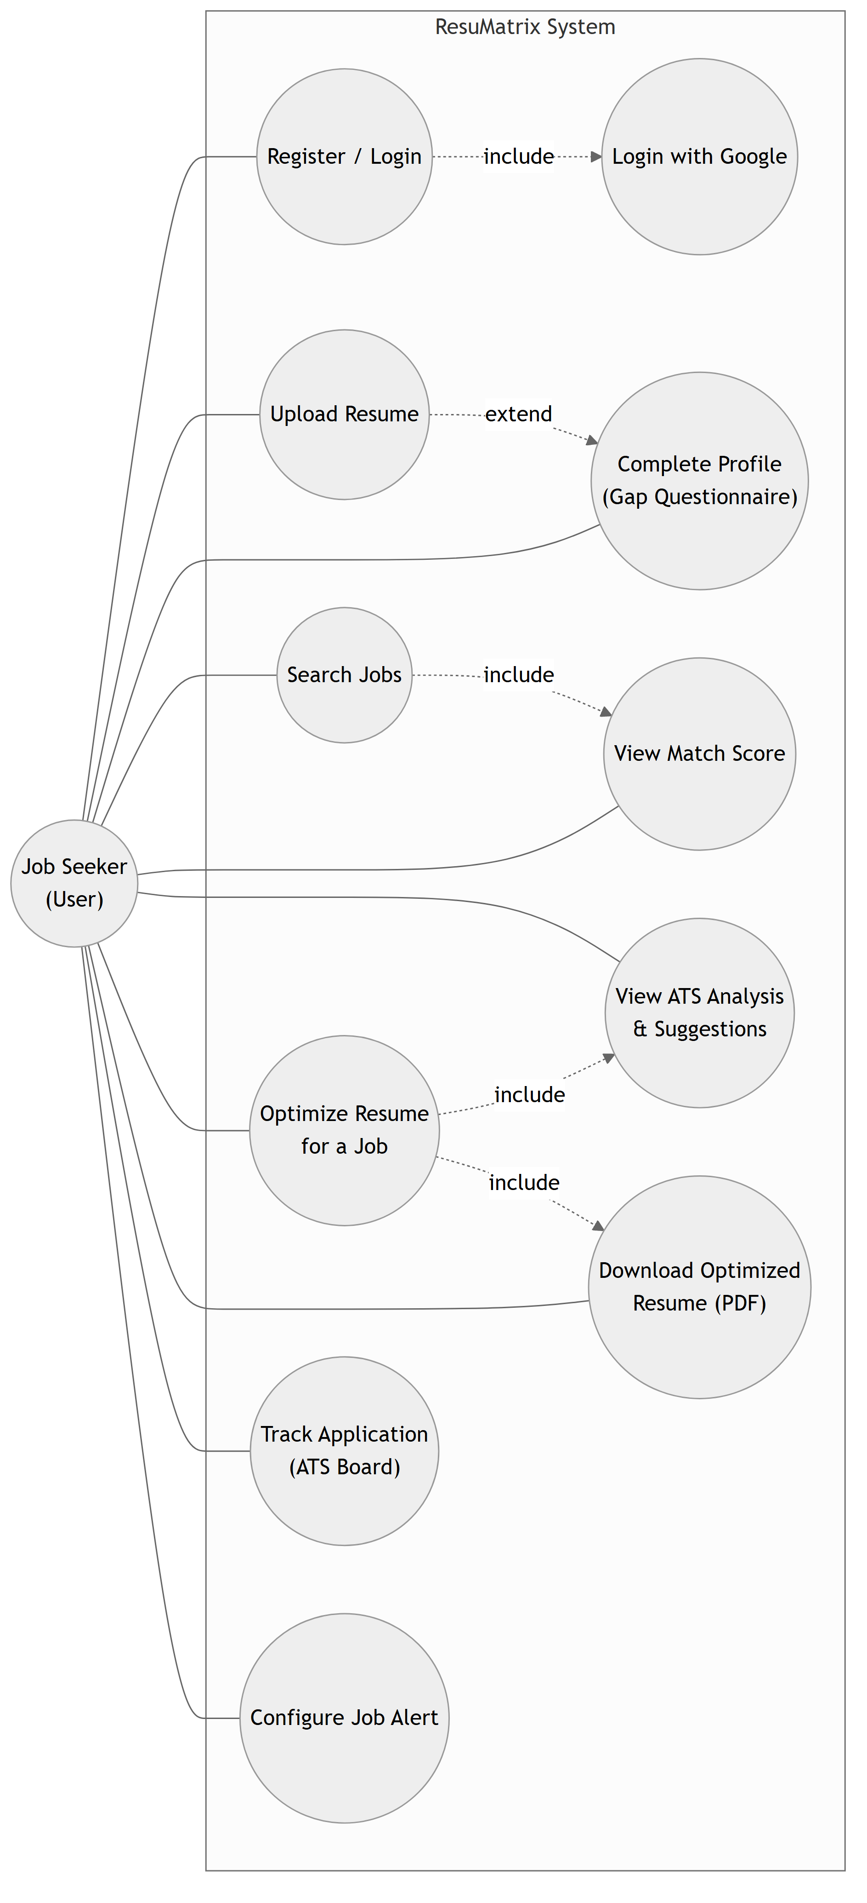
Figure 3.1: Use Case Diagram of the ResuMatrix System

3.1.3.2 Object Modelling using Class, Entity-Relationship, and Object Diagrams
Object modelling captures the static structure of ResuMatrix by identifying the key entities, their attributes, and the relationships among them. The class diagram (Figure 3.2) identifies the core domain entities — User, Profile, WorkExperience, Education, Application, and JobAlert — together with the top-level service classes that operate on them: AuthService, CVParserEngine, and ATSService.
A User owns exactly one Profile, tracks any number of Applications, and may subscribe to any number of JobAlerts. A Profile lists any number of WorkExperience and Education entries. CVParserEngine populates a Profile from parsed resume text; ATSService reads a Profile to score and evaluate an Application.
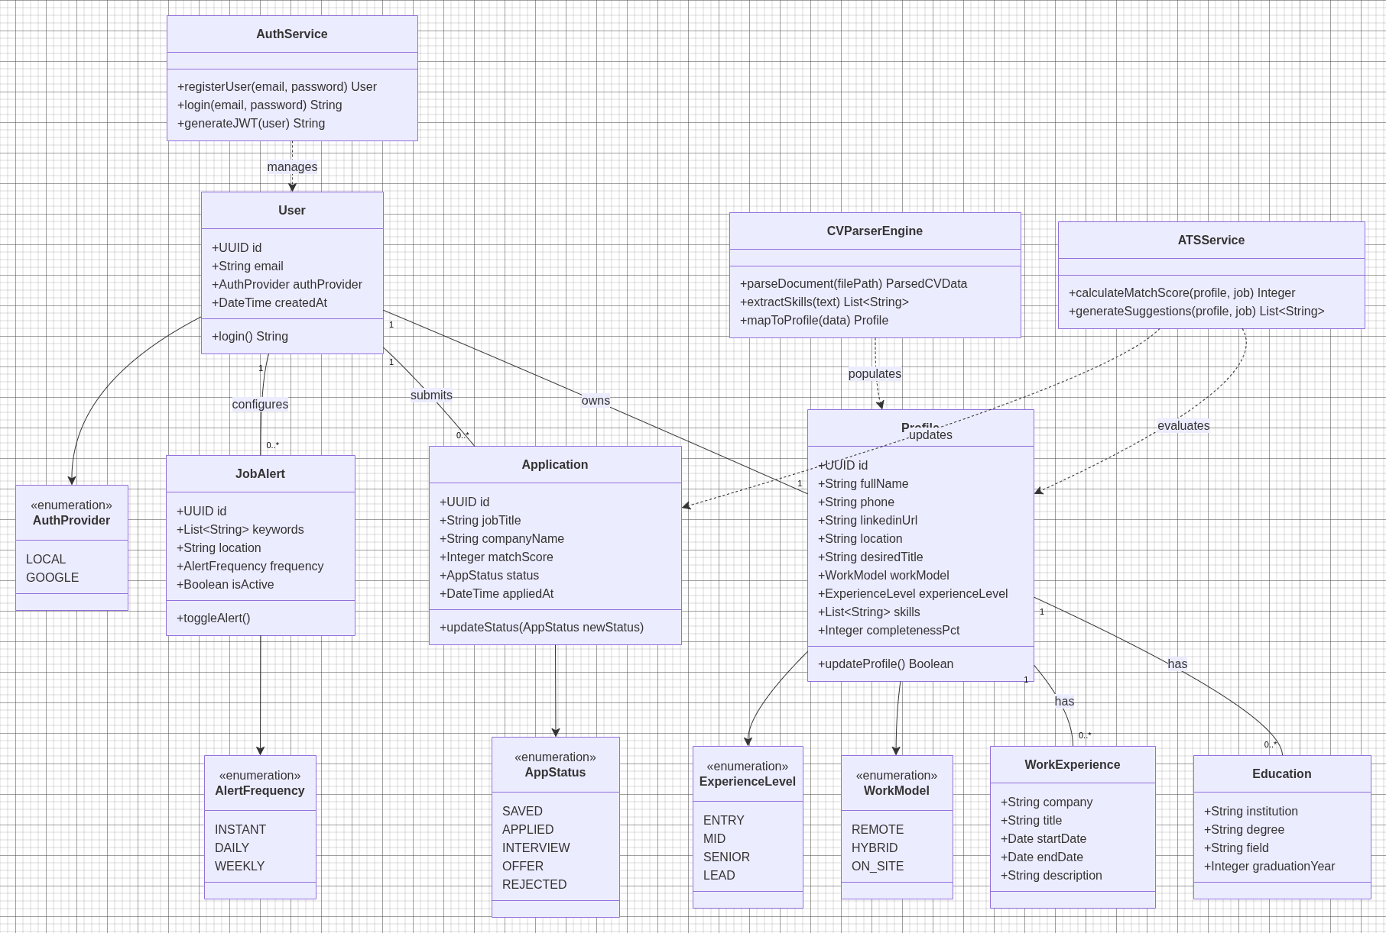
Figure 3.2: Class Diagram of the ResuMatrix System
The entity-relationship diagram (Figure 3.3) shows how the same entities are realized as tables in the PostgreSQL database, including primary/foreign keys and column-level types — the persistence-level counterpart of the class diagram above.
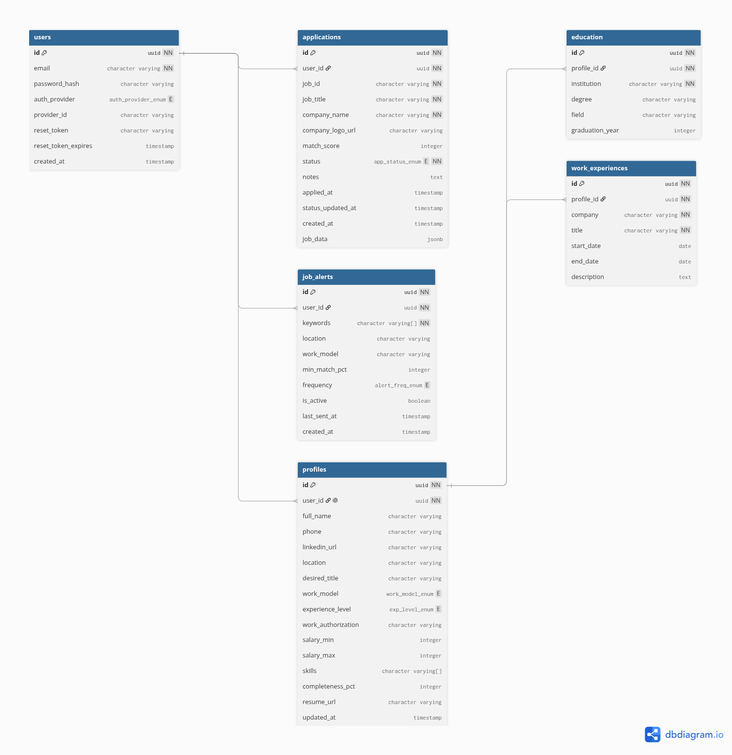
Figure 3.3: Entity-Relationship Diagram of the ResuMatrix Database Schema
The object diagram (Figure 3.4) illustrates a concrete snapshot of the system during a typical session: a User object ("alex@example.com") owns a Profile object populated with skills and an experience level, the Profile lists a WorkExperience instance, and the User tracks two Application instances in different status states ("applied" and "saved") with their own match scores.
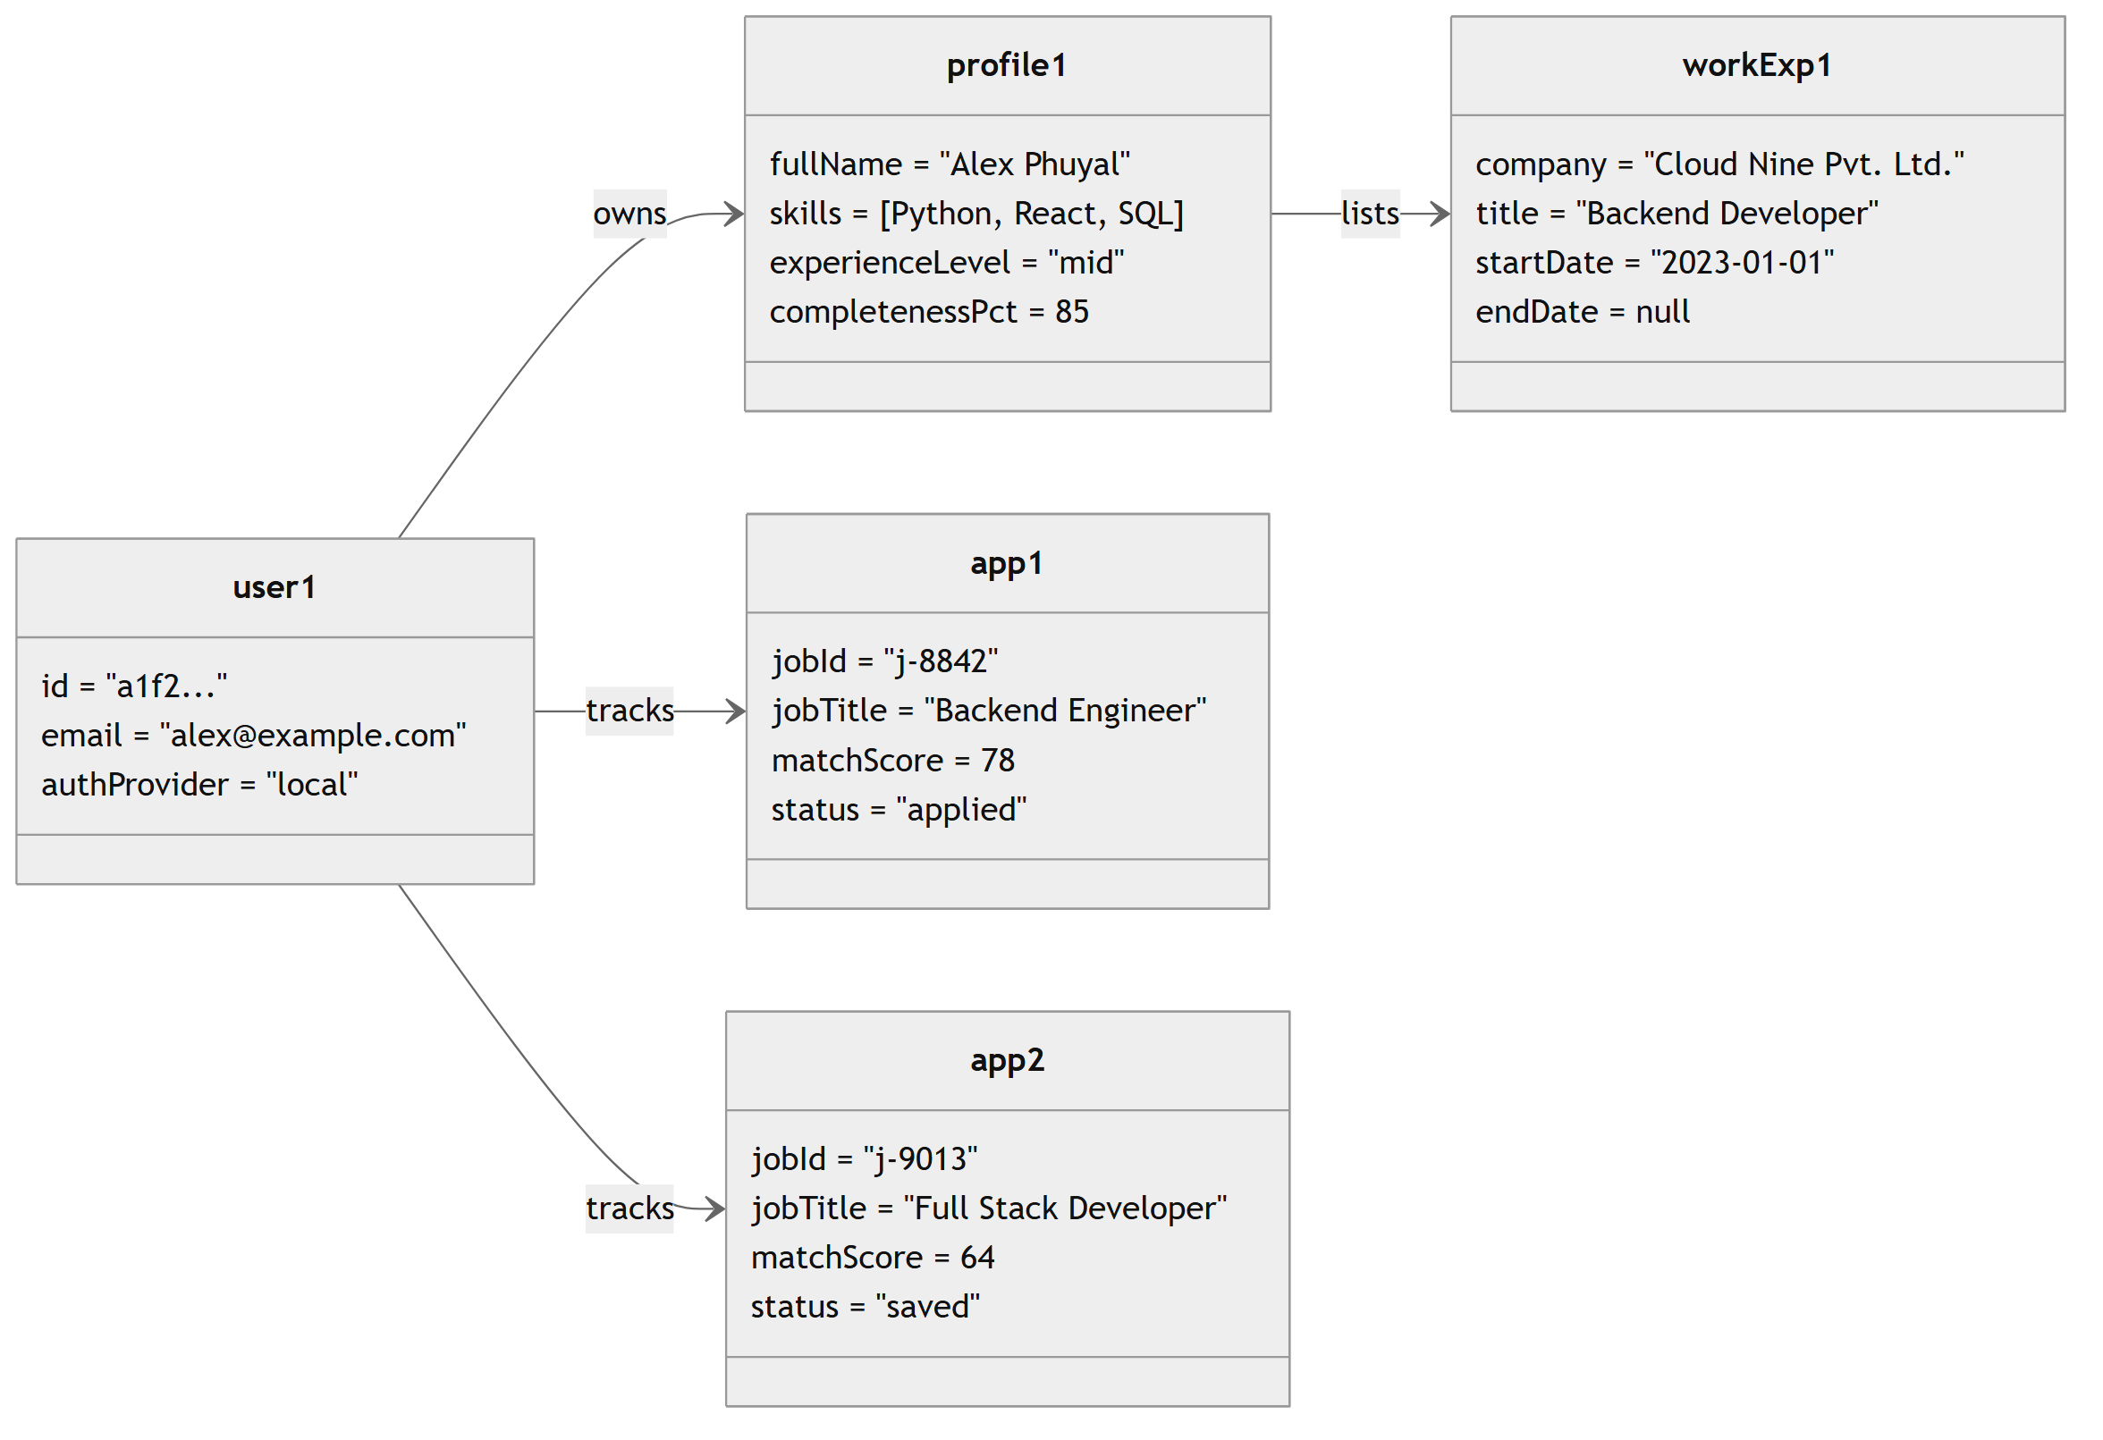
Figure 3.4: Object Diagram of the ResuMatrix System

3.1.3.3 Dynamic Modelling using State and Sequence Diagrams
Dynamic modelling captures the behavior of the system over time. State diagrams describe the lifecycle of key objects, and sequence diagrams show the interactions between objects for a specific use case.
State Diagram — Application (Job) Lifecycle: This is a real, enforced state machine in the system — the `status` column on the Application table is constrained to exactly these five values. A job first enters the Saved state when the user clicks Save on a job card. From Saved it can move to Applied; from Applied it can move to Interview or directly to Rejected; from Interview it can move to Offer or Rejected. Every status change is timestamped (`status_updated_at`), and the first transition into Applied additionally stamps `applied_at`.
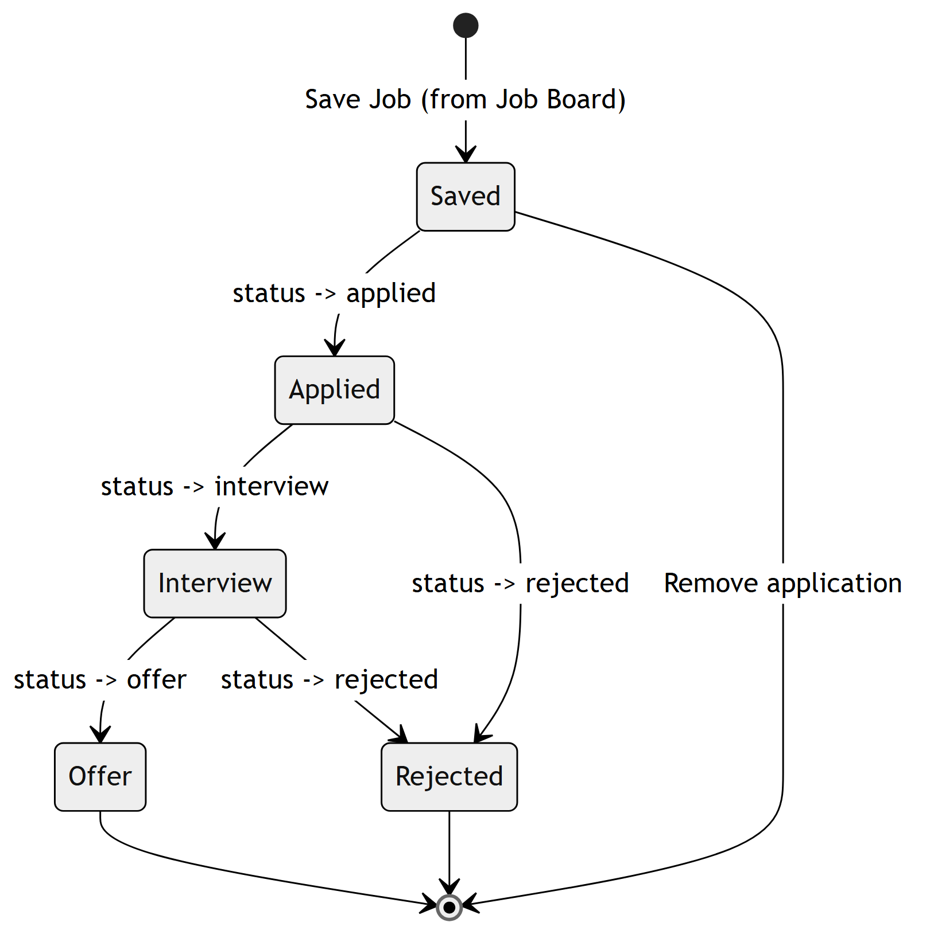
Figure 3.5: State Diagram — Application (Job) Lifecycle
State Diagram — Resume Parsing Request Lifecycle: A resume upload begins in an Idle state, moves to Uploading while the file is transferred, to TextExtracted once `pypdf`/`python-docx` has pulled raw text out of the file, to Parsing while the parsing pipeline runs (offloaded to a thread pool since it is CPU-bound), and terminates in either a Parsed state — with the profile and its child records persisted — or a Failed state on an unreadable or corrupted file.
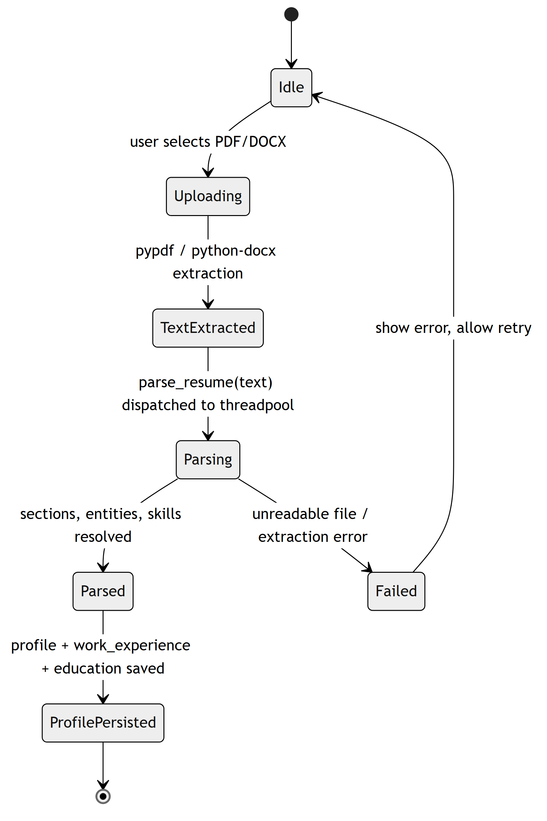
Figure 3.6: State Diagram — Resume Parsing Request Lifecycle
Sequence Diagram — Registration, Resume Parsing, and Job Matching: Figure 3.7 traces the end-to-end flow across the Web Application, Authentication Service, Resume Parser, NER Engine, Regex Engine, Database, Job Matching Engine, ATS Scoring Engine, and Suggestion Engine. A new user registers and the account is created and persisted; a returning user's credentials are verified against the Database. Once logged in, the user uploads a resume PDF, which the Resume Parser sends to the NER Engine (personal info, skills, education, experience) and the Regex Engine (email, phone, links) before storing the parsed profile. The parser then requests matching jobs from the Job Matching Engine, an ATS score from the ATS Scoring Engine, and improvement suggestions from the Suggestion Engine, and the combined jobs, score, and suggestions are returned to the frontend for display.
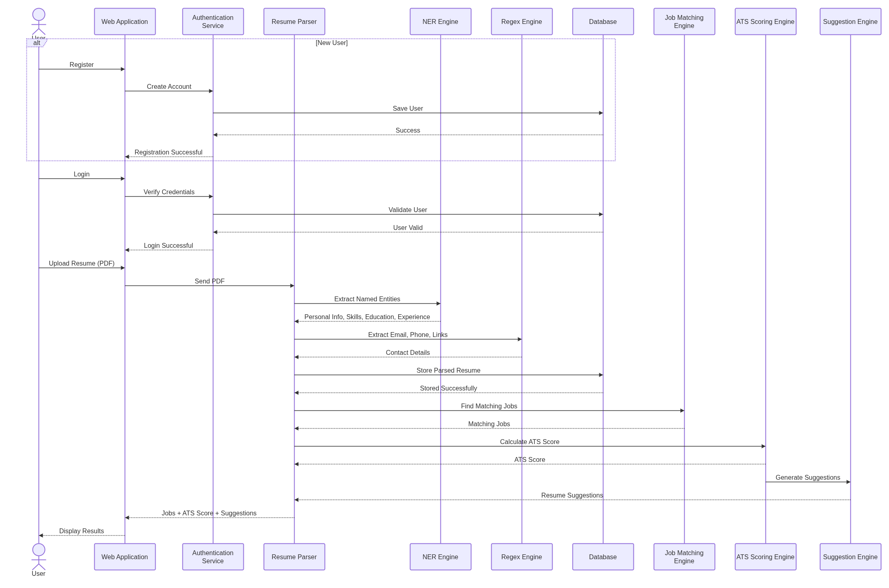
Figure 3.7: Sequence Diagram — Registration, Resume Parsing, and Job Matching

3.1.3.4 Process Modelling using Activity Diagrams
Process modelling using activity diagrams captures the workflow and control flow of the system's key operations, including decision points and termination conditions.
Activity Diagram — Resume Parsing Workflow: The workflow begins when the user selects a resume file. The file's type and size are validated before any parsing begins. Raw text is extracted, then run through the four pipeline stages in sequence (regex, section segmentation, NER, gazetteer), after which the structured profile is assembled and persisted, and the completeness percentage is recomputed to decide whether the user still needs to fill in any required fields.
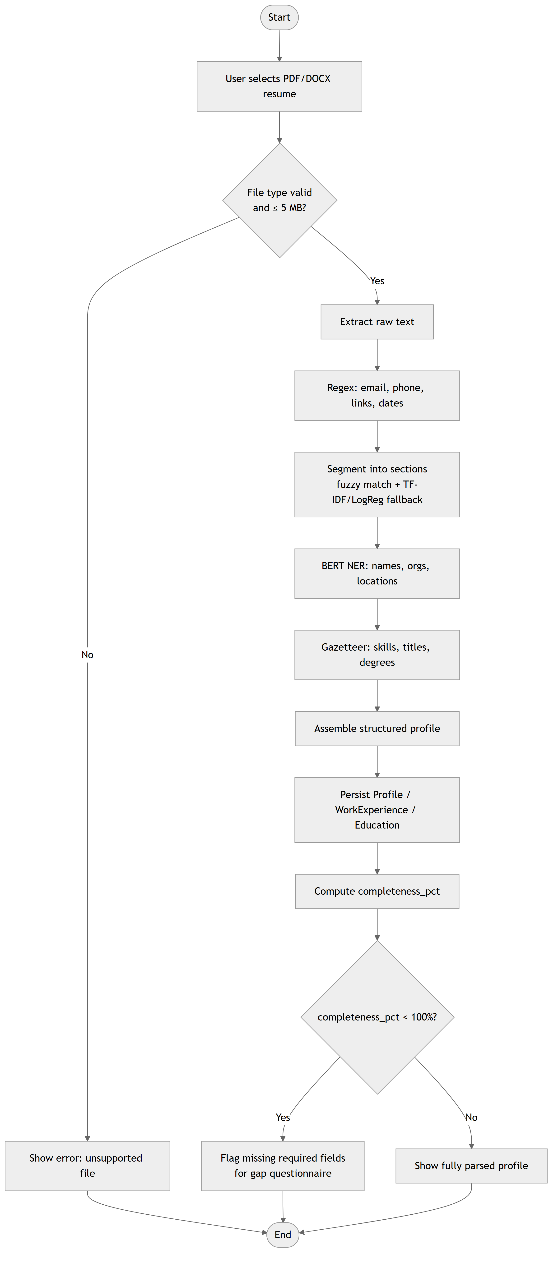
Figure 3.8: Activity Diagram — Resume Parsing Workflow
Activity Diagram — Job Search and Scoring Workflow: A search query is built from the user's profile or a manual search. A cache lookup avoids re-calling the JSearch API for a query/location pair seen within the last 15 minutes; on a cache miss the API is called and the result is cached. If an experience-level filter is active, results are further filtered by a keyword heuristic. If the user's profile has recorded skills, every remaining job is scored and the list is sorted by match score before being rendered.
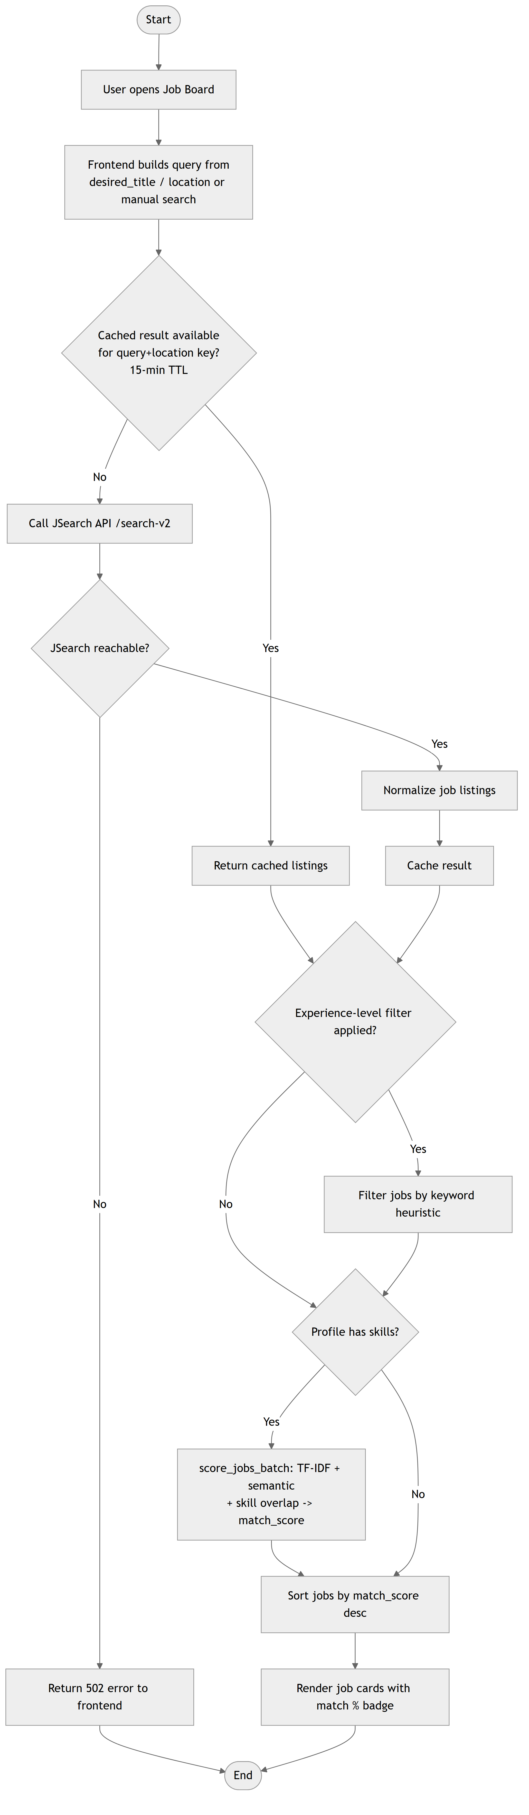
Figure 3.9: Activity Diagram — Job Search and Scoring Workflow
Activity Diagram — Application Status Update Workflow: Saving a job from the Job Board creates an Application record in the Saved state. Opening the Dashboard lists all of the user's tracked applications. Selecting a new status from a card's dropdown issues a status-update request, which stamps `status_updated_at` (and `applied_at` on first entry into Applied) before the card re-renders with its new status.
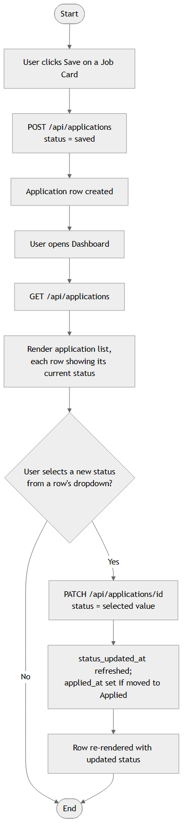
Figure 3.10: Activity Diagram — Application Status Update Workflow

CHAPTER 4: SYSTEM DESIGN

4.1 Design
System design translates the requirements and analysis models into a concrete blueprint for implementation. This chapter presents a swimlane activity diagram that clarifies the client/server/external-API boundary left implicit in Chapter 3, followed by the component and deployment diagrams that describe the physical and logical architecture of ResuMatrix, and closes with a detailed description of every algorithm used in the system.

4.1.1 Activity Diagram with Swimlanes
The job-search-and-scoring activity diagram from Section 3.1.3.4 (Figure 3.9) is redrawn below with three swimlanes — Frontend (client), Backend API (server), and the external JSearch API — making explicit which steps run on which side of the network boundary and which step is genuinely external.
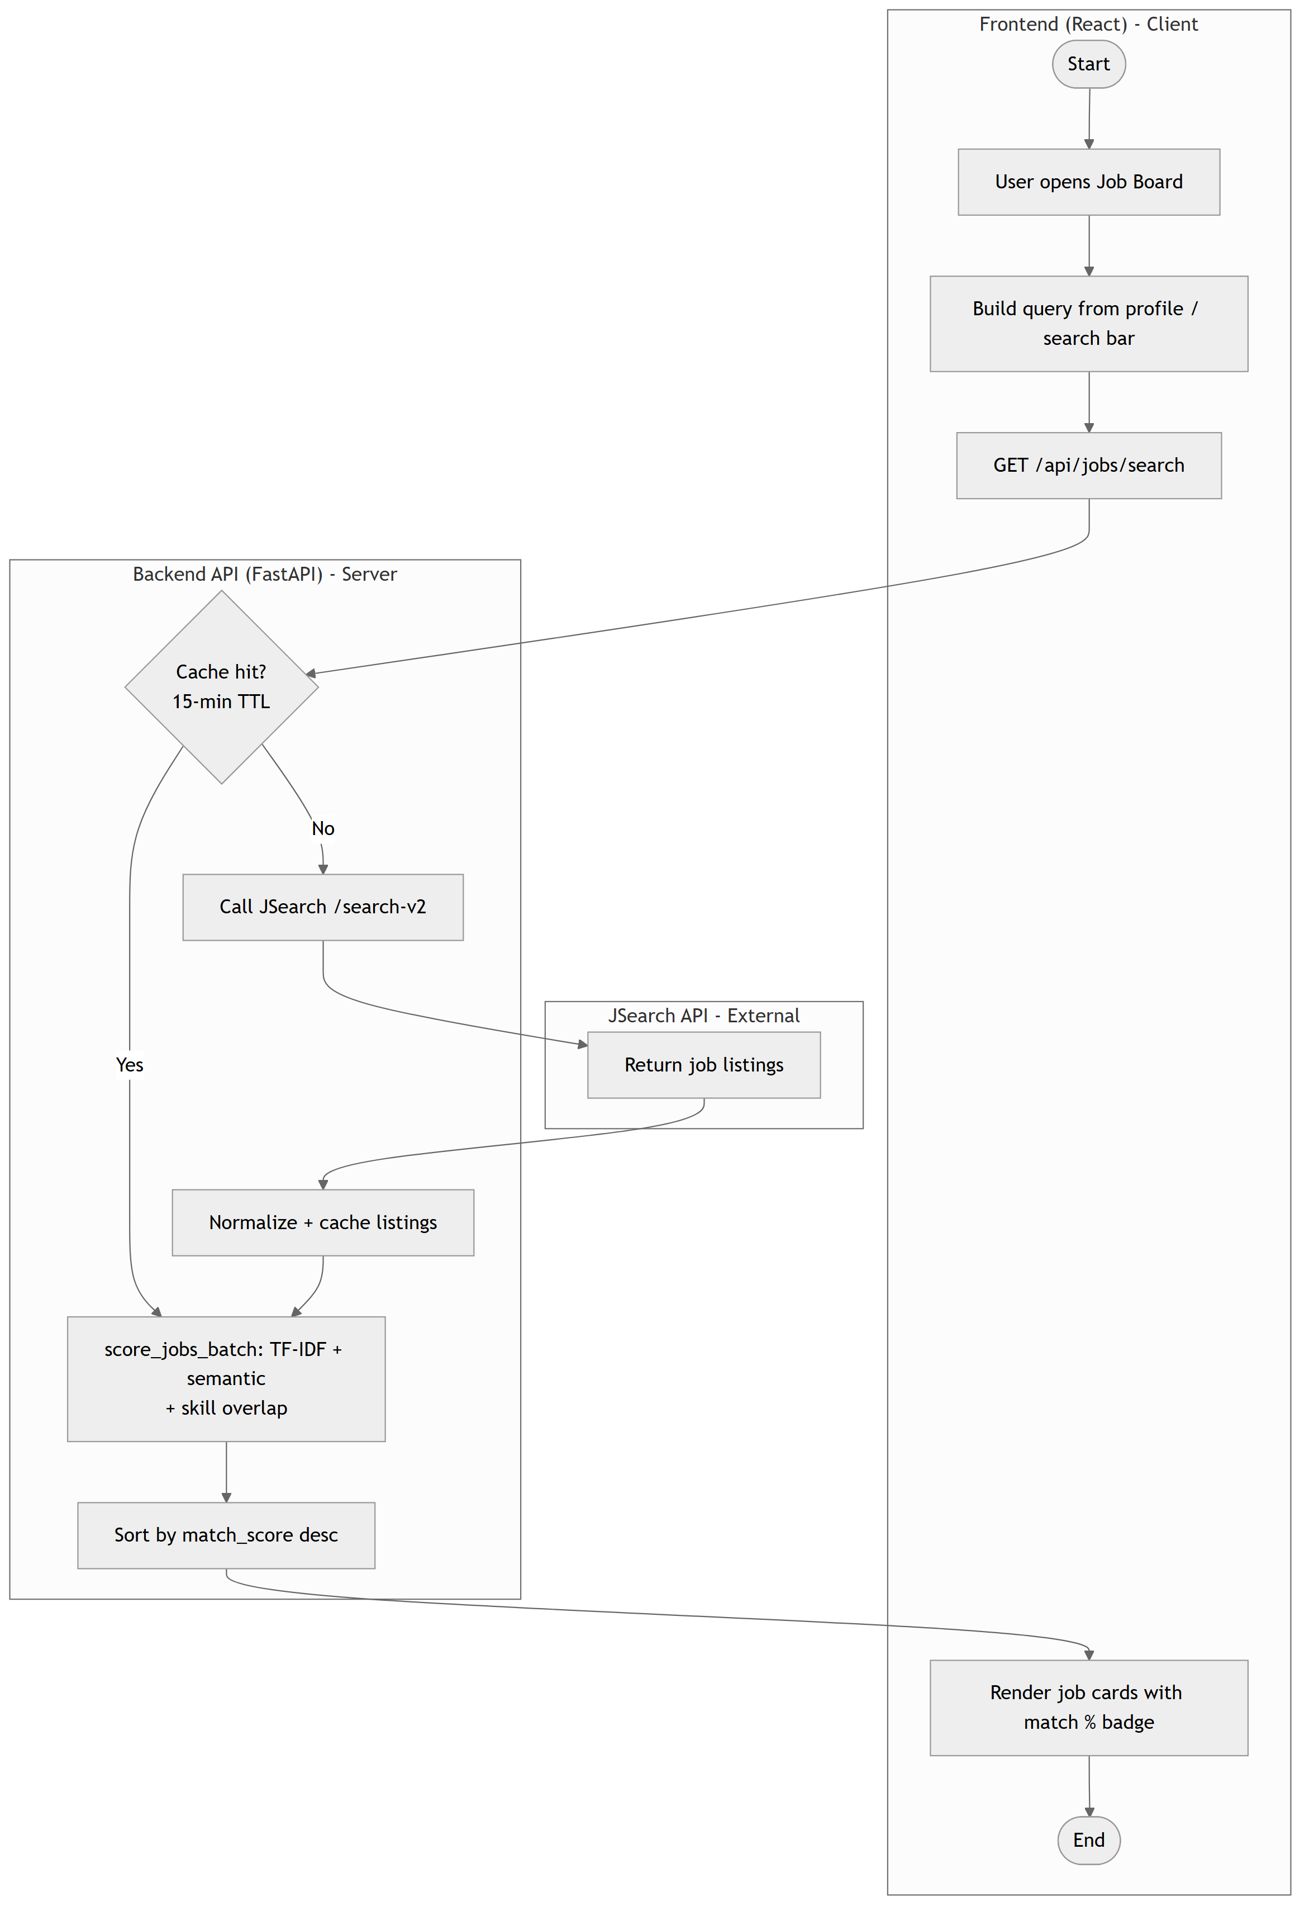
Figure 4.1: Activity Diagram with Swimlanes — Job Search and Scoring (Frontend / Backend / External API)

4.1.2 Component Diagram
The component diagram (Figure 4.2) describes the high-level software components of ResuMatrix and the interfaces through which they communicate. The system is composed of two major subsystems — the Browser Client and the Backend Server — plus the external services both depend on.
- Browser Client Components: Pages (Landing, Login, Register, Dashboard, JobBoard, ProfileSetup) compose reusable Components (JobCard, JobDetailModal, JobSuggestionsPanel, Navbar, ProtectedRoute), which read and write through a State layer — TanStack Query for server-state caching and a Zustand store for auth state — which in turn goes through a thin API layer (lib/api.ts, services/api.ts) that attaches the JWT to every request via an axios interceptor.
- Backend Server Components: Routers (auth, google, profile, resume, jobs, applications, alerts) are the sole entry points into the server; they depend on a Core layer (security.py for Argon2/JWT, database.py, config.py), the ml_resume_parser package for resume parsing, and a Services layer (ats_service, resume_optimizer_service, suggestion_service, skill_service, job_service, email_service, pdf_service) for scoring, optimization, and integration logic.
- External Services: PostgreSQL (via SQLAlchemy/Alembic), the JSearch API on RapidAPI (via httpx), Google OAuth 2.0 (via Authlib), Resend (email), Cloudflare R2 (optional object storage), and the Hugging Face model hub (from which the BERT NER and MiniLM sentence-embedding weights are downloaded at first run).
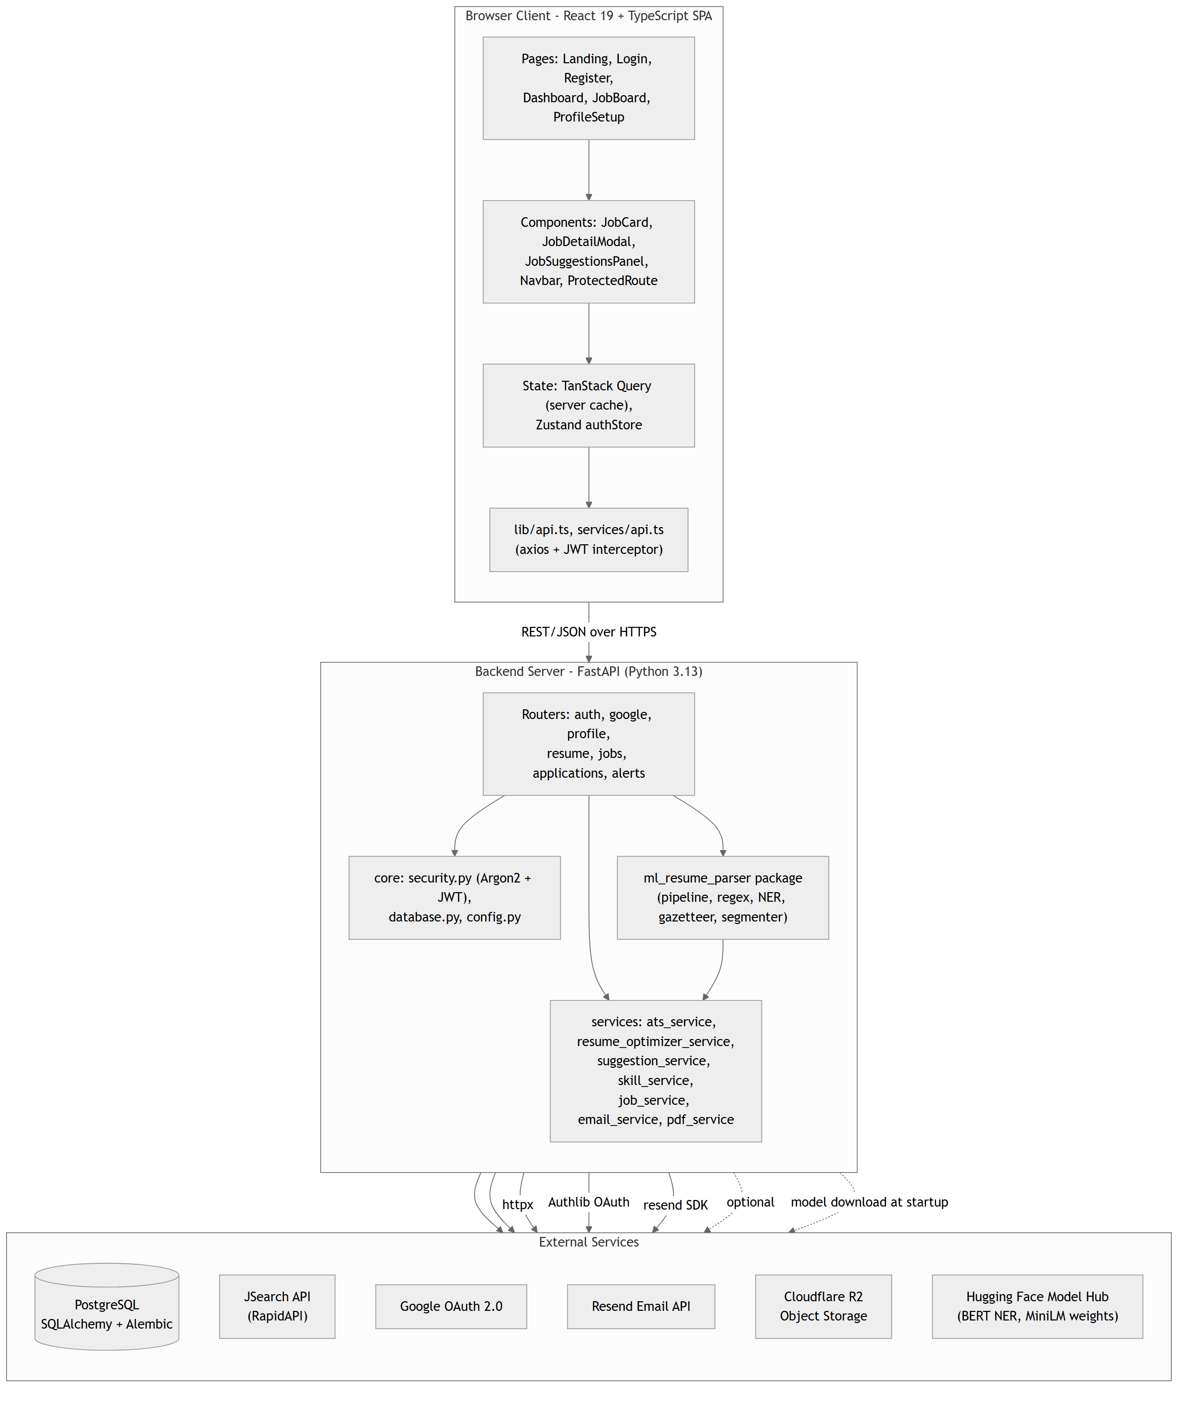
Figure 4.2: Component Diagram of the ResuMatrix System

4.1.3 Deployment Diagram
The deployment diagram (Figure 4.3) describes the physical architecture of ResuMatrix — how software components map to hardware/cloud nodes and how those nodes communicate.
- Client Node — User's Computer: Runs a standard web browser hosting the compiled React single-page application (a static Vite build); no additional software installation is required.
- Server Node — Railway Platform: Runs the FastAPI application under Uvicorn (ASGI) inside a Python 3.13 container, alongside a managed PostgreSQL service. Configuration (database URL, secret key, third-party API keys, OAuth credentials) is supplied entirely through environment variables, so the same container image runs unmodified in development and in production.
- Third-Party Cloud Services: The server node communicates over HTTPS with the JSearch API (job listings), Google's OAuth 2.0 endpoints (sign-in), Resend (alert emails), optionally Cloudflare R2 (resume file storage), and the Hugging Face model hub (one-time model weight download at build/startup).
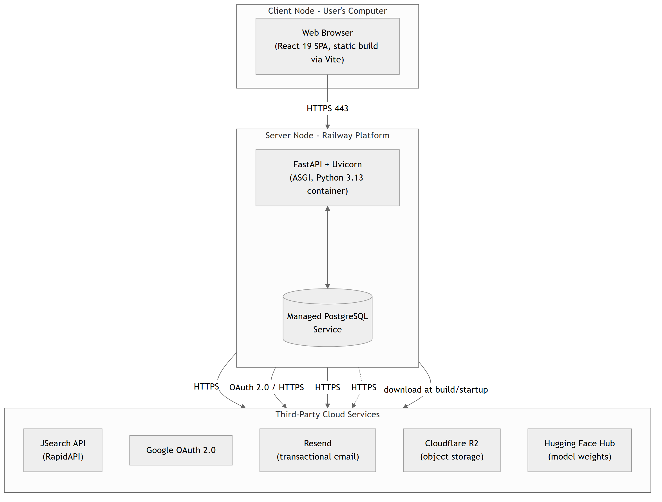
Figure 4.3: Deployment Diagram of the ResuMatrix System

4.2 Algorithm Details
This section describes every non-trivial algorithm implemented in the backend, organized by the pipeline stage it belongs to, including the governing formula for each scoring or matching step.

4.2.1 Resume Parsing Pipeline
The resume parsing pipeline (`app/ml_resume_parser/pipeline.py`) runs five stages in sequence:
- Deterministic field extraction (regex_extractor.py): Email, phone, LinkedIn/GitHub URLs, and date ranges are extracted with hand-written regular expressions. These fields are highly regular in structure, so regex achieves near-100% precision with no accuracy to be gained from a statistical model.
- Section segmentation (section_segmenter.py): Raw resume text is split into named sections (contact, summary, skills, experience, education) using a two-stage header detector. The primary pass computes a difflib.SequenceMatcher fuzzy-match ratio between each candidate line and a curated list of header synonyms, accepting a match only above a 0.82 similarity threshold. Short lines the fuzzy matcher cannot confidently place fall through to a secondary classifier — a scikit-learn Pipeline of a character n-gram (2–4 grams) TfidfVectorizer feeding a multinomial LogisticRegression — which is only trusted above a 0.55 predicted-probability threshold. This deterministic-rule-first, learned-model-fallback design lets uncommon header phrasing (e.g. "Employment Background" instead of "Work Experience") still be recognized without letting a low-confidence guess override a clear non-match.
ratio(a, b) = 2M / T, where M = number of matching characters between strings a and b, T = |a| + |b|
- Named entity recognition (ner_extractor.py): A pretrained BERT token classifier (`dslim/bert-base-NER`) extracts PERSON, ORGANIZATION, and LOCATION spans from the contact block and from each experience/education entry. No fine-tuning was performed — the pretrained CoNLL-2003 weights are used as-is, since no labeled resume-NER dataset was available for this project. Results are ranked by the model's own confidence score rather than by their position in the text, since a low-confidence false positive can otherwise appear earlier than the correct entity.
- Gazetteer lookup (skill_service.py, title_gazetteer.py): Skills, job titles, and academic degrees are matched against curated vocabularies. Skills use a spaCy PhraseMatcher over a JSON gazetteer of terms and synonyms, categorized into groups (e.g. languages, frameworks, cloud/DevOps). Because a fixed vocabulary alone silently drops any skill outside its list, the Skills section (when detected) is additionally tokenized on its own delimiter structure (bullets, commas, pipes) to recover skills the gazetteer does not recognize, which are then surfaced as "uncategorized" rather than dropped. Job titles and degrees use a simpler longest-match lookup against a fixed keyword list.
- Entry boundary detection and field assembly (experience_parser.py, education_parser.py): Work-experience entries are split wherever a line matches the date-range regex (a resume's own convention: the date range for a role almost always appears on or next to its title/company header). Education entries are split wherever a line matches a degree-name gazetteer entry instead, since education blocks usually list a single graduation year rather than a range. Within each entry block, NER supplies the company/institution candidate (discarding any candidate that is really just the extracted title text mis-tagged as an organization) and the gazetteer supplies the title/degree, with a regex-based fallback for company name when NER finds nothing.
The output of `parse_resume(text)` is a single dictionary matching the shape of Profile plus lists of WorkExperience and Education dictionaries, so it can be persisted directly without any intermediate transformation.

4.2.2 ATS Match Scoring
The ATS scoring service (`ats_service.py`) computes a 1–10 match score for a (job, profile) pair by blending three independent signals:
- Lexical similarity: The profile's skills, desired title, and experience-bullet text are concatenated into one document; the job's description, highlights, and any structured technology/skill fields are concatenated into another. Both are vectorized with a shared scikit-learn TfidfVectorizer (English stop-words removed, unigrams and bigrams) and compared with cosine similarity.
- Semantic similarity: The same two documents are encoded with the `all-MiniLM-L6-v2` sentence-transformer model into dense embeddings, compared with cosine similarity (clipped to be non-negative). This is the signal that recognizes near-synonymous phrasing the lexical pass misses.
- Skill-set overlap: If the job's structured technology/skill fields are present (from the JSearch job-details enrichment endpoint), they are used directly; otherwise the gazetteer is run over the job description text to extract an equivalent skill set. Overlap is the size of the intersection with the profile's skill set divided by the size of the job's skill set.
Both the lexical and semantic signals are compared with cosine similarity between their vector representations A and B:
cosine_sim(A, B) = (A · B) / (||A|| · ||B||)
Skill-set overlap is a direct set-intersection ratio between the profile's skill set S_p and the job's skill set S_j:
skill_overlap = |S_p ∩ S_j| / |S_j|
The three scores are combined with fixed weights and mapped onto an integer 1–10 scale:
match_score = round(1 + 9 × (0.5 × skill_overlap + 0.25 × tfidf_cosine + 0.25 × semantic_cosine))
Skill overlap is weighted most heavily because it is the most directly interpretable and least noisy of the three signals for this domain; the lexical and semantic scores are weighted equally so that neither exact keyword matches nor purely semantic phrasing similarity can dominate the score on their own. All jobs in a search result page are scored in a single batched call (shared TF-IDF vocabulary fit once per request, embeddings encoded in one batch), and the CPU-bound embedding step is offloaded to a thread pool so it does not block the async event loop.

4.2.3 Resume Optimization
The resume optimizer (`resume_optimizer_service.py`) reuses the ATS scoring building blocks to generate concrete, job-targeted edit suggestions, through three independent signals:
- Bullet-injection targeting: For each skill the profile already claims but never mentions in any experience-bullet text ("underemphasized"), the job-description sentence that mentions that skill is embedded alongside every candidate experience bullet using the same sentence-transformer model; the bullet with the highest cosine similarity to that sentence (above a 0.15 threshold, and not already used for a different skill) receives an appended clause naming the skill. This only ever adds a sentence referencing a skill the user already claimed elsewhere in their profile — it never invents a new skill.
target_bullet = argmax_b cosine_sim(embed(skill_sentence), embed(b)), subject to cosine_sim > 0.15
- Missing-skill ranking: Skills the job wants but the profile never claims at all are ranked purely by how often they appear in the job description text (a raw term-frequency count) and the top few are proposed as additions to the Skills section only — never inserted into an experience bullet — and explicitly flagged for the user to confirm or remove.
- Quantification-gap detection: Each experience bullet is checked with a simple regex for the presence of any digit. A bullet with no digit at all is flagged with a message suggesting the user add a measurable outcome (team size, percentage improvement, requests/sec, etc.). This is a flag only — the system never fabricates a number on the user's behalf.
After the above changes are computed, the optimizer recomputes the lexical, semantic, and skill-overlap scores against the modified skills list and experience text, producing a `score_before` and `score_after` pair so the user can see the projected impact of accepting the suggested edits before committing to them.

4.2.4 Authentication and Session Security
Passwords are never stored in plaintext or with a fast general-purpose hash: `security.py` uses `pwdlib`'s recommended password hash (Argon2), a memory-hard hashing algorithm specifically designed to resist GPU/ASIC brute-force attacks. On successful login, the server issues a signed JSON Web Token (HS256) carrying the user's ID and email as claims, with a 7-day expiry; every subsequent request to a protected endpoint passes this token in the Authorization header, and a shared FastAPI dependency (`get_current_user`) decodes and validates it before the request reaches any route handler. The Google OAuth 2.0 path (via Authlib) never receives or stores a user's Google password — the frontend exchanges an authorization code for Google's own access token, the backend uses that token once to fetch the user's verified email/name/picture, and then issues ResuMatrix's own JWT exactly as it would for a local login, so both authentication paths converge on the same downstream session mechanism.

CHAPTER 5: IMPLEMENTATION AND TESTING

5.1 Implementation

5.1.1 Tools Used
Table 5.1 lists the tools and technologies used in the development of ResuMatrix.
Table 5.1: Tools and Technologies Used
Category | Tool / Technology | Purpose
Frontend Framework | React 19.2 + TypeScript | Single-page application UI
Build Tool | Vite 8 | Development server and production bundler
Styling | Tailwind CSS v4 | Utility-first styling
UI Components | shadcn/ui (Radix UI / Base UI primitives) | Accessible, unstyled component primitives
Routing | React Router v7 | Client-side routing
Data Fetching / Cache | TanStack Query v5 | Server-state caching and refetching
Forms & Validation | React Hook Form + Zod | Form state management and schema validation
Client State | Zustand | Auth store
HTTP Client | axios | API calls with a JWT-attaching interceptor
Backend Framework | FastAPI 0.136 (Python 3.13) | REST API application
ASGI Server | Uvicorn | Application server
ORM & Migrations | SQLAlchemy 2.0 + Alembic | Database access layer and schema migrations
Database | PostgreSQL | Primary data store
Password Hashing | pwdlib (Argon2) | Secure password storage
Session Tokens | python-jose (JWT, HS256) | Stateless session authentication
OAuth | Authlib | Google OAuth 2.0 sign-in
NLP — Gazetteer | spaCy 3.8 (en_core_web_sm) | PhraseMatcher-based skill/title/degree lookup
NLP — Classical ML | scikit-learn 1.5 | TF-IDF vectorization, Logistic Regression, cosine similarity
NLP — Deep Learning (NER) | transformers 5.12 + torch 2.12 (dslim/bert-base-NER) | Name / organization / location extraction
NLP — Sentence Embeddings | sentence-transformers 5.6 (all-MiniLM-L6-v2) | Semantic similarity scoring
File Parsing | pypdf, python-docx | Resume text extraction from PDF/DOCX
PDF Generation | reportlab | Optimized resume PDF export
Job Search | JSearch API (RapidAPI) via httpx | Live job listing retrieval
Email | Resend SDK | Job alert digest emails
Object Storage (optional) | Cloudflare R2 (boto3, S3-compatible) | Resume file storage
Error Monitoring | Sentry SDK | Exception tracking
Deployment | Railway | Application hosting platform
Version Control | Git and GitHub | Source control and collaboration

5.1.2 System Implementation

5.1.2.1 Frontend Module
The frontend is a React 19 + TypeScript single-page application built with Vite. Routing is handled by React Router v7: public routes (Landing, Login, Register, the Google OAuth redirect handler) sit outside a ProtectedRoute wrapper, while Dashboard, JobBoard, and ProfileSetup are nested under it and share a common authenticated layout (Navbar plus a max-width content area). ProtectedRoute checks for a stored JWT and redirects unauthenticated users to Login.
Server state (profile, jobs, applications) is managed through TanStack Query, which handles caching, retries, and cache invalidation after mutations (e.g. invalidating the profile query after a resume upload); a lightweight Zustand store separately tracks the authenticated user's identity. All outgoing requests go through a shared axios instance (`services/api.ts`) whose request interceptor attaches the stored JWT as a Bearer token and whose response interceptor clears the token and redirects to Login on a 401. The ProfileSetup page implements the gap-filling flow described in Chapter 3: resume-derived fields (name, phone, links, summary, skills) render as disabled inputs once populated from an upload, while the two genuinely required fields for job matching — preferred location and experience level — are always editable and validated with a Zod schema through React Hook Form. The JobBoard page renders job cards (with the circular match-score indicator described in Section 4.2.2) and opens a JobDetailModal that lazily fetches the ATS analysis and optimization suggestions for the selected job only when the user opens it, avoiding the cost of scoring every job in full detail up front. The Dashboard page renders the tracked applications as a list, each with a status dropdown (Saved, Applied, Interview, Offer, Rejected) that issues a status-update mutation on selection.

5.1.2.2 Backend Module
The backend is a FastAPI application (`main.py`) that mounts seven routers under an `/api` prefix — auth, google, profile, resume, jobs, applications, and alerts — each responsible for one bounded area of functionality. `Base.metadata.create_all` provisions the schema against the configured PostgreSQL database on startup, and CORS middleware is scoped to the frontend's origin. Every protected route depends on `get_current_user` (`dependencies.py`), which decodes the bearer JWT and loads the corresponding `User` row, so authorization is enforced centrally rather than being re-implemented per route.
The `ml_resume_parser` package (Section 4.2.1) is invoked from `routers/resume.py`'s `upload_resume` handler; because the pipeline's regex/scikit-learn/spaCy/torch work is synchronous and CPU-bound, it is dispatched through FastAPI's `run_in_threadpool` so it does not block the async event loop that the rest of the application relies on for concurrency. The `services` package holds the remaining business logic: `ats_service.py` and `resume_optimizer_service.py` implement the scoring and optimization algorithms from Sections 4.2.2–4.2.3; `job_service.py` wraps the JSearch API behind a 15-minute in-memory cache keyed on the sorted request parameters; `skill_service.py` is shared by both the resume parser and the ATS scorer so skill categorization stays consistent across the whole system; `pdf_service.py` renders the optimized resume with ReportLab; and `email_service.py` wraps the Resend SDK for job alert digests.

5.1.2.3 Inter-Module Communication
The frontend and backend communicate exclusively over a JSON REST API served under `/api`, with every request beyond registration/login/OAuth carrying a Bearer JWT. Table 5.2 lists the endpoints exposed by the backend.
Table 5.2: Inter-Module Communication Protocol (REST Endpoints)
Method | Endpoint | Purpose
POST | /api/auth/register | Register a new local-auth user and an empty Profile
POST | /api/auth/login | Authenticate and issue a JWT
POST | /api/auth/logout | Clear the client-side session cookie
GET | /api/google/login | Get the Google OAuth 2.0 authorization URL
POST | /api/google/callback | Exchange an OAuth code, find-or-create the user, issue a JWT
GET | /api/profile | Fetch the current user's profile
PATCH | /api/profile | Update editable (non-resume-locked) profile fields
POST | /api/resume/upload | Upload and parse a PDF/DOCX resume
POST | /api/resume/optimized-pdf | Stream a generated, job-optimized resume PDF
GET | /api/jobs/search | Search and score jobs against the current profile
POST | /api/jobs/ats-analysis | Detailed matched/missing-skill analysis for one job
POST | /api/jobs/optimize-resume | Generate resume-optimization suggestions for one job
GET | /api/applications | List the current user's tracked applications
POST | /api/applications | Save a job as a new Application (status = saved)
PATCH | /api/applications/{id} | Update an application's status / notes
DELETE | /api/applications/{id} | Remove a tracked application
GET | /api/alerts | List the current user's job alerts
POST | /api/alerts | Create a job alert
PATCH | /api/alerts/{id} | Update or toggle a job alert
DELETE | /api/alerts/{id} | Delete a job alert
GET | /api/health | Liveness check

The communication flow for a standard job-search request is: (1) the frontend calls GET /api/jobs/search with the current query/filters; (2) the backend checks its in-memory cache and calls the JSearch API on a miss; (3) if the profile has recorded skills, the backend scores every returned job through the ATS scoring service; (4) the ranked job list is returned as JSON; (5) the frontend renders the list and caches it client-side via TanStack Query until the next search or a 5-minute staleness timeout.

5.2 Testing
Testing was conducted in three phases — unit, integration, and system testing — using manual, scenario-driven verification against the running application and, for backend modules, direct function-level checks executed in a Python REPL/script against representative inputs. The project does not yet include an automated test runner (e.g. pytest) wired into a CI pipeline; this is listed as a limitation in Section 1.4.2 and as future work in Section 6.2.

5.2.1 Unit Testing
Unit testing exercised individual functions within each pipeline module in isolation, using small, hand-constructed inputs with a known expected output.
Table 5.3: Unit Test Cases
ID | Module | Description | Input | Expected Output | Result
UT-01 | regex_extractor | Extract email from a contact line | "Jordan Rivera — jordan.rivera@example.com" | jordan.rivera@example.com | Pass
UT-02 | regex_extractor | Extract a date range | "Jan 2022 - Present" | start=2022-01, end=None (Present) | Pass
UT-03 | section_segmenter | Detect a standard section header | "WORK EXPERIENCE" | section = experience | Pass
UT-04 | section_segmenter | Classifier fallback on unusual header phrasing | "Employment Background" | section = experience (via TF-IDF/LogReg) | Pass
UT-05 | ner_extractor | Extract a person name | Contact block text | ["Jordan Rivera"] | Pass
UT-06 | skill_service | Categorize a known gazetteer skill | "Python" | {"languages": ["Python"]} | Pass
UT-07 | skill_service | Recover an out-of-gazetteer skill from a Skills section | "Skills: Figma, Notion" | "Figma", "Notion" returned as uncategorized | Pass
UT-08 | experience_parser | Split a block into per-role entries by date range | Two-role experience block | 2 parsed entry dicts | Pass
UT-09 | ats_service | Blend score upper bound | Full skill/lexical/semantic overlap | match_score = 10 | Pass
UT-10 | ats_service | Blend score lower bound | No overlap (empty profile skills) | match_score = 1 | Pass
UT-11 | resume_optimizer_service | Detect a bullet with no quantified outcome | Bullet text with no digits | quantify_suggestion generated | Pass
UT-12 | security | Argon2 password hash / verify round-trip | "P@ssw0rd123" | verify_password returns True | Pass
UT-13 | security | JWT encode / decode round-trip | {"sub": user_id} | Decoded payload matches, correct expiry | Pass
UT-14 | pdf_service | Generate a PDF from a profile and optimization result | Sample profile + optimization dict | Non-empty bytes with a valid PDF header | Pass

5.2.2 Integration Testing
Integration testing verified that the frontend, the backend routers, and the underlying services and database worked correctly together across a full request/response cycle.
Table 5.4: Integration Test Cases
ID | Scenario | Expected Result | Result
IT-01 | Register then log in with the created credentials | JWT returned; a Profile row exists for the new user | Pass
IT-02 | Upload a real resume file | Profile, WorkExperience, and Education rows are populated and completeness_pct reflects them | Pass
IT-03 | Search jobs with a profile that has skills set | Returned jobs are annotated with match_score and sorted descending | Pass
IT-04 | POST /api/jobs/ats-analysis for a specific job | Response includes matched/missing skills (categorized) and a suggestions list | Pass
IT-05 | Optimize resume, then download the optimized PDF | PDF content reflects the optimized skills list and updated bullets | Pass
IT-06 | Save a job, then change its status via the Dashboard dropdown | Application status and status_updated_at update after each change | Pass
IT-07 | Complete the Google OAuth callback flow | User is found-or-created and a valid JWT is issued | Pass
IT-08 | Repeat an identical job search within 15 minutes | Second call is served from the in-memory cache (no duplicate JSearch request) | Pass
IT-09 | Call a protected endpoint with no/invalid token | 401 Unauthorized is returned | Pass
IT-10 | Simulate a JSearch API failure | Backend returns 502 with a clear detail message; frontend shows a retry option | Pass

5.2.3 System Testing
System testing evaluated the end-to-end behavior of the complete application, from registration through resume upload, job search, ATS analysis, optimization, PDF export, and application tracking, running the full stack (frontend, backend, PostgreSQL) together against a range of real and synthetic resumes and job search queries.
- Resume parsing was exercised against resumes of varying formats — single-column chronological, resumes with non-standard section headers, and resumes with multiple experience/education entries — to verify the fuzzy-match/classifier fallback and the entry-boundary splitting behaved correctly.
- Job search was exercised with both common titles (with dense JSearch coverage) and narrow/location-specific queries (sparse coverage), verifying the location-broadening fallback in `jobs.py` correctly re-queries without a location filter when the scoped query returns nothing.
- Match scoring was spot-checked by constructing profiles with a controlled skill overlap against a fixed job description and confirming the resulting score moved in the expected direction as skills were added or removed.
- Boundary conditions tested included an empty resume upload, a resume at the 5 MB size limit, a profile with zero skills (job search proceeds without scoring rather than failing), and a job with no structured skill fields (falls back to gazetteer extraction over the description text).
- Error conditions tested included an unreachable JSearch API (mocked failure), an invalid/expired JWT, and a corrupted or non-PDF/DOCX file upload — all confirmed to fail with a clear, appropriate HTTP status rather than an unhandled server error.
- Cross-browser manual verification was performed on the frontend in a Chromium-based browser, covering the full authenticated flow from login through to PDF export.

5.3 Result Analysis
ResuMatrix was evaluated qualitatively against the objectives stated in Section 1.3, through the manual system testing described above.
Resume Parsing: The parsing pipeline correctly separated conventional resume sections (clear "Work Experience"/"Education"/"Skills" headers) with the fuzzy-match rule alone in the majority of cases tested, with the TF-IDF/Logistic-Regression classifier fallback correctly catching header phrasing not present in the curated synonym list (e.g. "Employment Background"). The BERT NER model reliably identified person names and organization names in the contact and experience blocks; its main observed failure mode was occasionally tagging a capitalized technology or project phrase (e.g. "Machine Learning") as an organization, which the experience-parser's title-overlap discard rule (Section 4.2.1) mitigates but does not eliminate entirely. The gazetteer-plus-delimiter-split combination for skills recovered both known-vocabulary terms and novel terms the fixed gazetteer had never seen, rather than silently dropping the latter.
ATS Match Scoring: Constructing profiles with progressively larger skill overlap against a fixed job description produced monotonically increasing match scores, confirming the blend formula behaves as designed. The semantic (sentence-embedding) component visibly changed scores for resume/job pairs that shared no exact keywords but used near-synonymous phrasing, validating the motivation for including it alongside the purely lexical TF-IDF signal.
Resume Optimization: Bullet-injection suggestions were only ever generated for skills the profile already claimed, and only placed into the most semantically related existing bullet (never a randomly chosen one); missing-skill suggestions were correctly restricted to the Skills list rather than fabricated into experience text; and the quantification-gap flag correctly identified bullets with no measurable outcome without ever inventing a number.
Application Tracking: Manual status transitions matched the state diagram in Figure 3.5 exactly, with `applied_at` and `status_updated_at` populated correctly on each observed transition. Since this status is self-reported through the dropdown rather than derived from any external source, testing could only confirm that the recorded transitions are stored and timestamped correctly — not that they reflect what actually happened with a given application (see Section 1.4.2).
Overall, the system met all specific objectives stated in Section 1.3 within the scope defined in Section 1.4.1, demonstrating that a resume analysis and job-matching product can be built end-to-end on regex, gazetteers, TF-IDF, and pretrained transformer models.

CHAPTER 6: CONCLUSION AND FUTURE RECOMMENDATIONS

6.1 Conclusion
ResuMatrix has been designed and implemented as a working, end-to-end resume analysis and job matching platform that turns a single resume upload into an ongoing, personalized job-search workflow: live job listings ranked by a computed match score, a detailed ATS-style breakdown of any specific job, concrete job-targeted resume edit suggestions, a downloadable optimized resume PDF, and a status tracker for recording an application's progress through to an outcome.
Resume parsing combines regex extraction, a fuzzy-match-plus-classifier section segmenter, a pretrained BERT named-entity recognizer, and a spaCy gazetteer; job-match scoring blends TF-IDF lexical similarity, sentence-embedding semantic similarity, and direct skill-set overlap into a single interpretable score; and resume optimization reuses that same scoring machinery to propose specific, defensible edits without ever fabricating a claim the user did not make.
All specific objectives stated in Section 1.3 were achieved: the resume-parsing pipeline, the blended match-scoring service, the resume-optimization feature, dual-mode authentication (local and Google OAuth), the application status tracker, and the PDF export feature are all implemented and were verified through the manual unit, integration, and system testing described in Chapter 5. The system is packaged for deployment on the Railway platform, with all environment-specific configuration externalized so the same codebase runs unmodified in development and production.

6.2 Future Recommendations
Although ResuMatrix meets its stated objectives and is fully functional, several enhancements could be pursued in future development:
- Automated Test Suite: Introducing a pytest-based unit and integration test suite (covering the pipeline modules and API routes) and wiring it into a CI pipeline would replace the current manual testing process and catch regressions automatically as the codebase evolves.
- Verified Application Tracking: Since job data comes from a read-only third-party API, status changes are currently self-reported. Parsing confirmation/rejection emails (with user consent) or integrating with employer ATS webhooks, where available, could corroborate the user-entered status rather than relying on it alone.
- Job Alerts Frontend: Building a dedicated Alerts page against the already-complete `/api/alerts` backend (and reviving/adapting the archived `Alerts.tsx` prototype) would expose the existing email-digest feature to users through the UI rather than only the API.
- OCR for Scanned Resumes: Adding an OCR fallback (e.g. Tesseract) for image-only PDF resumes would remove the current dependency on an embedded text layer.
- Fine-Tuned NER on Resume Data: Fine-tuning the NER model on a labeled resume-entity dataset (rather than using the pretrained CoNLL-2003 weights as-is) would likely reduce the observed false-positive rate on capitalized technology/project phrases mis-tagged as organizations.
- Section Coverage Beyond Experience/Education/Skills: Extending the parser and the optimized-resume PDF layout to recognize additional common resume sections — Projects, Certifications, Publications — as first-class structured fields rather than only preserving them in the raw-text fallback.
- Learned Score Weights: Replacing the fixed 0.5/0.25/0.25 blend weights in the match-scoring formula with weights learned from labeled (resume, job, human-relevance-judgment) triples, once such a dataset exists, could improve ranking quality beyond the current hand-tuned blend.
- Employer-Facing Features: The current scope is entirely job-seeker-facing; an employer portal for posting jobs directly (rather than only sourcing from JSearch) is explicitly out of scope for this version but is a natural extension.

REFERENCES
[1] J. Devlin, M.-W. Chang, K. Lee, and K. Toutanova, "BERT: Pre-training of Deep Bidirectional Transformers for Language Understanding," in Proceedings of NAACL-HLT 2019, 2019, pp. 4171-4186.
[2] E. F. Tjong Kim Sang and F. De Meulder, "Introduction to the CoNLL-2003 Shared Task: Language-Independent Named Entity Recognition," in Proceedings of CoNLL-2003, 2003, pp. 142-147.
[3] N. Reimers and I. Gurevych, "Sentence-BERT: Sentence Embeddings using Siamese BERT-Networks," in Proceedings of the 2019 Conference on Empirical Methods in Natural Language Processing (EMNLP-IJCNLP), 2019, pp. 3982-3992.
[4] W. Wang, F. Wei, L. Dong, H. Bao, N. Yang, and M. Zhou, "MiniLM: Deep Self-Attention Distillation for Task-Agnostic Compression of Pre-Trained Transformers," in Advances in Neural Information Processing Systems (NeurIPS), vol. 33, 2020, pp. 5776-5788.
[5] G. Salton and C. Buckley, "Term-weighting approaches in automatic text retrieval," Information Processing & Management, vol. 24, no. 5, pp. 513-523, 1988.
[6] J. Ramos, "Using TF-IDF to Determine Word Relevance in Document Queries," in Proceedings of the First Instructional Conference on Machine Learning, 2003.
[7] M. Honnibal and I. Montani, "spaCy 2: Natural language understanding with Bloom embeddings, convolutional neural networks and incremental parsing," 2017. [Online]. Available: https://spacy.io
[8] F. Pedregosa et al., "Scikit-learn: Machine Learning in Python," Journal of Machine Learning Research, vol. 12, pp. 2825-2830, 2011.
[9] M. Jones, J. Bradley, and N. Sakimura, "JSON Web Token (JWT)," RFC 7519, Internet Engineering Task Force, 2015. [Online]. Available: https://www.rfc-editor.org/rfc/rfc7519
[10] FastAPI Documentation, "FastAPI Framework, high performance, easy to learn," 2024. [Online]. Available: https://fastapi.tiangolo.com
[11] React Documentation, "React — The library for web and native user interfaces," 2024. [Online]. Available: https://react.dev

APPENDIX A: GITHUB REPOSITORY AND CODE STRUCTURE
Repository Link: https://github.com/Abishek-khadka01/resume-parser
The repository contains the complete source code for both the frontend and backend, organized as a two-package monorepo:
- frontend/ — React 19 + TypeScript + Vite application (src/pages, src/components, src/services, src/stores, src/lib, src/types).
- backend/ — FastAPI application (app/core, app/models, app/schemas, app/routers, app/services, app/ml_resume_parser) plus main.py and requirements.txt.
The resume-parsing pipeline lives entirely under `backend/app/ml_resume_parser/`; the scoring, optimization, and integration services live under `backend/app/services/`. Section 5.1.2 describes the responsibility of each module in detail.

APPENDIX B: SCREENSHOTS OF THE SYSTEM
The following pages present screenshots of ResuMatrix captured from the running application.
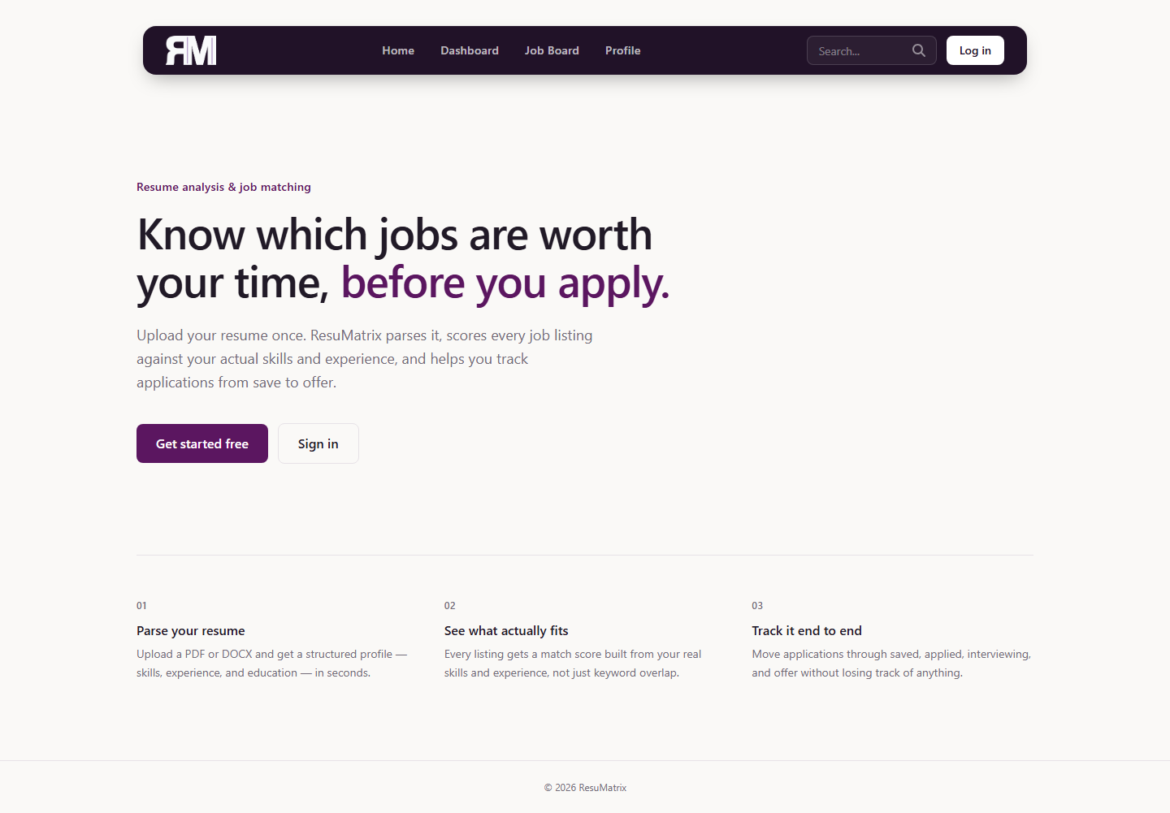
Landing page

Login screen

Register screen

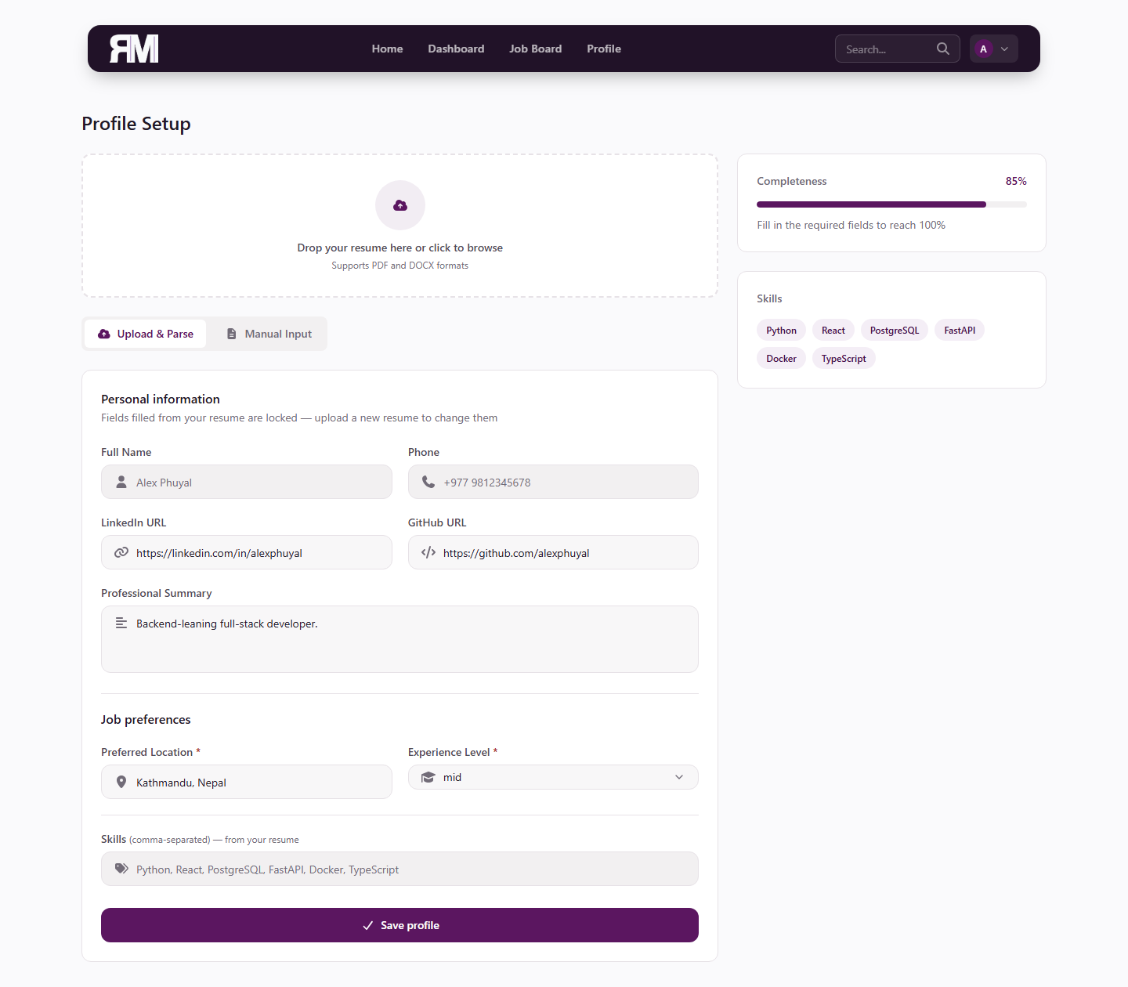
Profile Setup — resume-locked fields and skills
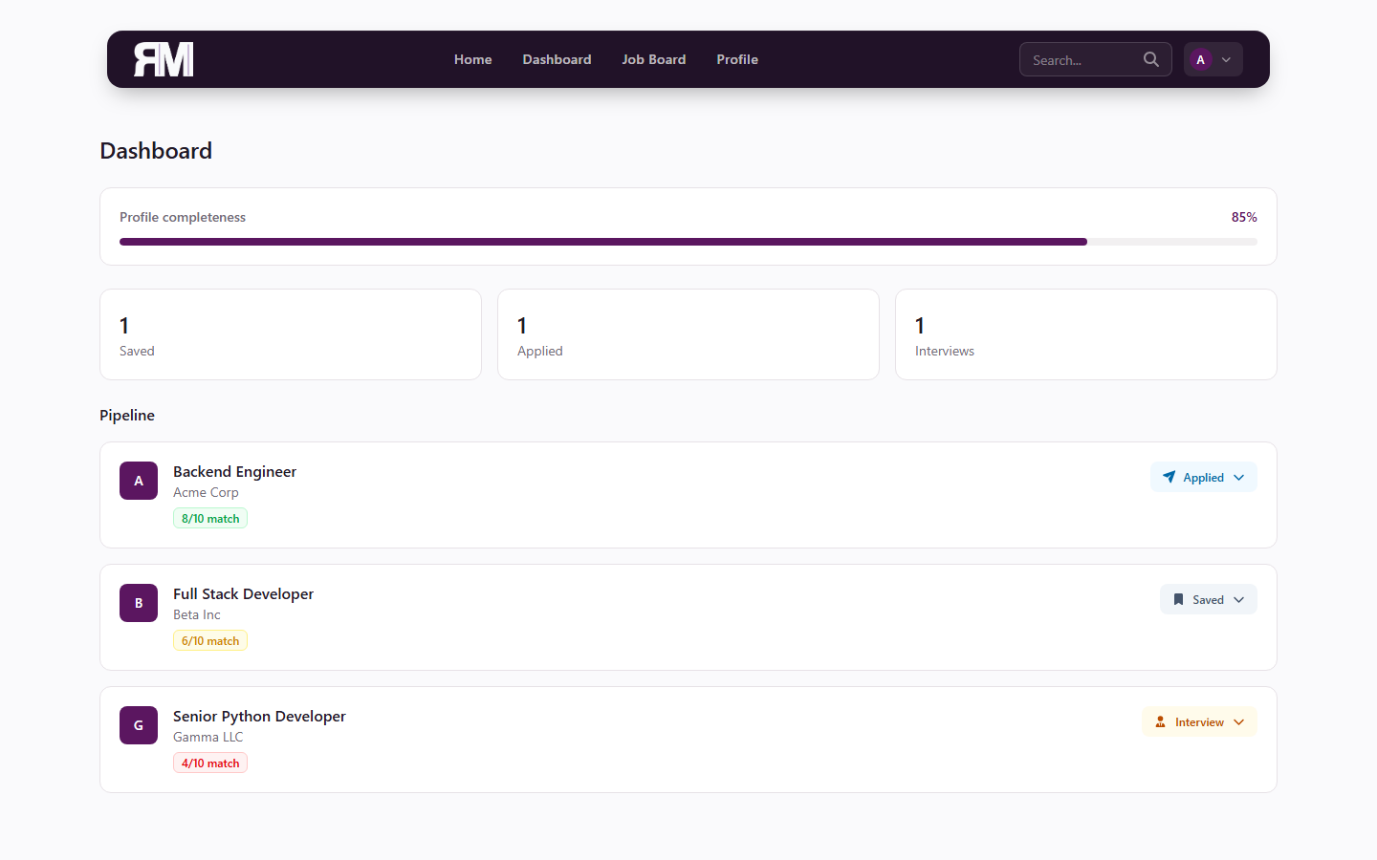
Dashboard — application status tracker with the per-row status dropdown


Job Board — job cards with the circular match-score indicator and suggested improvements panel


Job Detail Modal — Overview tab

Job Detail Modal — Match Analysis tab (matched/missing skills and suggestions)

APPENDIX C: MAJOR SOURCE CODE SNIPPETS

C.1 pipeline.py — Resume Parsing Orchestrator
def parse_resume(text: str) -> dict:
sections = segment_resume(text)
contact_text = sections.get("contact", "")
return {
"full_name": _extract_full_name(contact_text, text),
"phone": regex_extractor.extract_phone(contact_text) or regex_extractor.extract_phone(text),
"linkedin_url": regex_extractor.extract_linkedin(text),
"github_url": regex_extractor.extract_github(text),
"location": _extract_location(contact_text),
"summary": sections.get("summary") or None,
"skills": _extract_skills(sections, text),
"work_experience": experience_parser.parse(sections.get("experience", "")),
"education": education_parser.parse(sections.get("education", "")),
}

C.2 ats_service.py — Weighted Score Blend
SKILL_WEIGHT = 0.5
TEXT_WEIGHT = 0.25
SEMANTIC_WEIGHT = 0.25
def _blend(skill_score: float, text_score: float, semantic_score: float) -> int:
combined = SKILL_WEIGHT * skill_score + TEXT_WEIGHT * text_score + SEMANTIC_WEIGHT * semantic_score
combined = max(0.0, min(1.0, combined))
return round(1 + 9 * combined)

C.3 resume_optimizer_service.py — Quantification-Gap Detection
def _has_number(text: str) -> bool:
return bool(re.search(r"\d", text or ""))
for exp in experiences:
if quantify_count >= MAX_QUANTIFY_SUGGESTIONS:
break
desc = optimized_descriptions[str(exp.id)]
if desc.strip() and not _has_number(desc):
changes.append({
"type": "quantify_suggestion",
"experience_id": str(exp.id),
"experience_title": exp.title,
"message": f"Your '{exp.title}' bullet has no measurable outcome...",
})
quantify_count += 1

C.4 security.py — Argon2 Hashing and JWT Session Tokens
password_hash = PasswordHash.recommended()
def hash_password(password: str) -> str:
return password_hash.hash(password)
def verify_password(plain: str, hashed: str) -> bool:
return password_hash.verify(plain, hashed)
def create_access_token(data: dict) -> str:
payload = data.copy()
payload["exp"] = datetime.now(timezone.utc) + timedelta(minutes=settings.ACCESS_TOKEN_EXPIRE_MINUTES)
return jwt.encode(payload, settings.SECRET_KEY, algorithm=settings.ALGORITHM)

C.5 job_service.py — 15-Minute In-Memory Job Search Cache
_cache: dict[str, tuple[list, str | None, float]] = {}
CACHE_TTL = 900 # 15 minutes
cache_key = repr(sorted(params.items()))
if cache_key in _cache:
jobs, next_cursor, ts = _cache[cache_key]
if time() - ts < CACHE_TTL:
return jobs, next_cursor

C.6 applications.py — Application Status Transition Timestamps
updates = body.model_dump(exclude_none=True)
if "status" in updates and updates["status"] == "applied" and not app.applied_at:
app.applied_at = datetime.now(timezone.utc)
app.status_updated_at = datetime.now(timezone.utc)
for field, value in updates.items():
setattr(app, field, value)

