TRIBHUVAN UNIVERSITY
INSTITUTE OF SCIENCE AND TECHNOLOGY, AMRIT COLLEGE

Project Summary
ResuMatrix: An AI-Powered Resume Analysis
and Job Matching Platform
Alex Phuyal (79010151) · Abishek Khadka (79010149) · Biraj Sapkota (79010173)
Supervisor: Er. Akkal Bist
July, 2026

1. Overview
ResuMatrix is a resume-driven job matching platform. A user uploads a resume once; the system parses it into a structured profile (regex, a fuzzy-match/ML section segmenter, a pretrained BERT NER model, and a skills gazetteer), then scores live job listings against that profile on a 1–10 scale using a blend of TF-IDF, sentence-embedding similarity, and skill overlap. From there the user can view a detailed ATS breakdown of any job, generate job-targeted resume optimization suggestions, download an optimized resume PDF, and record each application's status (Saved, Applied, Interview, Offer, Rejected).
Stack: React 19 + TypeScript + Vite frontend; FastAPI (Python) backend; PostgreSQL via SQLAlchemy/Alembic; deployed on Railway.

2. System Design

2.1 Entity-Relationship Diagram
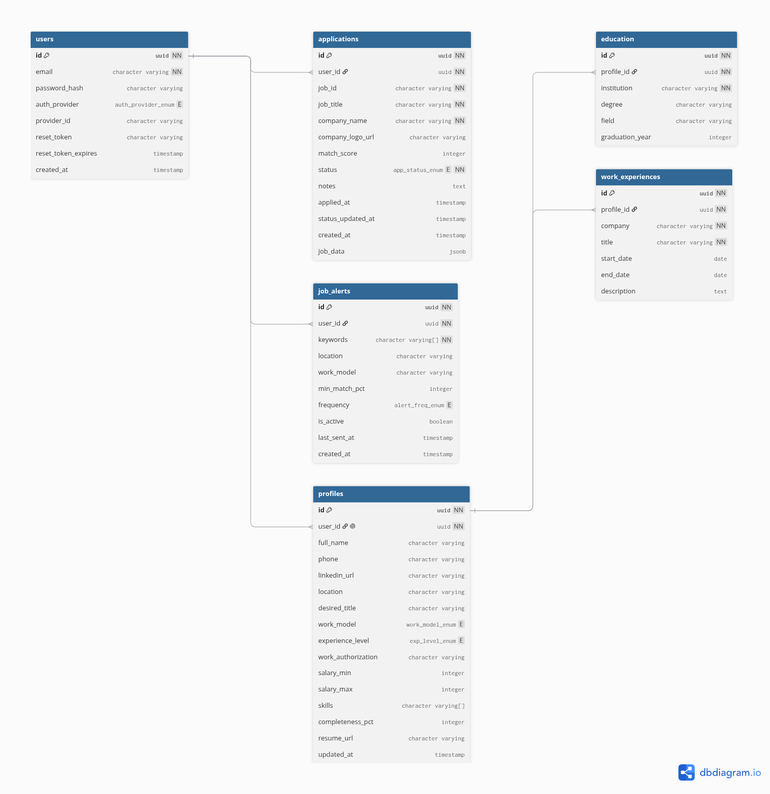
Figure 1: ER Diagram — ResuMatrix PostgreSQL Schema

2.2 Class Diagram
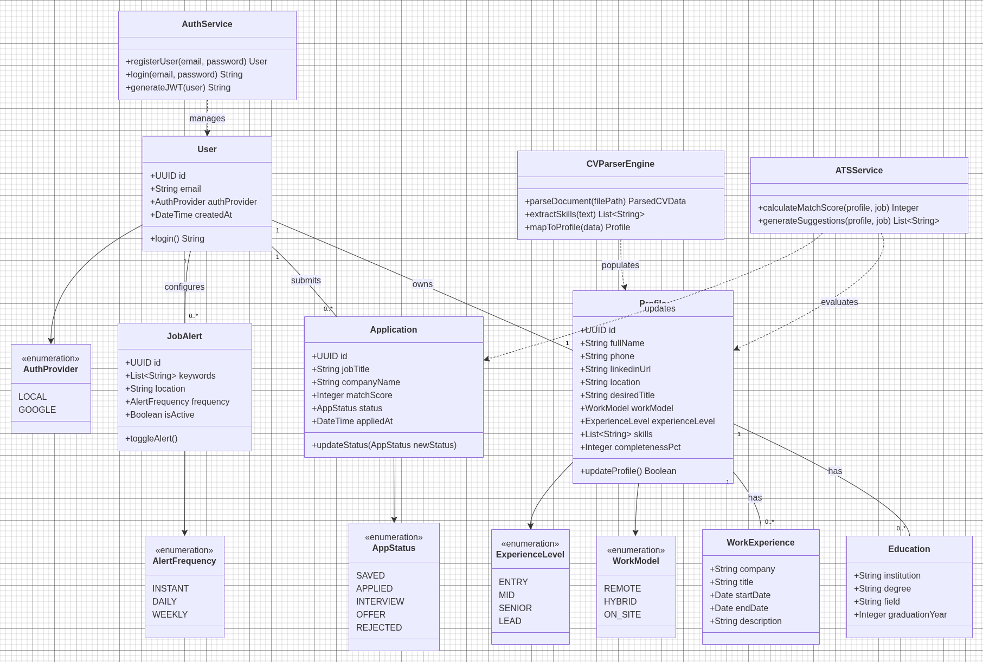
Figure 2: Class Diagram — ResuMatrix Domain and Service Classes

2.3 Sequence Diagram
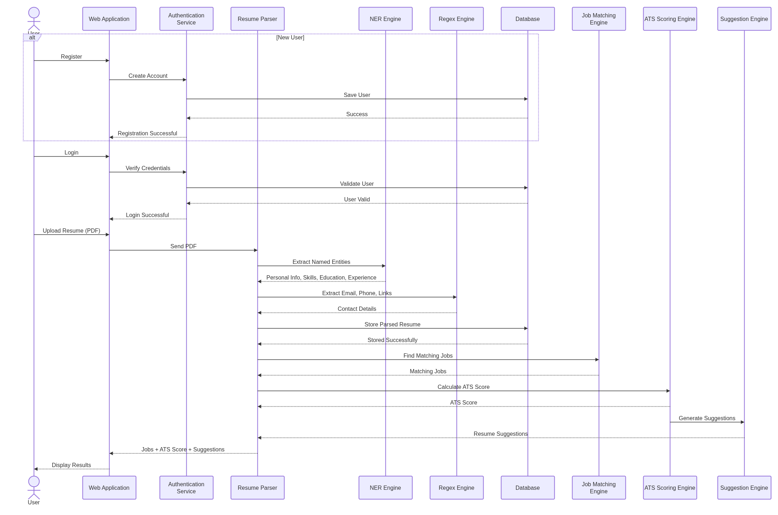
Figure 3: Sequence Diagram — Registration, Resume Parsing, and Job Matching

3. Key Algorithms

3.1 Resume Parsing
- Regex extraction — email, phone, LinkedIn/GitHub URLs, date ranges.
- Section segmentation — difflib fuzzy match against header synonyms, falling back to a TF-IDF + Logistic Regression classifier below threshold.
ratio(a, b) = 2M / T (M = matching characters, T = |a| + |b|)
- Named entity recognition — pretrained BERT (dslim/bert-base-NER) for person/organization/location spans.
- Gazetteer lookup — spaCy PhraseMatcher over a curated skills/titles/degrees vocabulary.

3.2 ATS Match Scoring
Lexical (TF-IDF) and semantic (all-MiniLM-L6-v2) similarity are both computed as cosine similarity; skill overlap is a set-intersection ratio:
cosine_sim(A, B) = (A · B) / (||A|| · ||B||)
skill_overlap = |S_profile ∩ S_job| / |S_job|
match_score = round(1 + 9 × (0.5×skill_overlap + 0.25×tfidf_cosine + 0.25×semantic_cosine))

3.3 Resume Optimization
For each skill the profile claims but never mentions in a bullet, the best-matching bullet is targeted by embedding similarity above a fixed threshold:
target_bullet = argmax_b cosine_sim(embed(skill_sentence), embed(b)), subject to cosine_sim > 0.15
Missing skills are proposed as additions to the Skills list only (never inserted into experience text); bullets with no digit are flagged for quantification — no number is ever fabricated.

4. Tech Stack
Layer | Technologies
Frontend | React 19 + TypeScript, Vite, Tailwind CSS v4, shadcn/ui, TanStack Query, Zustand
Backend | FastAPI (Python 3.13), SQLAlchemy 2.0 + Alembic, PostgreSQL
Auth | Argon2 password hashing, JWT (HS256), Google OAuth 2.0 (Authlib)
NLP / ML | spaCy (gazetteer), scikit-learn (TF-IDF + Logistic Regression), transformers (BERT NER), sentence-transformers (MiniLM)
Integrations | JSearch API (job search), Resend (email), Cloudflare R2 (optional storage)
Deployment | Railway (Uvicorn/ASGI, managed PostgreSQL)

5. Screenshots

Landing page

Login


Dashboard — application status tracker

Profile Setup


Job Board — match score and suggested improvements


Job Detail — Match Analysis

6. Limitations
- English-only parsing; heuristic section segmentation can mis-parse highly unconventional resume layouts.
- No OCR — scanned/image-only PDF resumes cannot be parsed.
- Application status is self-reported: job data comes from a read-only third-party API (JSearch), so the system cannot verify what actually happened with an application.
- No automated test suite; verification during development was manual.
- Job Alerts backend (API + email digest) is complete but has no frontend page yet.

7. Conclusion
ResuMatrix is implemented end-to-end: resume parsing, blended job-match scoring, ATS analysis, resume optimization, authentication, and application tracking are all working and verified through manual unit, integration, and system testing.

