ARRAY IMPLEMENTATION OF LIST

Code:

//RA2211003011292 ABISHEK S R

#include <stdio.h>

int main()

{

int arr[100];

int n,i,choice;

printf("\nEnter the no of elements:");

scanf("%d",&n);

printf("Enter the elements of the array:\n");

for(int i=0;i<n;i++)

{

scanf("%d",&arr[i]);

}

while(1){

printf("\nCurrent Array:");

for (int i=0;i<n;i++)

{

printf("%d ",arr[i]);

}

printf("\n");

printf("1. Insert element at the beginning\n");

printf("2. Insert element at the end\n");

printf("3. Delete element from the end\n");

printf("4. Exit\n");

printf("Enter your choice:");

scanf("%d",&choice);

//Insert element at the beginning

if(choice==1)

{

int val1;

printf("Enter the no. to insert at the beginning:");

scanf("%d",&val1);

for(int i=n;i>0;i--)

{

arr[i]=arr[i-1];

}

arr[0]=val1;

n++;

}

//Insert element at the end

else if(choice==2)

{

int val2;

printf("Enter the no. to insert at the end:");

scanf("%d",&val2);

arr[n]=val2;

n++;

}

// Delete element from the end

else if(choice==3)

{

if(n>0)

{

n--;

}

}

// Exit the program

else if(choice==4)

{

printf("Exiting the program.\n");

return 0;

}

else // Invalid choice

{

printf("Invalid choice.\n");

}

}

return 0;

}

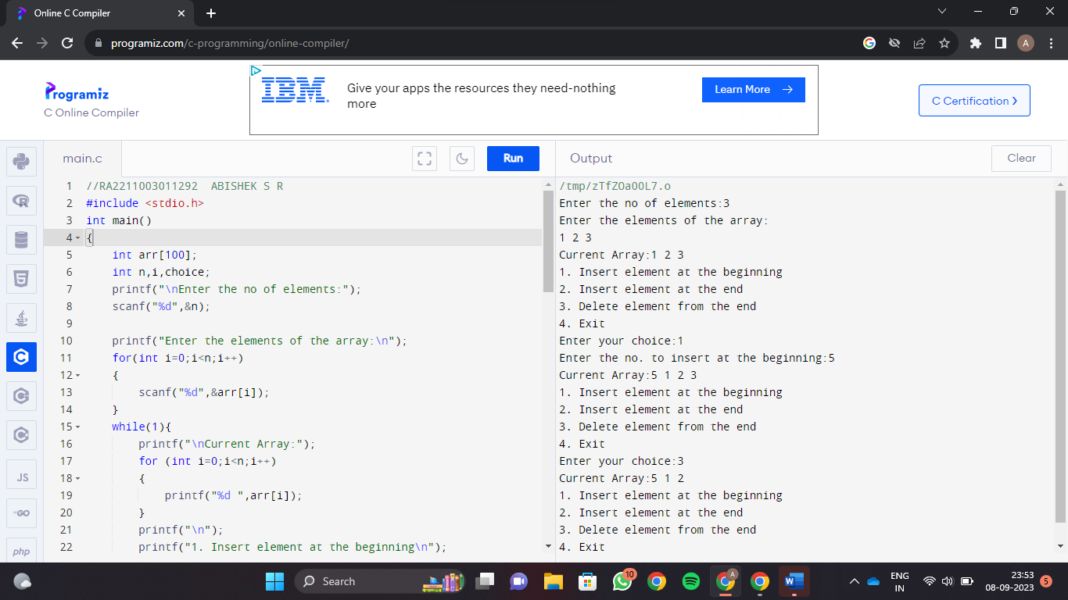Screenshots:

**ABISHEK S R  
RA2211003011292**