*Experiment No: 1*

**Implementation of Structure**

**Source Code:**

//RA2211003011292 ABISHEK S R

#include <stdio.h> // Pre-processor Directives

#include <string.h>

struct emp_designation // Initialization of Structure

{

char company_name[50]; // Declaring Structure Members

char post_name[50];

int id_no;

int salary;

};

struct emp_details

{

char first_name[50];

char last_name[50];

char state[50];

int age;

int mobile_no;

struct emp_designation emp_desig;

};

int main()

{

int n;

printf("No. of Employees:");

scanf("%d",&n); ; // Getting No. of employees from User

struct emp_details employees[n];

int i;

// Input loop to collect data for up to n employees

for (i = 0; i < n; i++)

{

printf("Enter Firstname: ");

scanf("%s", employees[i].first_name);

printf("Enter Lastname: ");

scanf("%s", employees[i].last_name);

printf("Enter State: ");

scanf("%s", employees[i].state);

printf("Enter Age: ");

scanf("%d", &employees[i].age);

printf("Enter Mobileno: ");

scanf("%d", &employees[i].mobile_no);

printf("Enter Companyname: ");

scanf("%s", employees[i].emp_desig.company_name);

printf("Enter Postname: ");

scanf("%s", employees[i].emp_desig.post_name);

printf("Enter IDno: ");

scanf("%d", &employees[i].emp_desig.id_no);

printf("Enter Salary: ");

scanf("%d", &employees[i].emp_desig.salary);

}

// Displaying the Entered Details

for (i = 0; i < n; i++)

{

printf("\nEmployee %d Details:\n", i + 1);

printf("First Name: %s\n", employees[i].first_name);

printf("Last Name: %s\n", employees[i].last_name);

printf("State: %s\n", employees[i].state);

printf("Age: %d\n", employees[i].age);

printf("Mobile No: %d\n", employees[i].mobile_no);

printf("Company Name: %s\n", employees[i].emp_desig.company_name);

printf("Post Name: %s\n", employees[i].emp_desig.post_name);

printf("ID No: %d\n", employees[i].emp_desig.id_no);

printf("Salary: %d\n", employees[i].emp_desig.salary);

printf("--------------------------\n");

}

return 0;

}

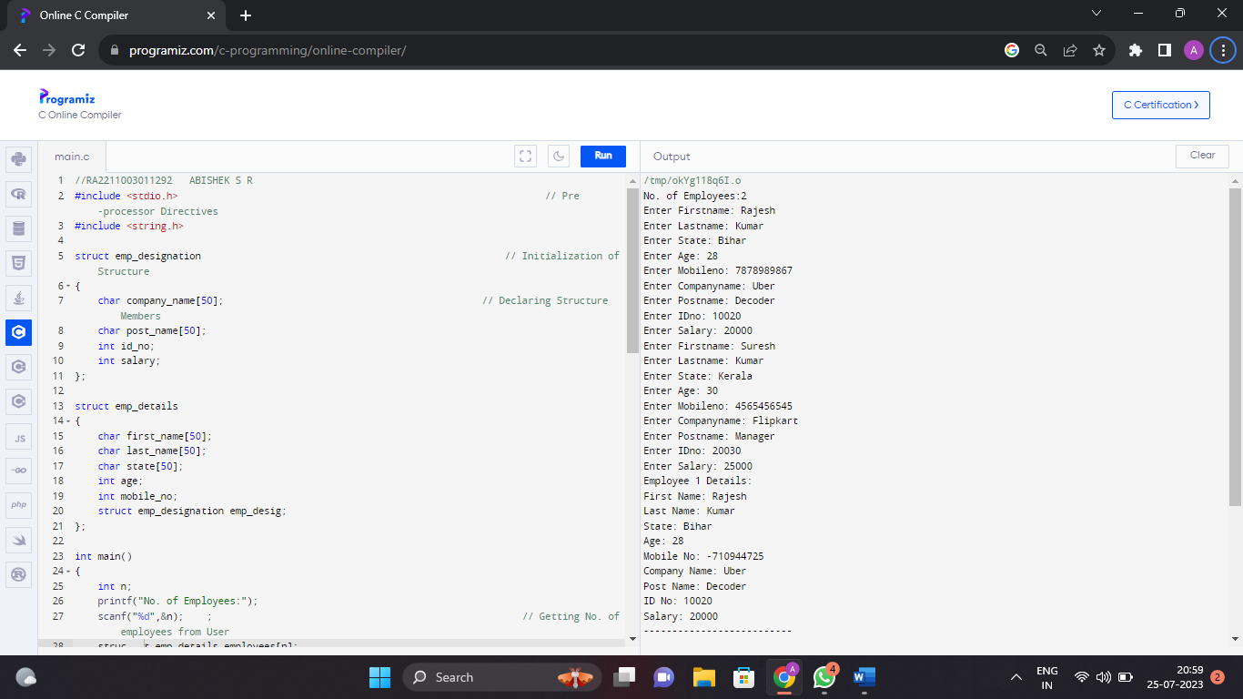**OUTPUT:**