**Sales Revenue and Quantity Insights Dashboard**

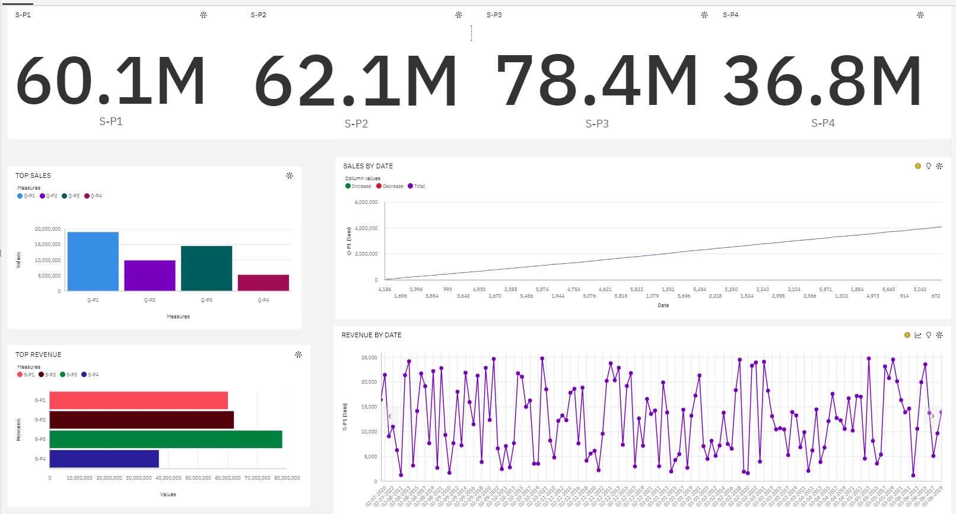

**Introduction:**

This extensive report provides in-depth insights into the sales revenue and quantity data for four distinct products: Product 1, Product 2, Product 3, and Product 4. We aim to present a comprehensive analysis of the financial performance and sales quantities of these products, offering valuable perspectives on trends, variations, and significant milestones within a specific timeframe.

**1. Sales Revenue:**

**1.1 Product-wise Sales Revenue:**

* Product 1 sales revenue: $60.1 million
* Product 2 sales revenue: $62.1 million
* Product 3 sales revenue: $78.4 million
* Product 4 sales revenue: $36.8 million

**1.2 Ranking of Products by Sales Revenue:**

* Notably, Product 3 emerges as the frontrunner in sales revenue, achieving a remarkable $78.4 million.
* In contrast, Product 4 lags behind with the lowest sales revenue of $36.8 million.

**2. Sales Quantity:**

**2.1 Product-wise Sales Quantity:**

* Product 1 sales quantity: Approximately 60,000,000 units
* Product 2 sales quantity: Approximately 62,000,000 units
* Product 3 sales quantity: Approximately 80,000,000 units
* Product 4 sales quantity: Approximately 40,000,000 units

**2.2 Ranking of Products by Sales Quantity:**

* Product 3 dominates in sales quantity, with a staggering estimated 80,000,000 units sold.
* Conversely, Product 4 resides at the bottom of the list, with roughly 40,000,000 units sold.

**3. Sales Revenue Fluctuations:**

**3.1 Sales Revenue on July 7, 2020:**

* A significant milestone occurred on July 7, 2020, as sales revenue notably exceeded $20,000.

**3.2 Sales Revenue After 2 Years (July 7, 2022):**

* Surprisingly, a sharp decline was witnessed two years later, in July 7, 2022, as the sales revenue dropped to below $10,000.

**3.3 Notable Sales Revenue Figures:**

* On June 1, 2019, the sales revenue was recorded at $6,000.
* By June 3, 2019, an increase to $10,000 was observed.
* It is intriguing to note that sales revenue remained constant on October 2 in both 2017 and 2019.

**3.4 Peak Sales Revenue:**

* A noteworthy trend emerged in the years 2018, 2013, and 2020 when sales revenue reached its zenith at $25,000.

**Conclusion:**

In conclusion, this comprehensive report unveils crucial insights regarding the sales revenue and quantity data for four distinct products. Product 3 consistently leads in both sales revenue and quantity, while Product 4 trails behind. Additionally, the report delves into significant fluctuations in sales revenue over time, providing valuable information for strategic decision-making in sales and marketing to optimize future performance.