[Your Name] ([Your Student ID])

http://www.metropolia.fi/fileadmin/template/images/Metropolia_RGB_B_eng.png





Assignments

Introduction to ASP.NET Web Forms

Contents

Introduction part 2

Exercise 1 3

Exercise 2 4

Exercise 3 5

Exercise 4 6

Exercise 5 7

Exercise 6 8

Video 1 9

Diary 10

First day 11

Second day 12

Third day 13

Fourth day 14

Fifth day 15

# Introduction part

## Exercise 1

**ASP.NET Web Forms vs. ASP.NET MVC** (Part A - Slide 8) (5 points)



Depeche Mode band wants to have a new website and they have been told to select what kind of technology they would like to have for their website and they have to select between ASP.NET Web Forms and ASP.NET MVC. Dave Gahan the vocal of the group replied, instead of searching for these technologies, we prefer to dedicate more time to create awesome songs like “Precious” and “Enjoy the Silence”. Can you help them and fully describe and compare ASP.NET Web Forms and ASP.NET MVC?

[Your answer]

Description:

**Asp.net web forms:**

ASP.NET Web Forms lets us build dynamic websites using a familiar drag-and-drop, event-driven model. A design surface and hundreds of controls and components lets us rapidly build sophisticated, powerful UI-driven sites with data access.

**Asp.net MVC:**

ASP.NET MVC gives us a powerful, patterns-based way to build dynamic websites that enables a clean separation of concerns and that gives us full control over markup for enjoyable, agile development. ASP.NET MVC includes many features that enable fast, TDD-friendly development for creating sophisticated applications that use the latest web standards.

**Comparison:**

| **ASP.NET Web Forms** | **ASP.NET MVC** |
| --- | --- |
| ASP.NET Web Forms use Page controller pattern approach for rendering layout. In this approach, every page has its own controller, i.e., code-behind file that processes the request. | ASP.NET MVC uses Front Controller approach. That approach means a common controller for all pages processes the requests. |
| No separation of concerns. As we discussed that every page (*.aspx*) has its own controller (code behind i.e. *aspx.cs/.vb* file), so both are tightly coupled. | Very clean separation of concerns. View and Controller are neatly separate. |
| Because of this coupled behavior, automated testing is difficult. | Testability is a key feature in ASP.NET MVC. Test driven development is quite simple using this approach. |
| To achieve stateful behavior, viewstate is used. Purpose was to give developers the same experience of a typical WinForms application. | ASP.NET MVC approach is stateless as that of the web. So there is no concept of viewstate. |
| Statefulness has a lot of problem for web environment in case of excessively large viewstate. Large viewstate means increase in page size. | As controller and view are not dependent and no viewstate concept in ASP.NET MVC, so output is very clean. |

## Exercise 2

**Solutions for hosting our projects** (Part A - Slide 11) (5 points)



Angelina Jolie and Leonardo DiCaprio are joining each other in a philanthropic project related to global warming. They need an advisor to recommend them from where they should register a domain for their organization’s website and also recommend few ASP.NET hosting plans.

[Your answer]

They can take a full package of domain registration and hosting features.

The source is:

The popular one.

<http://www.hostgator.com/windows-hosting>



**I have selected Enterprise plan; the highlighted feature can be seen below:**

**This is economical and good for starting.**



**Other features included in the same plan:**

1. **Powerful Admin Tools**
2. **Programming features**
3. **Award-winning support**
4. **Windows hosting features**
5. **Programming and databases**
6. **Email features**
7. **Application hosting**

## Exercise 3

**Static vs. Dynamic** (Part A - Slide 20) (5 points)



Jennifer Lawrence will act in a movie as an IT specialist and she has to understand the concept of static and dynamic websites. Find one example for a static website and one example for dynamic website and explain why they are static or dynamic to her.

[Your answer]

I have chosen:

**Static website:** <http://www.gembiz.co.uk/>

**This website provides information for integrating website with business.**

**Reasons for this site to be static:**

1. **The look and feel is like an ancient website, with no modern controls or design.**
2. **Poor user interactions, improper navigation.**
3. **No server interaction.**
4. **The website is not for multiple users.**
5. **Its maintenance is dull.**

**Dynamic website:** <https://metrotarkari.com/>

**This website is an online shopping platform of groceries**

**Reasons for this site to be dynamic:**

1. **The appearance is vibrant and graphical designs are appealing.**
2. **Quick and responsive interaction with all the features included.**
3. **Proper server interaction.**
4. **The website is for multiple users and each role for the system is defined properly.**
5. **The maintenance is quick and very responsive.**

## Exercise 4

**Web application** (Part A - Slide 21) (5 points)



Convince Marisa Meyer the CEO of Yahoo! to create her company’s new service as a web application and not as a software provided in a CD. Make sure to mention and explain its benefits.

[Your answer]

The technique of providing services through a software written in a cd has become totally obsolete. It requires a cd drive(hardware) which is not reliable and are usually slow. In fact, nowadays computer manufacturing companies are stopping the integration of cd drive in CPUs.

The whole access of the services of a company can be done by just having a web browser, no other things are required. Other benefits are listed below:

1. No installation required. Just click and access from browser.
2. Automatic updates
3. Available anytime and anywhere we want.
4. Cost effective.

Due to these kind of advantages, the access of a service from software has being deviating to web applications.

## Exercise 5

**Common Language Runtime (CLR)** (Part A - Slide 23) (5 points)

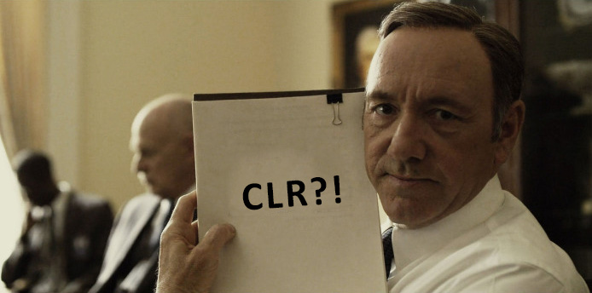

Francis Underwood has difficulty explaining Common Language Runtime to congress men to help him pass a law in the US congress. Can you briefly make him understands CLR and its role in compiling ASP.NET projects?

[Your answer]

The .NET Framework provides a run-time environment called the common language runtime(CLR), which runs the code and provides services that make the development process easier.

Compilers and tools expose the common language runtime's functionality and enable us to write code that benefits from this managed execution environment. Code that we develop with a language compiler that targets the runtime is called managed code; it benefits from features such as cross-language integration, cross-language exception handling, enhanced security, versioning and deployment support, a simplified model for component interaction, and debugging and profiling services.

To enable the runtime to provide services to managed code, language compilers must emit metadata that describes the types, members, and references in our code. Metadata is stored with the code; every loadable common language runtime portable executable (PE) file contains metadata. The runtime uses metadata to locate and load classes, lay out instances in memory, resolve method invocations, generate native code, enforce security, and set run-time context boundaries.

## Exercise 6

**Master Pages vs. User Controls** (Part A - Slide 35,39) (5 points)



Cooper (Starring by Matthew McConaughey in Interstellar) realized in order to get back to earth and see his children, he needs to develop a web application that consists Master Pages and User Controls and install it in his spaceship. Can you describe and compare them to him.

[Your answer]

For this there comes different stages: planning, coding and publishing, they all are described below:

1. Planning:

This part consists of gathering all the logics, needed data and other constraints so that a proper coding is done.

1. Coding:

It includes different steps:

1. Opening a new asp.net project in visual studio
2. Adding web forms and master pages as required. Master pages develops a theme which occur frequently to enhance viewing experience of users. Web forms are the actual contents.
3. In the contents we can add different user controls to design and implement our logic.
4. The logic would be to trace a route back to Earth, precisely locating the current position and destination position.
5. Finally we deploy that system to the spaceship after publishing the website.

## Video 1

**Title: Understanding how ASP.NET works** (5 point)

**Duration: 6 min**

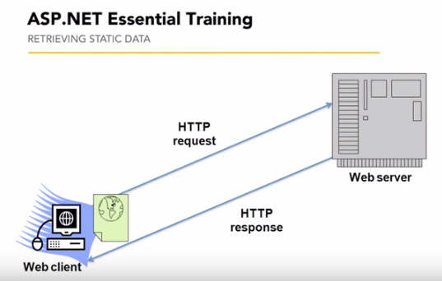

Link: <https://www.youtube.com/watch?v=fIK2ZDqBBac>

**How was it? Anything new you learned?Your answer**

[Your answer]

It was fine, understood the general concepts behind working of asp.net Apps. Following steps are included in it:

1. The Browser Makes an HTTP Request for an ASP.NET Web Page.
2. The Web Server Receives the HTTP Request.
3. Examination of ASP.NET engine.
4. Finally generating the output.

# Diary

(This part is not for e-learning students)

## First day

(3 point) Write briefly about your first day. (The material you learned, the material you already were familiar with, and anything else related to our session) (If you were absent just write I was absent and yes you will not get points from this question, sorry.)

[Your answer]

## Second day

(3 point) Write briefly about your second day. (The material you learned, the material you already were familiar with, and anything else related to our session) (If you were absent just write I was absent and yes you will not get points from this question, sorry.)

[Your answer]

## Third day

(3 point) Write briefly about your third day. (The material you learned, the material you already were familiar with, and anything else related to our session) (If you were absent just write I was absent and yes you will not get points from this question, sorry.)

[Your answer]

## Fourth day

(3 point) Write briefly about your fourth day. (The material you learned, the material you already were familiar with, and anything else related to our session)(If you were absent just write I was absent and yes you will not get points from this question, sorry.)

[Your answer]

## Fifth day

(3 point) Write briefly about your fifth day. (The material you learned, the material you already were familiar with, and anything else related to our session) (If you were absent you cannot pass this course since doing group project and quiz were compulsory!)

[Your answer]