Student name: Mahto Abishek Chandra

Student ID: 1605534

Score: \_\_\_\_\_\_ /80 (Please do not fill this field)

|  |
| --- |
| **Note:**  You are allowed to solve this group project individually / with a pair  You are allowed to use class materials and all online materials with your pair.  C:\Users\Farhad\Downloads\delete.png You are not allowed to communicate with anyone else other than your pair during this project. |

**Project: Microsoft Store**

**Time: 2.5 hours**

**C:\Users\Farhad\Downloads\database_3.png Step 1: Create your database. (4 points)**

Create your database and name it.

create database AbishekDB

**C:\Users\Farhad\Downloads\table.png Step 2: Create tables. (20 points)**

Create following tables with proper data types, primary keys, and foreign keys based on the following details:

|  |  |  |
| --- | --- | --- |
| **#** | **Tables** | **Fields** |
| 1 | Products | ProductID, ProductName, Price, Description, ManifacturedDate, Quantity, Brand |
| 2 | Customers | CustomerID, CustomerName, Address, Phone, Email, Gender, Age |
| 3 | Orders | OrderID, CustomerID, ProductID, OrderDate |

**Things to consider:**

1. Select the best possible data types
2. Let the database give values to Primary Keys
3. OrderDate in Orders table has to be set by default with the current date and time

--table 1

create table Products(

ProductId int primary key not null identity,

ProductName nvarchar(100) not null,

Price int not null,

Descriptions nvarchar(1000) ,

ManufacturedDate datetime,

Quantity int not null,

Brand nvarchar(50) not null,

)

--table 2

create table Customers(

CustomerId int primary key identity not null,

CustomerName nvarchar(50) not null,

Addresses nvarchar(50),

Phone int not null unique,

Email nvarchar(50) not null unique,

Gender nvarchar(10) not null,

Age int not null

)

--table 3

create table Orders(

OrderId int primary key identity not null,

CustomerId int not null,

ProductId int not null,

OrderDate datetime not null default current\_timestamp

)

--adding foreign keys

alter table Orders add constraint orders\_CustomerId\_fk foreign key

(CustomerId) references Customers(CustomerId)

alter table Orders add constraint orders\_ProductId\_fk foreign key

(ProductId) references Products(ProductId)

**C:\Users\Farhad\Downloads\edit.png Step 3: Insert data. (4 points)**

Insert at least 10 rows of data for your tables manually. (Remember to have such amount of data when you were returning your project for assessment after finishing your project.)

select \*from Customers

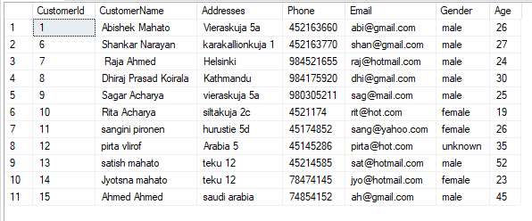

select \*from Products

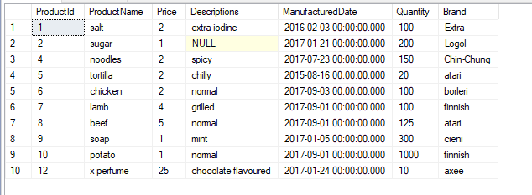

select \*from Orders

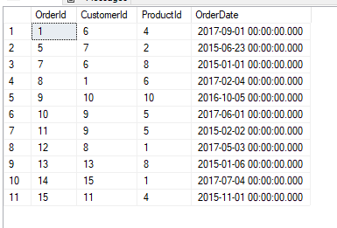

**C:\Users\Farhad\Downloads\command_prompt.png Step 4: Write queries. (15 points)**

Write following queries for your tables.

Query 1 – Get the full list of all the customers

select \*from Customers

Query 2 – Get the full list of all the available products

select \*from Products where Quantity='0'

Query 3 – Get the orders list of the year 2015 of all the users who are older than 24 and are female

select OrderId,ProductId,OrderDate,CustomerName,Age,Gender from Orders

join

Customers

on Orders.CustomerId=Customers.CustomerId

where Customers.Age>24 and Customers.Gender='female' and year(Orders.OrderDate)='2015'

Query 4 – Get the total number of sold products

select count(ProductId) from Orders

Query 5 – Statement for adding new data to products table

insert into products values('x perfume',25,'chocolate flavoured','24 jan 2017',10,'axee')

Query 6 – Statement for adding new data to customers table

insert into Customers values('mamta mahato','',8485824,'mam@hmail.com','female',50)

Query 7 – Modifying customers’ information with certain customer id

update customers set CustomerName='Dhiraj Prasad Koirala' where CustomerId=8

Query 8 – Modifying available quantity of certain product id

update Products set Quantity=150 where ProductId=4

Query 9 – Remove records of products table which are not available

delete from Products where quantity=0

Query 10 – Remove records of users who has no address

delete from Customers where Addresses=''

**C:\Users\Farhad\Downloads\bookmark.png Step 5: Create Indexes. (4 points)**

Create 2 indexes for necessary fields of your tables.

create index IX\_Customers1 on Customers(CustomerName asc,Age asc)

create index IX\_Orders1 on Orders(Orderdate asc)

**C:\Users\Farhad\Downloads\class_libraries.png Step 6: Create Stored Procedures. (6 points)**

Create following stored procedures for your tables.

Stored Procedure 1 – Getting the full information of a certain customer id

create procedure spaddrow

as

begin

select \*from Customers where CustomerId=9

select \*from Orders where CustomerId=9

end

Stored Procedure 2 - Modifying products’ information with certain product id

create procedure spSelect

as begin

update Products set Quantity=0 where ProductId=2

end

Stored Procedure 3 – Removing orders before the given date

create procedure spDell

as begin

delete from Orders where OrderDate<'2015-04-01'

end

**C:\Users\Farhad\Downloads\trigger_mode.png Step 7: Create Triggers. (6 points)**

Create following triggers for your tables.

Trigger 1 - When new row added to the orders increase the ordered number of that certain product and the user.

create trigger tr\_Orders\_forInsert

on Orders

for insert

as

begin

declare @id int

select @id=ProductId from inserted

update Products set Quantity=Quantity-1 where ProductId=@id

end

Trigger 2 – When the certain user got removed, remove his/her orders.

create trigger tr\_Orders\_forDel

on Customers

for delete

as

begin

declare @id int

select @id=CustomerId from deleted

delete from Orders where CustomerId=@id

end

**C:\Users\Farhad\Downloads\gnome_view_restore.png Step 8: Create Views. (4 points)**

Create 2 views.

1. This view gives data from Customers table and Orders table, from which we get to know the orders that were placed after Jan 2015

create view vWV2

as

select Customers.CustomerId,Customers.CustomerName,Orders.OrderDate from Orders inner join

Customers on Orders.CustomerId=Customers.CustomerId where Orders.OrderDate>'2015'

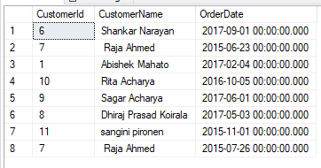

1. This view gives info of those customers whose name initial is ‘s’ and age is greater than 40.

create view vWV3

as

select \*from Customers where CustomerName like 's%' and Age<40

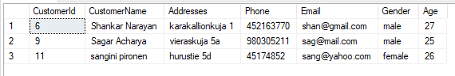

**C:\Users\Farhad\Downloads\application_x_desktop.png Step 9: Create Function. (4 points)**

Create one related user-defined function.

1. I created a function which checks whether the given phone number by customers are correct or not. The parameter to be correct is that, it should have exactly 9 digits.

create function getCorrectNumbers(@num int)

returns varchar(30)

as

begin

declare @X varchar(30);

set @X=

case

when(len(@num)=9)

then 'correct'

else 'not correct'

end

return @X

end

select dbo.getCorrectNumbers(546522222) as x

**C:\Users\Farhad\Downloads\backup_checkmark.png Step 10: Backup your database. (3 points)**

Backup your database (full type backup).

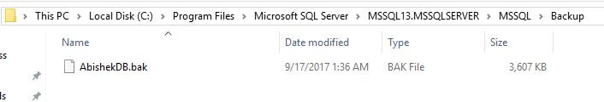

**C:\Users\Farhad\Downloads\diagram.png Step 11: Get reports. (4 points)**

Get following reports from your database.

Report 1 - Disk usage

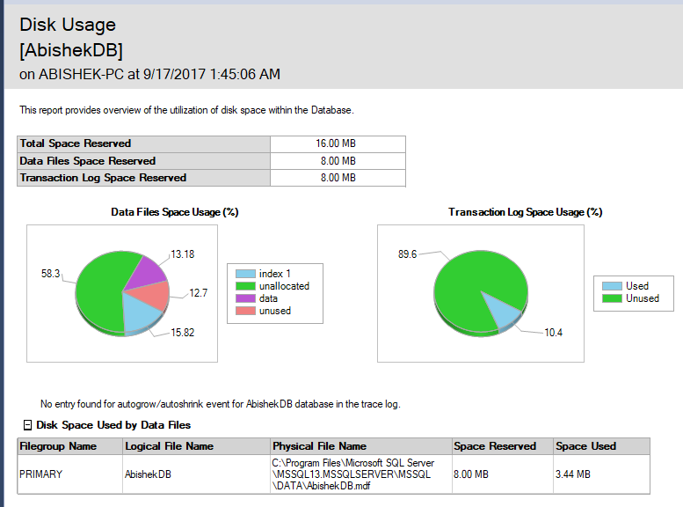

Report 2 - Disk usage by table

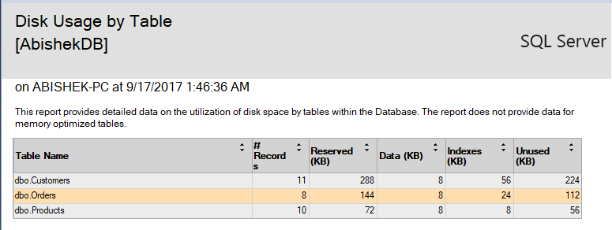

**C:\Users\Farhad\Downloads\table_relationship.png Step 12: Create your database diagram. (4 points)**

Create your database diagram in MS Management Studio, and make sure to connect the tables together based on their primary key and foreign key.

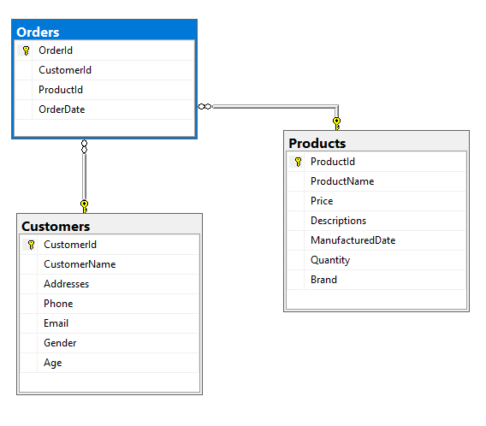

**C:\Users\Farhad\Downloads\hello_my_name_is_rupert.png Step 13: Unified naming structure (2 points)**

**You need to return this document for your final assessment.**

**Good luck!** ☺ **Farhad Eftekhari**

Copyright © 2015 by Farhad Eftekhari

All rights reserved. No part of this publication may be reproduced, distributed, or transmitted in any form or by any means, including photocopying, recording, or other electronic or mechanical methods, without the prior written permission of the publisher, except in the case of brief quotations embodied in critical reviews and certain other noncommercial uses permitted by copyright law. For permission requests, write to the publisher, addressed “Attention: Permissions Coordinator,” at the address below.

Helsinki Metropolia UAS  
Vanha maantie 6  
02650 Espoo, Finland  
www.techclass.co

  