[Your Name] ([Your Student ID])







Assignments

Introduction to SQL Server

5th edition

Contents

Introduction part 2

Exercise 1 3

Exercise 2 4

Exercise 3 5

Exercise 4 6

Video 1 7

Intermediate part 8

Exercise 5 9

Exercise 6 10

Exercise 7 11

Exercise 8 12

Exercise 9 13

Exercise 10 14

Exercise 11 15

Advanced part 16

Exercise 12 17

Exercise 13 18

Exercise 14 19

Exercise 15 20

Exercise 16 21

Diary 22

First day 23

Second day 24

Third day 25

Fourth day 26

Fifth day 27

Feedback 28

# Introduction part

## Exercise 1

**Text files vs. XML files vs. Relational database** (Slide 8) (3 points)



Bradly Cooper wants to star in a movie as an IT specialist. He wants to know about comparing storing information methods, using text files, xml files, and relational database. Describe for him these methods and advantages and disadvantages of them.

[Your answer]

|  |  |  |  |
| --- | --- | --- | --- |
| **Sn** | **Method** | **Advantages** | **Disadvantages** |
| **1** | **Text files: just storing static data to text based interfaces.** | **Low space, good for small task.** | **Unprofessional, obsolete, no proper interaction.** |
| **2** | **XMl: storing dynamically described data in a standard format as desired.** | **Eligible to standard formats of data.** | **Not much interaction between user and the system.** |
| **3** | **Relational DB: most dynamic form of storing data with a very interactive user interface.** | **Standards are defined, dynamic approach to anything related to storing, retrieving and manipulation data.** | **Might take lot of space.** |

## Exercise 2

**Solutions for hosting our projects** (Slide 16) (3 points)



Taylor Swift wants to host its website for her fans, but as she stated before she knows nothing about the technology, and specially information technology! Help her to find a solution. You need to estimate the resources she needs for having a website that is able to be available for millions of her fans. Describe the advantages and disadvantageous of different types of solutions and recommend a solution for her. And finally from search engines find a proper hosting company and a plan for her and recommend it to her.

[Your answer]

The best solution in this scenario would be ‘Dedicated Servers’. The server will be dedicated (24*7) for all fans.

Required resources will be provided by a hosting company, ‘the dedicated server itself’. However, she must also look at advantages and disadvantages of this service. They are as follows:

Advantages:

1. Greater performance and customization at every service level.
2. Maximum control of the website over the web server.

Disadvantages:

1. Expensive, as it is dedicated.
2. Requires skills to maintain and run. This can be solved by having a staff, she is too busy with her work.
3. Licensing may be required.

Hosting company: <http://www.hostgator.com/dedicated-server>



## Exercise 3

**Descriptions and comparison of SQL Servers** (Slide 23) (3 points)

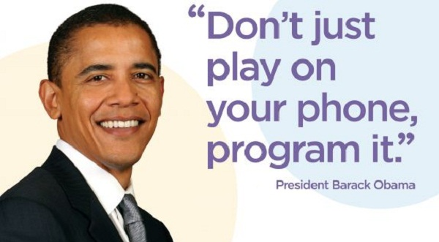

Barack Obama wants to learn to program its mobile phone, and he wants to know more about the current powerful SQL Servers. Help him to compare them and select one of them (select one except MS SQL Server) and write more about its advantageous and abilities.

[Your answer]

Here are some selected SQL servers:

1. Oracle
2. MS SQl Server
3. IBM DB
4. SAP ASE
5. …

I recommend him to go with Oracle, and following are the abilities or advantages of Oracle:

1. Enterprise level Database experience.
2. Consolidation
3. Data optimization
4. Data warehousing
5. Trustable
6. High availability
7. In-memory
8. Performance and scalability
9. Security and compliance.

## Exercise 4

**Microsoft SQL Server management tools – SQLCMD** (Slide 38) (3 points)



Someone gave Jon Snow a time machine and he realized before he goes back to the past to save his father from King Joffrey, he needs to come to our time and use SQLCMD! Find online material for SQLCMD commands and provide some important screenshots from this tool. Then in your words compare it briefly with MS SQL Management Studio.

[Your answer]

1. It has completely different syntax than SSMS with some similarities.

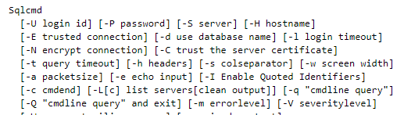

1. It has command line interface unlike of graphical interactions with SSMS

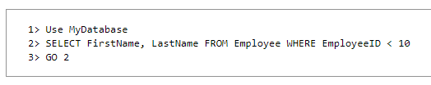

1. Connecting to database: with SSMS its too simple with graphics, with CMD we need to specify each term.

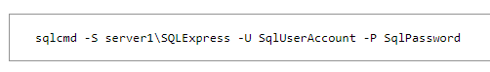

1. The interface is static, and is not user friendly since it’s only a command line interface. Look, How SSMS looks:
2. 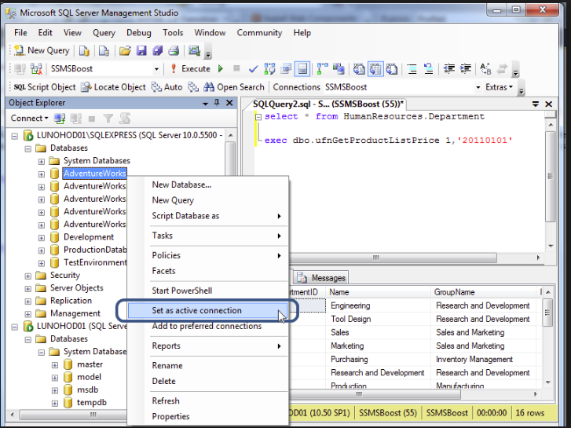

## Video 1

**Title: DNS Explained** (1 point)

**Duration: 6 min**

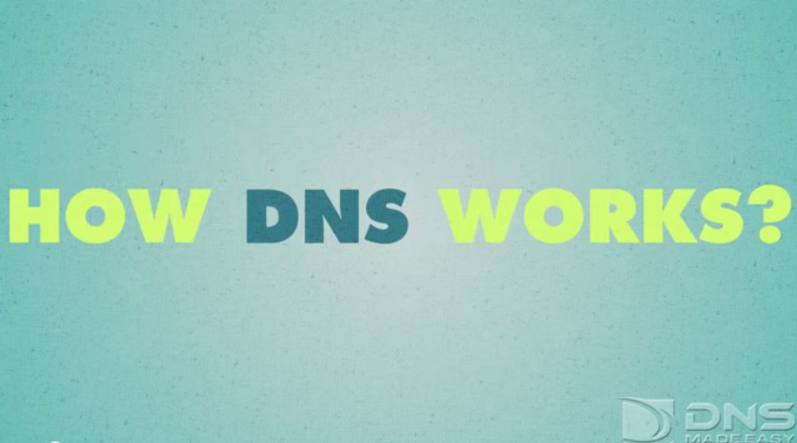

Link: <https://www.youtube.com/watch?v=72snZctFFtA>

**How was it? Anything new you learned?Your answer**

[Your answer]

The Domain Name System (DNS) manages the domain and website settings for your domain. When we visit our domain, its DNS settings specify which company's server will be contacted.

For example, if we use GoDaddy's DNS settings, visitors will go to GoDaddy servers when they migrate to our domain. If we switch these settings to the servers of another business, visitors will end up with the servers of that company when they visit our domain.

# Intermediate part

## Exercise 5

**Data types and art of selecting proper ones** (Slide 6) (5 points)



Write the best possible data types for the following cases:

|  |  |
| --- | --- |
| **Case** | **Data type** |
| If the user uploaded his/her profile photo or not | Image |
| ActionType field in a table which actions can has the type from 1-10 | tinyint |
| Start date and time of our class | smalldatetime |
| Storing messages up to 1000 from people all around the world with their own mother tongue. | Ntext |
| Specific dates for the years 2000-2014 | date |
| Row ID for a table with people of Finland information | int |
| Row ID for a table with people of the Earth information | bigint |
| English messages up to 255 character. | varchar |
| Balance value of users of a bank | Money |
| Storing random numbers from 0-30’000 | Smallint |

## Exercise 6

**Understanding primary key and foreign key** (Slide 12) (4 points)

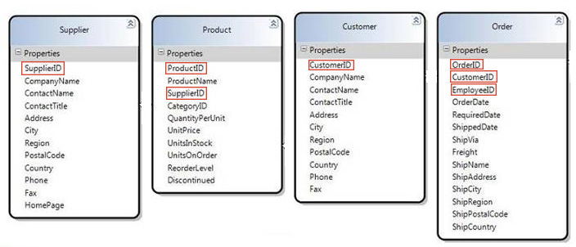

Write which of the following fields are primary keys and which are foreign keys based on the mentioned tables only (consider there are no other tables).

|  |  |  |
| --- | --- | --- |
| **Table** | **Field** | **Type** |
| Supplier | SupplierID | pk |
| Product | ProductID | pk |
| Product | SupplierID | fk |
| Customer | CustomerID | pk |
| Order | OrderID | pk |
| Order | CustomerID | fk |
| Order | EmployeeID | fk |

## Exercise 7

**Working with tables inside a database** (Slide 16, 20) (4 points)

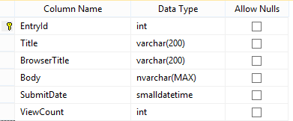

Write a query to create the table which has been shown in the figure.

[Your answer]

create table table1(

EntryId int not null primary key,

Title varchar(200) not null,

BrowserTitle varchar(200) not null,

Body nvarchar(MAX) not null,

SubmitDate smalldatetime not null,

ViewCount int not null

)

## Exercise 8

**SELECT statement** (Slide 22) (4 points)

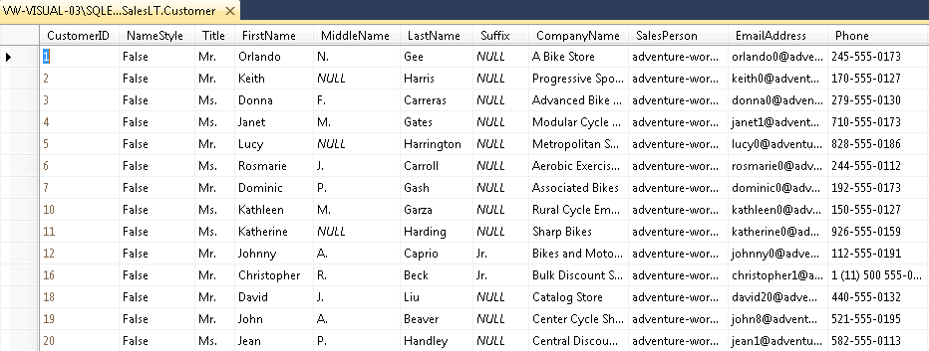

Consider “SalesLT.Customer” table in “AdventureWorksLT2008R2” database of our virtual machine, and write the following queries:

Getting all the information from this table

[Your answer]

Select *from SalesLT.Customer

Getting the records which “Title” is “Ms.” and “Suffix” is NUL (hint: “Suffix IS NULL”)

[Your answer]

Select *from SalesLT.Customer where Title=’Ms.’ And Suffix is NULL

Getting only “FirstName” and “LastName” sorted by “Phone”

[Your answer]

Select FirstName,LastName from SalesLT.Customer order by Phone

Getting the “FirstNames” values which has been listed in this table (each value only once)

[Your answer]

Select distinct FirstName from SalesLT.Customer

## Exercise 9

**INSERT statement** (Slide 30) (4 points)

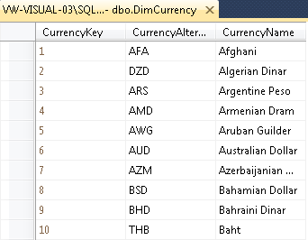

Consider “dbo.DimCurrency” table in “AdventureWorksDW2008R2” database of our virtual machine, and write an insert query with following values:

CurrencyAlternateKey = IRR

CurrencyName = Iranian Rial

[Your answer]

Insert into dbo.DimCurrency(CurrencyKey, CurrencyAlternateKey, CurrencyName)

values(11,’ IRR’, ‘Iranian Rial’)values(11,’ IRR’, ‘Iranian Rial’)

## Exercise 10

**UPDATE statement** (Slide 32) (4 points)



Consider “SalesLT.Customer” table in “AdventureWorksLT2008R2” database of our virtual machine, and write the following queries:

Change records with FirstName “Lucy” to “Veronica”

[Your answer]

Update SalesLT.Customer set FirstName=’ Veronica’ where FirstName=’Lucy’

Change “EmailAddress” to “john.ford@metropolia.fi” of the records with “FirstName”, “John”, and “LastName”, “Ford”.

[Your answer]

Update SalesLT.Customer set EmailAddress=’ john.ford@metropolia.fi’ where FirstName=’John’ and LastName=’Ford’

## Exercise 11

**DELETE statement** (Slide 34) (4 points)



Consider “SalesLT.Customer” table in “AdventureWorksLT2008R2” database of our virtual machine, and write the following queries (be aware that you cannot test your query in the sample database because the database will not allow you to delete records due to the relations with other tables):

Remove all the records which their “Title” is “Mr.”

[Your answer]

Delete from SalesLT.Customer where Title=’Mr.’

Write a query to delete all the table’s data (only the data not the table itself)

Delete from SalesLT.Customer

[Your answer]

Delete from SalesLT.Customer

# Advanced part

## Exercise 12

**Indexes** (Slide 34) (4 points)



Consider “SalesLT.Customer” table in “AdventureWorksLT2008R2” database of our virtual machine, and write the following indexes:

FirstName + LastName

[Your answer]

create index IX_table1 on SalesLT.Customer(FirstName asc,LastName)

Title

[Your answer]

create index IX_table1_1 on SalesLT.Customer(Title dsc)

## Exercise 13

**Built-in functions** (Slide 34) (4 points)



Write the name of 1 functions you researched about on the following document (which no one ever researched before), and try to improve the research of two other functions:

<https://docs.google.com/document/d/1Ztn1cYsuWT1dZzMqtnAkwD-x2Bj4w43zvIKj4wBgSBw/edit?usp=sharing>

I could not find any function which no one has researched before from the following link. So, I am selecting 3 functions in a random way and describe it. I have selected aggregate functions which are frequently used.

[Your answer]

1. Count()

The COUNT() function returns the number of rows that matches a specified criteria.

Syntax:

SELECT COUNT(column_name)  
FROM table_name  
WHERE condition;

1. Avg()

The AVG() function returns the average value of a numeric column.

Syntax:

SELECT AVG(column_name)  
FROM table_name  
WHERE condition;

1. Sum()

The SUM() function returns the total sum of a numeric column.

Syntax:

SELECT SUM(column_name)  
FROM table_name  
WHERE condition;

## Exercise 14

**Stored Procedures** (Slide 34) (4 points)

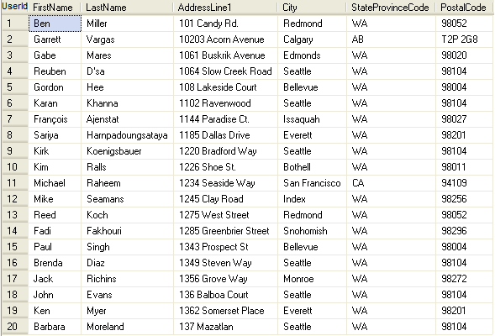

Consider the following table:

Name: Users

Data Types: UserId int - LastName nvarchar(50) - FirstName nvarchar(50) - AddressLine1 varchar(100) - City varchar(25) - StateProvinceCode char(2) - PostalCode varchar(10)

Write these 3 Stored Procedures for this table:

Stored Procedure 1 – For adding a row (UserId will be given by the database):

[Your answer]

create procedure spaddrow

as

begin

insert into table Users values('Abishek','Mahato','Vieraskuja','Espoo','Us','02770')

end

Stored Procedure 2 – For deleting a row (By finding a certain UserId):

[Your answer]

create procedure spdelrow

as

begin

delete from Users where UserId=9

end

Stored Procedure 3 – For selecting a row (By finding a certain UserId):

[Your answer]

create procedure spslctrow

as

begin

select *from Users where UserId=8

end

## Exercise 15

**Views** (Slide 34) (2 points)

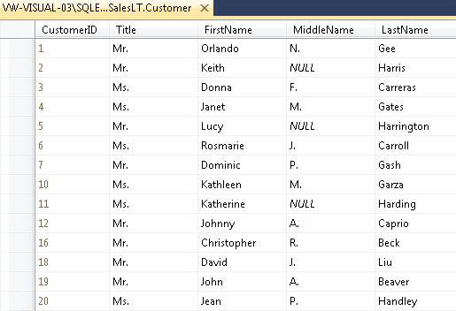

Write a view for “SalesLT.Customer” table in “AdventureWorksLT2008R2” database of our virtual machine that only returns the mentioned columns.

[Your answer]

create view vWV1

as

select CustomerID,Title,FirstName,MiddleName,LastName from SalesLT.Customer

## Exercise 16

**Triggers** (Slide 34) (4 points)

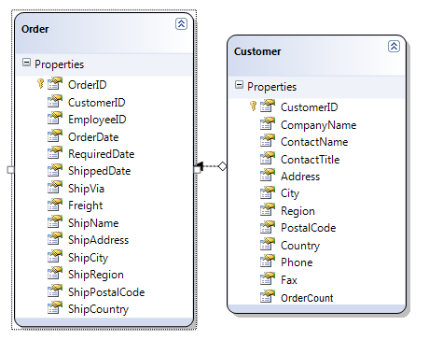

Consider these tables. Write 2 triggers (ForInsert and ForDelete) for “Order” table that +1 and -1 the specific user’s “OrderCount” column.

[Your answer]

#triggerForInsert

create trigger tr_Order_forInsert

on Order

for insert

as

begin

declare @id int

select @id=id from inserted

update Customer set OrderCount=count(OrderCount)+1 where CustomerID=id

end

#triggerForDelete

create trigger tr_Order_fordelete

on Order

for delete

as

begin

declare @id int

select @id=id from deleted

update Customer set OrderCount=count(OrderCount)-1 where CustomerID=id

end

# Diary

## First day

Write briefly about your first day. (The material you learned, the material you already were familiar with, and anything else related to our session) (If you were absent just write I was absent and yes you will not get points from this question, sorry.) (2 points)

[Your answer]

1. I was a bit familiar with SSMS and the PDF documents provided for learning.
2. The overview of the materials were well managed and organized in a proper manner for students.

## Second day

Write briefly about your second day. (The material you learned, the material you already were familiar with, and anything else related to our session) (If you were absent just write I was absent and yes you will not get points from this question, sorry.) (2 points)

[Your answer]

1. I knew a basic definition and working of database, however I was unfamiliar with SSMS.
2. Gradually I started playing around different tools of SSMS with respect to the slides provided and videos.

## Third day

Write briefly about your third day. (The material you learned, the material you already were familiar with, and anything else related to our session) (If you were absent just write I was absent and yes you will not get points from this question, sorry.) (2 points)

[Your answer]

1. I learned different terminologies that are included in database systems.
2. I started navigating important tools required to design and develop a database around SSMS.

## Fourth day

Write briefly about your fourth day. (The material you learned, the material you already were familiar with, and anything else related to our session)(If you were absent just write I was absent and yes you will not get points from this question, sorry.) (2 points)

[Your answer]

1. I started the quiz, which was fun to do. Then I knew many key points about database.
2. I searched many things for ex. 1-4 and the video, to give a proper answer.

## Fifth day

Write briefly about your fifth day. (The material you learned, the material you already were familiar with, and anything else related to our session) (If you were absent you cannot pass this course since doing group project and quiz were compulsory!) (2 points)

[Your answer]

1. I started making my own tables in SSMS, and explore different features while watching video tutorials.
2. Self-learning for the issues that occurred while doing different activities.

# Feedback

**Quiz**

1. In your opinion, how hard was the quiz?

|  |  |  |  |  |
| --- | --- | --- | --- | --- |
| Very Hard | Hard | Moderate | Easy | Very Easy |
|  |  | X |  |  |

2. Your feedback/suggestions/comments about the quiz.

[Answer here]

**Project**

3. In your opinion, how hard was the project?

|  |  |  |  |  |
| --- | --- | --- | --- | --- |
| Very Hard | Hard | Moderate | Easy | Very Easy |
|  |  | X |  |  |

4. Your feedback/suggestions/comments about the project.

[Answer here]

**Assignments**

5. In your opinion, how hard was the assignments?

|  |  |  |  |  |
| --- | --- | --- | --- | --- |
| Very Hard | Hard | Moderate | Easy | Very Easy |
|  |  | X |  |  |

1. Your feedback/suggestions/comments about the assignments.

The working server file must be available , so that student can practice well.

[Answer here]

Moderate

**Teacher**

7. How much satisfied you are about the teacher’s professional skills?

|  |  |  |  |  |
| --- | --- | --- | --- | --- |
| Very Satisfied | Satisfied | So-so | Unsatisfied | Very unsatisfied |
|  |  | X |  |  |

8. How much satisfied you are about the teacher’s skills to deliver the material in the lectures?

|  |  |  |  |  |
| --- | --- | --- | --- | --- |
| Very Satisfied | Satisfied | So-so | Unsatisfied | Very unsatisfied |
|  |  | X |  |  |

1. Your feedback/suggestions/comments for the teacher to improve himself.

Email should be replied on time, students may ask something about assignments or anything. I didn’t get reply at all when I asked about the server issue. No interaction!!!

[Answer here]

**Course**

10. How much satisfied you are about the course material?

|  |  |  |  |  |
| --- | --- | --- | --- | --- |
| Very Satisfied | Satisfied | So-so | Unsatisfied | Very unsatisfied |
|  | X |  |  |  |

11. How much satisfied you are about the course teaching method and structure?

|  |  |  |  |  |
| --- | --- | --- | --- | --- |
| Very Satisfied | Satisfied | So-so | Unsatisfied | Very unsatisfied |
|  |  | X |  |  |

12. Your feedback/suggestions/comments about the course.

[Answer here]

13. Your satisfaction percentages from everything related to this course (0-100).

[Answer here]

75%

14. Were there any other material related to the course that you were looking forward to learn but they were not in the course material?

[Answer here]

15. Did you encounter any mistakes in the course material?

[Answer here]

16. Do you have any other feedback/suggestions/comments?

[Answer here]

Please reply quickly by mail, students might have many difficulties. How can I student interact with you as you being a teacher? I didn’t get any reply when I was having difficulties.

**You need to return this assignment before its deadline for your final assessment.**

**Good luck!** ☺ **Farhad Eftekhari**

Copyright © 2016 by Farhad Eftekhari

All rights reserved. No part of this publication may be reproduced, distributed, or transmitted in any form or by any means, including photocopying, recording, or other electronic or mechanical methods, without the prior written permission of the publisher, except in the case of brief quotations embodied in critical reviews and certain other noncommercial uses permitted by copyright law. For permission requests, write to the publisher, addressed “Attention: Permissions Coordinator,” at the address below.

Helsinki Metropolia UAS  
Bulevardi 31  
00079 Heksinki, Finland  
www.techclass.co

