

Sri Lanka Institute of Information Technology

**Cellular Phone Shop Management System**

**(OSGI FRAMEWORK)**

Software Architecture (SE3030)

2022

**CSSE_WE_12**

Assignment 01

**Submitted by:**

|  |  |
| --- | --- |
| **Registration No** | **Name** |
| IT21013096 | Perera A.S.A |
| IT21026898 | Mayadunna J. B |
| IT21022838 | Ranasinghe H.R.A.L.N |
| IT21018282 | Udunuwara U.K.C |

# Table of Contents

Table of Contents 2

Introduction 3

Requirement of the Assignment 3

Scope of the Assignment 3

Goal of the Assignment 3

Tools and Technologies 3

System Overview 4

Scenario Explanation 5

Functional Diagram 5

System Component Diagram 5

System Flow Chart 6

Bundle and Manifest Files 7

Admin Managing Producer 7

Bill Managing Producer 7

Stock Managing Producer 8

Employee Managing Producer 8

Supplier Managing Producer 9

Database Managing Producer 9

Main Managing Consumer 10

All Commands of Bundle Install and Run in OSGi 10

Compilation 10

Create JAR with MANIFEST 12

Login to felix:- 13

Install OSGi 13

Sample Behavior and Outputs 14

Login 14

Admin Management System 15

Bill Management System 18

Stock Management System 21

Employee Management System 24

Supply Management System 27

MySQL Database 30

Individual Contribution 32

# Introduction

This report provides an overview of the use of the OSGi framework for implementing a producer-consumer model, which involves the production and consumption of services. For this project, we have developed a producer-consumer model for the admin party of a Phone Shop Management System, which includes several sub-systems such as Billing Management, Stock Management, Admin Management, Employee Management and Supply Management. The producer-consumer model utilizes the OSGi framework, where the producer generates services, and the consumer subscribes to these generated services for its consumption.

## Requirement of the Assignment

Implementing a plugin project for a producer-consumer scenario. The implementations should be capable of publishing services and consuming the services by implementing the inner logics of the scenario.

## Scope of the Assignment

With the use of OSGi framework establishing communication between the producer and the consumer bundles in the “Cellular Store Management System”. Designing and implementing the producer bundles that publishes the services and a consumer bundle that subscribes and receive the services from the service producer bundles.

## Goal of the Assignment

The goal of the assignment is to implement a producer-consumer scenario using OSGi framework, to demonstrate the use of OSGi services to establish communication between the producer and consumer bundles.

Moreover, gaining the practical experience in software architecture principles, ability to implement OSGi services by utilizing OSGi framework and to handle complex scenarios by applying critical thinking and problem-solving skills.

## Tools and Technologies

* Eclipse Enterprise IDE for development.
* Java as the programming language.
* OSGi as the framework.
* Eclipse Equinox as the open-source implementation of OSGi framework
* Apache Felix Gogo shell is a shell console used for interacting with OSGi bundle and to install and run the producer and consumer bundles in the OSGi framework.

## System Overview

There are 5 Publisher components and 1 Consumer (Subscriber) component in this “Cellular Shop Management System”.

This scenario illustrates the admin side of a Cellular Shop Management System.

* Here the shop owner can assign admins to the shop, and he can add admins, update admin details, retrieve and search for admin details using the Admin Managing Producer bundle.
* Admins of this shop can perform main 4 functions as Bill Management, Stock Management, Employee Management and Supplier Management
* Bill management refers to the procedure where the admin can add bills, update bills, retrieve and search for bill details and delete bills.
* Stock management refers to the procedure where the admin can add stocks, update stocks, retrieve and search for stock details and delete stock details.
* Employee management refers to the procedure where the admin can add employees, update employees, retrieve and search for employee details and delete employees.
* Supplier management refers to the procedure where the admin can add suppliers, update supplier details, retrieve and search for supplier details and delete suppliers.

# Scenario Explanation

## Functional Diagram

## System Component Diagram

## System Flow Chart

# Bundle and Manifest Files

## Admin Managing Producer

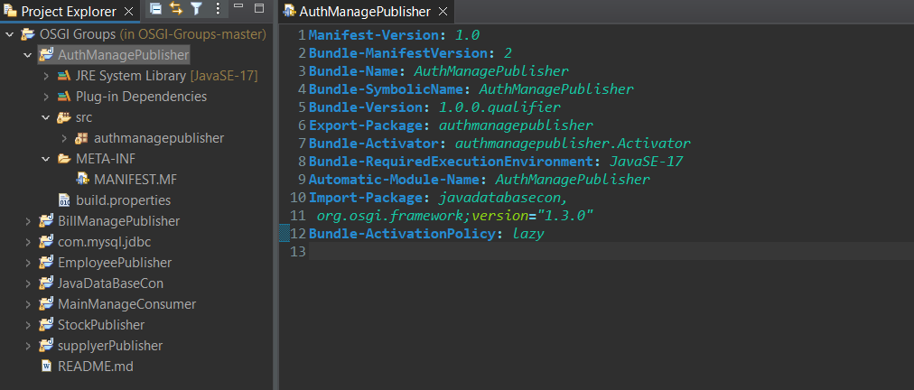

## Bill Managing Producer

## Stock Managing Producer

## Employee Managing Producer

## Supplier Managing Producer

## Database Managing Producer

## Main Managing Consumer

# All Commands of Bundle Install and Run in OSGi

## Compilation

1. **Compile Database connection**



C:\OSGi\felix-framework-4.0.3\bin>javac -cp C:\OSGi\felix-framework-4.0.3\bin\felix.jar JavaDataBaseCon\javadatabasecon\*.java.

1. **Compile Auth Manage Publisher**



C:\OSGi\felix-framework-4.0.3\bin>javac -cp C:\OSGi\felix-framework-4.0.3\bin\felix.jar AuthManagePublisher\authmanagepublisher\*.java

1. **Compile Bill Manage Publisher**



C:\OSGi\felix-framework-4.0.3\bin>javac -cp C:\OSGi\felix-framework-4.0.3\bin\felix.jar BillManagePublisher\billmanagepublisher\*.java

1. **Compile Employee Publisher**



C:\OSGi\felix-framework-4.0.3\bin>javac -cp C:\OSGi\felix-framework-4.0.3\bin\felix.jar EmployeePublisher\employeepublisher\*.java

1. **Compile Stock Publisher**



C:\OSGi\felix-framework-4.0.3\bin>javac -cp C:\OSGi\felix-framework-4.0.3\bin\felix.jar StockPublisher\stockpublisher\*.java

1. **Compile Supplier Publisher**



C:\OSGi\felix-framework-4.0.3\bin>javac -cp C:\OSGi\felix-framework-4.0.3\bin\felix.jar supplyerPublisher\suppyerpublisher\*.java

1. **Compile MainManageConsumer**



C:\OSGi\felix-framework-4.0.3\bin>javac -cp C:\OSGi\felix-framework-4.0.3\bin\felix.jar MainManageConsumer\mainmanageconsumer\*.java

## Create JAR with MANIFEST

1. **Create JDBC.jar from the Manifest**



C:\OSGi\felix-framework-4.0.3\bin\com.mysql.jdbc\META-INF>jar cfm JDBC.jar MANIFEST.mf

1. **Create AuthManagePublisher.jar from the Manifest**



C:\OSGi\felix-framework-4.0.3\bin\AuthManagePublisher>jar cfm authmanagepublisher.jar MANIFEST.mf

1. **Create Bill manage publisher**



C:\OSGi\felix-framework-4.0.3\bin\BillManagePublisher\billmanagepublisher>jar cfm billmanagepublisher.jar MANIFEST.mf

1. **Create Employee Manage publisher**



C:\OSGi\felix-framework-4.0.3\bin\EmployeePublisher>jar cfm empliyeemanagement.jar MANIFEST.mf

1. **Create Main Manage Consumer**



C:\OSGi\felix-framework-4.0.3\bin\MainManageConsumer>jar cfm mainmanageconsumer.jar MANIFEST.mf

1. **Create stock publisher**



C:\OSGi\felix-framework-4.0.3\bin\StockPublisher>jar cfm stockpublisher.jar MANIFEST.mf

1. **Create supplier publisher**



C:\OSGi\felix-framework-4.0.3\bin\supplyerPublisher>jar cfm suplierpuiblisher.jar MANIFEST.mf

## Login to felix:-

## Install OSGi

1. **Install AuthManager**

1. **Install BillManagePublishe**



1. **Install EmployeeManager**



1. **Install StockPublisher**



1. **Install SupplierPublisher**



1. **Install MainManageConsumer**



# Sample Behavior and Outputs

Login

## Admin Management System

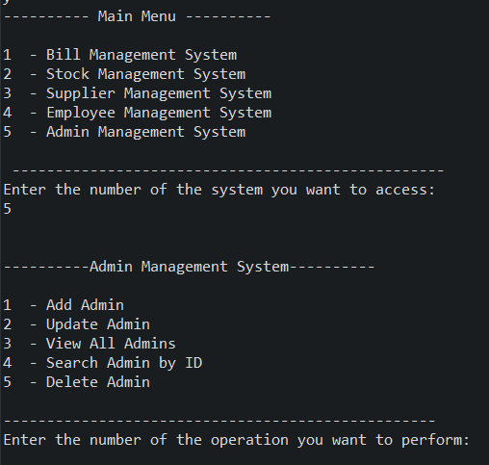

Add Admin

Retrieve All Admins

Update Admin

Delete Admin

Search Admin

## Bill Management System

Add Bills

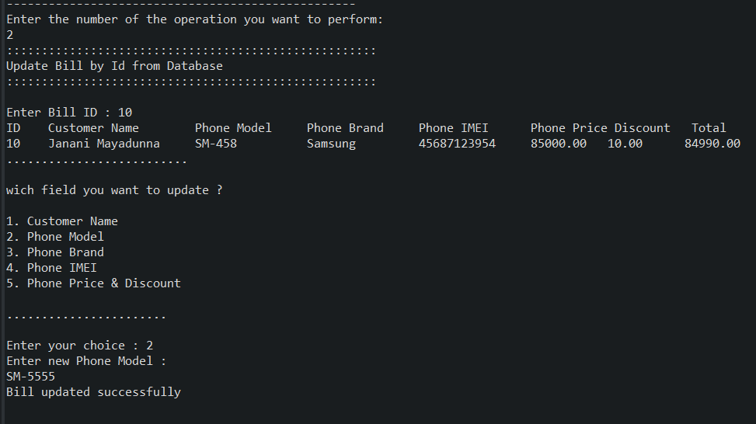

View All Bills

Update Bills

Search Bills

Delete Bills

## Stock Management System

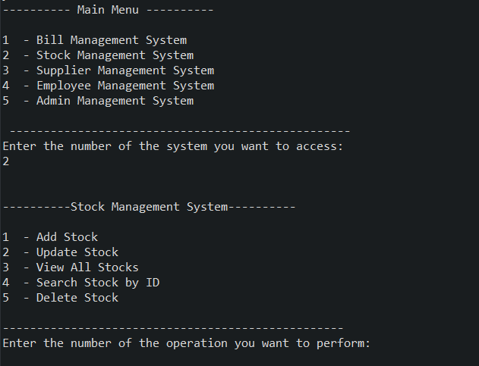

Add Stocks

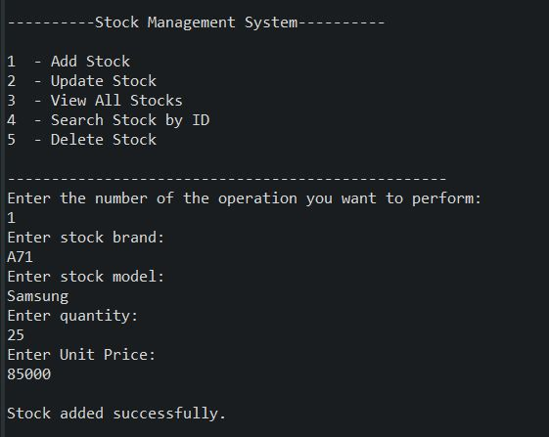

View All Stocks

Update Stocks

Search Stocks

Delete Stocks

## Employee Management System

Add Employees

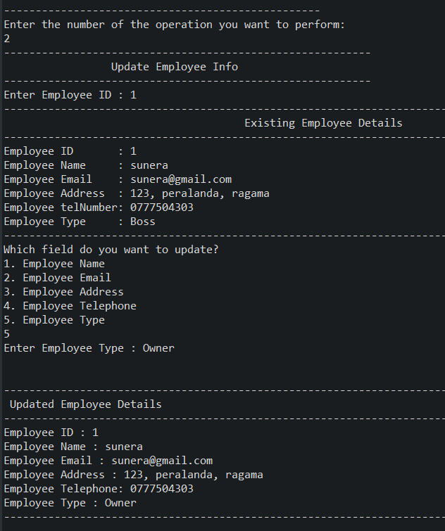

Update Employee

View All Employees

Search Employees

Delete Employees

## Supply Management System

Add Supplier

Update Supplier

View All Suppliers

Search Suppliers

Delete Suppliers

# MySQL Database

# Individual Contribution

|  |  |  |
| --- | --- | --- |
| Registration No | Student Name | Individual Contribution |
| IT21013096 | Perera A.S.A | Implement Admin Managing Producer.  Implement Bill Managing Producer.  Contributed to implement the database connection.  Contributed for the final assignment report. |
| IT21026898 | Mayadunna J. B | Implement Stock Managing Producer.  Contributed to implement the database connection.  Contributed for the final assignment report. |
| IT21022838 | Ranasinghe H.R.A.L.N | Implement Employee Managing Producer.  Contributed to implement the database connection.  Contributed for the final assignment report. |
| IT21018282 | Udunuwara U.K.C | Implement Supplier Managing Producer.  Contributed to implement the database connection.  Contributed for the final assignment report. |

------- END ------