**Laravel**

# Init

## Route

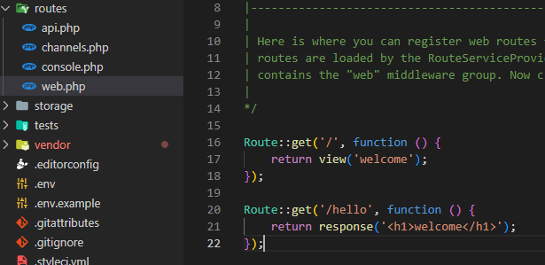

## Headers

## Debug

## Send data using URL

## API

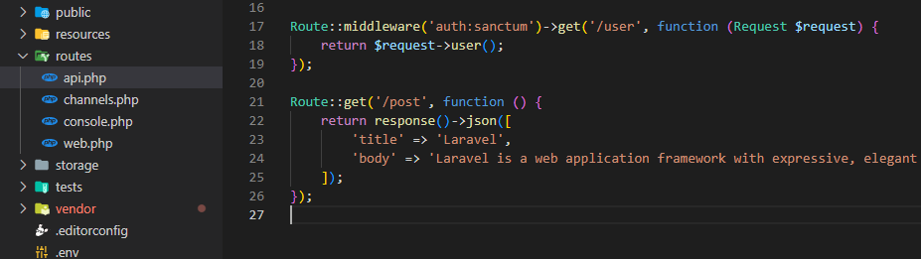

URL ගහද්දි අනිවා ../api/..

## Show data in a view

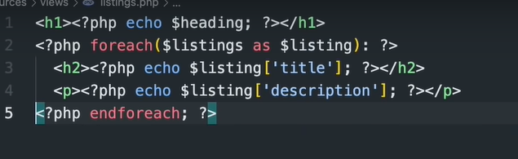

(BLADE)

Laravel වල data එන්නෙ Eloquent

## Models

php artisan make: model Listing

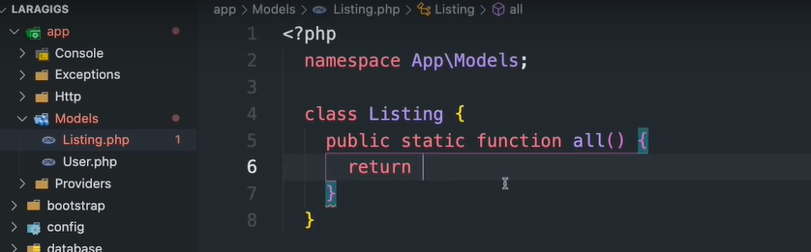

## Use model.

## Single ID Wildcard

## Composter Update අව්ල් තියෙන එව අයින් කරල අනිත් එව ගහනව

composer update --ignore-platform-reqs

# Data Base

php artisan make:migration create_listings_table

## Config db

## Create DB

php artisan migrate

## Find DB Query

composer require itsgoingd/clockwork

<https://chrome.google.com/webstore/detail/clockwork/dmggabnehkmmfmdffgajcflpdjlnoemp?hl=en>

## Seeders Fake users

php artisan db:seed

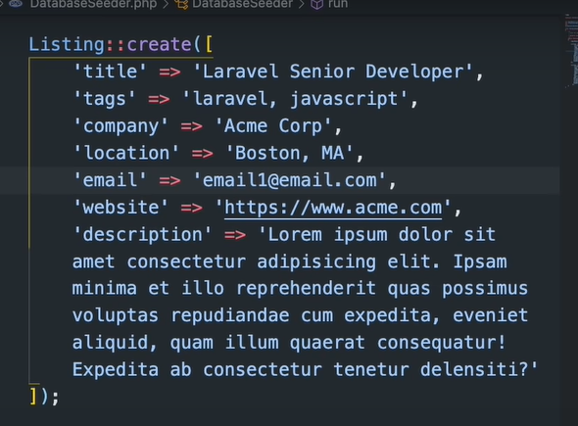

## Create fake factory

php artisan make:factory ListingFactory

## Delete Data

php artisan migrate:refresh

## Insert Data

Form එකකින් data දාන්වනම් අනිව මෙක දාන්න

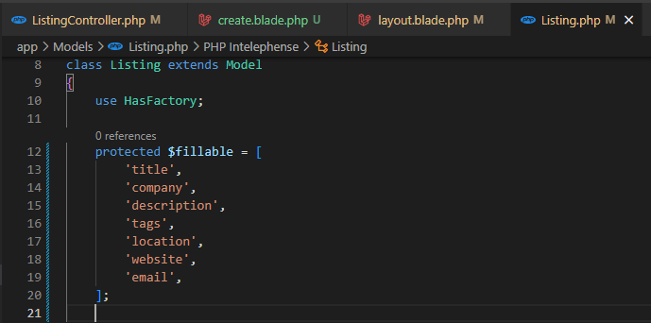

ඒම නැත්නම්

# Views

## Headings and Footer

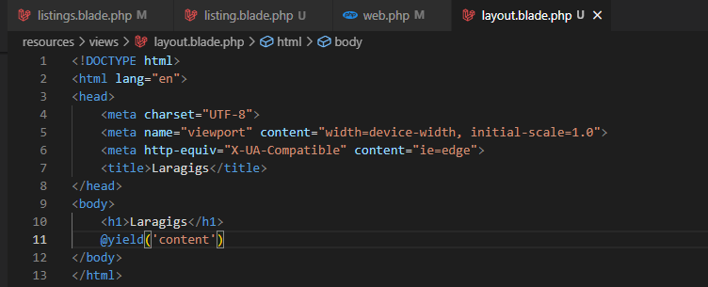

## Eloquent නිසා



## Reffer components

### Props



### <x-card>

## Create Controllers

php artisan make:controller ListingController

Web එකෙ තියෙන functions වෙනුවට කෙලින්ම controller එකෙ තියෙන functions කෝල් ක්‍රනව.

## Create filter

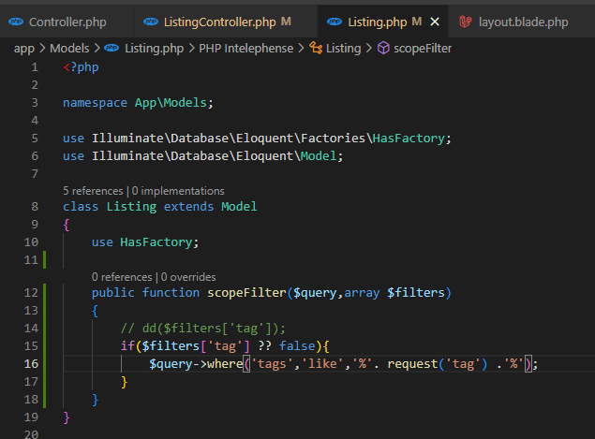

## Pagination

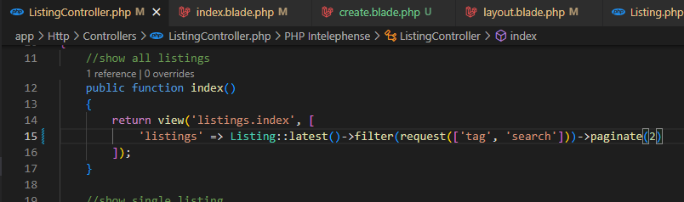

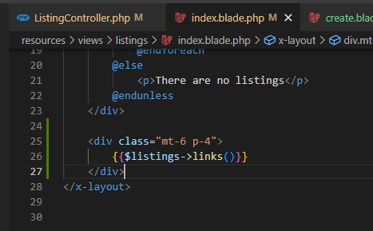

## Simple Pagination

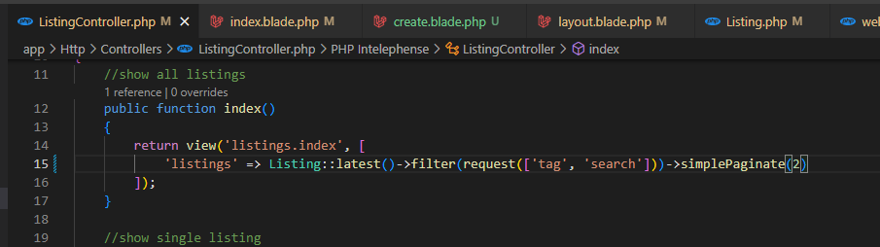

# Security

## Cross Site scripting attacks

අනුන්ගෙ website වලින් අපෙ forms වලට submit කරන්න බැරි කරන්ව

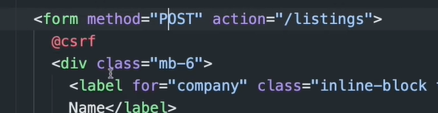

tests