**PHASE 3 : DEVELOPING PART 1**

**CHATBOT USING IBM CLOUD WATSON ASSISTANT**

**Problem Definition:** The project involves creating a chatbot using IBM Cloud Watson Assistant. The goal is to develop a virtual guide that assists users on messaging platforms like Facebook Messenger and Slack. The chatbot should provide helpful information, answer frequently asked questions (FAQs), and offer a friendly conversational experience. The project includes designing the chatbot's persona, configuring responses, integrating with messaging platforms, and ensuring a seamless user experience.

In this phase, we have to create an IBM cloud account to use Watson assistant.

Here's a step-by-step guide on how to create an IBM Cloud account and get started with Watson Assistant:

**Step 1: Sign Up for IBM Cloud**

1. Open a web browser and go to the IBM Cloud website: [https://cloud.ibm.com/](https://cloud.ibm.com/).

2. Click on the "Sign up" button, which is typically located in the top right corner.

3. It will be prompted to create an IBM ID. Follow the instructions and provide the required information to create your IBM Cloud account.

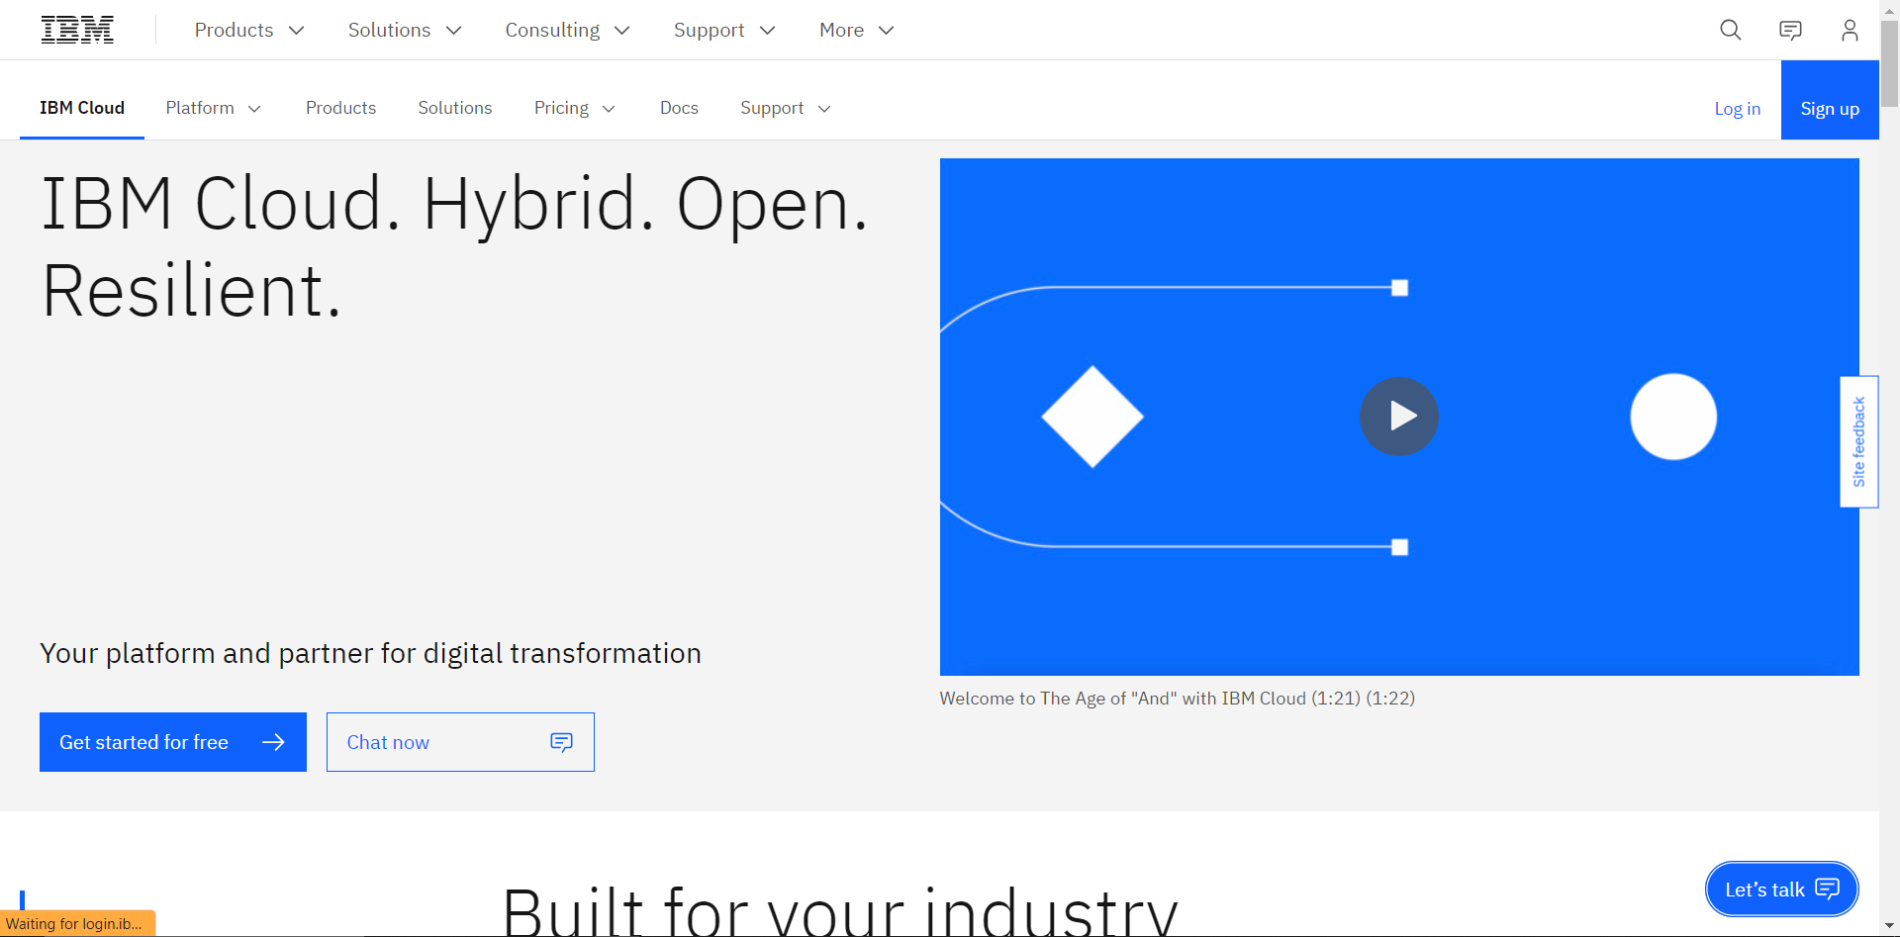

**Step 2: Verify Your Email**

After creating IBM Cloud account, it will receive an email with a verification link. Click on the link to verify email address.

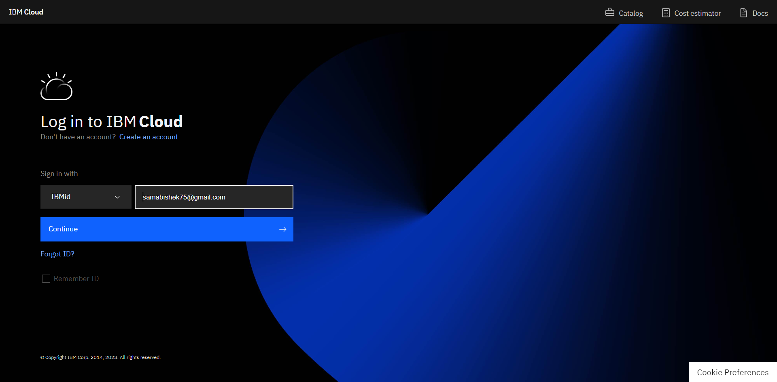

**Step 3: Log In to IBM Cloud**

Once email is verified, log in to the IBM Cloud account using the IBM ID and password.

**Step 4: Create an IBM Watson Assistant Service**

1. After logging in, it will be taken to the IBM Cloud dashboard.

- Click on "Create Resource" or "Create a resource" from the dashboard.

- In the catalog, search for "Watson Assistant" or select the "AI" category to find it.

2. Click on the "Watson Assistant" service to configure it.

3. Fill out the required information, such as the service name and tags, and click "Create" or "Create Service."

4. Once the service is created, you'll be redirected to the Watson Assistant service dashboard.

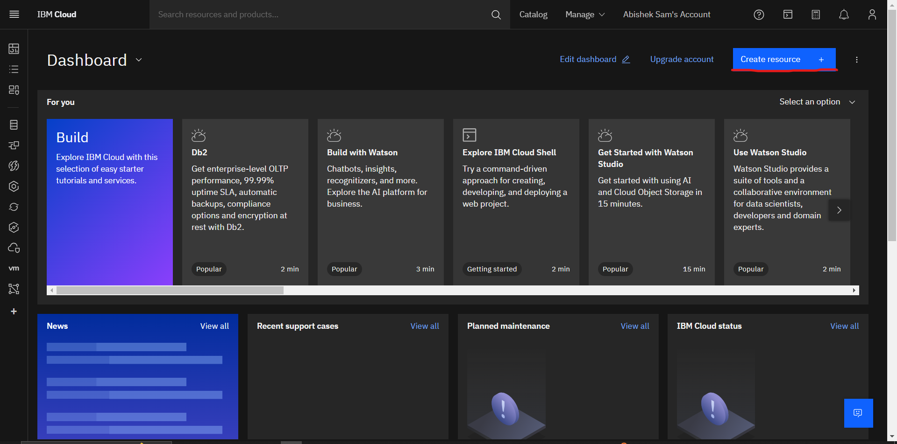

**Step 5: Set Up Watson Assistant**

1. In the Watson Assistant dashboard, create and manage assistant instances. Click "Create assistant" to create a new chatbot instance.

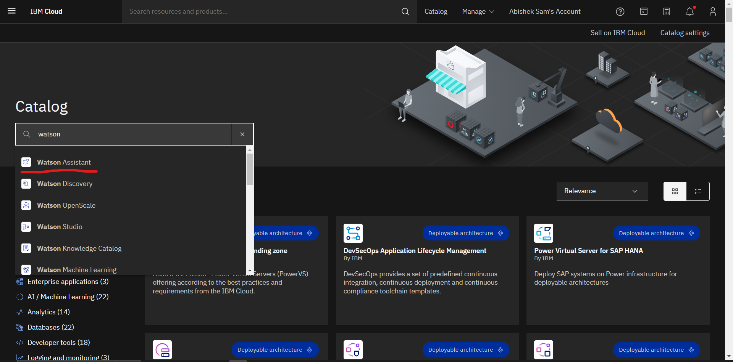

2. Configure the assistant by providing a name, description, and other details as needed.

3. Design the chatbot by adding intents, entities, and dialog flows to handle user interactions. We can use the Watson Assistant interface to create and train your chatbot.

4. We can also integrate our chatbot with various channels and services, such as websites, mobile apps, or other communication platforms.

5. Once the chatbot is configured and trained, we can test it using the built-in tools in the Watson Assistant dashboard.

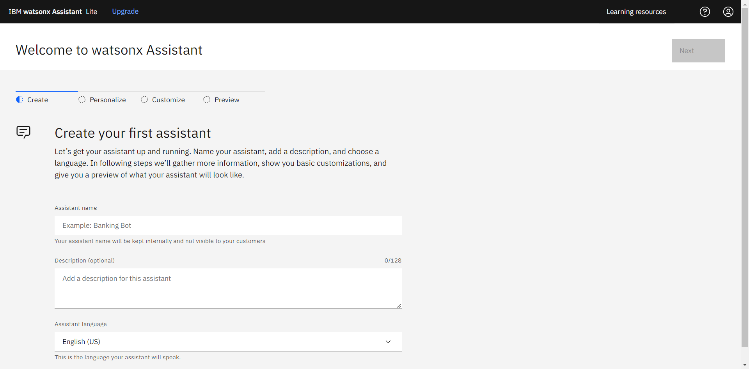

**Step 6: Connect Watson Assistant to the Application**

After configuring and testing our Watson Assistant chatbot, we can integrate it into our application or website using the provided API keys and endpoints. IBM Cloud offers various SDKs and documentation to help us connect our chatbot to different platforms and programming languages.

**\*\*\*\*\*\*\***