RESILION 2.0
Hackathon Submission — PS13: Landslide and Hazard Alert Management for Hill Roads
Item | Detail
Initial design corridor | NH-27 within Dima Hasao district, Assam (problem context: hill roads across India). No Assam-wide coverage or confirmed government pilot is claimed.
Submission status | Solution design and requirements complete. No RESILION 2.0 prototype has been built or tested yet. Components reused from the team’s SIH 2026 project RESILION were tested in that project’s demos only.
Version / date | 1.0 · 1 November 2026
How to read | Each section gives a short summary and exact references (§ = section) to the supporting documents listed at the end. Where the Solution Design v1.0 differs in wording from the MRD or PRD, the MRD and PRD v1.0 apply.

1. Problem Statement Analysis
On landslide-prone hill roads in India, warnings — where they exist — cover a whole district or route. Authorities cannot act on a specific stretch, and travellers are not told where to stop, whether a diversion is safe, or when the road will reopen, so they are repeatedly stranded on both sides of a slide.
Evidence (selected) | Source
NH-27 Jatinga–Harangajao blocked on 21 Jun 2026; hundreds of vehicles stranded on both sides; no reopening time or diversion stated | MRD EV-01
Repeated NH-27 failures in Dima Hasao in 2022, 2024 and 2025, including 5 deaths in Haflong (May 2022) | MRD EV-02–EV-05
Dima Hasao is not among the 21 districts covered by GSI’s 2025 landslide bulletins | MRD EV-06
National systems forecast (GSI), deliver alerts (SACHET) or log complaints (Rajmargyatra), but none of those reviewed gives road-segment decisions | MRD §4

Market needs identified: N1 segment-level risk · N2 a safe place to wait before the risk zone · N3 fast verified ground reports · N4 an expected reopening time · N5 diversions only when safe · N6 alerts people can read and receive.
Limits stated openly: evidence is from news and official sources; closure frequency and traffic volume are not quantified; personas are provisional (no interviews yet).
Full analysis: MRD §1 (problem and scope), §2 (segments, personas), §3 (evidence register EV-01–EV-19, needs N1–N6, assumptions), §4 (alternatives and gaps); Solution Design §2–§3.

2. Proposed Solution
RESILION 2.0 turns “avoid travel” into “stop at Haflong — road expected to reopen around 4 PM”. It is a road-level decision layer: for each ~1 km segment it shows a risk level with reasons, and for travellers approaching that segment it issues a deterministic decision — GO, HOLD at a named Safe Holding Point, or DIVERT only on a route that is itself risk-checked — with every closure, reopening and public alert approved by an officer.
Feature | Priority | Addresses
F1 Segment Risk Map (rule-based Risk Index, reasons, 6-hour validity) | Must | N1
F2 Safe Passage and Closure Engine (approach zones, decision rules, holding points, risk-checked diversion, closure, clearance log, reopening estimate) | Must | N2, N4, N5
F3 Verified Ground Reports (web upload, AI photo check, officer confirmation) | Must | N3
F4 Multilingual Alerts and CAP export (English, Hindi, Assamese, Bengali, Dimasa) | Should | N6
F5 Access control and audit log | Should | N3
F6 Offline cache and SMS fallback · F7 Equipment tracking | Could | N6 · N4

What is new: stopping travellers before the danger zone at a named place; one officer-confirmed report updating the road for every approaching traveller; diversions offered only when their own segments are safe; a labelled reopening estimate. Forecasting, photo reporting and alert delivery already exist and are not claimed as new; RESILION 2.0 complements GSI, SACHET and district authority.
Details: PRD §1–§2 (summary, features, traceability); Solution Design §7 (uniqueness), §9 (modules M1–M5), §10 (decision rules); MRD §6.

3. Proposed Methodology / Approach

3.1 How the product works
- Score: compute a Risk Level per segment from susceptibility, slope, rainfall (24 h, 3 days, 7 days), past incidents and official warnings; warnings can only raise a level; missing data is never shown as safe.
- Verify: field reports are classified by AI and confirmed or rejected by an officer; only confirmed reports change a road’s state.
- Decide: deterministic rules turn segment state and risk into GO / HOLD / DIVERT per approach zone, with the most restrictive decision winning.
- Approve and inform: the officer approves closures and alerts; alerts are validated, translated and exported in CAP format.
- Clear and reopen: crew assignment, reopening estimate and staged reopening return decisions to GO.
Reference: Solution Design §8, §10; PRD §4 (user flows), §6 (business rules BR-01–BR-12).

3.2 How the team developed the solution
Phase | What was done | Output
1. Problem research | Reviewed official, product and research sources on landslide warning in India; identified the gaps; selected three core problems (segment risk, alert-to-action, unverified reports) | MRD §4 evidence base
2. Corridor evidence | Collected dated incidents on NH-27 (Dima Hasao), chosen by the team for its fit with the team’s existing Assam road data; Himachal NH-3 used as supporting evidence | MRD EV-01–EV-09
3. Prior-work audit | Audited RESILION (SIH 2026) and classified each component as confirmed, partly known or unverified; only confirmed items may be claimed | Solution Design §13.1
4. Design and critical review | Drafted the solution; ran an independent assessment and a 37-item gap analysis; the team approved corrections (for example, removing a “GO NOW” decision for safety and replacing per-vehicle decisions with approach zones) | Solution Design v1.0
5. Requirements | Wrote the MRD and PRD from one shared requirement set; computed a traceability audit (needs → features → requirements → acceptance criteria → metrics) | MRD, PRD §14–§15
6. Delivery planning | Built a Jira-ready backlog with automated checks for coverage, IDs, dependencies and priorities | Backlog workbook

3.3 Use of AI in preparing this work
- Assistant: Claude (Anthropic) was used for source research with citations, critical assessments, gap analyses and drafting documents.
- Human control: every scope, design and priority decision was approved by the team before documents changed; approvals were requested one decision at a time with stated options.
- Accuracy rules applied in every prompt: no invented statistics, results or agreements; facts, assumptions and pending items labelled; geography limited to the initial corridor.
- Verification, not trust: document generation scripts computed traceability and consistency checks; the first PRD audit found two requirements without acceptance criteria, which were fixed before delivery.
A separate Prompt Engineering Document, Skills Workflow and Evidence file are planned deliverables and are not part of this submission yet.

4. Technologies and Tools to Be Used
Area | Technology / tool | Purpose | Status
Data store | PostgreSQL + PostGIS | Road segments, states, reports, incidents | Used in RESILION; segments planned
Backend | Python, FastAPI | Risk Index, decision engine, report intake, alert writer | Used in RESILION; RESILION 2.0 planned
Routing | OSRM on OpenStreetMap | Diversion check | Tested in RESILION (public server)
AI | Claude Sonnet 5.5 via Anthropic API | Photo classification; alert filling and translation | Planned
Front end | React, TypeScript, MapLibre | Officer console and corridor map | Used in RESILION; RESILION 2.0 planned
Field app | RESILION field app (framework to be confirmed) or web upload page | Report intake | Field app pending verification; web page planned
Alerts | Common Alerting Protocol (CAP) XML; SMS gateway | Alert export for SACHET; SMS fallback | CAP planned; SMS gateway not selected
Data sources | IMD rainfall and warnings; GSI susceptibility (Bhukosh); team Assam OSM road data | Risk inputs and segments | Pending verification for NH-27
Data preparation | QGIS, Google Colab | Terrain and event processing (as used in RESILION) | Team record
Project and documentation | Jira (import-ready backlog), Claude, Microsoft Word and Excel, Mermaid diagrams | Planning, analysis, documents | In use

PS13 suggests Flutter for the app; the team’s field-app framework is not yet confirmed. Reference: Solution Design §14; PRD §9, §11.

5. Expected Outcomes

5.1 Measurable at the hackathon demonstration (targets, not results)
Metric | Target | Shows
SM1 Decision correctness — scripted NH-27 scenarios returning the rule-specified decision | 100% | Decision rules behave as specified (N2, N4, N5)
SM2 Alert safety — generated alerts matching source fields, or blocked | 100%; 0 unblocked mismatches | AI-written alerts cannot carry wrong places or times (N6)
SM3 Report-to-decision time — upload to officer-ready decision | Measured and reported as demo timing | Speed of the verified-report path (N3)

5.2 Expected impact if piloted in future (not claimed now)
- Officers act on specific stretches instead of whole routes.
- Fewer travellers held inside risk zones; held travellers see where to wait and an expected reopening time.
- No unsafe diversion offered; alerts readable in local languages, including Dimasa.
Reference: PRD §3 (metrics with definition, calculation, baseline, data source, procedure and limits; future validation metrics); MRD §7.

6. Initial Prototype / Solution Design
Prototype status: no RESILION 2.0 prototype has been built or tested. The solution design and a buildable, testable plan are complete. Reusable components exist from the team’s SIH 2026 project RESILION.
Component | Status
Assam road network in PostGIS (265,680 records); route-to-road matching; OSRM routes with alternatives; road states with history; decision rules | Tested in RESILION (SIH 2026 demos) — team record
RESILION 2.0 modules F1–F5, AI photo check, alert writer, officer console | Planned — not started
Offline cache, SMS fallback, SACHET publishing, sensors | Proposed / future
NH-27 data coverage, risk datasets, holding-point suitability, field-app upload | Pending verification

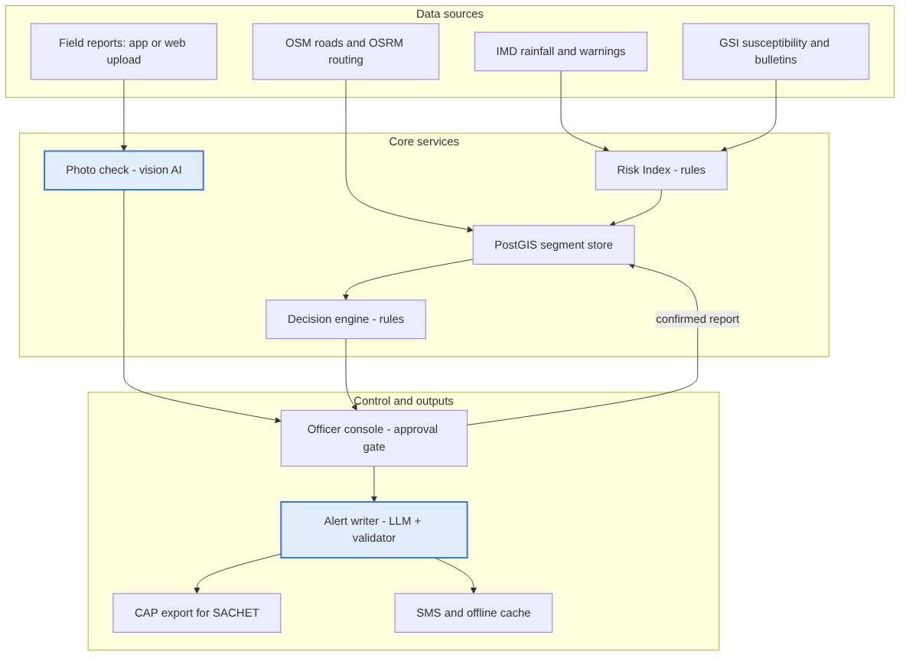
Figure 1 — Architecture: AI components (blue) only classify photos and write alert text; rules and the officer decide
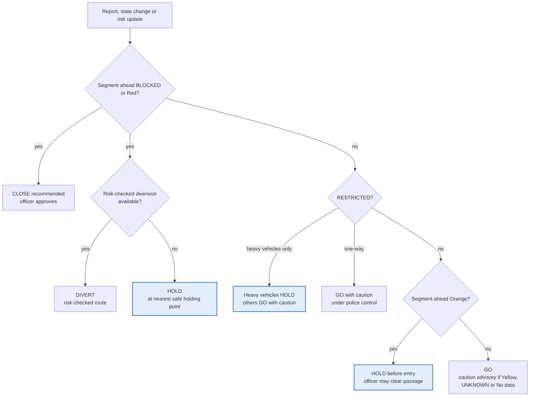
Figure 2 — Safe Passage decision flow; when several conditions apply, the most restrictive decision wins
Build plan: 6 epics, 25 user stories, 41 subtasks and 34 test cases, all traced to the PRD; every test is “Not Run” until implemented. The planned demo shows one scripted NH-27 scenario from rising risk to reopening, with the incident clearly labelled as a scenario.
Reference: Solution Design §9–§10, §14, §16.2 (demo plan); PRD §4, §8, §11; Backlog (Epics, Stories, Test Checklist, UI Evidence).

Supporting Documents
# | Document | File | Covers
1 | RESILION 2.0 – Complete Solution Design & Technical Validation v1.0 | RESILION_2.0_Complete_Solution_Design_and_Technical_Validation.docx | Full design, architecture, AI, data, security, testing, open items
2 | RESILION 2.0 – Market Requirements Document v1.0 | RESILION_2.0_MRD_v1.0.docx | Problem, evidence, personas, needs, alternatives, opportunity
3 | RESILION 2.0 – Product Requirements Document v1.0 | RESILION_2.0_PRD_v1.0.docx | Features, metrics, flows, requirements, rules, acceptance criteria, traceability
4 | RESILION 2.0 – Jira-Ready Epics and User Stories | RESILION_2.0_Jira_Ready_Backlog.xlsx | Epics, stories, subtasks, test checklist, UI evidence, QA summary

Open items still pending verification are listed in Solution Design §19, MRD §9 and PRD §13.

