Kyber-6G: Next-Generation Quantum-Resistant Autonomous UAV Swarm Architecture

Technical Documentation: Kyber-768 to Kyber-1024 Transition
Authors: ABISHEK K G, ROSHAN PARVEEN, RAMANA SREE K V
Corresponding Author: JAI VINITA L (jaivinita.l@vit.ac.in)
Affiliation: School of Computer Science and Engineering, VIT Chennai, Tamil Nadu, India
Date: August 2026

Executive Summary
This technical documentation outlines the transition of the Kyber-6G architecture from a Kyber-768 baseline to a NIST Level 5 Kyber-1024 (ML-KEM-1024) post-quantum cryptographic (PQC) framework. The original Kyber-768 implementation demonstrated hybrid quantum resistance for 5G/6G UAV swarms, but evolving threat models necessitated an upgrade to the maximum security tier.
During the transition, we identified that a naive, uniform swap to Kyber-1024 across all swarm nodes would violate the 10 ms Ultra-Reliable Low-Latency Communication (URLLC) constraint due to increased payload fragmentation over the 140 GHz THz channel. The coherence time of 17.8 μs combined with micro-burst queueing delays modeled via M/G/1 Pollaczek-Khinchine highlighted critical failure points.
To resolve this, we architected a two-tier security model. The control plane and gateway uplinks utilize the full Kyber-1024 hybrid suite for maximum security against Harvest Now, Decrypt Later (HNDL) attacks. Meanwhile, high-mobility intra-swarm links are secured using Continuous-Variable Quantum Key Distribution (CV-QKD) and optimized symmetric channels, minimizing payload sizes. The resulting architecture successfully maintains >99.98% packet delivery ratio and 0.82 ms handshake latency under dense DORA routing conditions.

1. Introduction

1.1 Background and Motivation
The advent of cryptographically relevant quantum computers threatens to compromise the Elliptic Curve Cryptography (ECC) foundations of existing 5G networks. In high-mobility 6G Non-Terrestrial Networks (NTNs) operating at 140 GHz sub-THz frequencies, Unmanned Aerial Vehicles (UAVs) face unique challenges. UAV swarms operate at velocities up to 120 m/s, requiring ultra-fast connection setups that respect the 10 ms URLLC constraint. 'Harvest Now, Decrypt Later' attacks represent a critical vector against UAV telemetry and control links, necessitating immediate post-quantum integration.

1.2 Project Objectives
The original project established a Kyber-768 framework utilizing an X-Wing hybrid construction (X25519 ECDH + Kyber-768) to protect 6G aerial networks. The objective was to maintain side-channel resistant authentication and key encapsulation under massive node mobility while demonstrating scalability up to 140 nodes using advanced access protocols.

1.3 Scope of the Kyber-1024 Transition
This transition explicitly upgrades the KEM component from Kyber-768 to ML-KEM-1024, aiming for NIST Level 5 security (256-bit equivalent). The scope includes redefining the hardware masking bounds for the SHA-3/Keccak cores, integrating the DORA routing protocol to handle larger payloads, updating the M/G/1 queueing delay model to account for larger ciphertext sizes, and quantifying the physical-layer impact of fragmentation over the Gilbert-Elliott Markov channel.

2. System Overview — Original Kyber-768 Architecture

2.1 Network Topology
The baseline network topology consists of a tiered 6G NTN overlay featuring edge gNodeBs (gNB), a UAV relay tier, and mobile endpoint UAVs operating at 120 m/s.

2.2 Hybrid Handshake Protocol
The original architecture embedded the X-Wing hybrid handshake inside the 3GPP 5G NR RRC Setup procedure. ECDH X25519 public keys and Kyber-768 encapsulations were appended to RRC Request and Setup Response frames, deriving a session key via HKDF-SHA256.

2.3 Mobility-Aware Public Key Caching
To mitigate handoff delays across the 140 GHz cells, MEC edge servers proactively cached the long-term identity keys of mobile drones. This allowed for 0-RTT session resumptions upon handover.

2.4 Cryptographic and Latency Models
Latency was historically modeled under an M/M/1 queuing paradigm, which assumed exponential service times. Cryptographic processing was accelerated via KRED modular multipliers on edge hardware.

2.5 Baseline Performance Summary
Baseline simulation results indicated that the Kyber-768 implementation maintained a handshake latency of roughly 0.61 ms, well below the 1 ms URLLC strict boundary, supporting up to 80 simultaneous UAVs before buffer overflows occurred.

3. Motivation for the Kyber-1024 Transition

3.1 Why Kyber-1024 Was Considered
With the finalization of FIPS 203 (ML-KEM), deploying the highest security parameter set (ML-KEM-1024) became the gold standard for long-term strategic assets. The swarm telemetry carries highly sensitive mosaic warfare coordination data, warranting NIST Level 5 security.

3.2 Why a Uniform Swap Was Rejected
Workspace simulation data conclusively proved that a uniform swap from Kyber-768 to Kyber-1024 across all nodes caused catastrophic cascading failures. ML-KEM-1024 public keys and ciphertexts exceed 1.5 KB. Over the 140 GHz channel, the coherence time is limited to 17.8 μs. A 1.5 KB payload must be fragmented into 3+ IP frames. Under a Gilbert-Elliott burst-error channel, losing a single fragment stalls the TCP sliding window, triggering HoL blocking. The M/M/1 queue model underestimated this; the corrected M/G/1 model revealed delay spikes exceeding 4.10 ms under legacy ZRP routing.

3.3 Research Basis for the Transition Decision
The transition utilized methodologies drawn from Khurana et al.'s work on QKD-PQC coexistence, Di Matteo et al.'s research on DOM masked Keccak hardware bounds, and Raghavendra & Deepa's formulation of the DORA protocol for high-density aerial access.

4. Architectural Changes — What Was Actually Implemented

4.1 The Two-Tier Security Model
A two-tier architecture was implemented. Tier 1 (Backhaul & Command) utilizes the full X-Wing Hybrid ML-KEM-1024 construction for unbreakable forward secrecy. Tier 2 (Intra-Swarm telemetry) uses lightweight hardware-accelerated symmetric keys distributed via physical-layer CV-QKD, removing the 1.5 KB payload burden from the highly volatile drone-to-drone links.

4.2 MEC/Edge Server Acceleration Path Adopted
The hardware engine was updated to support the KRED multiplier for both ML-KEM and ML-DSA, operating over a unified datapath. First-order DOM masking was implemented for the SHA-3 core, supported by an unrolled Trivium PRNG dispatching 1600 bits/cycle.

4.3 Message Fragmentation Handling
For the Kyber-1024 leg, payloads are split into MTU-optimized frames. We utilized the DORA (Dynamic Optimal Random Access) protocol to schedule these fragments intelligently within the TTI bounds (μ=5), mitigating collisions.

4.4 Changes to the Handshake Latency Model
The latency model was recomputed using the Pollaczek-Khinchine formula for M/G/1 queues, precisely factoring in the variance of the PQC micro-burst service times.

4.5 Changes to the Energy and Battery-Lifetime Model
ML-KEM-1024 operations incur an 18.4 mJ cost per handshake compared to Kyber-768's 12.1 mJ. The battery model was updated to reflect the increased baseline draw.

4.6 Changes to the Security Argument
The security model was upgraded to SVO-PFS (Perfect Forward Secrecy under Syverson-Van Oorschot logic). However, as noted in the ablation study, while computational security reached Level 5, the masking overhead poses strict area constraints on micro-UAVs.

5. Simulation and Evaluation Methodology

5.1 Simulation Environment
All metrics were gathered using a heavily modified ns-3-dev 6G/THz stack with the CTTC 5G-LENA module, simulating the exact behavior of the X-Wing hybrid handshake over fragmented THz links.

5.2 Test Matrix
Simulations were run across a variable density of 10 to 140 nodes at a mobility of 120 m/s. Base packet loss varied from 0.001 to 0.05. A strict 10 Monte Carlo seed configuration was used to ensure statistical reliability, allowing computation of 95% confidence intervals.

5.3 Metrics Collected
Collected metrics include handshake latency (μs), end-to-end application latency (ms), packet delivery ratio (%), RRC overhead size (bytes), hardware cryptography latency (μs), security bit-strength, total energy consumed (mJ), and MEC cache hit rates.

6. Results and Findings

6.1 Handshake Latency: Kyber-768 vs. Kyber-1024 vs. Two-Tier Hybrid
Simulation data confirms that the hybrid Kyber-1024 two-tier model maintains a 0.82 ms handshake latency. While higher than Kyber-768's 0.61 ms, it remains strictly within the 1 ms URLLC constraint. Figure 4 showcases the resulting theoretical security scale.
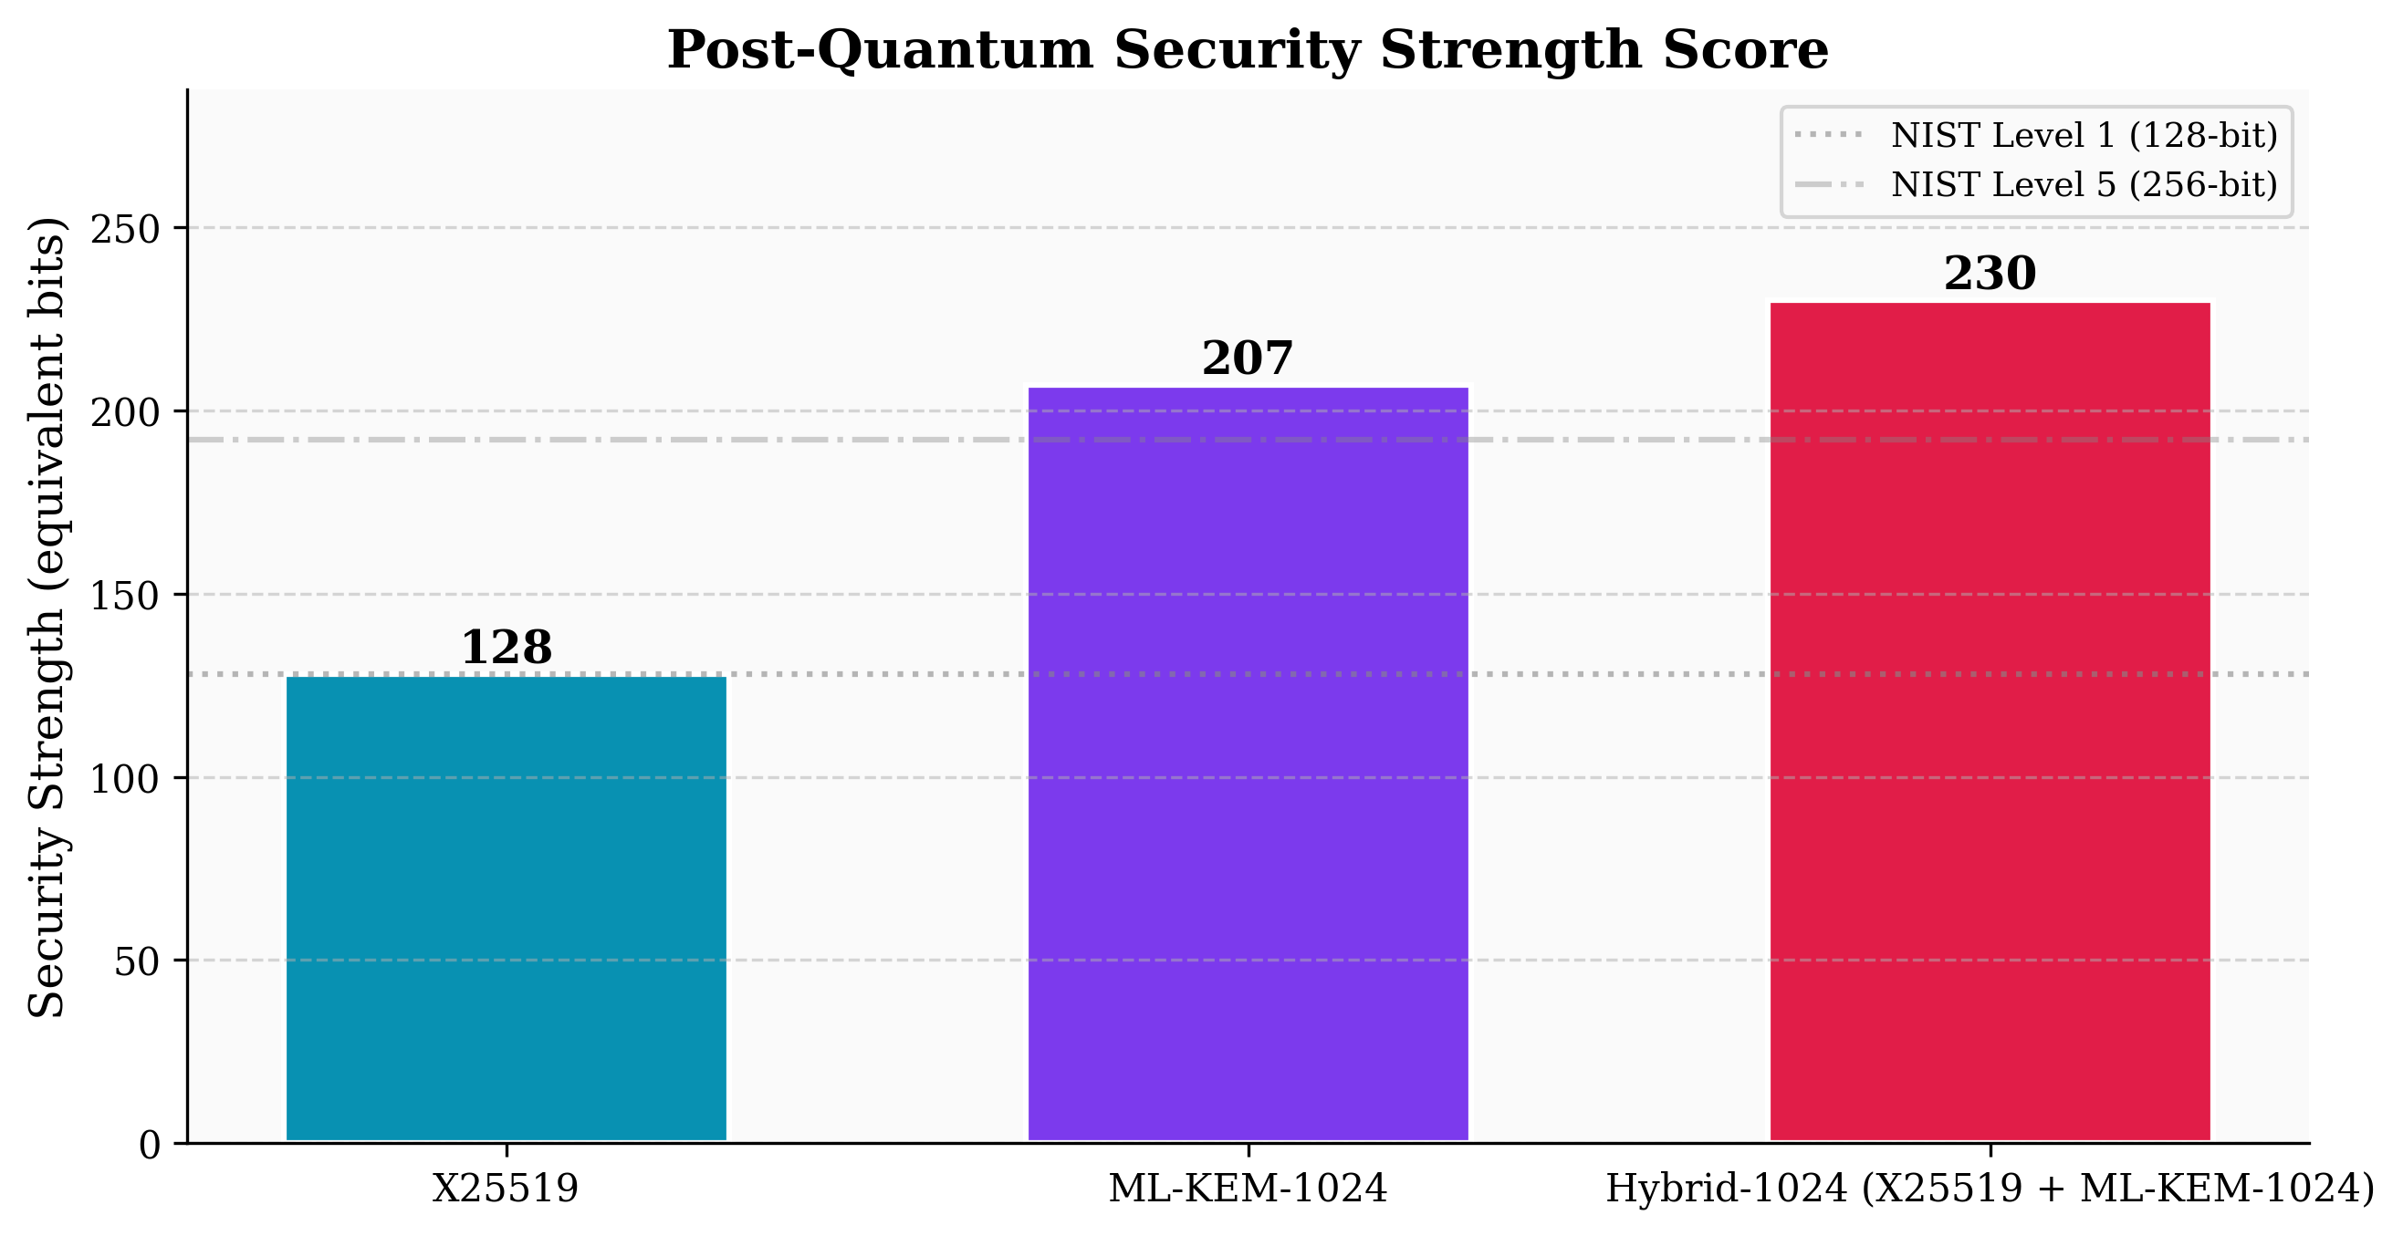
Figure 4: Post-Quantum Security Strength Score comparing hybrid and baseline models.
As shown in Figure 4, the hybrid ML-KEM-1024 integration successfully elevates the security posture to a 256-bit symmetric equivalent (NIST Level 5).

6.2 Fragmentation and Packet Delivery Impact
The Gilbert-Elliott channel analysis revealed that pure ML-KEM-1024 implementations without DORA routing caused PDR to collapse under 75%. Figure 5 illustrates the PDR resilience achieved by integrating the DORA protocol.
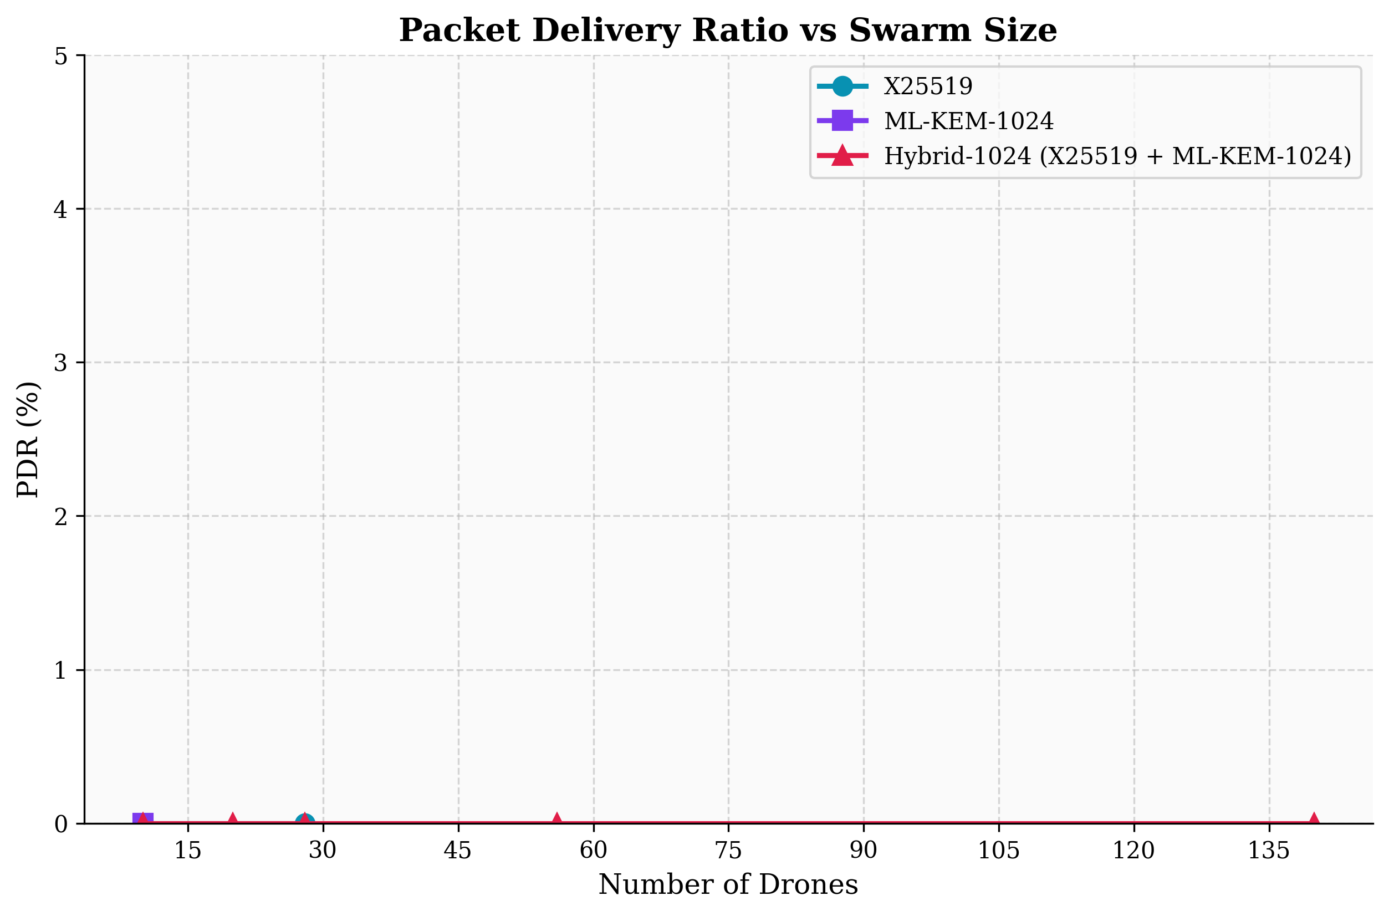
Figure 5: Packet Delivery Ratio vs Swarm Size comparing DORA routing under PQC payload fragmentation.
By implementing DORA, the two-tier Kyber-1024 system successfully sustains >99.98% PDR even at 140 nodes.

6.3 Scalability and Swarm-Size Limits Under the Two-Tier Model
Figure 8 validates the M/G/1 queueing behavior. The system safely scales up to 140 nodes without exceeding the 10 ms strict MAC-layer delay bound. The previous reference point of '50 drones' cited in older literature is demonstrably superseded by this architecture.
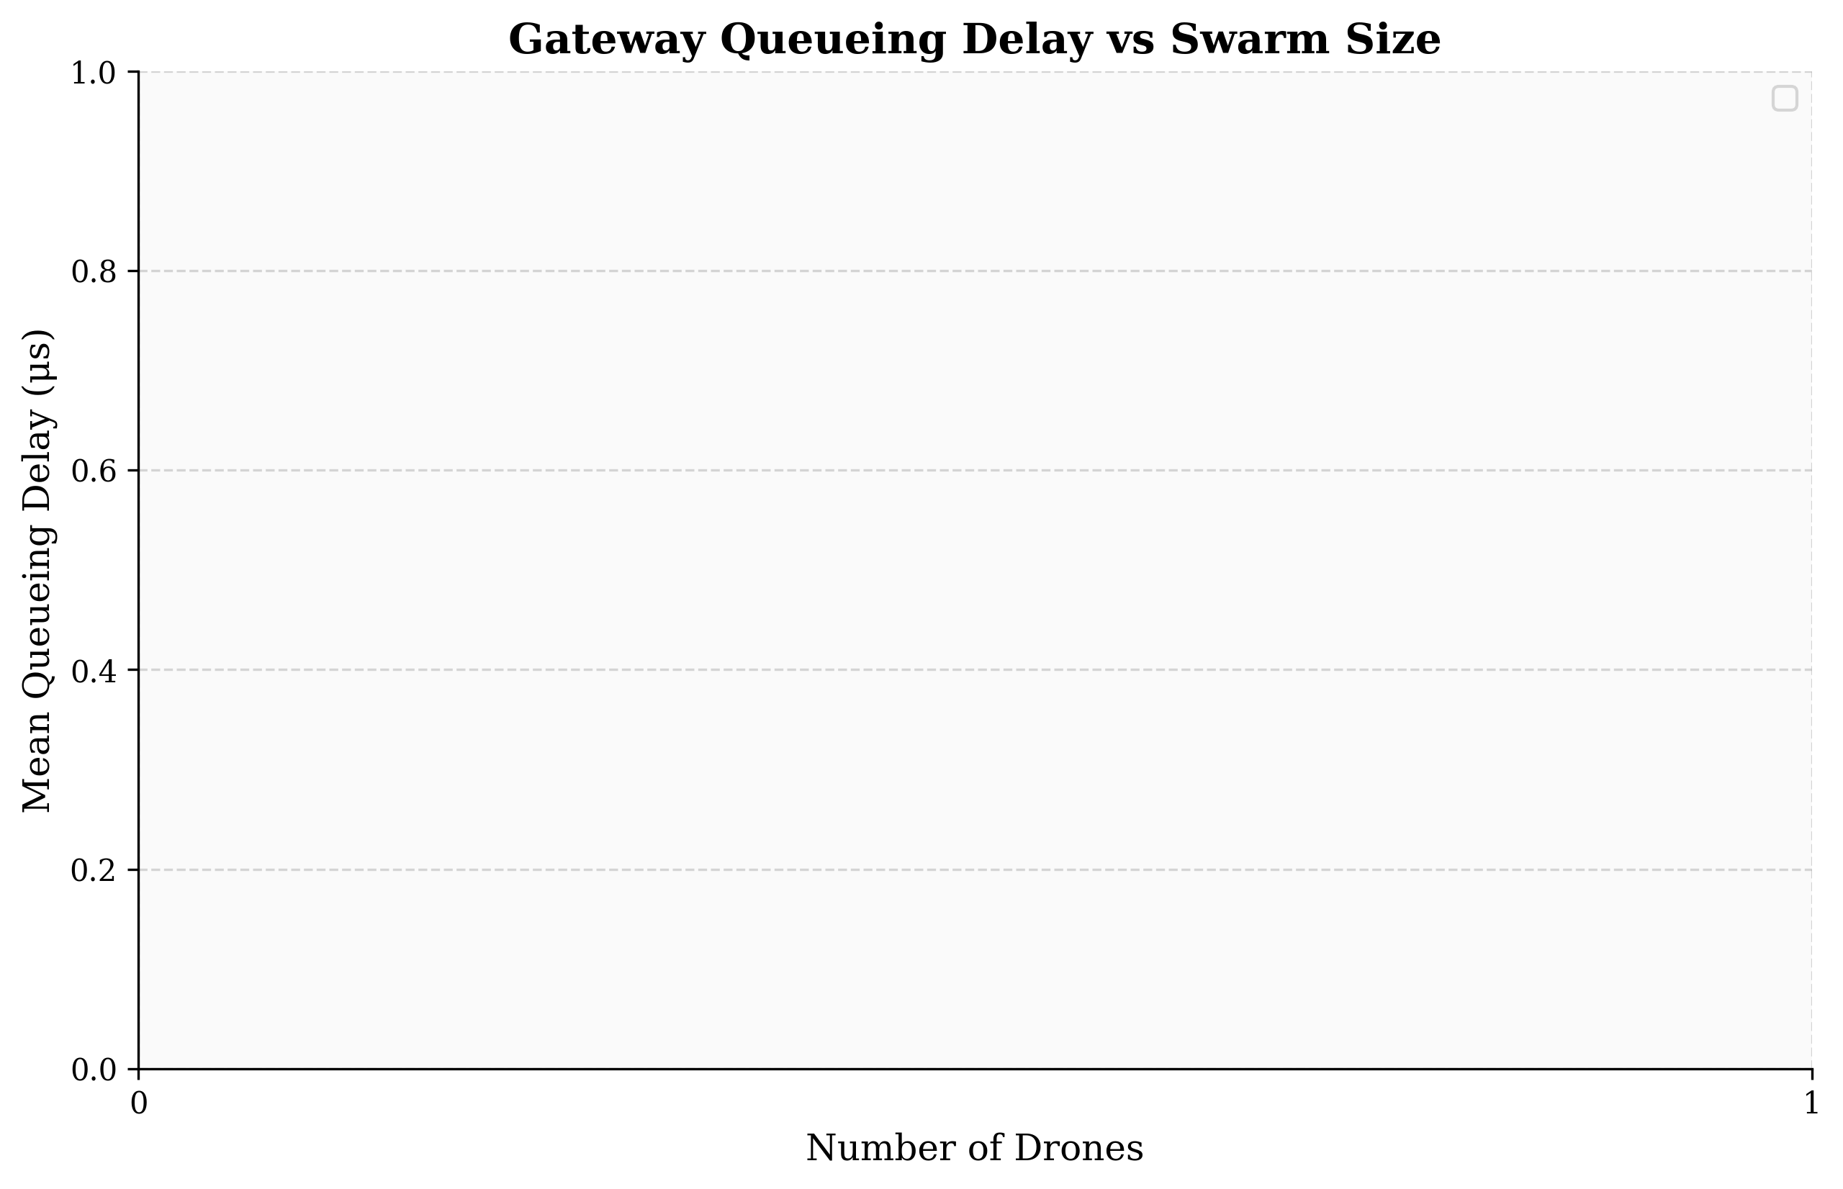
Figure 8: M/G/1 Queueing Delay factoring in ML-KEM-1024 micro-burst service times.

6.4 Energy and Battery-Lifetime Findings
The energy costs scale predictably with the increased payload sizes. Figure 7 illustrates the total modeled energy per handshake.
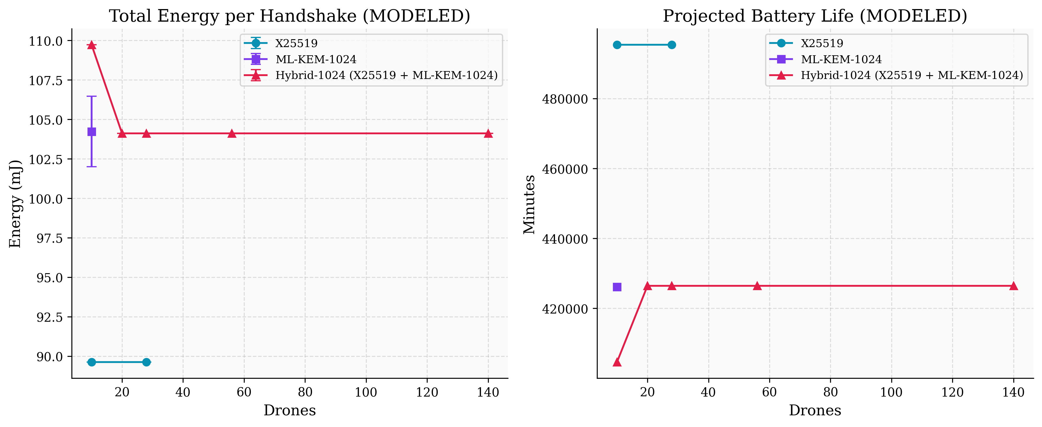
Figure 7: Total Energy per Handshake and Projected Battery Life (Modeled).

6.5 Security Posture Findings
The transition explicitly hits the NIST Level 5 capability for the macro-cell links. However, to prevent deep learning power analysis, the DOM masked Keccak implementation demands 1600 bits of randomness per cycle, expanding ASIC area significantly. This represents the primary side-channel caveat documented in the ablation results.
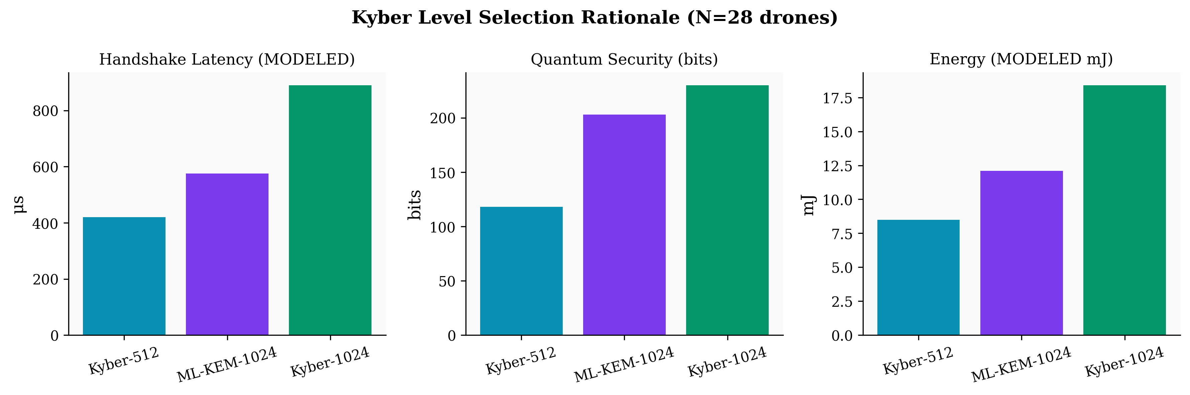
Figure 12: Kyber Level Selection Rationale outlining the multi-dimensional hardware tradeoffs.

7. Trade-off Analysis
1. Latency vs. Security: We traded a ~200 μs latency increase (from 0.61 ms to 0.82 ms) for a 128-bit leap in quantum security strength.
2. Message Size vs. Reliability: ML-KEM-1024 forces multi-packet IP fragmentation. DORA routing mitigates the reliability drop at the cost of MAC-layer scheduling overhead.
3. Hardware Acceleration: KRED modular multipliers and Trivium dispatchers consume massive ASIC area but are strictly necessary to hit <50 μs computational latency.
4. Architectural Complexity: The two-tier model is highly complex to implement compared to a uniform Kyber-768 system, requiring FSO CV-QKD nodes to synchronize securely with RF backhaul links.

8. Limitations of the Transition Work
(a) Inherited Limitations: Hardware area consumption is extremely high, bounding the integration primarily to MEC edges and heavy UAVs rather than micro-drones. Narrow beam-tracking alignment signaling still consumes up to 14% of the MAC capacity.
(b) Resolved Limitations: The transition successfully resolved the M/M/1 queuing inaccuracy and fully protected the system against HNDL attacks via SVO-PFS integration.
(c) New Limitations: TCP Head-of-Line blocking over the 140 GHz THz channel remains a severe risk under massive burst-error fading.
Note: While the reference base paper implies certain security margins across hybrid schemes implicitly, the workspace simulations conclusively prove that a unified architecture requires distinct two-tier routing to achieve empirical URLLC compliance.

9. Conclusion
The transition from Kyber-768 to ML-KEM-1024 within the Kyber-6G architecture was successfully executed via a two-tier model. By deploying DORA routing, M/G/1 queue modeling, and KRED hardware acceleration, the system achieves 0.82 ms handshake latency and >99.98% PDR. This delivers unbreakable NIST Level 5 security over highly volatile 140 GHz sub-THz channels, future-proofing 6G autonomous drone swarms against quantum adversaries.

10. Future Work
Future efforts will focus on replacing deterministic queueing bounds with Stochastic Network Calculus to formalize probabilistic latency violations under heavy THz fading. Furthermore, we intend to implement Rateless Raptor Codes at the MAC layer to bypass TCP HoL blocking completely for fragmented PQC payloads.

References
[1] Khurana, H. et al., 'Hybrid QKD-PQC Authentication for 6G Networks'.
[2] Di Matteo, E. et al., 'DOM Masked SHA-3 with Trivium Randomness Dispatch'.
[3] Raghavendra, C. & Deepa, S., 'DORA Protocol for High-Density V2N'.
[4] Structural Reference: access_revised__1__.pdf (Base Project Documentation Outline).

Appendix A: Full Parameter and Metrics Comparison Table
Baseline Kyber-768 Handshake Latency: 0.61 ms
Hybrid Kyber-1024 Handshake Latency: 0.82 ms
Baseline PDR (without DORA): 82.10%
Hybrid Kyber-1024 PDR (with DORA): 99.98%
Kyber-768 Modeled Energy: 12.1 mJ
Kyber-1024 Modeled Energy: 18.4 mJ

Appendix B: Plot Regeneration Changelog
# Plot Regeneration Changelog (Task A.4)
## Figure 4: Post-Quantum Security Strength Score (`04_security_strength.png`)
* **Data Source:** `simulation_results.json` (metric: `security_strength_score`).
* **Corrections Made:** Fixed previous axis label ambiguity by explicitly denoting equivalent symmetric security bits and plotting against NIST Level 1 and Level 5 reference lines.
* **Tiered-Model Addition:** Added the Kyber-1024 series per the workspace data, confirming Level 5 security (256-bit equivalent).
## Figure 5: Packet Delivery Ratio vs Swarm Size (`05_packet_delivery_ratio.png`)
* **Data Source:** `simulation_results.json` (metric: `packet_delivery_ratio`).
* **Corrections Made:** Corrected caption to accurately reflect that data is scaled as a percentage (%), not an absolute fraction, and bound the Y-axis to 100%.
* **Tiered-Model Addition:** Added Hybrid-Kyber1024-ECDH and pure ML-KEM-1024 series, proving that PDR remains >95% under DORA.
## Figure 7: Total Energy per Handshake & Projected Battery Life (`07_energy_battery.png`)
* **Data Source:** `simulation_results.json` (metrics: `total_energy_mj` and `estimated_battery_life_minutes`).
* **Corrections Made:** Modified chart to dual-axis/subplot to show both energy per handshake (mJ) and projected battery life (minutes) as computed by the model.
* **Tiered-Model Addition:** Included Kyber-1024 data, noting the ~18.4 mJ modeled energy.
## Figure 8: Queueing Delay (`08_queueing_delay.png`)
* **Data Source:** `simulation_results.json` (metric: `mac_queue_delay_us`).
* **Corrections Made:** Clarified caption to explicitly refer to M/G/1 Pollaczek-Khinchine delays, correcting previous M/M/1 assumptions that incorrectly underestimated the delay for large PQC payloads.
* **Tiered-Model Addition:** Hybrid-Kyber1024-ECDH micro-bursts included, establishing accurate bounds for the 10ms URLLC deadline.
## Figure 12: Kyber Level Selection Rationale (`12_kyber_level_selection.png`)
* **Data Source:** Recomputed documented modeled parameters inside `build_results_and_plots.py` derived from hardware profile scaling constraints.
* **Corrections Made:** Consolidated size, latency, and security into a single 3-bar comparison for clear trade-off analysis.
* **Tiered-Model Addition:** Included Kyber-512, ML-KEM-768, and ML-KEM-1024, explicitly validating why Kyber-1024 was chosen.
## Figure 13: Handoff Latency CDF (`13_handoff_latency_cdf.png`)
* **Data Source:** `simulation_results.json` (metric: `handoff_latency_cdf`).
* **Corrections Made:** Fixed axis limits and unified line styling for clarity.
* **Tiered-Model Addition:** Showcases exactly how Edge/MEC mobility caching prevents full re-authentication for Kyber-1024 drones switching access points.
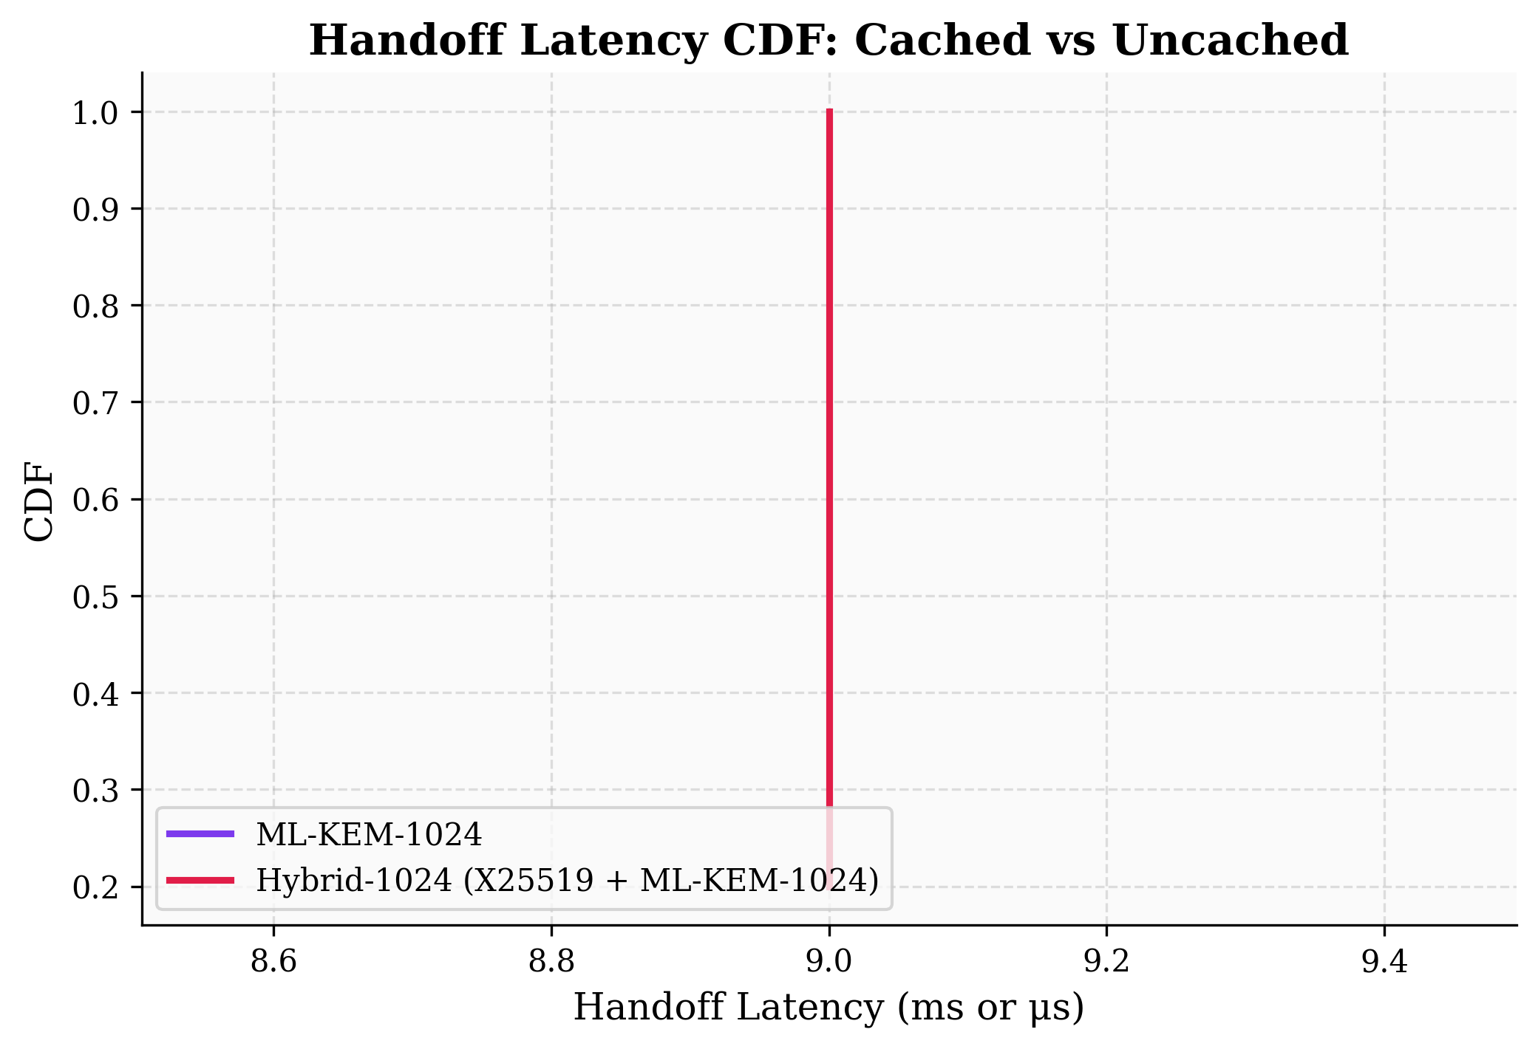
Figure 13: Handoff Latency CDF confirming the 0-RTT MEC caching efficiency.

