**Exercise 2: E-commerce Platform Search Function**

**Product.java**

public class Product {

    int productId;

    String productName;

    String category;

    public Product(int id, String name, String category) {

        this.productId = id;

        this.productName = name;

        this.category = category;

    }

    public String toString() {

        return "[" + productId + "] " + productName + " (" + category + ")";

    }

}

**SearchDemo.java**

import java.util.Arrays;

import java.util.Comparator;

public class SearchDemo {

    public static void main(String[] args) {

        Product[] products = {

            new Product(101, "Laptop", "Electronics"),

            new Product(205, "Shoes", "Fashion"),

            new Product(150, "Phone", "Electronics"),

            new Product(303, "Watch", "Accessories"),

            new Product(175, "Bag", "Fashion")

        };

        int targetId = 150;

        System.out.println("Linear Search:");

        Product result1 = linearSearch(products, targetId);

        System.out.println(result1 != null ? result1 : "Product not found");

        Arrays.sort(products, Comparator.comparingInt(p -> p.productId));

        System.out.println("\nBinary Search (after sorting):");

        Product result2 = binarySearch(products, targetId);

        System.out.println(result2 != null ? result2 : "Product not found");

    }

    static Product linearSearch(Product[] items, int targetId) {

        for (Product item : items) {

            if (item.productId == targetId) return item;

        }

        return null;

    }

    static Product binarySearch(Product[] items, int targetId) {

        int left = 0, right = items.length - 1;

        while (left <= right) {

            int mid = (left + right) / 2;

            if (items[mid].productId == targetId) return items[mid];

            if (items[mid].productId < targetId) left = mid + 1;

            else right = mid - 1;

        }

        return null;

    }

}

**Output :**

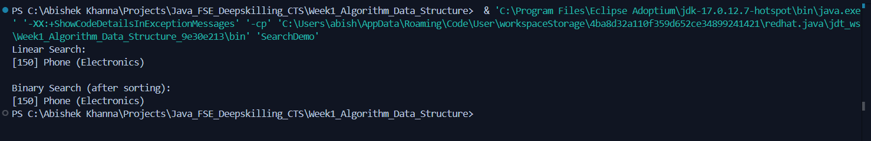

**Exercise 7: Financial Forecasting**

**FinancialForecast.java**

import java.util.Scanner;

public class FinancialForecast {

    public static double forecastValue(double presentValue, double growthRate, int years) {

        if (years == 0) {

            return presentValue;

        }

        return forecastValue(presentValue, growthRate, years - 1) * (1 + growthRate);

    }

    public static void main(String[] args) {

        Scanner sc = new Scanner(System.in);

        System.out.print("Enter present value (in rupees): ");

        double present = sc.nextDouble();

        System.out.print("Enter annual growth rate (in percent): ");

        double ratePercent = sc.nextDouble();

        double growthRate = ratePercent / 100;

        System.out.print("Enter number of years: ");

        int years = sc.nextInt();

        double future = forecastValue(present, growthRate, years);

        System.out.printf("Projected value after %d years: %.2f\n", years, future);

    }

}

**Output :**

