**Exercise 1: Control Structures**

**DB creation and Data insertion:**

SET SERVEROUTPUT ON SIZE 1000000;

CREATE TABLE customers (

customer_id NUMBER PRIMARY KEY,

customer_name VARCHAR2(100) NOT NULL,

date_of_birth DATE NOT NULL,

balance NUMBER(15,2) DEFAULT 0,

is_vip CHAR(1) DEFAULT 'N' CHECK (is_vip IN ('Y', 'N')),

email VARCHAR2(100),

phone VARCHAR2(15),

created_date DATE DEFAULT SYSDATE

);

CREATE TABLE loans (

loan_id NUMBER PRIMARY KEY,

customer_id NUMBER NOT NULL,

loan_amount NUMBER(15,2) NOT NULL,

interest_rate NUMBER(5,2) NOT NULL,

loan_start_date DATE NOT NULL,

loan_due_date DATE NOT NULL,

loan_status VARCHAR2(20) DEFAULT 'ACTIVE',

CONSTRAINT fk_loan_customer FOREIGN KEY (customer_id) REFERENCES customers(customer_id)

);

CREATE SEQUENCE seq_customer START WITH 1 INCREMENT BY 1;

CREATE SEQUENCE seq_loan START WITH 1 INCREMENT BY 1;

INSERT INTO customers (customer_id, customer_name, date_of_birth, balance, email, phone) VALUES

(seq_customer.NEXTVAL, 'David Lee', DATE '1952-09-10', 16000.00, 'david.lee@email.com', '999-0001');

INSERT INTO customers (customer_id, customer_name, date_of_birth, balance, email, phone) VALUES

(seq_customer.NEXTVAL, 'Olivia Martin', DATE '1965-01-25', 9500.00, 'olivia.martin@email.com', '999-0002');

INSERT INTO customers (customer_id, customer_name, date_of_birth, balance, email, phone) VALUES

(seq_customer.NEXTVAL, 'James King', DATE '1958-07-14', 27000.00, 'james.king@email.com', '999-0003');

INSERT INTO customers (customer_id, customer_name, date_of_birth, balance, email, phone) VALUES

(seq_customer.NEXTVAL, 'Ava Thompson', DATE '1989-06-11', 11000.00, 'ava.thompson@email.com', '999-0004');

INSERT INTO customers (customer_id, customer_name, date_of_birth, balance, email, phone) VALUES

(seq_customer.NEXTVAL, 'William Scott', DATE '1946-10-05', 4800.00, 'william.scott@email.com', '999-0005');

INSERT INTO customers (customer_id, customer_name, date_of_birth, balance, email, phone) VALUES

(seq_customer.NEXTVAL, 'Emma Harris', DATE '1993-12-01', 7000.00, 'emma.harris@email.com', '999-0006');

INSERT INTO loans (loan_id, customer_id, loan_amount, interest_rate, loan_start_date, loan_due_date) VALUES

(seq_loan.NEXTVAL, 1, 55000.00, 5.7, DATE '2024-01-10', SYSDATE + 18);

INSERT INTO loans (loan_id, customer_id, loan_amount, interest_rate, loan_start_date, loan_due_date) VALUES

(seq_loan.NEXTVAL, 2, 28000.00, 6.2, DATE '2024-02-25', SYSDATE + 12);

INSERT INTO loans (loan_id, customer_id, loan_amount, interest_rate, loan_start_date, loan_due_date) VALUES

(seq_loan.NEXTVAL, 3, 72000.00, 5.0, DATE '2024-03-15', SYSDATE + 35);

INSERT INTO loans (loan_id, customer_id, loan_amount, interest_rate, loan_start_date, loan_due_date) VALUES

(seq_loan.NEXTVAL, 4, 43000.00, 5.4, DATE '2024-04-20', SYSDATE + 22);

INSERT INTO loans (loan_id, customer_id, loan_amount, interest_rate, loan_start_date, loan_due_date) VALUES

(seq_loan.NEXTVAL, 5, 18000.00, 6.7, DATE '2024-05-01', SYSDATE + 9);

COMMIT;

**Scenario 1:**

DECLARE

total_checked NUMBER := 0;

discount_applied NUMBER := 0;

loan_rows_updated NUMBER := 0;

CURSOR cur_seniors IS

SELECT customer_id, customer_name,

TRUNC(MONTHS_BETWEEN(SYSDATE, date_of_birth)/12) AS age

FROM customers

WHERE EXISTS (

SELECT 1 FROM loans

WHERE loans.customer_id = customers.customer_id

);

BEGIN

DBMS_OUTPUT.PUT_LINE('*** APPLYING DISCOUNT FOR SENIOR CUSTOMERS ***');

FOR rec IN cur_seniors LOOP

total_checked := total_checked + 1;

IF rec.age > 60 THEN

UPDATE loans

SET interest_rate = GREATEST(interest_rate - 1.0, 1.0)

WHERE customer_id = rec.customer_id AND loan_status = 'ACTIVE';

loan_rows_updated := SQL%ROWCOUNT;

discount_applied := discount_applied + loan_rows_updated;

DBMS_OUTPUT.PUT_LINE('Discounted: ' || rec.customer_name || ' (Age: ' || rec.age || ')');

ELSE

DBMS_OUTPUT.PUT_LINE('Skipped: ' || rec.customer_name || ' (Age: ' || rec.age || ')');

END IF;

END LOOP;

DBMS_OUTPUT.PUT_LINE('Customers Processed: ' || total_checked);

DBMS_OUTPUT.PUT_LINE('Total Loans Updated: ' || discount_applied);

IF discount_applied > 0 THEN

COMMIT;

END IF;

EXCEPTION

WHEN OTHERS THEN

ROLLBACK;

DBMS_OUTPUT.PUT_LINE('Error in Scenario 1: ' || SQLERRM);

END;

/

**Output :**

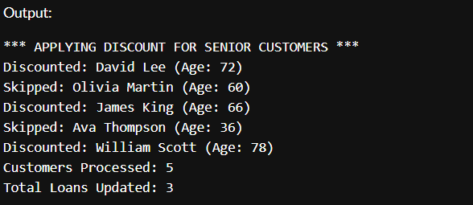

**Scenario 2:**

DECLARE

vip_upgraded NUMBER := 0;

existing_vips NUMBER := 0;

not_qualified NUMBER := 0;

total_customers NUMBER := 0;

CURSOR vip_cursor IS

SELECT customer_id, customer_name, balance, is_vip

FROM customers;

BEGIN

DBMS_OUTPUT.PUT_LINE('*** PROCESSING VIP PROMOTIONS ***');

FOR cust IN vip_cursor LOOP

total_customers := total_customers + 1;

IF cust.balance > 10000 THEN

IF cust.is_vip = 'N' THEN

UPDATE customers SET is_vip = 'Y' WHERE customer_id = cust.customer_id;

vip_upgraded := vip_upgraded + 1;

DBMS_OUTPUT.PUT_LINE('Promoted to VIP: ' || cust.customer_name);

ELSE

existing_vips := existing_vips + 1;

END IF;

ELSE

not_qualified := not_qualified + 1;

END IF;

END LOOP;

DBMS_OUTPUT.PUT_LINE('Total Customers: ' || total_customers);

DBMS_OUTPUT.PUT_LINE('New VIPs: ' || vip_upgraded);

DBMS_OUTPUT.PUT_LINE('Already VIPs: ' || existing_vips);

DBMS_OUTPUT.PUT_LINE('Not Eligible: ' || not_qualified);

IF vip_upgraded > 0 THEN

COMMIT;

END IF;

EXCEPTION

WHEN OTHERS THEN

ROLLBACK;

DBMS_OUTPUT.PUT_LINE('Error in Scenario 2: ' || SQLERRM);

END;

/

**Output :**

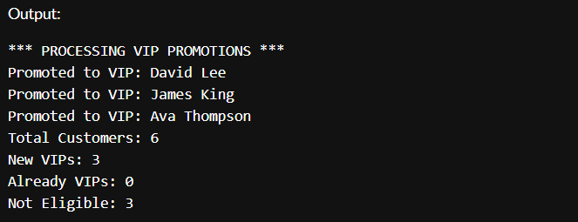

**Scenario 3:**

BEGIN

DBMS_OUTPUT.PUT_LINE('*** UPCOMING LOAN DUE REMINDERS (NEXT 30 DAYS) ***');

FOR due_rec IN (

SELECT l.loan_id, l.loan_due_date, l.loan_amount,

c.customer_name, c.email, c.phone

FROM loans l

JOIN customers c ON l.customer_id = c.customer_id

WHERE l.loan_due_date BETWEEN SYSDATE AND (SYSDATE + 30)

AND l.loan_status = 'ACTIVE'

ORDER BY l.loan_due_date

) LOOP

DBMS_OUTPUT.PUT_LINE('Reminder: ' || due_rec.customer_name ||

' | Loan ID: ' || due_rec.loan_id ||

' | Due: ' || TO_CHAR(due_rec.loan_due_date, 'DD-Mon-YYYY') ||

' | Amount: ₹' || TO_CHAR(due_rec.loan_amount, '999,999.00'));

DBMS_OUTPUT.PUT_LINE('-> Contact: ' || due_rec.email || ' / ' || due_rec.phone);

DBMS_OUTPUT.PUT_LINE('-----------------------------------------------');

END LOOP;

EXCEPTION

WHEN OTHERS THEN

DBMS_OUTPUT.PUT_LINE('Error in Scenario 3: ' || SQLERRM);

END;

/

**Output :  
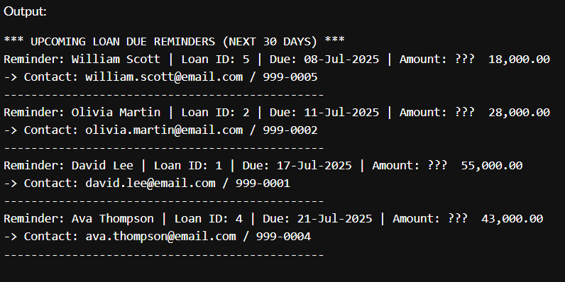**

**Exercise 3: Stored Procedures**

SET SERVEROUTPUT ON SIZE 1000000;

CREATE TABLE customers (

customer_id NUMBER PRIMARY KEY,

customer_name VARCHAR2(100) NOT NULL,

date_of_birth DATE NOT NULL,

balance NUMBER(15,2) DEFAULT 0,

is_vip CHAR(1) DEFAULT 'N' CHECK (is_vip IN ('Y', 'N')),

email VARCHAR2(100),

phone VARCHAR2(15),

created_date DATE DEFAULT SYSDATE

);

CREATE TABLE loans (

loan_id NUMBER PRIMARY KEY,

customer_id NUMBER NOT NULL,

loan_amount NUMBER(15,2) NOT NULL,

interest_rate NUMBER(5,2) NOT NULL,

loan_start_date DATE NOT NULL,

loan_due_date DATE NOT NULL,

loan_status VARCHAR2(20) DEFAULT 'ACTIVE',

CONSTRAINT fk_customer_loan FOREIGN KEY (customer_id) REFERENCES customers(customer_id)

);

CREATE SEQUENCE customer_seq START WITH 1 INCREMENT BY 1;

CREATE SEQUENCE loan_seq START WITH 1 INCREMENT BY 1;

INSERT INTO customers (customer_id, customer_name, date_of_birth, balance, email, phone) VALUES

(customer_seq.NEXTVAL, 'Ankit Verma', DATE '1949-06-10', 18000.00, 'ankit.verma@email.com', '987-1111');

INSERT INTO customers (customer_id, customer_name, date_of_birth, balance, email, phone) VALUES

(customer_seq.NEXTVAL, 'Nisha Patel', DATE '1962-09-05', 9200.00, 'nisha.patel@email.com', '987-1112');

INSERT INTO customers (customer_id, customer_name, date_of_birth, balance, email, phone) VALUES

(customer_seq.NEXTVAL, 'Suresh Iyer', DATE '1957-02-15', 27000.00, 'suresh.iyer@email.com', '987-1113');

INSERT INTO customers (customer_id, customer_name, date_of_birth, balance, email, phone) VALUES

(customer_seq.NEXTVAL, 'Rekha Nair', DATE '1987-01-25', 14500.00, 'rekha.nair@email.com', '987-1114');

INSERT INTO customers (customer_id, customer_name, date_of_birth, balance, email, phone) VALUES

(customer_seq.NEXTVAL, 'Arvind Rao', DATE '1947-08-12', 4700.00, 'arvind.rao@email.com', '987-1115');

INSERT INTO customers (customer_id, customer_name, date_of_birth, balance, email, phone) VALUES

(customer_seq.NEXTVAL, 'Deepika Sinha', DATE '1994-10-30', 8900.00, 'deepika.sinha@email.com', '987-1116');

INSERT INTO loans (loan_id, customer_id, loan_amount, interest_rate, loan_start_date, loan_due_date) VALUES

(loan_seq.NEXTVAL, 1, 42000.00, 5.3, DATE '2024-01-12', SYSDATE + 22);

INSERT INTO loans (loan_id, customer_id, loan_amount, interest_rate, loan_start_date, loan_due_date) VALUES

(loan_seq.NEXTVAL, 2, 25000.00, 6.1, DATE '2024-03-18', SYSDATE + 18);

INSERT INTO loans (loan_id, customer_id, loan_amount, interest_rate, loan_start_date, loan_due_date) VALUES

(loan_seq.NEXTVAL, 3, 69000.00, 5.0, DATE '2024-02-28', SYSDATE + 40);

INSERT INTO loans (loan_id, customer_id, loan_amount, interest_rate, loan_start_date, loan_due_date) VALUES

(loan_seq.NEXTVAL, 4, 39000.00, 5.4, DATE '2024-05-01', SYSDATE + 26);

INSERT INTO loans (loan_id, customer_id, loan_amount, interest_rate, loan_start_date, loan_due_date) VALUES

(loan_seq.NEXTVAL, 5, 22000.00, 6.3, DATE '2024-04-14', SYSDATE + 12);

CREATE TABLE employees (

employee_id NUMBER PRIMARY KEY,

employee_name VARCHAR2(100),

department_id NUMBER,

salary NUMBER(10,2)

);

CREATE TABLE accounts (

account_id NUMBER PRIMARY KEY,

customer_id NUMBER,

balance NUMBER(15,2)

);

INSERT INTO employees VALUES (11, 'Meera Joshi', 10, 52000);

INSERT INTO employees VALUES (12, 'Tarun Nair', 10, 49000);

INSERT INTO employees VALUES (13, 'Sneha Desai', 20, 61000);

INSERT INTO accounts VALUES (2001, 1, 3500);

INSERT INTO accounts VALUES (2002, 2, 1200);

COMMIT;

CREATE OR REPLACE PROCEDURE ProcessMonthlyInterest AS

BEGIN

UPDATE customers

SET balance = balance + (balance * 0.01)

WHERE balance > 0;

DBMS_OUTPUT.PUT_LINE('Monthly interest of 1% applied to all savings accounts.');

COMMIT;

END;

/

CREATE OR REPLACE PROCEDURE UpdateEmployeeBonus (

p_dept_id IN NUMBER,

p_bonus_percent IN NUMBER

) AS

BEGIN

UPDATE employees

SET salary = salary + (salary * p_bonus_percent / 100)

WHERE department_id = p_dept_id;

DBMS_OUTPUT.PUT_LINE('Bonus of ' || p_bonus_percent || '% applied to department ' || p_dept_id);

COMMIT;

END;

/

CREATE OR REPLACE PROCEDURE TransferFunds(

p_from_account IN NUMBER,

p_to_account IN NUMBER,

p_amount IN NUMBER

) AS

v_balance NUMBER;

BEGIN

SELECT balance INTO v_balance FROM accounts WHERE account_id = p_from_account FOR UPDATE;

IF v_balance < p_amount THEN

RAISE_APPLICATION_ERROR(-20001, 'Insufficient funds in source account.');

END IF;

UPDATE accounts SET balance = balance - p_amount WHERE account_id = p_from_account;

UPDATE accounts SET balance = balance + p_amount WHERE account_id = p_to_account;

DBMS_OUTPUT.PUT_LINE('Transferred ' || p_amount || ' from account ' || p_from_account || ' to account ' || p_to_account);

COMMIT;

END;

/