**Database Schema Diagram**

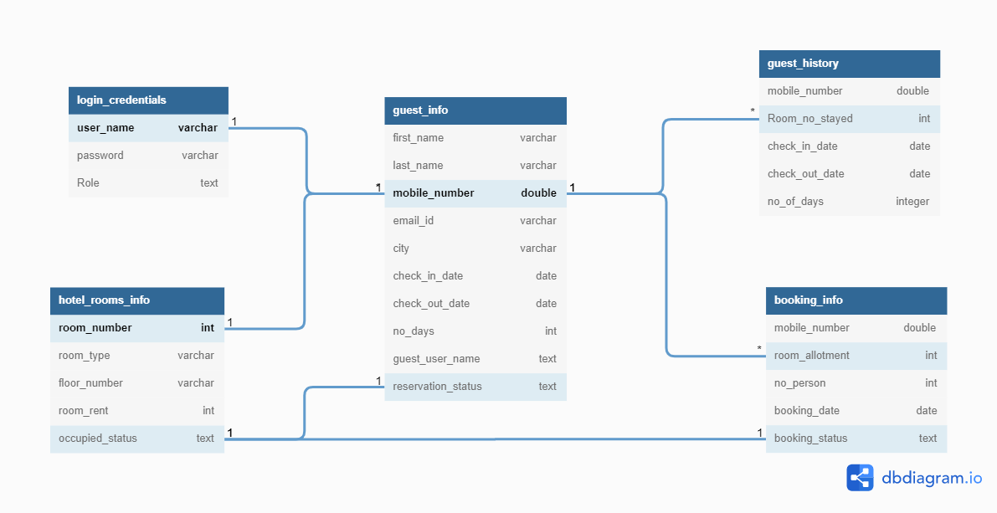

**Schema Diagram Constrains:**

* Each Guest can have for one User_name and Password.
* Each Guest can request for one or more Room.
* Each Guest can have for one Personal details like First name, Mobile number.
* Each Guest can reserve for one or more Room in a particular time.
* Each Guest can book a room twice in a particular time.
* The occupied Status depends on the Reservation Status and Booking Status.