SpyAware

DevOps & CI/CD Implementation

1. Project Overview
SpyAware is an Android-based defensive security application focused on BLE device awareness and analysis using BLE scanning, device information, RSSI and distance-oriented analysis.
As part of the project development, a DevOps workflow was implemented using Git, GitHub, Docker and GitHub Actions.

Objectives
- Maintain the project using Git/GitHub.
- Containerize the Android build environment.
- Automate testing and APK generation.
- Implement CI/CD using GitHub Actions.
- Create versioned APK releases.

2. Technologies Used
Technology | Purpose
Git | Version control
GitHub | Source-code hosting
Docker | Reproducible Android build environment
GitHub Actions | CI/CD automation
Gradle 9.2.1 | Android build system
JDK 17 | Docker build environment
Android SDK 36.1 | Application compilation
Java 11 | Application source compatibility

3. Git and GitHub Setup
The SpyAware project was pushed to GitHub and the repository was configured to use SSH authentication.
Repository:
git@github.com:TINKU6113/SpyAware.git
SSH authentication was verified using:
ssh -T git@github.com
The main branch was pushed using:
git branch -M main
git push -u origin main

Source-Control Cleanup
Generated files such as Gradle caches, build directories, APK files and local Android configuration were removed from Git tracking.
A .gitignore file was added:
.gradle/
build/
*/build/
local.properties
.idea/
*.iml
*.apk
*.aab
*.jks
*.keystore
This keeps generated and machine-specific files out of the repository.
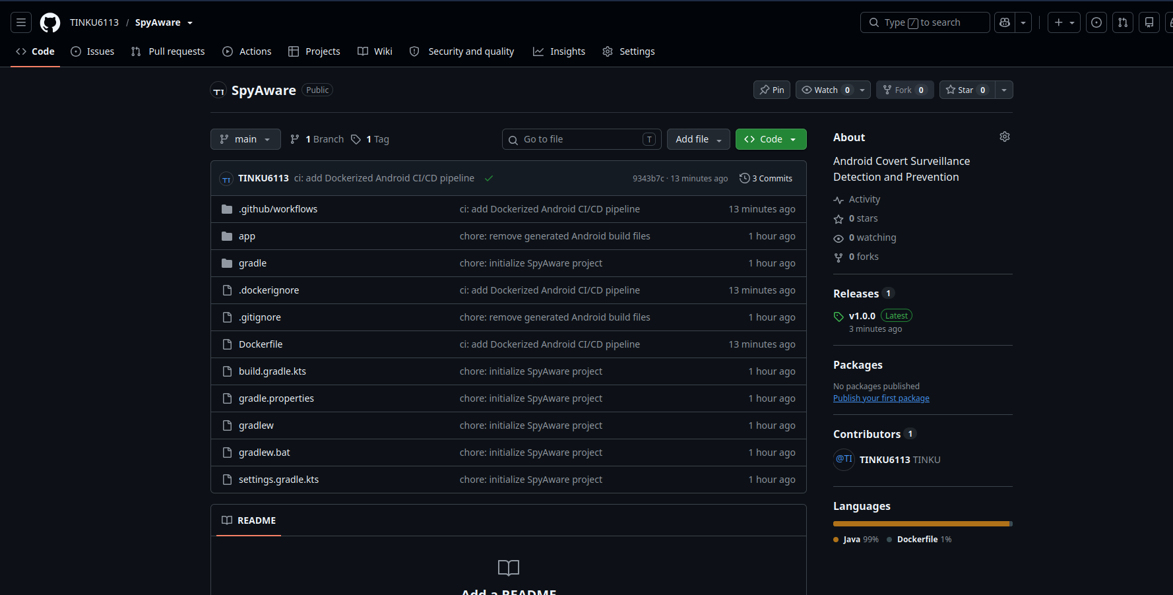

4. Docker Containerization
The Android application itself is not containerized because it runs on an Android device. Instead, the Android build environment is containerized.
The Docker container contains:
JDK 17
↓
Android SDK
↓
Android Build Tools
↓
Gradle
↓
SpyAware APK

Dockerfile
The project contains a Dockerfile that installs:
- JDK 17
- Android command-line tools
- Android Platform 36
- Android Build Tools 36.1.0
The Docker image was created using:
docker build -t spyaware-android-build .
The image was successfully built.
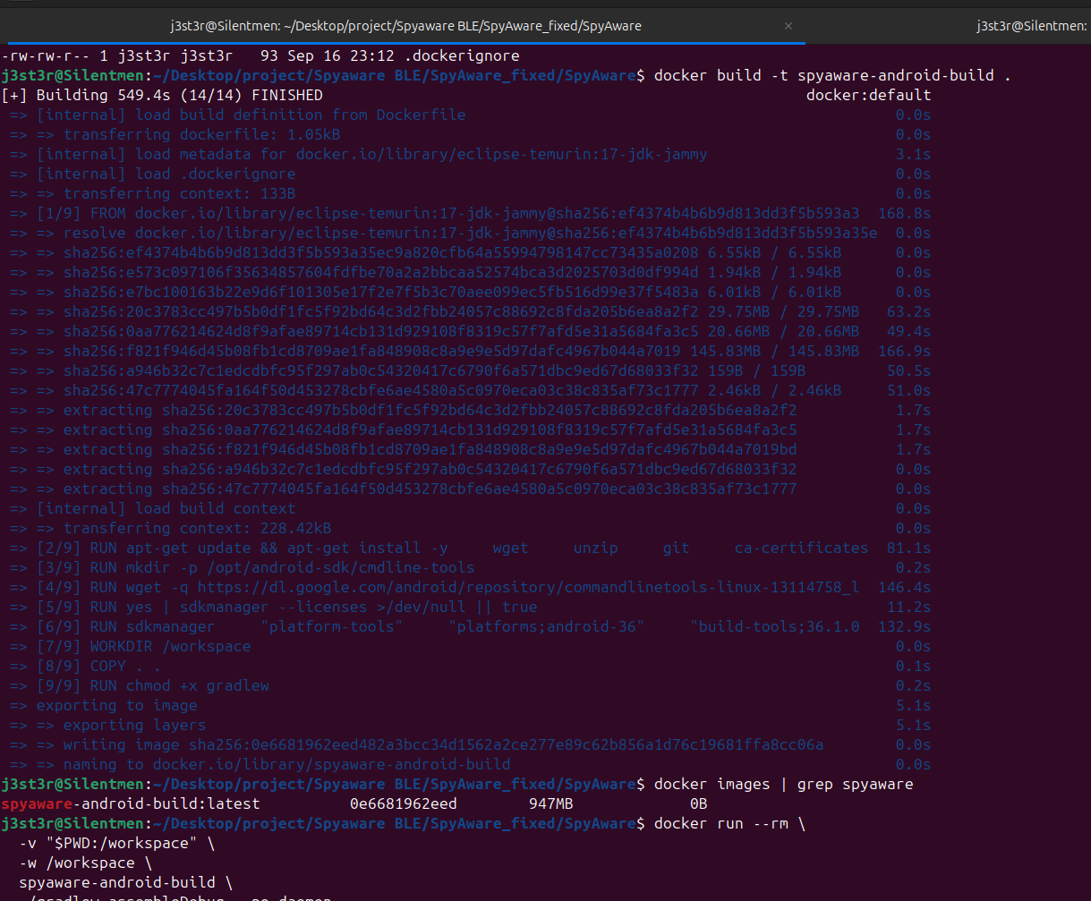

5. Building SpyAware Using Docker
The application was successfully built inside the Docker container using:
docker run --rm \
-v "$PWD:/workspace" \
-w /workspace \
spyaware-android-build \
./gradlew assembleDebug --no-daemon
The generated APK is:
app/build/outputs/apk/debug/app-debug.apk
This demonstrates that the application can be built using a controlled and reproducible environment.
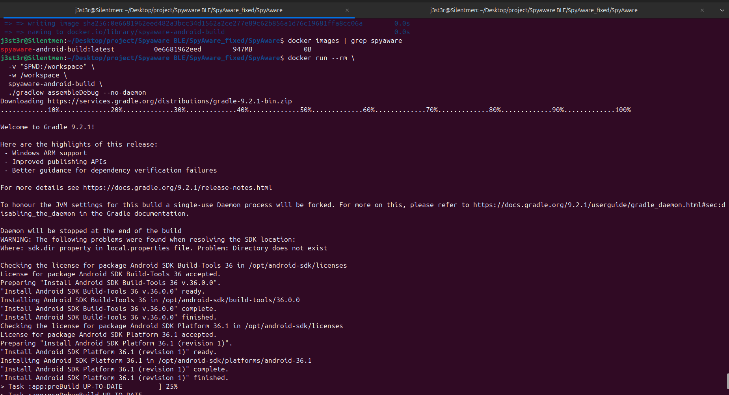

6. CI — Continuous Integration
GitHub Actions was configured using:
.github/workflows/ci-cd.yml
The CI pipeline performs:
Git Push
↓
GitHub Actions
↓
Checkout Code
↓
Build Docker Image
↓
Run Gradle Tests
↓
Build APK
↓
Upload APK Artifact
The main commands executed by the pipeline are:
./gradlew test --no-daemon
and:
./gradlew assembleDebug --no-daemon
The generated APK is uploaded as a GitHub Actions artifact named:
SpyAware-debug-apk
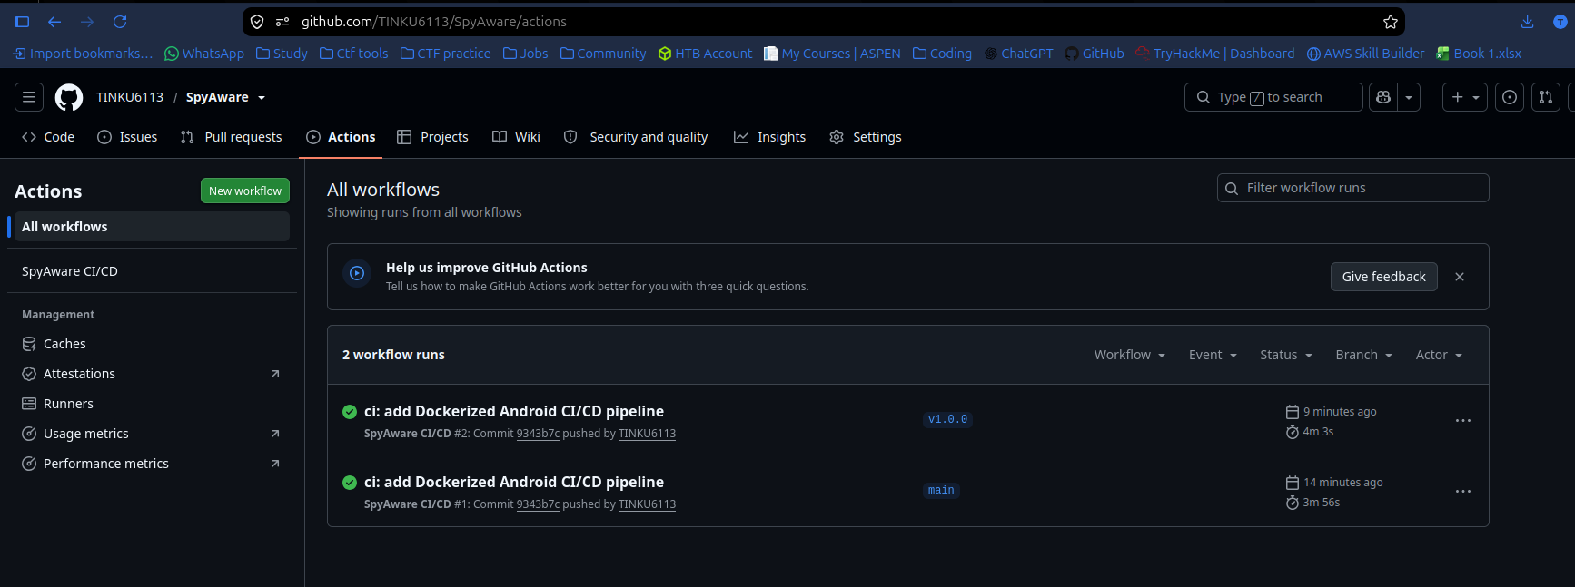

7. CD — Continuous Delivery
Continuous Delivery was implemented using Git tags.
A version tag was created:
git tag v1.0.0
git push origin v1.0.0
The v* tag triggers the release portion of the GitHub Actions workflow.
The process is:
v1.0.0
↓
GitHub Actions
↓
Docker Build
↓
Gradle Tests
↓
APK Build
↓
GitHub Release
↓
app-debug.apk
The v1.0.0 tag was successfully pushed to GitHub.
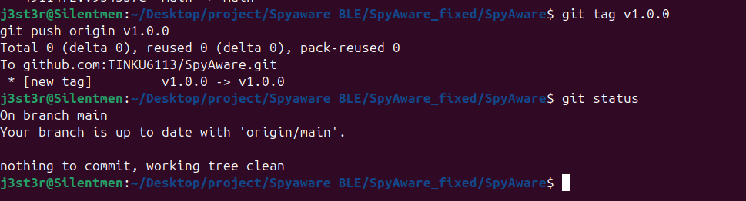

8. Final DevOps Architecture
Developer
│
▼
Git/GitHub
│
git push
│
▼
GitHub Actions
│
▼
Docker
│
┌──────┴──────┐
▼ ▼
Testing APK Build
│ │
└──────┬──────┘
▼
APK Artifact
│
Version Tag
│
▼
GitHub Release

9. Security Considerations
The following practices were implemented:
- local.properties is excluded from Git.
- APK and AAB files are excluded from normal source control.
- .jks and .keystore files are excluded.
- Docker provides a controlled build environment.
- SSH is used for GitHub authentication.
- Signing credentials should be stored using GitHub Secrets in future release builds.
- Passwords and API keys should never be committed to the repository.

10. Results
The following were successfully implemented:
Task | Status
Git repository | ✅ Completed
GitHub integration | ✅ Completed
SSH authentication | ✅ Completed
.gitignore cleanup | ✅ Completed
Docker build environment | ✅ Completed
Dockerized Android build | ✅ Completed
APK generation | ✅ Completed
GitHub Actions CI | ✅ Completed
APK artifact | ✅ Completed
Version v1.0.0 | ✅ Created
CD workflow | ✅ Implemented

11. Future Improvements
The current implementation can be extended with:
- Signed release APK/AAB
- Android Lint
- Static code analysis
- Dependency vulnerability scanning
- Automated test coverage
- GitHub branch protection
- Secure release signing using GitHub Secrets

12. Conclusion
The SpyAware project was integrated with a complete basic DevOps workflow using Git, GitHub, Docker and GitHub Actions.
Docker provides a reproducible Android build environment, while GitHub Actions automatically performs testing and APK generation. Version tagging provides a controlled mechanism for delivering versioned application builds through GitHub Releases.
The implementation establishes a foundation for extending SpyAware into a more advanced DevSecOps pipeline with security scanning, signed releases and automated quality checks.

